Urban Water Demand Prediction System

Problem Id: AIML- 6

Name : Shivya Sinha (Team Leader)
Class Roll Number: 23
University Roll Number : 2028497
Section and Group: U (G1)

Name : Srishti Kuletha
Class Roll Number: 25
University Roll Number : 2028502
Section and Group: U (G1)

Name : Divya Jain
Class Roll Number: 12
University Roll Number : 2028414
Section and Group: U (G1)

TABLE OF CONTENTS
- Problem Description 3
  - Dataset Description 3
  - Flow diagram 5
- Modules for Project Implementation 5
  - Modules Used 5
  - Platform Used 8
- Machine Learning model/ Searching Technique used 8
- Evaluation metrics used 10
- Results and Visualizations 9
- Conclusion and Future Scope 11
- References 12

1. Problem Description
Water is one of the most essential natural resources, and its efficient management is critical in urban environments where demand fluctuates significantly. Rapid urbanization, population growth, and changing lifestyle patterns have placed increasing pressure on water distribution systems. Municipal authorities and urban planners face the challenge of forecasting daily water consumption accurately to ensure adequate supply, minimize wastage, and optimize resource allocation. Without a reliable prediction system, water utilities risk either over-supplying — leading to resource waste — or under-supplying — causing shortages and public inconvenience.

Efficient resource management requires accurate forecasting of daily water usage across urban households. The daily water consumption of a household is influenced by several factors including the number of members in the household, the season of the year, and the size of garden or outdoor area that requires irrigation. However, these factors are often recorded inconsistently, with missing entries and varying scales, making raw data unreliable for direct analysis. There is a need for a structured machine learning pipeline that cleans, standardizes, and models this data to produce accurate predictions of daily water usage in liters.

• To curate a dataset capturing key factors influencing urban water consumption, namely Household Size, Seasonal Index, and Garden Area.
• To clean the dataset by handling missing values and removing inconsistencies that may affect model performance.
• To standardize features using StandardScaler to ensure all input variables contribute equally to the model.
• To build and train a Linear Regression model to forecast daily water usage (Daily_Liters_Used).
• To evaluate model performance through residual analysis and standard regression metrics.

The model is expected to accurately forecast the daily water usage of urban households in liters based on household size, seasonal conditions, and garden area. The outcome will assist urban water management authorities in making data-driven decisions for resource planning, infrastructure development, and demand forecasting — ultimately contributing to more sustainable and efficient water distribution in cities.

1.1 Dataset Description

The model is expected to accurately forecast the daily water usage of urban households in liters based on household size, seasonal conditions, and garden area. The outcome will assist urban water management authorities in making data-driven decisions for resource planning, infrastructure development, and demand forecasting — ultimately contributing to more sustainable and efficient water distribution in cities.
Features and Nature of Data Points:
1. Household_Size
- Type: Continuous numerical (float64)
- Range: 1.0 – 9.5 | Mean: 3.57 | Std Dev: 1.84
- Nature: Represents the number of individuals residing in a household. Although household size is inherently a count variable (integer), the dataset contains decimal values (e.g. 3.5, 4.5), suggesting it may represent an average household size or a weighted estimate across multiple time periods. The distribution is spread across small (1–2 members) to large households (8–9+ members), capturing a realistic range of urban living conditions. Larger households are expected to consume significantly more water daily.
2. Seasonal_Index
- Type: Continuous numerical (float64), ordinal in nature
- Range: 1.0 – 6.0 | Mean: 2.43 | Std Dev: 1.23
- Nature: Represents seasonal variation in water consumption encoded as a numerical index. The scale of 1 to 6 likely corresponds to six seasonal or monthly periods (e.g. 1 = Winter, 2 = Spring, 3 = Summer, and so on). With a mean of 2.43 and 75th percentile at 3.0, the majority of records fall in lower-to-mid seasonal demand periods. Higher index values indicate seasons with increased water usage such as summer or dry months, particularly for garden irrigation and increased personal hygiene needs.
3. Garden_Area
- Type: Continuous numerical (float64)
- Range: 0.93 – 298.90 m² | Mean: 98.53 | Std Dev: 61.44
- Nature: Represents the outdoor garden or green space area associated with each household, measured in square meters. The wide range (under 1 m² to nearly 300 m²) reflects the diversity of urban housing — from apartments with minimal outdoor space to independent houses with large gardens. The standard deviation of 61.44 indicates high variability across households. Garden area is a strong predictor of water consumption, as larger outdoor spaces require more irrigation, especially during high seasonal index periods.
4. Daily_Liters_Used (Target Variable)
- Type: Continuous numerical (float64)
- Range: 30.86 – 537.40 L | Mean: 226.36 | Std Dev: 106.08
- Nature: This is the dependent variable the model aims to predict — the total daily water consumption per household in liters. The wide range (30.86 L to 537.40 L) reflects realistic diversity in urban water usage, from minimal single-person consumption to high-demand large households with gardens in peak seasons. The mean of 226.36 L aligns with global urban per-capita consumption benchmarks. The relatively high standard deviation of 106.08 indicates that water usage is significantly influenced by the combined effect of all three input features, justifying the use of a regression model.

1.2 Flow Diagram

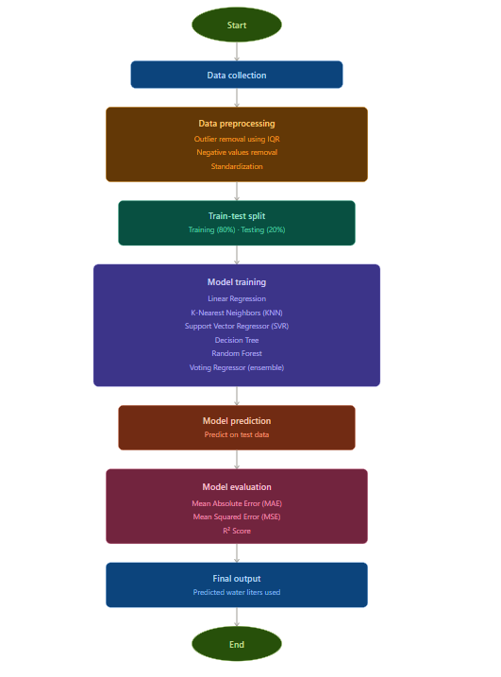

Fig.1 Sample flow diagram

2. Modules for Project Implementation

2.1 Modules Used(mention all the inbuilt/ custom modules used and the purpose)

Standard Library

Pickle — A built-in Python module used to serialize (convert to byte stream) and save trained machine learning models to a .pkl file. This allows the model to be stored permanently on disk and reloaded later for predictions without having to retrain from scratch, saving significant time and computation.
Data Handling

Pandas (pd) — A powerful data manipulation library that provides the DataFrame structure, which is essentially a table with rows and columns. It is used for loading datasets (CSV, Excel, etc.), handling missing values, filtering rows, creating new features, and preparing data before feeding it into ML models.

Numpy (np) — A foundational numerical computing library that provides support for multi-dimensional arrays and a wide range of mathematical operations. It works closely with pandas and scikit-learn under the hood, and is used for array manipulation, statistical calculations, and efficient numerical transformations during preprocessing.
Visualization
Seaborn (sns) — A high-level statistical data visualization library built on top of matplotlib that makes it easy to create attractive and informative plots with minimal code. It is commonly used to visualize feature distributions, boxplots for outlier detection, heatmaps for correlation matrices, and model performance comparisons.
Matplotlib.pyplot (plt) — The foundational plotting library in Python that gives full control over figure creation, axes, labels, colors, and layout. It is used directly to render and customize charts, and also serves as the backend engine that seaborn relies on for rendering its plots.
Preprocessing
StandardScaler — A preprocessing tool that standardizes each feature by subtracting its mean and dividing by its standard deviation, transforming all values into a common z-score scale with mean 0 and variance 1. This is essential for distance-based models like KNN and SVR, which are sensitive to features with very different numerical ranges.
MinMaxScaler — A scaling technique that compresses all feature values into a fixed range, typically between 0 and 1, by subtracting the minimum and dividing by the range. It is imported as an alternative to StandardScaler and is useful when the data does not follow a normal distribution or when preserving zero values in sparse data is important.
Feature Selection
SequentialFeatureSelector — A wrapper-based feature selection method that iteratively adds (forward selection) or removes (backward selection) features one at a time based on model performance using cross-validation. It helps identify the most informative subset of input features, reducing dimensionality, preventing overfitting, and improving model efficiency.
Model Selection & Tuning
Train_Test_split — A utility function that randomly splits the full dataset into separate training and testing subsets, ensuring the model is evaluated on data it has never seen before. In this project it is configured as an 80/20 split, meaning 80% of the data is used for training the models and the remaining 20% is held out for unbiased performance evaluation.
GridSearchCV — A hyperparameter tuning technique that takes a dictionary of parameter values and exhaustively trains and evaluates the model for every possible combination using k-fold cross-validation. It automatically selects the best-performing combination of hyperparameters, helping extract maximum performance from each model without manual trial and error.
ML Models
LinearRegression — A simple and interpretable regression algorithm that models the relationship between input features and the target variable as a straight line (or hyperplane in multiple dimensions) by minimizing the sum of squared residuals. It serves as a strong baseline model to compare against more complex algorithms in the pipeline.
KNeighborsRegressor — A non-parametric, instance-based learning algorithm that predicts the output for a new data point by finding its K nearest neighbors in the training set and averaging their target values. It requires no explicit training phase but is sensitive to feature scaling and the choice of K, which is why StandardScaler and GridSearchCV are used alongside it.
DecisionTreeRegressor — A tree-structured model that recursively partitions the feature space into regions by selecting the feature and threshold that best reduces prediction error at each split. While highly interpretable and capable of capturing non-linear relationships, it is prone to overfitting on training data, which is why it is often used as a base estimator within ensemble methods.
RandomForestRegressor — An ensemble learning method that builds a large number of decision trees, each trained on a random bootstrap sample of the data and a random subset of features, then averages their predictions to produce a final output. This process of bagging and random feature selection significantly reduces variance, making it much more robust and accurate than a single decision tree.
VotingRegressor — A meta-estimator that combines the predictions of multiple heterogeneous regression models (such as Linear Regression, KNN, and Random Forest) and outputs their averaged prediction as the final result. By leveraging the strengths of different algorithms together, it typically achieves better generalization and stability than any individual model alone.

2.2 Platform Used: (mention all the platforms with the reason of using it)
  - Visual Studio Code: For code writing, testing, and debugging.
VS Code is equipped with multiple extensions, debugger which enhance the development experience.
  - Jupyter: Used as an interactive computing environment for exploratory data analysis, visualizations, and iterative model development. Jupyter allows code to be written and executed in small, independent cells, making it easy to test individual steps of the pipeline — such as preprocessing, feature selection, and model training — without rerunning the entire script. Its inline output support for plots and tables (via matplotlib and seaborn) makes it ideal for presenting results, analyzing model performance, and documenting the workflow in a clear, readable format that combines code, output, and explanations in a single notebook file.

3. Machine Learning Model/ Searching Technique Used(Describe each ML model/ searching technique used)
1. Linear Regression
Linear Regression is one of the most fundamental and widely used supervised learning algorithms for regression tasks. It works by establishing a mathematical relationship between the input features (independent variables) and the target variable (dependent variable) in the form of a straight line or hyperplane. The model learns a set of coefficients (weights) for each feature by minimizing the Residual Sum of Squares (RSS) — the total squared difference between the predicted and actual values — using a method called Ordinary Least Squares (OLS). In this project, it serves as the baseline model against which all other complex models are benchmarked. Its key advantage is interpretability — each coefficient directly tells how much the target variable changes for a unit change in a feature, making it easy to understand the influence of each input on water usage prediction.
2. K-Nearest Neighbors Regressor (KNN)
KNN is a non-parametric, lazy learning algorithm that makes predictions based on the similarity between data points rather than learning an explicit mathematical function. During prediction, it identifies the K most similar (nearest) data points in the training set using a distance metric — typically Euclidean distance — and averages their target values to produce the final prediction. The term "lazy" refers to the fact that the algorithm defers all computation to the prediction phase, storing the entire training dataset in memory. The value of K is a critical hyperparameter — a very small K leads to overfitting (high variance) while a very large K leads to underfitting (high bias). GridSearchCV is used in this project to identify the optimal K value. Since KNN is highly sensitive to the scale of features, StandardScaler is applied beforehand to ensure all features contribute equally to distance calculations.
3. Support Vector Regressor (SVR)
SVR is the regression variant of the Support Vector Machine (SVM) algorithm, which operates on the principle of finding a function that fits the data within a specified margin of tolerance called epsilon (ε). Unlike Linear Regression which minimizes the error for all points, SVR tries to fit as many data points as possible within a tube of width 2ε around the predicted line, ignoring errors smaller than ε (called the epsilon-insensitive loss). Data points that fall outside this tube are called support vectors, and the model penalizes them using a regularization parameter C. SVR can model non-linear relationships by using kernel functions — such as the Radial Basis Function (RBF) kernel — that implicitly map data into a higher-dimensional space where a linear boundary can be found. This makes SVR particularly powerful for complex datasets with non-linear patterns in water usage data.
4. Decision Tree Regressor
A Decision Tree is a tree-structured model that makes predictions by recursively splitting the dataset into smaller subsets based on feature values. At each internal node, the algorithm selects the feature and threshold that best reduces the prediction error, measured using criteria such as Mean Squared Error (MSE). This splitting continues until a stopping condition is met — such as reaching a maximum depth or a minimum number of samples per leaf — at which point a leaf node is created that holds the average target value of all samples within that region. Decision Trees are highly intuitive and can capture complex non-linear relationships and feature interactions without requiring feature scaling. However, they are prone to overfitting — especially when grown too deep — as they tend to memorize training data rather than generalize. This limitation is addressed in this project by using it as a component within the ensemble models.
5. Random Forest Regressor
Random Forest is a powerful ensemble learning method that constructs a large collection of decision trees during training and merges their predictions to produce a more accurate and stable output. It employs two key randomization techniques to ensure diversity among the trees — Bootstrap Aggregating (Bagging), where each tree is trained on a random sample of the training data drawn with replacement, and Random Feature Selection, where each split in a tree considers only a random subset of features rather than all features. These two mechanisms ensure that the individual trees are uncorrelated with each other, so their errors cancel out when averaged, significantly reducing variance and overfitting compared to a single decision tree. Random Forest also provides a built-in feature importance score, which ranks input features based on how much they contribute to reducing prediction error across all trees — a valuable tool for understanding which variables most influence water usage.
6. Voting Regressor
The Voting Regressor is a meta-ensemble technique that combines the predictions of multiple heterogeneous base regression models and outputs their average as the final prediction. Unlike bagging (which uses the same algorithm with different data samples) or boosting (which trains models sequentially), the Voting Regressor trains each base model independently on the full training data and then aggregates their outputs. In this project, it combines Linear Regression, KNN, SVR, Decision Tree, and Random Forest — each of which captures different aspects and patterns of the data. By averaging their predictions, the Voting Regressor reduces the risk of any single model's weaknesses dominating the output, resulting in a more balanced, robust, and generalizable prediction of water liters used.

Searching Technique Used
GridSearchCV (Exhaustive Hyperparameter Search)
GridSearchCV is a systematic hyperparameter optimization technique provided by scikit-learn that automates the process of finding the best configuration for a machine learning model. The user defines a parameter grid — a dictionary specifying the hyperparameters to tune and the list of values to try for each. GridSearchCV then trains and evaluates the model for every possible combination of these parameter values using k-fold Cross-Validation, where the training data is split into k equal folds and the model is trained k times, each time using a different fold as the validation set and the remaining k-1 folds for training. The average validation score across all k folds is computed for each parameter combination, and the combination that yields the best score is selected as the optimal configuration. In this project, GridSearchCV is applied to tune hyperparameters such as the number of neighbors in KNN, the depth of Decision Trees, the number of estimators in Random Forest, and the regularization parameters of SVR — ensuring each model performs at its best before final evaluation on the test set.

4. Evaluation metrics used (Describe each evaluation metric used along with formulae)

1. Mean Absolute Error (MAE)
Mean Absolute Error is one of the most straightforward and interpretable regression evaluation metrics. It measures the average magnitude of errors between the predicted values and the actual values, without considering their direction (positive or negative). For each data point, the absolute difference between the predicted and actual value is computed, and then all these absolute differences are averaged across the entire test set. Since it takes the absolute value of errors, positive and negative errors do not cancel each other out, giving a true picture of the average prediction deviation. MAE is expressed in the same units as the target variable — in this project, liters of water — making it highly intuitive to understand. It is also robust to outliers compared to MSE because it does not square the errors, meaning large individual errors do not disproportionately inflate the metric.
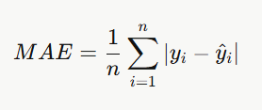
Formula:

Where:
- n = total number of data points in the test set
- yi= actual (true) value of the i-th data point
- y^​i​ = predicted value of the i-th data point
- ∣yi​−y^​i​∣= absolute error for the i-th prediction
A lower MAE value indicates better model performance. An MAE of 0 would mean the model predicts every value perfectly.

2. Mean Squared Error (MSE)
Mean Squared Error is a widely used regression metric that measures the average of the squared differences between the predicted and actual values. Unlike MAE, MSE squares each individual error before averaging, which has two important effects — it ensures all errors are positive (so they do not cancel out), and it penalizes larger errors much more heavily than smaller ones due to the squaring operation. This makes MSE particularly sensitive to outliers and large prediction errors, which can be both an advantage (when large errors are especially undesirable) and a disadvantage (when the dataset contains natural outliers). In the context of water usage prediction, a high MSE would indicate that the model is making some very large prediction errors on certain data points, even if the average error (MAE) appears acceptable. MSE is expressed in squared units of the target variable, which can make direct interpretation slightly less intuitive compared to MAE.
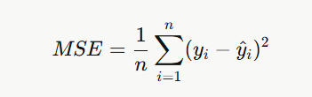
Formula:

Where:
- n = total number of data points in the test set
- yi​​ = actual (true) value of the i-th data point
- y^​i​= predicted value of the i-th data point
- (yi​−y^​i​)² = squared error for the i-th prediction
A lower MSE value indicates better model performance. Because errors are squared, MSE will always be greater than or equal to MAE for the same set of predictions.

3. Root Mean Squared Error (RMSE)
Root Mean Squared Error is simply the square root of the Mean Squared Error, and it is often reported alongside or in place of MSE because it brings the error metric back into the same units as the target variable, making it more interpretable. Like MSE, it still penalizes larger errors more heavily than smaller ones due to the squaring involved in its computation, but the final square root makes the scale human-readable. For example, if the target variable is liters of water, RMSE will also be expressed in liters, directly telling how far off on average the model's predictions are while still being more sensitive to large errors than MAE. RMSE is particularly useful when comparing models — a lower RMSE always indicates a model that is closer to the true values on average, with less tendency to make large individual errors.
Formula:
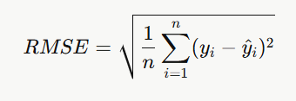

Where:
- n = total number of data points in the test set
- yi​ = actual (true) value of the i-th data point
- y^​i​ = predicted value of the i-th data point
- (yi​−y^​i​)²= squared error for the i-th prediction
RMSE ≥ MAE always holds true. When RMSE is significantly larger than MAE for the same model, it is a strong indication that the model is making a few very large errors on specific data points.

4. R² Score (Coefficient of Determination)
The R² Score, also known as the Coefficient of Determination, is a statistical metric that measures how well the model's predictions explain the variance present in the actual target variable. Rather than measuring the absolute size of errors like MAE or MSE, R² provides a relative measure of model quality by comparing the model's prediction errors to the errors that would result from simply predicting the mean of the target variable for every data point (a naive baseline). In other words, it quantifies what proportion of the total variability in the target variable is captured and explained by the model. An R² of 1.0 means the model perfectly predicts all values with zero error. An R² of 0.0 means the model performs no better than simply predicting the mean every time. A negative R² is also possible and indicates the model is performing worse than the mean baseline — a sign of severe underfitting or a completely inappropriate model. In this project, R² is used to compare the relative explanatory power of all six regression models on the water usage dataset.
Formula:
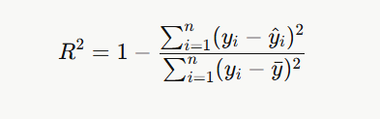

Where:
- n = total number of data points in the test set
- yi​ = actual (true) value of the i-th data point
- y^​i​ = predicted value of the i-th data point
- yˉ​ = mean of all actual target values
- 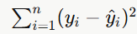= Sum of Squared Residuals (SS\_res) — total prediction error of the model
- = Total Sum of Squares (SS\_tot) — total variance in the actual data

Among all four metrics, R² is the most holistic indicator of overall model quality as it contextualizes errors relative to the inherent variability in the data, making it the primary metric used to rank and compare the six regression models in this project.

5. Results and Visualizations

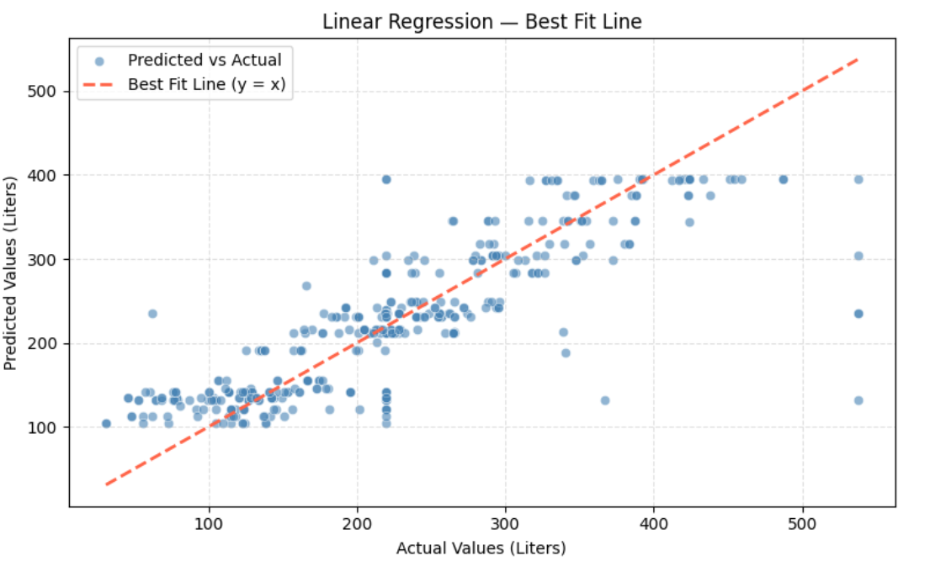

Fig.2 Scatter Plot showing best fit line (Linear Regression)

mean_absolute_error- 44.42769364122154
mean_squared_error- 4152.522044559001
r2_score- 0.6080068544958361
Inference- Our analysis shows that water demand follows a non-linear pattern that simple linear models cannot fully capture.
6. Conclusion and Future Scope:

Conclusion
This project successfully developed a machine learning-based system for predicting water consumption (in liters) using a structured and systematic pipeline that encompassed data collection, preprocessing, feature engineering, model training, and evaluation. The primary objective was to build an accurate and reliable regression model capable of estimating water usage based on the available input features, which can serve as a valuable tool for water resource management and conservation planning.
The data preprocessing stage played a critical role in improving the quality of the dataset by eliminating outliers using the Interquartile Range (IQR) method, removing physically impossible negative values, and standardizing all features using StandardScaler to bring them onto a common scale. These steps ensured that the models received clean, well-structured, and properly scaled input data, which is essential for achieving reliable predictions.
Six machine learning regression models were trained and evaluated — Linear Regression, K-Nearest Neighbors Regressor, Support Vector Regressor, Decision Tree Regressor, Random Forest Regressor, and Voting Regressor. Each model brought a unique approach to learning patterns from the data. Linear Regression provided a simple and interpretable baseline. KNN and SVR captured local and non-linear patterns respectively. Decision Tree offered rule-based splitting logic, while Random Forest improved upon it significantly through ensemble bagging and random feature selection. The Voting Regressor, as the final ensemble model, aggregated the strengths of all individual models to deliver the most balanced and robust predictions.
Hyperparameter tuning was performed using GridSearchCV with cross-validation to ensure that each model was operating at its optimal configuration rather than default settings. The models were evaluated using three key metrics — Mean Absolute Error (MAE), Mean Squared Error (MSE), and R² Score — providing a comprehensive view of each model's accuracy, error magnitude, and explanatory power.
The results demonstrated that ensemble methods, particularly Random Forest and the Voting Regressor, outperformed individual models in terms of lower prediction errors and higher R² scores, confirming that combining multiple learning algorithms leads to more generalized and accurate predictions. The trained models were serialized and saved using pickle, making them ready for deployment in real-world applications without the need for retraining.
Overall, this project demonstrated that machine learning can be effectively applied to water usage prediction, providing actionable insights that can assist municipalities, water utility companies, households, and policymakers in making informed decisions about water distribution, demand forecasting, and conservation strategies.

Future Scope
1. Integration of Real-Time Data Streams
The current model is trained on a static dataset. In the future, the system can be extended to incorporate real-time data streams from IoT-based smart water meters, sensors, and flow monitoring devices installed in households and industrial units. By continuously feeding live data into the model, it can provide dynamic and up-to-date predictions, enabling proactive water management and instant anomaly detection such as leakage or unusual consumption spikes.
2. Deep Learning and Neural Network Models
While the current project uses traditional machine learning algorithms, future work can explore the application of deep learning models such as Artificial Neural Networks (ANN), Long Short-Term Memory (LSTM) networks, and Convolutional Neural Networks (CNN) for time-series water consumption data. LSTM networks in particular are well-suited for capturing temporal dependencies and seasonal patterns in water usage — such as higher consumption during summers or festivals — which traditional regression models may fail to capture effectively.
3. Incorporation of Additional Features
The predictive accuracy of the model can be further improved by incorporating additional relevant features such as weather and climate data (temperature, humidity, rainfall), population density, time of day and seasonality, type of land use (residential, commercial, agricultural, industrial), socioeconomic indicators, and historical consumption trends. Richer and more diverse feature sets would allow the model to learn more complex relationships and deliver more nuanced predictions.
4. Geospatial and Regional Analysis
Future versions of the system can be extended to perform geospatial analysis by mapping water consumption predictions across different geographic regions, zones, or districts. This would help water authorities identify high-consumption zones, plan infrastructure upgrades, detect distribution inefficiencies, and allocate water resources more equitably across different areas of a city or region.
5. Anomaly Detection for Leak and Fraud Detection
The prediction model can be augmented with anomaly detection capabilities to automatically flag households or regions where actual water consumption significantly deviates from the predicted value. Such deviations could indicate pipeline leakages, meter tampering, unauthorized water usage, or equipment failures. This would add significant practical value to the system beyond simple prediction.
6. Web and Mobile Application Deployment
The trained and serialized models (saved via pickle) can be deployed as a fully functional web application using frameworks such as Flask, FastAPI, or Django, with a user-friendly front-end interface built using React or HTML/CSS. A mobile application can also be developed to allow individual households and water utility workers to input parameters and receive instant water usage predictions, consumption alerts, and personalized conservation recommendations directly on their smartphones.

7. References:
Books:
-Let Us Python – Yashavant Kanetkar

Online Resources:
  - GeeksforGeeks – https://www.geeksforgeeks.org/
  - TutorialsPoint – https://www.tutorialspoint.com/cprogramming/index.htm
  - Stack Overflow – https://stackoverflow.com

