Urban Water Demand Prediction System

Problem Id: AIML- 6

Name : Shivya Sinha (Team Leader)
Class Roll Number: 23
University Roll Number : 2028497
Section and Group: U (G1)

Name : Srishti Kuletha
Class Roll Number: 25
University Roll Number : 2028502
Section and Group: U (G1)

Name : Divya Jain
Class Roll Number: 12
University Roll Number : 2028414
Section and Group: U (G1)

TABLE OF CONTENTS

1. Problem Description 3
2. Architecture 4
3. Models mode 4
4. Evaluation metrics used 5
5. Preliminary Results and Visualizations 6
6. References 6

1. Problem Description
The Predictive Analytics for Urban Water Demand project is a comprehensive machine learning initiative designed to address the challenges of resource scarcity and infrastructure planning in modern metropolitan environments. At its core, the project operates on the principle that efficient water management is predicated on the ability to accurately anticipate daily usage patterns. To achieve this, the workflow begins with a rigorous Dataset Curation phase, where multidimensional data is gathered to capture the primary drivers of consumption: the density of residents (Household_Size), environmental and climatic fluctuations (Seasonal_Indices), and the irrigation demands of outdoor spaces (Garden_Area).
The technical implementation follows a structured end-to-end pipeline to ensure data integrity and model reliability. First, Data Cleaning protocols are applied to identify and rectify missing entries or anomalies that could otherwise skew the results. Because the input variables exist on vastly different scales—ranging from single-digit household counts to potentially thousands of square meters for garden areas—the StandardScaler is employed. This mathematical transformation centers the data around a mean of zero and a standard deviation of one, which is essential for the stability and performance of the subsequent modeling phase.
The predictive engine itself utilizes Linear Regression, a supervised learning algorithm that identifies the weighted relationship between the independent variables and the target output, Daily_Liters_Used. By establishing these coefficients, the model can provide quantifiable insights into how changes in any single factor impact overall demand. To conclude the pipeline, a Residual Analysis is performed to evaluate the model’s performance. By examining the "residuals"—the discrepancies between predicted values and actual recorded usage—students can diagnose whether the model effectively captures the underlying data patterns or if non-linear complexities require further refinement. This holistic approach not only produces a functional forecasting tool but also provides a deep diagnostic understanding of urban water consumption behavior.
Ultimately, this project serves as a bridge between theoretical statistical modeling and practical environmental stewardship. By transforming raw household and environmental data into actionable intelligence, the pipeline provides a scalable solution for municipal authorities to mitigate waste and optimize distribution networks. The integration of robust preprocessing, linear modeling, and post-hoc diagnostic analysis ensures that the resulting forecasts are not only mathematically sound but also practically viable. As urban populations continue to grow and climate variability increases, such predictive frameworks become indispensable tools in the global effort to build resilient, data-informed communities that can manage their most precious natural resources with precision and foresight.

2. Architecture

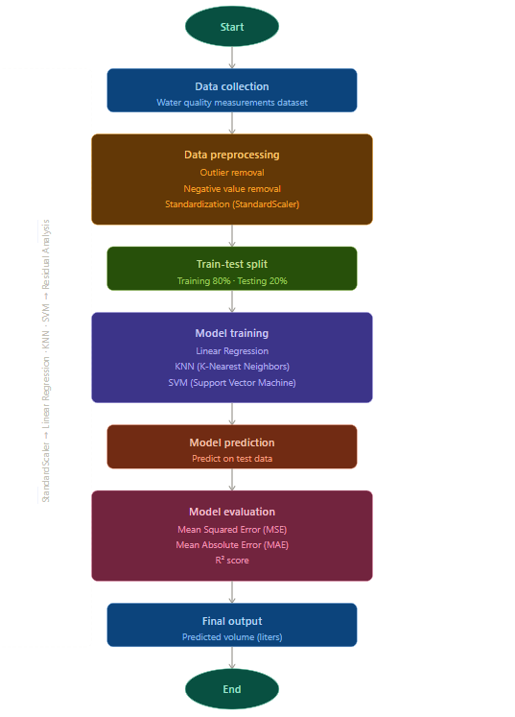

Fig.1 Flow diagram.

3. Models Used(Applied/ Planned) Give a brief introduction of the models used
This project employs three supervised machine learning models to predict water volume (in liters) based on preprocessed water quality data.
1. Linear Regression- Linear Regression is a fundamental statistical model that establishes a linear relationship between input features and the target variable. It works by fitting a best-fit line through the data by minimizing the sum of squared errors. It serves as a strong baseline model due to its simplicity and interpretability.
2. K-Nearest Neighbors (KNN)- KNN is a non-parametric, instance-based learning algorithm that predicts the output by averaging the values of the k most similar data points in the training set. It requires no explicit training phase and is effective when local patterns in the data are significant. However, it is sensitive to feature scaling — making standardization a critical preprocessing step.
3. Support Vector Machine (SVM)- SVM is a powerful supervised learning algorithm originally designed for classification but extended to regression tasks as Support Vector Regression (SVR). It works by finding a hyperplane that best fits the data within a defined margin of tolerance (epsilon). SVM performs well in high-dimensional spaces and is robust to outliers, making it well-suited for complex, non-linear water quality data.
3. Evaluation metrics used
To assess the performance of the regression models, three standard evaluation metrics were used:
1. Mean Squared Error (MSE)- MSE measures the average of the squared differences between the actual and predicted values. It penalizes larger errors more heavily due to the squaring operation, making it sensitive to outliers. A lower MSE indicates better model performance.
MSE = (1/n) × Σ(yᵢ − ŷᵢ)²
2. Mean Absolute Error (MAE)- MAE measures the average of the absolute differences between actual and predicted values. Unlike MSE, it treats all errors equally regardless of magnitude, providing a more intuitive measure of average prediction error in the same unit as the target variable (liters). A lower MAE indicates better accuracy.
MAE = (1/n) × Σ|yᵢ − ŷᵢ|
3. R² Score (Coefficient of Determination)- The R² score indicates how well the model explains the variance in the target variable. It ranges from 0 to 1, where a value closer to 1 means the model captures most of the variability in the data. A negative R² indicates the model performs worse than a simple mean baseline.
R² = 1 − [Σ(yᵢ − ŷᵢ)² / Σ(yᵢ − ȳ)²]

4. Preliminary Results and Visualizations

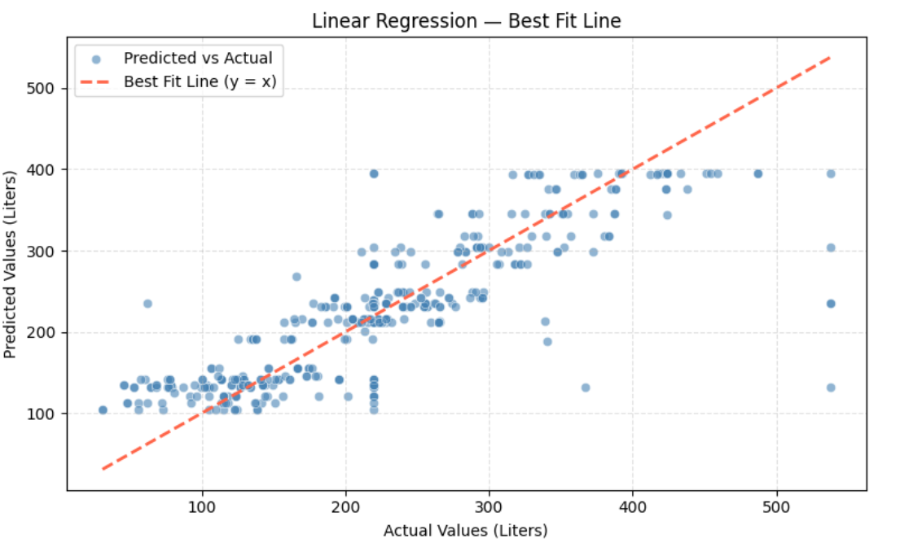

Fig.2 Scatter Plot showing best fit line (Linear Regression)

Inference: Points scattered closely along the y = x line indicate the model predicts water volume with reasonable accuracy.

References:
Books:
-Let Us Python – Yashavant Kanetkar

Online Resources:
  - GeeksforGeeks – https://www.geeksforgeeks.org/
  - TutorialsPoint – https://www.tutorialspoint.com/cprogramming/index.htm
  - Stack Overflow – https://stackoverflow.com

