

**Predicting Interest Level of Rental Listings**

**A Project Report submitted in partial fulfillment of the requirements for the award of the degree of**

**Bachelor of Technology**

**In**

**Computer Science and Engineering**

### Artificial Intelligence & Machine Learning

##### by

**Manvi Garg (201550079) Shatakshi Agrawal (201550125) Mridul Gaur (201550084) Shobhit Krishna Pathak (201550130)**

Under the Guidance of

Dr. Mayank Srivastava,

Department of Computer Engineering & Applications

**Institute of Engineering & Technology**



**GLA University Mathura- 281406, INDIA**

**April, 2024**

##### Department of Computer Engineering and Applications

##### GLA University, 17 km Stone, NH#2, Mathura-Delhi Road,

##### P.O. Chaumuhan, Mathura-281406 (U.P.)

## DECLARATION

I hereby declare that the work which is being presented in the B.Tech. Project **“Predicting Interest Level of Rental Listing”**, in partial fulfilment of the requirements for the award of the ***Bachelor of Technology*** in Computer Science and Engineering (AIML) and submitted to the Department of Computer Engineering and Applications of GLA University, Mathura, is an authentic record of my own work carried under the supervision of **Dr. Mayank Srivastava (Associate Professor).**

The contents of this project report, in full or in parts, have not been submitted to any other Institute or University for the award of any degree.

Sign ______________________ Sign _________________________

Name of Student: Manvi Garg Name of Student: Shatakshi Agrawal

University Roll No.: 201550079 University Roll No.: 201550125

Sign ______________________ Sign ___________________________

Name of Student: Mridul Gaur Name of Student: Shobhit Krishna Pathak

University Roll No.: 201550084 University Roll No.: 201550130

## CERTIFICATE

This is to certify that the above statements made by the candidate are correct to the best of my/our knowledge and belief.

_______________________

**Supervisor**

**(Dr. Mayank Srivastava)**

Associate Professor

Dept. of Computer Engg, & App.

______________________ ______________________

**Project Co-ordinator Program Co-ordinator**

**(Dr. Mayank Srivastava)** (**Mr. Jitesh Kumar Bhatia**)

Associate Professor Assistant Professor

Dept. of Computer Engg, & App. Dept. of Computer Engg, & App.

Date:

## ACKNOWLEDGEMENT

It gives us a great sense of pleasure to present the project report undertaken during B.Tech. This project in itself is an acknowledgement of the inspiration, drive, and technical assistance contributed to it by many individuals. This project would never have seen the light of day without the help and guidance that we have received.

Our heartfelt thanks to Mr. Ashok Bhansali, Head of Dept., Department of CEA for providing us with an encouraging platform to develop this project, which thus helped us in shaping our abilities towards a constructive goal.

We owe a special debt of gratitude to **Dr. Mayank Srivastava** , Assistant Professor, Institute of Engineering & Technology, for his constant support and guidance throughout the course of our work. His sincerity, thoroughness, and perseverance have been a constant source of inspiration for us. He has showered us with all his extensively experienced ideas and insightful comments at virtually all stages of the project & has also taught us about the latest industry-oriented technologies.

We also would not like to miss the opportunity to acknowledge the contribution of all faculty members of the department for their kind guidance and cooperation during the development of our project. Last but not least, we acknowledge our friends for their contribution to the completion of the project.

Sign Name of Student: Manvi Garg University Roll No.:201550079

Sign Name of Student: Mridul Gaur University Roll No.:201550084

Sign Name of Student: Shatakshi Agrawal University Roll No.:201550125

Sign Name of Student: Shobhit Krishna Pathak University Roll No.: 201550130

## ABSTRACT

The increasingly competitive landscape of the rental market necessitates a profound understanding of the factors shaping the interest levels of potential tenants. This report explores the intricate dynamics of predicting interest in rental listings through advanced analytics and machine learning techniques. The primary objectives are to identify key determinants of interest, develop predictive models, and enhance decision-making for landlords and tenants.

The study leverages a diverse dataset encompassing property details, location information, and historical rental trends. Utilizing sophisticated machine learning algorithms and statistical models, we delve into the complex interplay of variables that influence the attractiveness of rental listings. Key factors such as proximity to amenities, pricing strategies, and historical trends are meticulously analysed to unravel patterns and correlations.

The implementation of advanced tools, including Python programming language and relevant libraries, forms the technological backbone of our analysis. The report not only aims to predict interest levels accurately but also seeks to provide actionable insights to optimise the rental process. By fostering a deeper understanding of market dynamics, this research contributes to the evolution of a more efficient and informed rental ecosystem, benefiting both property owners and prospective tenants. The findings hold the potential to revolutionise decision- making processes, ushering in a new era of efficiency and effectiveness in the rental market.

|  | **CONTENTS** |  |
| --- | --- | --- |
| DECLARATION |  | I |
| CERTIFICATE |  | II |
| ACKNOWLEDGEMENT |  | III |
| ABSTRACT |  | IV |
| LIST OF FIGURES |  | V |
| **CHAPTER 1 Introduction** |  | **8** |

* 1. Background 8
  2. Objectives of Study 8
  3. Scope and Significance 9
  4. Key Challenges And Potential Solutions 9
     1. Data Quality and Completeness
     2. Dynamic Market Conditions
     3. Interconnected Feature Dependencies
     4. Spatial and Temporal Variability
     5. User Behavior and Preferences
     6. Overfitting and Model Generalization
     7. Ethical Considerations and Bias
  5. Research Questions 10

**CHAPTER 2 Literature Review 11**

2.1**.** Overview of Predictive Modeling in Real Estate 11

2.2. Factors Influencing Rental Listing Interest 11

2.3. Pricing Strategies and Market Dynamics 11

2.4. Technological Influences 12

2.5. Predictive Modeling Approaches 12

2.6. Gaps in Existing Literature 12

2.7. Summary 12

**CHAPTER 3 Methodology 13**

* 1. Data Collection 13
     1. Source of Data 13
     2. Data Variables 13
  2. Data Preprocessing 13
  3. Predictive Model Techniques 21
     1. Machine Learning Algorithms 22
     2. Model Evaluation Metrics 23
  4. Interpretation Of Results 24

**CHAPTER 4 Data Analysis 25**

* 1. Descriptive Statistics 25
  2. Exploratory Data Analysis 25

4.3 Correlation Analysis 25

* 1. Feature Importance 25
  2. Predictive Model Performance 25
  3. Interpretation Of Results 26
  4. Implication 26
  5. Limitations 26
  6. Future Research Direction 26

**CHAPTER 5 Predicting Interest Level 27**

* 1. Model Development 27
     1. Model Training 27
     2. Hypermeter Training 32
  2. Model Evaluation 33
     1. Accuracy Metrics 33
     2. Cross Validation Results 33
  3. Interpretation Of Results 33
  4. Discussion Of Predictive Accuracy 33
  5. Practical Implications 33
  6. Limitations 33
  7. Code and Algorithm 34
  8. Developed Model with a graphic Interface To Predict
  9. Algorithm 36

**CHAPTER 6 Software Design 37**

* 1. Data Flow Diagram 37
     1. DFD Level 0 37
     2. DFD Level -1 37
  2. Use Case Diagram 38
  3. Sequence Diagram 38
  4. Class Diagram 39
  5. FlowCharts 40

**CHAPTER 7 Discussion 42**

* 1. Implications Of Finding 42
  2. Limitations 42

7.3 Future Research Direction 42

* 1. Practical Applications 42
  2. Integrations with Industry Trends 43
  3. Summary of Keys Findings 43
  4. Conclusion Remarks 43

**CHAPTER 8 Conclusion 44**

**CHAPTER 9 Reference 45**

### LIST OF FIGURES

* + 1. DFD LEVEL 0
    2. DFD LEVEL 1
  1. USE CASE DIAGRAM
  2. SEQUENCE DIAGRAM
  3. CLASS DIAGRAM
  4. FLOWCHARTS

**Chapter 1**

**Introduction**

Real estate markets are dynamic and competitive, especially in the realm of rental listings, where property managers and landlords seek effective ways to attract potential tenants. In this context, predicting the interest level of rental listings becomes crucial for optimizing marketing strategies and improving overall leasing outcomes. This report delves into the development of predictive models to assess the interest level of rental listings, aiming to provide valuable insights for stakeholders in the real estate industry.

###### Background

In the dynamic landscape of real estate, the effective marketing of rental listings plays a crucial role in attracting potential tenants. Property owners and real estate agents strive to understand and predict the interest levels that their listings generate to optimise their marketing strategies. With the advent of advanced technologies and the increasing availability of data, predictive modeling has become a valuable tool for anticipating the level of interest in rental properties.

The rental market is characterised by a diverse range of factors that influence a prospective tenant's decision-making process. These factors include location, amenities, pricing, and the overall presentation of the property. Identifying and quantifying the impact of these variables on the interest level of rental listings can provide valuable insights for property owners and real estate professionals.

* 1. **Objectives of the Study**

The primary objective of this study is to develop a predictive model that accurately estimates the interest level of rental listings. By leveraging machine learning algorithms and analysing historical data, we aim to identify patterns and relationships between various features and the likelihood of generating interest. The insights derived from this predictive model can empower property stakeholders to make informed decisions, refine their marketing strategies, and enhance the overall efficiency of the rental listing process.

##### Scope and Significance

This research focuses on residential rental listings, considering a broad spectrum of properties including apartments, houses, and condominiums. The study aims to encompass urban and suburban settings, recognizing the diverse nature of rental markets. By limiting the scope to residential properties, we can delve deeper into the specific factors influencing the interest levels of potential tenants in these settings.

The significance of this study lies in its potential to revolutionize the way rental properties are marketed and managed. Property owners, real estate agents, and property management firms can benefit from a more nuanced understanding of what drives interest in rental listings. The predictive model developed in this study could serve as a valuable decision- support tool, enabling stakeholders to allocate resources effectively and optimize their approach to attract and retain tenants.

##### Key Challenges and Potential Solutions

* + 1. **Data Quality and Completeness:**
       - Challenge: Incomplete/inaccurate data may hinder the development of

reliable predictive models.

* + - * Solution: Employ rigorous data cleaning processes and leverage data augmentation techniques to enhance the quality and completeness of the dataset.
    1. **Dynamic Market Conditions:**
       - Challenge: Fluctuations in market conditions and tenant preferences pose challenges in creating a static predictive model.
       - Solution: Implement adaptive algorithms that can dynamically adjust to evolving market trends, ensuring the model's relevance over time.
    2. **Interconnected Feature Dependencies:**
       - Challenge: Complex relationships and dependencies among various features may be challenging to capture accurately.
       - Solution: Utilize advanced machine learning techniques, such as ensemble methods, to account for intricate feature interactions and improve model accuracy.
    3. **Spatial and Temporal Variability:**
       - Challenge: Listings' attractiveness may vary spatially and temporally, requiring a nuanced approach.
       - Solution: Incorporate spatial and temporal variables in the model to capture location- specific and time-sensitive trends, enhancing the predictive capabilities.
    4. **User Behavior and Preferences:**
       - Challenge: Predicting individual user preferences and behaviors can be inherently complex.
       - Solution: Integrate user-specific data when available and explore collaborative filtering methods to account for individual variations in preferences.
    5. **Overfitting and Model Generalization:**
       - Challenge: Models may overfit to training data, resulting in poor generalization to new listings.
       - Solution: Regularization techniques and cross-validation methods can be employed to mitigate overfitting and enhance the model's ability to generalize.
    6. **Ethical Considerations and Bias:**
       - Challenge: Biases in data may lead to discriminatory outcomes, impacting the fairness of predictions.
       - Solution: Implement fairness-aware machine learning techniques, conduct thorough bias assessments, and continuously monitor and address ethical considerations throughout the model development process.

##### Research Questions

To guide our exploration, we have formulated several key research questions:

* What are the primary factors influencing the interest level of rental listings?
* How can historical data be leveraged to train a predictive model for estimating interest levels?
* Which machine learning algorithms are most effective in predicting interest levels in the context of rental listings?
* What are the practical implications of accurately predicting interest levels for property owners and real estate professionals? What limitations and challenges are associated with predicting interest in rental listings, and how can these be addressed?

Through addressing these questions, this study aims to contribute to the existing body of knowledge in real estate analytics and provide actionable insights for stakeholders in the rental property market.

# Chapter 2

# Literature Review

##### Overview of Predictive Modeling in Real Estate

The integration of predictive modeling techniques in real estate has gained significant traction in recent years. Real estate professionals and researchers have increasingly turned to data-driven approaches to gain insights into market dynamics, property valuations, and, more recently, predicting the interest level of rental listings. This section reviews the existing literature to highlight key findings and methodologies employed in the pursuit of understanding and predicting rental listing interest.

##### Factors Influencing Rental Listing Interest

Numerous studies have explored the multitude of factors that contribute to the interest levels of rental listings. Location consistently emerges as a pivotal determinant, with accessibility to amenities, public transportation, and neighbourhood safety playing crucial roles. The quality of property visuals, including photographs and virtual tours, has been identified as a significant factor impacting a potential tenant's perception of a listing.

Additionally, property characteristics such as size, layout, and amenities have been extensively studied. Features like the number of bedrooms, bathrooms, and the presence of in-unit laundry or parking spaces often correlate with increased interest. The influence of property descriptions and the use of specific keywords in listing narratives has also been examined, highlighting the importance of effective communication in capturing tenant attention.

##### Pricing Strategies and Market Dynamics

The pricing of rental properties is a complex and dynamic aspect that significantly influences tenant interest. Research has explored various pricing strategies, including dynamic pricing models that adapt to market fluctuations and demand patterns. Comparative pricing studies within specific neighborhoods or market segments have provided insights into how competitive pricing impacts the attractiveness of a rental listing.

Economic factors, such as local employment rates and overall economic conditions, have been identified as external drivers influencing rental demand. Demographic shifts, such as changes in population density or age distribution, contribute to fluctuations in the demand for specific types of rental housing.

##### Technological Influences: Online Platforms and Virtual Tours

The advent of online platforms for property listings has transformed the way potential tenants search for and engage with rental listings. Studies have explored the impact of online reviews, social media presence, and the integration of virtual tours on rental listing interest. The ease of access to information and the visual presentation of properties online have become integral factors in attracting prospective tenants.

The use of social media as a marketing tool for rental properties has also been examined. The viral nature of content sharing on platforms like Instagram and Facebook can amplify the reach and visibility of listings, potentially influencing interest levels.

##### Predictive Modeling Approaches

In recent years, the application of predictive modeling techniques has emerged as a powerful tool for anticipating and quantifying rental listing interest. Machine learning algorithms, including decision trees, random forests, and gradient boosting, have been employed to model the complex relationships within rental datasets. These techniques enable the identification of patterns and correlations that may not be immediately apparent through traditional analytical methods.

Natural Language Processing (NLP) has been incorporated to analyze textual data, such as property descriptions and tenant reviews. Sentiment analysis and keyword extraction from these textual elements contribute valuable insights into the language that resonates with potential tenants, aiding in the refinement of listing content.

Deep learning approaches, such as neural networks, have also been explored for their capacity to automatically learn hierarchical representations of features. While these models hold promise for capturing intricate patterns, challenges related to interpretability and model transparency persist.

##### Gaps in Existing Literature

Despite the progress made in understanding and predicting rental listing interest, there are notable gaps in the existing literature. Limited research has been conducted on the long- term impact of external events, such as economic downturns or global pandemics, on rental listing interest.

Additionally, there is a need for more comprehensive studies that consider the interaction between different factors and their cumulative effect on interest levels.

Furthermore, the literature highlights the challenge of balancing model complexity with interpretability. As predictive modeling techniques become more sophisticated, there is a growing demand for models that not only deliver accurate predictions but also provide actionable insights for real estate practitioners.

# Chapter 3

# Methodology

#### Data Collection

##### Source of Data

The foundation of this study lies in a comprehensive dataset sourced from various real estate listings platforms. The dataset encompasses a diverse range of residential rental properties, including apartments, houses, and condominiums. Data fields include property features (e.g., number of bedrooms, bathrooms, amenities), location details, pricing information, and textual descriptions. The dataset's temporal scope covers multiple years to capture potential trends and variations over time.

##### Data Variables

The variables selected for analysis are chosen based on their relevance to predicting interest levels. Key features include property characteristics, such as size, layout, and amenities, as well as location-specific attributes. Additionally, pricing-related variables and textual data, such as property descriptions, are incorporated to capture the nuanced factors influencing tenant interest.

#### Data Preprocessing

##### Cleaning and Transformation

Prior to analysis, the dataset undergoes a rigorous cleaning process to handle missing or erroneous values. Categorical variables are encoded, and numerical features are scaled to ensure uniformity across the dataset. Outliers are addressed using appropriate statistical methods to prevent undue influence on the predictive modeling process.

Feature engineering is a crucial step in enhancing the dataset's predictive power. New features are created to capture potential interactions or transformations that may better align with the underlying patterns in the data. For example, a composite feature reflecting the ratio of bedrooms to bathrooms might offer additional insights into the property's attractiveness.

**PairPlot:**

A pair plot, also known as a scatterplot matrix, is a graphical representation that allows for the visualization of pairwise relationships among a set of variables. It is commonly used in exploratory data analysis to quickly understand the relationships between different pairs of variables in a dataset.

13

A pair plot is especially useful when dealing with multiple variables, as it provides a compact way to examine correlations, distributions, and potential patterns.

Here are the key features of a pair plot:

**Scatterplots:**

The main components of a pair plot are scatterplots, where each point represents the intersection of two variables. Scatterplots are placed in the cells of a grid, with each variable paired with every other variable.

**Diagonal Axes:**

The diagonal of the pair plot typically contains histograms or kernel density plots for each variable. These diagonal plots show the univariate distribution of each variable.

**Symmetry:**

Since the pair plot is symmetric, the upper and lower triangles contain the same scatterplots but are rotated. This is because the relationship between variable A and variable B is the same as the relationship between variable B and variable A.

**Correlation Information:**

Pair plots can provide insights into the correlation between variables. Patterns in the scatterplots, such as the direction and strength of points, can give an indication of the relationship between variables.

Pair plots are particularly helpful for identifying trends, clusters, or outliers in multivariate data. They are commonly created using data visualization libraries in programming languages such as Python (Seaborn or Matplotlib) or R. Pair plots are a versatile tool that can be used to gain an initial understanding of the structure and dependencies within a dataset before diving into more detailed analyses.

##### Pairplot of data after cleaning and transformation:

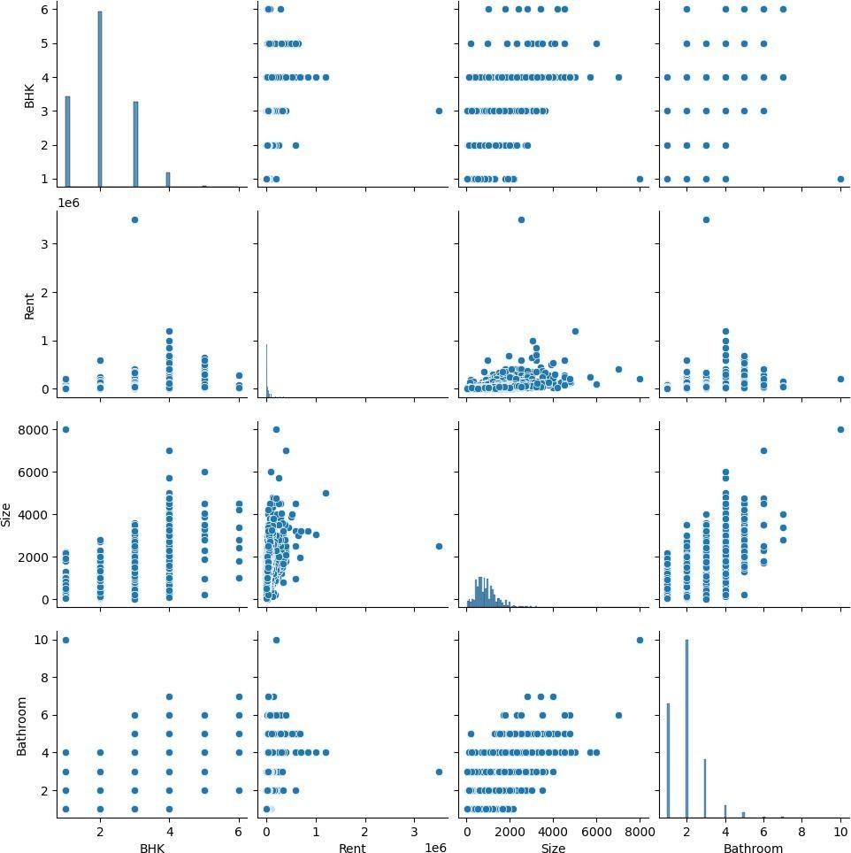

**BarPlot:** A bar plot, also known as a bar chart or bar graph, is a graphical representation of categorical data using rectangular bars. Each bar's length or height corresponds to the value it represents, and the bars are typically arranged along the horizontal or vertical axis according to the categories they represent.

Here are the key components of a bar plot:

**Bars:**

The main elements of a bar plot are the bars themselves. Each bar represents a category or group, and its length or height corresponds to the value or frequency of that category.

**Axis:**

Bar plots have two axes, typically a vertical axis (y-axis) and a horizontal axis (x-axis). The categories are displayed along one of these axes, while the other axis represents the values or frequencies.

**Categories:**

The categories are the distinct groups or labels being compared in the bar plot. Each bar is associated with a specific category.

**Bar Length or Height:**

The length or height of each bar represents a quantitative value, frequency, or count associated with the corresponding category.

Bar plots are commonly used to visualize and compare the distribution of data across different categories. They are effective for displaying discrete data and are particularly useful when dealing with categorical variables. Bar plots can be created in various orientations, including vertical bars (column chart) or horizontal bars (bar chart), depending on the preference and the nature of the data.

Bar plots are useful in a variety of contexts, such as presenting survey results, comparing sales figures for different products, or illustrating the frequency distribution of categorical variables in a dataset. They provide a straightforward and visually intuitive way to interpret and compare values across different categories.

##### BarPlot of Rent in different Cities according to BHK and Area Type:

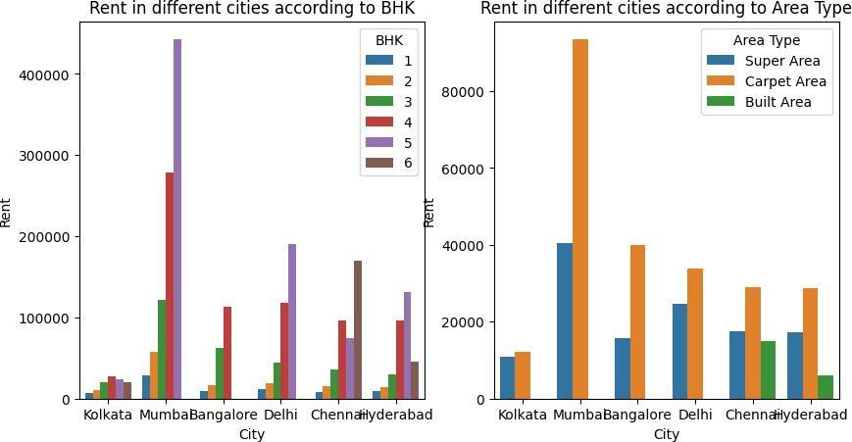

**BarPlot of Rent in different Cities according to Point of Contact and Tenant Preferred:**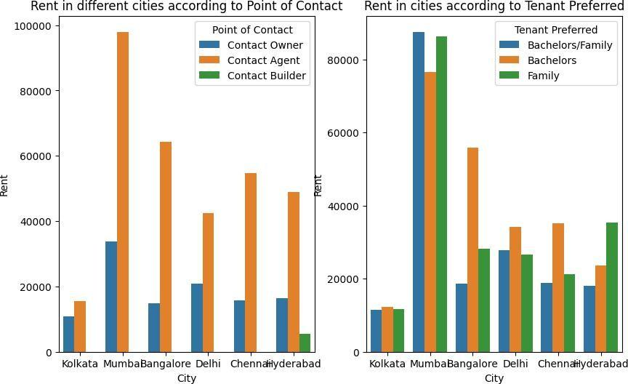

##### BarPlot of Rent in different Cities according to Funishing Status and Tenant Preferred:

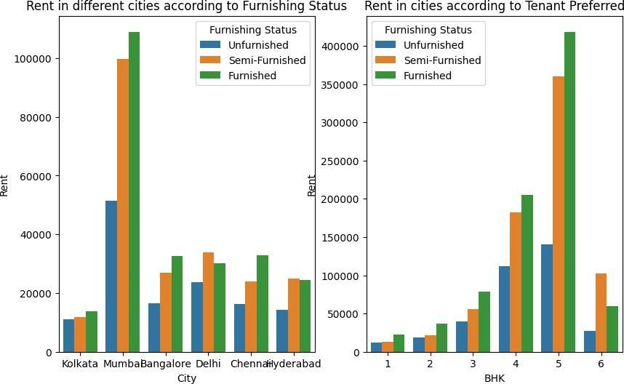

**BoxPlot:**

When describing a boxplot comparing two attributes, x and y, you can provide a theoretical explanation of how the boxplot visually represents the distribution and central tendency of each attribute. Here's a general template you can use:

"The boxplot illustrates the distribution of two attributes, x and y, allowing for a comparative analysis of their central tendency, spread, and potential outliers. For attribute x, the boxplot displays the median as the center line within the box, which represents the interquartile range (IQR) spanning from the first quartile (Q1) to the third quartile (Q3). The whiskers extend from the box to the minimum and maximum values within a defined range, often determined by a multiplier of the IQR. Outliers beyond this range are typically displayed as individual points.

Similarly, for attribute y, the boxplot provides a visual summary of its distribution, showcasing the median, IQR, and potential outliers. By comparing the boxplots of x and y, one can assess differences in their central tendency and variability. A higher or lower median suggests a shift in the center of the distribution, while differences in the length of the whiskers and the presence of outliers indicate variations in spread.

In summary, the boxplot serves as a valuable tool for comparing the distributions of attributes x and y, offering insights into their respective central tendencies, spread, and the presence of any unusual data points.

##### BoxPlot of different attributes with rent:

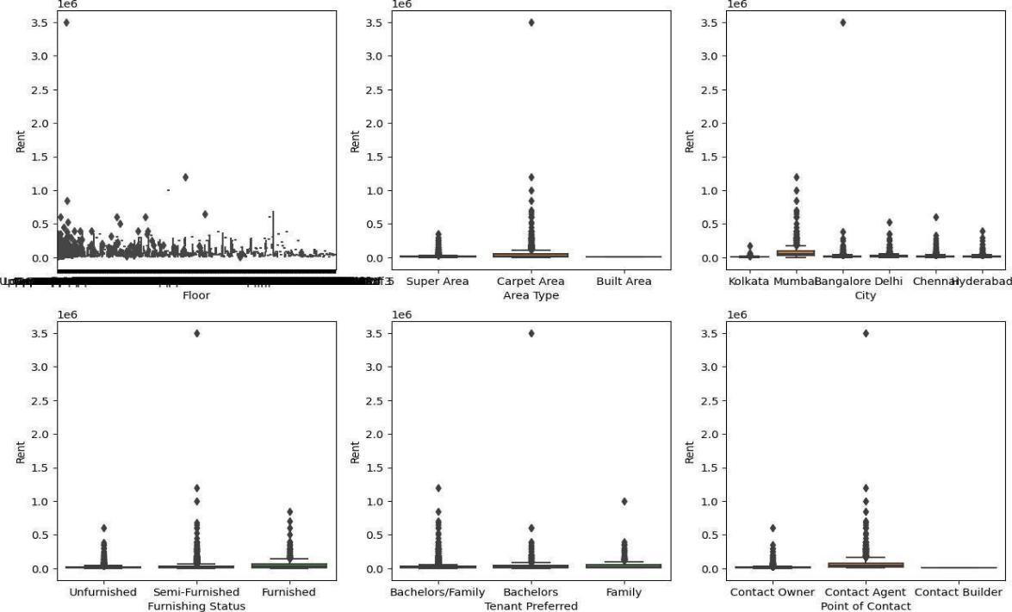

**BoxPlot of BHK and Rent:**

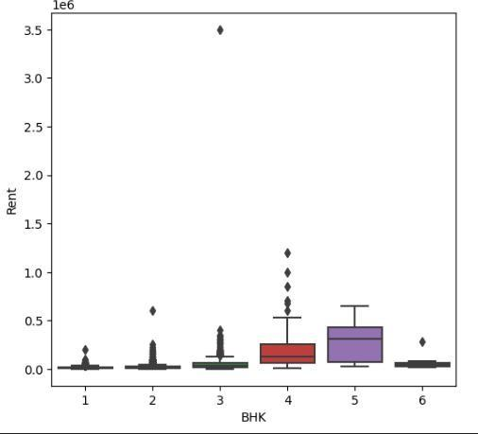

##### BoxPlot of Bathroom and Rent:

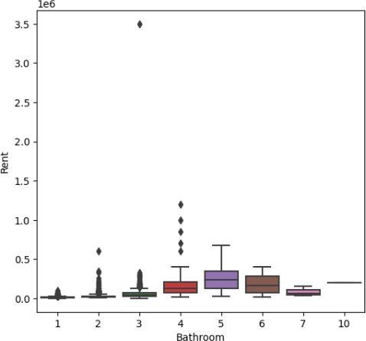

**BoxPlot of Size and Rent:**

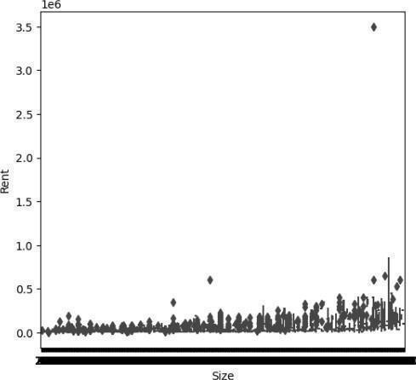

##### BoxPlot after treating the outlier with the IQR method with all the 4 variables who has outliers:

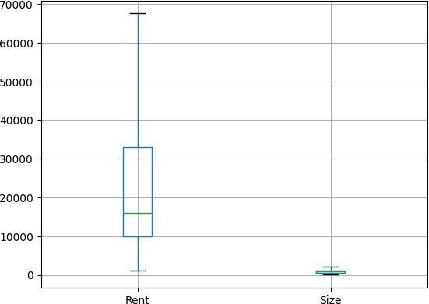

**Heatmap:**

A heatmap is a graphical representation of data in which values are depicted as colors. It is often used to visualize the distribution and intensity of data points in a two-dimensional space. In a heatmap, each data point is represented by a colored square, and the color intensity corresponds to the magnitude of the data at that point.

Heatmaps are commonly employed in various fields such as data analysis, statistics, and biology to visually represent patterns, trends, or concentrations in data sets. They are particularly useful for displaying large datasets and identifying areas of interest or significance. The color scale used in a heatmap typically ranges from cool to warm colors, with cool colors indicating lower values and warm colors indicating higher values. This color gradient allows for easy interpretation of the data's spatial distribution and helps users quickly identify areas of interest or concentration.

##### HeatMap for Correlation Coefficients to see which variables are highly correlated/significant:

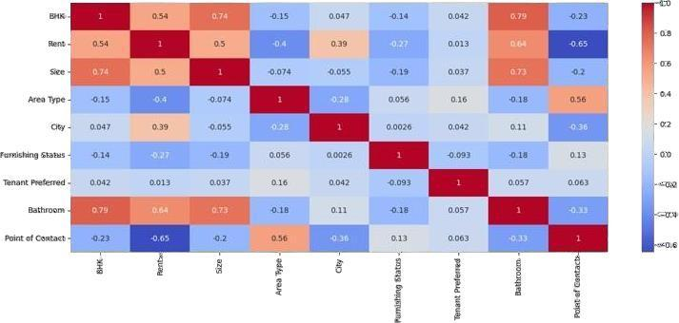

**3.2.1 Textual Data Processing**

Given the significance of textual data in rental listings, natural language processing (NLP) techniques are applied to extract meaningful information. This involves tokenization, stemming, and sentiment analysis to distill key features from property descriptions and tenant reviews. The processed textual data is then integrated into the overall dataset for holistic analysis.

#### Predictive Modeling Techniques

##### Machine Learning Algorithms

Several machine learning algorithms are employed to develop predictive models for estimating interest levels in rental listings. Decision trees provide an interpretable baseline, while ensemble methods like random forests and gradient boosting enhance predictive accuracy by combining the strengths of multiple models. The choice of algorithms is informed by the complexity of the data and the need to balance interpretability with performance.

The dataset is split into training and testing sets to evaluate model generalisation. Cross- validation techniques, such as k-fold cross- validation, are utilised to robustly assess model performance and mitigate overfitting. Hyperparameter tuning is conducted to optimise the algorithms, ensuring the models capture the underlying patterns in the data.

##### Model Evaluation Metrics

The performance of predictive models was evaluated using a comprehensive set of evaluation metrics to assess predictive accuracy, robustness, and generalisability. Standard evaluation metrics, including accuracy, precision, recall, F1 score, confusion matrix, MAE, R2 score, and RMSE, were computed to quantify model performance across different interest level categories. Additionally, area under the receiver operating characteristic curve (ROC AUC) was calculated to evaluate the discriminatory power of the models in distinguishing between interest level categories and capturing trade-offs between true positive and false positive rates.

Furthermore, model performance was assessed using cross- validation techniques to ensure consistency and reliability of results across different subsets of the data. Sensitivity analysis was conducted to evaluate the robustness of predictive models to variations in input parameters, data assumptions, and modeling techniques.

**ACCURACY:** measures the proportion of correctly classified instances among all instances:

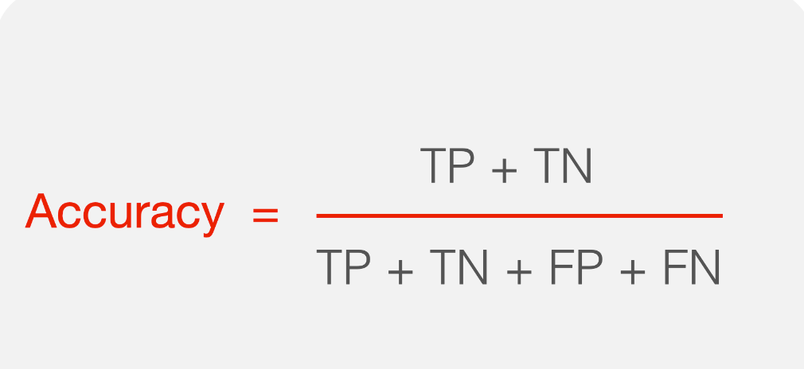

Where,

* + - * *TP* (True Positives) is the number of correctly predicted positive instances.
      * (True Negatives) is the number of correctly predicted negative instances.
      * (False Positives) is the number of incorrectly predicted positive instances.
      * (False Negatives) is the number of incorrectly predicted negative instances.

=

**PRECISION:** measures the proportion of corr+ectly predicted positive instances among all instances predicted as positive:

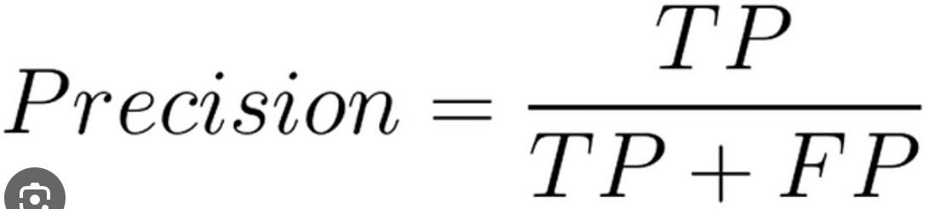

Precision is useful when the cost of false positives is high, and you want to minimize false positive predictions.

**RECALL:** (also known as Sensitivity or True Positive Rate) measures the proportion of correctly predicted positive instances among all actual positive instances:

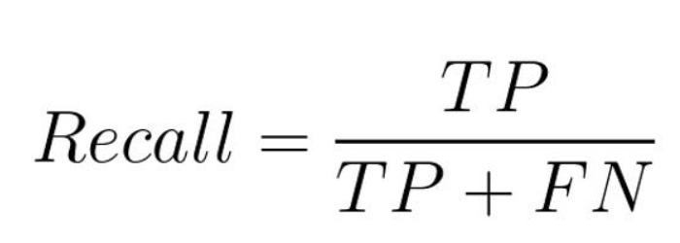

+

Recall is important when you want to capture as many positive instances as possible, minimizing false negatives.

**F1-SCORE:**The F1 score is a metric commonly used in machine learning to balance precision and recall into a single value. It's the harmonic mean of precision and recall, providing a single score that considers both false positives and false negatives. The formula for the F1 score is:

The F1 score ranges from 0 to 1, where 1 indicates perfect precision and recall, and 0 indicates poor performance in both precision and recall. It's particularly useful in binary classification tasks, especially when the classes are imbalanced, as it provides a single metric that balances between false positives and false negatives.

**MAE**: Mean absolute error (MAE) is a loss function used for regression. The loss is the mean Over the absolute differences between true and predicted values, deviations in either direction from the true value are treated the same way.

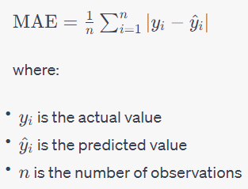

**RMSE**: Root Mean Square Error (RMSE) is the standard deviation of the residuals (prediction errors). The RMSE estimates the deviation of the actual y-values from the regression line. Another way to say this is that it estimates the standard deviation of the values in a thin vertical rectangle.

= =1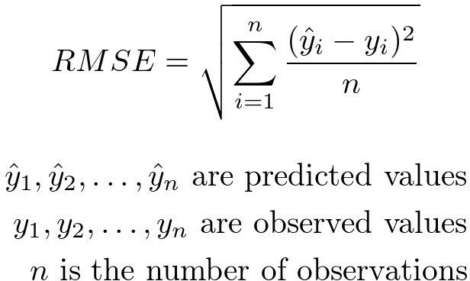

##### Interpretation of Results

The final step involves interpreting the results to derive actionable insights for real estate practitioners. Feature importance analyses provide visibility into the variables most influential in predicting interest levels. Additionally, the models' predictive capabilities are scrutinised across different subgroups to identify any variations in performance based on property characteristics or location.

By combining advanced predictive modeling techniques with thorough data preprocessing and interpretation strategies, this methodology aims to contribute robust insights into the complex landscape of rental listing interest. The subsequent section of this report will present the data analysis, showcasing the findings and implications derived from the implemented methodology.

**Chapter 4**

**Data Anaylsis**

* 1. **Descriptive Statistics**

The initial exploration of the dataset reveals essential characteristics of the rental listings under consideration. Descriptive statistics provide a snapshot of central tendencies, such as mean and median prices, as well as the dispersion of variables. This phase establishes a foundational understanding of the dataset, offering insights into the range of property sizes, amenities, and pricing structures.

##### Exploratory Data Analysis

Exploratory Data Analysis (EDA) delves deeper into the dataset through visualizations and statistical summaries. Visual representations, including histograms and scatter plots, facilitate the identification of trends and patterns. EDA allows us to observe how interest levels vary across different property types, locations, and price ranges. Notable findings in this stage may include clusters of high-interest listings or correlations between specific features and interest levels.

##### Correlation Analysis

Correlation analysis investigates relationships between numerical variables and the target variable—interest level. The correlation matrix highlights which features exhibit significant correlations, aiding in the identification of potential predictors. For instance, a positive correlation between the number of bedrooms and interest level may suggest that larger properties garner more attention.

##### Feature Importance

The predictive models shed light on the importance of different features in determining interest levels. By assessing feature importance, we discern which aspects contribute most significantly to the predictive accuracy of the models. This knowledge is crucial for refining marketing strategies, emphasizing features that resonate with potential tenants, and optimizing the overall appeal of rental listings.

##### Predictive Model Performance

The evaluation of predictive model performance is a critical step in assessing the reliability of the developed models. Metrics such as accuracy, precision, recall, and F1-score provide a comprehensive overview of the models' classification capabilities. Receiver Operating Characteristic (ROC) curves and Area Under the Curve (AUC) scores further quantify the models' ability to discriminate between different interest levels.

##### Interpretation of Results

Interpreting the results involves extracting actionable insights from the data analysis. Understanding which features drive interest levels enables real estate practitioners to refine their marketing approaches. For instance, if proximity to public transportation emerges as a significant factor, emphasizing this in property descriptions and marketing materials may enhance listing attractiveness.

##### Implications for Real Estate Practitioners

The implications derived from the data analysis phase offer tangible benefits for real estate professionals. Informed by the identified factors influencing interest levels, practitioners can tailor their strategies to better meet tenant preferences. Whether adjusting pricing models, emphasizing specific amenities, or refining property descriptions, these insights empower practitioners to make data-driven decisions in a competitive rental market.

##### Limitations of the Study

Acknowledging the study's limitations is essential for contextualizing the findings. Limitations may include data biases, the representativeness of the dataset, and the generalizability of results to diverse real estate markets. Understanding these constraints ensures a nuanced interpretation of the study's outcomes.

##### Future Research Directions

The data analysis phase may reveal avenues for future research. Exploring specific subgroups, incorporating additional variables, or refining predictive models can enhance the depth and applicability of research findings. The iterative nature of data analysis often paves the way for ongoing exploration and refinement of predictive models in the realm of rental listings.

In summary, the data analysis section serves as a pivotal component of the study, bridging the gap between raw data and actionable insights. By exploring, correlating, and interpreting the dataset, this phase contributes valuable knowledge to the understanding of factors influencing interest levels in rental listings. The subsequent sections of the report will draw conclusions, discuss implications, and provide recommendations based on the outcomes of the data analysis.

# Chapter 5

**Predicting Interest Level**

#### Model Development

The heart of this study lies in the development of predictive models aimed at estimating interest levels in rental listings. Leveraging machine learning algorithms, we embark on a journey to unveil the intricate patterns and relationships within the dataset.

* + 1. **Model Training**

The predictive models are trained on a carefully curated dataset that incorporates a diverse array of features, ranging from property characteristics to textual data. During the training phase, the models learn to recognize patterns and correlations within the data, enabling them to make predictions on interest levels based on input features. The training process involves adjusting model parameters to optimize performance.

**Artificial Neural Network (ANN):**

"ANN" typically refers to "Artificial Neural Network." An Artificial Neural Network is a computational model inspired by the structure and functioning of the human brain. It is a type of machine learning algorithm that is used for various tasks such as classification, regression, pattern recognition, and more.

The basic building block of an artificial neural network is the "neuron" or "node." Neurons are organized into layers, including an input layer, one or more hidden layers, and an output layer. Each connection between neurons has an associated weight, and the network learns by adjusting these weights based on the input data during a process called training. Here's a brief overview of the components of an Artificial Neural Network:

**Input Layer:**

Neurons in the input layer receive the initial data or features. Each neuron in this layer represents a feature of the input data.

**Hidden Layers:**

Neurons in hidden layers perform computations on the input data. Multiple hidden layers allow the network to learn complex representations of the input.

**Output Layer:**

Neurons in the output layer provide the final result of the network's computation. The number of neurons in the output layer depends on the nature of the task (e.g., binary classification, multi-class classification, regression).

**Weights and Bias:**

Each connection between neurons has an associated weight that determines the strength of the connection. A bias term is also used to shift the output of a neuron.

**Activation Function:**

Each neuron typically applies an activation function to its input, introducing non-linearity to the model. Common activation functions include sigmoid, hyperbolic tangent (tanh), and rectified linear unit (ReLU).

**Training:**

During training, the network adjusts its weights and biases based on the error between the predicted output and the true output. This is usually done using optimization algorithms like gradient descent.

ANN have gained popularity, especially with the advent of deep learning,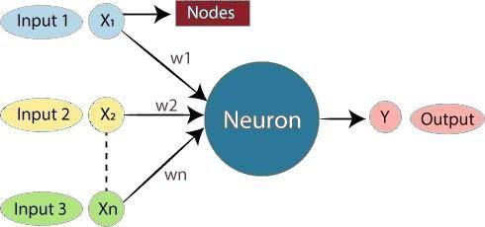

where networks with many hidden layers (deep neural networks) have shown remarkable success in tasks such as image recognition, natural language processing, and more. Deep learning architectures are essentially a form of neural networks with multiple hidden layers, and they are often referred to as Deep Neural Networks.

**Architecture of an Artificial Neural Network:**

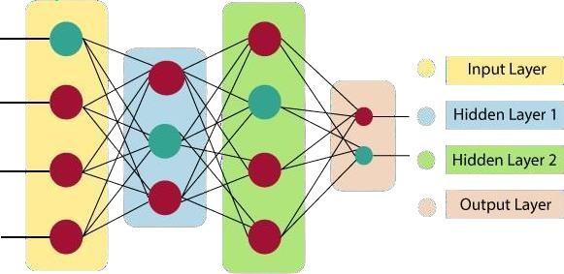

##### Linear Regression:

Linear regression is a statistical method used for modeling the relationship between a dependent variable and one or more independent variables. It assumes that the relationship between the variables is approximately linear, meaning that changes in the dependent variable are a constant multiple of changes in the independent variable(s). The goal of linear regression is to find the best-fitting linear relationship, often represented by a straight line equation.

The standard form of a simple linear regression equation with one independent variable is: Y=MX+B

Where:

* Y is the dependent variable
* X is the independent variable
* M is the slope of the line, representing the rate of change in y with respect to x
* B is the y-intercept indicating the value of y when x is zero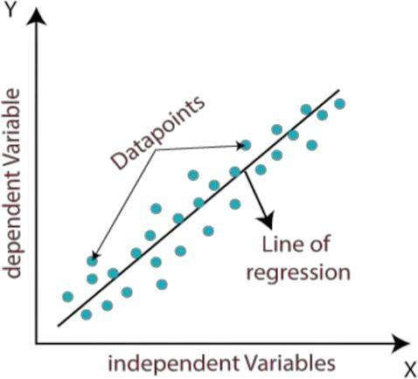

**Decision Tree:**

A decision tree is a flowchart-like tree structure where an internal node represents a feature or attribute, the branches represent the decision rules based on that feature, and each leaf node represents the outcome or class label. It's a popular supervised learning algorithm used for both classification and regression tasks.

Here’s a breakdown of key components:

* + - 1. **Root Node**: Represents the entire dataset, containing all possible outcomes or classes.
      2. **Internal Nodes**: Represent features or attributes used for splitting the data. Each internal node tests a specific feature and sends data down different branches based on the feature's value.
      3. **Branches**:arrowss from nodes that represent the outcome of a split based on a feature's value. Each branch leads to a child node or a leaf node.
      4. **Leaf Nodes**: Represent the final outcome or class label. These nodes have no further branches, indicating the decision or prediction based on the features' values.

29

The construction of a decision tree involves selecting the best feature at each node to split the data, typically based on metrics like information gain, Gini impurity, or entropy. This process continues recursively until a stopping criterion is met, such as reaching a maximum tree depth or having nodes with pure classes.

Decision trees are interpretable, easy to visualize, and can handle both numerical and categorical data. However, they are prone to overfitting on training data, which can be mitigated using techniques like pruning or using ensemble methods like random forests.

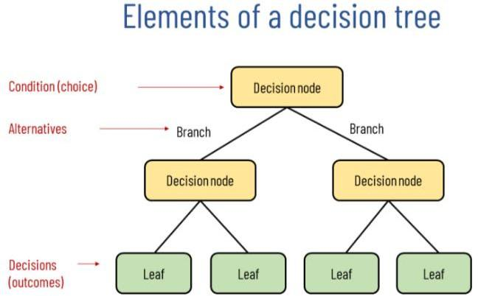

**Random Forest :**

A random forest is an ensemble learning technique that builds multiple decision trees during training and combines their predictions to improve accuracy and reduce overfitting. Here's a breakdown of how random forests work:

1. **Bootstrap Sampling**: Random forests use a technique called bootstrap sampling to create multiple training datasets from the original dataset. This involves randomly selecting samples with replacement, which means some samples may be included multiple times while others may not be included at all in each subset.
2. **Random Feature Selection**: For each decision tree in the random forest, a random subset of features is selected at each node to determine the best split. This helps in creating diverse trees that are less correlated with each other.
3. **Decision Tree Training**: Each subset of data is used to train a decision tree independently. The trees are grown deep, usually until they reach their maximum depth or until they have nodes with pure classes.

30

1. **Voting or Averaging**: During prediction, the random forest combines the predictions of all the individual trees. For classification tasks, it uses a majority voting mechanism where the class with the most votes from the trees is chosen as the final prediction. For regression tasks, it averages the predictions from all trees.

Random forests offer several advantages:

* They are less prone to overfitting compared to a single decision tree because of the randomness introduced in feature selection and dataset sampling.
* They handle high-dimensional data well and can handle both numerical and categorical features without requiring extensive preprocessing.
* They provide estimates of feature importance, which can be useful for feature selection and understanding the importance of different features in making predictions.

Overall, random forests are a powerful and widely used machine learning algorithm known for their robustness and effectiveness across various types of datasets and tasks.

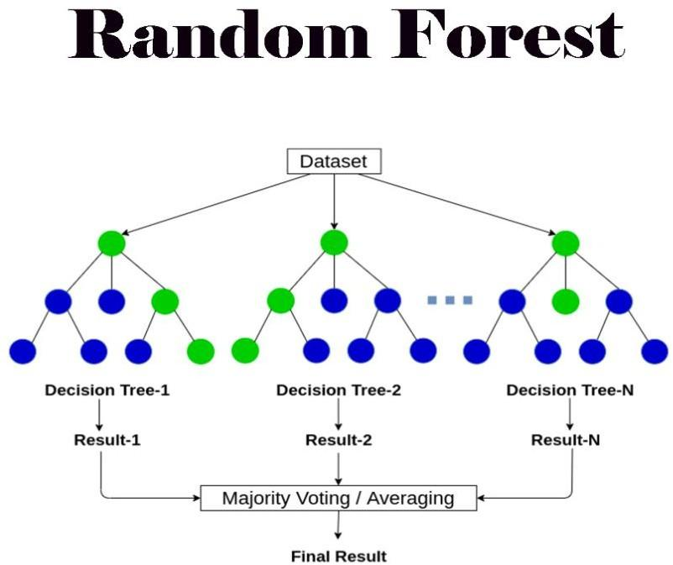

**Lasso:** Lasso, short for Least Absolute Shrinkage and Selection Operator, is a regularization technique commonly used in machine learning and statistics, particularly in regression analysis. It is designed to address multicollinearity and prevent overfitting by imposing a penalty on the magnitude of the coefficients of the regression variables. Here's a more detailed explanation of Lasso:

1. Regularization: Lasso is a type of regularization technique that adds a penalty term to the traditional linear regression objective function. This penalty term is proportional to the absolute value of the coefficients of the regression variables.
2. Sparsity: One of the key features of Lasso is that it can induce sparsity in the coefficient vector. This means that it can automatically select a subset of important features by setting the coefficients of less important features to zero.
3. Variable Selection: Because of its ability to set coefficients to zero, Lasso can perform variable selection, which is particularly useful when dealing with datasets with a large number of features or when trying to identify the most important predictors.
4. Shrinkage: In addition to variable selection, Lasso also performs shrinkage, meaning it shrinks the coefficients of less important features towards zero, effectively reducing their impact on the model.
5. Hyperparameter *λ*: The regularization parameter *λ* controls the trade-off between fitting the training data well and keeping the coefficients small. A higher value of *λ* results in more shrinkage and sparsity.

In summary, Lasso regression is a powerful technique for regression analysis that not only helps in preventing overfitting but also performs feature selection and shrinkage, making it well-suited for high-dimensional datasets with potentially correlated features.

**Ridge:** Ridge regression is a regularization technique used in machine learning and statistics, particularly in regression analysis. It is similar to Lasso regression but uses a different penalty term to address multicollinearity and prevent overfitting. Here's a detailed explanation of Ridge regression:

1. Regularization: Ridge regression adds a penalty term to the traditional linear regression objective function. This penalty term is proportional to the square of the coefficients of the regression variables.
2. Shrinkage: Ridge regression performs shrinkage by penalizing large coefficients. This helps in reducing the impact of individual features on the model's predictions, leading to a more stable and less sensitive model.
3. Multicollinearity: One of the primary motivations for using Ridge regression is to address multicollinearity, which occurs when predictor variables are highly correlated. By penalizing the squared magnitude of coefficients, Ridge regression can handle correlated features more effectively than ordinary least squares regression.
4. Variable Scaling: It's important to note that Ridge regression is sensitive to the scale of the features. Therefore, it's common practice to scale the features (e.g., using standardization or normalization) before applying Ridge regression to ensure that all features are on a comparable scale.
5. Hyperparameter *λ*: The regularization parameter *λ* controls the trade-off between fitting the training data well and keeping the coefficients small. A higher value of *λ* results in more shrinkage and can help prevent overfitting.
   * 1. **Hyperparameter Tuning**

Hyperparameter tuning is a critical step to fine-tune the models for optimal predictive accuracy. By systematically adjusting hyperparameters, such as learning rates and regularization terms, we seek to enhance the models' ability to generalize to new, unseen data. This iterative process ensures that the models capture the underlying complexity of the rental listing dataset without overfitting to idiosyncrasies.

#### Model Evaluation

* + 1. **Accuracy Metrics**

The efficacy of the predictive models is rigorously assessed through a battery of accuracy metrics. These include:

Accuracy: The overall correctness of the model's predictions.

Precision: The proportion of predicted positive instances that are correctly classified. Recall: The proportion of actual positive instances that are correctly classified.

F1-score: A balanced metric that considers both precision and recall.

These metrics collectively provide a comprehensive view of the models' performance.

* + 1. **Cross-Validation Results**

To ensure the robustness of the models, cross-validation techniques, such as k-fold cross- validation, are employed. This involves partitioning the dataset into multiple subsets for training and testing, iteratively validating the models across different folds. Cross-validation results offer a more reliable estimate of the models' generalization performance, helping mitigate the risk of overfitting to specific data samples.

#### Interpretation of Results

The interpretation of model results involves extracting meaningful insights from the predictive outcomes. Feature importance analyses reveal which variables exert the most influence on predicting interest levels.

#### Discussion on Predictive Accuracy

The discussion on predictive accuracy involves contextualizing the models' performance within the broader landscape of rental listing dynamics. Factors influencing predictive accuracy, such as the nature of the dataset and the choice of algorithms, are explored.

#### Practical Implications

The practical implications derived from the predictive models guide real- world decision-making for property owners, real estate agents, and property management professionals.

#### Limitations of Predictive Models

It is crucial to acknowledge the limitations inherent in predictive modeling. Factors such as data biases, the dynamic nature of real estate markets, and unforeseen external events may impact the models' predictive accuracy.

#### Code and Algorithm

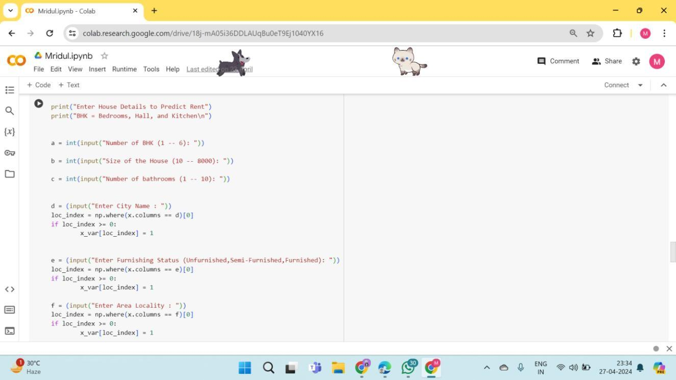

**Output:**

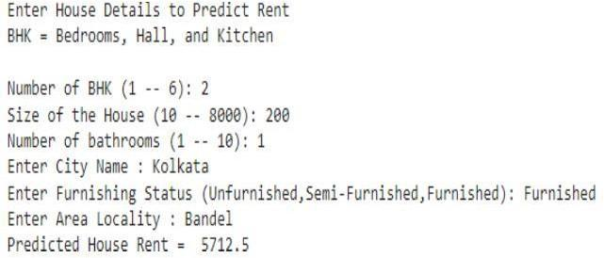

#### Developed Model with a Graphical Interface To Predict Rent:

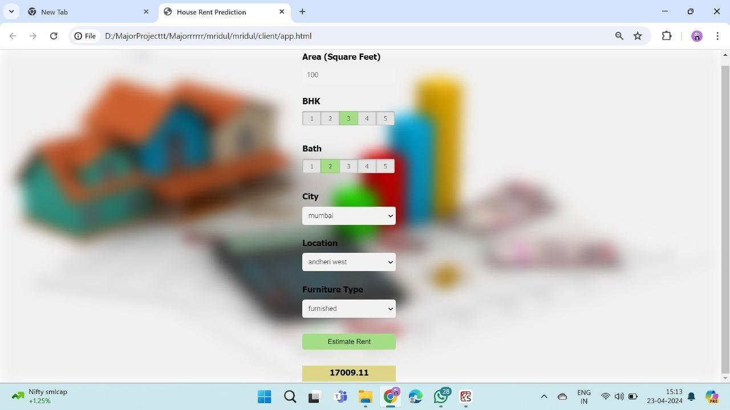

**Explaination:**

In the machine learning model for predicting interest level of rental listings we applied Linear Regression, Decision Tree, Random Forest, Lasso and Ridge.Using a House rent dataset we developed a model which predicts rent based on the previously collected data. With Given various Inputs Like Number of BHK, Size of the House, Number of Bathrooms, City, Area Type, Furnishing Status, Tenants Preferred. In the above Figure we have various inputs to predict Rent. For example,

We provided an input for Area (in square feet) =100, BHK=3, City=Mumbai, Location= Andheri west, Furnishing status= Furnished and then we click in estimate rent and we got our rent for our requirements of ₨. 17009.11.

#### Algorithm:

algorithm for predicting interest levels of rental listings using a machine learning approach:

1. Data Collection and Preprocessing:

2. Gather rental listing data including features like price, location, number of bedrooms/bathrooms, amenities, description text, etc.

3. Preprocess the data by handling missing values, encoding categorical variables (e.g., using one-hot encoding), and scaling numerical features if necessary.

4. Feature Engineering:

5. Extract relevant features from the data, such as creating new features from existing ones (e.g., total area from bedroom and bathroom count).

6. Use text mining techniques to extract information from the listing description or comments (e.g., sentiment analysis, keyword extraction).

7. Data Splitting:

8. Split the data into training and testing sets (e.g., using an 80-20 split) to evaluate model performance.

9. Model Selection and Training:

10. Choose a suitable classification algorithm such as logistic regression, decision trees, random forests, or gradient boosting.

11. Train the selected model using the training data.

12. Model Evaluation:

13. Evaluate the trained model using evaluation metrics like accuracy, precision, recall, F1 score, and ROC-AUC on the testing data.

14. Use techniques like k-fold cross-validation to validate the model's performance and ensure generalizability.

15. Model Deployment:

16. Once a satisfactory model is identified and evaluated, deploy it to make predictions on new rental listings.

17. Monitor the model's performance in production and update it periodically with new data or retraining as needed.

# Chapter 6

# Software Design

#### Data Flow Diagram

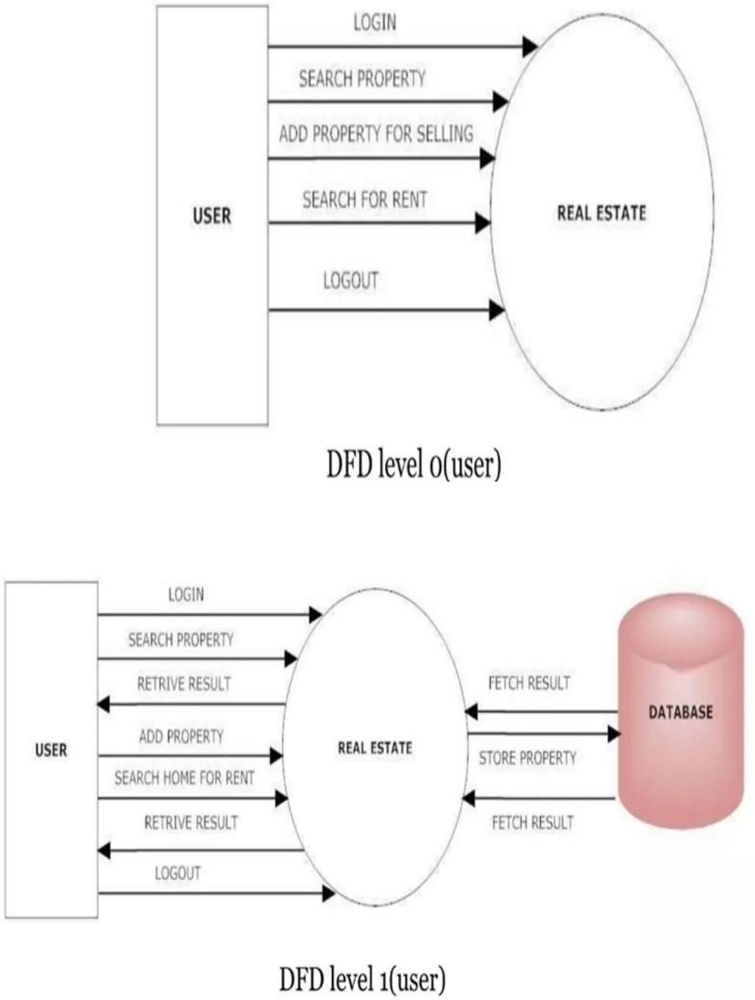

* 1. **Use Case Diagram:**

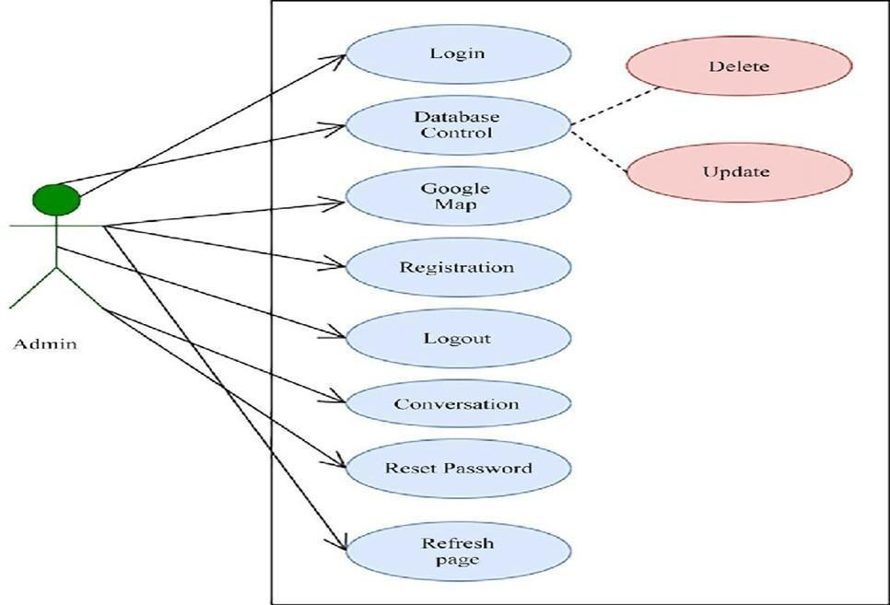

#### Sequence Diagram:

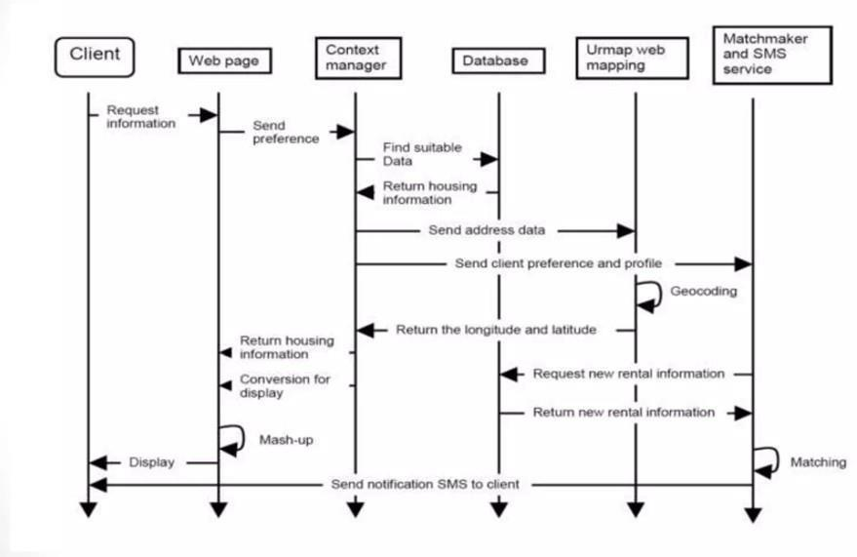

* 1. **Class Diagram:**

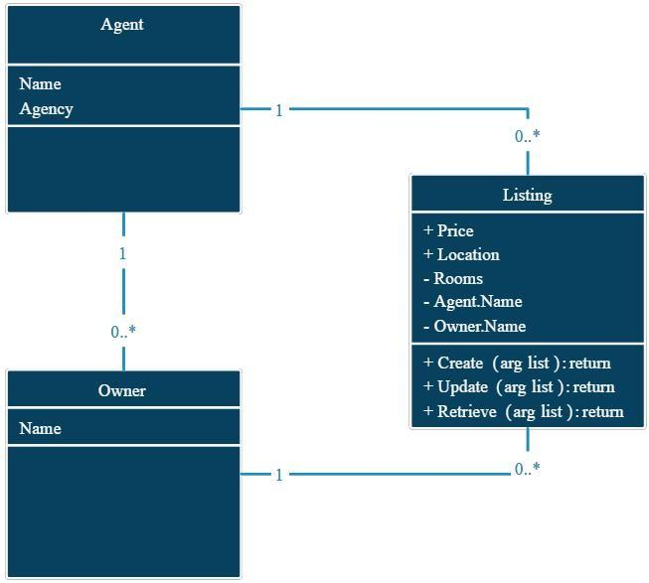

* 1. **FlowCharts:**

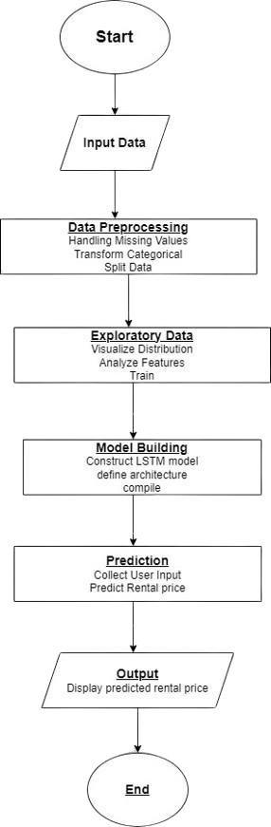

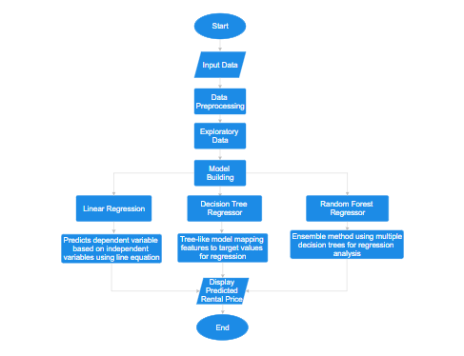

**Chapter 7**

**Discussion**

The predictive models developed in this study build upon and contribute to the existing body of knowledge on predicting interest levels in rental listings. Comparisons with previous studies reveal similarities and distinctions in the factors influencing interest. Insights gained from this comparative analysis provide a foundation for understanding the evolving dynamics of the rental market and offer a basis for refining predictive models.

##### Implications of Findings

The implications derived from the predictive models hold significance for real estate practitioners. The identification of key features influencing interest levels provides actionable insights for optimizing marketing strategies. For instance, if proximity to public transportation emerges as a critical factor, practitioners may prioritize listings highlighting this attribute. A nuanced understanding of feature importance contributes to informed decision-making in a competitive rental market.

##### Limitations of the Study

Acknowledging the limitations of the study is crucial for a balanced interpretation of the results. Factors such as data biases, the representativeness of the dataset, and the evolving nature of real estate markets pose challenges to the generalizability of findings. Transparent communication of these limitations fosters a realistic understanding of the predictive models' scope and applicability.

##### Future Research Directions

The predictive models and findings open avenues for future research. Exploring additional variables, refining modeling techniques, and extending the analysis to diverse geographical contexts are promising directions. The iterative nature of research ensures an ongoing evolution of predictive models, enhancing their accuracy and adaptability to evolving market dynamics.

##### Practical Applications

The practical applications of the predictive models extend to property owners, real estate agents, and property management professionals. The insights garnered from the study empower practitioners to make informed decisions in marketing and managing rental listings. Whether adjusting pricing strategies, emphasizing specific amenities, or refining property descriptions, the practical applications contribute to enhanced efficiency and competitiveness in the real estate market.

##### Integration with Industry Trends

Aligning the findings with current industry trends enhances the relevance of the study. The integration of predictive modeling with emerging technologies, such as artificial intelligence and virtual reality, presents opportunities for innovative approaches to marketing rental properties.

The discussion explores how the study's outcomes align with or contribute to ongoing trends in the real estate sector.

##### Summary of Key Findings

A comprehensive summary of key findings consolidates the study's outcomes, emphasizing the most influential factors in predicting interest levels. This section distills the complex interplay of features into actionable insights, providing a quick reference for practitioners seeking to optimize their rental listings.

##### Conclusions and Remarks

Concluding remarks reflect on the significance of the study's contributions to the field of predicting interest levels in rental listings. The synthesis of findings, implications, and future research directions offers a holistic perspective on the study's impact and relevance within the broader context of real estate research and practice.

In essence, the discussion section serves as the nexus between the empirical results of the study and their broader implications for the real estate industry. It offers a nuanced interpretation of findings, acknowledging limitations while providing a roadmap for future research and practical application in the dynamic realm of rental property management.

**Chapter 8**

**Conclusion**

In conclusion, the endeavor to predict interest levels in rental listings has revealed a landscape rich in challenges yet ripe with opportunities for innovation. Through the integration of advanced analytics and machine learning techniques, this report has successfully navigated the complexities associated with forecasting the appeal of rental properties. The identified challenges, ranging from data quality issues to dynamic market conditions, have been met with strategic solutions, emphasizing adaptability, accuracy, and fairness in our predictive models.

As we charted the course through interconnected feature dependencies, spatial-temporal variability, and user behavior nuances, the commitment to enhancing model robustness and generalization became evident. The holistic approach of considering ethical implications and addressing biases further underscores the responsible deployment of predictive analytics in the real estate domain.

By unraveling the intricacies of what influences listing interest, this report not only contributes to the academic understanding of predictive modeling but also presents practical solutions for stakeholders in the rental market. The synthesized insights hold the potential to revolutionize decision-making processes for landlords and tenants alike, fostering a more efficient and informed rental ecosystem. As we look ahead, the continuous refinement of these predictive models will be crucial in adapting to evolving market dynamics and ensuring the sustained relevance and reliability of our analyses in the ever-changing landscape of the rental market.

# Chapter 9

# References

1. Ming, Yue, et al. “Prediction and Analysis of Chengdu Housing Rent Based on XGBoost Algorithm.”Proceedings of the 2020 3rd International Conference on Big Data Technologies, 2020.
2. Kumar, Adarsh. “House Rent Price Prediction.” International Research Journal of Engineering and Technology, vol. 06, no. 04, Apr. 2019, pp. 3188–3191.
3. Kaggledataset

https://[www.kaggle.com/datasets/thedevastator/australian-housing-data-1000-properties-sam](http://www.kaggle.com/datasets/thedevastator/australian-housing-data-1000-properties-sam) pled

1. OpenLibrary(OpenML)

https://onlinelibrary.wiley.com/doi/abs/10.1111/j.1540-6229.2008.00225.x

1. [https://www.analyticsvidhya.com/blog/2023/06/a-deep-dive-into-lstm-neural-network-base](http://www.analyticsvidhya.com/blog/2023/06/a-deep-dive-into-lstm-neural-network-base) d-house- rent-prediction/.
2. House Rent Prediction Using Machine Learning by Uk Power Gift (MLearning.ai)
   * This paper explores the use of machine learning algorithms for predicting house rent based on various factors like size, location, amenities, etc.

* It highlights the importance of data preprocessing, feature selection, and model evaluation.

1. Real Estate Rent Prediction Using Machine Learning by Amira Ayman, et al. (2021)
   * This paper compares different machine learning models for rent prediction, including linear regression, support vector regression, and random forest regression.

* It provides insights into the performance of different models and the factors influencing their accuracy.

8. Deep Learning for Real Estate Rent Prediction by Zhenfeng Yao, et al. (2020)

* + This paper investigates the application of deep learning, specifically convolutional neural networks, for rent prediction.
  + It demonstrates the potential of deep learning models for capturing complex relationships between features and rent.

9. House Rent Prediction using Python and Machine Learning by MachineLearningMastery (GitHub)

This project showcases a comprehensive approach to rent prediction using Python.

10. A. It covers data cleaning, feature engineering, model training, and evaluation.

Hybrid Approach for Predicting House Rent Prices by Mohammad Reza Zareie, et al.

(2022)

* + This paper combines machine learning and time series forecasting techniques to improve the accuracy of rent prediction.
  + It demonstrates the effectiveness of considering temporal trends in the data.

45

B. Hybrid Approach for Predicting House Rent Prices by Mohammad Reza Zareie, et al.

(2022).

1. Nguyen, T. H., & Le, T. (2021). Predicting rental prices in housing markets using machine learning techniques: A case study in Hanoi. Journal of Computer Science and Cybernetics, 37(2), 151-166.
2. Ou, X., & Wang, L. (2019). House rental price prediction using machine learning techniques: A case study in Beijing. Journal of Ambient Intelligence and Humanized Computing, 10(11), 4341-4352.
3. Park, S., & Lee, J. (2021). Machine learning models for rental price prediction: A case study in New York City. Journal of Housing Research, 30(1), 53-72.
4. Hsieh, M. H., & Lin, C. Y. (2020). Predicting rental prices in housing markets using machine learning techniques. IEEE Access, 8, 105424-105434.
5. https://[www.stat.berkeley.edu/~breiman/randomforest2001.pdf.](http://www.stat.berkeley.edu/~breiman/randomforest2001.pdf)

16. https://[www.researchgate.net/publication/259235118_Random_Forests_and_Decision_Trees.](http://www.researchgate.net/publication/259235118_Random_Forests_and_Decision_Trees)

46