Q1.
Answer: Water boils at 100 degrees Celsius at sea level, but this temperature decreases at higher altitudes due to lower atmospheric pressure.
Keywords: water, boils, 100, celsius, altitude, pressure
Q2:
Answer: Addition is the process of combining numbers or quantities to find their total. It is one of the four basic arithmetic operations and can be represented using the '+' symbol.
Keywords: addition, combining, numbers, total, arithmetic, plus
Q3:
Answer: The sun is a massive, glowing sphere of hot plasma that generates energy through nuclear fusion and is the primary source of light and heat for Earth.
Keywords: sun, star, plasma, fusion, light, heat, life
Diagram:

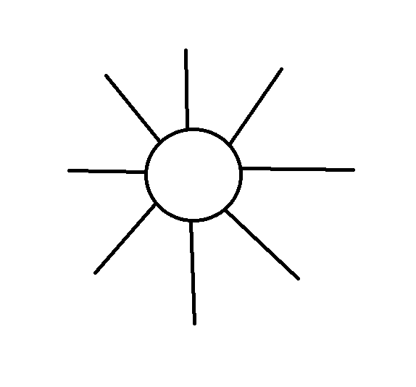
Q4:
Answer: A sustainable house design should maximize energy efficiency, use renewable materials, and incorporate passive heating and cooling techniques.
Keywords: house, sustainable, energy, renewable, design
Diagram:

