LOVELY PROFESSIONAL UNIVERSITY **Academic Task-3 (Programming In Java)**

School of Computer Science and Engineering Faculty of Technology & Sciences

Name of the faculty member: Mrs. Subhita

Course Code: CSE 310 Course Title: Programming In Java

**Student Name : Manvir Kaur**

**Student ID : 11604523**

**Roll Number : A-19**

**Section : K18UW**

**Q1:** **Write a Java Program to Implement “Personal Budget Management”.**

**Solution:**

import java.util.Scanner;

abstract class PersonalBudget

{

static Scanner s = new Scanner (System.in);

static double df;

static double save;

static double income ()

{

double job, savings, anyOther, totalIncome;

System.out.println("--------------------------------------------------------------------------------------");

System.out.println("\n --- Calculate Your Monthly Income ---");

System.out.println("\nEnter Your Salary:");

job = s. nextDouble ();

System.out.println("Enter the Amount of Savings You Wish to Spend ... In This Month:");

savings = s. nextDouble ();

System.out.println("Enter Any Other Income You May Have:");

anyOther = s. nextDouble ();

totalIncome = job + savings + anyOther;

return totalIncome;

}

static double essentialOutgoing ()

{

double totalEssentialOutgoing, rent, travel, insurance, utilityBills, mobile, food;

System.out.println("\n --- Essential Costs ---");

System.out.println("\nEnter The Amount of Rent You Will Pay:");

rent = s. nextDouble ();

System.out.println("Enter the Amount of Travel Costs:");

travel = s. nextDouble ();

System.out.println("If You Have Insurance ... Enter the Total Cost:");

insurance = s. nextDouble ();

System.out.println("Enter the Amount You Expect to Spend on Utility Bills ... Gas, Electric, Oil etc.");

utilityBills = s. nextDouble ();

System.out.println("Enter the Amount You Expect to Spend on Your Mobile:");

mobile = s. nextDouble ();

System.out.println("Enter How Much You Expect to Spend on Groceries:");

food = s. nextDouble ();

totalEssentialOutgoing = rent + travel + food + utilityBills + mobile + insurance;

return totalEssentialOutgoing;

}

static double otherCosts ()

{

double totalOtherCosts, clothing, socialActivities;

System.out.println("\n--------------------------------------------------------------------------------------");

System.out.println("\n --- Other Costs ----");

System.out.println("\nEnter How Much You Would Like to Spend on Clothing:");

clothing = s. nextDouble ();

System.out.println("Enter How Much You Would Like to Spend on Social Activities:");

socialActivities = s. nextDouble ();

totalOtherCosts = socialActivities + clothing;

return totalOtherCosts;

}

public static void main (String[] args)

{

double theTotalIncome = 0, theTotalEssentialOutgoing, theTotalOtherCosts, budget1, budget2, spend, budget3, budget4;

System.out.println("--------------------------------------------------------------------------------------");

System.out.println("--------------------------------------------------------------------------------------");

System.out.println("\n ---- WELCOME!! To The Personal Budget Management ----");

System.out.println("\n--------------------------------------------------------------------------------------");

System.out.println("--------------------------------------------------------------------------------------");

System.out.println("\nEnter How Much You Want to Save?");

save = s. nextDouble ();

theTotalIncome = income ();

System.out.println("--------------------------------------------------------------------------------------");

System.out.println("\n Your Income for The Month $"+ theTotalIncome);

spend = theTotalIncome - save;

System.out.println(" You Have $"+spend+ " to spend.");

System.out.println("\n--------------------------------------------------------------------------------------");

theTotalEssentialOutgoing = essentialOutgoing ();

budget1 = spend - theTotalEssentialOutgoing;

System.out.println("--------------------------------------------------------------------------------------");

System.out.println("\n You Have Spent $"+ theTotalEssentialOutgoing +" Essentials Costs.");

System.out.println(" The Amount Left After the Essentials $" +budget1);

theTotalOtherCosts = otherCosts ();

budget2 = budget1 - theTotalOtherCosts;

System.out.println("--------------------------------------------------------------------------------------");

System.out.println("\n You Have Spent $"+theTotalOtherCosts+ "For Other Costs.");

budget3 = theTotalEssentialOutgoing + theTotalOtherCosts;

System.out.println("\n---------------------------------------------------------------------------------------------------------------");

System.out.println("\n---------------------------------------------------------------------------------------------------------------");

System.out.println("\n You Have Spent (Rent, Travel, Insurance, UtilityBills, Mobile, Food, Clothing, SocialActivities) $" + budget3);

budget4 = budget3 - spend;

if (spend > budget3)

{

System.out.println("\n YOU ARE UNDER BUDGET BY $" + budget2 + " \n YOU HAVE $" +budget2+ " AT THE END OF THE MONTH!!");

}

else if (spend < budget3)

{

System.out.println("\n YOU ARE OVER BUDGET By $" + budget4);

}

else

{

System.out.println("\n YOU SPENT THE BUDGET AMOUNT EXACTLY $" +budget3);

}

System.out.println("\n----------------------------------------------------------------------------------------------------------------");

System.out.println("\n----------------------------------------------------------------------------------------------------------------");

}

}

**OUTPUT:**

**TEST CASE 1: UNDER BUDGET**

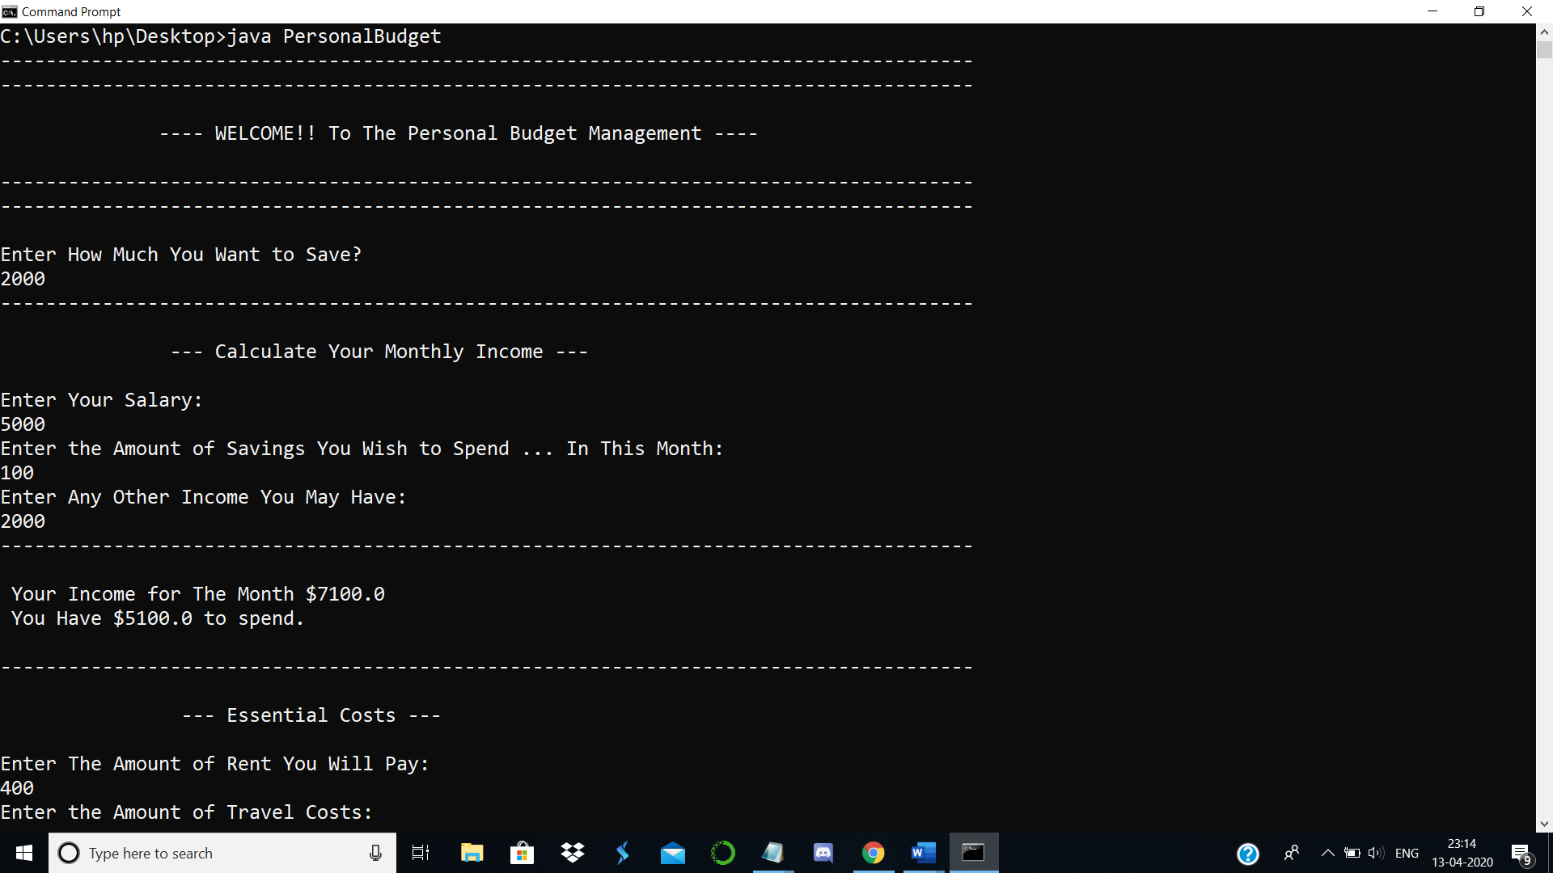

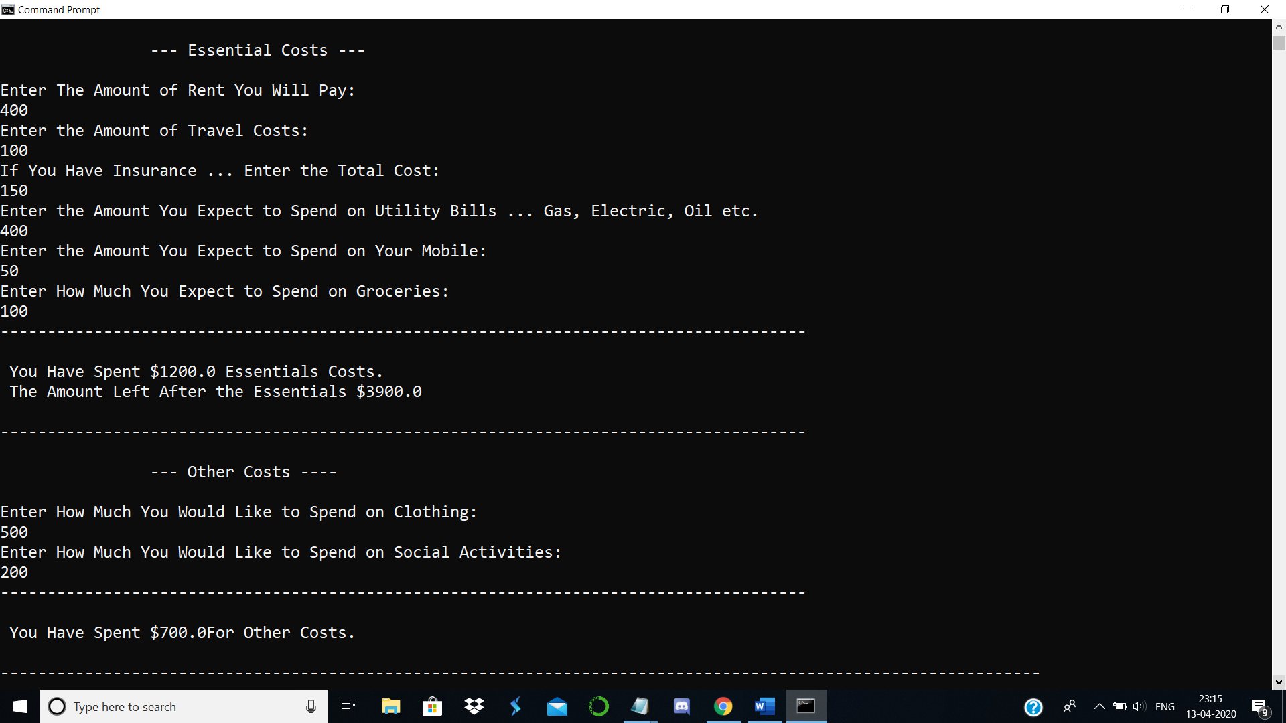

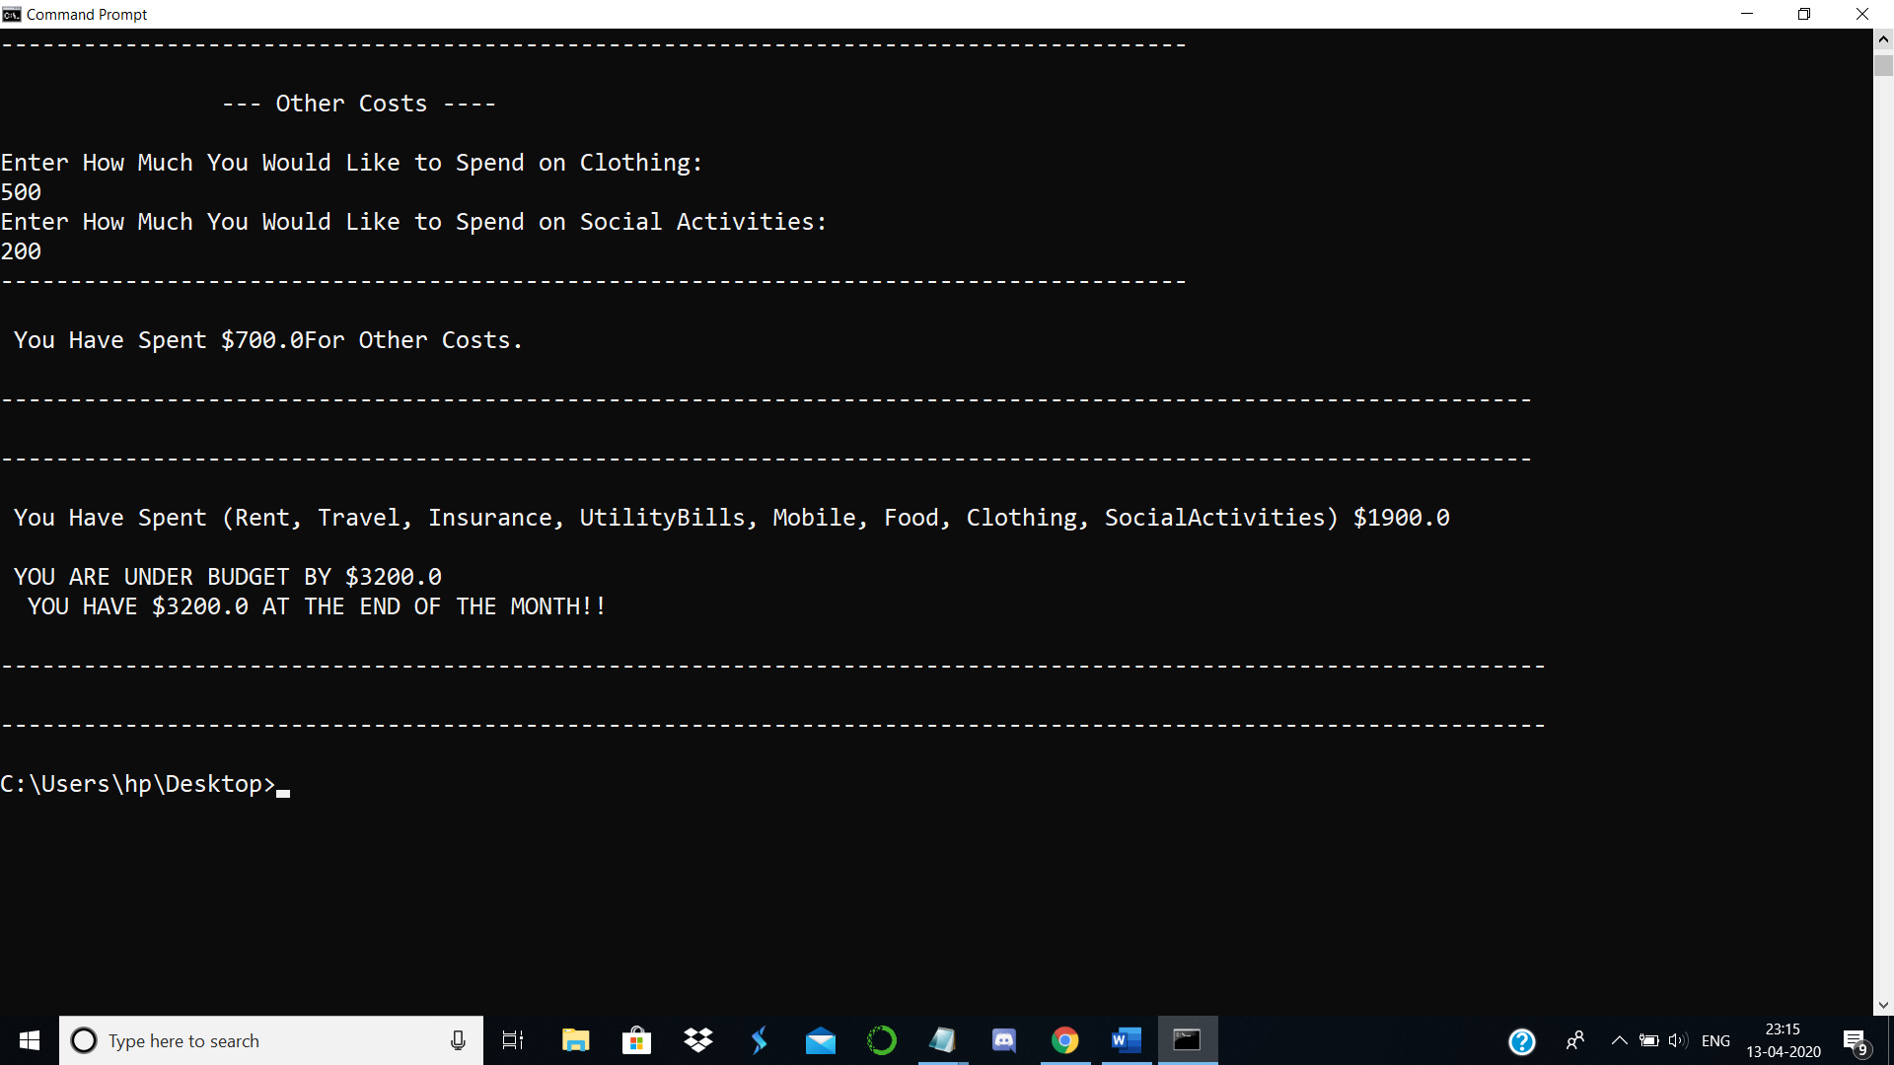

**TEST CASE 2: OVER BUDGET**

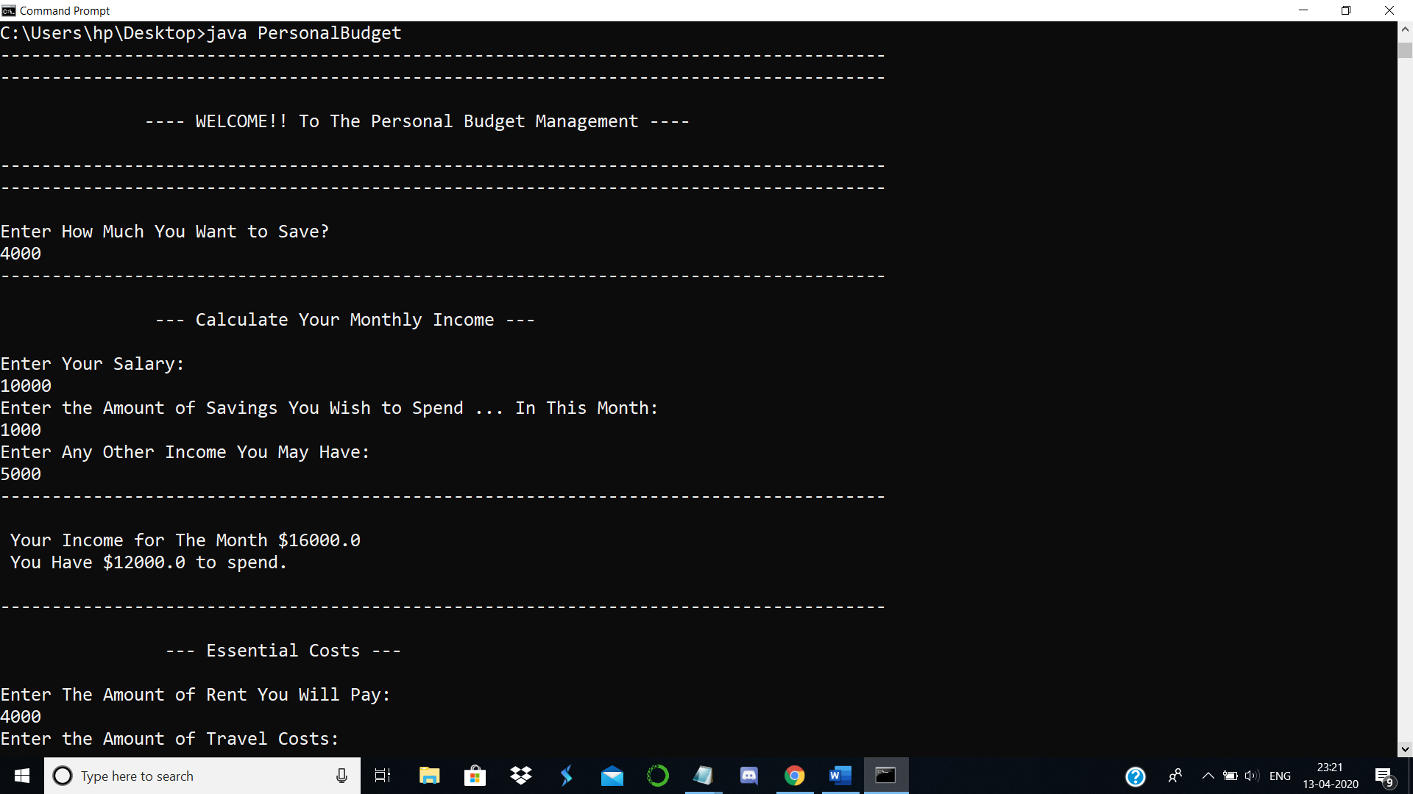

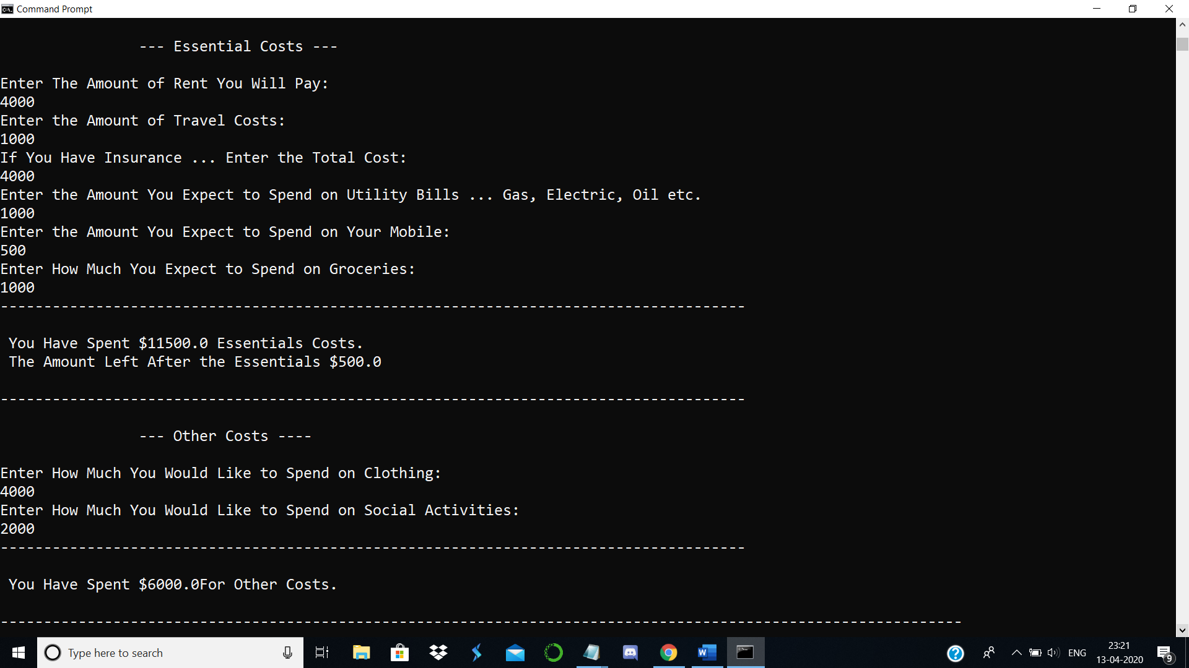

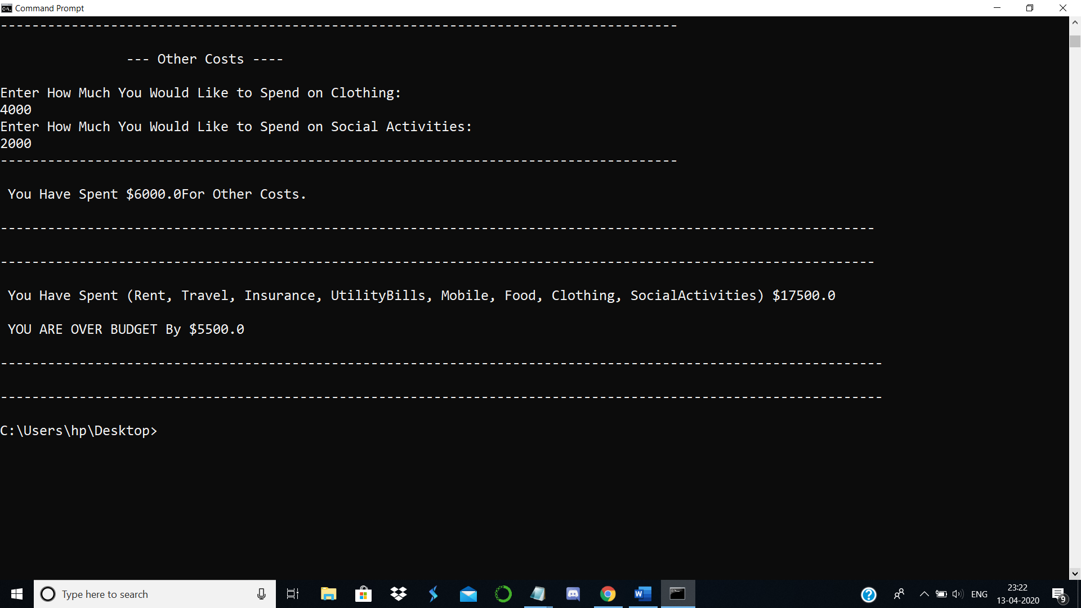

**TEST CASE 3: BUDGET AMOUNT EXACTLY**

