Use Case 6 — Supplier & Sourcing Intelligence
“Supply Radar” · approach, prediction models and Azure architecture · Manvith M · July 2026

1. The problem, in one paragraph
Procurement has no consolidated view of how Vaighai’s buying compares with the wider coir supplier market. MIR field reports tell us how much each mill produced and dispatched, and how much we took; the ERP tells us what we actually received. Nobody overlays the two, so shrinking suppliers, competitor buying moves and monsoon-driven regional swings surface only after they have hurt offtake. Supply Radar overlays these two sources, predicts problems one quarter ahead, and pushes a short act-here list to purchase managers.

2. What the data told us
The build pack covers roughly 1,170 reconciled mills across five main regions (Pollachi, Kangeyam, Madurai, Salem, Peravurani). Purchase records run from FY2013; MIR field estimates begin in FY2021, so all market modelling uses the FY2021+ window. Four data-quality findings shaped the design:
- Field-entry outliers — single-quarter dispatch entries up to 2.1 million MT (a mill’s physical ceiling is under ~1,600 MT). We cap quantities at the 99.5th percentile of positive values before any modelling.
- Future-dated MIR rows — some field entries carry dates months into the future. We cut everything after the latest complete fiscal quarter so no partial quarter leaks into training or scoring.
- Zeros are real — a zero in MIR means genuinely no production that quarter, so zeros stay in the panel and gaps in supply become a feature (quarters-since-active).
- Estimates vs actuals disagree by design — MIR is a human estimate, purchases are system receipts. The gap is itself a signal we surface for reconciliation, not an error to fix.

3. The approach — four lenses on the supplier market
Everything is computed on a supplier × fiscal-quarter panel built from the joined table. Each lens answers one procurement question:
Lens | Question it answers | Method
Decline risk (predictive) | Which mills will supply materially less next quarter? | Classifier on lag features
Offtake forecast (predictive) | How much will each mill dispatch next quarter? | Champion of ridge / seasonal-naive / blend
Sourcing opportunity | Which big, growing mills do we barely buy from? | Size × share-headroom × growth score
Concentration risk | Are we over-dependent on a few mills? | HHI + top-5 share per year

3.1 Predicting supplier decline one quarter ahead
For every active supplier we build features from its own history only: four quarterly lags of dispatch, rolling mean and volatility, momentum (quarter-on-quarter change and four-quarter slope), our share of the mill, quarters since it last supplied, and a region seasonal index that captures the monsoon cycle. The target is “next-quarter dispatch falls more than 50% below the supplier’s trailing four-quarter average.” The model is trained on all history and validated on the four most recent held-out quarters, exactly as it would run in production.
On held-out quarters the classifier reaches AUC 0.762 against a 47.6% base rate. Scoring the latest complete quarter (FY2027 FQ1) flags 71 suppliers as Critical and 198 as Moderate for FY2027 FQ2 out of 510 scored. In the prototype the classifier is a regularised logistic regression so it runs anywhere with zero dependencies; in production Azure ML would train a gradient-boosted version of the same design, which is a drop-in upgrade.

3.2 Forecasting next-quarter volumes
Three candidate forecasters are backtested on the same held-out quarters: a ridge regression on the lag features, a seasonal-naive model (trailing four-quarter mean scaled by the region’s seasonal index), and a 50/50 blend. The champion is picked automatically by weighted absolute percentage error. On current data the seasonal-naive wins at 50.2% WAPE — an honest result for quarterly, human-estimated mill data, and the champion mechanism means a stronger model simply takes over once more history accumulates. The watchlist combines both models: expected volume = P(decline) × depressed scenario + (1 − P) × forecast.

3.3 Sourcing opportunities and concentration
For the latest complete year (FY2026) every mill gets an opportunity score: its dispatch-size percentile, times the share of its output we do not take, times a growth factor. The top of that list is the call sheet — large, growing mills where our share is a few percent. Concentration is tracked yearly as HHI and top-5 share of purchases; the FY2021–FY2026 trend shows dependency easing from 88% to 51% top-5 share, which the dashboard keeps visible so it does not quietly reverse.

4. Automation — how it runs without anyone remembering to run it
The whole pipeline is a scheduled loop; the prototype scripts map one-to-one onto the production components:
Step | What happens | Azure component
1 · Ingest (weekly) | Pull new MIR entries, ERP purchase receipts (internal transfers excluded) and district weather via API | Logic Apps → Bronze
2 · Clean | Supplier-name matching, outlier caps, fiscal-calendar mapping, drop future-dated rows | Functions (Python) → Silver
3 · Feature build | Supplier × quarter panel with lags, seasonality, share and gap features | Functions → Gold
4 · Score (quarterly + on new data) | Decline risk, champion forecast, opportunity and concentration tables | Azure ML batch endpoint
5 · Explain & alert | Agent turns flags into plain-language reasons and a weekly sourcing brief | AI Foundry + Power Automate
6 · Act & learn | Purchase managers work the list; actuals feed back and models retrain, versioned in the registry | Teams / Power BI → ML registry

The retrain loop is what makes it predictive rather than a one-off report: every quarter the newly observed actuals become training data, the backtest re-runs, and the champion forecaster is re-selected automatically.

5. Architecture on Azure
Same stack agreed for Use Case 1, so both use cases share one data lake, one ML workspace and one alerting fabric — procurement inherits the sales investment rather than building a parallel platform.
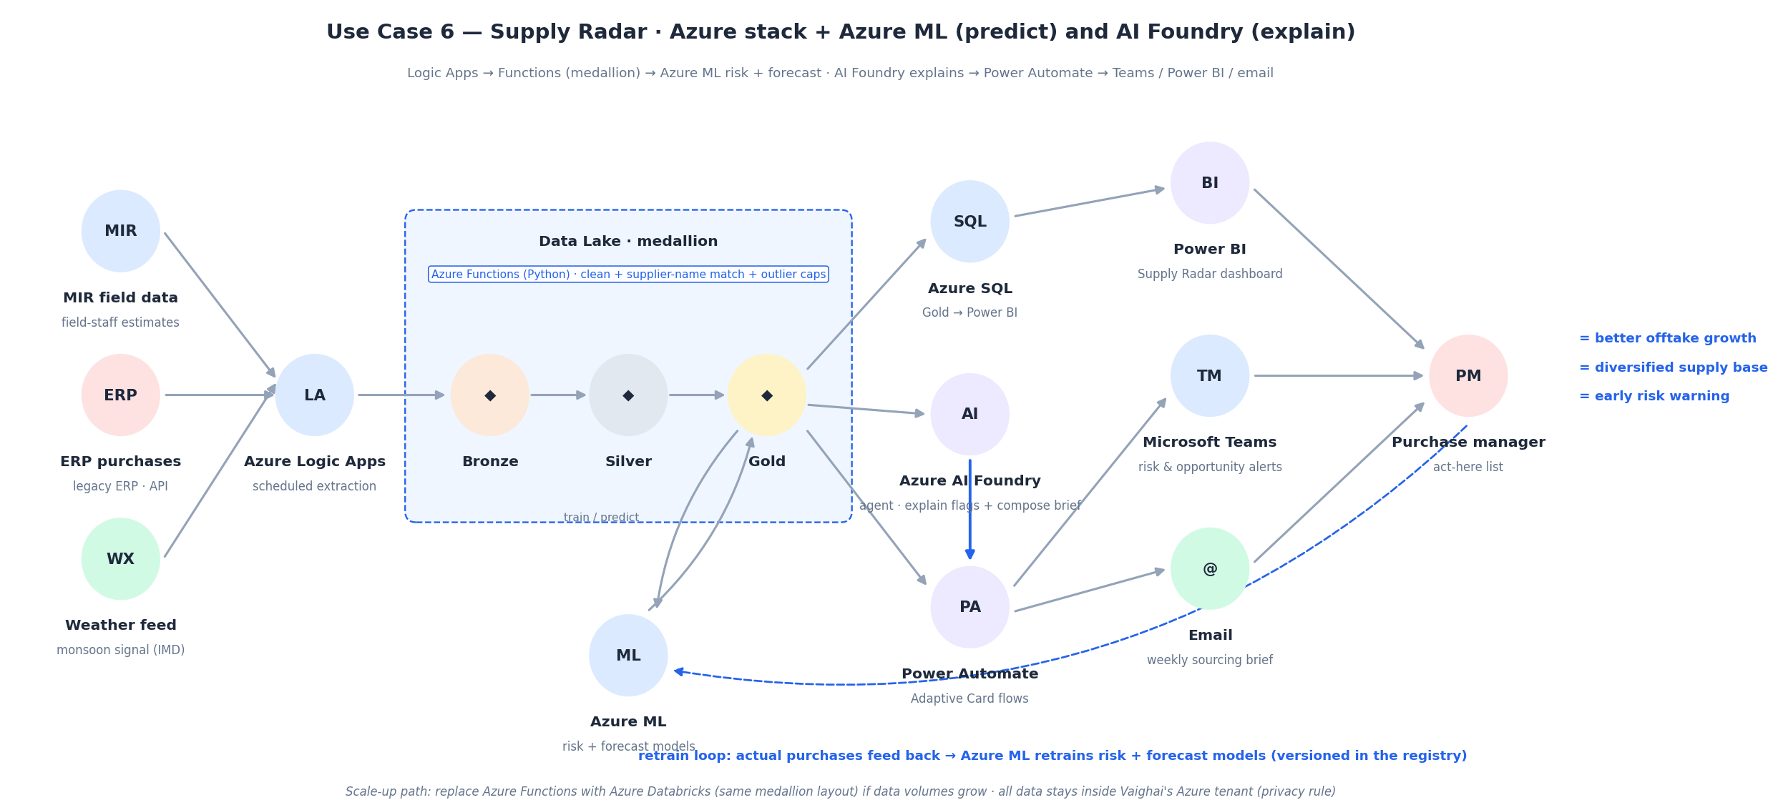
- Scale-up path — the medallion layout is engine-agnostic. If MIR coverage or granularity grows beyond what Functions handles comfortably, swap the transform layer for Azure Databricks — nothing upstream or downstream changes.
- Privacy rule — supplier names never leave the tenant. Dashboards, ML training and the AI Foundry agent all run inside Vaighai’s Azure environment; if open-source LLMs are preferred, they run in-tenant on the same data.
- APIs needed from IT — read-only extracts for ERP purchase lines (with the internal-transfer flag), MIR submissions, and the supplier master. A district-level weather feed (e.g. IMD) completes the monsoon signal.

6. Risks and open questions
- MIR is a human estimate — model quality is bounded by field-staff diligence. The purchase-vs-MIR reconciliation view doubles as a data-quality monitor per field officer.
- A few mills were left unmatched between MIR and purchase names rather than guessed; they appear one-sided until procurement confirms the mapping.
- Quarterly grain limits how early the warning can fire; if MIR moves to monthly entry the same pipeline gives a month-ahead signal.
- Weather is joined at region level only for now — mill-level geolocation would sharpen the monsoon feature.
- Thresholds (50% decline definition, risk bands, opportunity weights) are first passes — they should be tuned with purchase managers in the pilot.

7. Deliverables in this pack
File | What it is
supply_radar.py | Full pipeline: clean → features → risk model → champion forecast → opportunity & concentration
supply_radar_dashboard.html | Interactive dashboard (open in any browser)
watchlist_decline_risk.csv | Ranked decline-risk watchlist for FY2027 FQ2
forecast_next_quarter.csv | Per-supplier next-quarter dispatch forecast
sourcing_opportunities.csv | Top-50 opportunity shortlist, FY2026
concentration_risk.csv | HHI and top-5 dependency by year
uc6_supply_radar_architecture.png | Architecture diagram (also embedded above)

