ER Diagram-3
STUDENT MANAGEMENT SYSTEM

.
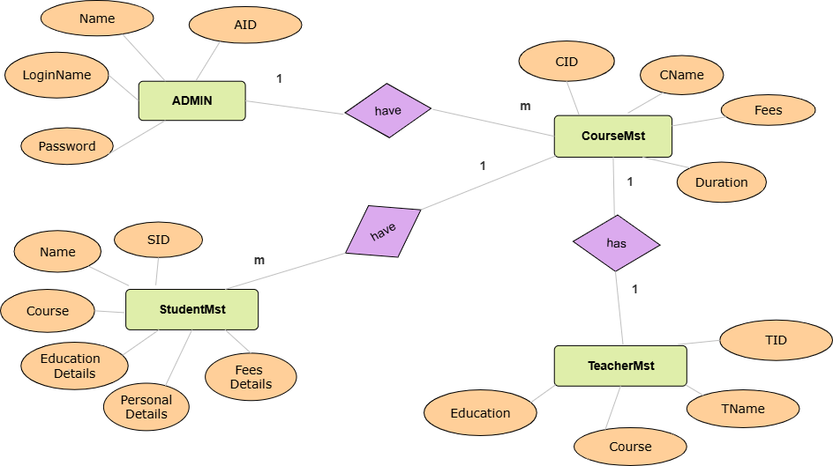

.

ER Diagram-04
HOSPITAL MANAGEMENT SYSTEM



