murphy-lab5.R

William Murphy

Thu Nov 29 21:27:47 2018

setwd("/home/manwthglasses/Documents/IntroToDataScience/")  
  
## Task 1  
norm <- rnorm(1000, mean = 80)  
  
ndist <- function(vector, min, max){  
 b <- length(vector[(vector>= min) & (max <= vector) ])  
 return(b)  
}  
  
replicate(5, ndist(rnorm(1000, mean = 80), 79, 81))

## [1] 162 157 177 146 155

##Task 2  
library(VGAM)

## Loading required package: stats4

## Loading required package: splines

FSApops <- rpareto(51, scale = 40000000, 3)  
hist(FSApops)

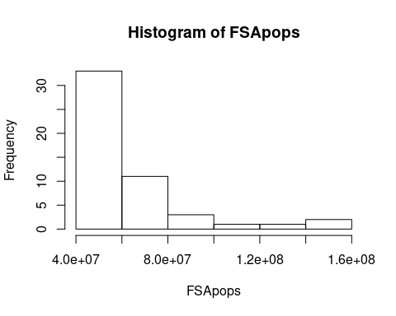

mean(FSApops)

## [1] 61352198

sd(FSApops)

## [1] 25124723

min(FSApops)

## [1] 40304336

max(FSApops)

## [1] 148676131