Ukraine's #1 job site

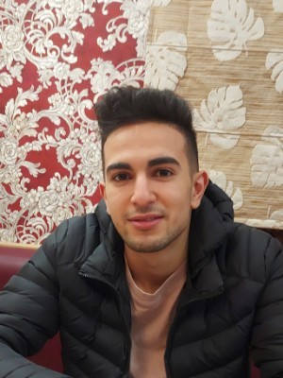Resume from November 2, 2021  
Хуфаче Маджид Many

## Développeur frontal

Age: 21 years

City: Kharkiv

## Contact information

Address: Otakara yaracha

Phone number: 063 371-25-45

Email address: kmadjid65@gmail.com

## Work experience

### Front-end developer

from 01.2019 to 04.2021 (2 years 3 months)  
Freelance.com

## Education

### Харьков/УИПО

Программист компьютер, Kharkiv  
Unfinished higher, from 2019 to 2022 (3 years)

## Additional education

* Uitschool (2020,3.5)
* HillelSchool (2020,3.5)

## Professional and other skills

* Computer skills  
  . JavaScript   
  .Experience with React js ⚛  
  .Apis analysts 🔍(fetch..)  
  .Nodejs /linux🐧  
  .Html / Css  
  .Sass  
  .figma 🧩  
  .github /bootstrap   
  .Filezilla

## Language proficiencies

* English ─ above average
* Russian ─ above average
* French ─ fluent
* Arabic ─ advanced

Резюме кандидата размещено по адресу: www.work.ua/resumes/7672838