COLLEGE MANAGEMENT
CREATE DATABASE college_management;
USE college_management;
CREATE TABLE Department (
department_id INT PRIMARY KEY AUTO_INCREMENT,
department_name VARCHAR(100) NOT NULL
);
CREATE TABLE Student (
student_id INT PRIMARY KEY AUTO_INCREMENT,
name VARCHAR(100),
department_id INT,
year INT,
email VARCHAR(100),
FOREIGN KEY (department_id)
REFERENCES Department(department_id)
);
CREATE TABLE Faculty (
faculty_id INT PRIMARY KEY AUTO_INCREMENT,
name VARCHAR(100),
department_id INT,
designation VARCHAR(100),
FOREIGN KEY (department_id)
REFERENCES Department(department_id)
);
CREATE TABLE Course (
course_id INT PRIMARY KEY AUTO_INCREMENT,
course_name VARCHAR(100),
credits INT,
department_id INT,
faculty_id INT,
FOREIGN KEY (department_id)
REFERENCES Department(department_id),
FOREIGN KEY (faculty_id)
REFERENCES Faculty(faculty_id)
);
CREATE TABLE Enrollment (
enrollment_id INT PRIMARY KEY AUTO_INCREMENT,
student_id INT,
course_id INT,
semester VARCHAR(20),
grade DECIMAL(3,2),
FOREIGN KEY (student_id)
REFERENCES Student(student_id),
FOREIGN KEY (course_id)
REFERENCES Course(course_id)
);
CREATE TABLE Attendance (
attendance_id INT PRIMARY KEY AUTO_INCREMENT,
student_id INT,
course_id INT,
attendance_percentage DECIMAL(5,2),
FOREIGN KEY (student_id)
REFERENCES Student(student_id),
FOREIGN KEY (course_id)
REFERENCES Course(course_id)
);
INSERT INTO Department(department_name)
VALUES
('Computer Science'),
('Electronics'),
('Mechanical');
INSERT INTO Student(name,department_id,year,email)
VALUES
('Rahul',1,3,'rahul@gmail.com'),
('Anjali',1,2,'anjali@gmail.com'),
('Kiran',2,4,'kiran@gmail.com'),
('Arun',3,1,'arun@gmail.com');
INSERT INTO Faculty(name,department_id,designation)
VALUES
('Dr. Kumar',1,'Professor'),
('Dr. Nair',2,'Associate Professor'),
('Dr. Joseph',3,'Assistant Professor');
INSERT INTO Course(course_name,credits,department_id,faculty_id)
VALUES
('DBMS',4,1,1),
('Data Structures',4,1,1),
('Digital Electronics',3,2,2),
('Thermodynamics',3,3,3);
INSERT INTO Enrollment(student_id,course_id,semester,grade)
VALUES
(1,1,'S5',8.5),
(1,2,'S5',9.0),
(2,1,'S3',7.5),
(3,3,'S7',8.0);
INSERT INTO Attendance(student_id,course_id,attendance_percentage)
VALUES
(1,1,90),
(1,2,85),
(2,1,75),
(3,3,88);
- Retrieve all students.
SELECT * FROM Student;
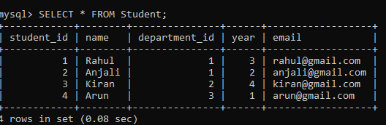

- Display courses offered by a department.
SELECT c.course_name,d.department_name
FROM Course c
JOIN Department d
ON c.department_id=d.department_id;
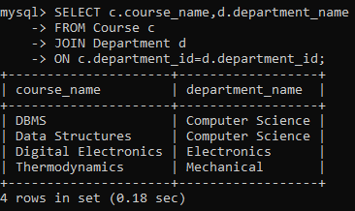

- Display student and enrollment details (2-table INNER JOIN).
SELECT s.student_id,
s.name,
e.course_id,
e.semester,
e.grade
FROM Student s
INNER JOIN Enrollment e
ON s.student_id=e.student_id;
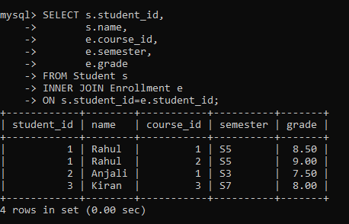
- Display student, course, and faculty details (3-table JOIN).
SELECT
s.name AS Student,
c.course_name,
f.name AS Faculty
FROM Student s
JOIN Enrollment e
ON s.student_id=e.student_id
JOIN Course c
ON e.course_id=c.course_id
JOIN Faculty f
ON c.faculty_id=f.faculty_id;
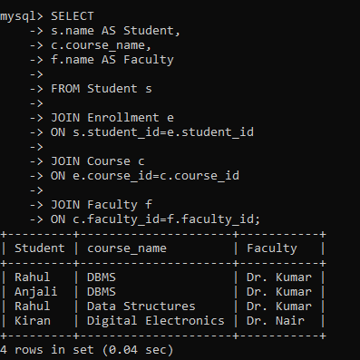

- Count students per department (GROUP BY).
SELECT
d.department_name,
COUNT(s.student_id) AS Total_Students
FROM Department d
JOIN Student s
ON d.department_id=s.department_id
GROUP BY d.department_name;
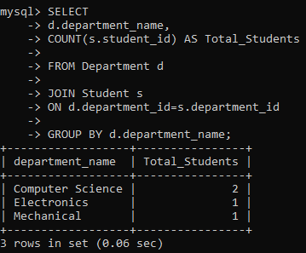

- Display departments having more than 50 students enrolled (HAVING).
SELECT
d.department_name,
COUNT(*) AS Total
FROM Student s
JOIN Department d
ON s.department_id=d.department_id
GROUP BY d.department_name
HAVING COUNT(*) > 50;

- Retrieve students scoring above average GPA (Subquery).
SELECT *
FROM Student
WHERE student_id IN
(
SELECT student_id
FROM Enrollment
GROUP BY student_id
HAVING AVG(grade)>
(
SELECT AVG(grade)
FROM Enrollment
)
);
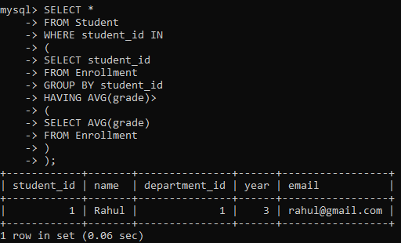

- Retrieve students who enrolled in more courses than a specific student (Correlated Subquery).
SELECT s1.*

FROM Student s1

WHERE
(
SELECT COUNT(*)
FROM Enrollment e
WHERE e.student_id=s1.student_id
)
>
(
SELECT COUNT(*)
FROM Enrollment e
WHERE e.student_id=1
);

- Display all students including those not enrolled in any course (LEFT JOIN).
SELECT
s.student_id,
s.name,
e.course_id
FROM Student s
LEFT JOIN Enrollment e
ON s.student_id=e.student_id;
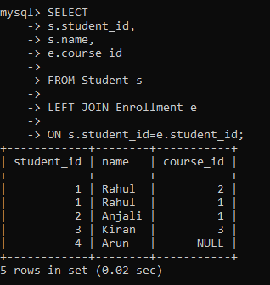

- Retrieve courses with no enrollments (NOT EXISTS).
SELECT *
FROM Course c
WHERE NOT EXISTS
(
SELECT *
FROM Enrollment e
WHERE e.course_id=c.course_id
);
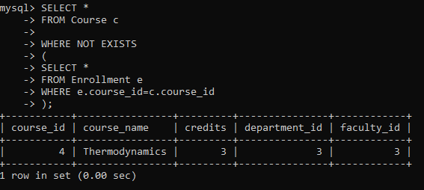
Stored Procedure Questions
- Write a procedure to calculate GPA of a student.
DELIMITER $$

CREATE PROCEDURE CalculateGPA(
IN sid INT
)

BEGIN

SELECT
student_id,
AVG(grade) AS GPA

FROM Enrollment

WHERE student_id=sid

GROUP BY student_id;

END$$

DELIMITER ;
CALL CalculateGPA(1);
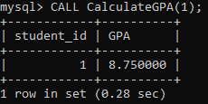
- Write a procedure to generate department-wise performance report.
DELIMITER $$

CREATE PROCEDURE DepartmentPerformance()

BEGIN

SELECT
d.department_name,
AVG(e.grade) AS Avg_GPA

FROM Department d

JOIN Student s
ON d.department_id=s.department_id

JOIN Enrollment e
ON s.student_id=e.student_id

GROUP BY d.department_name;

END$$

DELIMITER ;

Trigger Questions
- Create a trigger to prevent duplicate enrollment in the same course.
DELIMITER $$

CREATE TRIGGER prevent_duplicate_enrollment

BEFORE INSERT

ON Enrollment

FOR EACH ROW

BEGIN

IF EXISTS
(
SELECT *
FROM Enrollment

WHERE student_id=NEW.student_id
AND course_id=NEW.course_id
)

THEN

SIGNAL SQLSTATE '45000'
SET MESSAGE_TEXT='Student already enrolled';

END IF;

END$$

DELIMITER ;
- Create a trigger to update attendance percentage after attendance insertion.
DELIMITER $$

CREATE TRIGGER attendance_update

AFTER INSERT

ON Attendance

FOR EACH ROW

BEGIN

UPDATE Attendance

SET attendance_percentage=
attendance_percentage

WHERE attendance_id=NEW.attendance_id;

END$$

DELIMITER ;

