**Screenshots –**

**Talend workflow run, Azure and MySQl databases-**

**MySQL database population-**

**MySQL database count-**

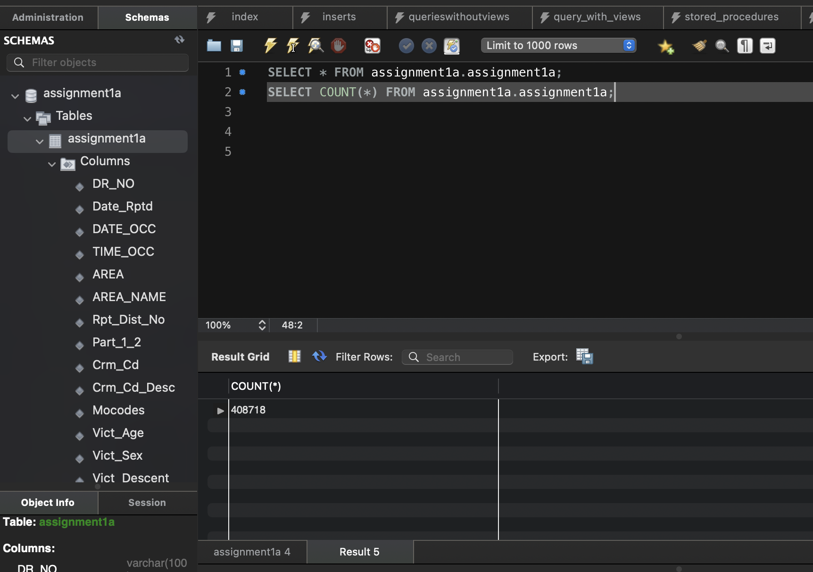

**Azure database population-**

**Azure database Count-**

