

Submitted

IN PARTIAL FULLFILLMENT OF THE REQUREMENT

FOR THE

ALL INDIA SENIOR SCHOOL CERTIFICATE

EXAMINATION

SESSION: 2024-25

CHEMISTRY INVESTIGATORY PROJECT ON

**STUDY of QUANTITY OF CASEIN PRESENT IN DIFFERENT SAMPLE OF MILK**

**GUIDED BY:- SUBMITTED BY:-**

**Mrs Sarika Gupta Akshat Sharma**

**CERTIFICATE**



**This is to certify that Akshat Sharma of class XII F, bearing registration number ___________ from International Public School, Bhopal has successfully completed the chemistry project entitled-**

*STUDY OF QUANTITY OF CASEIN PRESENT IN DIFFERENT SAMPLE OF MILK*

**Under the guidance of Mrs Sarika Gupta in laboratory of the institution prescribed by CBSE for AISSCE**

**2024-2025.**

**Teacher’s Signature Principal’s Signature**

**Examiner’s Signature Date:**

ACKNOWLEDGEMENT

I wish to express my deep gratitude and sincere thanks to the principal, Mrs Deepti Singh for her encouragement provided for this project. I extend my hearty thanks to, Mrs Sarika Gupta, my Chemistry teacher, who guided me to successful completion to this project on the topic**:**

*STUDY OF QUANTITY OF CASEIN PRESENT IN DIFFERENT SAMPLE OF MILK*

Secondly I offer my sincere thanks to my parents and my friends who helped me to carry out this project work successfully and for their support, which I receive from them time to time.

INDEX

1. **AIM**
2. **APPARATUS**
3. **PRINCIPLES APPLIED AND THEORY**
4. **PROCEDURE**
5. **OBSERVATION**
6. **Conclusion**
7. **Application**
8. **PRECAUTIONS**
9. **BIBLOGRAPHY**

*AIM*

THE STUDY OF QUANTITY OF CASEIN PRESENT IN DIFFERENT SAMPLE OF MILK

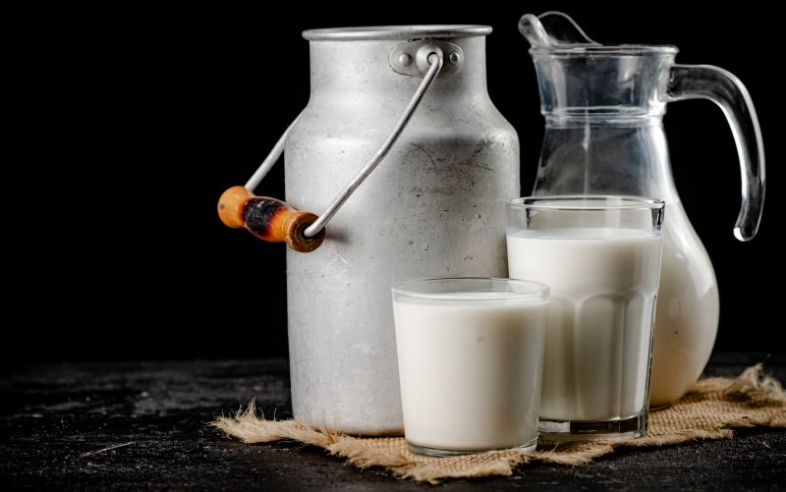

**APPARATUS REQUIRED**

* *Beakers (250 ml)*

* *Filter-paper*

* *Glass rod*

* *Weight box*

* *Filtration flask*

* *Buchner funnel*

* *Test tubes*

* *Porcelain dish*

* *Different samples of milk*

* *1 acetic acid solution*

* *Ammonium sulphate solution*

*THEORY*

**What is Casein?**

Casein is the protein found in all mammals’ milk. Mammals include cow, goat, sheep, yak, buffalo, camel and humans. Milk is a complete diet as it contains minerals, vitamins, proteins, Carbohydrates, Fats and Water.

***Average composition of milk from different sources is given below***

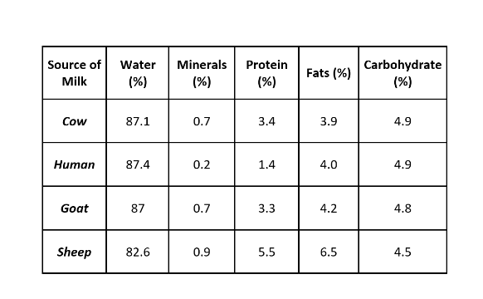

Casein (from Latin caseus"cheese") is a family of related phosphor proteins (αS1, αS2, β, κ). These proteins are commonly found in mammalian milk, comprising c. 80% of the proteins in cow's milk and between 20% and 45% of the proteins in human milk. The j Casein has a wide variety of uses, from being a major component of chees, to use as a food additive. The most common form of casein is

Sodium caseinate. As a food source, casein supplies amino acids, carbohydrates, and two essential elements, calcium and phosphorus. Casein contains a high number of proline residues, which do not interact. There are also no disulphide bridges. As a result, it has relatively little tertiary structure.

Casein in the most predominant protein in milk and is a mixed phosphor protein. Casein has an isoelectric pH of about 4.7 can be easily separated around this isoelectric pH. It readily dissolves in dilute acids and alkalis.

Casein is present in milk as calcium caseinate in the form of micelles. These micelles have negative charge and on adding acid to milk the negative charges are neutralized.

One of them proposes the micelle nucleus is formed by several sub micelles, the periphery consisting of micro velocities of κ-casein. Another model suggests the nucleus is formed by casein-interlinked fibrils. Finally, the most recent model proposes a double link among the caseins for gelling to take place. All three models consider micelles as colloidal particles formed by casein aggregates wrapped up in soluble κ-casein molecules. The iso electric point of casein is 4.6. Since milk's pH is6.6, casein has a negative charge in milk. The purified protein is water-insoluble.

While it is also insoluble in neutral salt solutions, it is readily dispersible in dilute alkalis and in salt solutions such as aqueous sodium oxalate and sodium acetate. The enzyme trypsin can hydrolyse a phosphate-containing peptone. It is used to form a type of organic adhesive

*Ca2+-Caseinate + 2CH3COOH (aq.) →Casein(s) + (CH3COOH) 2Ca*

Natural milk is an opaque white fluid Secreted by the mammary glands of Female mammal the main constituents of natural milk are Protein, Carbohydrate, Mineral Vitamins, Fats and Water and is a complete balanced diet Fresh milk is sweetish in taste However, when it is kept for long time at a temperature of 5 degree it become sour because of bacteria present in air. These bacteria convert lactose of milk into lactic acid which is sour in taste. In acidic conditions casein of milk separate out as precipitate. When the acidity in milk is sufficient and temperature is around 36 degree, it forms curd.

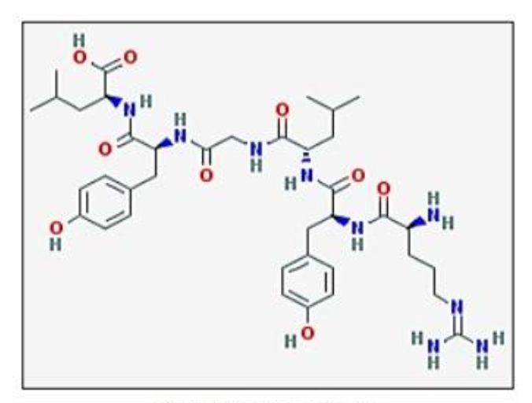

*Structure of Casein*

Natural milk is an opaque white fluid Secreted by the mammary glands of Female mammal. The main constituents of natural milk are Protein, Carbohydrate, Mineral Vitamins, Fats and Water and is a complete balanced diet. Fresh milk is sweetish in taste.

However, when it is kept for long time at a temperature of 5 degree it become sour because of bacteria present in air. These bacteria convert lactose of milk into lactic acid which is sour in taste. In acidic condition casein of milk starts separating out as a precipitate. When the acidity in milk is sufficient and temperature is around 36 degree, it forms semi-solid mass, called curd.

*PROCEDURE*

1. Wash the beaker (250 ml) with the distilled water and dry it.
2. Take 20 ml of buffalo’s milk in 250 ml beaker and find its weight.
3. Add 20 ml saturated solution of ammonium sulphate slowly with stirring. Fat and casein will separate out as precipitate.
4. Filter the above solution and transfer the precipitate in another beaker.
5. Treat the above precipitate with 30 ml distilled water. Casein dissolves forming milky solution whereas fat remains as such.
6. Warm the above contents of the beaker to 40 – 45°C on a low flame. Now, add 1% acetic acid solution drop wise with stirring when casein gets precipitated.
7. Filter the precipitated casein and wash with distilled water and dry it.
8. Find the weight of dry precipitate.
9. Repeat the whole experiment with cow’s milk, goat’s milk and sheep’s milk.

*OBSERVATION*

* Volume of milk taken in each case = **20ml**
* Weight of milk taken = W1**g**
* Weight of Casein isolate = W2**g**
* Percentage of casein = {Weight of casein (W2)/Weight of casein (W1) } * 100

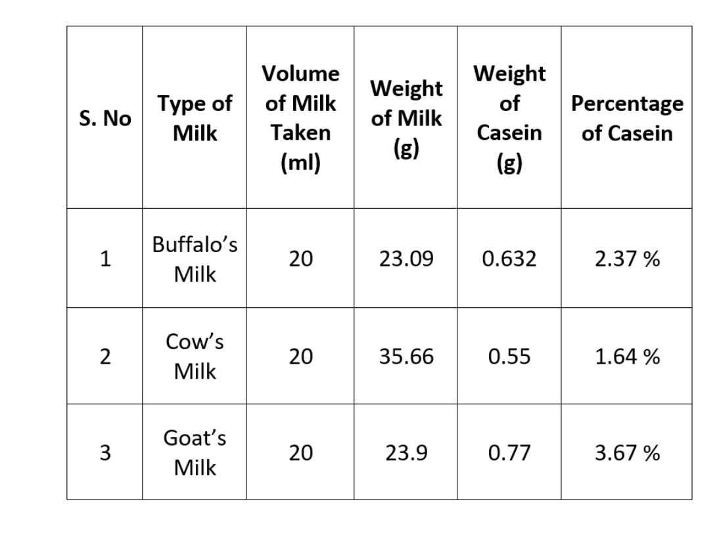

*CONCLUSION*

Different sample of milk contain different amount of casein

Highest percentage of casein is present in Go

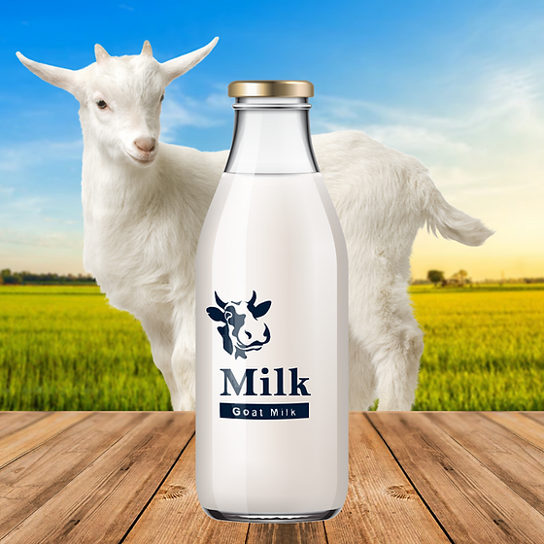

***I*APPLICATION**

* In addition to being consumed in milk casein is used in the manufacture of:  
  **Adhesives, binders, protective coatings, plastics (such as knife handles and knitting needles), fabrics, food additives, and many other products.**
* It is commonly used by body builders as slow digesting whey proteins and also as an extremely high source of glutamine (post workout).

* Another reason, it is used in bodybuilding is because of its anti-catabolic effect, meaning that casein consumption inhibits protein breakdown in the body. Casein is frequently found in non-dairy substitutes to improve consistency especially when melted.

**PRECAUTION**

* Handle apparatus and chemicals carefully.
* Add ammonium sulphate solution very slowly.
* Stir milk while adding chemicals.
* Do not disturb milk after adding ammonium sulphate solution and wait some time for fat and casein to precipitate out.
* Take the amount readings carefully with digital weighing machine only.

***BIBLIOGRAPHY***

* http://www.indiainfo.org
* www.encyclopedia.com
* www.caesine-pro.com
* www.sciencejournals.com
* www.icar.nic.in
* www.zetascience.com