

GOVT. POLYTECHNIC MOSALEHOSAHALLI INDUSTRIAL VISIT REPORT

Karnataka Milk Federation (KMF) , Hassan

(HAMUL)
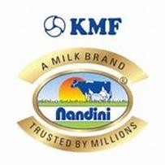

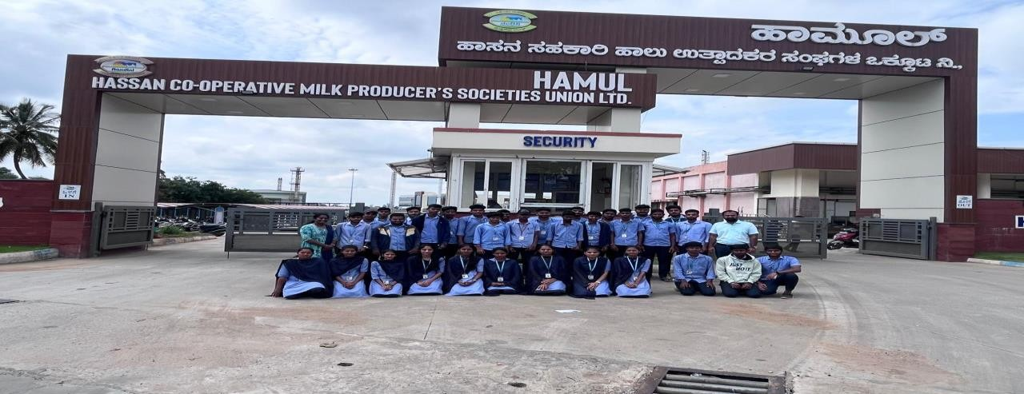

WELCOME TO KMF

Karnataka Co-Operative Milk Federation a harbinger of rural prosperity Karnataka Milk Federation (KMF) is the largest Cooperative Dairy Federation in South India, owned and managed by milk producers of Karnataka State. KMF has over 2.23 million milk producers in over 12066 Dairy Cooperative Societies at village level, functioning under 13 District Cooperative Milk Unions in Karnataka State. The mission of the Federation is to usher rural prosperity through dairy development. During the last four decades of Cooperative Dairy Development by KMF, the dairy industry in Karnataka has progressed from a situation of milk - scarcity to that of milk-surplus.

KMF MILK PRODUCTS

"Quality Excellence from Cow to Consumer" is the motto of the Federation to obtain better- quality Milk and milk products from our value chain (Procurement to Processing to Marketing). Thus milk and milk products, under nandini brand name, are unmatched in quality made available to consumers at most competitive prices. In a way Nandini Milk and Milk Products are "Spreading wealth of health".

Hassan Co-operative Milk Producers Societies Union Ltd

Coffee, Potatoes, Oranges, Honey, Cardamom, Butter & Pepper used to be the talk of the districts covered by the union in this historical fame of Shravanabelagola, Belur, Halebid along with iron ore in Kudremukh.

Today 78% of the 17 taluks are covered under more than 1300 fiunctioning DCSs. It has chilling centers at H.N. Pure-100 TLPD, Birur-20 TLPD and C.R.Patna-100 TLPD. Total chilling capacity 220 TLPD. There is Bulk Milk Coolers-19 and Automatic Milk Collection- 108 units in the union

The union procures on an AVG 5.54 lac kg/day of milk and sales 1.23 lac litres/per Speciality of the Union: First union to record the growth of 100% increase in milk procurement. The Union has been awarded by GOI with "National energy conservation award" 4 times for implementation of energy conservation programs.

Introduction

Nandini milk union is situated in Dairy circle, Hassan. The company manufactures Ghee, Peda, Curd, and milk powder as part of its production. HAMUL who work in two regular shifts.
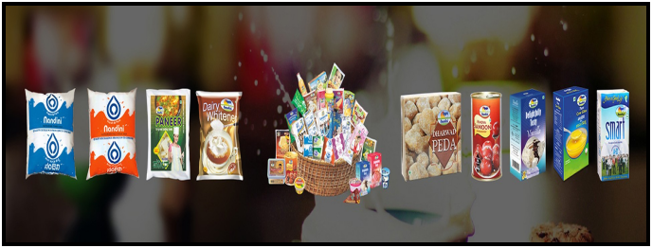

Quality assurance, or QA for short, is the systematic monitoring and evaluation of the various aspects of a project, service or facility to maximize the probability that minimum standards of quality are being attained by the production process. QA cannot absolutely guarantee the production of quality products.

Quality is determined by the product users, clients or customers, not by society in general. It is not the same as 'expensive' or 'high quality. Low priced products can be considered as having high quality if the product users determine them as such.

Karnataka Co-Operative Milk Federation a harbinger of rural prosperity Karnataka Milk Federation (KMF) is the largest Cooperative Dairy Federation in South India, owned and managed by milk producers of Karnataka State. KMF has over 2.23 million milk producers in over 12066 Dairy Cooperative Societies at village level, functioning under 13 District Cooperative Milk Unions in Karnataka State. The mission of the Federation is to usher rural prosperity through dairy development. During the last four decades of Cooperative Dairy Development by KMF, the dairy industry in Karnataka has progressed from a situation of milk - scarcity to that of milk-surplus.

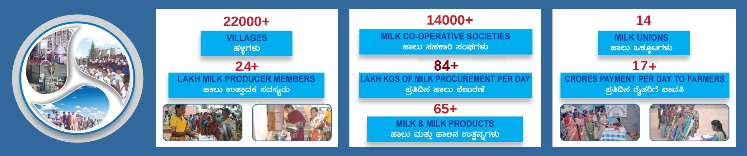

Objective of the Visit

  - To understand the milk collection, processing, and packaging processes.
  - To gain insights into quality control measures in the dairy industry.
  - To learn about the technologies used in dairy processing.
  - To observe the supply chain and distribution network of dairy products.

Overview of Hassan Dairy Industry

Hassan Dairy is a key player in the Karnataka Cooperative Milk Producers’ Federation

(KMF), which operates under the brand name “Nandini.” The dairy processes milk collected from local farmers and produces a range of dairy products, including milk, butter, curd, cheese, and ghee.

3 Process Flow at Hassan Dairy

1.1Milk Collection
- The milk is collected from various rural cooperative societies and farmer

The collection process ensures that milk is obtained twice a day to maintain freshness.

- Strict quality control measures, including fat and SNF(Solid-Not-Fat) tests, are performed at the collection centers.

Milk Reception and Storage
- Upon arrival at the plant, the milk under goes a series of tests to check for quality, including checks for adulteration.
- Accepted milk is then chilled and stored in large stainless-steel tanks.

Processing

- Pasteurization:The milk is heated to a specific temperature to kill harmful bacteria without affecting the nutritional value.
- Homogenization:This process breaks down fat molecules in the milk to ensure a uniform mixture.
- Separation:The milk is separated into cream and skin milk using centrifugal forces.

Production
- Milk Packing: The processed milk is packed in sterilized pouches of varying capacities.
- Butter and Ghee:Cream extracted from the milk is further processed to produce butter and ghee.
- Curd and Yogurt:Some milk is cultured with bacterial cultures to produce curd and yogurt.

Quality Control
Samples from each batch undergo rigorous testing in the in-house laboratory to ensure they meet the quality standards.Hygiene and cleanliness are strictly maintained throughout the plant.

Distribution
The final products are packed and distributed through a well-established supply chain, ensuring the products reach consumers in a fresh state.

2 Observations and Learning Outcomes

- Understanding the Dairy Industry:The visit provided an in-depth understanding of the entire milk processing chain, from collection to packing and distribution.
- Quality Control Practices:We observed the importance of quality control in ensuring that dairy products are safe for consumption.
- Technological Exposure:The advanced machinery and automation used in the dairy industry were impressive, highlighting the role of technology in modern food processing industries.
- Sustainability:The industry’s efforts to maintain sustainability through waste management and energy efficiency were commendable.

Conclusion
The visit to Hassan Dairy Industry was an enriching experience, providing valuable insights into the workings of a large-scale dairy processing facility. It enhanced our understanding of the practical aspects of dairy processing, quality control, and the
importance of hygiene in the food industry. This experience will undoubtedly benefit us in our future careers in the food processing sector.

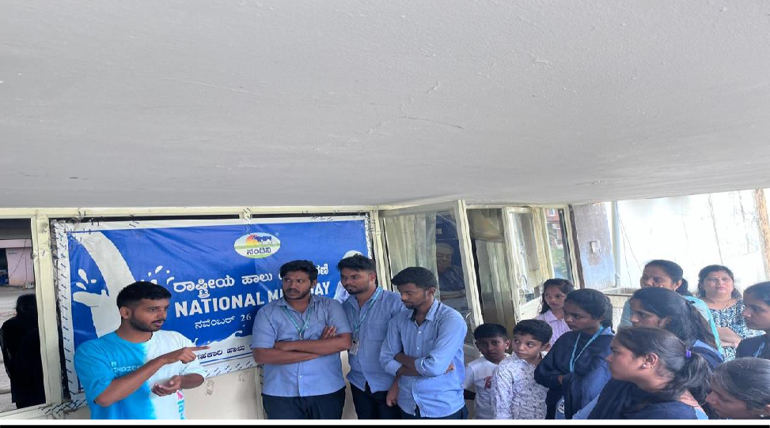
Dairy information:

