VISVESVARAYA TECHNOLOGICAL UNIVERSITY
“JnanaSangama”, Belgaum -590014, Karnataka.


LAB REPORT

On

ANALYSIS AND DESIGN OF ALGORITHMS (23CS4PCADA)

Submitted by

MANYA KULSHRESHTHA (1BF24CS169)

in partial fulfillment for the award of the degree of
BACHELOR OF ENGINEERING
in
COMPUTER SCIENCE AND ENGINEERING



B.M.S. COLLEGE OF ENGINEERING
(Autonomous Institution under VTU)
BENGALURU-560019
February to June 2026
CERTIFICATE

B. M. S. College of Engineering,
Bull Temple Road, Bangalore 560019
(Affiliated To Visvesvaraya Technological University, Belgaum)
Department of Computer Science and Engineering



This is to certify that the Lab work entitled “ANALYSIS AND DESIGN OF ALGORITHMS” carried out by MANYA KULSHRESHTHA(1BF24CS169), who is bonafide student of B. M. S. College of Engineering. It is in partial fulfillment for the award of Bachelor of Engineering in Computer Science and Engineering of the Visvesvaraya Technological University, Belgaum during the year 2025-26. The Lab report has been approved as it satisfies the academic requirements in respect of Analysis and Design of Algorithms Lab - (23CS4PCADA) work prescribed for the said degree.

Dr. Namratha M Dr. Kavitha Sooda
Assistant Professor Professor and Head
Department of CSE Department of CSE
BMSCE, Bengaluru BMSCE, Bengaluru

Index Sheet
Sl.  No. | Experiment Title | Page No.
1 | Write program to obtain the Topological ordering of vertices in a given digraph. | 4-6
2 | Implement Johnson Trotter algorithm to generate permutations. | 8-10
3 | Sort a given set of N integer elements using Merge Sort technique and compute its time taken. Run the program for different values of N and record the time taken to sort. | 11-14
4 | Sort a given set of N integer elements using Quick Sort technique and compute its time taken. | 15-18
5 | Sort a given set of N integer elements using Heap Sort technique and compute its time taken. | 19-20
6 | Implement 0/1 Knapsack problem using dynamic programming. (5 Marks) | 21-23
7 | Implement All Pair Shortest paths problem using Floyd’s algorithm. | 24-27
8 | - Find Minimum Cost Spanning Tree of a given undirected graph using Prim’s algorithm.  - Find Minimum Cost Spanning Tree of a given undirected graph using Kruskal’s algorithm. | 28-32
9 | Implement Fractional Knapsack using Greedy technique. | 33-36
10 | From a given vertex in a weighted connected graph, find shortest paths to other vertices using Dijkstra’s algorithm. | 37-38
11 | Implement “N-Queens Problem” using Backtracking. | 39-40

Course outcomes:
CO1 | Analyze time complexity of algorithms using asymptotic notations.
CO2 | Apply various algorithm design techniques for the given problem.
CO3 | Evaluate the appropriate algorithm/design technique for solving a given problem.
CO4 | Conduct practical experiments by applying appropriate algorithm design technique to solve problems.

Lab program 1:
CODE:

#include <stdio.h>
#define MAX 100
int graph[MAX][MAX];
int visited[MAX];
int stack[MAX];
int top = -1;
int n;
void dfs(int v){
visited[v] = 1;
for (int i = 0; i < n; i++){
if (graph[v][i] == 1 && !visited[i]) {
dfs(i);
}
}
stack[++top] = v;
}
void topologicalSort(){
for (int i = 0; i < n; i++) {
if (!visited[i]){
dfs(i);
}
}

printf("\nTopological Ordering:\n");
while (top != -1) {
printf("%d ", stack[top--]);
}
}
int main()
{
printf("Enter number of vertices: ");
scanf("%d", &n);
printf("Enter adjacency matrix:\n");
for (int i = 0; i < n; i++) {
for (int j = 0; j < n; j++){
scanf("%d", &graph[i][j]);
}
}
topologicalSort();
return 0;
}

OUTPUT:
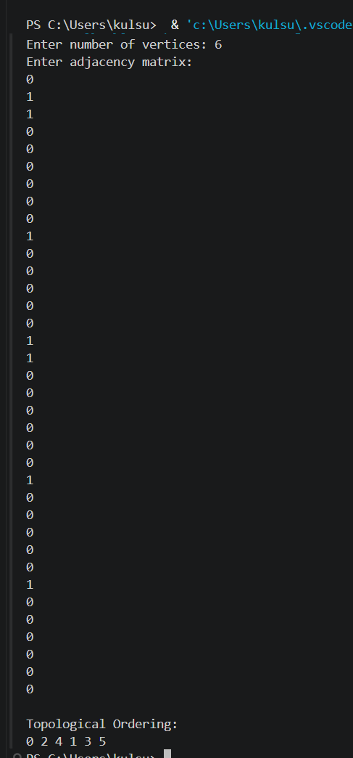

GRAPH:

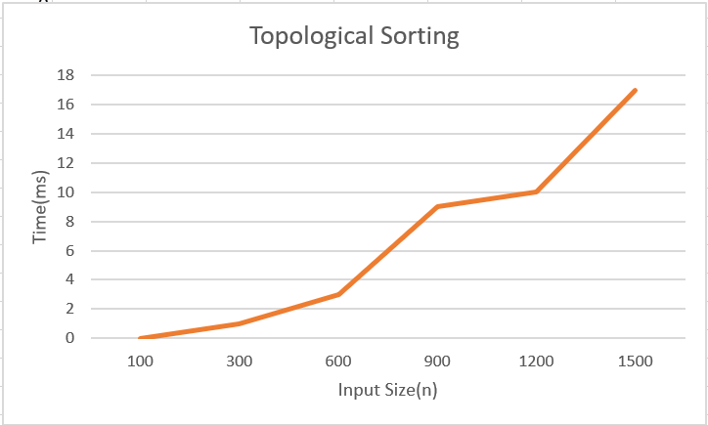

LEETCODE 802. Find Eventual Safe States

CODE:
bool dfs(int node, int** graph, int* graphColSize, int* state)
{
if (state[node] == 1)
return false;
if (state[node] == 2)
return true;
state[node] = 1;
for (int i = 0; i < graphColSize[node]; i++)
{
int neighbor = graph[node][i];
if (!dfs(neighbor, graph, graphColSize, state))
return false;
}
state[node] = 2;
return true;
}

int* eventualSafeNodes(int** graph, int graphSize,
int* graphColSize, int* returnSize)
{
int* state = (int*)calloc(graphSize, sizeof(int));
int* result = (int*)malloc(graphSize * sizeof(int));
int count = 0;
for (int i = 0; i < graphSize; i++)
{
if (dfs(i, graph, graphColSize, state))
{
result[count++] = i;
}
}
*returnSize = count;
return result;
}

OUTPUT:
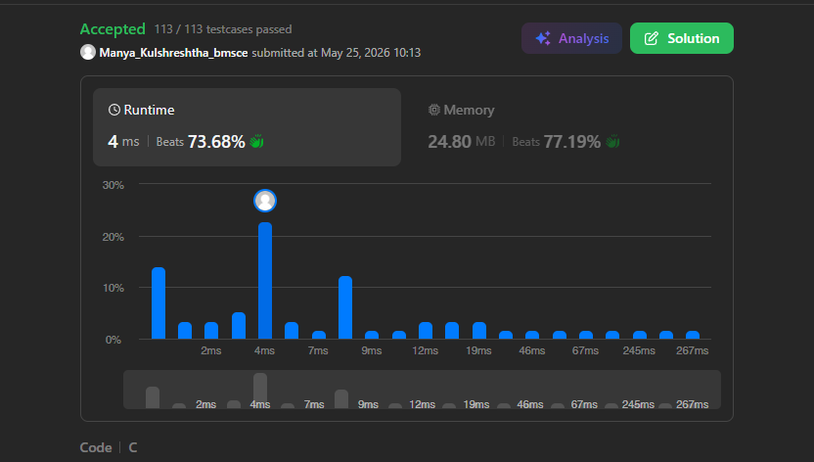
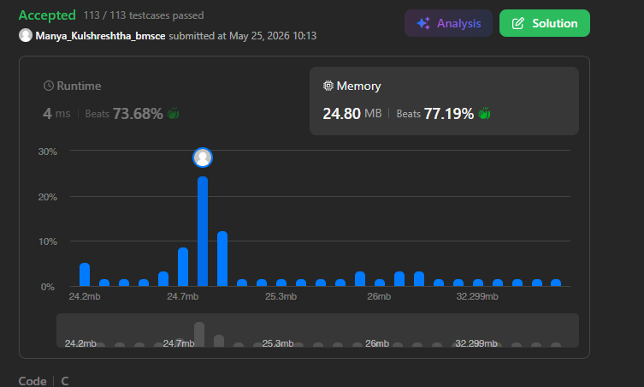

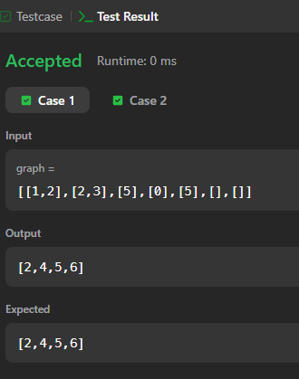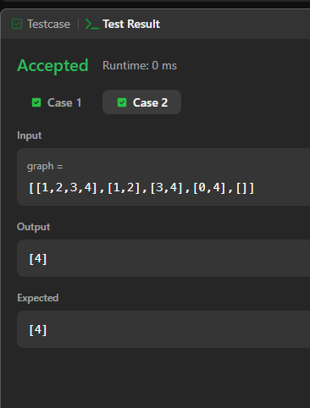

Lab program 2:
CODE:

#include <stdio.h>
#define LEFT -1
#define RIGHT 1
void printPermutation(int a[], int n){
for(int i = 0; i < n; i++)
printf("%d ", a[i]);
printf("\n");
}

int getMobile(int a[], int dir[], int n)
{
int mobile = 0, mobile_pos = -1;
for(int i = 0; i < n; i++){
if(dir[a[i]-1] == LEFT && i != 0) {
if(a[i] > a[i-1] && a[i] > mobile)
{
mobile = a[i];
mobile_pos = i;
}
}

if(dir[a[i]-1] == RIGHT && i != n-1)
{
if(a[i] > a[i+1] && a[i] > mobile)
{
mobile = a[i];
mobile_pos = i;
}
}
}
return mobile;
}

void generatePermutations(int n)
{
int a[n], dir[n];
for(int i = 0; i < n; i++)
{
a[i] = i + 1;
dir[i] = LEFT;
}
printPermutation(a, n);
while(1)
{
int mobile = getMobile(a, dir, n);
if(mobile == 0)
break;

int pos;
for(pos = 0; pos < n; pos++)
if(a[pos] == mobile)
break;

if(dir[mobile-1] == LEFT)
{
int temp = a[pos];
a[pos] = a[pos-1];
a[pos-1] = temp;
pos--;
}
else
{
int temp = a[pos];
a[pos] = a[pos+1];
a[pos+1] = temp;
pos++;
}

for(int i = 0; i < n; i++)
{
if(a[i] > mobile)
dir[a[i]-1] *= -1;
}

printPermutation(a, n);
}
}

int main()
{
int n;
printf("Enter n: ");
scanf("%d", &n);

generatePermutations(n);

return 0;
}

OUTPUT:

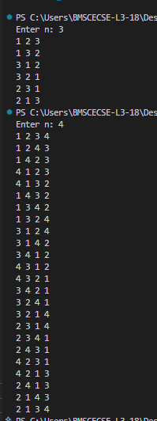


Lab program 3:
CODE:

#include<stdio.h>
#include<stdlib.h>
#include<time.h>
int c[100000];
void merge(int a[],int l,int m, int h){
int i=l,j=m+1,k=l;
while(i<=m && j<=h){
if(a[i]<a[j]){
c[k++]=a[i++];
}
else{
c[k++]=a[j++];
}
}
while(i<=m){
c[k++]=a[i++];
}
while(j<=h){
c[k++]=a[j++];
}
for(i=0;i<=h;i++){
a[i]=c[i];
}
}
void mergeSort(int a[],int l, int h){
int m;
if(l<h){
m=(l+h)/2;
mergeSort(a,l,m);
mergeSort(a,m+1,h);
merge(a,l,m,h);
}
}
int main(){
int n;
clock_t start, end;
printf("enter no. of elements\n");
scanf("%d",&n);
int *a = (int *)malloc(n * sizeof(int));
srand(time(NULL));
for(int i=0;i<n;i++){
a[i] = rand() % 100000;
}
start=clock();
mergeSort(a,0,n-1);
end=clock();
double time=(double)(end-start)/CLOCKS_PER_SEC;
printf("time taken %f",time);
free(a);
return 0;
}

OUTPUT:

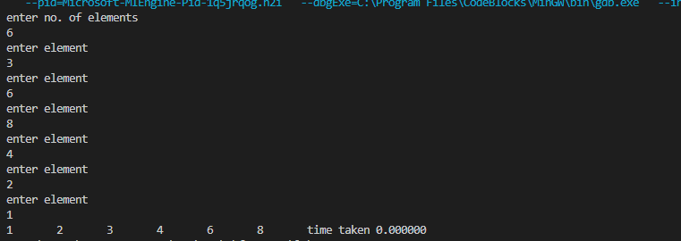

GRAPH:

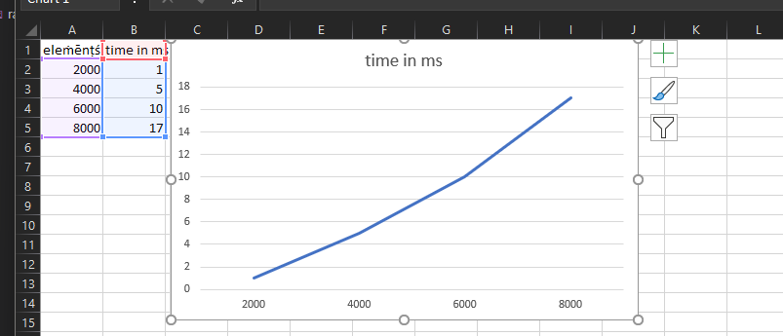

LEETCODE 912.Sort an Array

CODE:

void merge(int* a, int l, int m, int r, int* t) {
int i=l, j=m+1, k=l;
while(i<=m && j<=r)
t[k++] = a[i] < a[j] ? a[i++] : a[j++];
while(i<=m) t[k++] = a[i++];
while(j<=r) t[k++] = a[j++];
for(i=l; i<=r; i++) a[i] = t[i];
}

void sort(int* a, int l, int r, int* t) {
if(l >= r) return;
int m = (l + r) / 2;
sort(a, l, m, t);
sort(a, m + 1, r, t);
merge(a, l, m, r, t);
}

int* sortArray(int* nums, int numsSize, int* returnSize) {
*returnSize = numsSize;
int* temp = malloc(numsSize * sizeof(int));
sort(nums, 0, numsSize - 1, temp);
free(temp);
return nums;
}

OUTPUT:

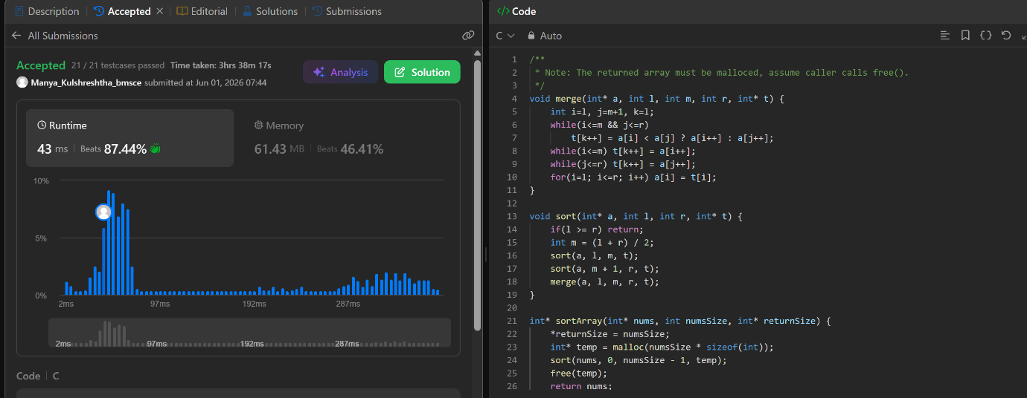
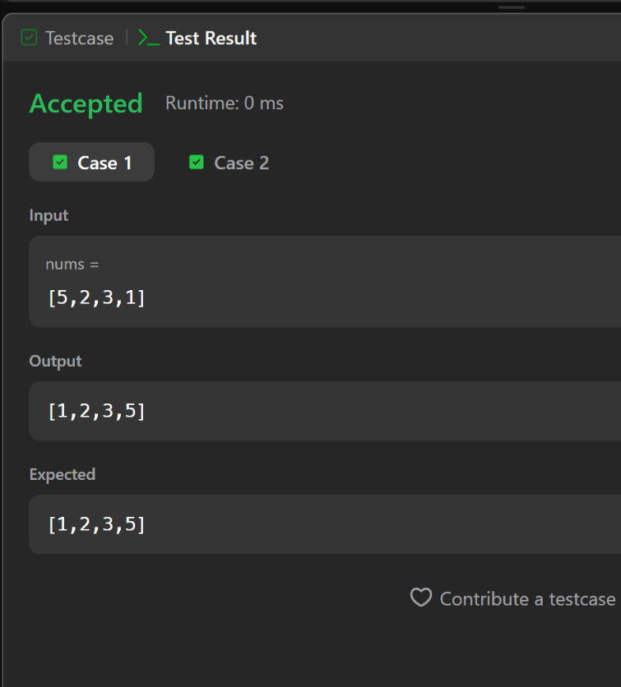

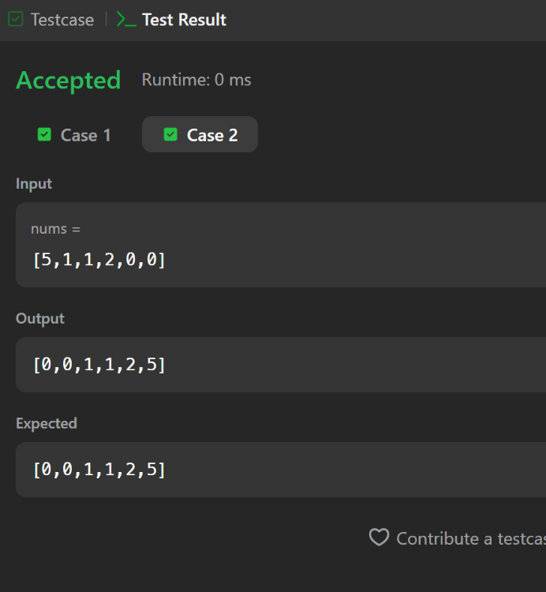

Lab program 4:
CODE:
#include<stdio.h>
#include<stdlib.h>
#include<time.h>
void swap(int *a, int *b){
int temp=*a;
*a=*b;
*b=temp;
}
int partition(int arr[],int low,int high){
int pivot=arr[low];
int i=low;
int j=high+1;

while(1){
do{
i++;
}while(i<=high && arr[i]<pivot);
do{
j--;
}while(arr[j]>pivot);
if(i>j){
break;
}
swap(&arr[i],&arr[j]);
}
swap(&arr[low],&arr[j]);
return j;
}
void quickSort(int arr[],int low, int high){
if(low<high){
int j=partition(arr,low,high);
quickSort(arr,low,j-1);
quickSort(arr,j+1,high);
}
}
int main(){
int n;
printf("enter no. of elements\n");
scanf("%d",&n);
int *arr = (int *)malloc(n * sizeof(int));
srand(time(NULL));
for(int i=0;i<n;i++){
arr[i] = rand() % 100000;
}
clock_t start=clock();
quickSort(arr,0,n-1);
clock_t end =clock();
double time=(double)(end-start)/CLOCKS_PER_SEC;
//for(int i=0;i<n;i++){
// printf("%d\t",arr[i]);
//}
printf("time taken %f",time);
free(arr);
return 0;
}

OUTPUT:

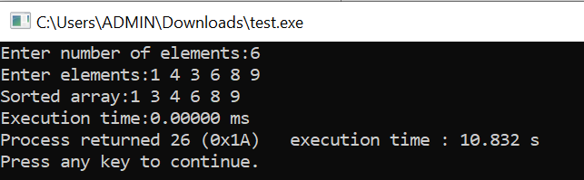

GRAPH:

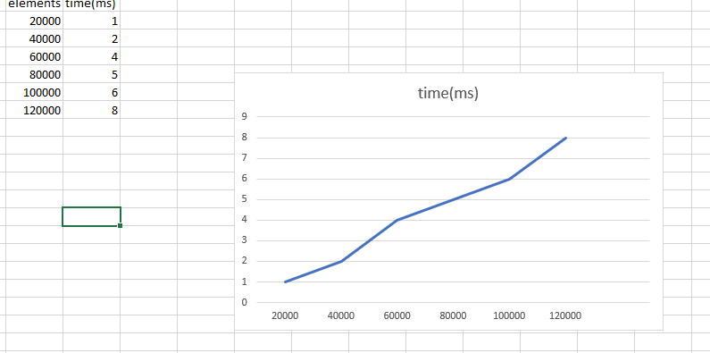

LEETCODE 75. Sort Colors

CODE:

void sortColors(int* nums, int numsSize) {
int l = 0, m = 0, r = numsSize - 1, t;

while (m <= r) {
if (nums[m] == 0) {
t = nums[l];
nums[l++] = nums[m];
nums[m++] = t;
}
else if (nums[m] == 2) {
t = nums[r];
nums[r--] = nums[m];
nums[m] = t;
}
else {
m++;
}
}
}

OUTPUT:

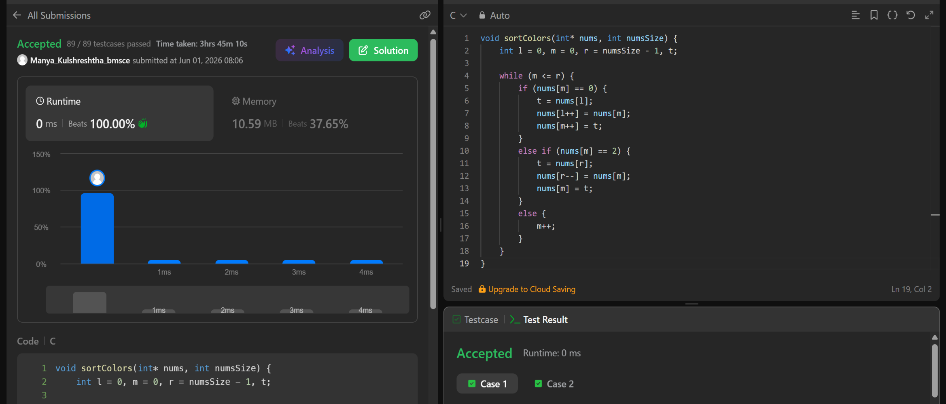
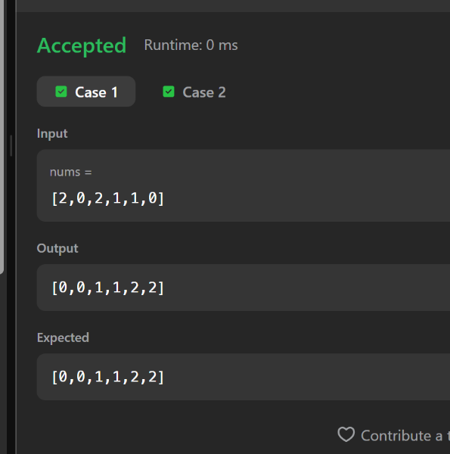

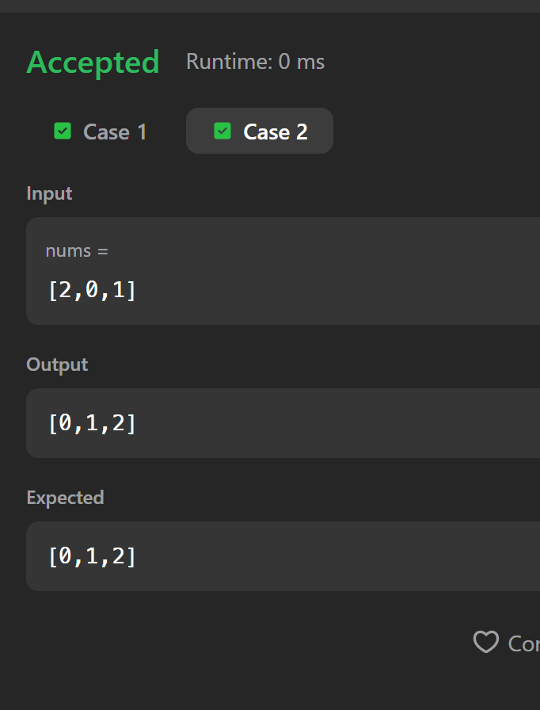

Lab program 5:
CODE:

#include <stdio.h>
#include <stdlib.h>
#include <time.h>

void swap(int *a, int *b)
{
int temp = *a;
*a = *b;
*b = temp;
}

void heapify(int arr[], int n, int i)
{
int largest = i;
int left = 2 * i + 1;
int right = 2 * i + 2;
if (left < n && arr[left] > arr[largest])
largest = left;
if (right < n && arr[right] > arr[largest])
largest = right;
if (largest != i)
{
swap(&arr[i], &arr[largest]);
heapify(arr, n, largest);
}
}

void heapSort(int arr[], int n)
{
for (int i = n / 2 - 1; i >= 0; i--)
heapify(arr, n, i);
for (int i = n - 1; i > 0; i--)
{
swap(&arr[0], &arr[i]);
heapify(arr, i, 0);
}
}

void printArray(int arr[], int n)
{
for (int i = 0; i < n; i++)
printf("%d ", arr[i]);
}

int main()
{
int n;
printf("Enter number of elements: ");
if (scanf("%d", &n) != 1){
printf("Invalid input.\n");
return 1;
}
if (n <= 0){
printf("No elements to sort.\n");
return 0;
}
int *arr = (int *)malloc((size_t)n * sizeof(int));
if (arr == NULL){
printf("Memory allocation failed.\n");
return 1;
}
srand(time(0));
for (int i = 0; i < n; i++){
arr[i] = rand() % 100000;
}
clock_t start, end;
start = clock();
heapSort(arr, n);
end = clock();
double time_taken = ((double)(end - start)) / CLOCKS_PER_SEC;
printf("\nSorted array:\n");
printArray(arr, n);
printf("\n\nTime taken = %f seconds\n", time_taken);
free(arr);
return 0;
}

OUTPUT:

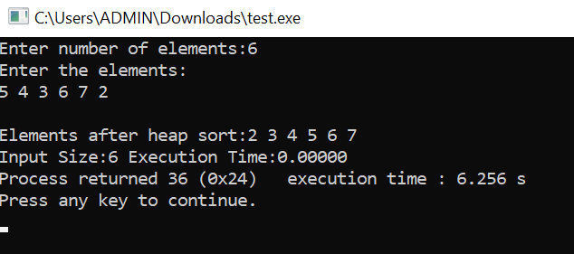

GRAPH:

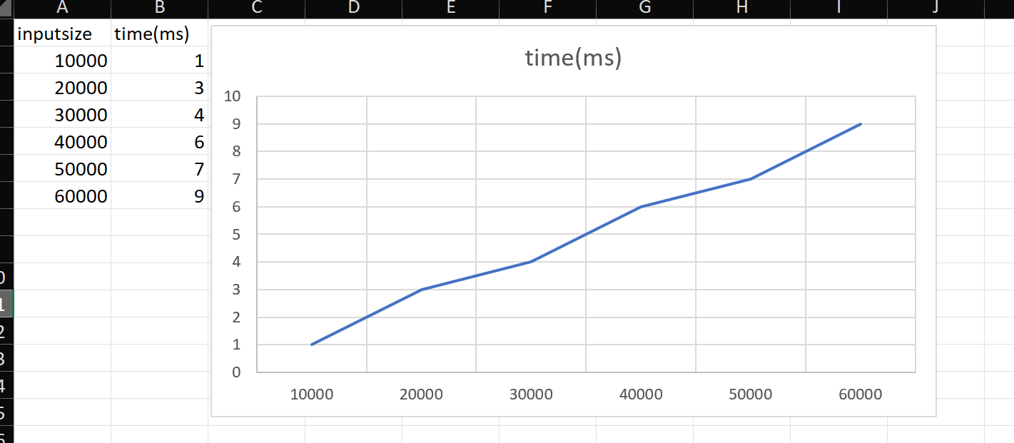

Lab program 6:
CODE:

#include <stdio.h>
#define MAX 100
int max(int a, int b) {
return (a > b) ? a : b;
}

int knapsack(int W, int wt[], int val[], int n) {
int dp[MAX][MAX];
for (int i = 0; i <= n; i++) {
for (int w = 0; w <= W; w++) {
if (i == 0 || w == 0) {
dp[i][w] = 0;
}
else if (wt[i-1] <= w) {
dp[i][w] = max(
val[i-1] + dp[i-1][w - wt[i-1]],
dp[i-1][w]
);
}
else {
dp[i][w] = dp[i-1][w];
}
}
}
return dp[n][W];
}

int main() {
int n, W;
int wt[MAX], val[MAX];
printf("Enter number of items: ");
scanf("%d", &n);
printf("Enter weights:\n");
for (int i = 0; i < n; i++){
scanf("%d", &wt[i]);}
printf("Enter values:\n");
for (int i = 0; i < n; i++){
scanf("%d", &val[i]);}
printf("Enter capacity of knapsack: ");
scanf("%d", &W);
int result = knapsack(W, wt, val, n);
printf("Maximum profit = %d\n", result);
return 0;
}

OUTPUT:

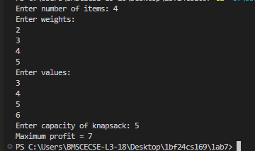\

LEETCODE 70. Climbing Stairs

CODE:

int climbStairs(int n) {
if (n <= 2) return n;

int dp[n + 1];
dp[1] = 1;
dp[2] = 2;

for (int i = 3; i <= n; i++) {
dp[i] = dp[i - 1] + dp[i - 2];
}

return dp[n];
}

OUTPUT:

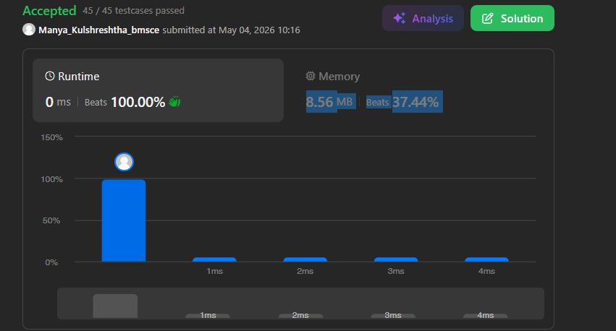

Lab program 7:
CODE:

#include<stdio.h>
#define MAX 100
#define INF 99999
void floydWarshall(int graph[MAX][MAX],int n){
int dist[MAX][MAX];
for(int i=0;i<n;i++){
for(int j=0;j<n;j++){
dist[i][j]=graph[i][j];
}
}
for(int k=0;k<n;k++){
for(int i=0;i<n;i++){
for(int j=0;j<n;j++){
if(dist[i][k]+dist[k][j]<dist[i][j]){
dist[i][j]=dist[i][k]+dist[k][j];
}
}
}
}
printf("All Pairs shortest Path Matrix \n");
for(int i=0;i<n;i++){
for(int j=0;j<n;j++){
if(dist[i][j]==INF){
printf("INF ");
}else{
printf("%d ",dist[i][j]);
}
}
printf("\n");
}
}
int main(){
int n,graph[MAX][MAX];
printf("Enter no. of Vertices\n");
scanf("%d",&n);
printf("Enter adjacency matrix (use %d for INF):\n", INF);
for (int i = 0; i < n; i++){
for (int j = 0; j < n; j++){
scanf("%d", &graph[i][j]);}}
floydWarshall(graph, n);
return 0;
}

OUTPUT:

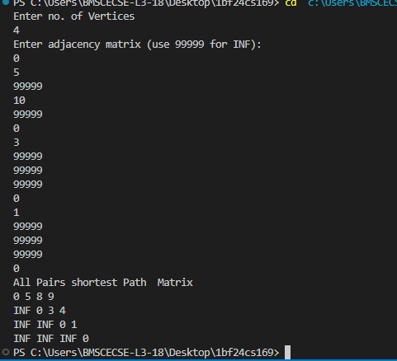

\

LEETCODE 743. Network Delay Time

CODE:

#define INF 1000000000

int networkDelayTime(int** times, int timesSize, int* timesColSize,
int n, int k) {

int graph[101][101];
int dist[101];
int visited[101] = {0};

for (int i = 1; i <= n; i++) {
for (int j = 1; j <= n; j++) {
graph[i][j] = INF;
}
}

for (int i = 0; i < timesSize; i++) {
int u = times[i][0];
int v = times[i][1];
int w = times[i][2];
graph[u][v] = w;
}

for (int i = 1; i <= n; i++)
dist[i] = INF;

dist[k] = 0;

for (int i = 1; i <= n; i++) {

int u = -1;

for (int j = 1; j <= n; j++) {
if (!visited[j] &&
(u == -1 || dist[j] < dist[u])) {
u = j;
}
}

visited[u] = 1;

for (int v = 1; v <= n; v++) {
if (graph[u][v] != INF &&
dist[u] + graph[u][v] < dist[v]) {

dist[v] = dist[u] + graph[u][v];
}
}
}

int ans = 0;

for (int i = 1; i <= n; i++) {
if (dist[i] == INF)
return -1;

if (dist[i] > ans)
ans = dist[i];
}

return ans;
}
OUTPUT:

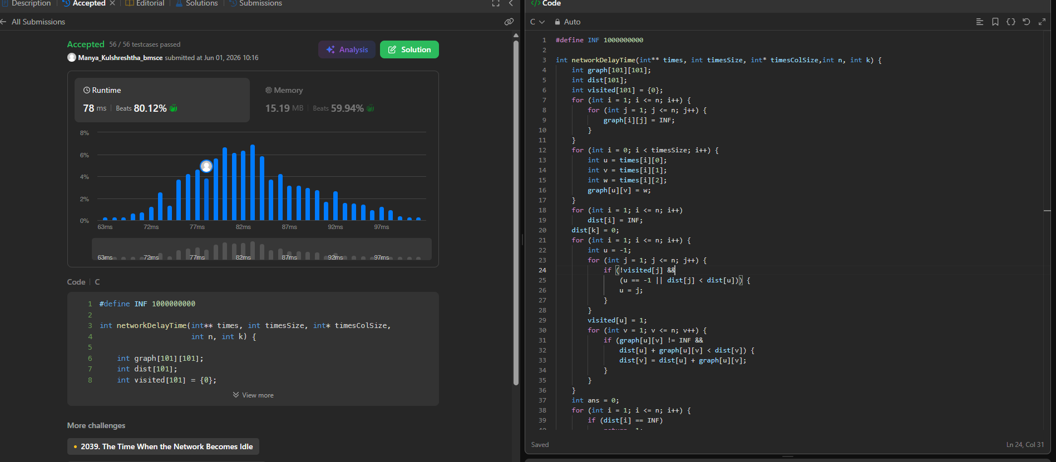

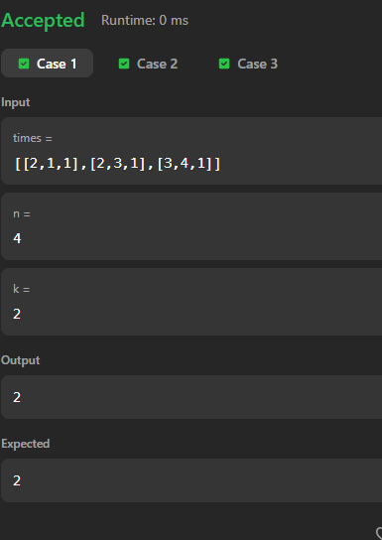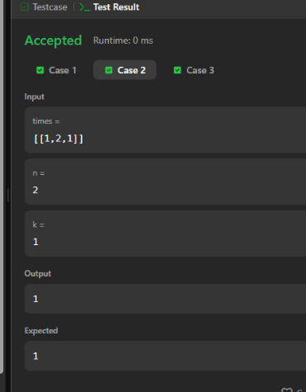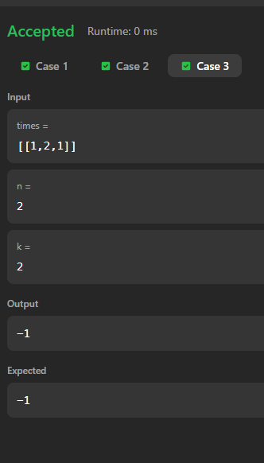

Lab program 8:
8(a)
CODE:

#include <stdio.h>
#define V 5
#define INF 99999

int minKey(int key[], int mstSet[])
{
int min = INF, min_index;
for (int v = 0; v < V; v++)
{
if (mstSet[v] == 0 && key[v] < min)
{
min = key[v];
min_index = v;
}
}
return min_index;
}

void printMST(int parent[], int graph[V][V])
{
int cost = 0;

printf("Edge \tWeight\n");
for (int i = 1; i < V; i++)
{
printf("%d - %d \t%d\n", parent[i], i,
graph[i][parent[i]]);
cost += graph[i][parent[i]];
}

printf("Total Cost = %d\n", cost);
}

void primMST(int graph[V][V])
{
int parent[V];
int key[V];
int mstSet[V];

for (int i = 0; i < V; i++)
{
key[i] = INF;
mstSet[i] = 0;
}

key[0] = 0;
parent[0] = -1;

for (int count = 0; count < V - 1; count++)
{
int u = minKey(key, mstSet);
mstSet[u] = 1;

for (int v = 0; v < V; v++)
{
if (graph[u][v] &&
mstSet[v] == 0 &&
graph[u][v] < key[v])
{
parent[v] = u;
key[v] = graph[u][v];
}
}
}

printMST(parent, graph);
}

int main()
{
int graph[V][V] = {
{0, 2, 0, 6, 0},
{2, 0, 3, 8, 5},
{0, 3, 0, 0, 7},
{6, 8, 0, 0, 9},
{0, 5, 7, 9, 0}
};

primMST(graph);

return 0;
}

OUTPUT:

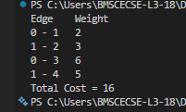

8(b)
CODE:

##include <stdio.h>
#include <stdlib.h>

struct Edge
{
int src, dest, weight;
};

struct Subset
{
int parent, rank;
};

int find(struct Subset subsets[], int i)
{
if (subsets[i].parent != i)
subsets[i].parent = find(subsets, subsets[i].parent);

return subsets[i].parent;
}

void Union(struct Subset subsets[], int x, int y)
{
int xroot = find(subsets, x);
int yroot = find(subsets, y);

if (subsets[xroot].rank < subsets[yroot].rank)
subsets[xroot].parent = yroot;
else if (subsets[xroot].rank > subsets[yroot].rank)
subsets[yroot].parent = xroot;
else
{
subsets[yroot].parent = xroot;
subsets[xroot].rank++;
}
}

int compare(const void *a, const void *b)
{
return ((struct Edge *)a)->weight -
((struct Edge *)b)->weight;
}

int main()
{
int V = 4;
int E = 5;

struct Edge edges[] = {
{0, 1, 10},
{0, 2, 6},
{0, 3, 5},
{1, 3, 15},
{2, 3, 4}
};

qsort(edges, E, sizeof(edges[0]), compare);

struct Subset subsets[V];

for (int v = 0; v < V; v++)
{
subsets[v].parent = v;
subsets[v].rank = 0;
}

printf("Edges in MST:\n");

int e = 0, i = 0, cost = 0;

while (e < V - 1)
{
struct Edge next_edge = edges[i++];

int x = find(subsets, next_edge.src);
int y = find(subsets, next_edge.dest);

if (x != y)
{
printf("%d -- %d == %d\n",
next_edge.src,
next_edge.dest,
next_edge.weight);

cost += next_edge.weight;
Union(subsets, x, y);
e++;
}
}

printf("Total Cost = %d\n", cost);

return 0;
}

OUTPUT:

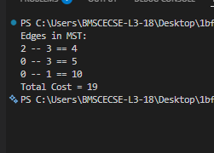

Lab program 9:
CODE:

#include<stdio.h>
#include<time.h>
struct Item
{
int weight;
int profit;
float ratio;
};
void swap(struct Item *a , struct Item *b){
struct Item temp=*a ;
*a=*b;
*b=temp;
};
void SortbyRatio(struct Item arr[],int n){
for(int i=0;i<n-1;i++){
for(int j=0;j<n-i-1;j++){
if(arr[j].ratio<arr[j+1].ratio){
swap(&arr[j],&arr[j+1]);
}
}
}
}
void SortbyProfit(struct Item arr[],int n){
for(int i=0;i<n-1;i++){
for(int j=0;j<n-i-1;j++){
if(arr[j].profit<arr[j+1].profit){
swap(&arr[j],&arr[j+1]);
}
}
}
}
void SortbyWeight(struct Item arr[],int n){
for(int i=0;i<n-1;i++){
for(int j=0;j<n-i-1;j++){
if(arr[j].weight<arr[j+1].weight){
swap(&arr[j],&arr[j+1]);
}
}
}
}
float knapsack(struct Item arr[],int n ,int capacity){
float totalProfit=0;
for(int i=0;i<n;i++){
if(capacity>=arr[i].weight){
totalProfit+=arr[i].profit;
capacity-=arr[i].weight;
}else{
totalProfit+=arr[i].ratio*capacity;
break;
}

}
return totalProfit;
}

int main(){
int n , capacity, choice;
printf("Enter number of items: ");
scanf("%d", &n);
struct Item arr[n];
printf("Enter weights:\n");
for(int i = 0; i < n; i++) {
scanf("%d", &arr[i].weight);
}

printf("Enter profits:\n");
for(int i = 0; i < n; i++) {
scanf("%d", &arr[i].profit);
arr[i].ratio = (float)arr[i].profit / arr[i].weight;
}

printf("Enter knapsack capacity: ");
scanf("%d", &capacity);
printf("choose a.p/w (optimal) b. profit c,weight\n");
scanf("%d",&choice);
clock_t start = clock();
switch(choice){
case 1: SortbyRatio(arr,n);
printf("Optimal method\n");
break;
case 2: SortbyProfit(arr,n);
printf("By profit\n");
break;
case 3: SortbyWeight(arr,n);
printf("By weight \n");
break;
default: printf("Invalid choice\n");
break;
}
float maxProfit=knapsack(arr, n, capacity);
clock_t end=clock();
double time_taken=((double)(end-start))/CLOCKS_PER_SEC;
printf("Max Profit: %.2f\n",maxProfit);
printf("execution time : %f seconds \n",time_taken);
return 0;
}

OUTPUT:

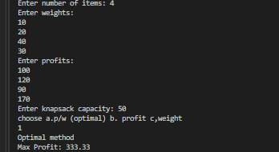

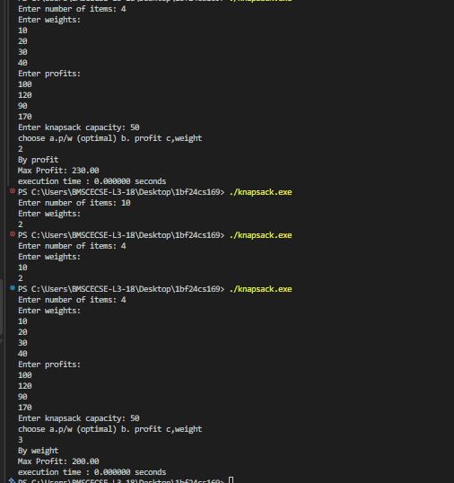



LEETCODE 561. Array Partition

CODE:

int compare(const void *a, const void *b) {
return (*(int *)a - *(int *)b);
}

int arrayPairSum(int* nums, int numsSize) {
qsort(nums, numsSize, sizeof(int), compare);

int sum = 0;
for (int i = 0; i < numsSize; i += 2)
sum += nums[i];

return sum;
}

OUTPUT:

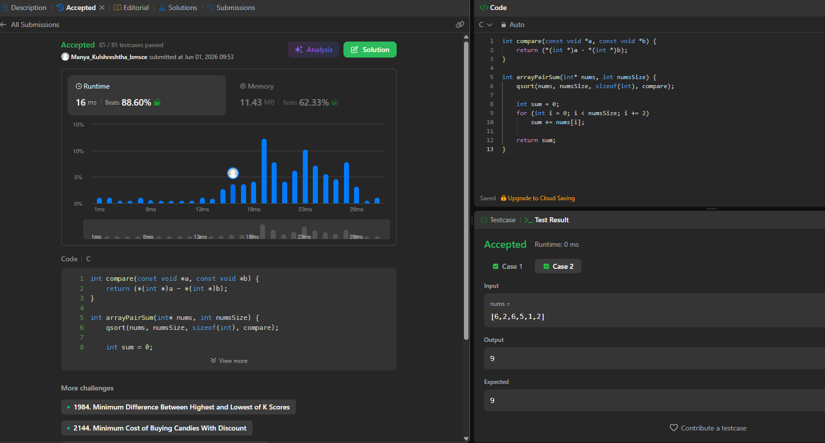\

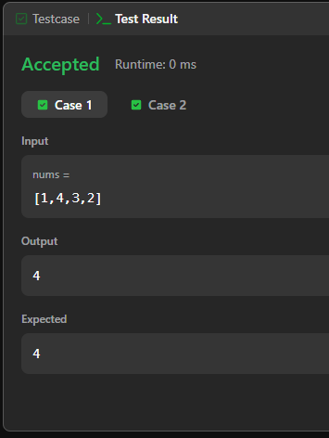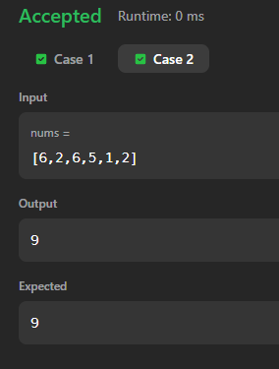

Lab program 10:
CODE:
#include<stdio.h>
#include<limits.h>
#define MAX 100
int minDistance(int dist[], int visited[],int n){
int min= INT_MAX, min_index;
for(int i=0;i<n;i++){
if(visited[i]==0 && dist[i]<=min){
min=dist[i];
min_index=i;
}
}
return min_index;
}
void dijkstra(int graph[MAX][MAX],int n, int src){
int dist[MAX],visited[MAX];
for(int i=0;i<n;i++){
dist[i]=INT_MAX;
visited[i]=0;
}
dist[src]=0;
for(int count=0;count<n-1;count++){
int u=minDistance(dist,visited,n);
visited[u]=1;
for(int v=0;v<n;v++){
if(!visited[v]&& graph[u][v]&& dist[u]!=INT_MAX && dist[u]+graph[u][v]<dist[v]){
dist[v]=dist[u]+graph[u][v];
}
}
}
printf("Vertex \t Dist from src\n");
for(int i=0;i<n;i++){
printf("%d\t%d\n",i,dist[i]);
}
}
int main(){
int n, graph[MAX][MAX],src;
printf("Enter no of vertices\n");
scanf("%d",&n);
printf("Enter adj matrix\n");
for(int i=0;i<n;i++){
for(int j=0;j<n;j++){
scanf("%d",&graph[i][j]);
}
}
printf("enter src vertex\n");
scanf("%d",&src);
dijkstra(graph,n,src);
return 0;
}

OUTPUT:

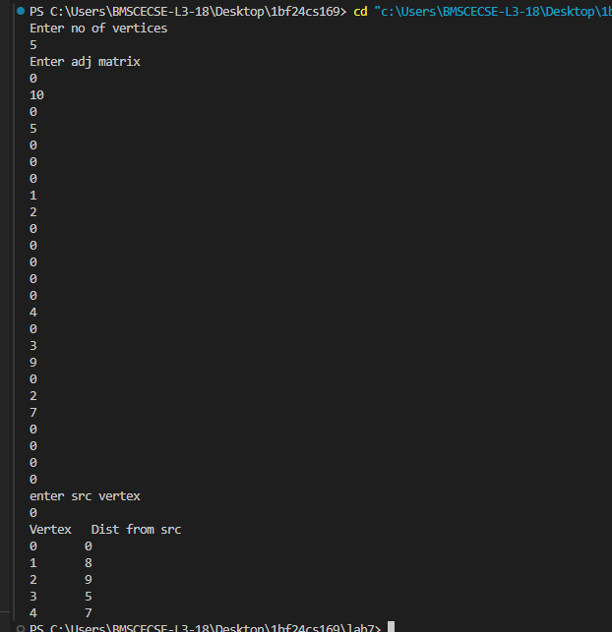

Lab program 11:
CODE:

#include <stdio.h>

int board[20], n, count = 0;

int isSafe(int row, int col) {
for (int i = 0; i < row; i++) {
if (board[i] == col ||
board[i] - i == col - row ||
board[i] + i == col + row)
return 0;
}
return 1;
}

void solve(int row) {
if (row == n) {
count++;
printf("\nSolution %d:\n", count);

for (int i = 0; i < n; i++) {
for (int j = 0; j < n; j++) {
if (board[i] == j)
printf("Q ");
else
printf(". ");
}
printf("\n");
}
return;
}

for (int col = 0; col < n; col++) {
if (isSafe(row, col)) {
board[row] = col;
solve(row + 1);
}
}
}

int main() {
printf("Enter N: ");
scanf("%d", &n);

solve(0);

printf("\nTotal Solutions = %d\n", count);

return 0;
}

OUTPUT:

