

Applied Machine Learning Lab
Experiment - 3
HANDWRITTEN DIGIT RECOGNITION USING NEURAL NETWORK

Submitted By Submitted To
Manya Nayak Prof.Kapish Nautial
500123429
Batch 26

1. Aim
To develop a handwritten digit recognition model using a Neural Network that can recognize digits from 0 to 9 using the MNIST dataset.

2. Objective
The objectives of this experiment are:
- To load the MNIST handwritten digit dataset.
- To preprocess and normalize the image data.
- To build a Neural Network using TensorFlow and Keras.
- To train the model using handwritten digit images.
- To evaluate the performance of the trained model.
- To predict the digit from an unseen image.
- To display the handwritten digit image using Matplotlib.

3. Software and Libraries Required
- Python 3.x
- Jupyter Notebook / Google Colab / VS Code
- TensorFlow
- Matplotlib
Install the required libraries:
pip install tensorflow matplotlib

4. Theory

MNIST Dataset
The MNIST dataset is a widely used dataset for handwritten digit recognition.
It contains grayscale images of handwritten digits from:
0 1 2 3 4 5 6 7 8 9
Each image has a size of:
28 × 28 pixels
The dataset contains:
- 60,000 training images
- 10,000 testing images
Each image represents one handwritten digit.

5. Neural Network
A Neural Network is a machine learning model inspired by the structure of the human brain.
The network used in this experiment consists of:
Input Image
↓
Flatten Layer
↓
Dense Layer (128 neurons)
↓
Output Layer (10 neurons)
↓
Predicted Digit

Input Layer
The input image has dimensions:
28 × 28
Therefore, there are:
28×28=78428 \times 28 = 784
pixel values.

Flatten Layer
tf.keras.layers.Flatten(input_shape=(28, 28))
The Flatten layer converts the 28 × 28 image into a one-dimensional array of 784 values.
28 × 28 image
↓
784 values

Dense Layer
tf.keras.layers.Dense(128, activation='relu')
This layer contains 128 neurons.
The ReLU (Rectified Linear Unit) activation function is used to introduce non-linearity into the network.

Output Layer
tf.keras.layers.Dense(10, activation='softmax')
There are 10 neurons, one for each digit:
0 → Neuron 1
1 → Neuron 2
2 → Neuron 3
...
9 → Neuron 10
The Softmax function produces probabilities for each digit.
For example:
0 → 0.01
1 → 0.02
2 → 0.03
3 → 0.01
4 → 0.02
5 → 0.05
6 → 0.01
7 → 0.02
8 → 0.01
9 → 0.82
The model selects the digit with the highest probability.
Therefore:
Predicted Digit = 9

6. Data Normalization
The original pixel values range from:
0 to 255
They are converted to values between:
0 and 1
using:
x_train = x_train / 255.0x_test = x_test / 255.0
This is called normalization.
It helps the neural network train more efficiently.

7.Code
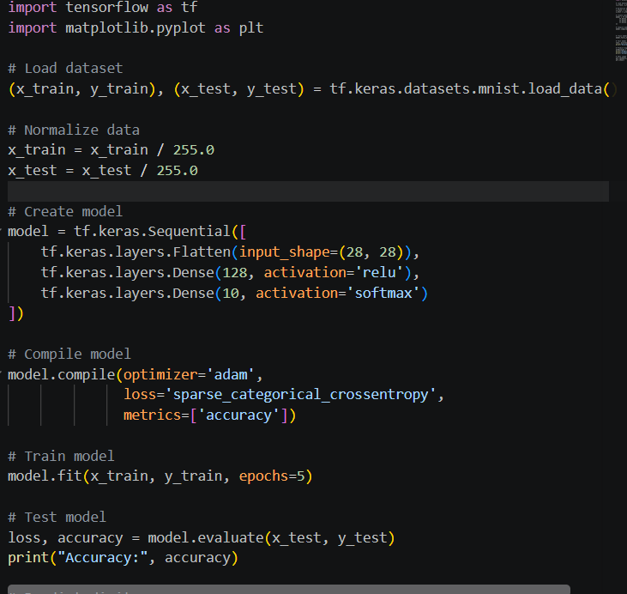
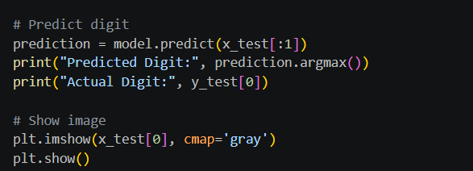

8. Result
The Handwritten Digit Recognition model was successfully implemented using TensorFlow and Keras. The MNIST dataset was used to train a Neural Network, and the model successfully recognized handwritten digits from 0 to 9.
The model was evaluated using the test dataset and its accuracy was calculated. A test image was also displayed along with its predicted and actual digit.
