

Applied Machine Learning Lab
Experiment - 1

Submitted By Submitted To
Manya Nayak Prof.Kapish Nautial
500123429
Batch 26

1. Aim
To develop a Machine Learning model using Linear Regression to predict house prices based on various features such as number of bedrooms, bathrooms, living area, location, condition, and year built.

2. Objective
The objectives of this experiment are:
- To load and preprocess a house-price dataset.
- To select relevant features for prediction.
- To handle categorical features using One-Hot Encoding.
- To divide the dataset into training and testing sets.
- To train a Linear Regression model.
- To predict house prices for unseen data.
- To evaluate the model using Mean Absolute Error (MAE) and R² Score.
- To visualize actual and predicted house prices.

3. Software/Tools Required
- Python 3.x
- Jupyter Notebook / Google Colab / VS Code
- Pandas
- Matplotlib
- Scikit-learn
- data.csv dataset
Install the required libraries using:
pip install pandas matplotlib scikit-learn

4. Theory

Linear Regression
Linear Regression is a supervised machine learning algorithm used to predict a continuous numerical value.
In this experiment, the continuous value is the price of a house.
The basic equation of linear regression is:
y=b0+b1x1+b2x2+...+bnxny = b_0 + b_1x_1 + b_2x_2 + ... + b_nx_n
where:
- y = predicted house price
- b₀ = intercept
- b₁, b₂, ..., bₙ = model coefficients
- x₁, x₂, ..., xₙ = input features
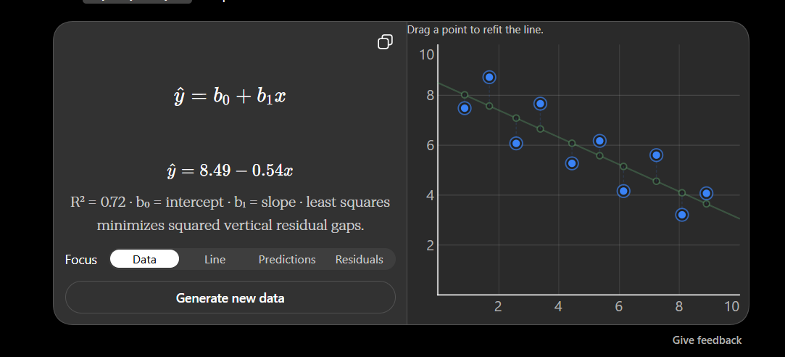The model tries to find the best-fitting relationship between the house features and its price by minimizing the prediction errors.

Dataset Description
The dataset contains information about houses and their prices.
The features used in this experiment are:
Feature | Description
bedrooms | Number of bedrooms
bathrooms | Number of bathrooms
sqft_living | Living area in square feet
sqft_lot | Lot area in square feet
floors | Number of floors
waterfront | Whether the house has waterfront access
view | Quality of the view
condition | Condition of the house
sqft_above | Area above ground
sqft_basement | Basement area
yr_built | Year the house was built
yr_renovated | Year the house was renovated
city | City of the house
statezip | State and ZIP code
price | Target house price

Code

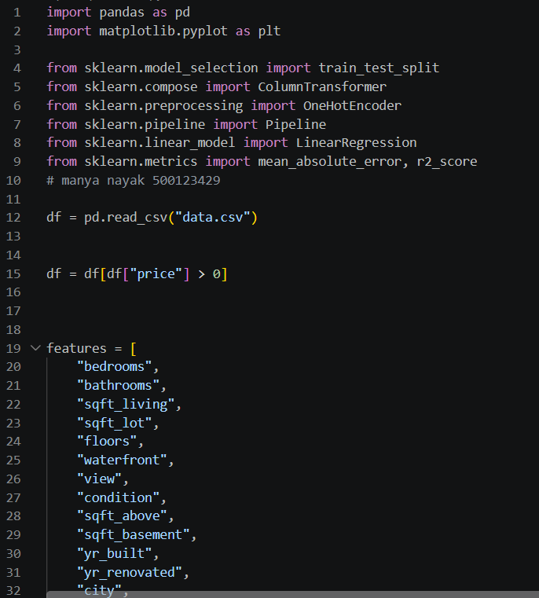
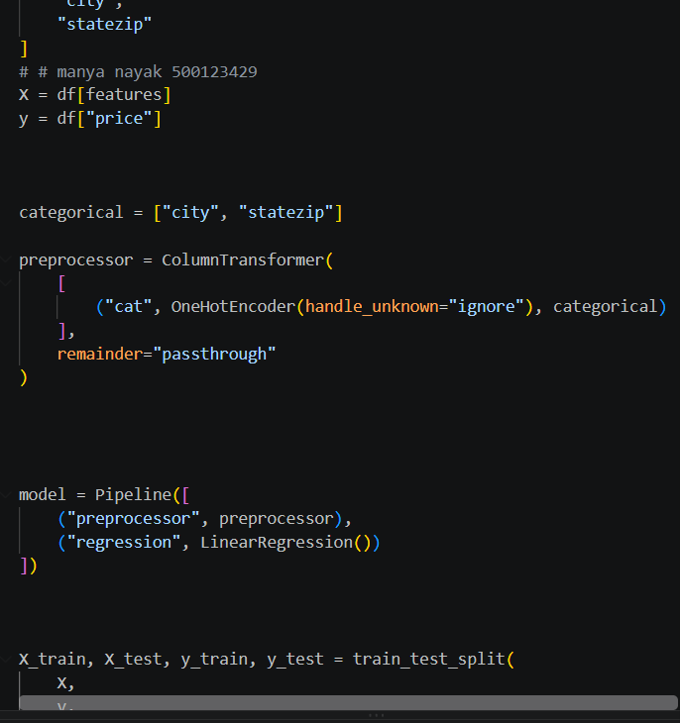
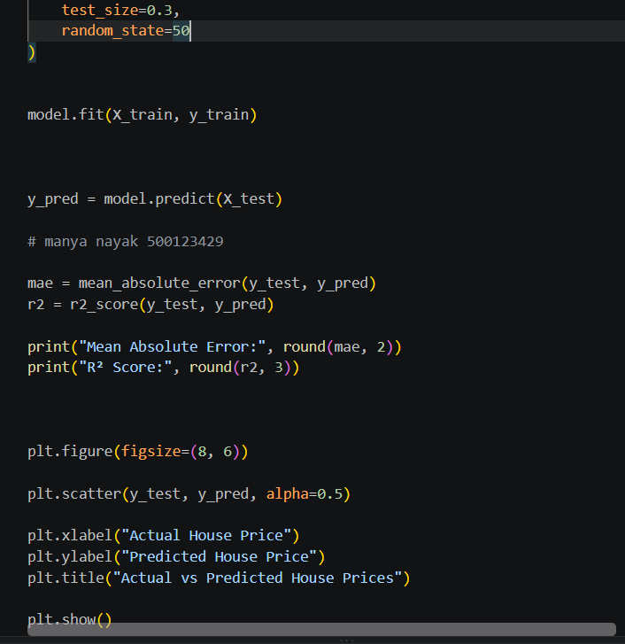

7. Result
The house price prediction model was successfully implemented using Linear Regression. The categorical features city and statezip were converted using One-Hot Encoding, and the model was evaluated using Mean Absolute Error (MAE) and R² Score. The actual and predicted house prices were also visualized using a scatter plot.

