

Applied Machine Learning Lab
Experiment - 2
IRIS FLOWER CLASSIFICATION USING KNN

Submitted By Submitted To
Manya Nayak Prof.Kapish Nautial
500123429
Batch 26

1. Aim
To develop a machine learning classification model using the K-Nearest Neighbors (KNN) algorithm to classify Iris flowers into different species based on their flower measurements.

2. Objective
The objectives of this experiment are:
- To load the Iris dataset using Scikit-learn.
- To understand the features of the Iris flower dataset.
- To divide the dataset into training and testing sets.
- To implement the K-Nearest Neighbors classification algorithm.
- To predict the species of Iris flowers.
- To calculate the accuracy of the classification model.
- To predict the species of a new flower.
- To visualize the classification results.

3. Software and Libraries Required
- Python 3.x
- Jupyter Notebook / Google Colab / VS Code
- Pandas
- Matplotlib
- Scikit-learn
Install the required libraries using:
pip install pandas matplotlib scikit-learn

4. Theory

Iris Dataset
The Iris dataset is a commonly used dataset in machine learning. It contains measurements of 150 Iris flowers belonging to three different species:
- Iris Setosa
- Iris Versicolor
- Iris Virginica
Each flower has four features:
Feature | Description
Sepal Length | Length of the sepal
Sepal Width | Width of the sepal
Petal Length | Length of the petal
Petal Width | Width of the petal
The goal is to use these measurements to predict the species of the flower.

5. K-Nearest Neighbors (KNN)
K-Nearest Neighbors (KNN) is a supervised machine learning algorithm used for classification and regression.
In KNN classification, when a new data point is given:
- The algorithm calculates the distance between the new point and existing training points.
- It finds the K nearest points.
- It looks at the classes of those neighboring points.
- The class occurring most frequently is assigned to the new data point.
In this experiment:
KNeighborsClassifier(n_neighbors=3)
is used.
This means the model considers the 3 nearest neighbors when making a prediction.

6. Working of KNN
For example, suppose we have a new flower whose measurements are:
Sepal Length = 5.1
Sepal Width = 3.5
Petal Length = 1.4
Petal Width = 0.2
The KNN algorithm finds the three closest flowers in the training dataset.
If most of those three flowers belong to Iris Setosa, the new flower is classified as:
Iris Setosa

7.Dataset Features
The Iris dataset provided by Scikit-learn contains:
X = Flower measurements
y = Flower species
The four input features are:
X[:, 0] → Sepal Length
X[:, 1] → Sepal Width
X[:, 2] → Petal Length
X[:, 3] → Petal Width
The target values represent:
0 → Setosa
1 → Versicolor
2 → Virginica

8.Accuracy
Accuracy is calculated using:
The formula is:
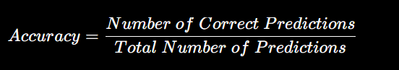For example, if the model correctly predicts 29 out of 30 test samples:
Accuracy=2930×100=96.67%Accuracy = \frac{29}{30}\times100 = 96.67\%
A higher accuracy indicates better classification performance

9. Complete Code
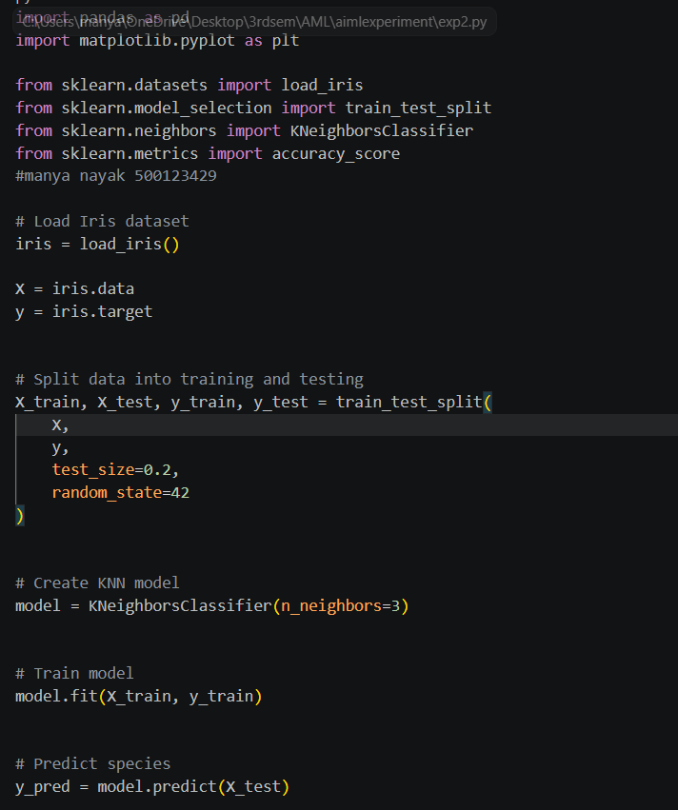

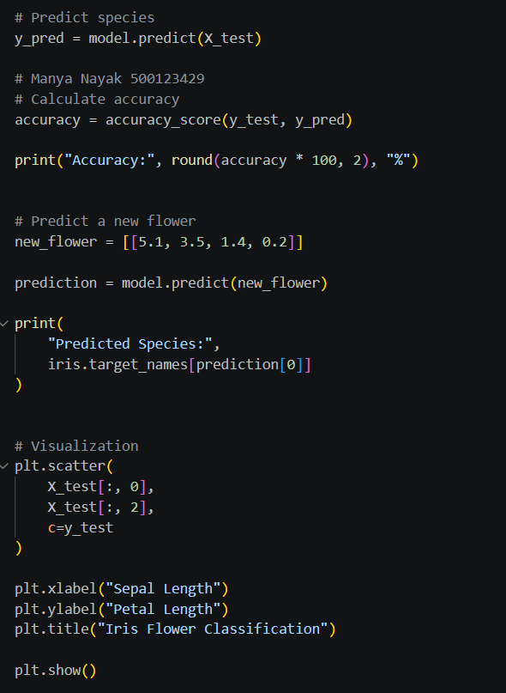

10. Result
The Iris Flower Classification model was successfully implemented using the K-Nearest Neighbors (KNN) algorithm. The model was trained using 80% of the Iris dataset and tested using the remaining 20%. The accuracy of the model was calculated, and the species of a new Iris flower was successfully predicted.
