LAB 1: DEVOPS FOUNDATIONS & CONTINUOUS INTEGRATION

TASK 01 - Create a Jenkinsfile defining Build, Test and Deploy stages and demonstrate execution

Project Structure
lab1_jenkins/
├── app/
│ ├── package.json
│ ├── package-lock.json
│ └── server.js
├── Dockerfile
├── docker-compose.yml
└── Jenkinsfile

1. Create the Express application
mkdir lab1_jenkins
cd lab1_jenkins
mkdir app
cd app
npm init -y
npm install express
Create server.js:
const express = require("express");
const app = express();
const PORT = 5000;
app.get("/", (req, res) => {
res.json({ message: "Jenkins DevOps Lab Application", status: "running" });
});
app.get("/health", (req, res) => {
res.json({ status: "healthy" });
});
app.listen(PORT, () => {
console.log(`Server running at http://localhost:${PORT}`);
});
Add a simple test script to package.json:
"scripts": {
"test": "node -e \"console.log('Tests passed')\""
}
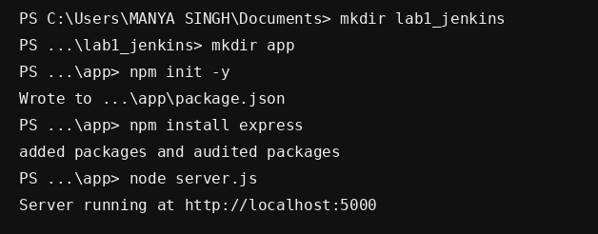

2. Containerize the application
Dockerfile:
FROM node:20-alpine
WORKDIR /app
COPY package*.json ./
RUN npm ci
COPY . .
EXPOSE 5000
CMD ["node","server.js"]
docker-compose.yml:
services:
app:
build: ./app
ports:
- "5000:5000"
restart: unless-stopped

3. Initialize Git
git init
git add .
git commit -m "Initial Express application"
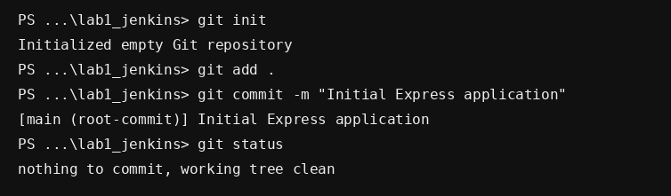

4. Create the Jenkinsfile
pipeline {
agent any
stages {
stage('Build') {
steps { sh 'npm ci' }
}
stage('Test') {
steps { sh 'npm test' }
}
stage('Deploy') {
steps { sh 'docker compose up -d --build' }
}
}
post {
success { echo 'Deployment completed successfully' }
failure { echo 'Pipeline failed' }
}
}

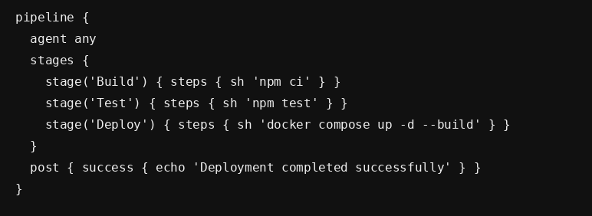

5. Configure the Jenkins Pipeline Job
- Open Jenkins Dashboard.
- Select New Item.
- Enter lab1-jenkins-pipeline.
- Select Pipeline.
- Use Pipeline script from SCM when using Git.
- Select Git and enter the repository URL.
- Set Script Path to Jenkinsfile.
- Save the job.

6. Run and verify the pipeline
Click Build Now, open the build, and select Console Output. Verify Build → Test → Deploy and Finished: SUCCESS.
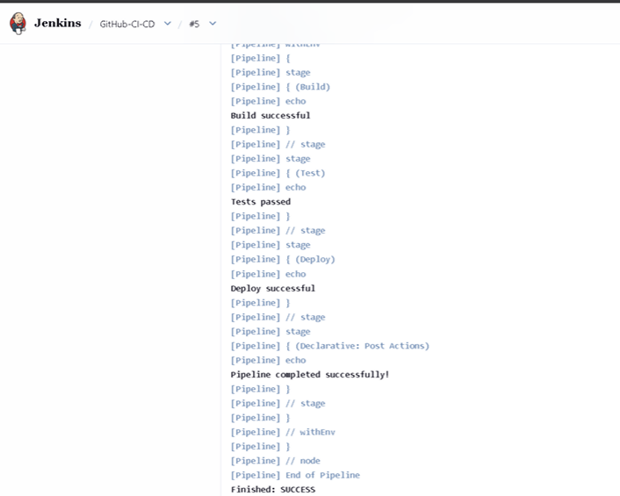

Result - A declarative Jenkinsfile was created with Build, Test and Deploy stages and the pipeline execution can be verified through Jenkins Console Output.

