Task 3 — Record All Commands, Pipeline Configurations, Screenshots, Commit History & Observations

1. Experiment Environment
- Node.js + Express — target application
- Git — source control and commit history
- Jenkins — CI/CD pipeline execution
- Docker / Docker Compose — containerized deployment
- Jenkinsfile — declarative pipeline definition

2. Project Structure
lab1_jenkins/
├── app/
│ ├── package.json
│ ├── package-lock.json
│ └── server.js
├── Dockerfile
├── docker-compose.yml
└── Jenkinsfile

3. Record of Commands

Project creation
mkdir lab1_jenkins
cd lab1_jenkins
mkdir app
cd app
npm init -y
npm install express
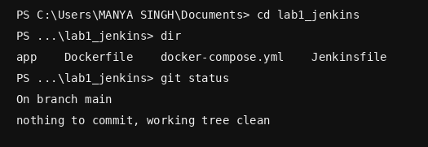

Local testing
node server.js
curl http://localhost:5000/health

Git
git init
git add .
git commit -m "Initial Express application"
git status
git log --oneline --decorate --graph –all
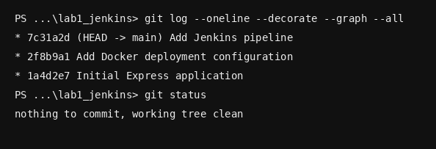

Docker
docker build -t lab1-app ./app
docker compose config
docker compose up -d --build
docker compose ps
docker ps
docker logs lab1-app
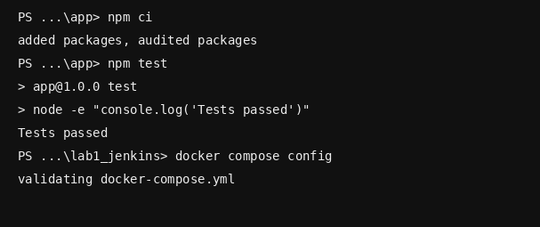

Jenkins
Build Now
Open build number
Open Console Output
Verify Build → Test → Deploy
Verify Finished: SUCCESS

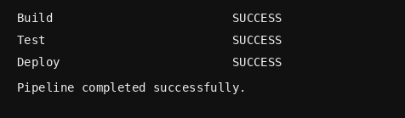

4. Jenkins Pipeline Configuration
pipeline {
agent any
stages {
stage('Build') {
steps { sh 'npm ci' }
}
stage('Test') {
steps { sh 'npm test' }
}
stage('Deploy') {
steps { sh 'docker compose up -d --build' }
}
}
post {
success { echo 'Deployment completed successfully' }
failure { echo 'Pipeline failed' }
}
}
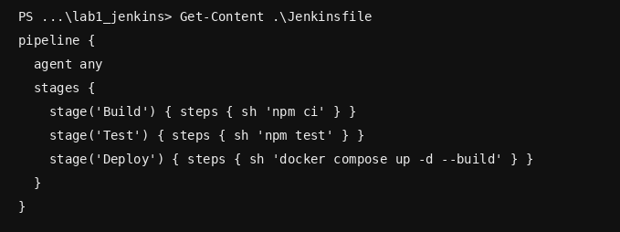.

5. Jenkins Job Configuration Record
- Job name: lab1-jenkins-pipeline
- Job type: Pipeline
- Definition: Pipeline script from SCM
- SCM: Git
- Script Path: Jenkinsfile
- Build trigger: Poll SCM or Git webhook
- Stages: Build, Test, Deploy
- Post-build: success/failure messages

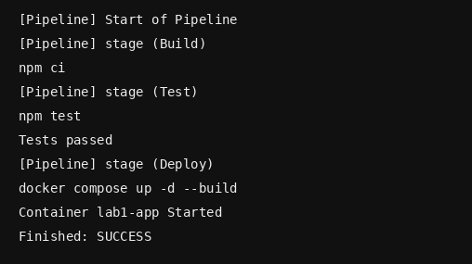

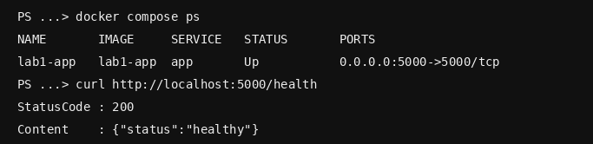

6. Observations
- The Express application can be built and tested independently before Jenkins execution.
- Git provides a traceable history of application, deployment and pipeline changes.
- The Jenkinsfile creates a repeatable Build → Test → Deploy sequence.
- A failed earlier stage should prevent the deployment stage from being considered successful.
- Docker Compose provides a repeatable deployment command.
- The /health endpoint provides a simple post-deployment verification.
- Jenkins Console Output is the main evidence for pipeline command execution.

7. Expected Results
npm test — Tests passed
git status — Working tree clean after commit
Build — SUCCESS
Test — SUCCESS
Deploy — SUCCESS
docker compose ps — Application container running
GET /health — HTTP 200 and healthy status

8. Final Submission Checklist
- All commands recorded.
- Jenkinsfile included.
- Jenkins job configuration documented.
- Build trigger documented.
- Git commit history included.
- Jenkins stage-view screenshot included.
- Jenkins Console Output screenshot included.
- Docker deployment verification included.
- Health endpoint verification included.

