Task 4 — Prepare a CI/CD Workflow Report
Objective: Prepare a CI/CD workflow report describing the pipeline architecture, stages, automation results, and observations with supporting screenshots.

1. CI/CD Workflow Overview
The workflow automates the application lifecycle from a source-code change to deployment and verification. A developer commits and pushes changes to Git. Jenkins detects the change and starts the pipeline. The pipeline builds the application, executes tests, deploys the application using Docker Compose, and verifies the deployed service using its health endpoint.

2. Pipeline Architecture

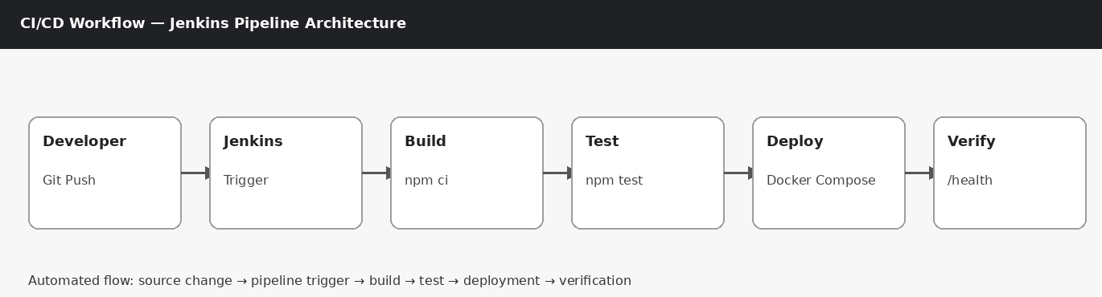
Architecture sequence: Developer/Git → Jenkins trigger → Build → Test → Deploy → Verification.

3. CI/CD Pipeline Stages

Stage 1 — Source / Version Control
Application changes are committed to Git. The commit provides a traceable version of the source code.
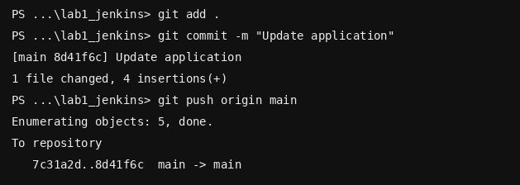

Stage 2 — Trigger
Jenkins detects a repository change using Poll SCM or a Git webhook and schedules a pipeline build.

Stage 3 — Build
Jenkins installs project dependencies using npm ci and prepares the application for execution.

Stage 4 — Test
Jenkins executes npm test. The pipeline should continue to deployment only when this stage succeeds.

Stage 5 — Deploy
Jenkins executes docker compose up -d --build to rebuild and start the application container.
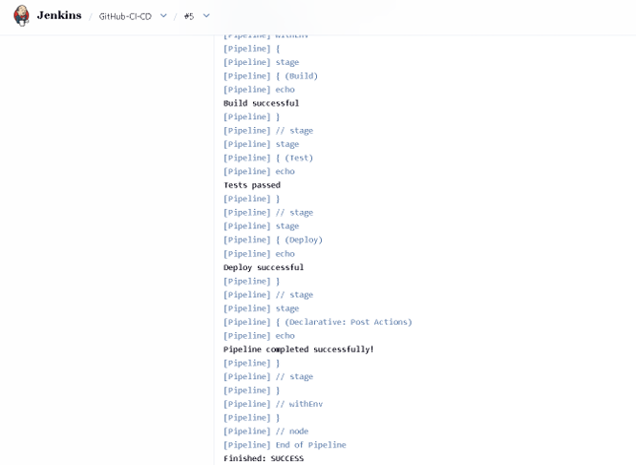

Stage 6 — Verification
The deployed application is checked using docker compose ps and GET /health. A successful deployment returns HTTP 200 with a healthy status.
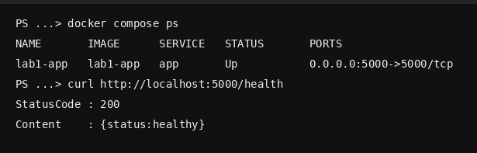

4. Jenkinsfile Used
pipeline {
agent any
stages {
stage('Build') {
steps {
sh 'npm ci'
}
}
stage('Test') {
steps {
sh 'npm test'
}
}
stage('Deploy') {
steps {
sh 'docker compose up -d --build'
}
}
}
post {
success {
echo 'Deployment completed successfully'
}
failure {
echo 'Pipeline failed'
}
}
}

5. Automation Workflow
- Developer modifies the Express application.
- Changes are committed to Git.
- The commit is pushed to the configured repository.
- Jenkins detects the change through the configured trigger.
- Jenkins starts the pipeline automatically.
- Build stage installs dependencies.
- Test stage executes the application tests.
- Deploy stage rebuilds and starts the Docker container.
- Post-build status is reported by Jenkins.
- The deployed application is verified through the /health endpoint.

6. Automation Results
Stage | Expected Result | Evidence
Trigger | Build automatically scheduled after source change | Jenkins trigger screenshot
Build | npm ci completes successfully | Console Output
Test | npm test completes successfully | Console Output
Deploy | Docker container starts successfully | Console Output + docker compose ps
Verify | HTTP 200 and healthy status | /health screenshot

7. Observations
- The workflow reduces manual steps between code changes and deployment.
- Git provides a traceable history of the source changes that triggered a build.
- Jenkins provides a centralized view of pipeline stages and execution status.
- The Test stage acts as a quality gate before deployment.
- Docker Compose makes the deployment process repeatable.
- The health endpoint provides a simple way to verify that the deployed application is responding.
- Console Output is useful for troubleshooting failed stages because it shows the commands executed by Jenkins.

