Task 02 — Automate application deployment using Jenkins triggers, post-build actions and deployment steps.

1. Configure a build trigger
Use Poll SCM for a simple classroom demonstration, or a Git webhook when repository hosting is available. Example Poll SCM schedule:
H/5 * * * *
A webhook is preferred for real continuous integration because Jenkins is notified immediately after a repository push.

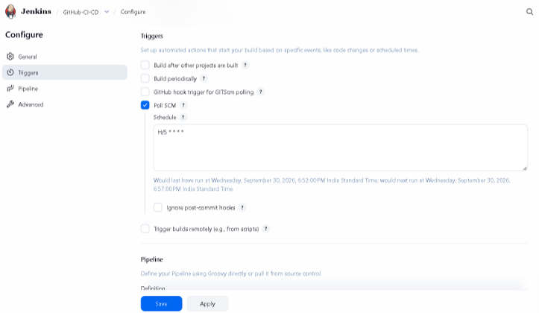

2. Configure deployment
The Deploy stage rebuilds the application and starts the container:
docker compose up -d –build

3. Configure post-build actions
post {
success { echo 'Deployment completed successfully' }
failure { echo 'Pipeline failed' }
}
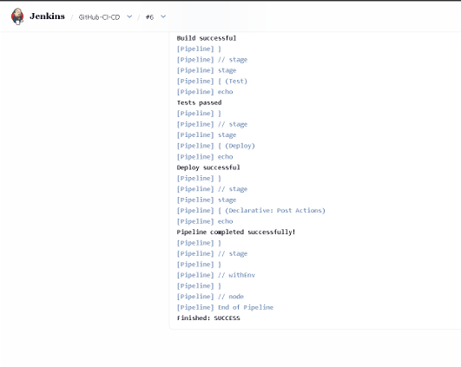
4. Verify automated deployment
Make a small application change.
Commit and push the change to the configured repository.
Allow the Jenkins trigger to start the job.
Verify Build, Test and Deploy execute in order.
Verify the Docker container is running.
Open http://localhost:5000/health and verify {"status":"healthy"}.

Results: Jenkins automates the application lifecycle from source change through build, test and Docker deployment. The health endpoint provides a simple verification of the deployed application.

