Lab 2: Containerization & Kubernetes Orchestration

Task 1: Containerize a Sample Application Using Docker
- app.py
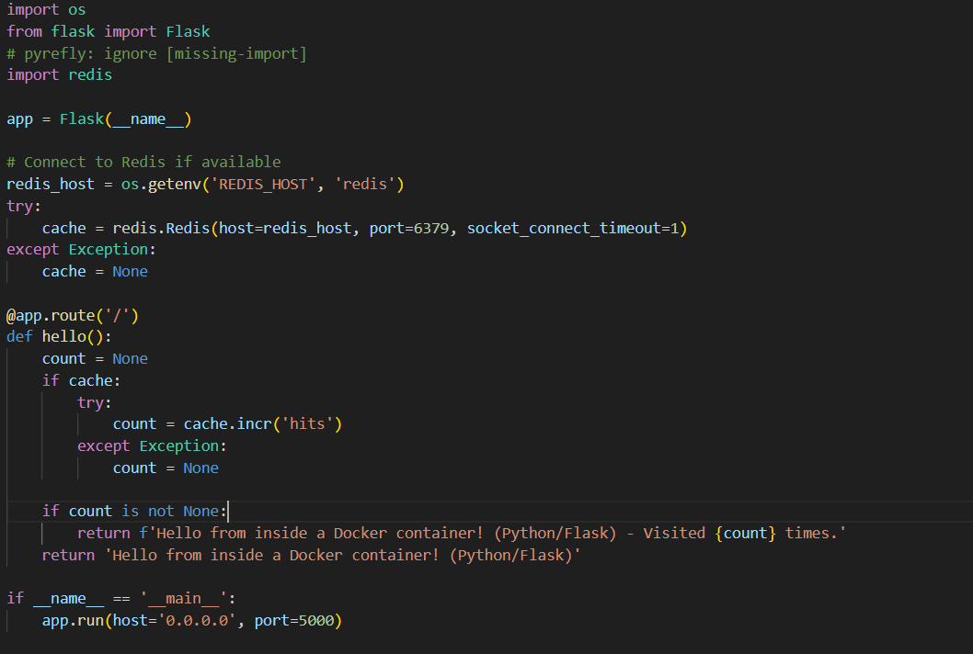

- requirements.txt
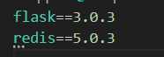

- Docker file
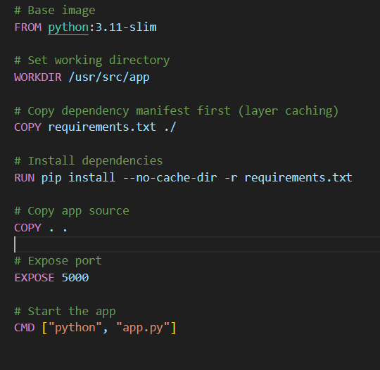

Build Process & Execution Verification

