Lab 2: Containerization & Kubernetes Orchestration

Task 2: Manage Docker Containers and Images

1. Container Lifecycle Management (list, start, stop, remove)

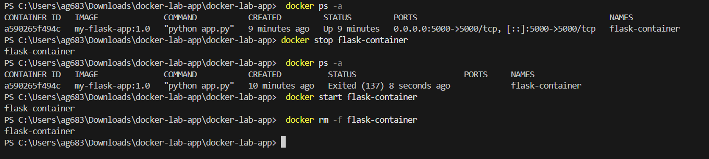

2. Docker Image Tagging & Registry Operations

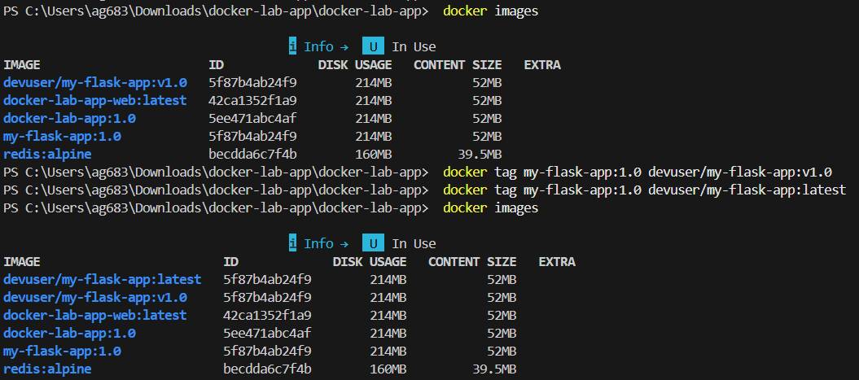

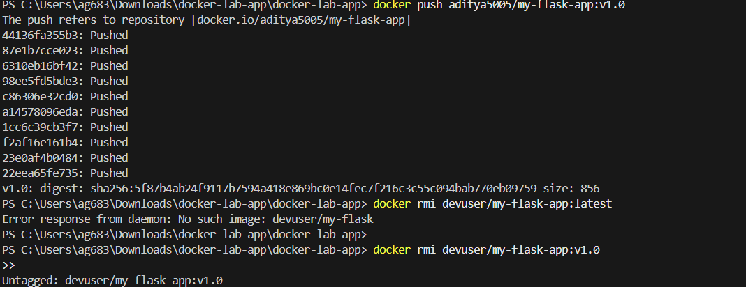

3. Multi-Container Setup with Docker Compose

3.1 Docker Compose Manifest
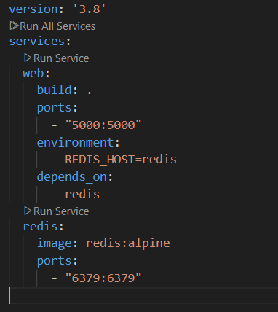

3.2 Compose Execution & Dynamic Counter Verification

