Lab 3: Monitoring, Logging & DevSecOps

Step 01 : Install Ansible
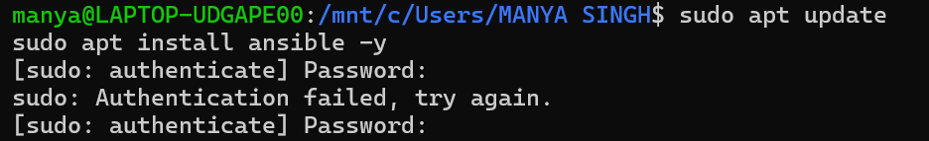
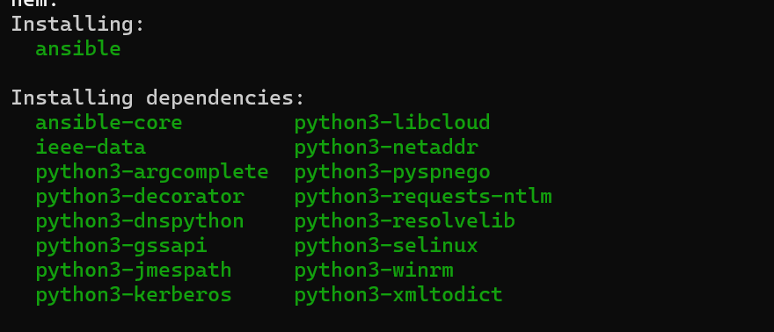
Step 02 : Install Terraform
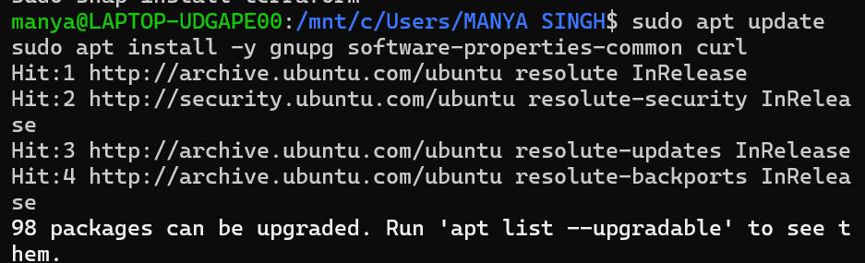
Step 03 : Install Terraform from HashiCorp's repository:
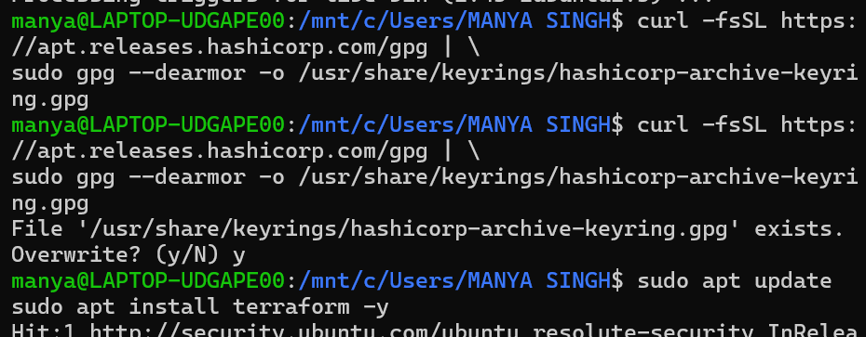
Step 04 : Verify:
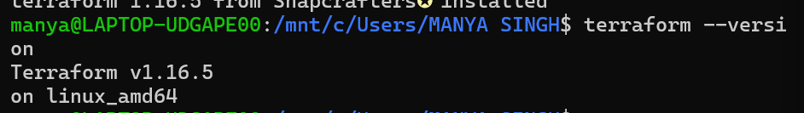
Step 05 : Create the Lab Directory
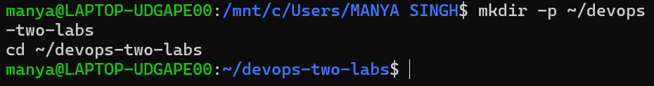
QUESTION 1 — ANSIBLE
Objective
Configure infrastructure and automate application configuration using Ansible by writing playbooks and applying them to target nodes.

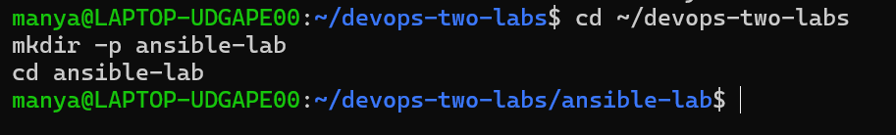
Step 01 : Create Ansible Directory

Step 02 : Create Two Ubuntu Containers
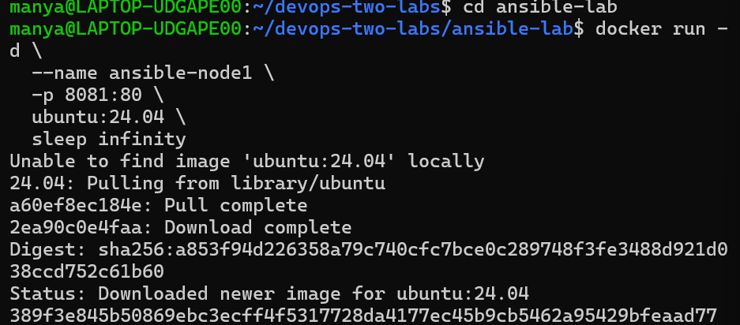
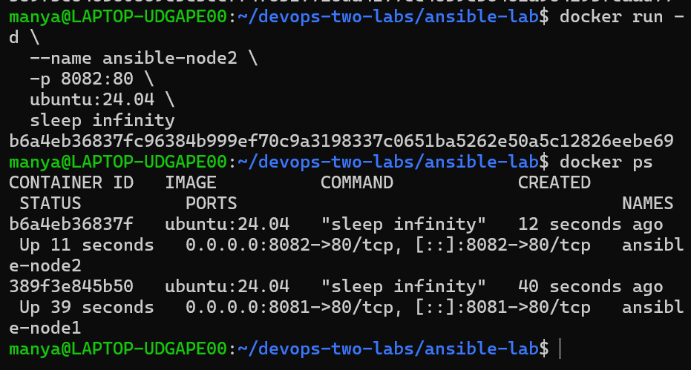

Step 03 : Prepare Containers for Ansible
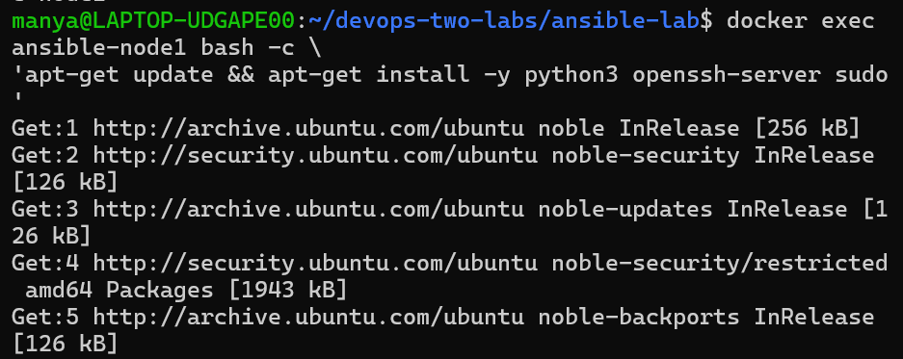
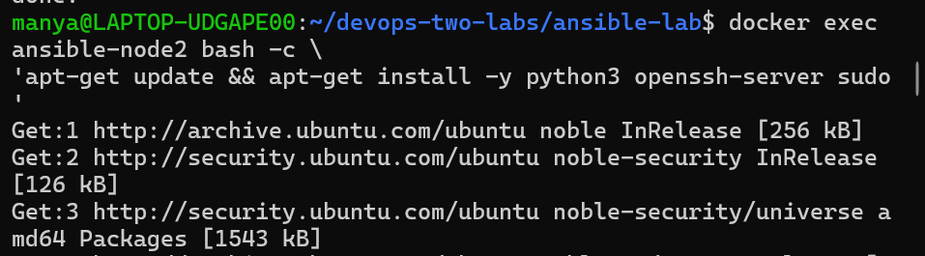

Step 04 : Create the inventory file
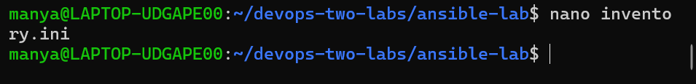
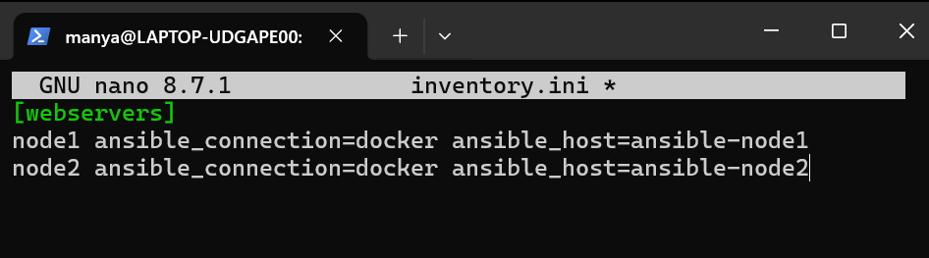

Step 05 : Install Docker collection for Ansible
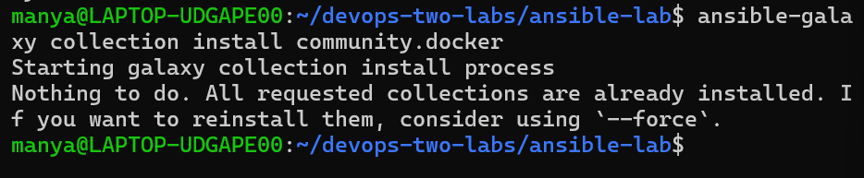

Step 06 : Test the two containers
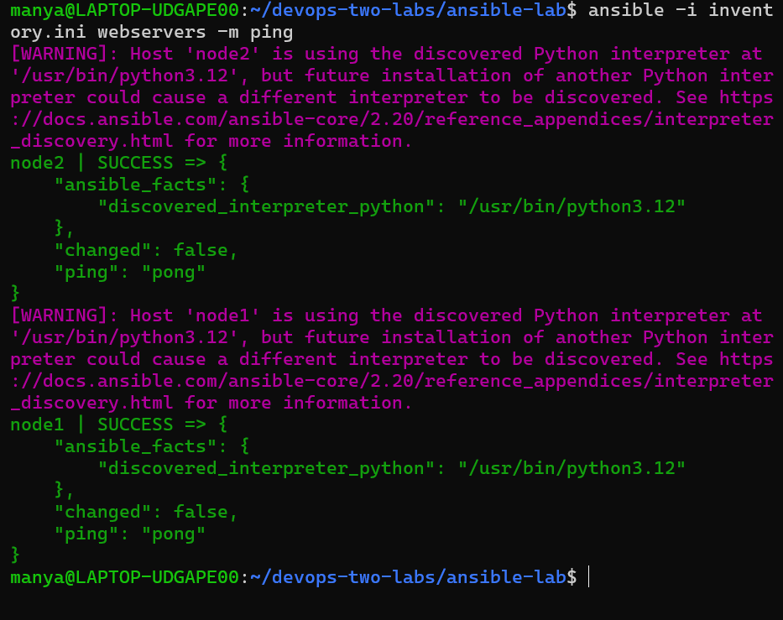
Step 07 : Create the Ansible playbook
Step 08 : Create nginx.yml
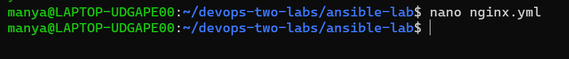
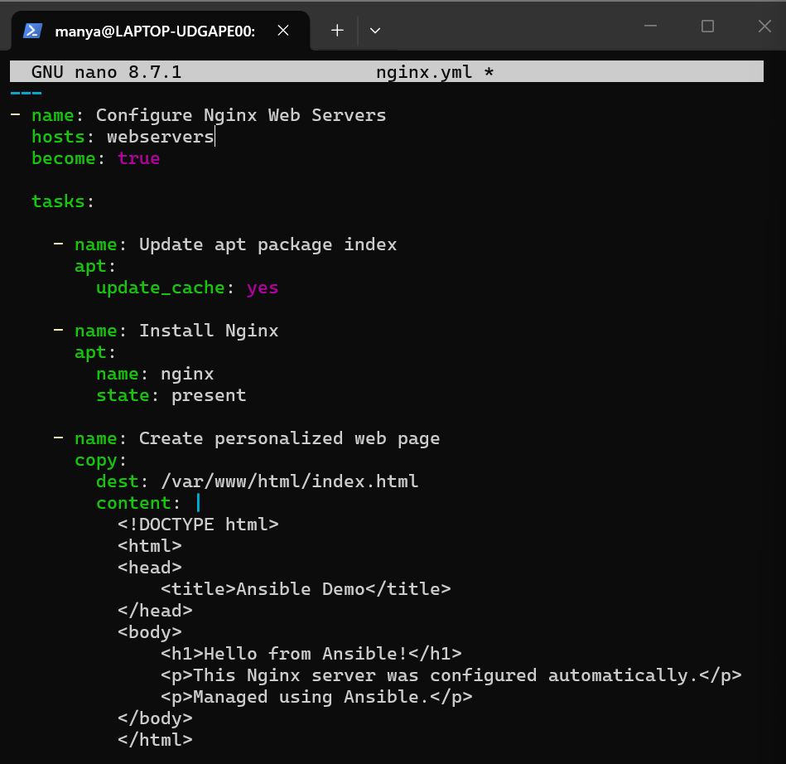
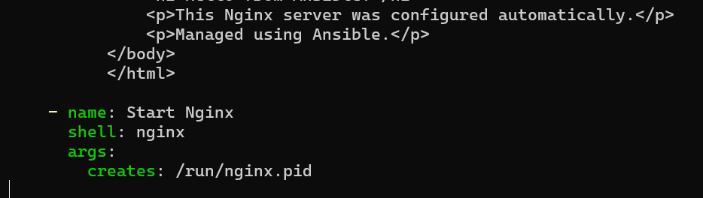

Step 09 : Check that the file exists and Check the playbook syntax
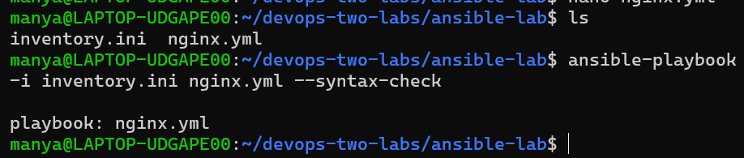

Step 10 : Run the Ansible playbook
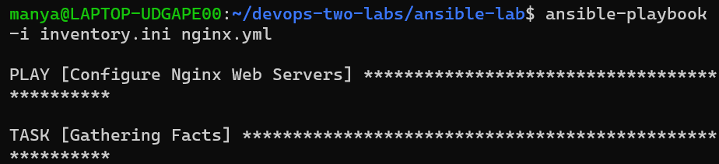
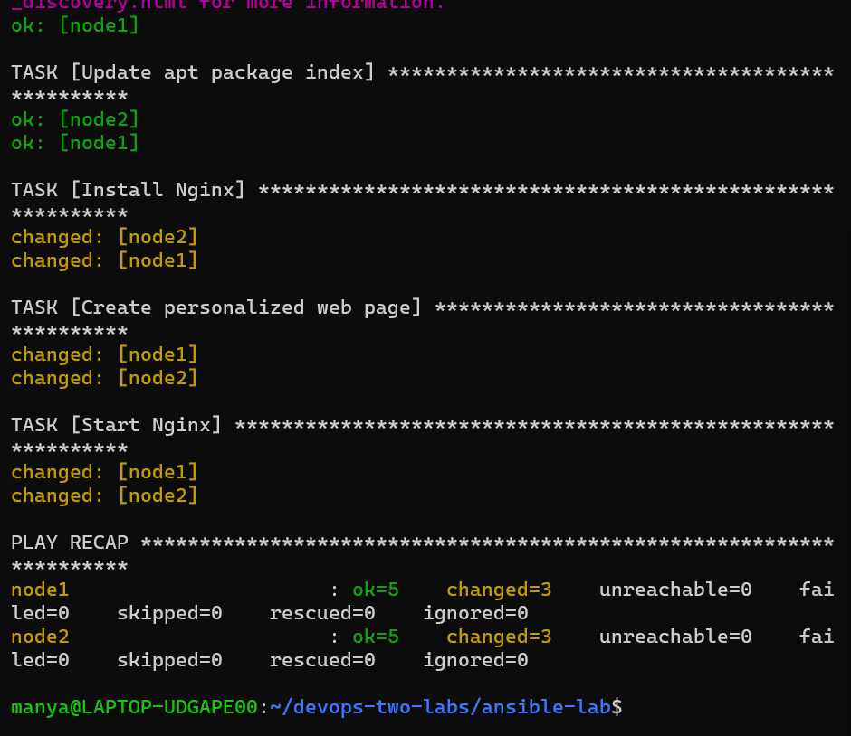

Step 11 : Test Node 1 from Ubuntu
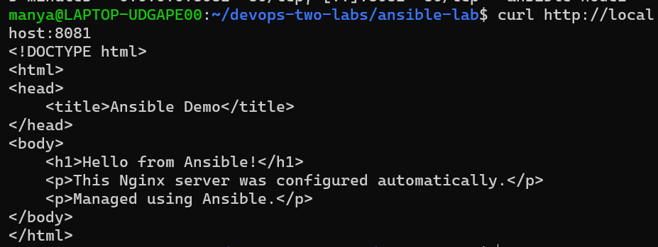

Step 12 : Open the website: http://localhost:8081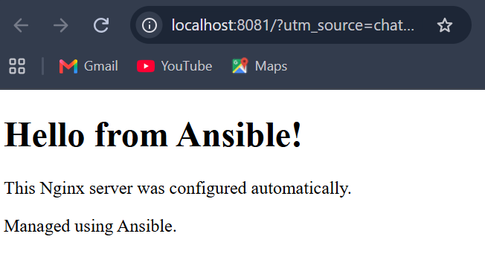
Step 13 : Test Node 2:
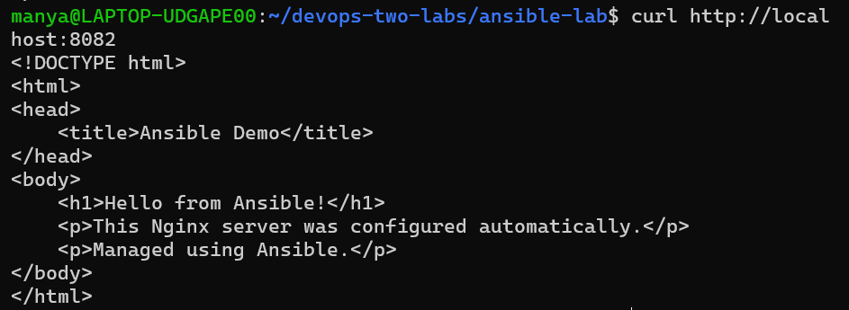

Step 14 : Open the website: http://localhost:8082
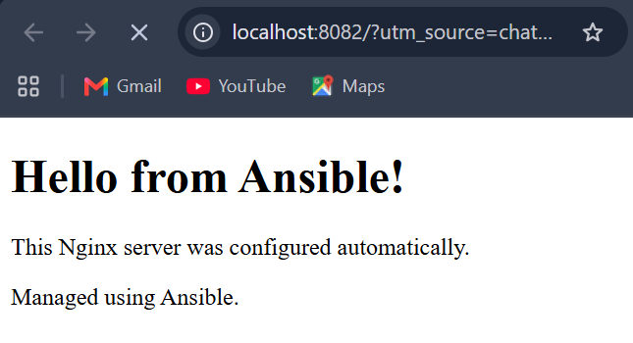

Step 15 : Verify Nginx inside the containers and Then verify the HTML directly for both the nodes:
