Lab 3: Monitoring, Logging & DevSecOps

QUESTION 2 — TERRAFORM
Objective
Provision scalable infrastructure using Terraform (Infrastructure as Code): write configuration files, initialize, plan, and apply the infrastructure.

Step 01 : Create the Terraform lab directory
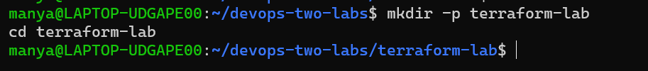

Step 02 : Create main.tf
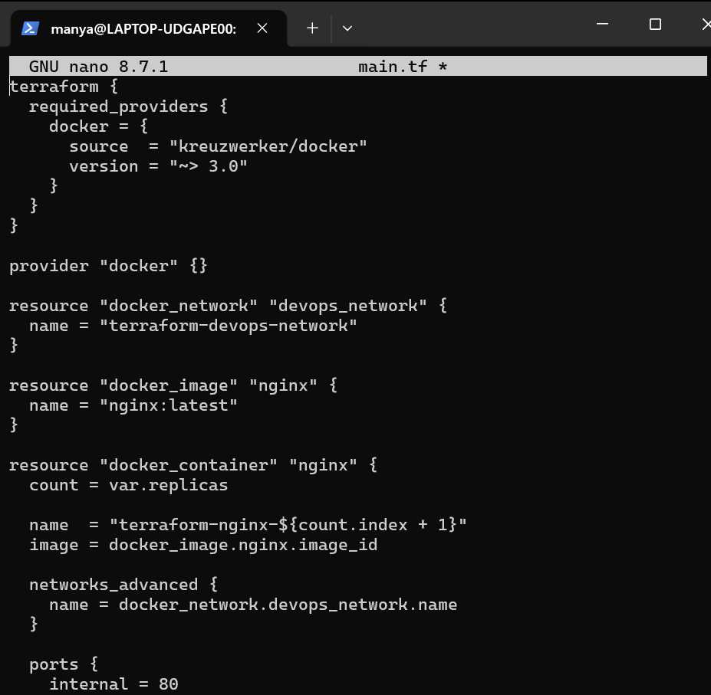
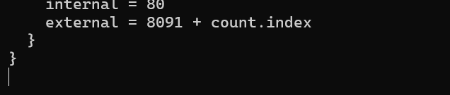

Step 03 : Create variables.tf
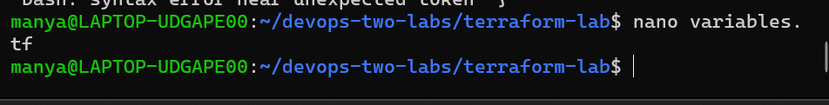

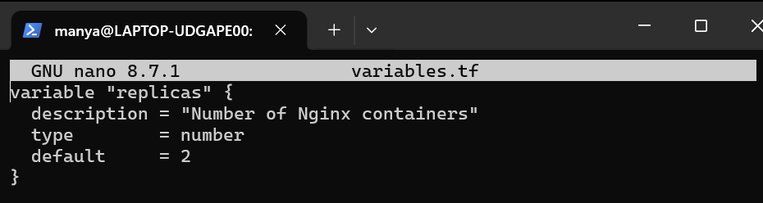

Step 04 : Create outputs.tf
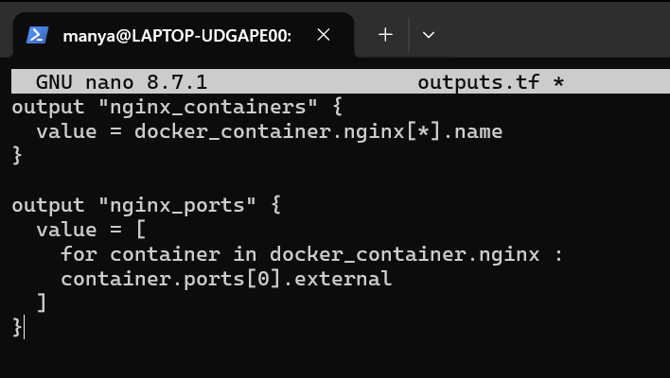

Step 05 : Run Terraform Init
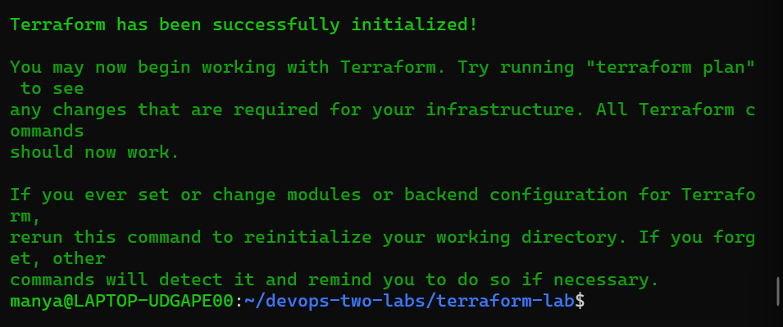

Step 06 : Validate the configuration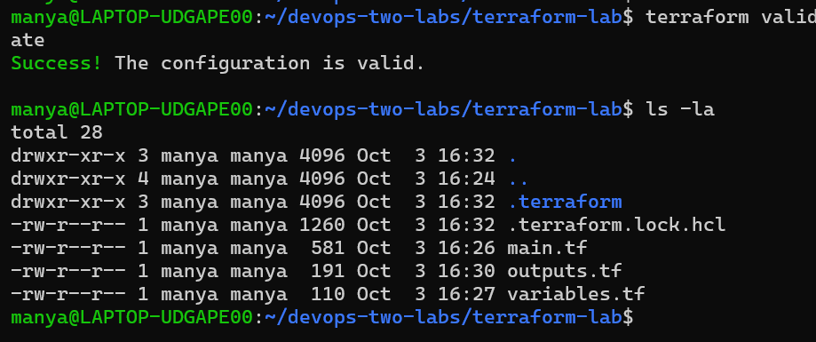
Step 07 : Run terraform plan
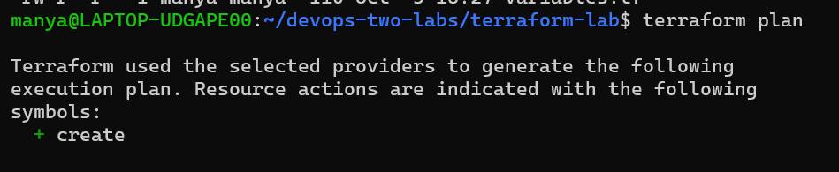
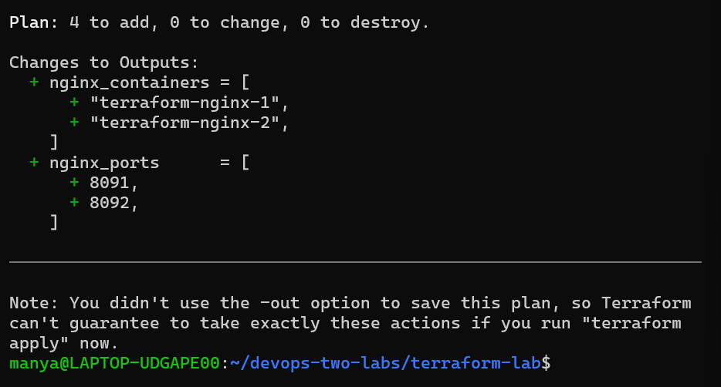

Step 08 : Create the infrastructure so run terraform apply:
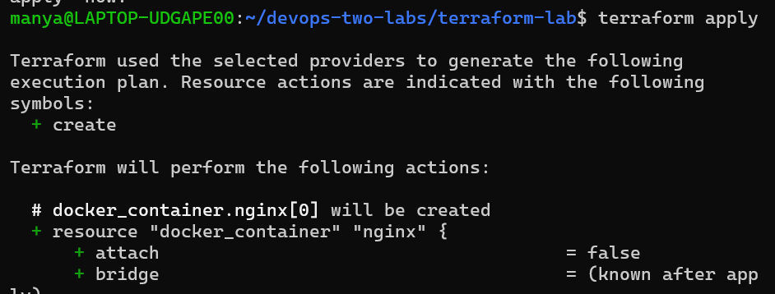
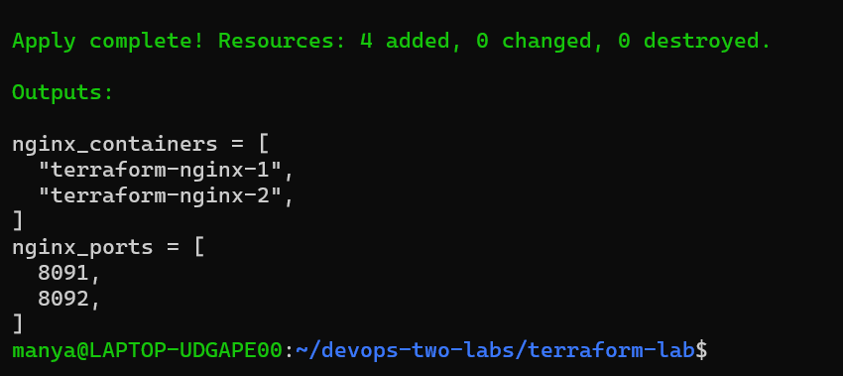
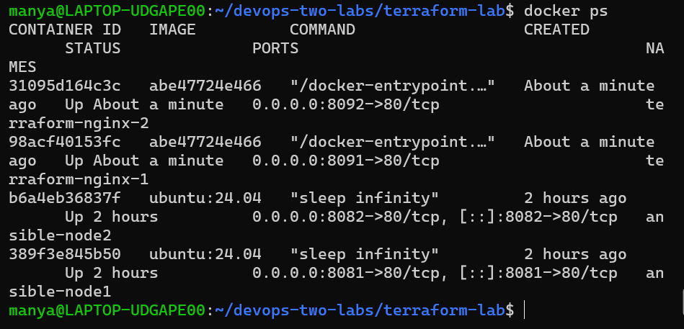
Step 09 : Verify Terraform containers with curl
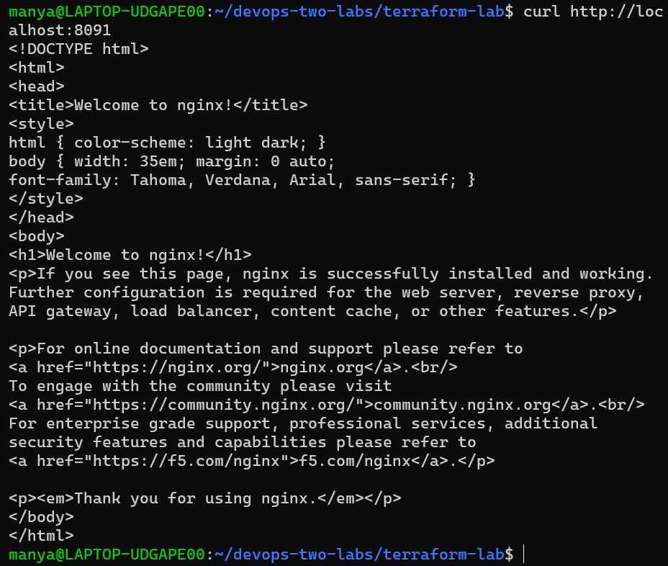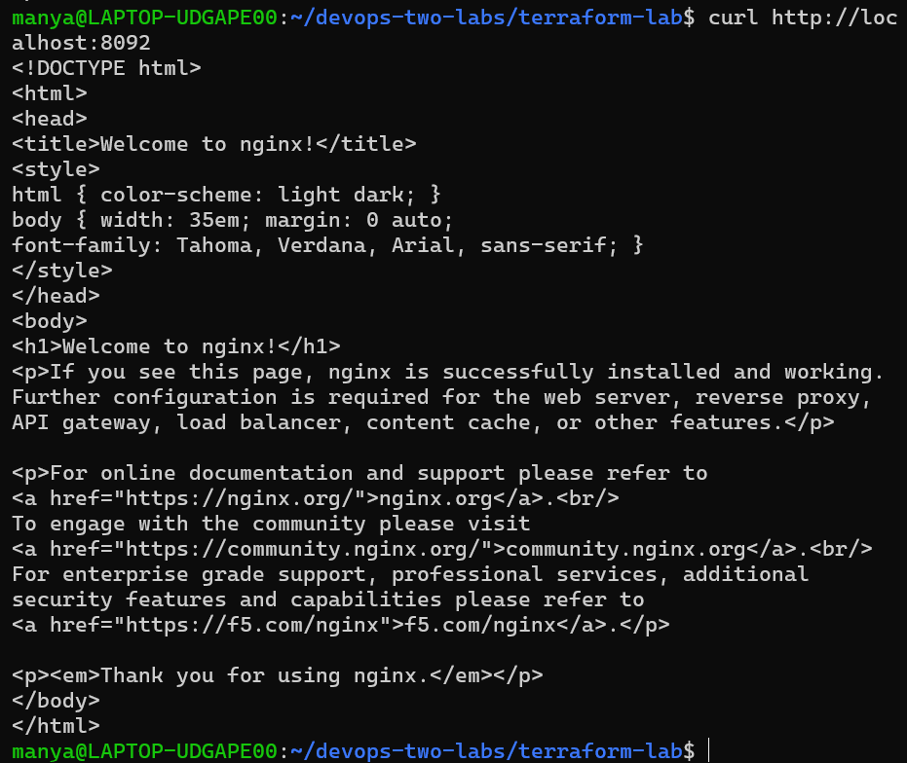

Step 10 : Verify in the browser. Open: http://localhost:8091
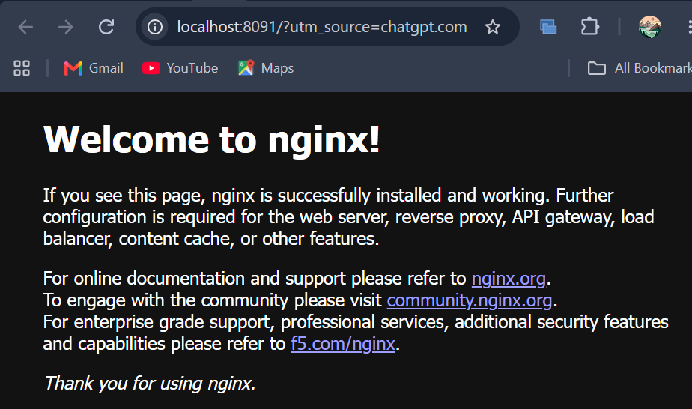
Step 11 : Open: http://localhost:8092
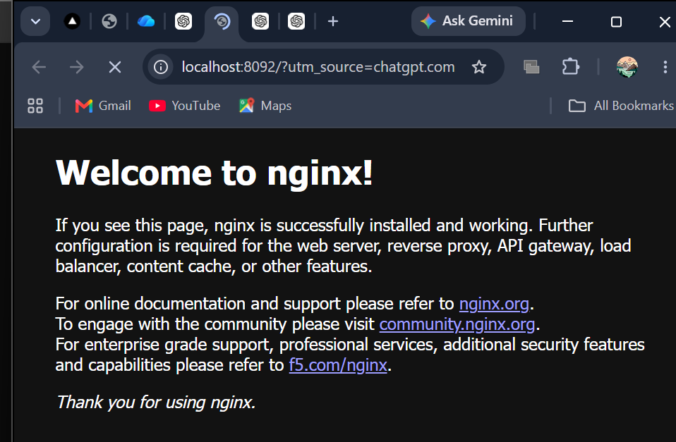

Step 12 : Check Terraform state
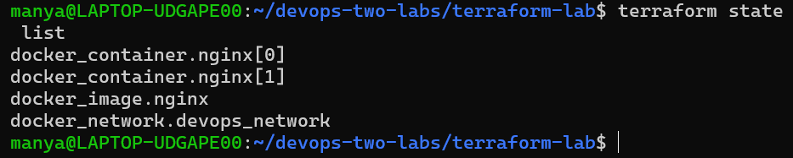

Step 13 : Terraform creates two Nginx containers, then scales them to four. Run:terraform apply -var="replicas=4"
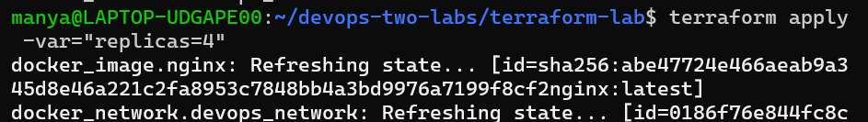
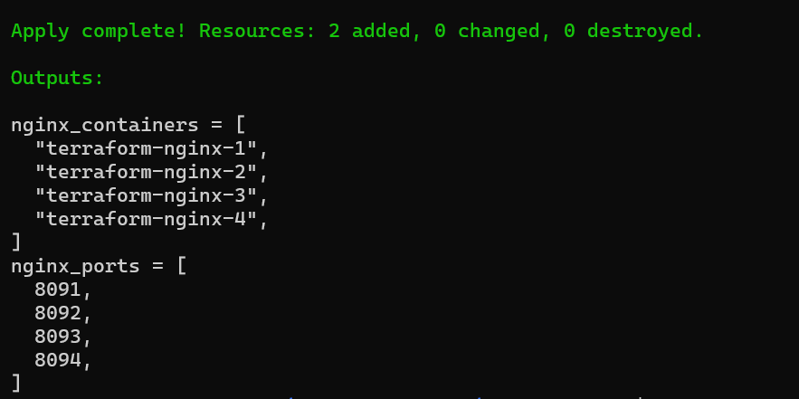
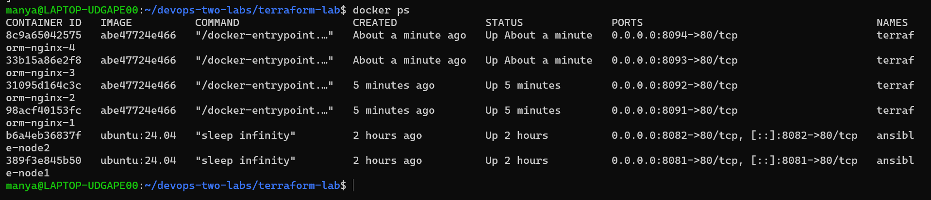

Step 14 : Verify the two new containers
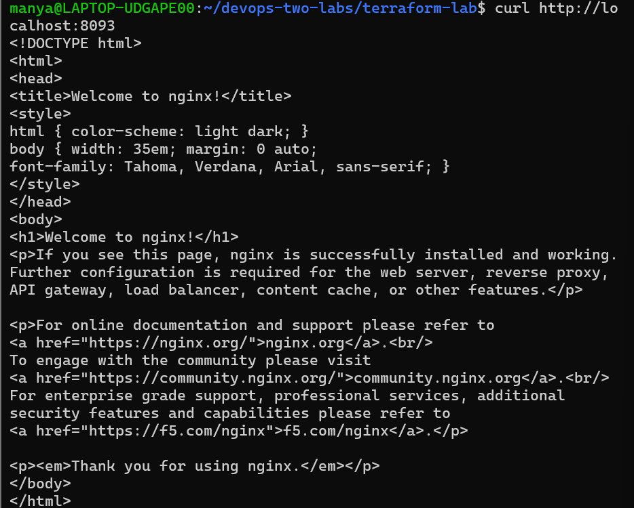
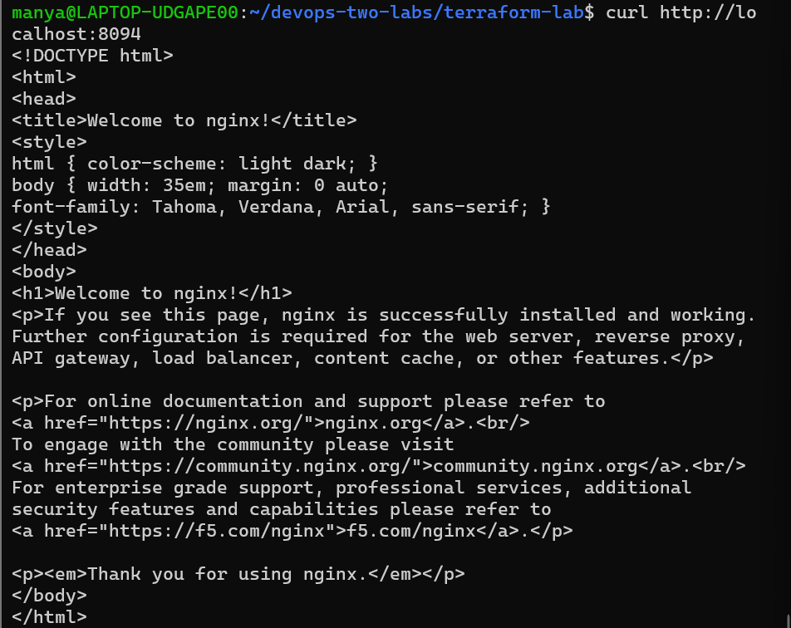

Step 15 : Open: http://localhost:8093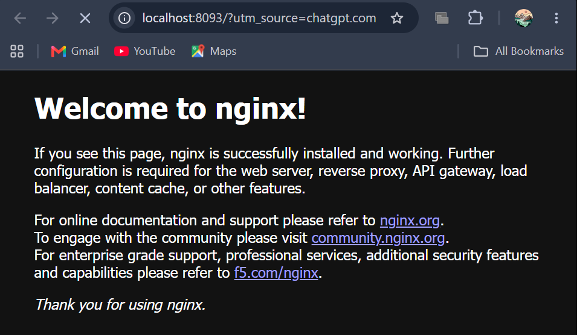

Step 16 : Open: http://localhost:8094
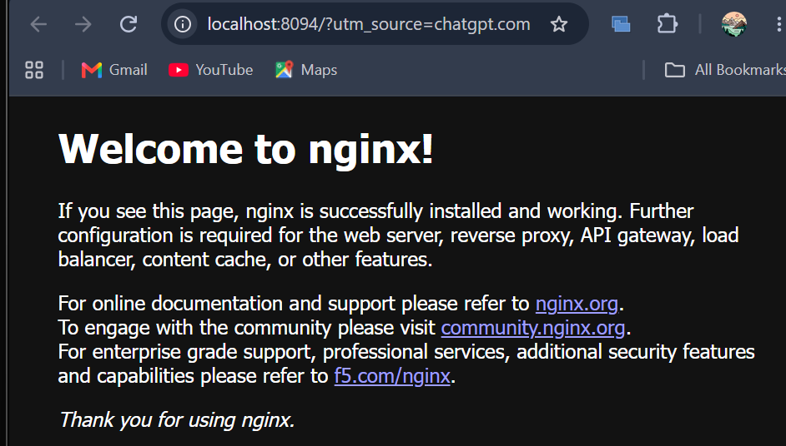

Step 17 : Verify Terraform knows about all 4. Run : terraform state list
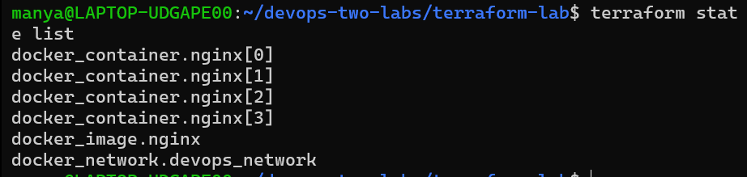

Step 18 : Verify Terraform outputs. Run : terraform output
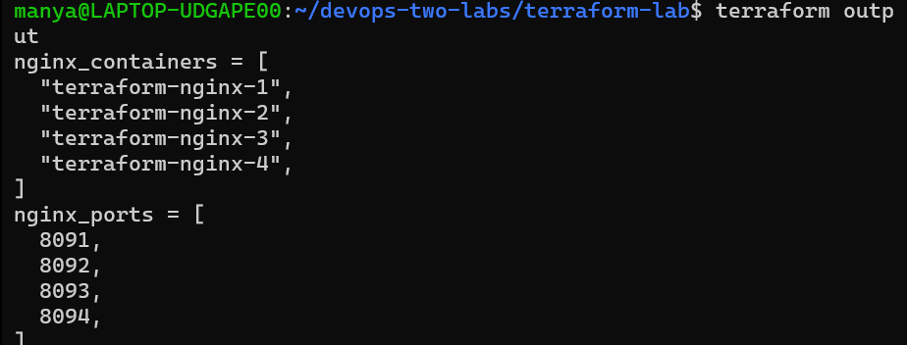

Step 19 : Demonstrate that there are no pending changes. Run : terraform plan -var="replicas=4"
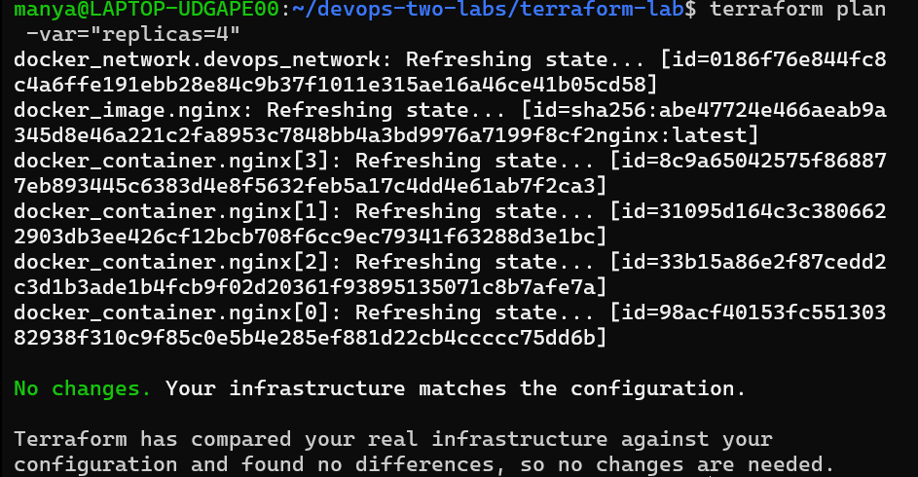

Step 20 : Cleanup- run: terraform destroy
