PES University – Dept. of CSE
Lab 1 Report
Requirements Engineering & UML Use-Case Modelling
Problem Statement #29 – Municipal Infrastructure Damage Reporting App
Domain: Smart Cities, Transport & Logistics
Actors: Citizen Reporter, Municipal Engineer, GIS Map Service

1. Problem Context & Overview
A citizen portal for reporting road potholes, broken streetlights, and water pipeline leaks using geotagged photos, with automated ticket dispatch to relevant municipal engineering departments.
Target Stakeholders / Actors: Citizen Reporter, Municipal Engineer, GIS Map Service (supporting system actor).

2. Requirements Table
Five functional requirements (FR-001–FR-005) and two non-functional requirements (NFR-001–NFR-002), each specifying an ID, Type, Description, Priority, measurable Acceptance Criteria, and Rationale.
Req ID | Type | Description | Priority | Acceptance Criteria | Rationale
FR-001 | Functional | The system shall extract EXIF GPS metadata from an uploaded damage photo and place the incident on the municipal GIS map. | High | Pass: a photo with valid EXIF GPS creates a map pin within 10 m of the embedded coordinates. Fail: no pin is shown or the error exceeds 10 m. | Accurate location enables the correct engineering division to receive the report quickly.
FR-002 | Functional | The system shall allow a citizen to select a damage category, enter a description, attach a photo, and provide a location by GPS or by manually dropping a map pin. | High | Pass: the report form accepts pothole, streetlight, or pipeline-leak category plus description and a GPS or manual map location. Fail: it permits submission without category or location. | A complete report gives engineers enough information to assess and act on the incident.
FR-003 | Functional | The system shall create a unique ticket and automatically dispatch it to Road Infrastructure, Streetlight Maintenance, or Water Engineering according to the selected category. | High | Pass: each submitted report receives a unique ticket ID and is routed to the matching division. Fail: the ticket has no ID or reaches an incorrect division. | Automatic dispatch reduces manual triage and speeds municipal response.
FR-004 | Functional | The system shall allow an authorized Municipal Engineer to review an assigned ticket and update its status as Acknowledged, In Progress, Resolved, or Rejected with a note. | Medium | Pass: an authorized engineer can save one of the four statuses and a note; the new status is visible on the ticket. Fail: an unauthorized user can update a ticket or the status is not saved. | Engineers need controlled workflow updates to manage field work and provide accountability.
FR-005 | Functional | The system shall allow a citizen to view the current status and history of a submitted ticket and receive a notification when its status changes. | Medium | Pass: entering a valid ticket ID displays the status history, and a notification is issued within 5 minutes of a saved status change. Fail: history is missing or no notification is issued in 5 minutes. | Status visibility keeps citizens informed and reduces duplicate reports or follow-up calls.
NFR-001 | Nonfunctional - Availability | The reporting portal shall support offline report drafting and automatically synchronize a saved draft when mobile connectivity resumes. | High | Pass: a report drafted without connectivity persists on the device and synchronizes within 60 seconds after a network connection is restored. Fail: the draft is lost or remains unsynchronized after 60 seconds. | Citizens may discover infrastructure damage in areas with poor or intermittent connectivity.
NFR-002 | Nonfunctional - Security | The reporting portal shall enforce role-based access and encrypt report data in transit using TLS 1.2 or later. | High | Pass: a Citizen account cannot access engineer-only ticket updates, and a TLS scan confirms TLS 1.2+ for report submission. Fail: unauthorized access succeeds or plaintext HTTP is accepted. | Reports include location data and operational information that require confidentiality and controlled access.

3. UML Use-Case Diagram
The diagram models 3 actors and 8 use cases, with 4 «include» relationships (mandatory reused behavior) and 1 «extend» relationship (optional/conditional behavior).
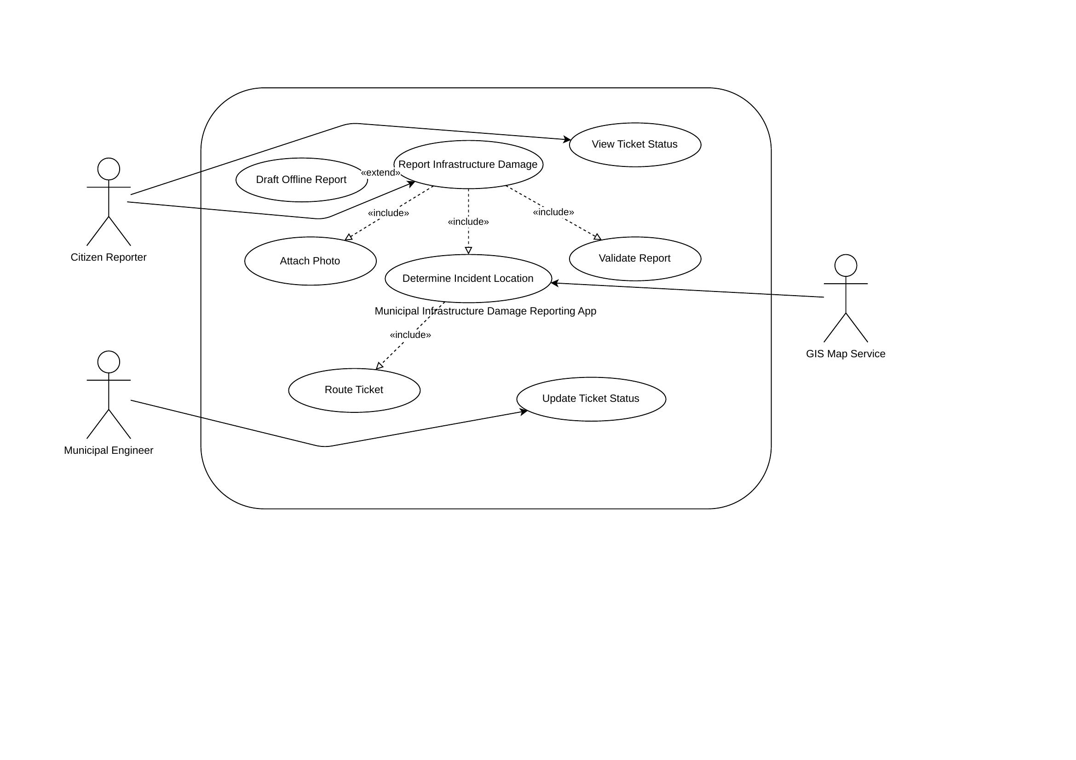
«include»: Report Infrastructure Damage always triggers Attach Photo, Determine Incident Location, and Validate Report; Determine Incident Location always triggers Route Ticket.
«extend»: Draft Offline Report optionally extends Report Infrastructure Damage when the citizen has no live connectivity.

4. Use-Case Flow Specification

UC-01: Report Infrastructure Damage
Primary Actor
Citizen Reporter
Supporting Actors
GIS Map Service; Municipal Engineer
Preconditions
The citizen can access the portal and has identified a pothole, broken streetlight, or water pipeline leak. The device has GPS access or the citizen can place a map pin.
Postconditions
A unique ticket is stored, routed to the matching municipal division, and a confirmation with the ticket ID is shown to the citizen.

Main Success Scenario
1. The citizen opens the portal and selects “Report Damage.”
2. The system displays the report form and requests a damage category, description, photo, and location.
3. The citizen selects pothole, broken streetlight, or water pipeline leak; enters a short description; and attaches a photo.
4. The system extracts EXIF GPS data from the photo and displays the incident location on the municipal GIS map.
5. The citizen verifies the shown location and submits the report.
6. The system validates the required details, creates a unique ticket, and dispatches it to the matching municipal engineering division.
7. The system stores the report and displays a confirmation containing the ticket ID and initial status “Submitted.”

Alternate Flow A1 — GPS metadata unavailable
A1.1 — At Step 4, if the uploaded photo contains no valid GPS data, the system informs the citizen that the location cannot be determined automatically.
A1.2 — The system displays the GIS map and asks the citizen to drop or adjust a manual location pin.
A1.3 — The citizen confirms the manual location; the use case resumes at Step 5.

