BIT GAYA OFFICIAL WEBSITE
A report submitted in partial fulfillment of the requirements for the award of
DIPLOMA
in
Computer Science Engineering
Submitted By
Manushankar Kumar (611741823020)
Mohan Kumar(611741823025)
Md Kaif(611741823035)
Sandeep kumar(611741823028)

Under the Supervision of

Guide
Er. Shambhu Chaupal
Co-Guide
Ms. Ruchi Kumari
(Mentor)


DEPARTMENT OF COMPUTER SCIENCE ENGINEERING
BUDHHA INSTITUTE OF TECHNOLOGY (GAYA)
INDUSTRIAL AREA, B-2, NH 83, GAYA, TIKUNA,BIHAR 823004

MAY 2026

BONAFIDE CERTIFICATE

Date: ……………

Certified that the dissertation entitled “Budhha Institute Of Technology Gaya Official Website” Submitted by Manushankar Kumar(1741823020), Mohan Kumar(1741823025), Md Kaif(1741823035), Sandeep Kumar(1741823028) to Buddha Institute of Technology, Gaya for the award of the degree of Diploma (Computer Science Engineering) has been accepted by the examination committee and that the student has successfully defended the dissertation in the viva-voce examination held today.

(Internal Examiner) (External Examiner)

DECLARATION

We, Manushankar Kumar(20), Mohan Kumar(25), Md Kaif(35), Sandeep Kumar(28), hereby declare that the Project Report entitled done by me under the guidance of Er Shambhu Chaupal, Ruchi Kumari at Buddha Institute of Technology Gaya is submitted in partial fulfillment of the requirements for the award of Diploma degree in Computer Science and Engineering.

Date :
Place :

- Manushankar kr 2. Mohan kr 3. Md Kaif 4. Sandeep Kr
(611741823020) (611741823025) (611741823035) (611741823028)

ACKNOWLEDGEMENT

I am pleased to acknowledge my sincere thanks to Board of Management of BIT Gaya for their kind encouragement in doing this project and for completing it successfully. I am grateful to them.
I convey my thanks to Neha Kumari Heads of the Department of Computer Science and Engineering for providing me necessary support and details at the right time during the progressive reviews.
I would like to express my sincere and deep sense of gratitude to my Project Guide for his valuable guidance, suggestions and constant encouragement paved way for the successful completion of my project work.
I wish to express my thanks to all Teaching and Non-teaching staff members of the Department of Computer Science and Engineering who were helpful in many ways for the completion the project

List Of Abbreviation

- BIT – Buddha Institute of Technology
- HTML – HyperText Markup Language
- CSS – Cascading Style Sheets
- JS – JavaScript
- UI – User Interface
- UX – User Experience
- URL – Uniform Resource Locator
- HTTP – HyperText Transfer Protocol
- WWW – World Wide Web
- DB – Database
- RWD – Responsive Web Design
- IDE – Integrated Development Environment
- VS Code – Visual Studio Code
- API – Application Programming Interface
- SBTE – State Board of Technical Education
- LMS – Learning Management System
- EMS – Examination Management System
- MNSBBY – Mukhyamantri Nischay Swayam Sahayata Bhatta Yojana
- DigiLocker – Digital Document Wallet by Government of India
- PDF – Portable Document Format

List Of Figures

Figure No. Page No.
Figure 1 ……………………………………………………………………………………………………. 17
Figure 2 ……………………………………………………………………………………….…………… 17
Figure 3 ……………………………………………………………………………………………………. 18
Figure 4 ………………………………………………………………………………………………….… 18
Figure 5 ……………………………………………………………………………………………………. 19
Figure 6…………………………………………………………………………………………………..… 19
Figure 7 ……………………………………………………………………………………………………. 20
Figure 8 ………………………………………………………………………………………………….… 20
Figure 9 ………………………………………………………………………………………………...….. 21
Figure 10 ……………………………………………………………………………………………….….. 21
Figure 11 …………………………………………………………………………………………….…….. 22
Figure 12 ………………………………………………………………………………………...………… 22
Figure 13 ………………………………………………………………………………………...………… 23
Figure 14 …………………………………………………………………………………...……………… 23
Figure 15 …………………………………………………………………………………..………………. 24
Figure 16 …………………………………………………………………………………...……………… 24
Figure 17 …………………………………………………………………………………...……………… 25
Figure 18 ………………………………………………………………………………...………………… 25
Figure 19 ……………………………………………………………………………...…………………… 26
Figure 20 …………………………………………………………………………….…………………….. 26
Figure 21 ……………………………………………………………...…………………………………… 27
Figure 22 …………………………………………………………….…………………………………….. 27
Figure 23 ……………………………………………………...…………………………………………… 28
Figure 24 …………………………………………………..………………………………………………. 28
Figure 25 ………………………………………………...………………………………………………… 29
Figure 26 ……………………………………………….………………………………………………….. 29
Figure 27 ……………………………………………...…………………………………………………… 30
Figure 28 ……………………………………..……………………………………………………………. 30

Figure 29 ………………………..…………………………………………………………………………. 31
Figure 30 ……………………….………………………………………………………………………….. 31
Figure 31 …………………...……………………………………………………………………………… 32
Figure 32 ……………….………………………………………………………………………………….. 32
Figure 33 ………...………………………………………………………………………………………… 33
Figure 34 ...………………………………………………………………………………………………… 33
Figure 35 …………………………………….…………………………………………………………….. 34
Figure 36 …………………………...……………………………………………………………………… 34
Figure 37 …………………...……………………………………………………………………………… 35
Figure 38 ……….………………………………………………………………………………………….. 35
Figure 39 ………………………………………………………….……………………………………….. 36
Figure 40 …………………………………………...……………………………………………………… 36
Figure 41 ……………………………...…………………………………………………………………… 37
Figure 42 ………………...………………………………………………………………………………… 37
Figure 43 …….……………………………………………………………………………………………..

ABSTRACT

The project titled “Official Website of Buddha Institute of Technology, Gaya (BIT Gaya)” has been developed with the objective of creating an informative, user-friendly, and responsive web platform for students, faculty members, administrative staff, and visitors. The website serves as a digital representation of the institute and provides comprehensive information about the college, its departments, academic programs, faculty members, and student services.
The primary goal of this project is to design a centralized digital system where students and staff can easily access important academic and institutional information. The website includes various essential pages such as Home, About Us, Departments, Faculty Details, Courses, Contact Page, and Gallery, which provide an overview of the institute’s academic environment, infrastructure, and educational facilities.
In addition to providing basic institutional information, the website also integrates several important student service sections. These include SBTE (State Board of Technical Education) link access, MNSBBY (Mukhyamantri Nischay Swayam Sahayata Bhatta Yojana) portal, Learning Management System (LMS), Examination Management System (EMS), Board Registration, Student Enrollment details, Examination Results, and DigiLocker integration. These features allow students to quickly access important academic portals and services without searching multiple platforms.
Furthermore, the website includes a Student Document Vault, which allows students to temporarily store and manage important documents in a secure digital space. It also provides access to Previous Year Question Papers (PYQ), helping students prepare effectively for their examinations. The Department and Teachers Detailed Page displays faculty information such as name, qualification, department, and contact details, enabling better communication between students and teachers.

Table Of Content

 | Topic | Page No
 | Title Page  Bonafied Certificate  Declaration  Acknowledgement  List Of Abbreviation  List Of Figures  Abstract  Table Of Content | i  ii  iii  iv  v  vi  vii  viii
Chapter 1 | Introduction :  - Introduction  - About the Institute  - Problem Statement  - Objectives Of the Project  - Scope Of the project  - Significance Of the Project  - Organization Of the Report | 1-3
Chapter 2 | Literature Review :  2.1 Introduction  2.2 Existing System  2.3 Study Of Existing System  2.4 Feature Of Existing System  2.5 Technology Used in Existing System  2.6 Limitation Of Existing Website  2.7 Need For the Proposed System  2.8 Summary Of Literature Review | 4-7
Chapter 3 | Methodology :  3.01 Introduction  3.02 Development Model  3.03 Requirment Analysis  3.04 Tools & Technologies Used  3.05 System Design  3.06 System Architecture  3.07 Data Flow Description  3.08 Flow Chart  3.09 Algorithm  3.10 Design Approach  3.11 Testing Strategy  3.12 Implementation Plan  3.13 Advantage Of the Methodology  3.14 Limitation Of the Methodology  3.15 Summary | 8-13
Chapter 4 | Implementation & Result:  4.01 Introduction  4.02 Development Enoviroment  4.03 Website Design  4.04 Page Implemented  4.05 Code Implemented  4.06 Form Submission Process  4.07 Output Screen/Snap  4.08 Feature Of the System  4.09 Testing & Debugging  4.10 Result  4.11 Advantage Of the System  4.12 Limitation  4.13 Summary | 14-40
Chapter 5 | Conclusion & Future Scope:  5.1 Intrduction  5.2 Conclusion  5.3 Achievements Of the Project  5.4 Limitation Of the Project  5.5 Future Scope  5.6 Overall Summary | 41-44
 | Refrences | 45

Chapter 1
INTRODUCTION
1.1 Introduction
In the modern digital era, the internet has become an essential part of our daily lives. Almost every organization, institution, and business relies on online platforms to communicate, share information, and provide services. Educational institutions are no exception, as they require an effective medium to present their academic offerings, infrastructure, and activities to students, parents, and other stakeholders.
A website acts as a digital identity of an institution. It provides a centralized platform where users can access important information such as courses offered, faculty details, admission procedures, infrastructure facilities, and contact details. A well-designed website enhances the visibility and reputation of the institution and helps in reaching a wider audience.
This project focuses on the design and development of an official website for Buddha Institute of Technology, Gaya (BIT GAYA). The main aim of this project is to create a responsive, user-friendly, and informative website that can efficiently deliver all necessary information to users.
The website is developed using modern web technologies such as HTML, CSS, and JavaScript. It is designed to be compatible with different devices, including desktops, tablets, and mobile phones, ensuring accessibility for all users.

1.2 About the Institute
Buddha Institute of Technology (BIT GAYA) is a well-known private engineering institution located in Gaya, Bihar. The institute was established in the year 2008 with the objective of providing quality technical education to students.
The institute is approved by the All India Council for Technical Education (AICTE) and is affiliated with a recognized university. BIT Gaya offers undergraduate and diploma programs in various engineering disciplines, including:
- Computer Science Engineering
- Mechanical Engineering
- Civil Engineering
- Electrical Engineering
- Electronics and Communication Engineering
The institute is committed to academic excellence and aims to develop skilled professionals who can contribute effectively to society and the industry. It provides modern infrastructure, experienced faculty, and a supportive learning environment to help students achieve their career goals.

1.3 Problem Statement
In many educational institutions, information is still shared through traditional methods such as notice boards, printed brochures, or manual communication. This approach has several limitations:
- Information is not easily accessible to everyone
- Updates are not delivered in real time
- Students need to visit the campus physically for details
- Communication between students and administration is slow
Due to these challenges, there is a need for a centralized digital platform where all information can be accessed quickly and efficiently. This project addresses these issues by developing a comprehensive college website.

1.4 Objective Of the Project
The main objectives of this project are as follows:
- To design and develop a professional website for BIT Gaya
- To provide accurate and up-to-date information about the institute
- To create a responsive design that works on all devices
- To improve communication between students and the institute
- To simplify access to academic and administrative information
- To provide an online platform for submitting queries or complaints

1.5 Scope Of the Project
The scope of this project is focused on developing a static and partially dynamic website for the college. The website includes multiple pages such as Home, About, Courses, and Contact.
The future scope of this project includes:
- Integration of an online admission system
- Development of a student login portal
- Implementation of an online fee payment system
- Addition of a complaint management system with status tracking
- Integration of AI-based chatbot for instant support
- Expansion into a mobile application

1.6 Significance Of the Project
This project is significant because it helps in digitalizing the information system of the institution. It reduces manual effort and improves efficiency in communication and data sharing.
Key benefits include:
- Easy access to information for students and parents
- Improved transparency
- Better communication between users and administration
- Enhanced institutional image and branding
- Time-saving and cost-effective solution

1.7 Organization Of the Report
This report is organized into five chapters:
- Chapter 1: Introduction – Provides an overview of the project
- Chapter 2: Literature Review – Discusses existing systems and their analysis
- Chapter 3: Methodology – Explains the development process and technologies used
- Chapter 4: Implementation & Result – Describes the working and results of the system
- Chapter 5: Conclusion & Future Scope – Summarizes the project and future improvements

Chapter 2
LITERATURE REVIEW
2.1 Introduction
The literature review is an important part of any project as it involves the study and analysis of existing systems, technologies, and solutions related to the proposed work. It helps in understanding the strengths and weaknesses of current systems and provides a foundation for developing a better solution.
In this project, the literature review focuses on analyzing existing college websites and online information systems. The aim is to identify common features, design patterns, and limitations in order to develop a more efficient and user-friendly website for Buddha Institute of Technology, Gaya.

2.2 Existing System
Traditionally, many educational institutions relied on offline methods to share information with students and parents
These methods include:
- Notice boards within the campus
- Printed brochures and pamphlets
- Manual inquiry systems
- Telephone communication
Although these methods were effective in the past, they have several limitations in the modern era

Limitations of Traditional System
- Information is not accessible remotely
- Updates are slow and not real-time
- Requires physical presence in the institution
- Difficult to manage large amounts of data
- Time-consuming and inefficient
Due to these issues, there is a growing need for digital systems such as websites

2.3 Study Of Existing Collage Website
To understand how modern college websites function, several existing websites were studied. These include:
- Government college websites (IITs, NITs)
- Private engineering college websites
- University portals
The study focused on their structure, design, features, and usability

2.4 Feature Of Existing Website
After analyzing multiple college websites, the following common features were observed:

1. Home Page
- Provides an overview of the institution
- Includes banners, announcements, and highlights

2. About Section
- Contains history, vision, and mission of the institution

3. Courses/Programs
- Lists available courses with details

4. Faculty Information
- Displays details of teaching staff

5. Admission Information
- Provides guidelines for admission process

6. Contact Section
- Includes address, phone number, and email
- Often includes a contact form

7. Responsive Design
- Websites are designed to work on mobile devices

2.5 Technology Used In Existing System
Most modern websites use the following technologies:

Frontend Technologies
- HTML (Structure of web pages)
- CSS (Styling and layout)
- JavaScript (Interactivity)

Backend Technologies
- PHP
- Node.js
- Python (Django/Flask)

Databases
- MySQL
- MongoDB
These technologies help in building dynamic and scalable websites

2.6 Limitation Of Existing Website
Despite having many features, existing websites also have several limitations:
- Complex navigation that confuses users
- Slow loading speed due to heavy content
- Poor mobile responsiveness in some cases
- Outdated design and user interface
- Lack of interactive features
- Limited accessibility options
These limitations affect user experience and reduce the effectiveness of the website

2.7 Need For the Proposed System
Based on the analysis of existing systems, there is a clear need for an improved solution
The proposed website aims to overcome the limitations by:
- Providing a simple and clean user interface
- Ensuring fast loading speed
- Making the website fully responsive
- Offering easy navigation
- Including interactive features such as forms
- Improving accessibility for all users

2.8 Summary Of Literature Review
The literature review highlights that while many institutions have adopted websites, there is still room for improvement in terms of usability, performance, and accessibility.
The study of existing systems helped in identifying key features that should be included in the proposed system, as well as the limitations that need to be addressed.
Based on this analysis, the proposed website for Buddha Institute of Technology, Gaya is designed to provide a better user experience, improved performance, and enhanced functionality.

Chapter 3
METHODOLOGY
3.01 Introduction
Methodology refers to the systematic approach used to develop the project. It includes the planning, design, development, testing, and implementation phases of the system.
For the development of the Official Website of Buddha Institute of Technology, Gaya (BIT GAYA), a structured approach has been followed to ensure efficiency, reliability, and quality.
This chapter explains the development model, tools and technologies used, system design, and overall workflow of the project

3.02 Development Model
The project follows the Waterfall Model, which is a linear and sequential software development approach. Each phase must be completed before moving to the next.

Phases of Waterfall Model:

1. Requirement Analysis
- Understanding user needs
- Identifying features required in the website

2. System Design
- Designing layout and structure
- Planning website pages and navigation

3. Implementation (Development)
- Writing code using HTML, CSS, JavaScript
- Creating different pages

4. Testing
- Checking for errors and bugs
- Ensuring responsiveness

5. Deployment
- Making the website live
- Hosting on a server

3.03 Requirment Analysis
Requirement analysis is the first and most important step in the development process. It helps in identifying what the user expects from the system.

Functional Requirements
- Display college information
- Show courses and details
- Provide contact form
- Complaint submission system
- Generate unique complaint ID

Non-Functional Requirements
- Fast loading speed
- Mobile-friendly design
- User-friendly interface
- Security and data protection

3.04 Tools & Technologies Used
The project is developed using modern web technologies.

Frontend Technologies
- HTML (HyperText Markup Language):
Used to create the structure of web pages
- CSS (Cascading Style Sheets):
Used for styling and layout design
- JavaScript:
Used for interactivity and dynamic behavior

Backend Technologies (Optional)
- Google Apps Script :
Used to handle form submission and email sending

Database
- Google Sheets:
Used to store form and complaint data

3.05 System Design
System design defines how the system is structured and how different components interact.

Modules of the System
- Home Module
  - Displays overview and highlights
- About Module
  - Contains institute information
- Courses Module
  - Displays course details
- Contact Module
  - Allows users to send messages
- Complaint Module
  - Enables users to submit complaints
  - Generates unique complaint ID

3.06 System Architecture
The system follows a simple web architecture:
User → Web Browser → Website → Server → Database
- The user interacts with the website through a browser
- The website processes the request
- Data is stored in the database

3.07 Data Flow Description
The data flow in the system is as follows:
- User opens the website
- User navigates through pages
- User fills out a form (contact/complaint)
- Data is sent to the server
- Data is stored in Google Sheets
- Confirmation message is displayed
3.08 Flow Chart

Start
↓
Open Website
↓
Select Page
↓
View Information
↓
Fill Form
↓
Submit Data
↓
Store in Database
↓
Display Confirmation
↓
End

3.09 Algorithm

Step 1: Start
Step 2: Open website
Step 3: Display homepage
Step 4: User selects required page
Step 5: If form is submitted → process data
Step 6: Generate complaint ID (if complaint)
Step 7: Store data in database
Step 8: Show success message
Step 9: End

3.10 Design Approach
The website is designed using a responsive design approach to ensure compatibility with all devices.

Key Design Principles:
- Simplicity
- Consistency
- Accessibility
- Responsiveness

3.11 Testing Strategy
Testing is performed to ensure the system works correctly.

Types of Testing:
- Functional Testing:
Checks whether all features work properly
- UI Testing:
Ensures proper layout and design
- Responsive Testing:
Checks compatibility with mobile devices
- Performance Testing:
Ensures fast loading speed

3.12 Implementation Plan
The implementation process includes:
- Creating HTML structure
- Designing with CSS
- Adding interactivity using JavaScript
- Integrating backend (if needed)
- Testing and debugging
- Final deployment

3.13 Advantages Of the Methodology
• Simple and easy to understand
• Well-structured development process
• Easy to manage and track progress
• Ensures quality output

3.14 Limitation Of the Methodology

• Less flexibility for changes
• Difficult to modify once development starts
• Not suitable for very large dynamic systems

3.15 Summary

The methodology used in this project provides a clear and structured approach to developing the website. The use of the Waterfall Model ensures that each phase is completed systematically, resulting in a well-organized and efficient system.

Chapter 4
IMPLEMENTATION & RESULT
4.01 Introduction
This chapter describes the practical implementation of the project “Official Website of Buddha Institute of Technology, Gaya (BIT GAYA)” and presents the results obtained after development.
It includes details about website design, development process, modules, features, and system performance. The implementation focuses on creating a responsive, user-friendly, and functional website.

4.02 Development Enoviroment
The project was developed using the following tools and environment:

Software Requirements
- Code Editor: Visual Studio Code
- Web Browser: Google Chrome / Microsoft Edge
- Operating System: Windows 10/11

Hardware Requirements
- Processor: Intel i3 or above
- RAM: Minimum 4 GB
- Storage: Minimum 10 GB free space

4.03 Website Design
The website is designed using modern UI/UX principles to ensure simplicity and ease of use.

Design Features:
- Clean and simple layout
- Responsive design for mobile and desktop
- Easy navigation menu
- Attractive color combination
- Proper alignment and spacing
The design ensures that users can easily access information without confusion.

4.04 Page Implemented
The website consists of multiple pages, each serving a specific purpose

4.4.1 Home Page
The Home Page is the main landing page of the website.
Features:
- Navigation bar
- Banner/hero section
- Brief introduction of the institute
- Highlight sections
4.4.2 About Page
his page provides detailed information about the institute.
Contents:
- History of BIT Gaya
- Vision and mission
- Institutional overview
4.4.3 Course Page
This page displays the courses offered by the institute.
Features:
- List of engineering branches
- Course descriptions
- Duration and eligibility
4.4.4 Contact Page
This page allows users to connect with the institute.
Features:
- Contact form
- Address and email details
- Phone number
4.4.5 Complaint Page
This is an important feature of the project.
Features:
- Complaint submission form
- Automatic complaint ID generation
- Data stored in Google Sheets
- Status tracking (Pending / Solved)

4.05 Code Implemented
The website is developed using HTML, CSS, and JavaScript.

4.5.1 HTML Example :

<!DOCTYPE html>
<html>
<head>
<title>BIT Gaya</title>
</head>
<body>
<h1>Welcome to BIT Gaya</h1>
</body>
</html>

4.5.2 CSS Example :

body {
font-family: Arial;
background-color: #f4f4f4;
}

4.5.3 Javascript Example :

function showMessage() {
alert("Form Submitted Successfully!");
}

4.06 Form Submission Process
The form submission process works as follows:
- User fills the form
- Clicks submit button
- Data is sent to backend (Google Apps Script)
- Data stored in Google Sheets
- Confirmation message displayed

4.07 Output Screen/Snap/ScreenShot

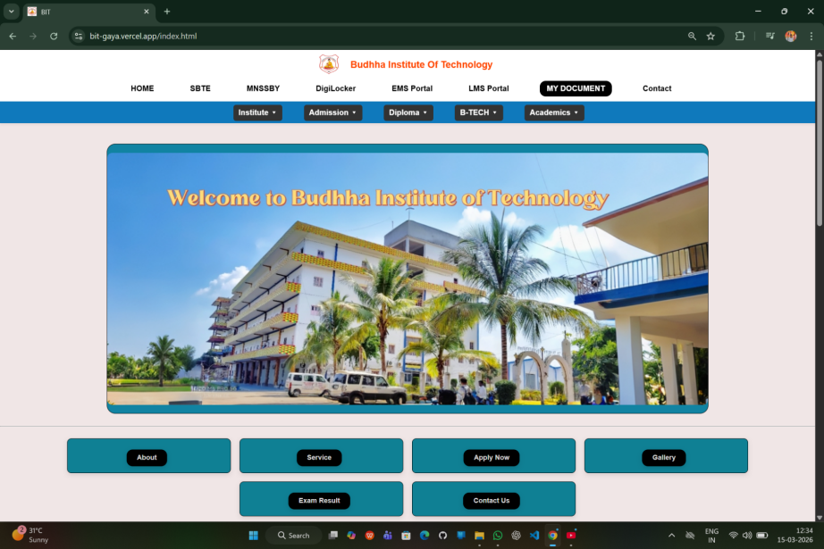
Figure :- 01

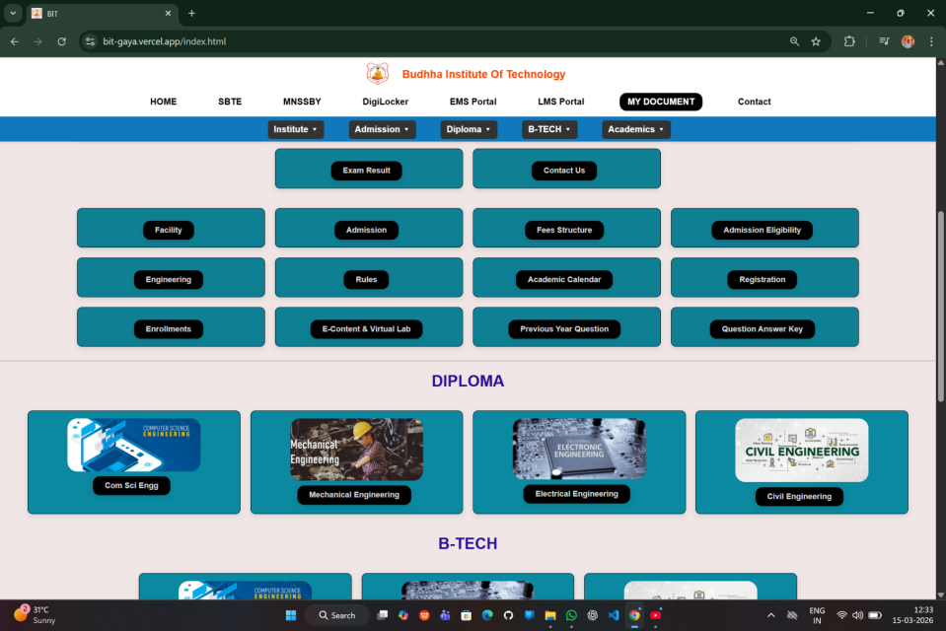

Figure :- 02
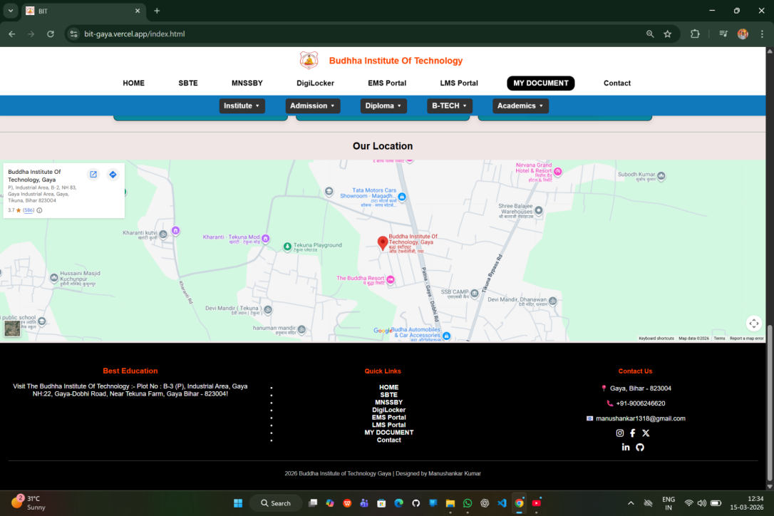
Figure :- 03

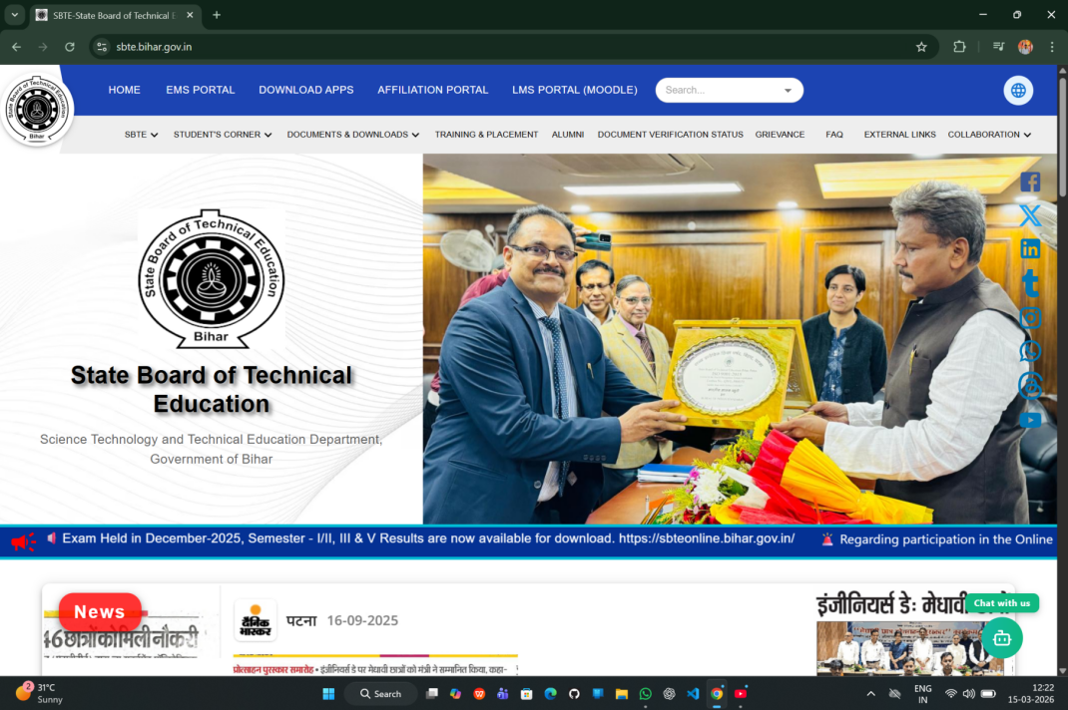

Figure :- 04
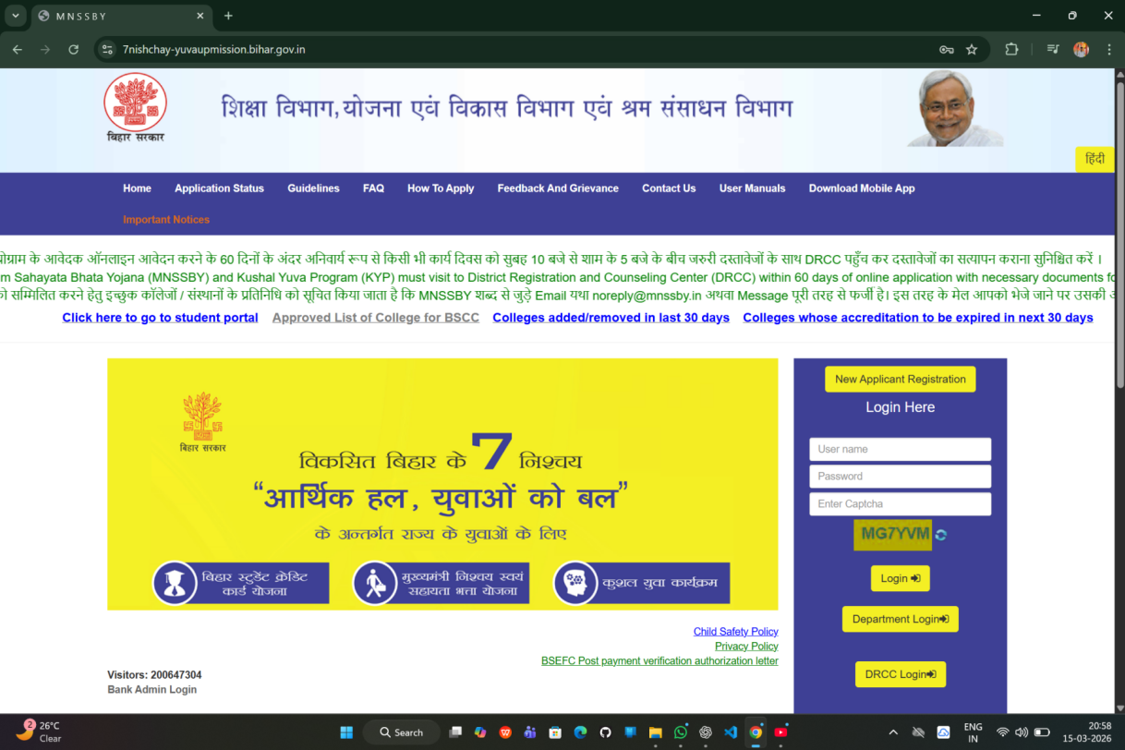
Figure :- 05

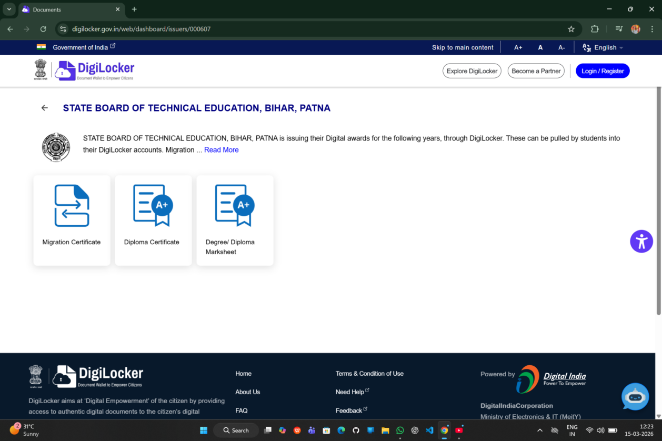
Figure :-06
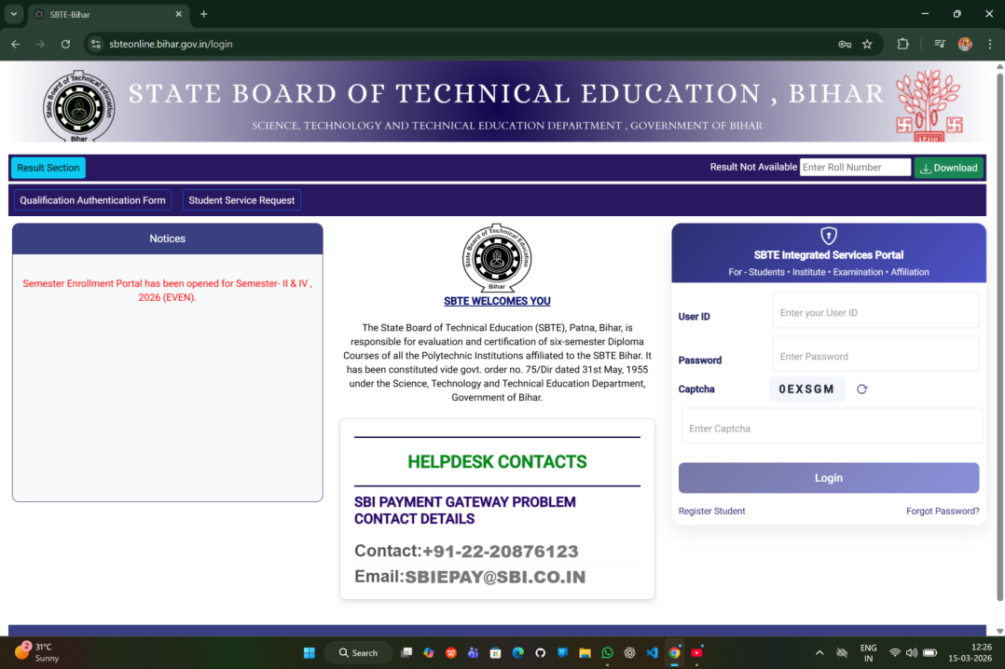
Figure :- 07

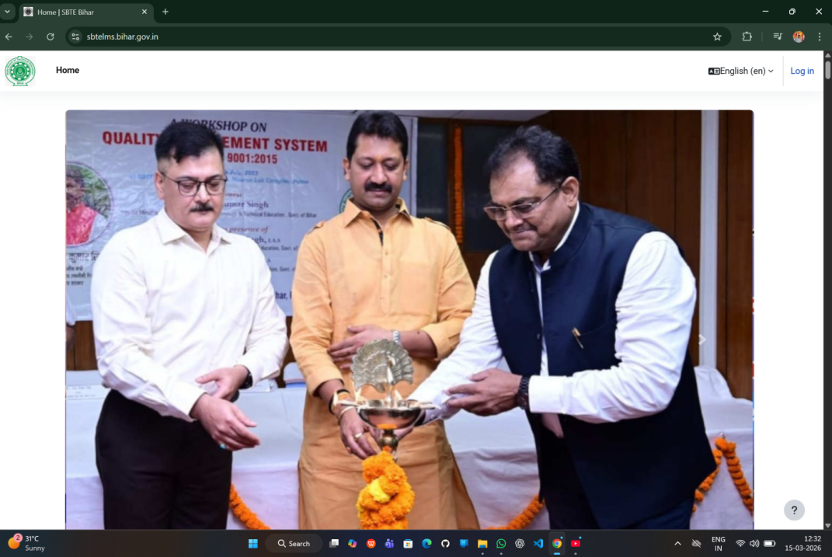
Figure :- 08

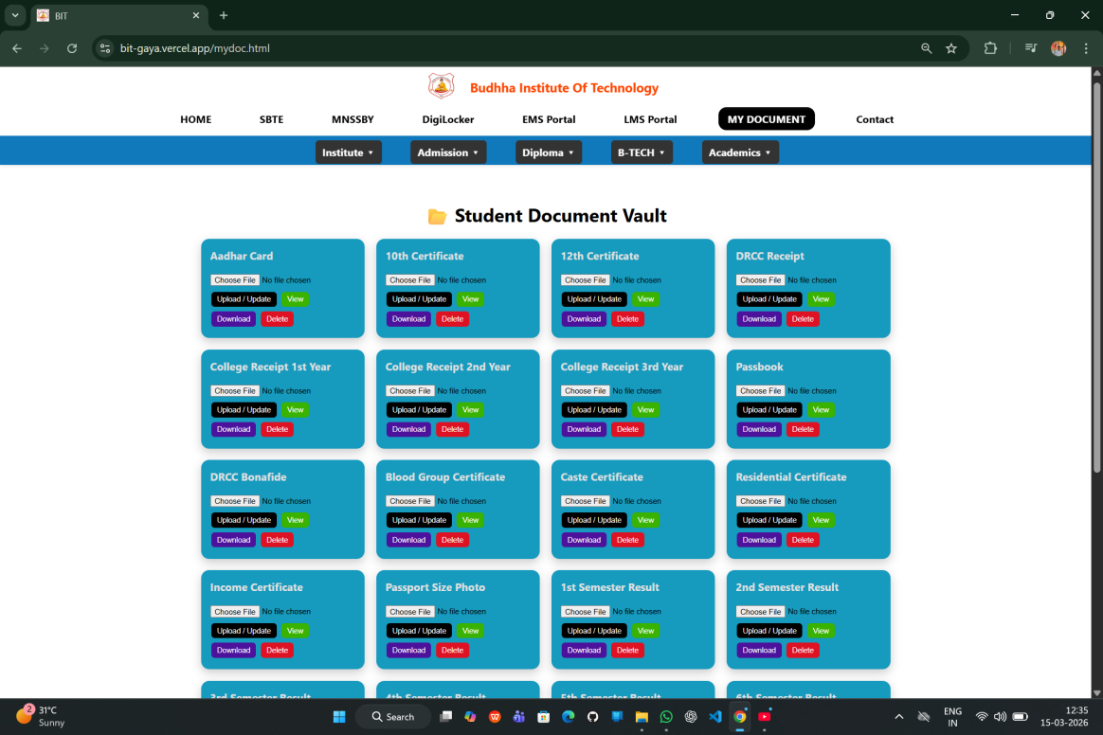

Figure :- 09

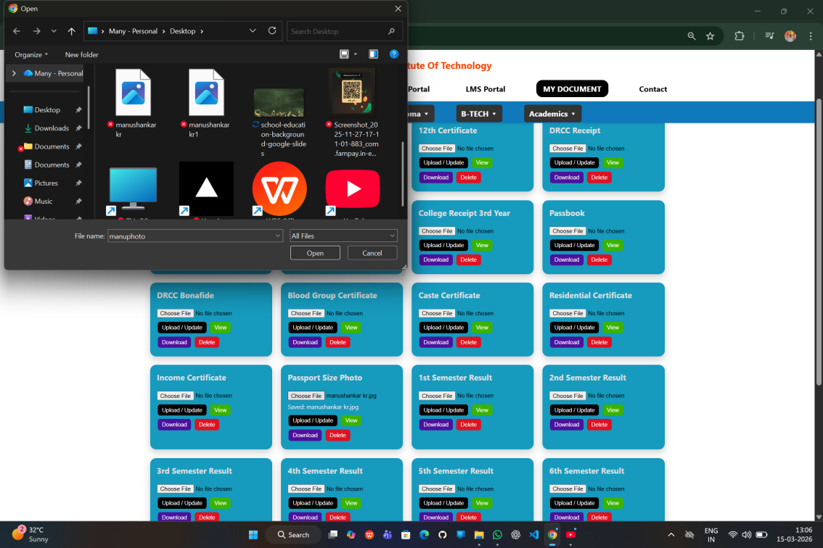

Figure :- 10
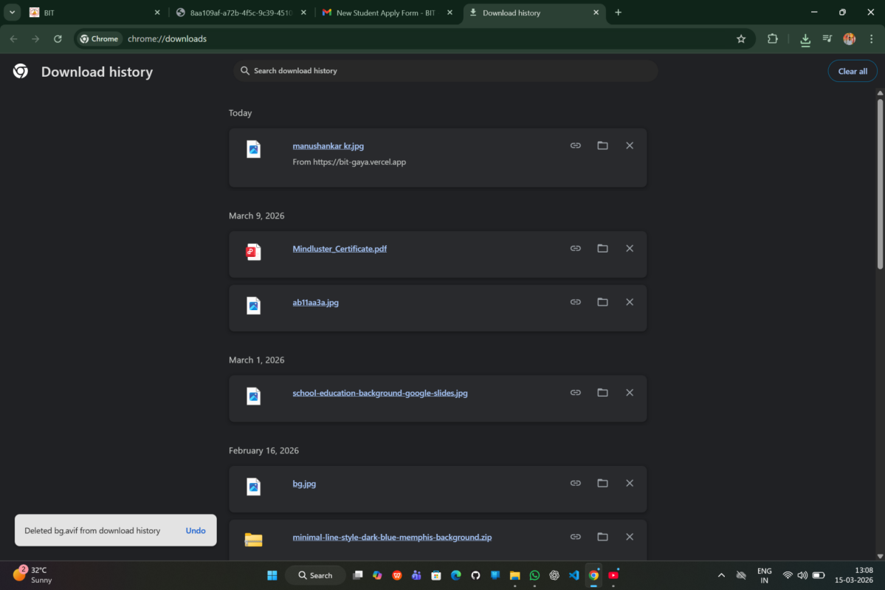
Figure :- 11

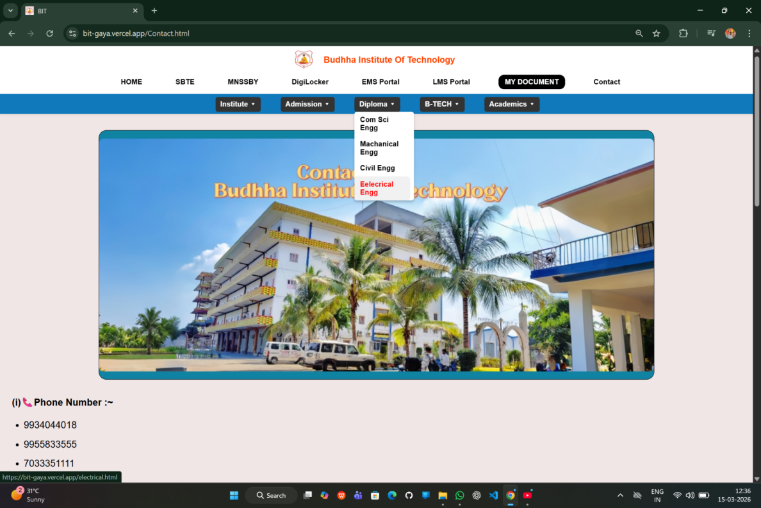
Figure :- 12

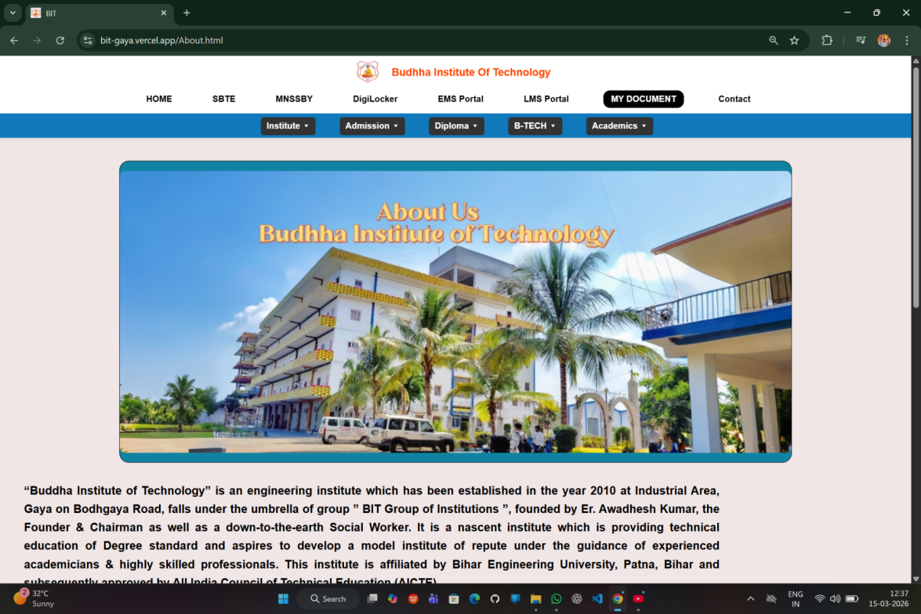
Figure :- 13

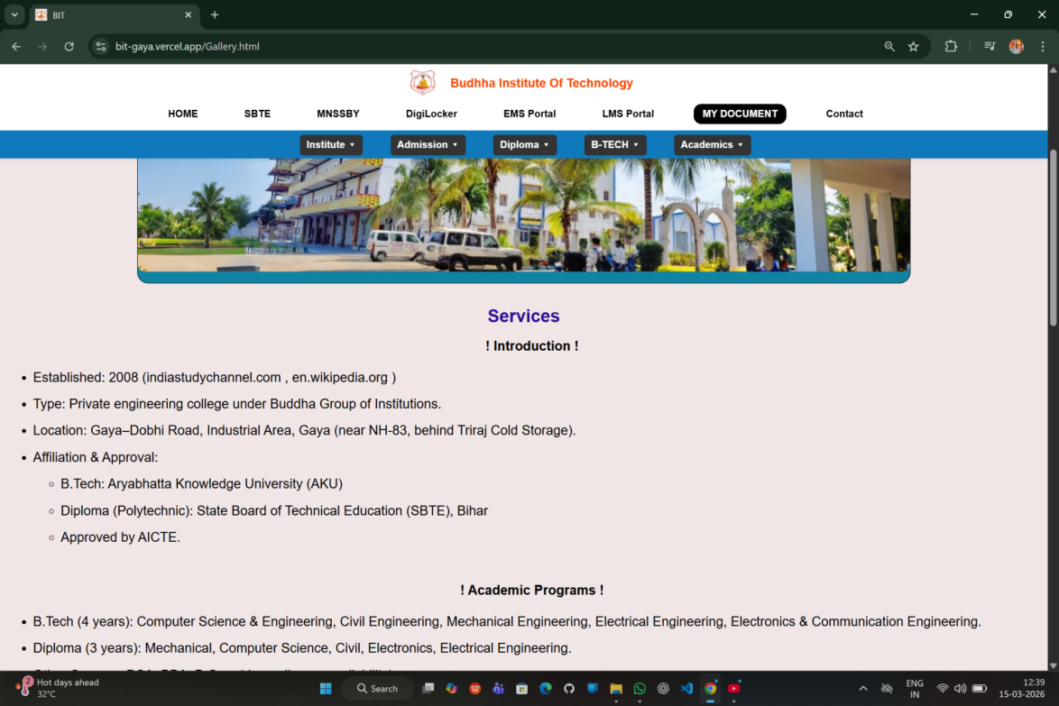
Figure :- 14
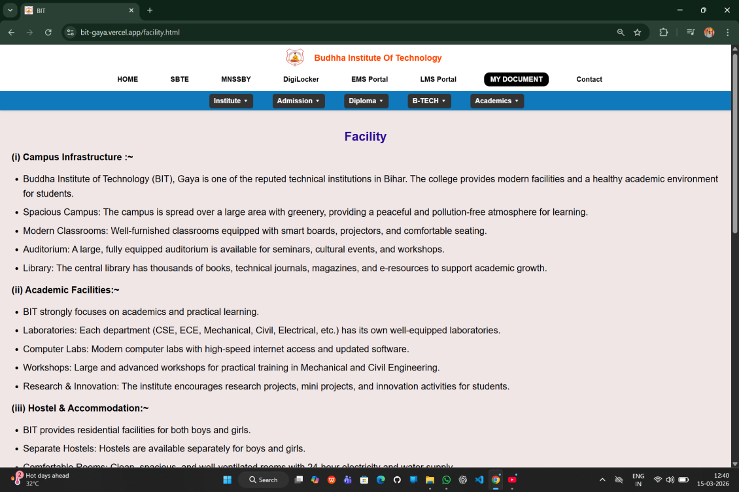
Figure :- 15

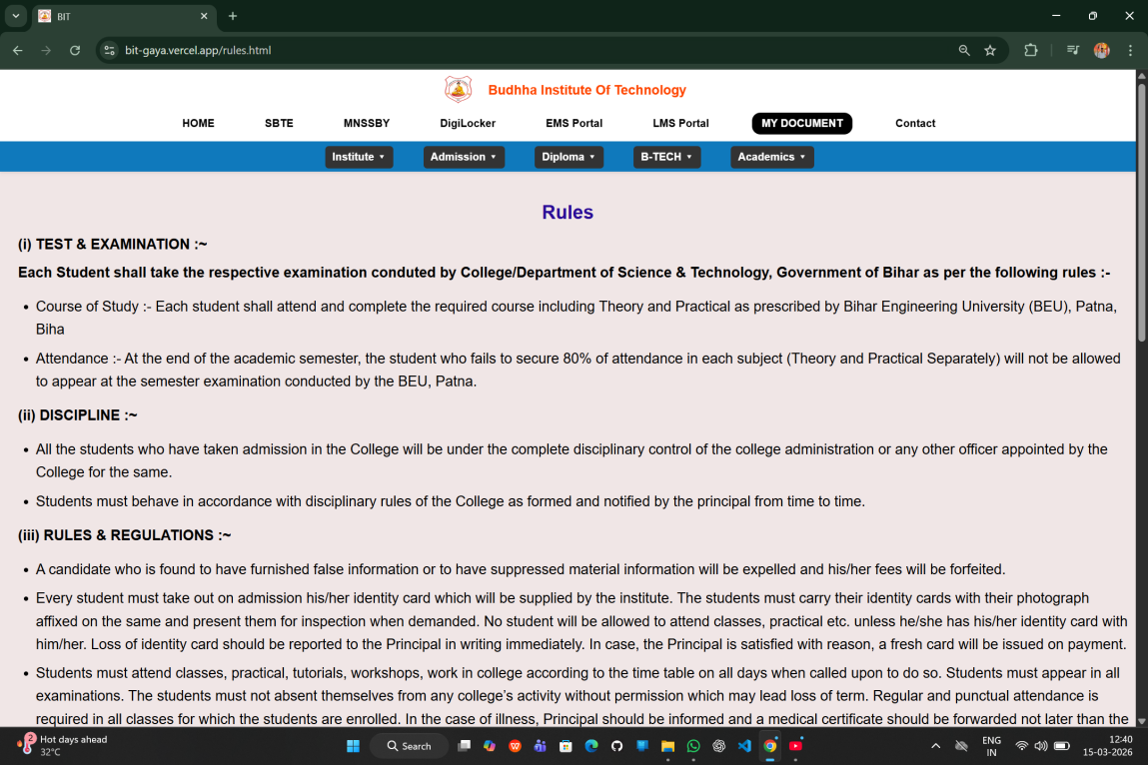
Figure :- 16
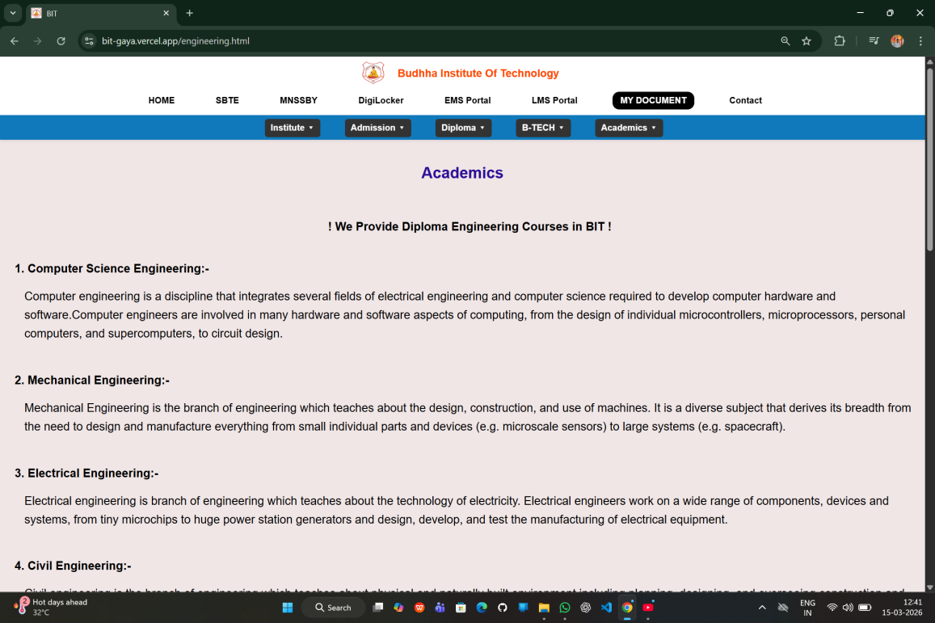
Figure :- 17

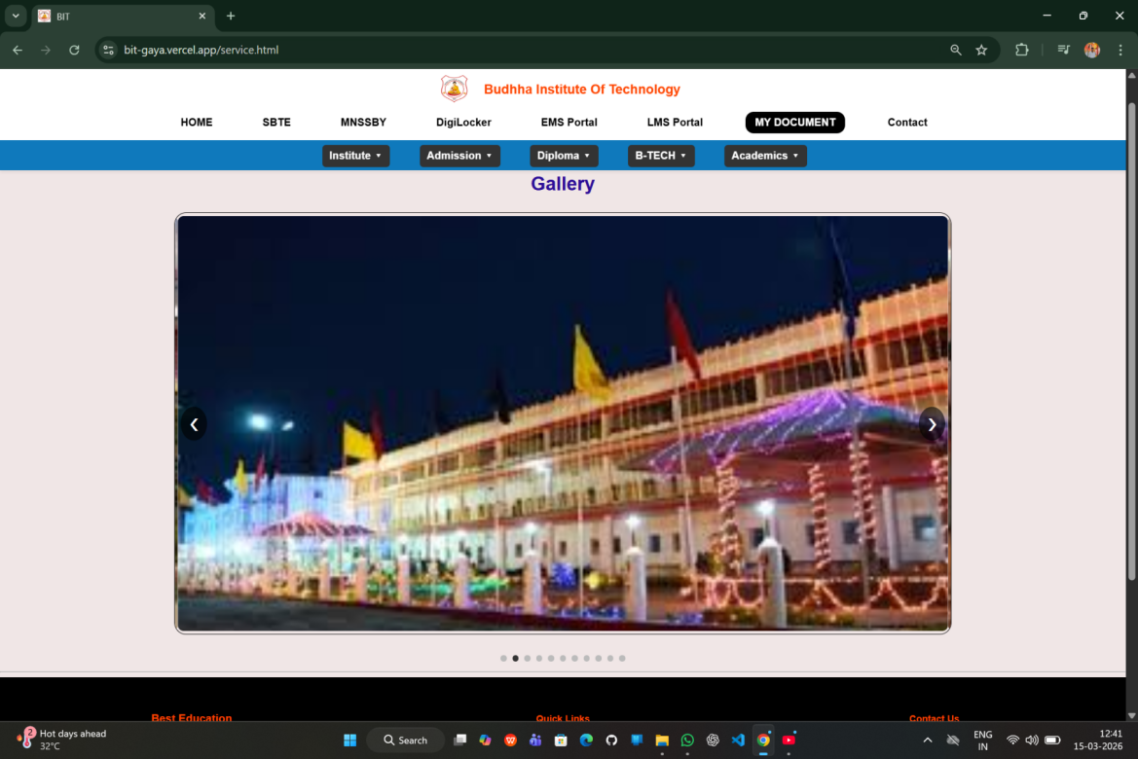
Figure :- 18
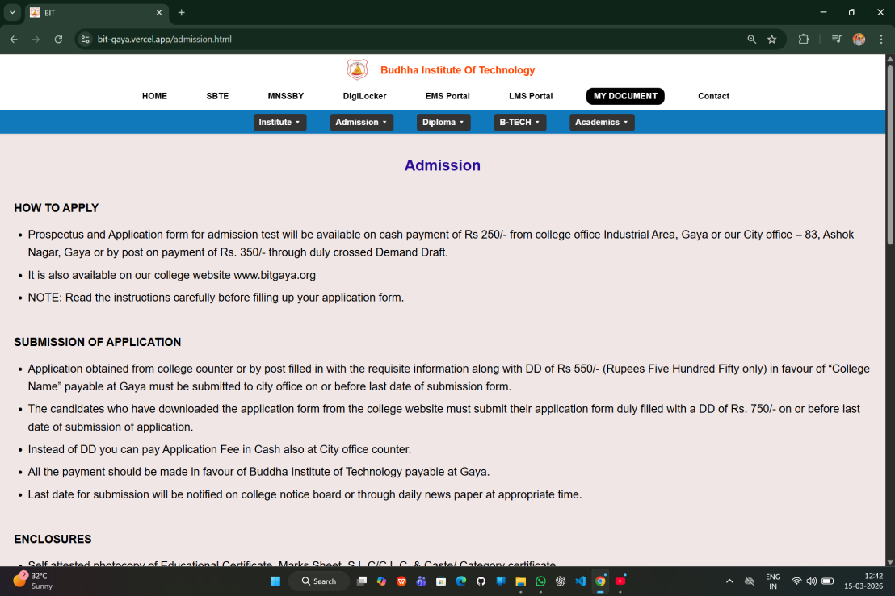
Figure :- 19

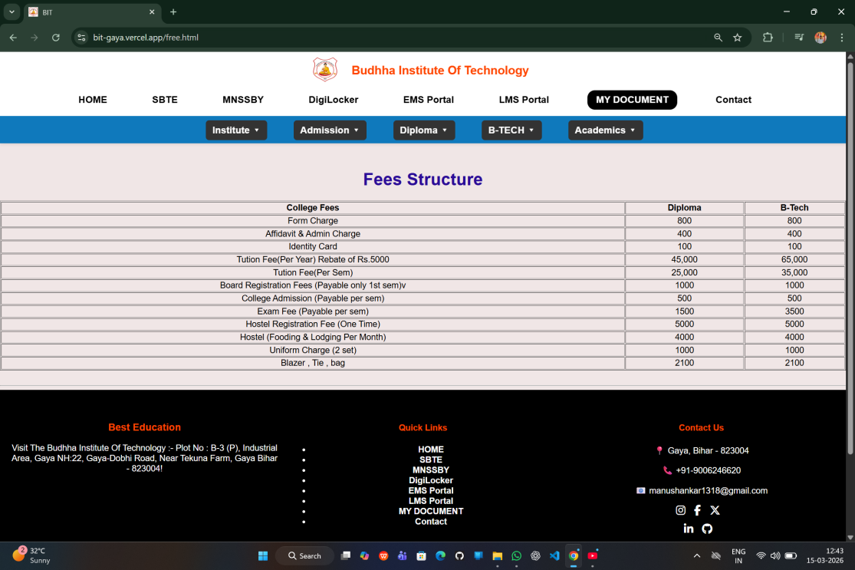
Figure :- 20
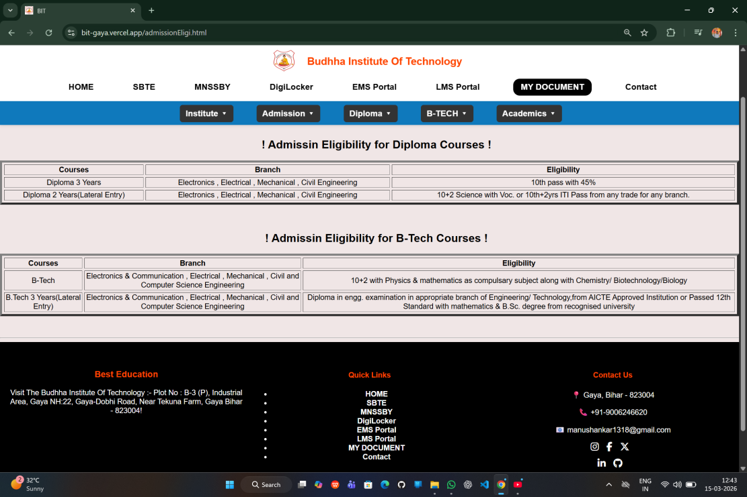
Figure :- 21

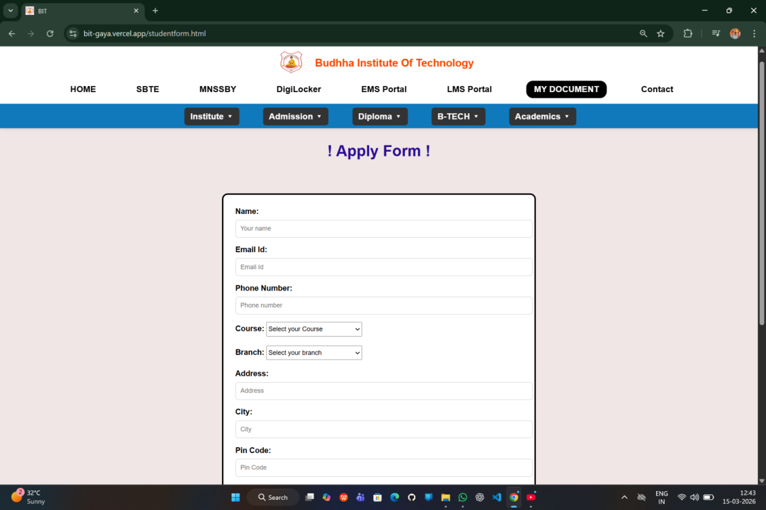
Figure :- 22
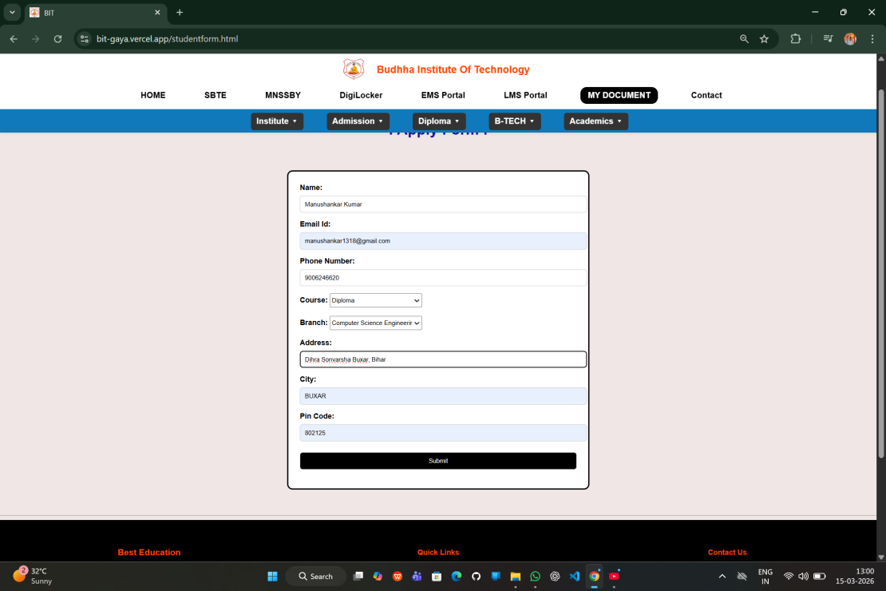
Figure :- 23

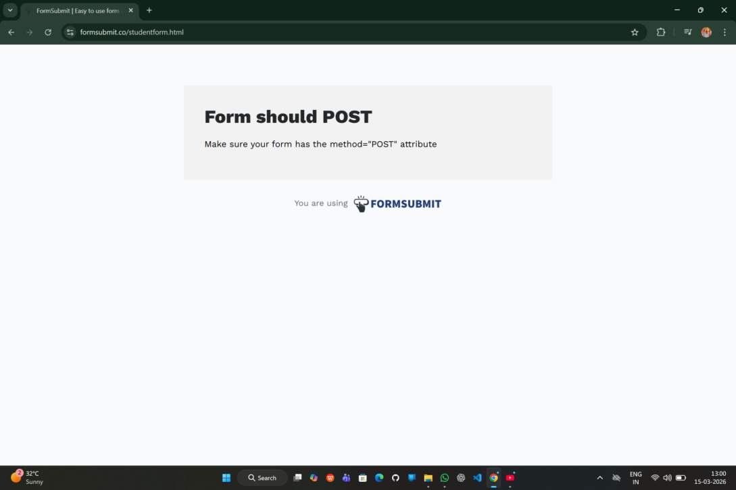
Figure :- 24
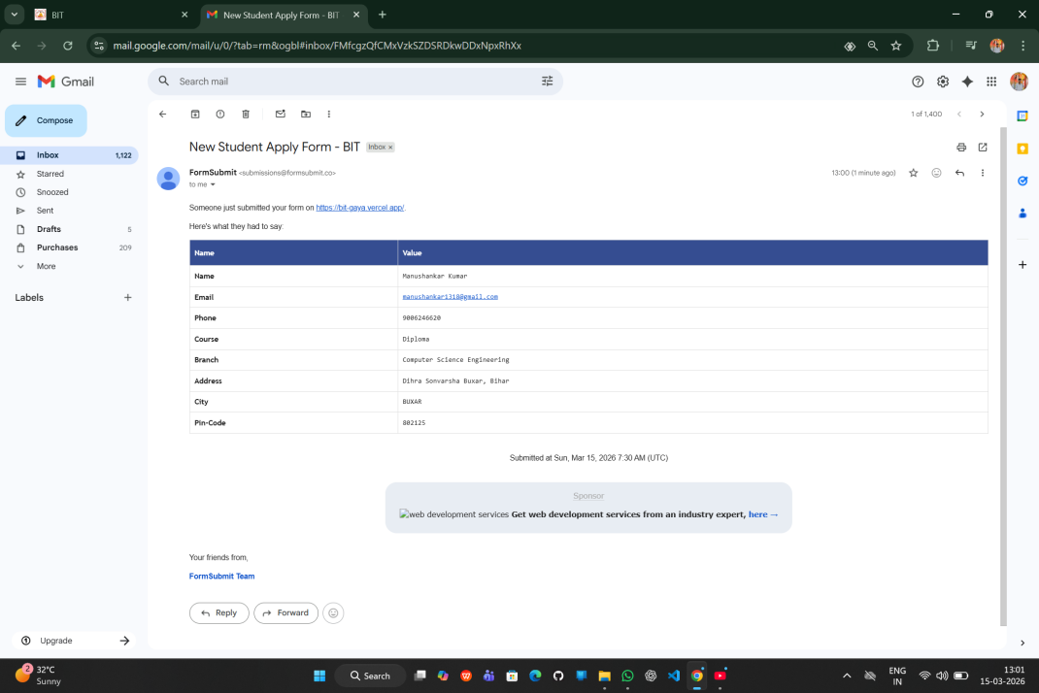
Figure :- 25

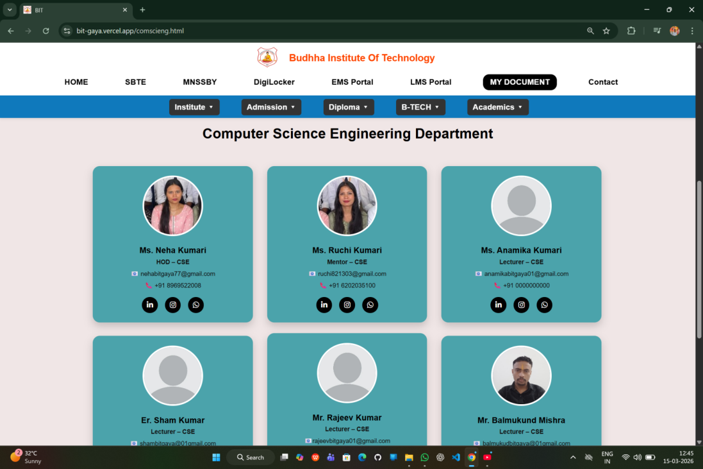
Figure :- 26
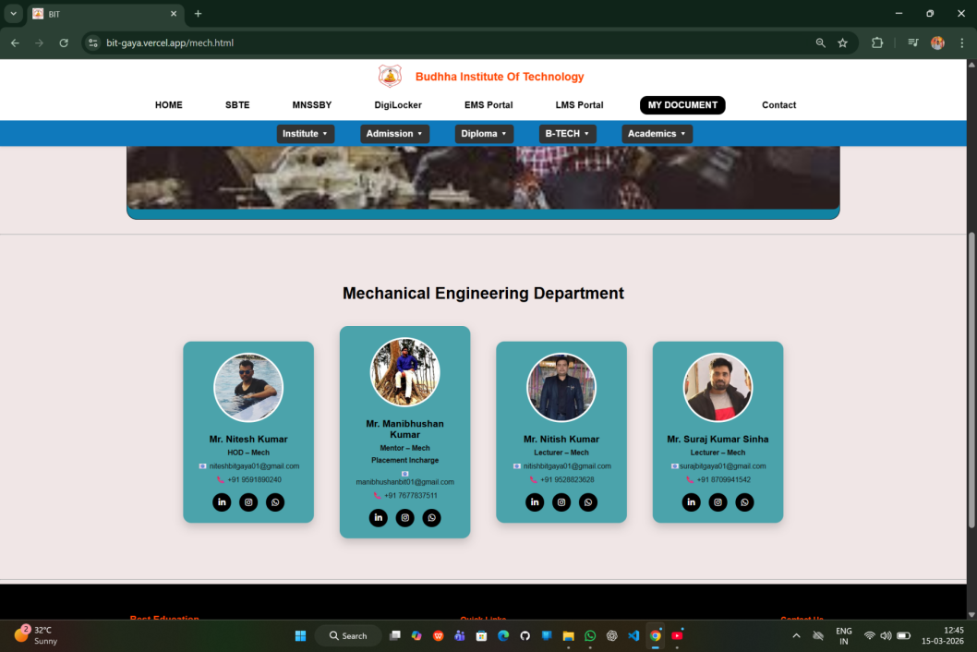
Figure :- 27

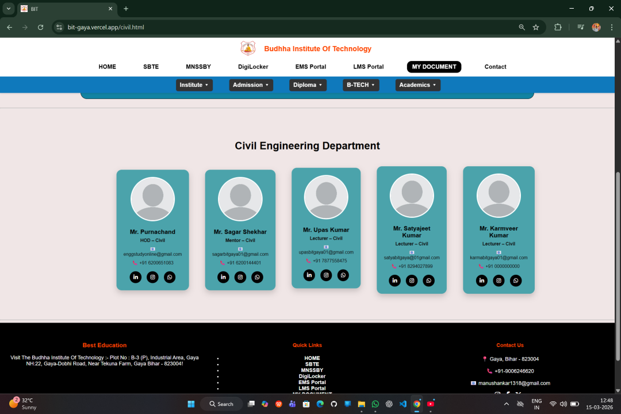
Figure :- 28
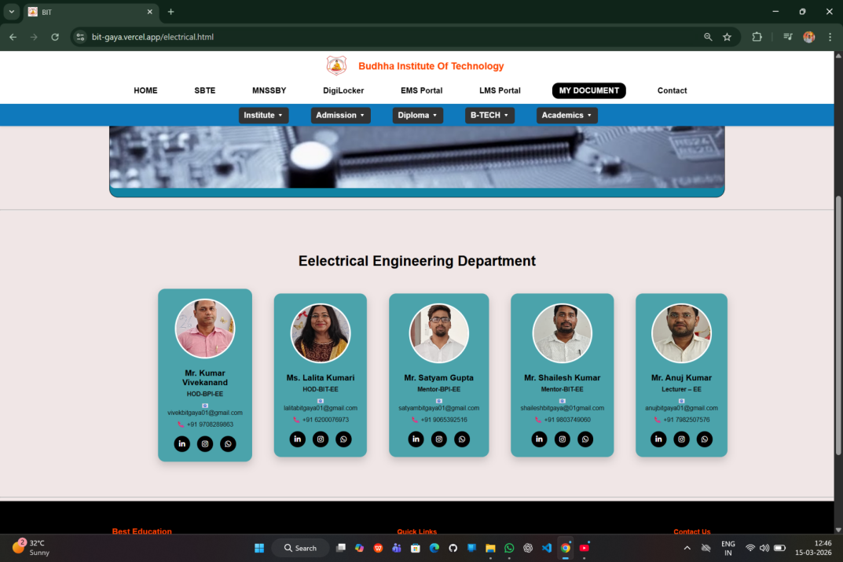
Figure :- 29

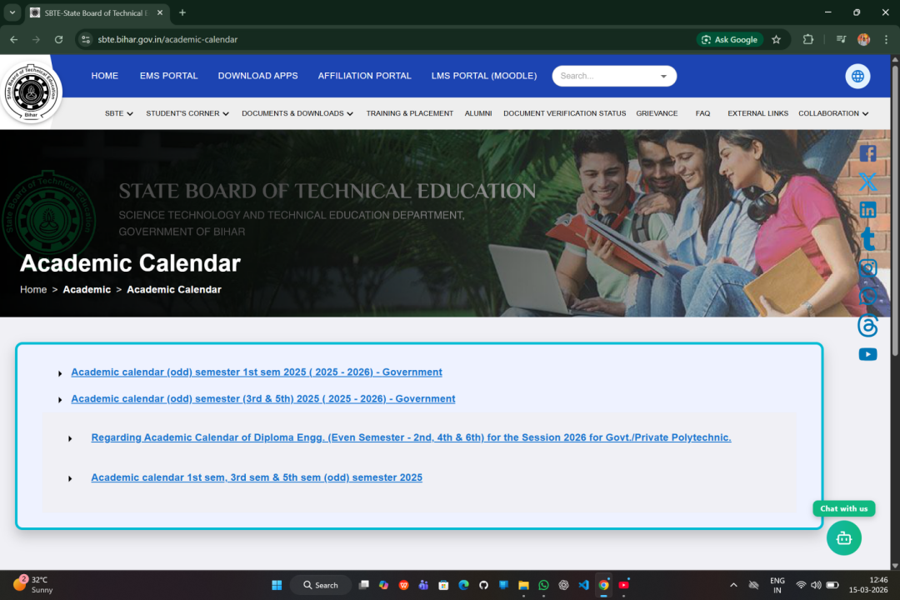
Figure :- 30
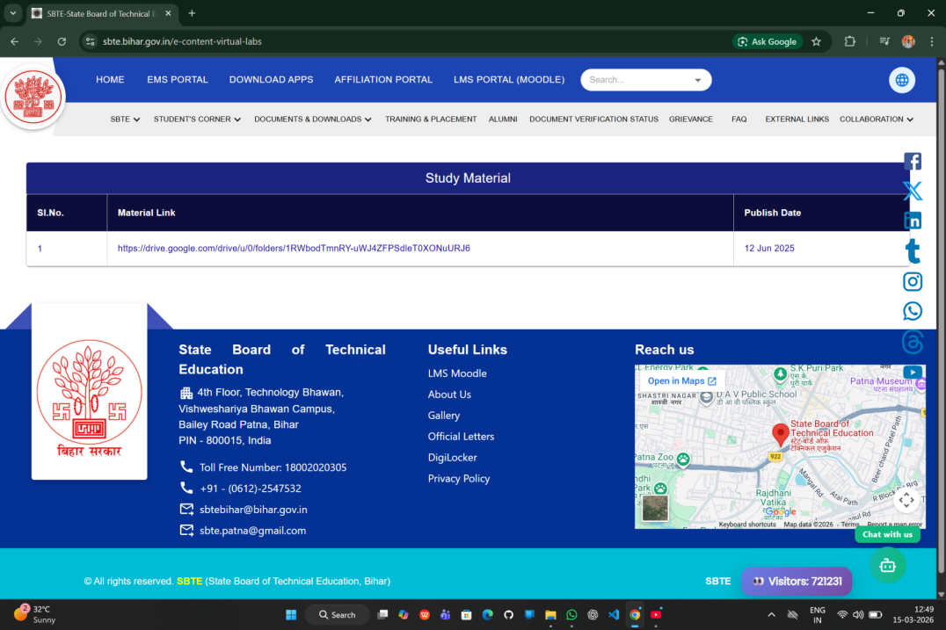
Figure :- 31

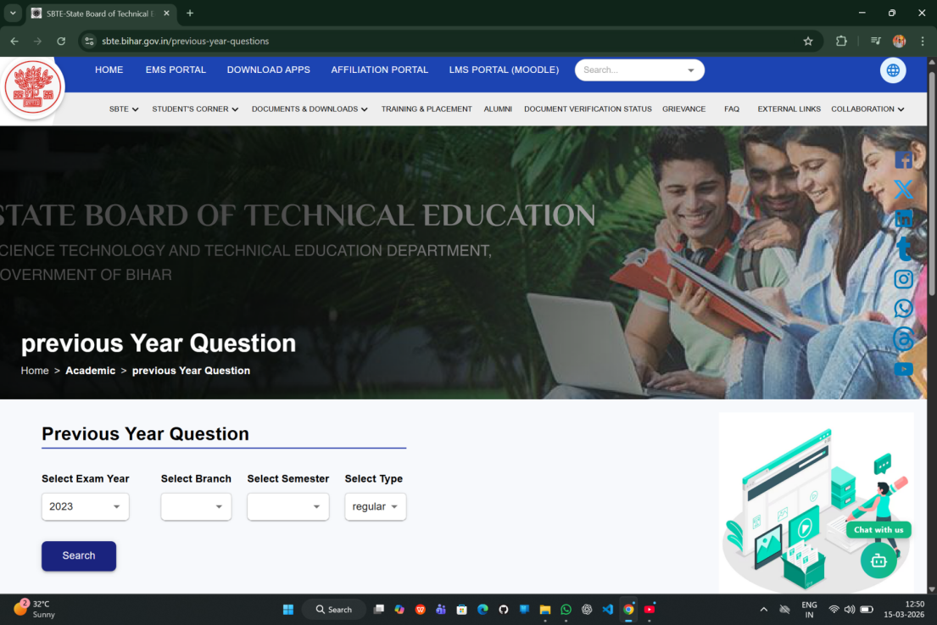
Figure :- 32
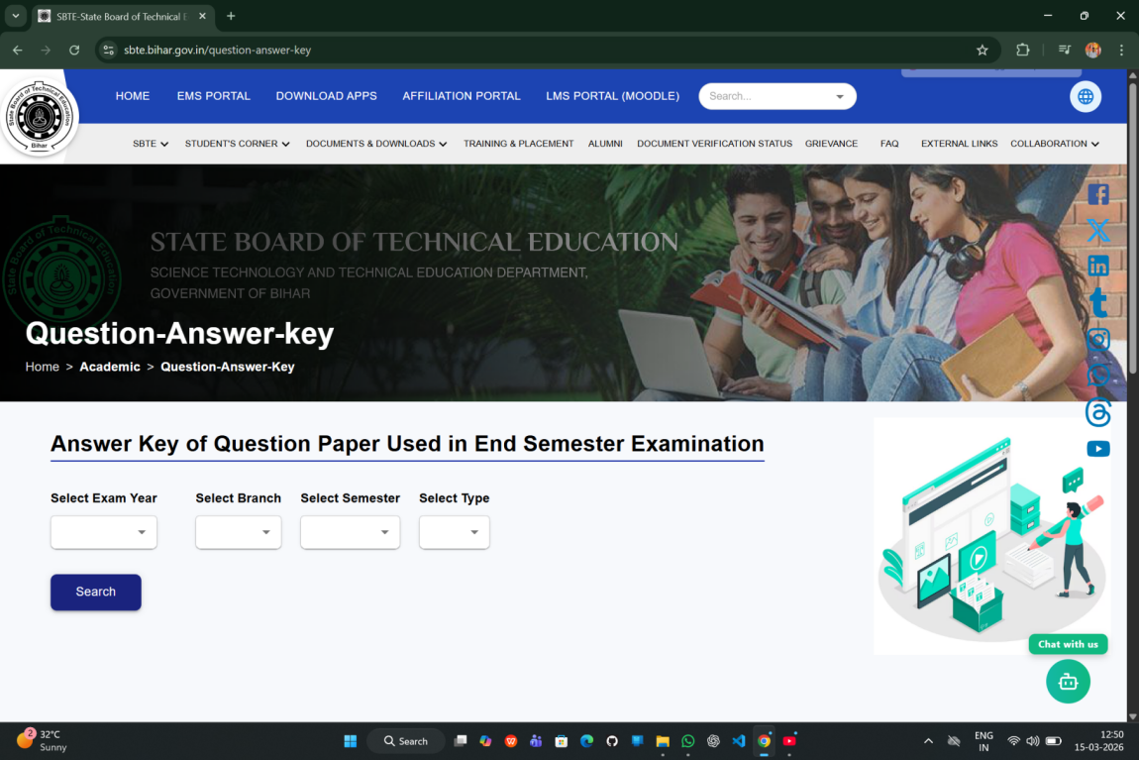
Figure :-33

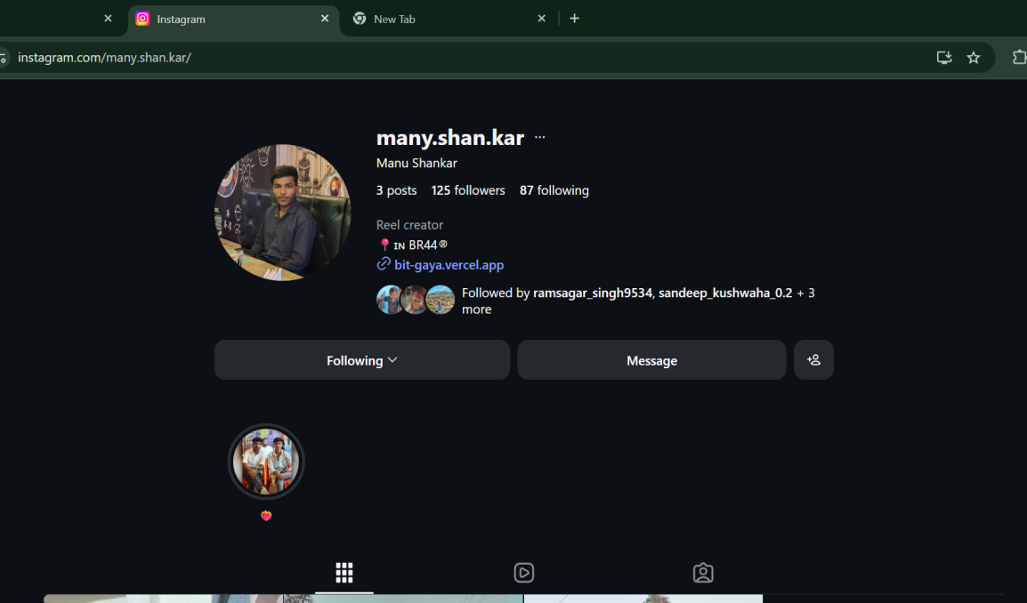
Figure :- 34
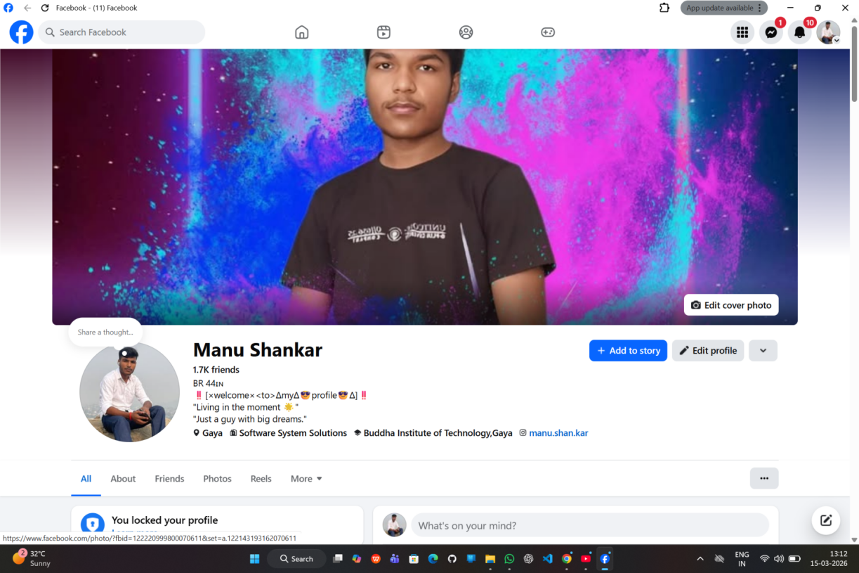
Figure :- 35

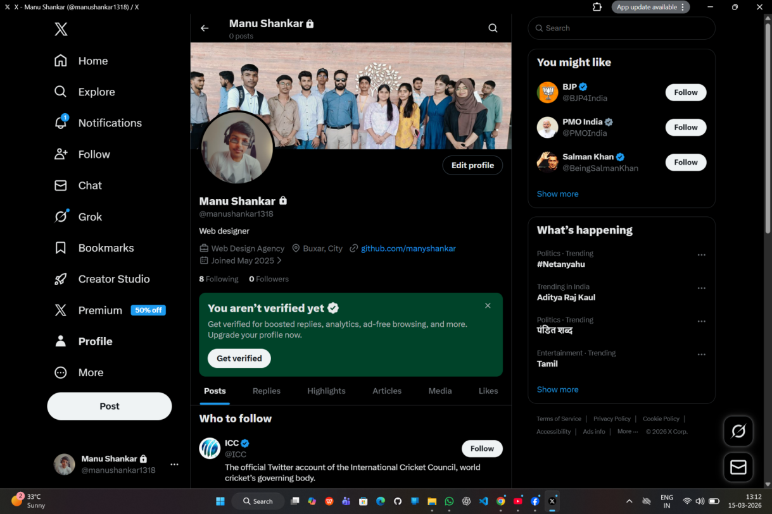
Figure :- 36


Figure :- 37

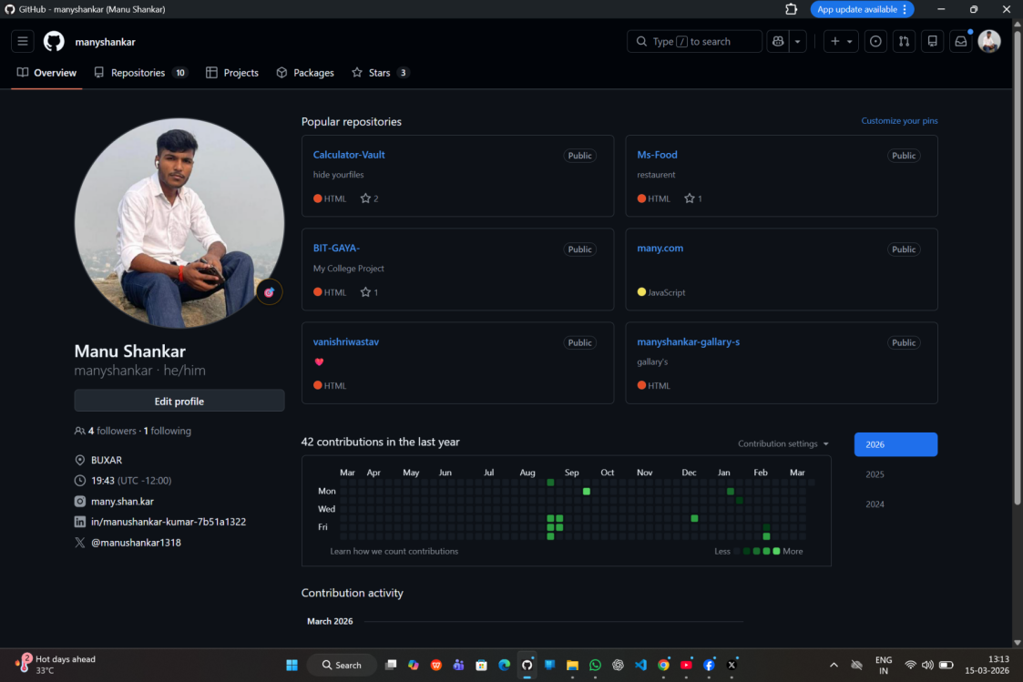

Figure :- 38

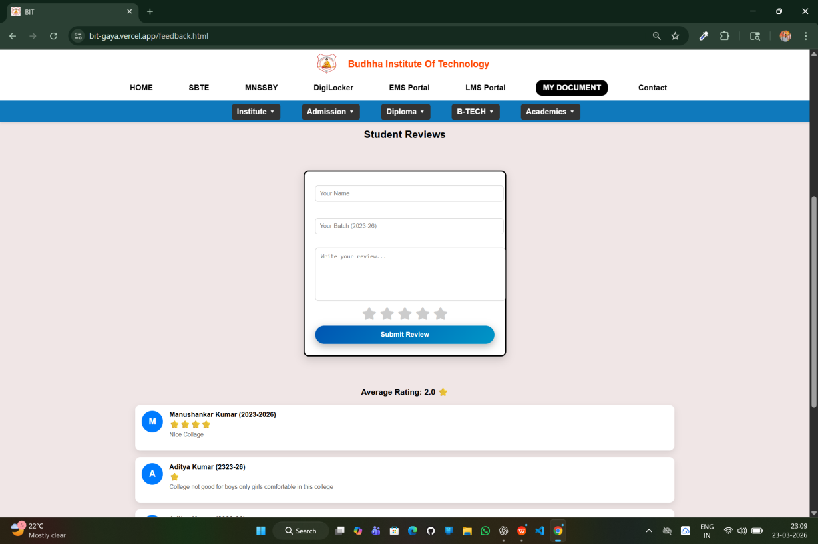
Figure :- 39

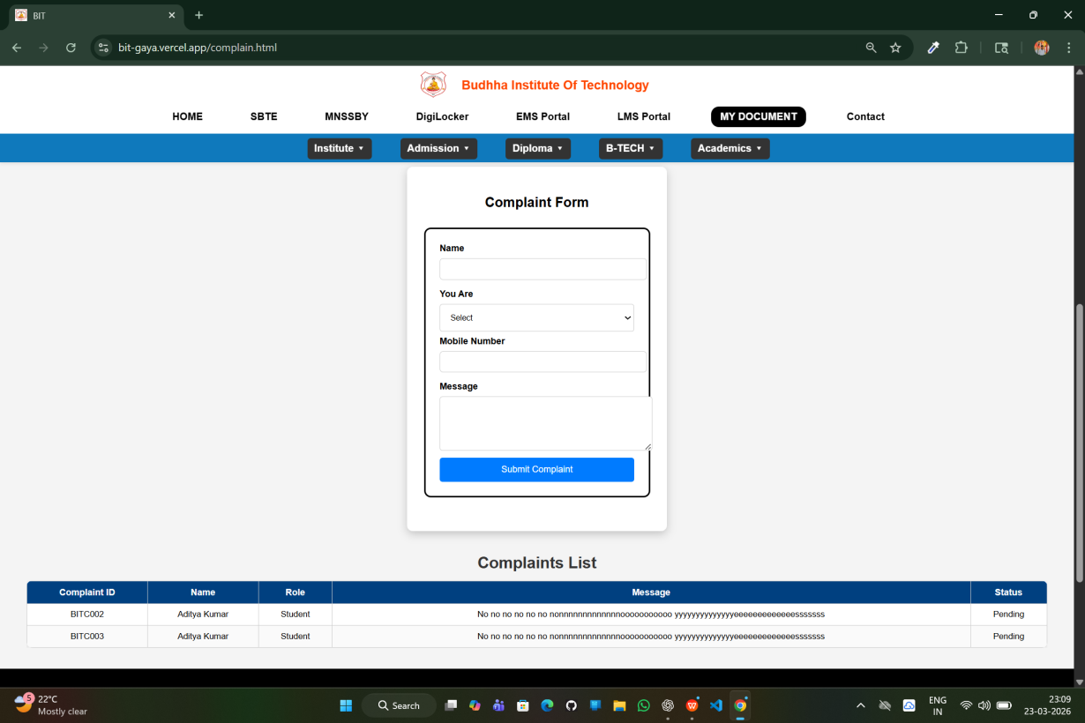
Figure:- 40

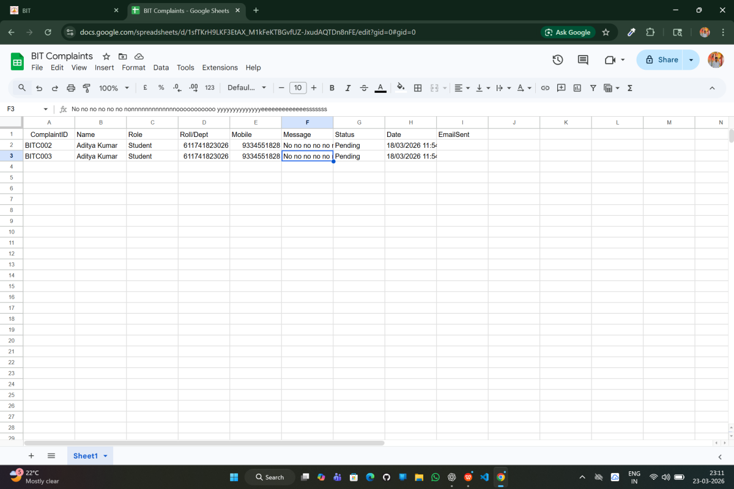
Figure :- 41

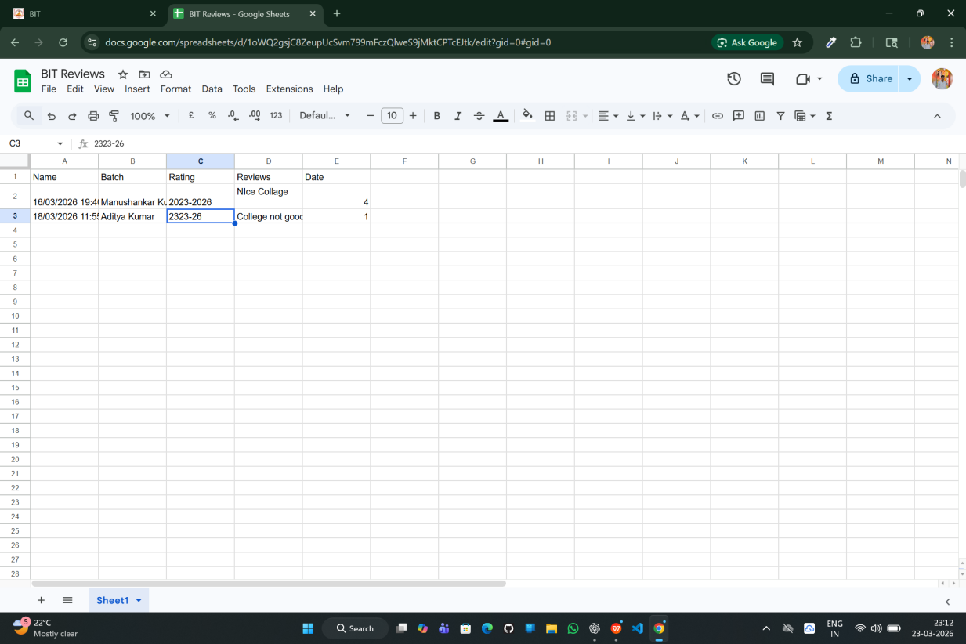
Figure :- 42

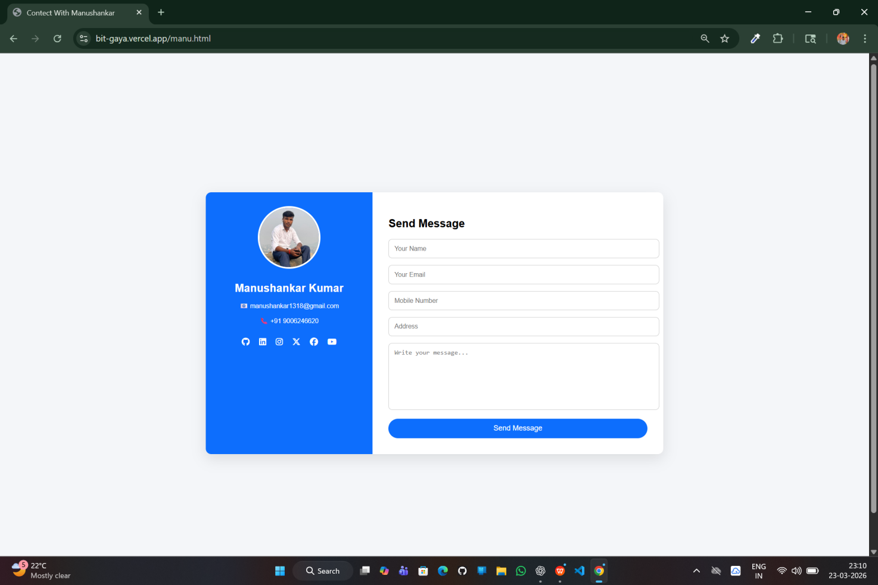
Figure :- 43

4.08 Feature Of the System
• Responsive design
• Easy navigation
• Fast loading speed
• Online form submission
• Complaint tracking system
• Email notification (if configured)

4.09 Testing & Debugging
Testing is done to ensure proper functioning.

Testing Performed:
- All links checked
- Forms tested for submission
- Website tested on mobile devices
- Errors and bugs fixed

4.10 Results
The project was successfully implemented and tested.

Results Obtained:
- Website loads properly
- All pages are working
- Forms submit data successfully
- Complaint system works correctly
- Data is stored in Google Sheets
The system meets all the objectives defined in the earlier chapters.

4.11 Advantage Of the System
• Saves time and effort
• Easy access to information
• Improves communication
• User-friendly interface
• Cost-effective solution

4.12 Limitation
• Limited backend functionality
• Requires internet connection
• Basic security features

4.13 Summary
This chapter explained the implementation process and results of the project. The website was successfully developed using modern technologies and tested for performance and usability.
The final system is efficient, responsive, and meets the requirements of the users.

Chapter 5
Conclusion & Future Scope
5.1 Introduction
This chapter presents the conclusion of the project and discusses the possible future enhancements. It summarizes the overall work carried out in the development of the “Official Website of Buddha Institute of Technology, Gaya (BIT GAYA)” and highlights its importance.

5.2 Conclusion
The project titled “Official Website of Buddha Institute of Technology, Gaya” has been successfully designed and developed. The main objective of this project was to create a user-friendly, responsive, and informative website for the institute.
The developed website provides a digital platform where students, faculty members, and visitors can easily access important information about the college. It includes essential sections such as Home, About, Courses, Contact, and Complaint Management System.
The website has been developed using modern web technologies like HTML, CSS, and JavaScript, ensuring compatibility across different devices such as desktops, tablets, and smartphones. The responsive design makes the website accessible anytime and anywhere.
The implementation of the complaint management system adds an extra feature that allows users to submit complaints online and track them using a unique complaint ID. This improves communication and transparency between students and the administration.
Overall, the project meets all the objectives defined in the initial stages. It improves the efficiency of information sharing and reduces dependency on traditional manual methods.

5.3 Achievement Of the Project
The major achievements of this project are:
- Successfully developed a fully functional college website
- Created a responsive and user-friendly interface
- Implemented multiple pages (Home, About, Courses, Contact)
- Developed a complaint management system
- Integrated form submission with data storage
- Ensured smooth navigation and fast performance
This project demonstrates practical knowledge of web development and system design.

5.4 Limitation Of the Project
Although the project is successfully implemented, it has some limitations:
- Limited backend functionality
- Basic security features
- No user authentication system
- No online payment integration
- Depends on internet connectivity
These limitations can be improved in future versions.

5.5 Future Scope
The project can be further enhanced by adding advanced features and functionalities.

1. Online Admission System
Students can apply for admission directly through the website.

2. Admin Dashboard
Admin panel to manage:
- Student data
- Complaints
- Website content

3. Mobile Application
A mobile app can be developed for better accessibility.

5.6 Overall Summary
The project successfully demonstrates the development of a modern and responsive website for an educational institution. It provides an effective solution for sharing information and improving communication.
The website not only meets current requirements but also has the potential to be expanded into a complete digital management system for the institute.

References
- Official Website of Buddha Institute of Technology, Gaya
Available at: https://bitgaya.org
- Wikipedia – Buddha Institute of Technology, Gaya
Available at: https://en.wikipedia.org/wiki/Buddha_Institute_of_Technology,_Gaya
- MDN Web Docs (Mozilla Developer Network)
Available at: https://developer.mozilla.org
- W3Schools – Web Development Tutorials
Available at: https://www.w3schools.com
- HTML & CSS: Design and Build Websites
Author: Jon Duckett
- JavaScript: The Definitive Guide
Author: David Flanagan
- Google Apps Script Documentation
Available at: https://developers.google.com/apps-script
- Various College Websites (for study and comparison)
  - IIT Official Websites
  - NIT Official Websites
  - Other Private Engineering College Websites
- TutorialsPoint – Web Development Tutorials
Available at: https://www.tutorialspoint.com
- GeeksforGeeks – Web Development Articles
Available at: https://www.geeksforgeeks.org

