**UNIVERSITY OF MUMBAI**

Project Entitled

**ATTENDANCE MANAGEMENT SYSTEM**

Submitted By

**Manish Verma**

UNDER GUIDANCE OF

**Mrs. Shubhangi Pawar**

**Mr. Abhijit Salvi**

SUBMITTED IN PARTIAL FULFILLMENT OF THE REQUIREMENT FOR THE AWARD OF DEGREE OF BACHELOR

IN COMPUTER SCIENCE

**PILLAI COLLEGE OF ARTS, COMMERCE &**

**SCIENCE, NEW PANVEL**

**2018-2019**

**ACKNOWLEDGEMENT**

I Manish Verma student of PILLAI COLLEGE OF ARTS,

COMMERCE & SCIENCE, NEW PANVEL would like to express my sincere gratitude towards Computer Science Department.

I would like to thank Mrs. Deepika Sharma H.O.D. (I.T. & C.S.) for granting me the opportunity to build project for the college. Last but not least I thank Lect. ( Mr. Abhijeet Salvi, Mrs. Shubhangi Pawar) for their constant support during the

Yours faithfully,

Manish Verma

(Final Year Computer Science)

***Index***

|  |  |
| --- | --- |
| **Sr. No** | **Name** |
| **1.** | **Preliminary Investigation** |
| **a** | Organizational overview |
| b | Description of the system |
| c | Scope of the system |
| d | Limitation of current system |
| e | Modules of the system |
| f | Proposed System |
| g | Adv. Of proposed system |
| h | Feasibility Study |
| i | Technologies Used |
| j | Gantt chart |
|  |  |
| **2.** | **System Analysis** |
| a | Event Table |
| b | Use Case diagram |
| c | Activity Diagram |
|  |  |
| **3.** | **System Design** |
| **a** | E-R diagram |
| b | Class diagram |
|  |  |
| **4.** | **System Coding** |
| a | Database Table |
| b | Coding |
|  |  |
| **5.** | **Future Enhancement** |
|  |  |
| **6.** | **Refrence and Bibliography** |
|  |  |

**PRELIMINARY**

**INVESTIGATION**

**Organizational overview:**

Student attendance management system deals with the maintenance of the student’s attendance details. It is generates the attendance of the student on basis of presence in class. It is maintained on the daily basis of their attendance. The staffs will be provided with the separate username & password to make the student’s status.

The staffs handling the particular subjects responsible to make the attendance for all students. Only if the student present on that particular day, the attendance will be calculated. The students attendance reports based on weekly and consolidate will be generated.

“Attendance Management System” is website developed for maintaining the attendance of the student on the daily basis in the college. An accurate report based on the student attendance is generated here. Report of the student’s attendance on weekly and monthly basis is generated. This project will helps the attendance system for the department calculate percentage and reports for eligibility criteria of examination .The application attendance entry system will provide flexible report for all students.

The website is modifiable hence if the student is absent for few days due to any genuine reasons changes can be made in his attendance. The teacher will act as an admin hence the extra manual work will not be there. If the student want to check his/her attendance for the day he can reach to that site and check whether he/she is marked present for the day or not. This site does not require any Login hence parents of the students can also check whether the respective student is present or not.

**Description of System**

**Objective of the System:**

Attendance Management System provides an easy way to take attendance of students of any stream without making any use of any physical objects like pen and paper.

This also reduces the wastage of paper which is one of the biggest problems in our counrty . The main aim of this project is to Digitalize the way attendance is taken in colleges . This project keeps the track of attendance of student in a proper manner and without utilizing much memory of the system .

**Scope of the System:**

The system has a wide scope, since the students use the system for seeing attendance.

The system also has a scope for the teachers, since they can login , select any stream and take attendance & also can add , view a student .

The outside students and parents (guests) also visit the website and see their attendance without even logging in .

**Limitations of current system**

The Existing system is a manual entry for the students. Here the attendance will be carried out in the hand written registers. It will be a tedious job to maintain the record for the user. The human effort is more here. The retrieval of the information is not as easy as the records are maintained in the hand written registers. This application requires correct feed on input into the respective field. Suppose the wrong inputs are entered, the application resist to work. so the user find it difficult to use.

As this system include manual work the attendance is taken on materialistic thing such as paper hence the attendance taken on the sheet of the paper can be modifiable. If the attendance file is maintained and by accidently it lands on some hands of the student then that student can make changes in attendance record.

Sometimes the file or attendance sheet can be misplaced and if lost then the whole record for a week can be lost. Hence it’s difficult for the student as well as teacher for maintaining the record.

**Modules of the system**

The modules concentrated in this project are as follows:

* **Teacher:** Teacher is responsible for managing the entire student data and making a part of that data available to student as and when required. Teacher can also update the student data .
* **Attendance:** Currently, the attendance system working in colleges is offline. The teachers have to take attendance in paper-sheets , fill it and submit . Thus, everything is paper based.

The new system/project aims at making the entire process of taking attendance online, thereby reducing the maintenance job of the teachers .

* **Student:** Based on the attendance taken by the teacher , students will able to view the attendance .

**Proposed system**

To overcome the drawbacks of the existing system, the proposed system has been evolved. This project aims to reduce the paper work and saving time to generate accurate results from the student’s attendance. The system provides with the best user interface. The efficient reports can be generated by using this proposed system.

Here the student as well as parents of the student can view the attendance record of the student for the day. And the data can be changed through the teacher if any mistake is been encountered during the maintenance of attendance record.

**Advantages of the proposed system:**

* It will be easy to use.
* Time saving.
* Easy to produce the report.
* Easy to view the old records.
* Maintain large amount of orders becomes easy.
* Details about the blood stock can be easily maintained.
* It is very helpful in this competitive world.

**Feasibility Study**

Feasibility analysis begins once the goals are defined. It starts by generating broad possible solutions, which are possible to give an indication of what the new system should look lime. This is where creativity and imagination are used. Analysts must think up new ways of doing things- generate new ideas.

There is no need to go into the detailed system operation yet. The solution should provide enough information to make reasonable estimates about project cost and give users an indication of how the new system will fit into the organization.

It is important not to exert considerable effort at this stage only to find out that the project is not worthwhile or that there is a need significantly change the original goal.

Feasibility of a new system means ensuring that the new system, which we are going to implement, is efficient and affordable. There are various types of feasibility to be determined. They are,

1. **Technical Feasibility**

The technical requirement for the system is economic and it does not use any other additional Hardware and software. Technical evaluation must also assess whether the existing systems can be upgraded to use the new technology and whether the organization has the expertise to use it. Install all upgrades framework into the .Net package supported widows based application. this application depends on Microsoft office and intranet service ,database. Enter their attendance and generate report to excel sheet.

1. **Economical Feasibility**

Development of this application is highly economically feasible. The only thing to be done is making an environment with an effective supervision. It is cost effective in the sense that has eliminated the paper work completely. The system is also time effective because the calculations are automated which are made at the end of the month or as per the user requirement.

1. **Operational Feasibility**:

The system working is quite easy to use and learn due to its simple but attractive interface. User requires no special training for operating the system. Technical performance include issues such as determining whether the system can provide the right information for the Department personnel student details, and whether the system can be organized so that it always delivers this information at the right place and on time using intranet services. Acceptance revolves around the current system and its personnel.

**TECHNOLOGIES USED**

***Hardware Requirements***

* 1.6GHz or faster processor
* 1024 MB RAM (1.5 GB if running in a virtual machine)
* 5.5 GB of available hard-disk space
* 5400 RPM hard drive

***Software Requirements***

* FRONT END : HTML, CSS , Bootstrap and JavaScript .
* BACK END : WampServer(MySQL)
* TECHNIQUE: Php

***Supported Architectures:***

* 32-Bit (x86)
* 64-Bit (x64)

**Php:**

PHP (recursive acronym for PHP: Hypertext Preprocessor) is a widely-used open source general-purpose scripting language that is especially suited for web development and can be embedded into HTML.

Following tasks are possible with Php:

* PHP can generate dynamic page content
* PHP can create, open, read, write, delete, and close files on the server
* PHP can collect form data
* PHP can send and receive cookies
* PHP can add, delete, modify data in your database
* PHP can be used to control user-access
* PHP can encrypt data

With PHP you are not limited to output HTML. You can output images, PDF files, and even flash movies. You can also output any text, such as XHTML and XML.

Advantages of Php are:

* PHP runs on various platforms (Windows, Linux, Unix, Mac OS X, etc.)
* PHP is compatible with almost all servers used today (Apache, IIS, etc.)
* PHP supports a wide range of databases
* PHP is free. Download it from the official PHP resource: www.php.net
* PHP is easy to learn and runs efficiently on the server side

**GANTT CHART**

|  |  |  |  |  |  |  |
| --- | --- | --- | --- | --- | --- | --- |
| **S.No** | **Phase Title** | **JUNE**  1 10 20 30 | **JULY**  1 10 20 31 | **AUGUST**  1 10 20 30 | **SEPTEMBER**  1 10 20 31 | **OCTOBER**  1 05 10 |
| **1** | **I. Planning Phase** |  |  |  |  |  |
| 1. **Define the Problem** |  |  |  |  |  |
| **b)Produce project schedule** |  |  |  |  |  |
| **c)Launch the Project** |  |  |  |  |  |
| **2** | **II. Analysis** |  |  |  |  |  |
| 1. **Gather the Information** |  |  |  |  |  |
| 1. **Define the System** |  |  |  |  |  |
| **3** | **III. Design Phase** |  |  |  |  |  |
| **a)Complete Application Design** |  |  |  |  |  |
| **b)Design User Interface** |  |  |  |  |  |
| 1. **Design and Integrate Database and System Control** |  |  |  |  |  |
| **4** | **IV. Coding Phase** |  |  |  |  |  |
| 1. **Writing Code for module** |  |  |  |  |  |
| **b)Integrating Module** |  |  |  |  |  |
| **5** | **V. Testing Phase** |  |  |  |  |  |
| **a)Unit Testing** |  |  |  |  |  |
| **b)System Testing** |  |  |  |  |  |
| **6** | **VI. Implementation** |  |  |  |  |  |

***SYSTEM ANALYSIS***

System Analysis by definition is a process of systematic investigation for the purpose of gathering data, interpreting the facts, diagnosing the problem and using this information to either build a completely new system or to recommend the improvements to the existing system.

**EVENT TABLE**

|  |  |  |  |  |  |  |
| --- | --- | --- | --- | --- | --- | --- |
| **No.** | **Event** | **Trigger** | **Source** | **Activity** | **Response** | **Destination** |
| 1 | Login | Teacher Click On Login | Teacher | Login | Login Successful/Fail | Index page/  Login |
| 2 | Stream | Select stream | Teacher | Select | Stream selected | Attendance |
| 3 | Add | Fills the details | Teacher | Add | Student added | Data inserted successfully |
| 4 | View Attendance | Teacher | Teacher/Student | View Attendance | List of date | Student Attendance |

**Use Case Diagrams**

**Use case diagram for Teacher & Student**

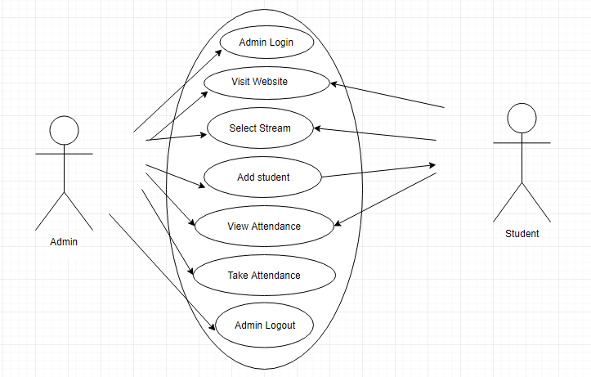

**ACTIVITY DIAGRAMS**

**Activity diagram for admin**

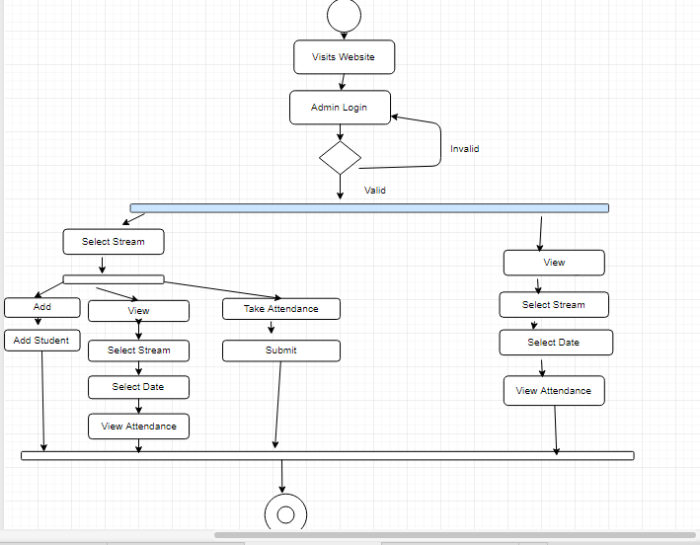

**Activity diagram for User**

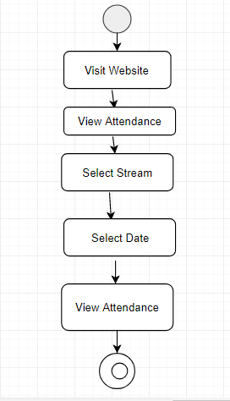

***SYSTEM DESIGN***

**Entity Relationship Diagram**

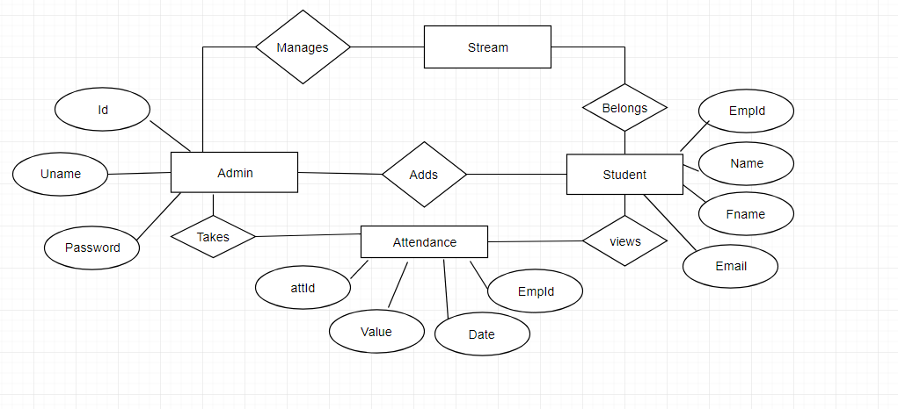

**Class diagram**

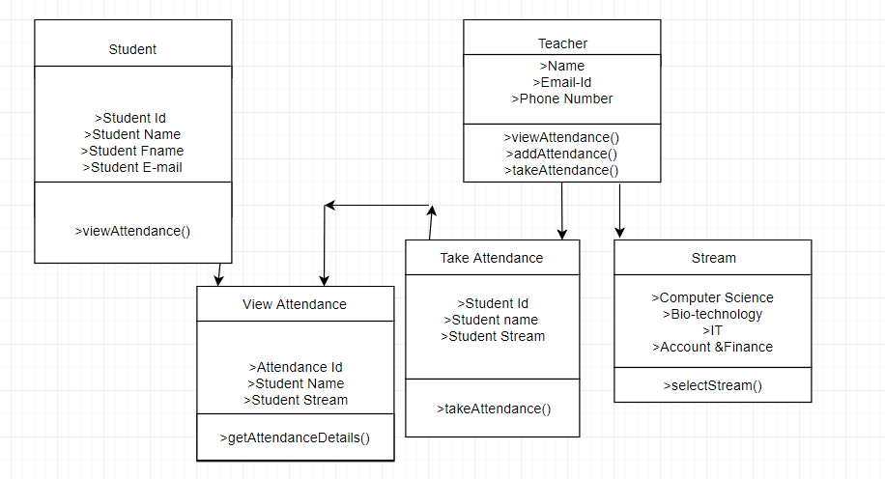

***SYSTEM CODING***

**LIST OF TABLE WITH ATTRIBUTES AND CONSTRAINT**

**admin**:-

|  |  |  |
| --- | --- | --- |
| **Attribute** | **Datatype** | **Constraint** |
| Id | Int | Primary Key |
| Name | varchar(70) | Not null |
| Password | varchar(30) | Not null |

**emp**

|  |  |  |
| --- | --- | --- |
| **Attribute** | **Datatype** | **Constraint** |
| Emp_id | int(11) | Primary key |
| Name | varchar(50) | Not null |
| Fname | varchar(50) | Not null |
| Email | varchar(50) | Not null |
|  |  |  |

**Std_is**

|  |  |  |
| --- | --- | --- |
| **Attribute** | **Datatype** | **Constraint** |
| Emp_id | int(11) | Primary key |
| Name | varchar(50) | Not null |
| Fname | varchar(50) | Not null |
| Email | varchar(50) | Not null |
|  |  |  |

**Std_af**

|  |  |  |
| --- | --- | --- |
| **Attribute** | **Datatype** | **Constraint** |
| Emp_id | int(11) | Primary key |
| Name | varchar(50) | Not null |
| Fname | varchar(50) | Not null |
| Email | varchar(50) | Not null |
|  |  |  |

**Std_it**

|  |  |  |
| --- | --- | --- |
| **Attribute** | **Datatype** | **Constraint** |
| Emp_id | int(11) | Primary key |
| Name | varchar(50) | Not null |
| Fname | varchar(50) | Not null |
| Email | varchar(50) | Not null |
|  |  |  |

**cs**

|  |  |  |
| --- | --- | --- |
| **Attribute** | **Datatype** | **Constraint** |
| Attd_id | int(11) | Primary key |
| Value | varchar(50) | Not null |
| Emp_id | Int(11) | Not null |
| Date | Date | Not null |
|  |  |  |

**af**

|  |  |  |
| --- | --- | --- |
| **Attribute** | **Datatype** | **Constraint** |
| Attd_id | int(11) | Primary key |
| Value | varchar(50) | Not null |
| Emp_id | Int(11) | Not null |
| Date | Date | Not null |
|  |  |  |

**it**

|  |  |  |
| --- | --- | --- |
| **Attribute** | **Datatype** | **Constraint** |
| Attd_id | int(11) | Primary key |
| Value | varchar(50) | Not null |
| Emp_id | Int(11) | Not null |
| Date | date | Not null |
|  |  |  |

**is**

|  |  |  |
| --- | --- | --- |
| **Attribute** | **Datatype** | **Constraint** |
| Attd_id | int(11) | Primary key |
| Value | varchar(50) | Not null |
| Emp_id | Int(11) | Not null |
| Date | date | Not null |
|  |  |  |

**Screen Layouts And Report Layouts**

**Config.php**

<?php

$con=new PDO('mysql:host=localhost;dbname=attnd1','root','');

if($con==false)

{

echo"connection failed";

}

else

{

echo"";

}

?>

**Login.php**

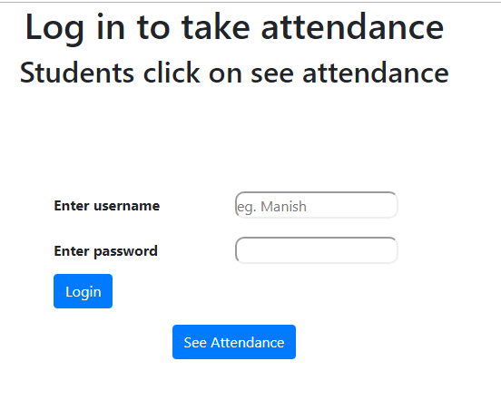

**Code:-**

<?php

include('Config.php');

session_start();

?>

<html>

<head>

<title>Admin Login</title>

<!-- Latest compiled and minified CSS -->

<link rel="stylesheet" href="https://maxcdn.bootstrapcdn.com/bootstrap/4.1.3/css/bootstrap.min.css">

<!-- jQuery library -->

<script src="https://ajax.googleapis.com/ajax/libs/jquery/3.3.1/jquery.min.js"></script>

<!-- Popper JS -->

<script src="https://cdnjs.cloudflare.com/ajax/libs/popper.js/1.14.3/umd/popper.min.js"></script>

<!-- Latest compiled JavaScript -->

<script src="https://maxcdn.bootstrapcdn.com/bootstrap/4.1.3/js/bootstrap.min.js"></script>

</head>

<body>

<div id="full">

<div id="inner_full">

<div id="header" align="center"><h1>Log in to take attendance</h1> </div>

<div id="header" align="center"><h2>Students click on see attendance</h2></div>

<div id="Body">

<br><br><br><br>

<form action="" method="post">

<table align="center">

<tr>

<td width="200px" height="50px"><b>Enter username</b></td>

<td width="200px" height="50px"><input type="text" name="un" placeholder="eg. Manish "

style="width: 180px;height: 30px;border-radius: 10px;"></td>

</tr>

<tr>

<td width="200px" height="50px"><b>Enter password</b></td>

<td width="200px" height="50px"><input type="password" name="pass"

style="width: 180px;height: 30px;border-radius: 10px;"></td>

</tr>

<tr>

<td><input type="submit" name="sub" value="Login" align="center" class="btn btn-primary pull-right"</td>

</tr>

</table>

</form>

<form action="main.php">

<table align="center">

<tr>

<td><input type="submit" name="sub" value="See Attendance"class="btn btn-primary pull-right"</td>

</tr>

</table>

</form>

<?php

if(isset($_POST['sub']))

{

$un=$_POST['un'];

$ps=$_POST['pass'];

$q=$con->prepare("SELECT * FROM login WHERE un='$un' && pass='$ps'");

$q->execute();

$res=$q->fetchAll(PDO::FETCH_OBJ);

if($res)

{

$_SESSION['un']=$un;

header('location:index.php');

}

else

{

echo"<script>alert('Invalid username or Password')</script>";

}

}

?>

</div>

<div id="footer"> </div>

</div>

</div>

</body>

</html>

**index.php**

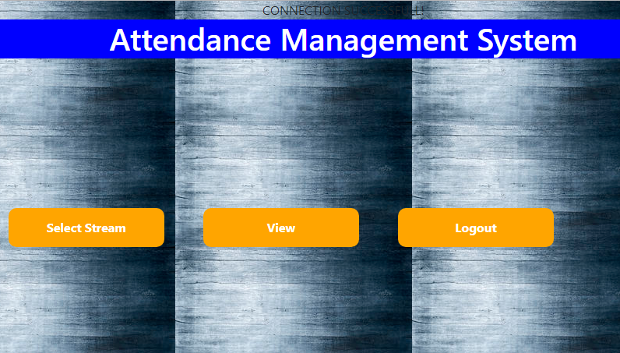

**Stream.php**

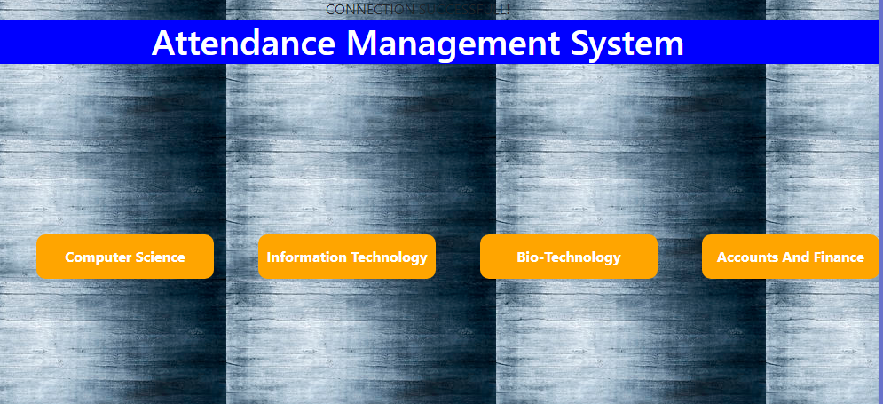

**Code:-**

<?php include_once("connection.php");

session_start();

?>

<!DOCTYPE html>

<html>

<head>

<title>Stream</title>

<link rel="stylesheet" type="text/css" href="s1.css">

<!-- Latest compiled and minified CSS -->

<link rel="stylesheet" href="https://maxcdn.bootstrapcdn.com/bootstrap/4.1.3/css/bootstrap.min.css">

<!-- jQuery library -->

<script src="https://ajax.googleapis.com/ajax/libs/jquery/3.3.1/jquery.min.js"></script>

<!-- Popper JS -->

<script src="https://cdnjs.cloudflare.com/ajax/libs/popper.js/1.14.3/umd/popper.min.js"></script>

<!-- Latest compiled JavaScript -->

<script src="https://maxcdn.bootstrapcdn.com/bootstrap/4.1.3/js/bootstrap.min.js"></script>

<style>

body {

background-image: url("bgimage.jpg");

}

</style>

</head>

<body>

<div id="full">

<div id="inner_full">

<div id="header" align="center"><a href="admindash.php" style="text-decoration: none;color:white;">

<h1>Attendance Management System</h1></a></div>

<div id="Body">

<br><br><br><br>

<?php

$un=$_SESSION['un'];

if(!$un)

{

header('Location:Login.php');

}

?>

<br><br> <br><br>

<ul>

<li><a href="CS.php"><b>Computer Science</b></h2></a></li>

<li><a href="IT.php"><b>Information Technology</b></a></li>

<li><a href="IS.php"><b>Bio-Technology</b></a></li>

<li><a href="AF.php"><b>Accounts And Finance</b></a></li>

</ul>

</div>

</div>

</body>

</html>

**Cs.php**

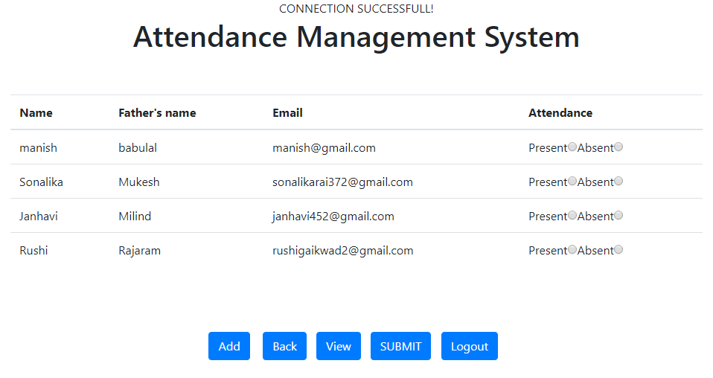

**Add_cs.php**

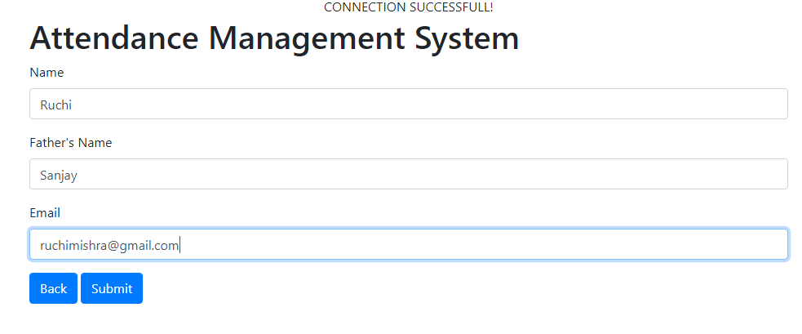

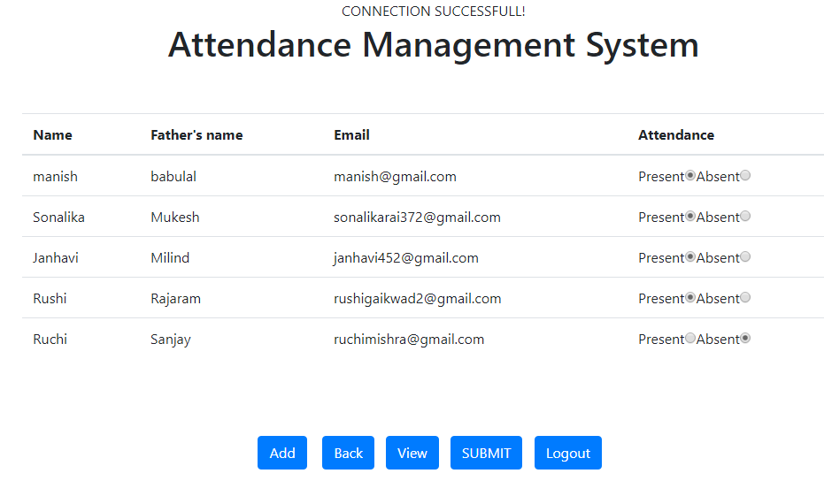

**View_cs.php**

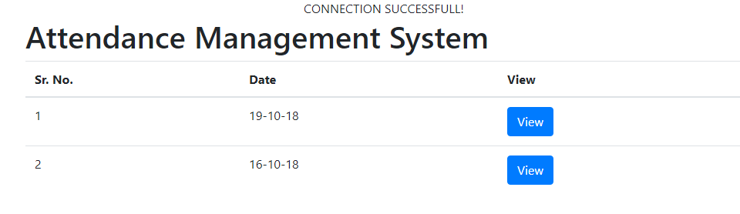

**Code:**

<?php include_once("connection.php"); ?>

<!DOCTYPE html>

<html>

<head>

<title></title>

<!-- Latest compiled and minified CSS -->

<link rel="stylesheet" href="https://maxcdn.bootstrapcdn.com/bootstrap/4.1.3/css/bootstrap.min.css">

<!-- jQuery library -->

<script src="https://ajax.googleapis.com/ajax/libs/jquery/3.3.1/jquery.min.js"></script>

<!-- Popper JS -->

<script src="https://cdnjs.cloudflare.com/ajax/libs/popper.js/1.14.3/umd/popper.min.js"></script>

<!-- Latest compiled JavaScript -->

<script src="https://maxcdn.bootstrapcdn.com/bootstrap/4.1.3/js/bootstrap.min.js"></script>

</head>

<body>

<div class="panel panel-default container">

<div class="panel-heading">

<h1 style="text-align: canter;">Attendance Management System</h1>

</div>

<div class="panel-body">

<form method="post">

<table class="table">

<thead>

<tr>

<th>Sr. No.</th>

<th>Name</th>

<th>Father's name</th>

<th>Email</th>

<th>Attendance</th>

</tr>

</thead>

<?php.

$date=.$_GET['date'];

echo"Attendance for $date \r\n\n";

if($_GET['date']){

$date=$_GET['date'];

$query="select emp.*,attendance.* from attendance

inner join emp on attendance.emp_id=emp.emp_id and

attendance.date='$date'";

$result=$link->query($query);

if($result->num_rows>0){

$i=0;

while($val=$result->fetch_assoc()){

$i++;

?>

<tr>

<td><?php echo $i; ?></td>

<td><?php echo $val['name']; ?></td>

<td><?php echo $val['fname']; ?></td>

<td><?php echo $val['email']; ?></td>

<td>

Present<input type="radio" value="Present" <?php

if($val['value']=='Present')

echo "checked";

?>

>

Absent<input type="radio" value="Absent" <?php

if($val['value']=='Absent')

echo "checked";

?>

>

</td>

</tr>

<?php }}

}

?>

</div>

<div class="panel-footer">

<h1></h1>

</div>

</body>

</html>

**Viewp_cs.php**

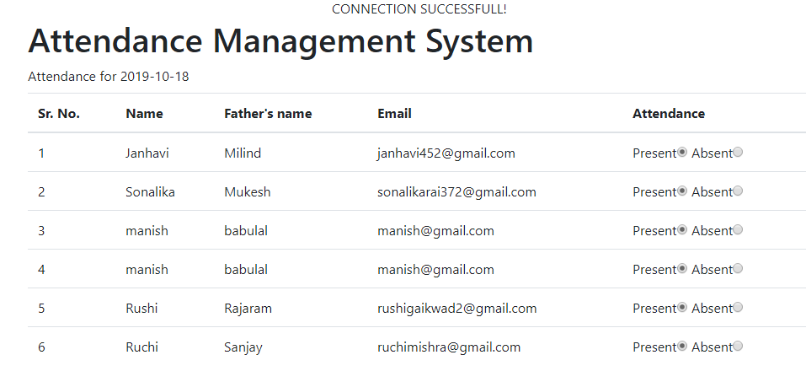

**Code:-**

<?php include_once("connection.php"); ?>

<!DOCTYPE html>

<html>

<head>

<title></title>

<!-- Latest compiled and minified CSS -->

<link rel="stylesheet" href="https://maxcdn.bootstrapcdn.com/bootstrap/4.1.3/css/bootstrap.min.css">

<!-- jQuery library -->

<script src="https://ajax.googleapis.com/ajax/libs/jquery/3.3.1/jquery.min.js"></script>

<!-- Popper JS -->

<script src="https://cdnjs.cloudflare.com/ajax/libs/popper.js/1.14.3/umd/popper.min.js"></script>

<!-- Latest compiled JavaScript -->

<script src="https://maxcdn.bootstrapcdn.com/bootstrap/4.1.3/js/bootstrap.min.js"></script>

</head>

<body>

<div class="panel panel-default container">

<div class="panel-heading">

<h1 style="text-align: canter;">Attendance Management System</h1>

</div>

<div class="panel-body">

<form method="post">

<table class="table">

<thead>

<tr>

<th>Sr. No.</th>

<th>Name</th>

<th>Father's name</th>

<th>Email</th>

<th>Attendance</th>

</tr>

</thead>

<?php

$date=$_GET['date'];

echo"Attendance for $date \r\n\n";

if($_GET['date']){

$date=$_GET['date'];

$query="select std_is.*,iis.* from iis

inner join std_is on iis.emp_id=std_is.emp_id and

iis.date='$date'";

$result=$link->query($query);

if($result->num_rows>0){

$i=0;

while($val=$result->fetch_assoc()){

$i++;

?>

<tr>

<td><?php echo $i; ?></td>

<td><?php echo $val['name']; ?></td>

<td><?php echo $val['fname']; ?></td>

<td><?php echo $val['email']; ?></td>

<td>

Present<input type="radio" value="Present" <?php

if($val['value']=='Present')

echo "checked";

?>

>

Absent<input type="radio" value="Absent" <?php

if($val['value']=='Absent')

echo "checked";

?>

>

</td>

</tr>

<?php }} } ?>

</div>

<div class="panel-footer">

<h1></h1>

</div>

</body>

</html>

**FUTURE ENHANCEMENTS**

Some of the future enhancements that can be done to this system are:

* Notice and time table can be displayed on site so student can get easily access to their daily schedule .
* Parents can get easily notified about their respective child if he/she is absent .
* The system can be designed to allow the multiuser platform .
* A mobile application based on the same functionalities can also be developed.

**References and Bibliography**

**References:**

* www.youtube.com
* http://stackoverflow.com/
* www.w3schools.com
* Complete Reference of php
* Programming in Notepad++
* www.youtube.com
* <https://www.scribd.com/doc>