**Syeda Kazmi-Shah**

**Problem 1:**

* Database You may need to learn how to type symbols such as *π* , *σ* ,

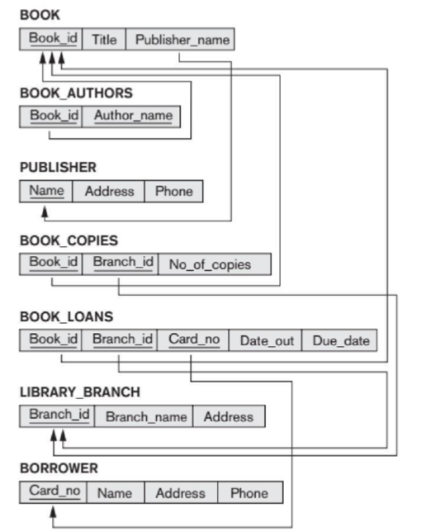

**(a) How many copies of the book titled “The Lost Tribe” are owned by the library branch whose name is "Sharpstown"?**

*π*No_of_Copies(*σTitle* = “The lost tribe” ^ BranchName = “Sharpstown”(Book ⋈ Book_Copies) ⋈ Library_Branch)

**(b) How many copies of the book titled “The Lost Tribe” are owned by each library branch?**

*π* No_of_copies(*σ* Title = “The Lost Tribe” (Book ⋈ Book_Copies) ⋈ Library_Branch))

**(c) Retrieve the names of all borrowers who do not have any books checked out.**

*πName (Borrower* ⋈ *(π CardN0* Borrower - *π CardN0* Book_Loans))

**(d) For each book that is loaned out from the "Sharpstown" branch and whose DueDate is today, retrieve the book title, the borrower's name, and the borrower's address.**

*Π*Title,Name, Address(*σBranchName = “Sharpstown” ^ DueDate* = “Today”(Library_Branch ⋈ Book_Loans))

(e) For each library branch, retrieve the branch name and the total number of books loaned out from that branch.

Final answer :

R(BranchId,Total) <-- BranchId ℱ BookId,CardNo (BOOK_LOANS)

RESULT <-- *Π* BranchName,Total (R ⋈ LIBRARY_BRANCH)

(Also, could this have worked too? 🡪 Branch_NameℱCOUNT Book_ID(Library_Branch ⋈ Book_Loans)) ?)

**Problem 2:**Consider the two tables T1 and T2 shown below. Show the results of the following

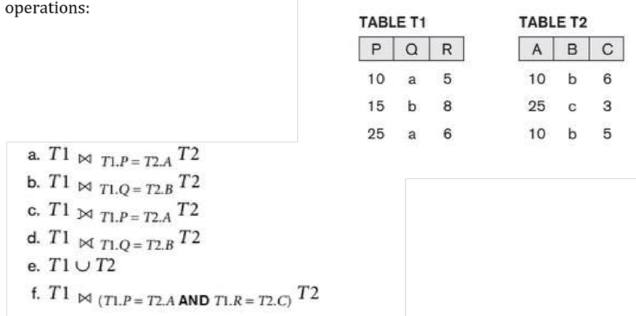

1. 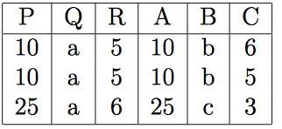
2. 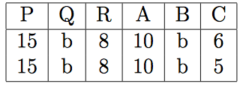
3. 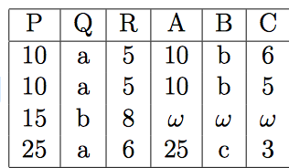
4. 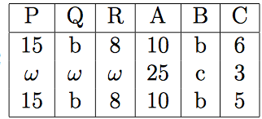
5. 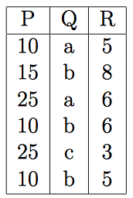
6. 