**A MINI PROJECT REPORT**

**ON**

**INTERACTIVE DICTIONARY**

Submitted to Mumbai University

In the partial fulfillment of the requirement for the award of the degree of

**Bachelor of Engineering**

In

**COMPUTER ENGINEERING**

By

**Mr. Manzar Shaikh (16CO50)**

**Mr. Shaikh Azam Ali(17DCO75)**

**Mr. Hasib Rawal(16CO45)**

Under the guidance of

**Mr. Aamer Syed Hashmi**

**Assistant Professor**



--

**Department of Computer Engineering Anjuman-I-Islam Kalsekar Technical Campus Affiliated to Mumbai University**

KHANDA GOAN, NEW PANVEL, NAVI MUMBAI, MAHARASHTRA

2017-2018

**Department of Computer Engineering Anjuman-I-Islam Kalsekar Technical Campus Affiliated to Mumbai University**

KHANDA GOAN, NEW PANVEL, NAVI MUMBAI, MAHARASHTRA 2017-2018



**DECLARATION BY THE CANDIDATE**

Shaikh Manzar bearing Roll number: 16CO50, hereby declare that the mini project report entitled **“Interactive Dictionary”**, is a record of bonafide work carried out by me and the results embodied in this project have not been reproduced or copied from any source. The results of this project report have not been submitted to any other University or Institute for the award of any other Degree or Diploma.

**Shaikh Manzar**

**(16CO50)**

**Department of Computer Engineering Anjuman-I-Islam Kalsekar Technical Campus Affiliated to Mumbai University**

KHANDA GOAN, NEW PANVEL, NAVI MUMBAI, MAHARASHTRA 2017-2018



**CERTIFICATE**

This is to certify that the project report entitled **“Interactive Dictionary”**, submitted by **Mr. Shaikh Manzar** , bearing **Roll. No.: 16CO50** in the partial fulfillment of therequirements for the award of the degree of **Bachelor of Computer Engineering** is a record of bonafide work carried out by him.

**Course Owner**

**(Assit. Prof. Aamer Syed Hashmi)**

**INDEX**

**CONTENTS**

CH**APTER 1: INTRODUCTION**

**1.1 Introduction…………………………………………….1**

**1.2 Scope…………………………………………1**

**1.3 Problem Statement……..……….....................1**

**CHAPTER 2 SYSTEM SPECIFICATION**

**2.1 System Requirement…………………………2**

**CHAPTER 3: SYSTEM IMPLEMENTATION**

**3.1 Modules in the System………...……………...2**

**3.2 Code…………………..…..……….…….……3**

**CHAPTER 4: RESULTS**

**4.1 Screen Shots…...……………………………..4**

**INTRODUCTION :**

**The Dictionary software has been developed for all operating system which is most popular.**

**This is a offline dictionary approach which doesn’t need any internet connection. Lots of similar sugession is also provided if user entered any wrong word.**

**So basically this dictionary is a offline dictionary for every computer users.**

**Purpose :**

**The dictionary is developed to solve users vocabulary confusions or problem. Just few clicks and the meaning is known.**

**Method :**

**The approach is to use a json file as Database where Every word with its meaning is stored. And retrieve the data according to user need.**

* **SCOPE :**

**The software target any type of computer users who ever get a word which meaning is not known to him.**

* **PROBLEM STATEMENT:**

**Creating a user Dictionary for ease the burdon of user. As he/she might be getting any vocabulary problem he/she can open this application and search for that word.**

**It should be offline to user. As no one will use the application is the application is online. He can get the meaning by just google it. So why whould he/she will use your application.**

**SYSTEM REQUIREMENTS:-**

**This Dictionary only need a 10MB of Disc space and 512MB of RAM.**

**And the most Important user should have Python Installed in his/her**

**Computer.**

**MODULE :**

1. **Only User Entry.**

**USER Entry:-**

Here user has to enter the word he/she search for, if word is correct then it return the meaning of that same.

Otherwise it will show some nearest match for that word and ask for is that word are you trying to search

**CODE:**

**import json**

**from difflib import get_close_matches**

**data=json.load(open("data.json"))**

**def check(word):**

**word=word.lower()**

**if word in data:**

**return data[word]**

**elif word.title() in data:**

**return data[word.title()]**

**elif word.upper() in data:**

**return data[word.upper()]**

**elif len(get_close_matches(word,data.keys()))>0:**

**yn=""**

**print("Did you mean {} instead Enter Y for YES And N for NO: ".format(get_close_matches(word,data.keys())[0]))**

**while(yn != "Y" or yn !="N"):**

**yn=input("")**

**if (yn=="Y"):**

**output=data[get_close_matches(word,data.keys())[0]]**

**return output**

**elif (yn=="N"):**

**output="No Match Found Please Double Check It"**

**return output**

**else:**

**print("We Didn't Understand What You Entered Please ReEnter")**

**else:**

**return "No Match Found Please Double Check It"**

**def main():**

**exit="Y"**

**while(exit == "Y"):**

**word=input("Enter The Word: ")**

**output=check(word)**

**if type(output)==list:**

**for i in output:**

**print(i)**

**else:**

**print(output)**

**exit=input("Want To Search Again Enter Y for YES and N for NO: ")**

**main()**

* **SCREENSHOT**

1. **When user Search for normal/non-mistake Word**

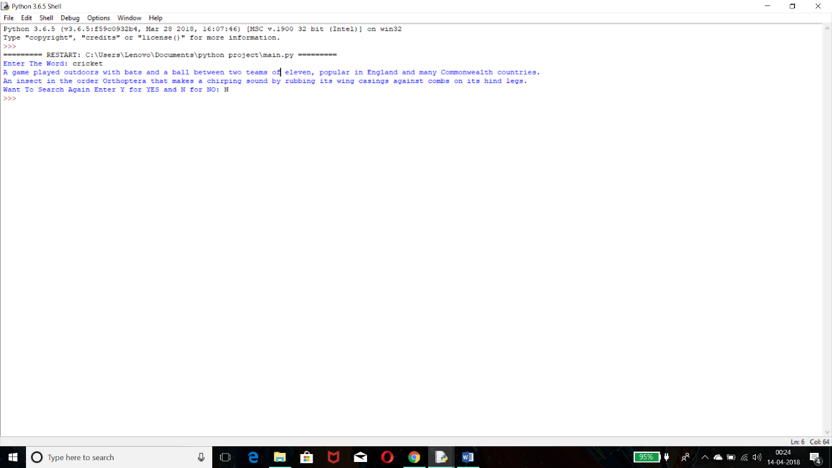

**2.When user search word with non-case sensitive format**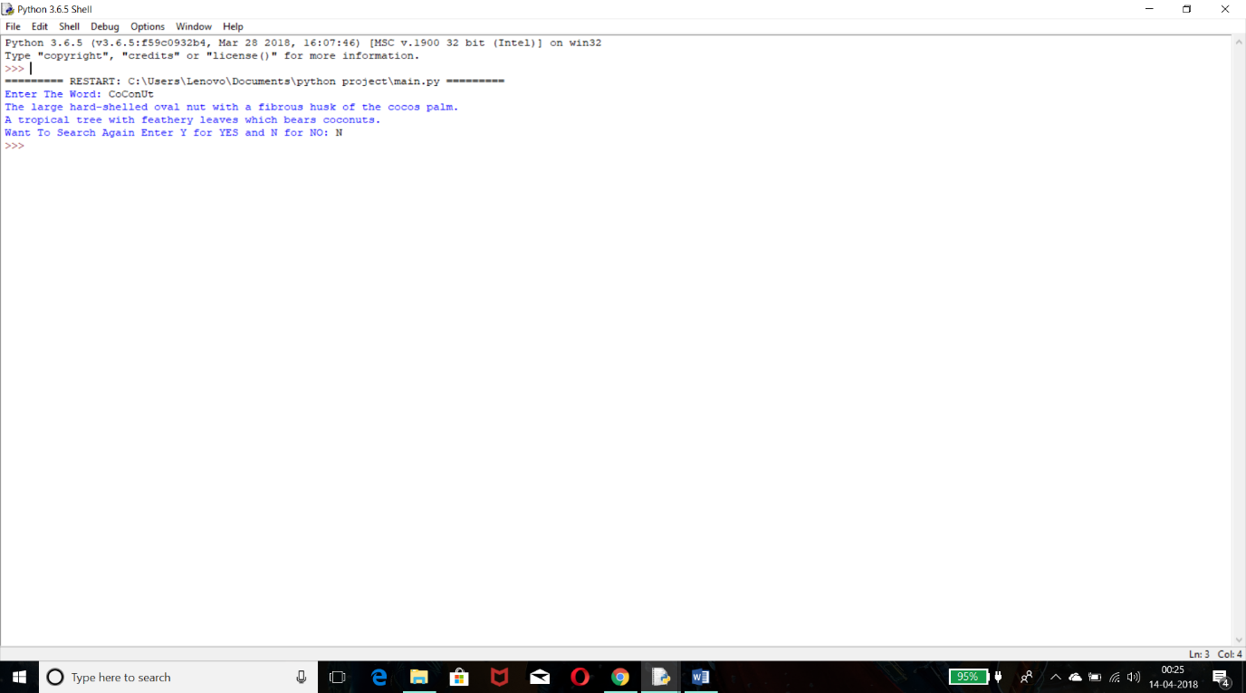

**3.When user search wrong Word**

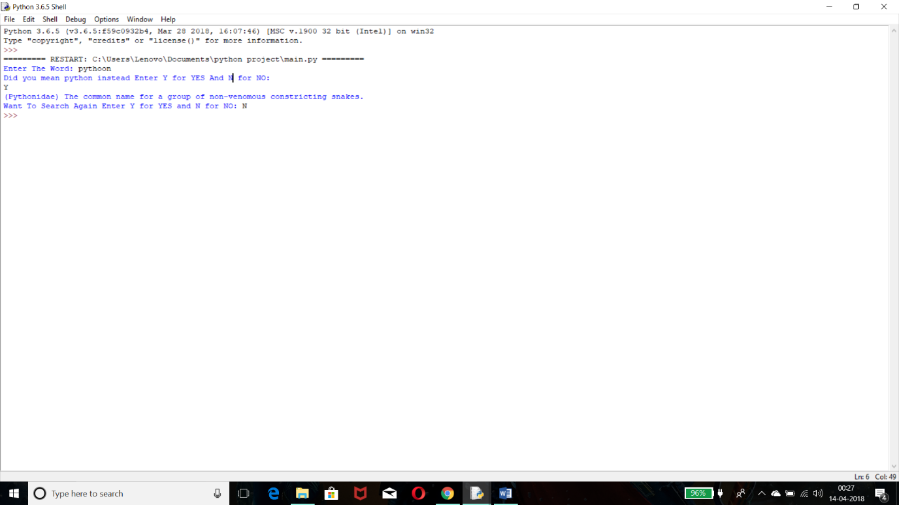

**4.When User want to search multiple word**

