

RUSIZI DISTRICT
P.O BOX: 450 CYANGUGU
Email : giheketss@gmail.com
Tel: +250788885418

ACADEMIC YEAR: 2023-2024
FIRST TERM EXAMINATION
TRADE: L4NIT
MODULE: WINDOWS SERVER ADMINISTRATION
INSTRUCTION:
The are 3 sections in this exam
Section A is compulsory
Choose 2 questions in section B
Section C is compulsory
Allocated time : 3hours

QUESTIONS/100Marks
SECTION A: Compulsory /55Marks
1. Write the following in full: /5Marks
a. AD: Active Directory
b. DHCP: Dynamic Host Configuration Protocol
C. NOS: Network Operating System
d. ADDS: Active Directory Domain Services
e. DC: Domain Controller
f. PDC: Primary Domain Controller
g. GC: Global Catalog
h. GPO: Group Policy Object
i. OU:Organization Unit
j.DNS: Domain Name sevice
2. Define the following terms /5Marks
a.Server: is a computer program that provides a service to another computer programs (and its user).
b. Server OS: is a network operating system specifically designed to run on servers to serve the requests of client computers on the network.
c.Virtualization: Virtualization relies on software to simulate hardware functionality and create a virtual computer system.

d.Domain: Logical units in AD that helps organize and manage objects within the network. Area of control.
e. Group Policy Object: is a collection of settings and configurations that define the behavior of users and computers in an Active Directory environment.
3 Match the following columns and write the answer. /5Marks
Column A | Column B | Answer
A. Tree | 1. is the core service within Active Directory that stores and manages directory data, including user accounts, computer accounts, and security policies. It provides authentication and authorization services. | A-4
B. User accounts | 2. Defines the structure of objects stored in Active Directory, including their attributes and classes | B-5
C. Active Directory Domain Services | 3. Is a collection of domains within Active Directory that share a common schema and trust relationship | C-1
D. Forest | 4. Is a collection of one or more trees within Active Directory. Domains within a forest share a common schema and global catalog | D-4
E. Schema | 5. Are created for individual users or human beings who need access to the network and its resources. These accounts are used to log in to the network and access various resources such as files, applications, and email | E-2
F. Computer accounts |  | E-2

4. Outline 5 key features of windows server. /7Marks
Answer: Key features of windows server
• Ability to access the server both in GUI and command-level interface
• Execute all or most processes from OS commands
• Advanced-level hardware, software and network configuration services
• Install/deploy business applications and/or web applications
• Provides central interface to manage users, implement security and other administrative processes
• Manages and monitors client computers and/or operating systems

5. Differentiate authentication from authorization. /6Marks
ANSWER:
Authentication: Identification of users and computers and
Authorization: Controls access users and computers to network resources based on permissions and policies.

6. Explain in 4 lines key functions of Global Catalog . /7Marks
Answer: Universal Object Lookups: The GC facilitates universal object lookups across the entire forest, providing a centralized location for queries involving all domains.
It represent the capability to perform queries or searches across an entire directory infrastructure,
Login Authentication: During authentication, the GC assists in the user login process by providing information about universal group memberships.
Efficient Searches: It improves search efficiency by allowing queries without requiring referrals to specific domain controllers.

7.True or false /5Marks
a. ADDS is the same as DC because all the two are services of windows server. False
b. A server becomes a domain controller before installing and promoting AD on it. False
c. It is very important to restart your server after installing and configuring any windows server role so that it can understand changes. True
d. Joining a computer on a domain allows that domain to be controlled . False
e. Among AD objects we have user accounts, computer accounts and groups. True
8.Is there any difference between computer account and user account. Defend your answer. /5Marks
Answer:
Computer accounts
Computer accounts are created for computer systems (servers, workstations, etc.) that need to be integrated into an Active Directory domain. These accounts represent the computer on the network.
User accounts: User accounts are created for individual users or human beings who need access to the network and its resources. These accounts are used to log in to the network and access various resources such as files, applications, and email

9.Explain why is it important for you as administrator of any server to update its drivers. /10Marks
Answer:
Identify Current Drivers:
- Open the "Device Manager" by right-clicking on "This PC" or "My Computer,"
- Selecting "Manage," and then
- Choosing "Device Manager."
- Review the hardware components listed and identify the drivers you want to update (e.g., network adapter, graphics card, storage controller).
Access Driver Properties
- Right-click on the hardware component you want to update and
- Select "Properties."
- Click on the "Update Driver" button to check for updates. Windows will search for the latest driver online.
- Choose "Search automatically for updated driver software." Windows will attempt to locate and install the most recent driver for the hardware
- Restart the server to apply the driver updates.

SECTION B: Attempt any two questions /30Marks
10. Defend 3 methods used to install windows sever. /15Marks

11. It is required for an admin to make a flash disk bootable when installing windows sever using USB .As someone who has knowledge in windows server explain 2 ways you can use to make a flash disk bootable( show step by step for each way) /15Marks
Answer: Making a flash disk bootable by using commands
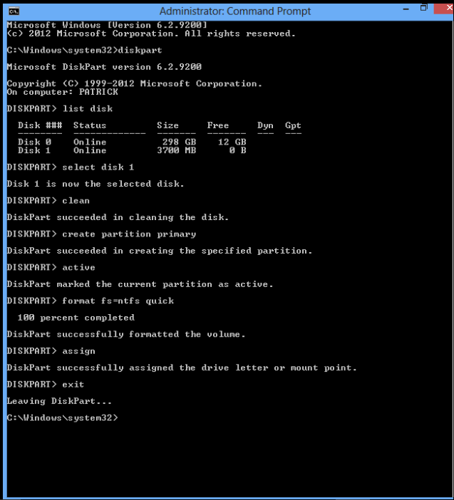
b. Making a flash disk bootable using rufus
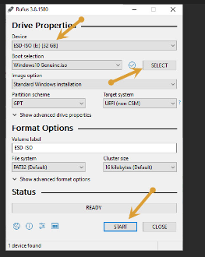
12. Discuss 5 types Group Policy Objects(GPO). 15Marks
Answer:
- Local GPOs:
  - These are applied to individual computers and aren't managed through Active Directory.
  - Local GPOs are used when settings need to be applied to a single machine.
- Domain GPOs:
  - These GPOs are linked to the entire domain and apply settings to all users and computers within that domain.
  - They are managed at the domain level and affect all objects within the domain.
- Site GPOs:
  - GPOs linked to Active Directory sites, which are physical or logical groupings of computers.
  - Site GPOs are applied to all objects within a specific site.
- Organizational Unit (OU) GPOs:
  - GPOs linked to specific OUs within the domain hierarchy.
  - These allow administrators to apply settings to specific sets of users or computers based on their location within the AD structure.
- Starter GPOs:
  - Templates for GPOs that contain preconfigured settings.
  - Starter GPOs serve as a baseline or starting point for creating new GPOs with standard configurations.
- Default GPOs:
  - These are predefined GPOs that come with default settings and configurations in Active Directory.
  - Default GPOs include settings for security, password policies, and other basic configurations.

SECTION C: This section is compulsory
13. Using a table Compare types of OS. /15marks
Answer:
Features | Standalone operating system | Network operating system
Definition | It is an OS that operates on desktop systems and other portable devices. | It is an OS that runs on connected devices and provides network-based functionality.
Functionality | It enables a single user to control and acquire services from the device at the same time. | It enables users to manage data, users, groups, and other network-related functions.
Examples | Some examples of the standalone OS are DOS, Windows 95, Mac OS, and Windows 2000 professionals. | Some examples of the network OS are Microsoft Windows Server 2003, UNIX, Linux, Novell NetWare, Microsoft Windows Server 2008, Mac OS X, and BSD.

END!!!!!!!

