Web Application POS for Alfredo’s Restaurant

Installation Manual

Cloning the whole Project.................................................................................
Installing the WampServer ..............................................................................
Importing the Database ...................................................................................
Creating Virtual Host on WampServer .............................................................
Accessing Virtual Host from another computer (optional).................................

Cloning the whole Project

Go to this URL and download/clone the application.

https://github.com/manzonPanda/Jael-uncle-restaurant.git

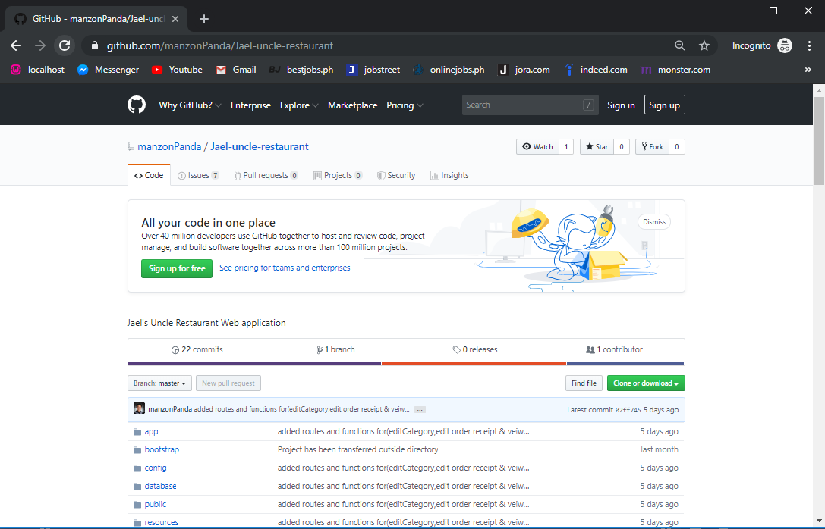

Installing the WampServer

Step 1. Open the WampServer file, and when a security window dialog appear click run.

Step 2. You will see a standard setup wizard of windows after clicking run button. Click Next.

Step 3. You have to agree the license of WampServer before selecting the installation destination.

Step 4. A window will pop up asking for the installation location for WampServer. Click Next.

Step 5. After clicking the Next button a “Select Additional Task” dialog will appear on the screen and click on “Create Desktop Icon” and click Next.

Step 6. Setup is now ready to begin installing WampServer on your computer. Click on Install Button to start installing WampServer.

Step 7. WampServer is already installing and setup will guide you for Apache configurations in the next steps.

Step 8. A “Windows Firewall” dialog will appear and click on “Allow Access”.

Step 9. You have now successfully installed WampServer at your computer. Click “Finish” To start WampServer along with other services.

Step 10. Now you can see the WampServer icon on the taskbar. WampServer icon has three states:
• Red
• Orange
• Green

Red – It shows that WampServer is offline and no service/s has been started.
Orange – WampServer icon shows that it is still offline and any service/s (Apache, PhP, MySql) failed to start.

Green – WampServer is working normal and all of the three services are running and ready to use.

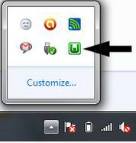

Step 11: Extract/Unzip the Project you have downloaded earlier and move it to the server path.

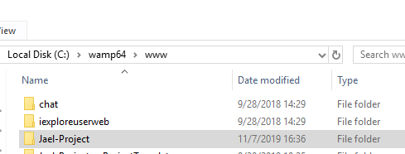
Server path: C:\wamp64\www

Importing the Database
Step 1. Click the wampserver icon and click on phpMyAdmin. You will now log in. Enter the following credentials:
Username: root
Password: (leave it blank)

Step 2. Create a new database “restaurant_alfredo” and click the create button.

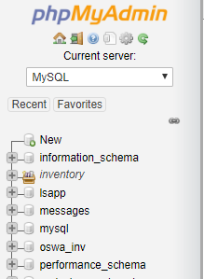

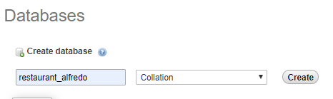

Step 3. After creating the database, click import and click browse. Brows the location of the “restaurant_alfredo.sql” file and click open, then click “Go” button at the bottom.

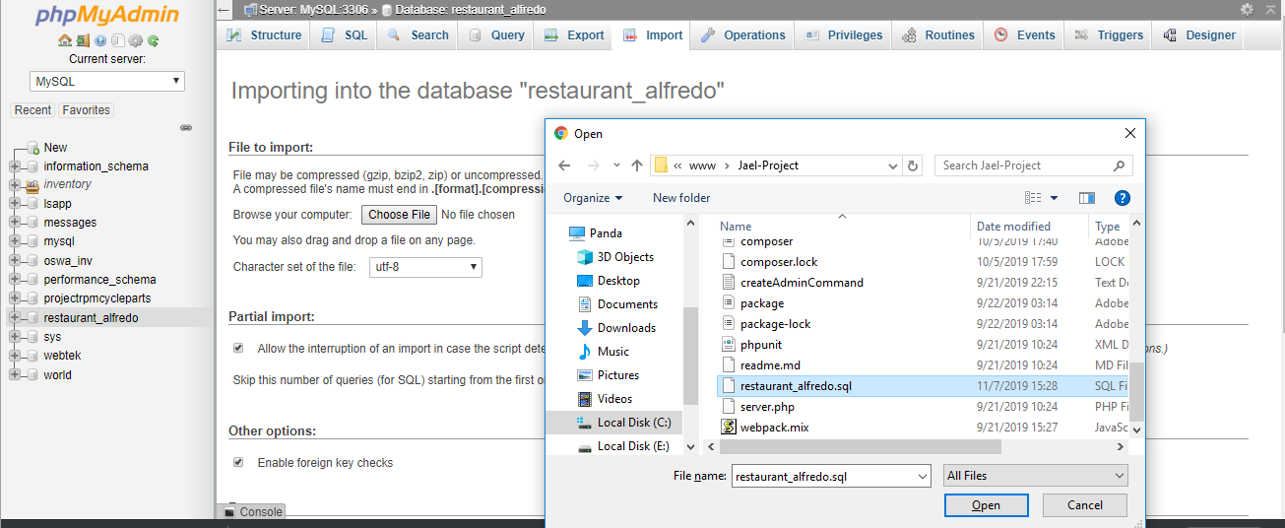

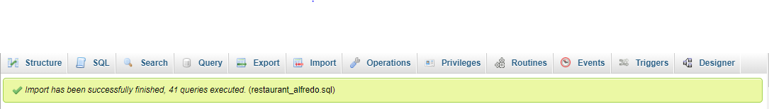
Step 4. After importing the database you will see a notification saying the Import has been successfully finished.

Creating Virtual Host on WampServer

Step 1. First, you need to edit your hosts file on the server (C:\Windows\System32\drivers\etc). This will map the virtual host name to an IP address. To keep this simple, we'll map 127.0.0.1 to jael.com. Here's how:
1. Open Notepad as the administrator.
2. Open the file C:\Windows\system32\drivers\etc\hosts.
3. Add the line: 127.0.0.1 jael.com.
4. Save the host file (making sure to not save it as a .txt file).

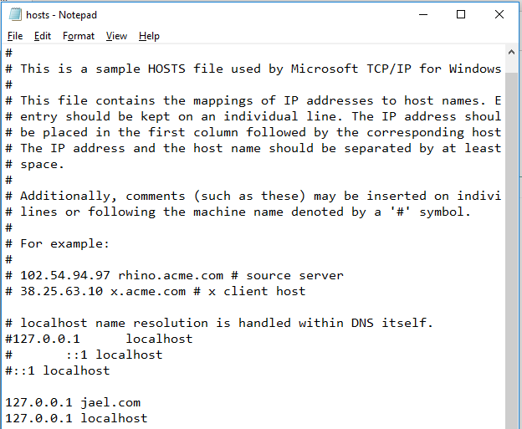

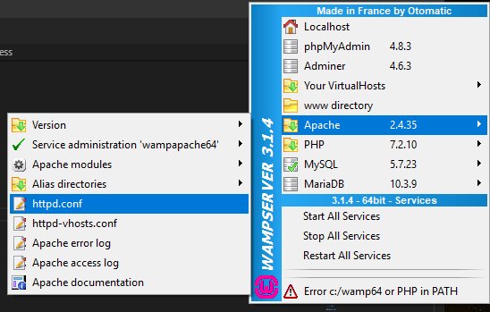
Step 2. Editing the http.conf file, the fastest way to access this file is to click the WAMP icon in the system tray and select Apache->httpd.conf.

When you select the httpd.conf entry, Notepad will open with the contents of the httpd.conf file. Within this file, you need to uncomment out the entry for virtual host’s configuration file location. Search for these two lines:

# Virtual hosts
# Include conf/extra/httpd-vhosts.conf

Remove the "#" in the second line above and save and close the httpd.conf file.

Remove the “#”, save and close the httpd file.

# LoadModule vhost_alias_module modules/mod_vhost_alias.so

Step 3. The next file to edit can be accessed through the WAMP user interface. Open Apache and click httpd-vhosts.conf and add the following.
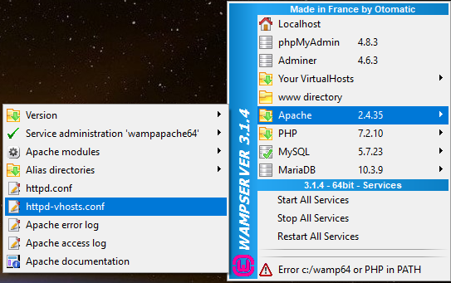

<VirtualHost *:80>
DocumentRoot c:/wamp64/www/Jael-Project/public
ServerName jael.com
<Directory "c:/wamp64/www">
Options +Indexes +Includes +FollowSymLinks +MultiViews
AllowOverride All
Require all granted
</Directory>
</VirtualHost>

<VirtualHost *:80>
DocumentRoot c:/wamp64/www/
ServerName localhost
</VirtualHost>
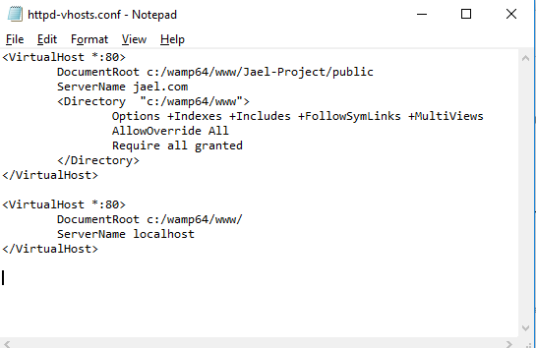

Accessing Virtual Host from another computer (optional)
On the other computer you could access it from the IP address by typing http://<server IP address> on the web browser or if you want the other computer to be able to just type http://jael you would need to modify the other computer's hosts file to have an entry of <server IP address> jael.

