***Robotic Arm control based on Accelerometer using Arduino with LabVIEW***

Manzoor. A1, abcd2

Department of Instrumentation Science,

Savitri Bai Phule Pune University, Pune, Maharashtra. Manzoor11@gmail.com1, abcd@gmail.com2

***Abstract* — This paper focus on hand movement based robotic arm with LabVIEW front end to analyse its movements. The proposed robotic arm imitates the motion of hand by the help of accelerometer sensor and communicate it with the controller to rotate motor and LabVIEW to display the motion of robotic arm. The arm has 4 degrees of freedom and an end effector to grab the object. A low cost MEMs chip of 3 axis accelerometer is used to derive the roll and pitch of operator hand. Some complex algorithm performed to obtain exact angle of operator arm. The Communication between sensor and controller has been established by I2C protocol interface, whereas controller and LabVIEW communicate via serial communication (USB). The controller part is implemented with Arduino mega IDE. 3 switches are provided to switch the control between individual joints (motor), hence operator will have full access in individual angle of freedom, and as well it helps to eliminate the movements accidently. The controlling method is simple to handle by untechnical person also, and more user friendly than joystick. And the robotic arm response is synchronised with operator arm. In conclusion, some tests have been performed with this robotic arm and results are discussed.**

***Keywords—roll and pitch; accelerometer; servo; Arduino mega; interface; MEMs; arm; automation; sensor etc.***

# I. INTRODUCTION

Robotic arm is introduced to replace human from certain tasks. But the controlling of robotic arm is still challenging because of many reasons. So many researchers proposed human-robot interaction.

In this field many research works are going on to establish appreciable interaction between human and robot. Few of them are: recognizing human gestures, control robot using wireless artificial neural network system [5], [6], [7], vision based system [1], [2], using finger gesture recognition systems [4]. Also many user-interfaces also available such as: icon-based programming, colour touch screens, 3D joystick, mouse [8] or Motion detecting system [3]. Among these motion detecting system is very widely accepted method because of its simplicity, accuracy and efficiency. MEMs Accelerometer sensor chip makes this operation very effective. Because, it analyse motion and can utilise the data directly in the program of embedded systems. So the same way we can analyse the hand movements of operator and utilise it to control robotic arm.

This paper proposes hand movement controlled robotic arm with LabVIEW as front end part, to analyse its movements. This arm has 4 degree of freedom and an end effector to grab object. A low cost MEMs chip of 3 axis accelerometer is used to derive the roll and pitch of operator hand. The motion detected by accelerometer is communicated to micro-controller for further processing to obtain exact roll and pitch of operator arm. This communication is over I2C protocol interface, whereas controller and LabVIEW communicate via serial communication (USB). The controller part is implemented with Arduino mega IDE. 3 switches are also provided for switching the control between individual joints (motor). Hence operator will have full access in individual angle of freedom, and as well it helps to increase stability of the arm in any posture, that is it will eliminate the accidental movements. Finally, the prototype of proposed arm is presented. And performance of the same is discussed.

## A. Why Hand movement based robotic arm is preferred.

There are many situations where human can’t act directly. Or need some assistance from machines. So for such situations, one of the good adoptable machines is robotic systems. Lot of controlling methods are existing to control Robotic arm. Among them motion based (Roll and pitch) controlling is very easy, efficient and saves controlling complexity. It can be controlled by untechnical persons also. So it may be helpful for differently abled persons, those who suffer difficulty on their hand. As well it can be utilised for industrial automation purpose also. Its synchronisation with the human hand gives the feel of having full control on user.

## B. Related Works

We know that hand movement based robotic arm is one of the existing method. But the control strategy is different and the LabVIEW part is also one extension. And in many cases, others used more than one accelerometer or combination of accelerometer with gyro-meter to achieve controlling.

# II. PROPOSED DESIGN

## System Overview

The whole system can be divide into three sections. One is data acquisition section, and second one is data processing and visualising section and the last one is actuator section which consist of a servo motor based artificial robotic arm which has 4 angle of freedom with 180-degree rotation angle each.

Acquiring of data is with ADXL-345 IC module. The IC is a 3-axis accelerometer. It features user-programmable 4 sensitivity ranges ±2*g*, ±4*g*, ±8*g* and ±16*g* [10]. And it supports SPI and I2C interface. In our system, it measures 3 axis acceleration (tilting) and send data to controller part. Arduino mega-2560 (ATmega-2560 microcontroller) is the board used for data processing, controlling Servo motors and communicate with LabVIEW. The controller finds the pitch and roll angles of sensor’s position, with some mathematical equations using the received tilting values. By controlling the corresponding switches, respective motor will rotate corresponds to the angle derived from sensor data. The LabVIEW part is to Display the Pitch and Roll variation in graphical representation.

## Block Diagram

First, sensor measures the tilting of operator hand then it sends data to the Arduino board for further processing. And the Arduino board control servo motor and share the pitch and roll angles with LabVIEW. The LabVIEW will visualise the movements in easily analysable way.

## Methodology

The sensor board will hold in the hand horizontally. And the hand movement in different angle is sensed by the sensor. And the data from the sensor transfer to the Arduino board.

Arduino mega-2560 board (which has Atmega2560 microcontroller with 12MHz crystal) is used for converting the data into pitch and roll angles, data averaging & rounding process and further controlling of servo motor. And it is also communicating with LabVIEW. Different library functions in Arduino, some tool suits in LabVIEW are utilised to implement this.

Communication between sensor and microcontroller is established with I2C protocol, which is the two wire serial communication. And the LabVIEW is communicated through USB communication, by the help of VISA tool suit in LabVIEW.

The servo motor is programmed to run in sweep mode for smooth rotation without much juggling. And the LabVIEW is to visualise the graphical representation of pitch and role variation which determine the robotic arm movements. Switch control is synchronised with Data processing, controlling servo and communicating with LabVIEW. So the whole system is synchronised with operator hand movements gated through the switches.

# III. OPERATION STRATEGY

## A. Arm Movement Control

To measure the movements, we need some reference frame. At the beginning of operation, accelerometer is calibrated with the initial position of sensor. And it is considered as the reference for the measurement, and calculate the displacement along with reference axis. This displacement is utilised further.

The arm has total 5 servo motor. One is acting as end effector to grab object and remaining four motors control the movement of robotic arm. Base servo is to control the x axis (yaw) of the arm and the following 2 servo motor control the y axis movements and the last servo control the roll angle of end effector. Each servo rotates in sweeping mode only, so that movements are smooth.

## B. Calculation

The Accelerometer (ADXL345) is a polysilicon surface-micromachined structure built on top of a silicon wafer. Polysilicon springs suspend the structure over the surface of the wafer and provide a resistance against forces due to applied acceleration. Deflection of the structure is measured using differential capacitors that consist of independent fixed plates and plates attached to the moving mass (M). Acceleration deflects the proof mass and unbalances the differential capacitor, resulting in a sensor output (Volts) whose amplitude is proportional to acceleration. Phase-sensitive demodulation is used to determine the magnitude and polarity of the acceleration.

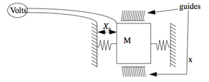

# **Fig 1: Capacitance sensing mechanism of accelerometer (1 axis)**

As acceleration felt as weight. Obviously at Earth surface and in restful condition sensor experience 1G. Acceleration is used as a vector quantity, here it used to sense the orientation of the device, and more precisely pitch and roll angles. So when turning of the operator hand is occurred, then the 1G component is distributed among those 3 axes.

The sensor provides only displacement values with respect to Reference axis that calibrated at the beginning of operation. *.* For the best accuracy we use all three axis to determine angle. With simple vector math, controller transforms raw data to pitch and roll angles, which we are interested in.

Let, acceleration component denotes as *x,* *y* and *z*

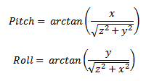

With the equations above, controller calculate the angle between the reference vector and X axis (pitch) or Y axis (roll). Since the rotation around y axis with constant x axis is the roll angle, and the rotation around x axis with constant y axis is the pitch angle.

The return value of ‘atan’ function (math library of Arduino) is in radians. So it has to convert to degree units, with the below conventional equation.

1 radian = 180/π, which is around ~57°.

# IV. PROPOSED ALGORITHM

The system has two algorithm. One is the algorithm for Arduino and the next one is for LabVIEW. Both of them are given below.

Control servo motor

Communicate angle with LV

Averaging and rounding thevalues

Detect switch pressed

Communication hand shake with LV

Define Pins & initialise system

Calculate angles

Get raw data fromsensor

**Fig 2: Flow chart of Arduino**

**Fig 4: Hardware parts**

Initialise system

Communication hand shake with LV

Detect switch pressed

Update respective graph & array and indicator

**Fig 3: Flow chart of LV**

# V. DESIGNED HARDWARE AND RESULT

Hardware has a great significant. Because the proper combination of hardware and software is the success of project. As the hardware is a prototype, finishing works are not much concerned.

## Total Hardware Structure

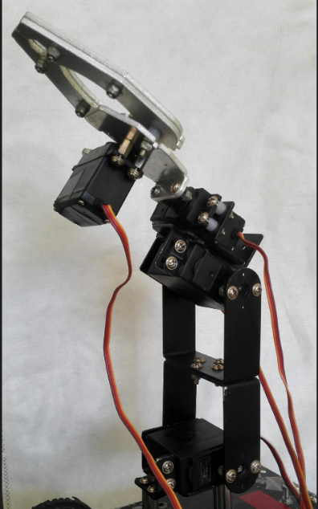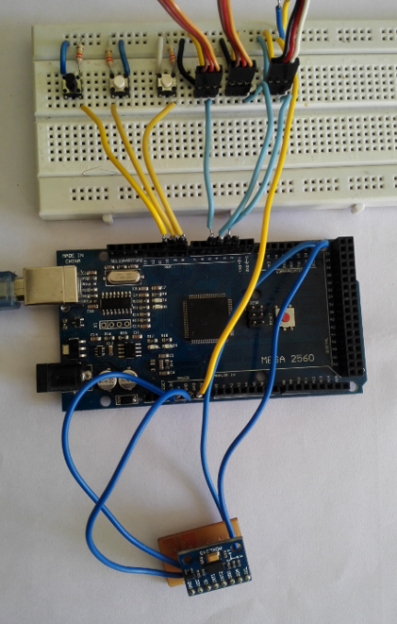

## B. Result

Time response and stability of the system is the main parameter to consider. The accelerometer used in the experiment is very accurate and specially designed for mobile purpose as mentioned in the datasheet. The movement of robotic arm is synchronised with the operator hand. The synchronization data is given below.

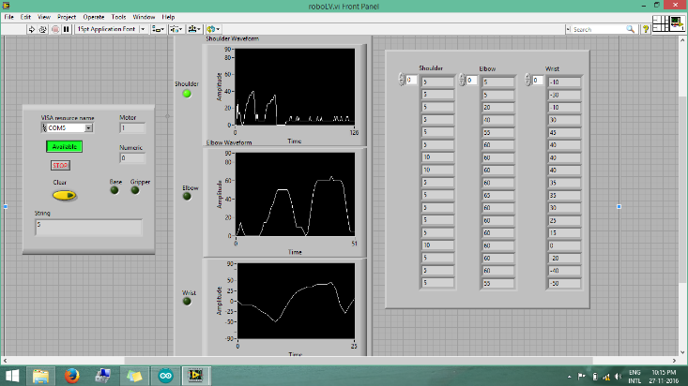

**Fig 5: Output screen in LV**

# VI. CONCLUSION AND FUTURE WORK

# REFERENCES

1. I. Mihara, Y. Yamauchi, and M. Doi, “A real-time vision-based interface using motion processor and applications to robotics,” in Systems and Computers in Japan, vol. 34, pp. 10-19, 2003.
2. S. Waldherr, R. Romero, and S. Thrun, “A gesture based interface for human-robot interaction,” in *Autonomous Robots*, vol. 9, no.2, pp.151173, Springer, 2000.
3. J. Aleotti, A. Skoglund and T. Duckett, “Position teaching of a robot arm by demonstration with a wearable input device,” in *International* *Conference on Intelligent Manipulation and Grasping (IMG04)*, Genoa, Italy, July 1-2, 2004.
4. S. Perrin, A. Cassinelli, and M. Ishikawa, “Gesture recognition using laser-based tracking system,” in *Sixth IEEE International Conference* *on Automatic Face and Gesture Recognition*, pp. 541-546, 2004.
5. Y. Song, S. Shin, S. Kim, D. Lee, and K. H. Lee, “Speed estimation from a tri-axial accelerometer using neural networks, ” in *29th Annual* *International Conference of the IEEE Engineering in Medicine and* *Biology Society*, EMBS 2007, pp. 3224-3227, 2007.
6. J. Yang, W. Bang, E. Choi, S. Cho, J. Oh, J. Cho, S. Kim, E. Ki, and D. Kim, “A 3D Handdrawn Gesture Input Device Using Fuzzy ARTMAPbased Recognizer,” in *Journal of Systemics, Cybernetics* *and*

*Informatics*, vol. 4, no. 3, pp. 1-7, 2006.

1. K. Murakami, and H. Taguchi, “Gesture Recognition using Recurrent Neural Networks,” in *Proceedings of ACM CHI’91Conference on* *Human Factors in Computing Systems*, pp. 237-242, New Orleans, USA, 1991.
2. G. Hirzinger, J. Bals, M. Otter, and J. Stelter, “The DLR-KUKA success story: robotics research improves industrial robots,” in *IEEE* *Robotics & Automation Magazine*, vol. 12, no. 3, pp. 16-23, 2005.