***Robotic Arm control based on Accelerometer using Arduino with LabVIEW***

Manzoor. A 1, Bhagyashree Joshi 2

Department of Instrumentation Science,

SavitriBaiPhule Pune University, Pune, Maharashtra. [manzoor11@gmail.com](mailto:manzoor11@gmail.com)1, [jbhagyashree@gmail.com](mailto:jbhagyashree@gmail.com)2

***Abstract* — Robotic arm is introduced to replace human from certain tasks. But the controlling of robotic arm is still challenging because of many reasons. So many researchers proposed human-robot interaction. This paper focus on hand movement based robotic arm control with accelerometer: - ADXL345. The controller part is implemented with Arduino mega IDE, with AT-Mega AT2560 microcontroller. The communication between sensor and controller has been established by I2C protocol interface. We know that hand movement based robotic arm is one of the existing method. But here the control strategy is different and the LabVIEW part is also one extension. 3 switches are provided to switch the control between individual joints (motor), hence operator will have full access in individual angle of freedom, and as well it helps to eliminate the movements accidently. The controlling method is simple to handle and more user friendly. And the robotic arm response is synchronised with operator arm.**

***Keywords—roll and pitch; accelerometer; servo; Arduino mega; interface; MEMs; arm; automation; sensor etc.***

# I. INTRODUCTION

Robotic arm is introduced to replace human from certain tasks. But the controlling of robotic arm is still challenging because of many reasons. So many researchers proposed human-robot interaction.

In this field many research works are going on to establish appreciable interaction between human and robot. Few of them are: recognizing human gestures, control robot using wireless artificial neural network system [1], [2], [3], vision based system [4], [5], using finger gesture recognition systems [6]. Also many user-interfaces also available such as: icon-based programming, colour touch screens, 3D joystick, mouse [7] or Motion detecting system [8]. Among these motion detecting system is very widely accepted method because of its simplicity, accuracy and efficiency. MEMs Accelerometer sensor chip makes this operation very effective. Because, it analyse motion and can utilise the data directly in the program of embedded systems. So, the same way we can analyse the hand movements of operator and utilise it to control robotic arm.

This paper proposes hand movement controlled robotic arm with LabVIEW as front panel part, to analyse the data of the sensor. This data can be further processed to get the animation of actual robotic arm. This arm has 3 degree of freedom and an end effector to grab object. A 3 axis accelerometer is used to derive the roll and pitch of operator hand. The motion detected by accelerometer is communicated to micro-controller to obtain exact roll and pitch of operator arm. Finally, the prototype of proposed arm is presented.

# II. PROPOSED SYSTEM

## System Overview

The whole system can be divide into three sections. One is data acquisition section, second one is data processing and visualising section and the last one is actuator section which consist of a servo motor based artificial robotic arm.

Acquiring of data is done with ADXL-345 IC module [9]. The IC is a 3-axis accelerometer. It features user-programmable 4 sensitivity ranges ±2*g*, ±4*g*, ±8*g* and ±16*g*. In our system, it measures 3 axis acceleration (tilting) and send data to controller part. Arduino performs data processing, controlling Servo motors and communicate the data to LabVIEW. With some mathematical equations, the controller finds the pitch and roll angles of sensor’s position. 3 switches are also provided for switching the control between individual joints (motor). The LabVIEW part is to Display the Pitch and Roll variation in graphical representation.

## Block Diagram

Figure (1) depicts the block diagram. Sensor measures the tilting of operator hand then it sends data to the Arduino board for further processing. The Arduino board control servo motor and share the pitch and roll angles with LabVIEW. The LabVIEW will visualise and store the data for further processing if required.

Accelerometer Sensor

Arduino Board

Servo motors

LabVIEW

**Fig 1: Block diagram**

## Methodology

The sensor board will hold horizontally. The hand movement in different angle is sensed by the sensor. Arduino perform data processing, data averaging, rounding and sends the data to the servo motor. Simultaneously it is getting updated in LabVIEW. Different library functions in Arduino, some tool suits in LabVIEW are utilised to implement this. Communication between LabVIEW is through USB communication, with the help of VISA tool suit in LabVIEW.

The servo motor is programmed to run in sweep mode for smooth rotation without much juggling. Switch control is synchronised with Data processing, controlling servo and communicating with LabVIEW. So the whole system is synchronised with operator hand movements gated through the switches.

# III. CONTROL & CALCULATION

To measure the movements, we need some reference frame. At the beginning of operation, accelerometer is calibrated with the initial position of sensor. And it is considered as the reference for the measurement, and calculate the displacement along with reference axis. This displacement is utilised further.

The arm has total 5 servo motor. One is acting as end effector to grab object and remaining four motors control the movement of robotic arm. Base servo motor is to control the x axis (yaw) of the arm and the following 2 servo motor control the y axis movements and the last servo motor control the roll angle of end effector.

The data used for processing is, with reference to reference axis that is being calibrated at the beginning of operation. For the best accuracy we used all three axis to determine angle. With simple vector math, controller transforms raw data to pitch and roll angles, which we are interested in.

Let, acceleration component denotes as *x,* *y* and *z*

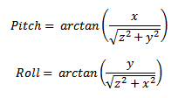

With the equations above, controller calculate the angle between the reference vector and X axis (pitch) or Y axis (roll). Since the rotation around y axis with constant x axis is the roll angle, and the rotation around x axis with constant y axis is the pitch angle.

Initialise system

Communication hand shake with LV

Detect switch pressed

Update respective graph & array and indicator

**Fig 3: Flow chart for data collection in LabVIEW**

The return value of ‘atan’ function (math library of Arduino) is in radians. So it has to convert to degree units, with the below conventional equation.

1 radian = 180/π, which is around ~57°.

# IV. PROPOSED FLOWCHART

The system has two separate flowcharts to be followed. Figure 2 and 3 shows the same.

Control servo motor

Communicate angle with LV

Averaging and rounding thevalues

Detect switch pressed

Communication hand shake with LV

Define Pins & initialise system

Calculate angles

Get raw data fromsensor

**Fig 2: Flow chart of Arduino**

# V. DESIGNED HARDWARE AND RESULT

Hardware has a great significant. Because the proper combination of hardware and software is the success of project. The hardware used in this project is prototype.

## Hardware Structure

Figure (4) shows the actual robotic arm and the figure (5) is the controller board connections.

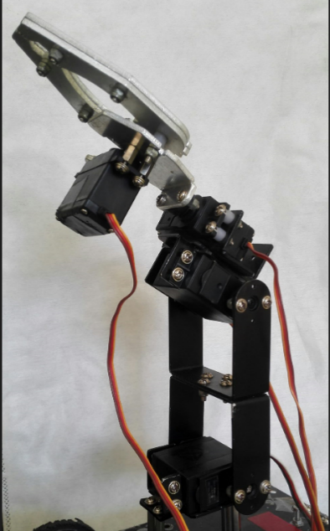

**Fig 4: Hardware arm**

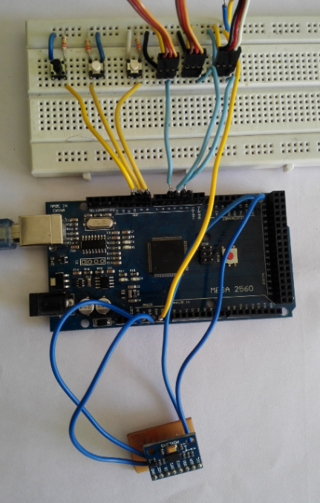

**Fig 5: Controller connections**

## B. Result

Time response and stability of the system is the main parameter to consider. The accelerometer used in the experiment is very accurate and specially designed for mobile purpose as mentioned in the datasheet. The movement of robotic arm is synchronised with the operator hand. And the real time working is updating in LabVIEW also. Figure (6) is the front panel designed in LabVIEW to capture and store the real time processed data.

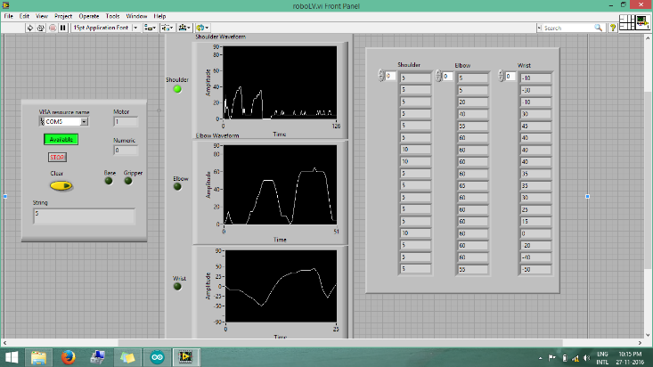

**Fig 6: Output screen in LV**

# REFERENCES

Y. Song, S. Shin, S. Kim, D. Lee, and K. H. Lee, “Speed estimation from a tri-axial accelerometer using neural networks, ” in *29th Annual* *International Conference of the IEEE Engineering in Medicine and* *Biology Society*, EMBS 2007, pp. 3224-3227, 2007.

1. J. Yang, W. Bang, E. Choi, S. Cho, J. Oh, J. Cho, S. Kim, E. Ki, and D. Kim, “A 3D Handdrawn Gesture Input Device Using Fuzzy ARTMAPbased Recognizer,” in *Journal of Systemics, Cybernetics* *and*

*Informatics*, vol. 4, no. 3, pp. 1-7, 2006.

1. K. Murakami, and H. Taguchi, “Gesture Recognition using Recurrent Neural Networks,” in *Proceedings of ACM CHI’91Conference on* *Human Factors in Computing Systems*, pp. 237-242, New Orleans, USA, 1991.
2. I. Mihara, Y. Yamauchi, and M. Doi, “A real-time vision-based interface using motion processor and applications to robotics,” in Systems and Computers in Japan, vol. 34, pp. 10-19, 2003.
3. S. Waldherr, R. Romero, and S. Thrun, “A gesture based interface for human-robot interaction,” in *Autonomous Robots*, vol. 9, no.2, pp.151173, Springer, 2000.
4. S. Perrin, A. Cassinelli, and M. Ishikawa, “Gesture recognition using laser-based tracking system,” in *Sixth IEEE International Conference* *on Automatic Face and Gesture Recognition*, pp. 541-546, 2004.
5. G. Hirzinger, J. Bals, M. Otter, and J. Stelter, “The DLR-KUKA success story: robotics research improves industrial robots,” in *IEEE* *Robotics & Automation Magazine*, vol. 12, no. 3, pp. 16-23, 2005.
6. J. Aleotti, A. Skoglund and T. Duckett, “Position teaching of a robot arm by demonstration with a wearable input device,” in *International* *Conference on Intelligent Manipulation and Grasping (IMG04)*, Genoa, Italy, July 1-2, 2004.
7. <http://www.analog.com/media/en/technical-documentation/data-sheets/ADXL345.pdf>
8. Ariful Islam Bhuyan, Tuton Chandra Mallick, “Gyro-Accelerometer based control of a robotic Arm using AVR Microcontroller,” in *9th International Forum on Strategic Technology (IFOST), Bangladesh, October 21-23, 2014.*
9. <http://morf.lv/modules.php?name=tutorials&lasit=31>
10. <http://rcarduino.blogspot.in/2012/04/servo-problems-with-arduino-part-1.html>