# PAMANTASAN NG LUNGSOD NG MAYNILA

(University of the City of Manila) Intramuros, Manila

# Microprocessor Lab

Laboratory Activity No. 3

Binary Representation of 8 LEDs in TinkerCad and Arduino Programming

Score

*Submitted by:*

## Manzo, Patricia Anne R.

## Saturday 1pm-7pm / CPE 0412.12

*Date Submitted*

## 10-14-2023

*Submitted to:*

## Engr. Maria Rizette H. Sayo

1. **Objectives**

This laboratory activity aims to create Arduino circuit of Binary representation (decimal 0- 256 using 8 LEDs)

* + creating an Arduino programming and circuit diagram.

## Method/s

* + Perform a task problem given in the presentation.
  + Write a code and perform an Arduino circuit diagram of a Binary Representation from decimal 0-256 using 8 LEDs.

Steps:

1. Connect 8 LEDs to the Arduino board, with each LED connected to a separate digital pin on the board. The pins should be connected in order, with the first LED connected to the lowest-numbered pin and the last LED connected to the highest-numbered pin.
2. Write a function that converts a decimal number (in the range 0-255) into an 8-bit binary sequence by turning on/off each LED. If the bit is "1", turn on the corresponding LED. If the bit is "0", turn off the corresponding LED.
3. Use a for loop to count from 0 to 256 and call the binary conversion function for each number in the loop.
4. Display the generated random number, the binary sequence, and a check-test on the serial monitor.

## Results

***Figure 1. Binary Representation of 8 LEDs Circuit Diagram TinkerCad Link:***

[***https://www.tinkercad.com/things/aWxSVSMUc5J-arduino-circuit-of-binary-representation-***](https://www.tinkercad.com/things/aWxSVSMUc5J-arduino-circuit-of-binary-representation-/editel?sharecode=follOXwwCsqW_XgvfUT05NrhPdQe_hgjO1gmLl4QZyg)

[***/editel?sharecode=follOXwwCsqW_XgvfUT05NrhPdQe_hgjO1gmLl4QZyg***](https://www.tinkercad.com/things/aWxSVSMUc5J-arduino-circuit-of-binary-representation-/editel?sharecode=follOXwwCsqW_XgvfUT05NrhPdQe_hgjO1gmLl4QZyg)

const int numLEDs = 8; // Number of LEDs

int ledPins[] = {2, 3, 4, 5, 6, 7, 8, 9}; // Digital pins connected to LEDs

void setup() {

// Initialize LED pins as OUTPUT

for (int k = 0; k < numLEDs; k++) {

pinMode(ledPins[k], OUTPUT);

}

// Start serial communication for monitoring

Serial.begin(9600);

}

void decimalToBinaryLED(int decimalValue) {

// Convert decimal to binary and control LEDs accordingly

if (0 <= decimalValue && decimalValue <= 255) {

for (int k = 0; k < numLEDs; k++) {

bool isBitSet = bitRead(decimalValue, k); // Check if the bit at position k is set

digitalWrite(ledPins[k], isBitSet ? HIGH : LOW); // Turn on or off the LED

}

// Display the decimal value, binary sequence, and check-test result

Serial.print("Decimal: ");

Serial.print(decimalValue);

Serial.print(", Binary: ");

for (int k = numLEDs - 1; k >= 0; k--) {

bool isBitSet = bitRead(decimalValue, k);

Serial.print(isBitSet ? "1" : "0");

}

int convertedValue = 0;

for (int k = 0; k < numLEDs; k++) {

int ledState = digitalRead(ledPins[k]);

convertedValue |= (ledState << k);

}

if (convertedValue == decimalValue) {

Serial.println(", Check-Test: Pass");

} else {

Serial.println(", Check-Test: Fail");

}

}

}

void loop() {

for (int value = 0; value <= 255; value++) {

decimalToBinaryLED(value);

delay(1000); // Delay for half a second

}

}

***Figure 2. Binary Representation of 8 LEDs Code***

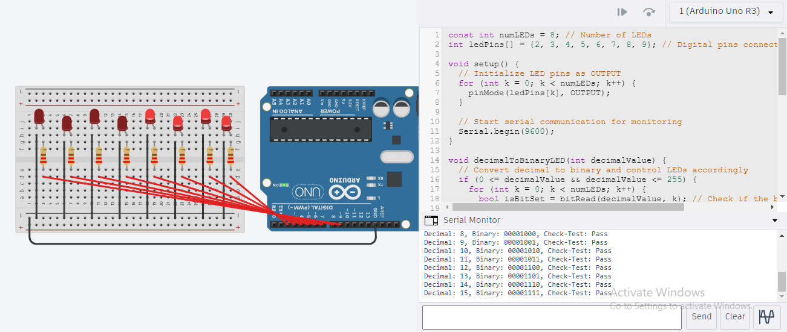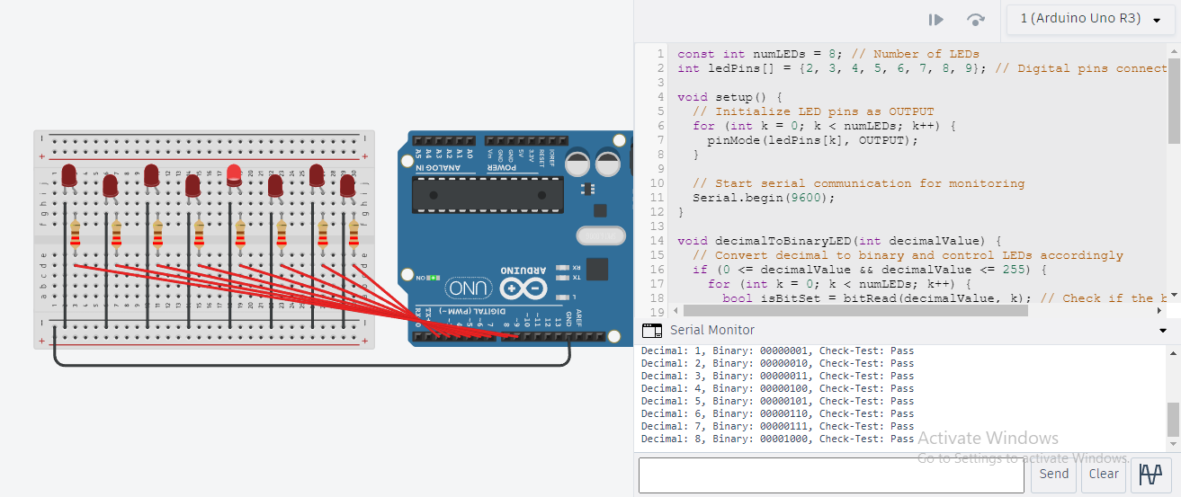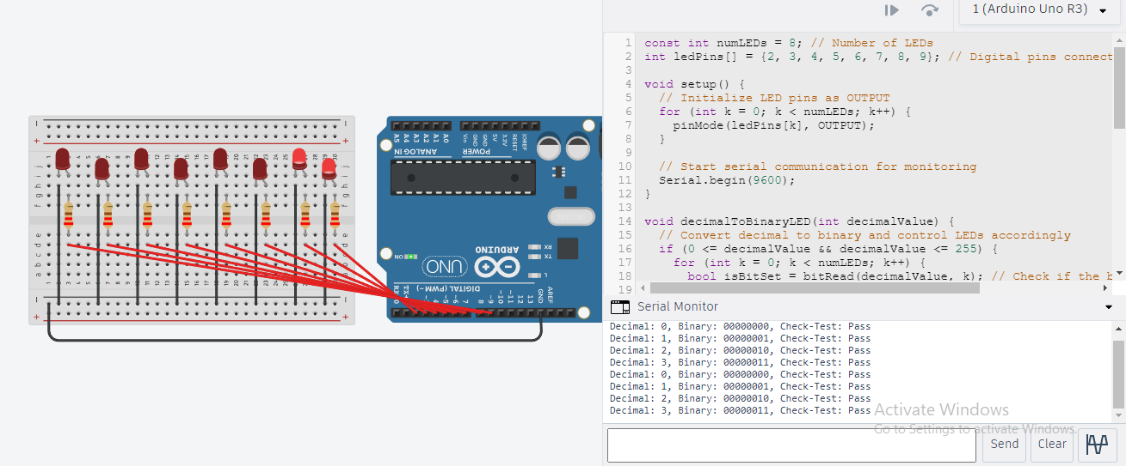

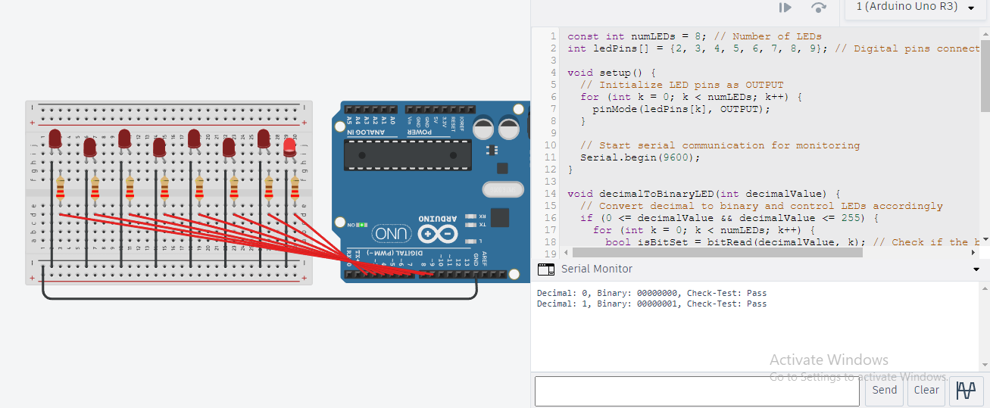***Figure 3. Sample Outputs***

## Conclusion

In conclusion, it is a fun and instructive project to design an Arduino circuit schematic that uses 8 LEDs to show the binary representation of decimal numbers from 0 to 256. Together, the circuit diagram and the code show how binary numbers are represented by computers. These are the main conclusions:

8 LEDs, 8 current-limiting resistors, a breadboard, jumper wires, an Arduino board, and all of these items are required. Connect the LEDs to various digital pins on the Arduino board. From the lowest-numbered pin to the highest-numbered pin, the LEDs should be arranged in order. By translating decimal numbers to their binary equivalent, the Arduino code manages the LEDs. The serial monitor shows both the decimal and binary values as it cycles through values between 0 and 255, adjusting the LEDs in accordance with the binary format. The binary representation is converted back to decimal and compared with the original value as part of a check-test in the code to ensure that the binary conversion was successful. You may better comprehend the binary numbering system and how information is stored and processed in computers by using the circuit to represent binary digits graphically. This project is not only a useful example of binary representation in practice, but it also provides beginners with an invaluable introduction to Arduino and binary math.

Overall, building an Arduino binary representation circuit is an excellent method to practice digital logic, programming, and electronics. It's an interesting idea that may be developed further for instructional reasons or just as an interactive binary concept presentation.