**Microprocessor Lab**

Laboratory Activity No. 2

**Arduino and Tinkercad Interface**

|  |
| --- |
|  |

Score

*Submitted by:*

**Manzo, Patricia Anne R.**

**<Saturday 1:00pm – 7:00pm> / <CPE 0412.1-2>**

*Date Submitted*

**30-09-2023**

*Submitted to:*

**Engr. Maria Rizette H. Sayo**

I. Objectives

This laboratory activity aims to implement the principles and techniques of hardware programming using Arduino through:

- creating an Arduino programming and circuit diagram.

II. Method/s

- Perform a task problem given in the presentation.

- Write a code and perform an Arduino circuit diagram of a ring counter that display eight (8)LEDs starting from left.

III. Results

**TinkerCad**

**Exercise 1: Write a code that does a ring counter display for eight (8) LEDs starting from left.**

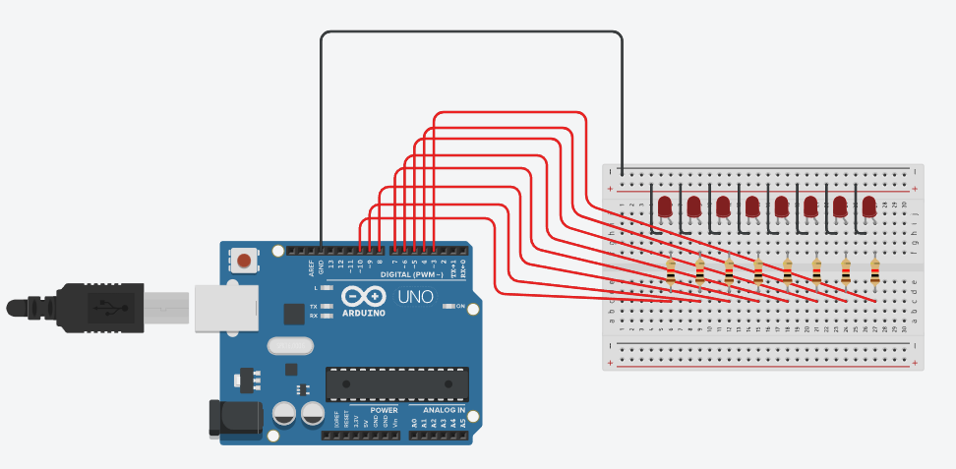

Figure No.1 Ring Counter Display Circuit Diagram

**Components Used**

1. 8 LEDs
2. Resistor
3. Breadboard

**CODE:**

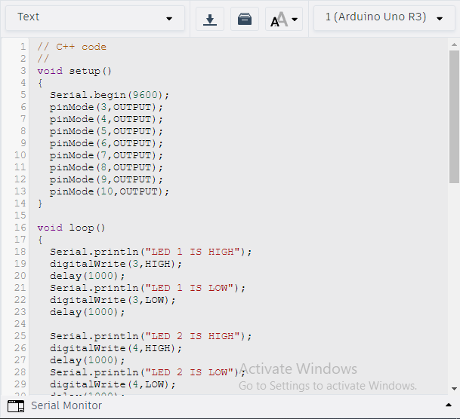

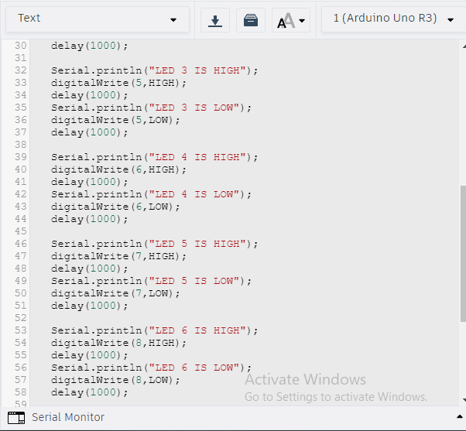

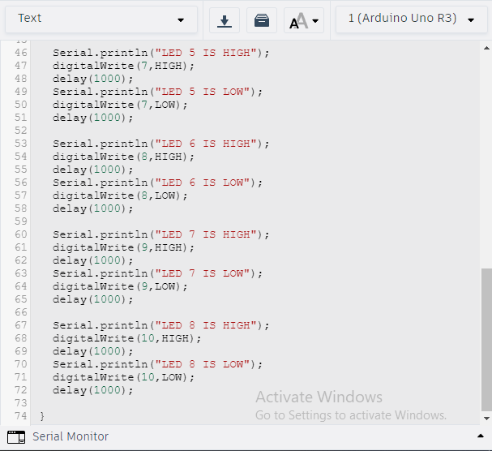

IV. Conclusion

The laboratory is utilizing 8 LEDs, 8 Resistors, an Arduino Uno, and a breadboard. First, connect the 8 LEDs to the breadboard and then connect the Arduino to the breadboard. After completing the setup, I began programming the device. Within 1 second the following LED switches between HIGH and LOW. I also used the Serial.println syntax to show whether the LED was HIGH or LOW.