Performance Comparison of Random Forest and Conditional Random Fields Models for Named Entity Recognition using the CoNLL-2003 Dataset

University of Juba
School of Computer Science and Information Technology,
Department of Computer Science


A dissertation submitted to the School of Computer Science and Information Technology, University of Juba in partial fulfillment
of the requirement leading to the award of Bachelor of Science (Hons) in the Department of Computer Science

By
ANTHONY BUSH CASTRO 20-CCS-281

Under the supervision of
Dr. Manzu Gerald S. KENYI, Ph.D.

April 2025

Approval

This is to certify that the Graduation Project titled: “Comparative Performance of Random Forest and Conditional Random Fields Models for Named Entity Recognition Using the CoNLL-2003 Dataset” has been carried out under my supervision, thoroughly reviewed, and meets the academic standards required as part as partial fulfillment of the requirements for the award of the Bachelor of Science (Hons) in Computer Science.
The dissertation presents a comparative performance analysis of the Random Forest and Conditional Random Fields models on the CoNLL-2003 dataset for Named Entity Recognition (NER). It reflects the student’s grasp of model design, experimentation, and evaluation in the domain of machine learning and natural language processing.

Submitted by:
Student Name: Anthony Bush Castro
Student ID: 20-CCS-281
Department: Computer Science
School: Computer Science and Information Technology

Supervised by:
Supervisor's Name: Dr. Manzu Gerald S. KENYI, Ph.D.
Position: Lecturer
Signature: ___________
Date: 2025/04/14

Approved by:
Name: Eng. Lodu Bosco John
Position: Head, Department of Computer Science
Signature: ___________
Date: ___________

Declaration

I, Anthony Bush Castro, do hereby declare that the dissertation titled “Comparative Performance of Random Forest and Conditional Random Fields Models for Named Entity Recognition Using the CoNLL-2003 Dataset” is my original work under the guidance of Dr. Manzu Gerald S. KENYI, Ph.D. This project has not been submitted to any other institution or University for any degree or diploma. All sources of information used in this project have been duly acknowledged. I affirm that the content presented herein is the result of my own research efforts and analysis.

Student’s Name: Anthony Bush Castro
Student ID: 20-CCS-281
Department: Computer Science
School: Computer Science and Information Technology
Signature: ___________
Date: ___________

Dedication

This dissertation is dedicated to my family, whose unwavering support and encouragement has been the cornerstone of my academic journey.
To my parents, who instilled in me the value of perseverance and hard work, I am eternally grateful. Your sacrifices have not gone unnoticed, and this achievement is as much yours as it is mine.
To my siblings, thank you for your constant motivation and belief in my abilities. This dedication also extends to my mentors and educators who have guided me with their wisdom and knowledge throughout my academic career.

Acknowledgement

I would like to express my deepest gratitude to all those who have contributed to the completion of this project.

First and foremost, I extend my sincere thanks to Dr. Manzu Gerald S. Kenyi, whose invaluable guidance and insightful feedback were instrumental in shaping the direction of this research. His expertise and patience are greatly appreciated.

I am also thankful to the faculty members of The School of Computer Science and Information Technology at the University of Juba (UoJ) for providing a conducive learning environment and access to necessary resources that facilitated this research.

Special thanks go out to my peers for their collaborative spirit and constructive discussions which enriched this study.
Furthermore, I acknowledge the support from various authors whose works provided a foundation for this research; their contributions are cited throughout this document.

Thank you all for your unwavering support

Abstract

This dissertation evaluates the effectiveness of Conditional Random Fields (CRF) and Random Forest (RF) models for Named Entity Recognition (NER) using the CoNLL-2003 dataset, addressing challenges in lexical ambiguity, domain variability, and data scarcity in natural language processing.

The study aims to compare these supervised approaches to determine their suitability for identifying entities such as persons, locations, organizations, and miscellaneous types. Employing the CoNLL-2003 English subset with 203,621 tokens, the methodology implements CRF with sequence-level dependencies and RF with token-level ensemble classification, using shared linguistic features and evaluating performance through accuracy, precision, recall, and F1-scores (macro and weighted averages).

Results show CRF significantly outperforms RF, achieving 95.6% test accuracy compared to RF’s 59.5%, highlighting CRF’s strength in modeling sequential dependencies and RF’s limitations with class imbalance and lack of inherent sequence modeling.
Despite CRF’s robust generalization, both models exhibit overfitting, with CRF’s macro F1-score dropping to 80.6% and RF’s to 40.4% on the test set. The findings recommend enhancing CRF with regularization and embeddings and augmenting RF with a CRF layer and oversampling to improve performance.

This research contributes to NLP by providing empirical insights into model selection for NER, bridging gaps between structured prediction and ensemble learning, with implications for optimizing entity recognition across diverse datasets.

Keywords: Named Entity Recognition, Conditional Random Fields, Random Forest, Natural Language Processing, CoNLL-2003

Table of Contents
Chapter 1: Introduction 11
1.1 Background 11
1.2 Problem Statement 13
1.3 Objectives 14
1.3.1 Primary Objective 14
1.3.2 Specific Objectives 14
1.4 Significance of the Study 15
1.5 Research Questions 15
1.6 Scope 15
Chapter 2: Literature Review 17
2.1 Introduction 17
2.2 Traditional Approaches to NER 18
2.2.1 Ruled-Based methods 18
2.3 Machine Learning Approaches to NER 18
2.4 Random Forest 19
2.5 Conditional Random Fields in NER 21
2.6 Research Gap and Novelty 23
2.6.1 Research Gap 23
2.6.2 Novelty 24
2.7 Conclusion 25
Chapter 3: Methodology 26
3.1 The CoNll-2003 Dataset 28
3.2 Data Preparation 29
3.3 Feature Extraction 30
3.4 Models 30
3.4.1 Conditional Random Fields (CRF) 30
3.4.2 Random Forest 31
3.5 Evaluation Metrics 32
3.5.1 Accuracy 33
3.5.2 Precision, Recall, and F1-Score (Per Class) 33
3.5.3 Macro Average 34
3.5.4 Weighted Average 35
3.6 Programming Language, Software, and Libraries Used in this research 36
Chapter 4: Results 37
4.1 Tag Distribution for the two models 37
4.2 Random Forest 39
4.2.1 Model Classification 39
4.2.2 Confusion Matrices 42
4.2.3 F1-Score 46
4.2.4 Precision vs Recall 48
4.2.5 Effect of Tag Distribution on Model Performance 50
4.2.6 Transition Weights 51
4.3 CRF 54
4.3.1 Model Classification 54
4.3.2 Confusion Matrices 56
4.3.3 F1-Score 61
4.3.4 Precision vs Recall 63
4.3.5 Effect of Tag Distribution on Model Performance 66
4.3.6 Transition Weights 67
Chapter 5: Discussion and Conclusion 69
5.1 Discussion: Comparative Performance 69
5.2 Conclusion 72
5.3 Limitations 73
5.4 Recommendations and Future Work 74

List of Figures

Figure 3-1: Implementation Flowchart 27
Figure 4-1: Tag distribution for the Training, Validation, and Test sets 38
Figure 4-2: RF Classification on the Training, Validation, and Test sets 40
Figure 4-3: RF Confusion Matrix for the Training set 42
Figure 4-4: RF Confusion Matrix for the Validation set 44
Figure 4-5: RF Confusion Matrix for the Test set 45
Figure 4-6: RF F-1Score comparison for Training vs Validation Vs Test sets 47
Figure 4-7: RF Precision vs Recall for the Training, Validation and Test sets 49
Figure 4-8: RF Transition Weights 52
Figure 4-9: CRF Classification on the Training, Validation and Test sets 54
Figure 4-10: CRF Confusion Matrix for the Training set 57
Figure 4-11: CRF Confusion Matrix for the Validation set 58
Figure 4-12: CRF Confusion Matrix for the Test set 59
Figure 4-13: CRF F1-Score comparison for Training, Validation and Test sets 61
Figure 4-14: CRF Precison-Recall Curves for Training, Validation and Test sets 64
Figure 4-15: CRF Transition Weights 67

List of Tables

Table 3-1: CoNLL-2003 English Dataset Statistics 29
Table 3-2: Libraries used in this study 36
Table 5-1: Tag Distribution for both models (Training, Validation, and Test sets) 80
Table 5-2: RF Classification Report metrics – Training Set 80
Table 5-3: RF Classification Report metrics – Validation Set 81
Table 5-4: RF Classification Report metrics – Test Set 81
Table 5-5: RF Confusion Matrix – Training Set 82
Table 5-6: RF Confusion Matrix – Validation Set 82
Table 5-7: RF Confusion Matrix – Test Set 82
Table 5-8: RF F1-Score comparison for Training vs Validation vs Test sets 83
Table 5-9: RF Precision vs Recall (Sample out of 17567 rows) – Training set 83
Table 5-10: RF Precision vs Recall (Sample out of 6799 rows) – Validation set 83
Table 5-11: RF Precision vs Recall (Sample out of 5924 rows) – Validation set 84
Table 5-12: RF Transition Weights 84
Table 5-13: CRF Classification Report metrics – Training Set 85
Table 5-14: CRF Classification Report metrics – Validation Set 85
Table 5-15: CRF Classification Report metrics – Test Set 85
Table 5-16: CRF Confusion Matrix – Training Set 86
Table 5-17: CRF Confusion Matrix – Validation Set 86
Table 5-18: CRF Confusion Matrix – Test Set 86
Table 5-19: CRF F1-Score comparison for Training vs Validation vs Test sets 87
Table 5-20: CRF Precision vs Recall (Sample out of 197072 rows) – Training set 87
Table 5-21: CRF Precision vs Recall (Sample out of 50,608 rows) – Validation set 87
Table 5-22: CRF Precision vs Recall (Sample out of 45339 rows) – Test set 88
Table 5-23: CRF Transition Weights 5-1 88

Nomenclature

- RF: Random Forest
- CRF: Conditional Random Fields
- NLP: Natural Language Processing
- NER: Named Entity Recognition

Introduction
Chapter Summary
Natural Language Processing (NLP) integrates computer science, linguistics, and artificial intelligence to enable machines to interpret human language (Chao et al., 2021; Adelakun et al., 2024). This field employs advanced machine learning, including deep neural networks, to analyze textual and spoken data, supporting applications like sentiment analysis, machine translation, and conversational AI.
A core NLP task is Named Entity Recognition (NER), which identifies and classifies entities such as names, dates, and locations (McCoy et al., 2013; Wang et al., 2020). Despite progress, NER faces challenges including lexical ambiguity, domain variability, and data scarcity, particularly in low-resource languages. This study evaluates two machine learning approaches: Conditional Random Fields (CRF) and Random Forest (RF); for NER using the CoNLL-2003 dataset.
By comparing their performance across overall accuracy precision, recall, F1-score metrics, macro and weighted averages, the research aims to determine their effectiveness in handling entity recognition and generalization. The findings will guide model selection for NER tasks, bridging gaps between structured prediction and ensemble learning in NLP.

Background
As the convergence of computer science, linguistic theory, and artificial intelligence, Natural Language Processing (NLP) represents a transformative and interdisciplinary technological domain that is primarily focused on enabling computational systems and machines to effectively analyze, interpret, understand, and generate human language in both written and spoken forms. (Chao, Trappey and Wu, 2021; Beatrice Oyinkansola Adelakun et al., 2024).
This interdisciplinary field addresses the fundamental challenge of creating meaningful interactions between humans and machines by developing computer algorithms capable of processing both textual and spoken communication. Contemporary NLP systems utilize advanced machine learning architectures, including deep neural networks, which demonstrate remarkable proficiency in linguistic pattern recognition and semantic analysis when trained on large-scale textual corpora (Chao, Trappey and Wu, 2021).
The practical implementations of NLP are widespread, touching on critical domains such as sentiment analysis, machine translation, automatic summarization, question answering, and conversational agents. Sentiment interpretation, for instance, uses computational methods to detect and classify emotional tone and subjectivity within digital text, providing organizations with actionable insights into customer feedback, brand perception, political trends, and online content moderation. Similarly, automated language translation technologies break down linguistic barriers by dynamically converting text between languages while maintaining semantic integrity—thereby facilitating cross-cultural communication and global information dissemination(Chao, Trappey and Wu, 2021; Beatrice Oyinkansola Adelakun et al., 2024).
At the core of these applications lies the essential process of text analysis, which involves transforming unstructured language data into structured, machine-interpretable representations. This process typically includes tasks such as tokenization (breaking text into meaningful units), part-of-speech (POS) tagging (assigning grammatical labels to words), and semantic entity identification. One of the most crucial of these tasks is Named Entity Recognition (NER), a specialized form of information extraction that identifies and classifies entities within a text into predefined categories such as names of persons, organizations, locations, dates, and numerical expressions(McCoy et al., 2013; Wang et al., 2020).
In recent years, significant research attention has been devoted to enhancing NER performance using machine learning techniques. While deep learning models have gained popularity, traditional supervised learning methods continue to offer competitive and interpretable alternatives, especially in scenarios involving structured prediction and limited annotated data. In this study, Random Forest (RF) and Conditional Random Fields (CRF) are adopted as primary methodological approaches for developing and evaluating NER systems. The Random Forest algorithm, a powerful ensemble learning method, is well-suited for handling high-dimensional feature spaces and offers robust performance through decision tree aggregation. On the other hand, Conditional Random Fields, as a type of probabilistic graphical model, are particularly effective for sequence labelling tasks like NER, as they capture contextual dependencies between adjacent labels and ensure globally optimal predictions over structured outputs.
By integrating these two approaches, the study aims to explore the comparative strengths and potential complementarities of tree-based and probabilistic models in accurately recognizing named entities across various text domains.

Problem Statement
Named Entity Recognition (NER) is a fundamental task in Natural Language Processing (NLP) that involves identifying and categorizing spans of text—referred to as named entities—into predefined classes such as persons, organizations, locations, dates, and domain-specific terms (Yu, Bohnet and Poesio, 2020). As a core component of information extraction, NER facilitates the structuring of unstructured text, making it a critical step in applications such as question answering, machine translation, and content summarization (Yu, Bohnet and Poesio, 2020). Despite the significant progress made in NLP, NER remains a challenging task due to several persistent issues:
Lexical Ambiguity and Context Dependence:
Named entities often appear in varied forms, including acronyms, abbreviations, and synonyms (Pereira et al., 2011; Stewart and Liu, 2020). The same entity may be referred to in multiple ways, while some terms may carry different meanings depending on the context. For example, in South Sudan, words like “Anger” and “But” are personal names in the Dinka community but also represent common English vocabulary. Similarly, the term “Apple” can refer to either a fruit or a technology company, depending on the context. Traditional models that lack contextual awareness often struggle with such ambiguity, necessitating the development of more context-sensitive approaches.
Domain-Specific Variability:
NER systems often generalize poorly across different domains. A model trained on news or financial data may underperform when applied to medical or legal texts, where entities and terminologies differ significantly (Zheng, Chen and Ma, 2022). For instance, the term “lead” may denote a business prospect in marketing but refers to a toxic substance in environmental science. Domain adaptation requires either custom training data or models capable of generalizing across multiple fields, both of which remain ongoing challenges (Liu et al., 2021).
Limited Availability of Annotated Data:
The success of machine learning-based NER systems heavily relies on large volumes of high-quality annotated datasets (Li et al., 2024). However, creating such datasets is labor-intensive and often unfeasible for low-resource languages or specialized domains (Nooralahzadeh, Lønning and Øvrelid, 2019). This data scarcity issue limits the development and deployment of effective NER models in underrepresented languages and fields, particularly those with minimal digital presence or smaller speaker populations. For many NER taskd, the CoNLL2003 dataset has provided a lot of informative literature. However, due to the scope of the dataset, its application on other languages is still a challenge.
Limited Comparative Research on Machine Learning Approaches:
While Conditional Random Fields (CRF) remain a widely adopted method for sequence labelling tasks such as NER due to their ability to model label dependencies in structured data, Random Forests (RF) have proven to be robust classifiers in various NLP and non-NLP applications (Lowe and Sayle, 2015). However, there exists a noticeable gap in research directly comparing the effectiveness of CRF and RF for NER using standardized datasets (Dong et al., 2022).
This study addresses these challenges by conducting a comparative analysis of Conditional Random Fields (CRF) and Random Forests (RF) for Named Entity Recognition. By evaluating these models on benchmark datasets, the research aims to assess their relative effectiveness, adaptability to linguistic ambiguity and domain-specific variation, and suitability for application in low-resource or specialized contexts.

Objectives

Primary Objective
The primary objective of this research is to evaluate and compare the performance of Conditional Random Fields (CRF), a structured statistical model, and Random Forest (RF), a supervised machine learning algorithm, for the task of Named Entity Recognition (NER) using the CoNLL-2003 dataset.

Specific Objectives
- To implement CRF and RF models for NER on the CoNLL-2003 dataset.
- To assess and compare the performance of both models using standard evaluation metrics such as precision, recall, and F1-score.
- To analyze the strengths and limitations of CRF and RF in recognizing and classifying different types of named entities.
- To investigate the generalization ability of each model across multiple named entity categories (e.g., person, organization, location, and miscellaneous)

Significance of the Study
This study contributes to the field of Named Entity Recognition by comparing two fundamentally different approaches:
- CRF, a structured prediction model well-suited for sequence labeling tasks, and
- RF, a non-linear ensemble learning algorithm typically applied to classification problems.
The comparative analysis in this study will contribute towards:
- Deepening the understanding of how statistical and machine learning methods behave in NER contexts.
- Informing model selection strategies based on task requirements, such as sequence dependency handling or interpretability.
- Supporting the development of adaptable and accurate NER systems for real-world applications.
- Providing a practical benchmark using the CoNLL-2003 dataset for future studies exploring NER techniques.
With detailed practical implications of each approach, this study seeks to bridge the gap between structured modeling and machine learning in information extraction tasks.

Research Questions
This study aims to answer the following research questions:
- How does the performance of CRF compare to RF in Named Entity Recognition?
- What are comparative strengths and limitations of CRF and RF for NER tasks?
- Which model demonstrates better generalization across different entity types in the CoNLL-2003 dataset?
- What practical insights can be drawn from the comparative analysis to guide future research in NER?

Scope
This study is limited to Named Entity Recognition (NER) using the English-language CoNLL-2003 dataset. It involves the implementation and evaluation of:
- Conditional Random Fields (CRF): a structured statistical model optimized for sequence labelling, and
- Random Forest (RF): a supervised machine learning algorithm based on ensemble decision trees.
The research focuses solely on English text and the four standard entity types defined in the dataset: PERSON, LOCATION, ORGANIZATION, and MISCELLANEOUS.

Literature Review
Chapter Summary
This chapter systematically reviews the evolution of Named Entity Recognition (NER) methodologies, from early rule-based systems to contemporary statistical and machine learning approaches. Initial rule-based methods demonstrated domain-specific effectiveness but struggled with generalization and contextual ambiguity. The transition to machine learning introduced feature-engineered models like SVMs, later surpassed by deep learning architectures (RNNs, LSTMs) that automate feature extraction. Recent breakthroughs with BERT have established new performance benchmarks through contextualized embeddings.
The analysis focuses comparatively on Random Forests (RFs) and Conditional Random Fields (CRFs), highlighting their literature: RFs excel in high-dimensional classification with interpretability, while CRFs dominate sequence labeling through dependency modeling. Hybrid approaches (e.g., BiLSTM-CRF) demonstrate their complementary potential.
However, a critical gap persists in direct empirical comparisons between standalone CRF and RF models regarding their NER performance, adaptability to entity types, and context sensitivity - a gap this study addresses through systematic benchmarking on CoNLL-2003.

Introduction
Named Entity Recognition (NER) is a fundamental task in Natural Language Processing (NLP), focused on identifying and categorizing entities mentioned in text into predefined classes such as persons, organizations, and locations (Zirikly and Diab, 2014). Over the years, a wide range of methodologies have been explored for NER, evolving from early rule-based systems to more sophisticated machine learning and, more recently, deep learning techniques.
This chapter reviews existing literature on NER, highlighting traditional and modern approaches, while specifically focusing on Conditional Random Fields (CRFs) and Random Forest (RF) models.

Traditional Approaches to NER

Ruled-Based methods
In the early stages of Named Entity Recognition (NER) development, systems largely relied on rule-based and statistical techniques. Rule-based approaches were constructed using manually defined linguistic rules, often tailored to specific languages or domains (Xu, Burdick and Raschid, 2016). These systems required extensive human effort to build and maintain, as rules had to be carefully crafted by experts. Although they could be effective in narrow, well-defined contexts, their performance often declined when applied to different languages, domains, or evolving textual patterns (Magnini, B., Lavelli, A. and Magnolini, S., 2020).
A major drawback of rule-based systems was their limited ability to generalize, often struggling especially with unseen entities due to the inability to interpret context accurately. For example, they might not distinguish between the word “Apple” as a fruit or as a technology company due to a lack of contextual sensitivity (Zhang and Wu, 2021). For instance, Debbarma et al. (Debbarma* et al., 2019) utilized a heuristic, rule-based approach that relied heavily on detailed linguistic analysis. However, they discovered that subtle contextual clues often fell outside the predefined rules, leading to misclassifications when the contextual semantics deviated from the expected patterns.
Similarly, Aboaoga and Aziz (Aboaoga, 2013) highlighted the challenges of developing comprehensive rules, even for well-structured languages like Arabic. Despite the clear linguistic framework, creating rules that capture all possible contextual variations remained a difficult and incomplete task. These difficulties suggest that while rule-based systems provide transparency and control, especially in domain-specific applications, combining rule-based methods with data-driven techniques is essential to handle the inherent ambiguity in natural language effectively.

Machine Learning Approaches to NER
Machine learning approaches have played a pivotal role in advancing Named Entity Recognition (NER) by enabling models to leverage labeled data for training, allowing them to generalize effectively across diverse languages and domains. Traditional machine learning algorithms such as Support Vector Machines (SVMs) and machine entropy models have been widely used for NER tasks (Magnini, Lavelli and Magnolini, 2020).These models often rely on feature engineering, where domain-specific knowledge is employed to design features that capture relevant information crucial for identifying named entities.
The rise of deep learning has further transformed NER by allowing models to automatically extract meaningful features directly from raw text data. Deep learning architectures like Recurrent Neural Networks (RNNs), Long Short-Term Memory (LSTM) networks, and Convolutional Neural Networks (CNNs) have gained significant attention for their ability to learn complex patterns within the data without requiring extensive feature engineering (Jiang and Bolshakova, no date). These models excel at capturing sequential relationships in text, making them particularly well-suited for NER tasks.
Recent breakthroughs have introduced pre-trained language models such as BERT (Bidirectional Encoder Representations from Transformers), which have set new benchmarks for performance in NER. By leveraging large-scale, pre-trained models that understand context bidirectionally, BERT and similar models have significantly advanced NER capabilities, achieving state-of-the-art results (Magnini, Lavelli and Magnolini, 2020). These advancements mark a shift towards more sophisticated, data-driven approaches in NER, reducing the reliance on manual feature extraction while improving accuracy and robustness across various domains and languages.

Random Forest
Random Forests, a popular ensemble learning algorithm, have gained significant attention in Named Entity Recognition (NER) due to their strong performance and ability to handle high-dimensional data effectively. The robustness of Random Forests in NER tasks has been showcased in various studies. For instance, Sumathipala et al., (Sumathipala, Yamada and Unehara, 2014) demonstrated the utility of Random Forests in protein name classification, achieving impressive precision and recall rates of 93.8% and 83.8%, respectively, on the GENIA corpus. This highlights the method’s ability to manage domain-specific NER tasks, where feature selection plays a critical role in boosting the classifier's performance. Their study underscored how carefully optimizing feature selection within Random Forest classifiers can substantially enhance their ability to identify named entities, thereby improving overall NER accuracy.
In addition to their application in protein classification, Random Forests have been employed in other biological domains. Wang et al., (Wang, Liu and Deng, 2018) explored their use in predicting protein-protein interaction hot spots, emphasizing the versatility of Random Forests in handling complex datasets common in biomedical research. Although their focus was not specifically on NER, their findings demonstrate how Random Forests can process intricate biological data, further validating their adaptability in specialized domains such as biomedical NER tasks.
Comparison to other Machine Learning Models
Random Forests are frequently compared to other machine learning algorithms to assess their performance in NER tasks. A notable example is a study by Yang et al., (Yang et al., 2019) who compared Random Forests with Support Vector Machines (SVMs) and other classifiers in the context of extracting medication-related entities from clinical notes. Their results revealed that Random Forests outperformed SVMs in relation extraction tasks, with an F1-score of 0.8233 for clinical NER. This comparison highlights the strengths of Random Forests in capturing and relating entities, particularly in specialized fields like medical NER. The superior performance of RF in such contexts makes it a valuable tool for extracting complex relationships in medical texts.
Integrated approaches
Integrating Random Forests with other models has also proven effective in enhancing NER capabilities, especially for more complex tasks. For instance Jiao et al., (Jiao et al., 2021) proposed a hybrid model combining Random Forests with deep learning architectures for predicting T cell antigens. This integrated approach leveraged the strengths of both models, highlighting the potential of combining Random Forests with other advanced methodologies to tackle complex NER problems. Such hybrid systems can benefit from the unique advantages of each model, resulting in improved overall performance.
In another integrated approach, Biradar et al. (Biradar et al., 2016) combined Random Forests with Conditional Random Fields (CRFs) in a multi-layered detection system for recognizing chemical named entities. This study emphasized the potential benefits of combining diverse methodologies to address the complexity of NER tasks, particularly for complex entity types. The success of these integrated models underscores the flexibility of Random Forests, showing their ability to function effectively within hybrid systems for diverse NER applications.
Challenges
While Random Forests have proven effective in many NER applications, challenges remain, particularly in the need for high-quality annotated datasets. The creation of more specialized and domain-specific datasets, as well as improvements in feature extraction techniques, will be crucial for advancing NER performance. Zhong and Hu (Zhong and Hu, 2013) discussed the potential of integrating semantic types and domain-specific knowledge to train more effective NER systems. Incorporating these elements could significantly enhance the accuracy and reliability of NER models, particularly in complex or underrepresented domains.
Addressing these challenges will be essential for further improving the effectiveness of Random Forests and other machine learning approaches in NER tasks.

Conditional Random Fields in NER
Conditional Random Fields (CRFs) have become a cornerstone for Named Entity Recognition (NER) tasks, particularly when applied to benchmark datasets like CoNLL 2003. Initially, statistical models like Hidden Markov Models (HMMs) (Settles, 2004) and CRFs (Peilin et al., 2019) were introduced to overcome the limitations of rule-based systems.
These models shifted the focus to data-driven approaches, where patterns are learned from annotated datasets rather than relying on manually crafted rules. This transition was pivotal, especially in capturing sequential dependencies between words, making CRFs highly effective for NER. Unlike HMMs, which assume that observations are independent, CRFs consider the entire sequence of observations when making predictions, allowing them to better model the complex relationships between adjacent words and their corresponding entity labels (Peilin et al., 2019; Zahra, Hidayatullah and Rani, 2022). This sequence-based approach enhances the model's ability to handle contextual ambiguity and ensures more accurate entity classification by considering the broader context.
CRFs and Hybrid CRFs
One of the key advancements in CRF-based NER tasks is the integration of CRFs with other sequential models to improve scalability and performance. (Ye and Ling, 2018) proposed a hybrid model that combines CRFs with a Semi-Markov CRF (SCRF) to extend the capabilities of traditional CRFs. This model incorporates both word-level and segment-level scoring, enabling the system to capture long-range dependencies in text more effectively. The hybrid approach, trained jointly, achieves state-of-the-art performance on the CoNLL 2003 NER task without relying on external knowledge sources. This advancement showcases how CRFs, when integrated with SCRFs, can model more complex dependencies by focusing on segments rather than just individual tokens, thus improving the accuracy and robustness of NER systems.
In a similar appraoch, (Okanohara et al., 2006) successfully combined the temporal strengths of HMMs with the feature-rich capabilities of CRFs by using semi-Markov CRFs. This approach provides a more comprehensive understanding of sequential data, allowing the model to better capture the relationships between observations and their corresponding labels. The hybrid SCRF model enhances scalability and performance, particularly in scenarios that demand a detailed understanding of the contextual relationships within sequences. This synergy between HMMs and CRFs illustrates how both models can complement each other, making the hybrid approach highly effective for complex NER tasks.
Another innovative approach involves the delayed feature combination method, explored by Ronran et al., (Ronran, Lee and Jang, 2020) within a bidirectional LSTM-CRF framework. In this model, various feature types—such as character-level CNN or LSTM word representations and contextualized word embeddings—are combined at a later stage in the network rather than at the input level. This delayed integration strategy allows each feature to contribute according to its specific strengths, resulting in a more flexible and effective use of different types of data. Their evaluation on the CoNLL 2003 dataset showed significant improvements in F1 scores, demonstrating the effectiveness of selective feature integration. By combining the best aspects of each feature type at an appropriate stage, this approach improves the model's ability to understand the contextual relationships within the sequence, further enhancing NER performance.
CRFs have also been adapted to work within emerging frameworks like federated learning, which allows for decentralized training while maintaining data privacy. Mathew et al., (Mathew, Stripelis and Ambite, 2022) explored this paradigm by implementing a BiLSTM-CRF model within a federated learning framework on the CoNLL 2003 dataset. Their findings indicate that federated learning can achieve performance levels comparable to centralized training, addressing critical issues like data privacy. This flexibility of CRFs in decentralized training paradigms underscores their robustness in sequence labeling tasks, ensuring high accuracy in NER tasks while respecting privacy constraints. This adaptability highlights the ongoing relevance of CRFs in modern machine learning settings, where privacy and data distribution are key considerations.
Another noteworthy advancement is the integration of CRFs into end-to-end neural sequence models, as exemplified by Ma and Hovy (Ma and Hovy, 2016). Their BiLSTM-CNN-CRF architecture brings together the strengths of convolutional neural networks (CNNs) for character-level feature extraction, bidirectional LSTMs for capturing contextual dependencies, and CRFs for ensuring global consistency during the decoding process. This combination of technologies resulted in an impressive F1 score of 91.21% on the CoNLL 2003 dataset, demonstrating the power of integrating CRFs with deep learning models. The model excels at both local feature extraction and global sequence consistency, making it highly effective for complex NER tasks.
To conclude, the evolution of CRFs in NER, from traditional feature-based models to improved and efficient neural network architectures has been instrumental in NER tasks. CRFs' ability to model dependencies across sequences and their adaptability to various integration strategies whether combined with SCRFs, LSTMs, or CNNs, has solidified their place in the state-of-the-art NER systems. Moreover, hybrid models combining CRFs with other techniques, like HMMs or federated learning, continue to push the boundaries of what is possible in NER. By continuing to evolve and adapt, CRFs will remain an important tool for tackling the challenges of modern NER tasks, offering more accurate, efficient, and context-aware solutions.

Research Gap and Novelty

Research Gap
Despite considerable progress in Named Entity Recognition (NER), several significant research gaps remain, particularly in the comparative evaluation of traditional machine learning approaches. Although Conditional Random Fields (CRFs) have been extensively studied as a structured prediction model for sequence labelling and Random Forests (RFs) have proven their robustness in classification tasks, there is limited empirical research directly comparing their performance in NER (Dong et al., 2022). Existing studies typically focus on deep learning models, such as BiLSTM-CRF and BERT, or evaluate CRFs and RFs in isolation rather than in a controlled, comparative framework (Ye & Ling, 2018; Ma & Hovy, 2016). This lack of direct comparison leaves a void in understanding the relative strengths and weaknesses of these models in NER tasks.
Moreover, previous research has not systematically addressed how CRFs and RFs handle crucial NER challenges, such as lexical ambiguity, domain adaptation, and generalization across various entity types (Zheng et al., 2022). While CRFs excel in sequence modeling by capturing dependencies between adjacent tokens, RFs are known for their ability to handle high-dimensional feature spaces and provide clear interpretability in classification tasks. Despite these strengths, how they perform in tandem with challenges inherent to NER—such as the diverse range of entity types—remains underexplored. A particularly notable gap is the absence of standardized benchmarking between CRFs and RFs on widely accepted datasets like CoNLL-2003. While CRFs have long been favoured for their ability to model sequential data, RFs offer interpretability and feature importance insights that could be valuable in understanding how different features contribute to NER predictions. However, the comparative evaluation of CRFs and RFs in terms of precision, recall, and their adaptability to various entity categories is lacking. This study aims to fill this gap by conducting a rigorous comparative analysis of CRF and RF models under identical experimental conditions on the CoNLL-2003 dataset.

Novelty
This research introduces several novel contributions to the field of NER:
- Direct Comparison of CRF and RF for NER: Unlike previous studies that evaluate CRFs and RFs independently, this research provides a head-to-head comparison of these two models using the CoNLL-2003 dataset. By doing so, it offers empirical evidence on their relative effectiveness in a real-world NER task, contributing to a deeper understanding of how these models perform when applied to sequence labeling.
- Analysis of Model Behavior Across Entity Types: The study not only compares the overall performance of CRFs and RFs but also examines their behavior across different types (e.g., PERSON, ORGANIZATION, LOCATION). This detailed analysis highlights the strengths and weaknesses of each model in terms of generalization and precision for specific entity categories. Such insights can guide model selection based on the entity types most relevant to a given NER task.
- Interpretability vs. Sequence Modeling Trade-offs: CRFs are known for their strong sequence modeling capabilities, which help capture dependencies between adjacent words, but they can be less interpretable compared to models like RFs. On the other hand, RFs offer superior interpretability and feature importance analysis, which allows practitioners to understand how specific features contribute to predictions. This study explores these trade-offs, providing valuable insights for practitioners on when to prioritize sequence modeling over interpretability or vice versa in practical NER applications.
- Hybridization Potential: By identifying the complementary strengths of CRFs and RFs, this research lays the groundwork for future hybrid models that combine CRFs' sequence-awareness with RFs' ensemble learning capabilities. Hybrid models have the potential to improve performance by leveraging the advantages of both approaches, offering a more robust solution for complex NER tasks.

Conclusion
This study fills a critical gap in NER research by systematically comparing two fundamentally different yet widely used machine learning approaches namely: CRFs and RFs. Through its rigorous analysis, the research provides actionable insights that can help guide model selection for NER tasks in real-world NLP applications.
By addressing comparative performance, domain adaptability, and trade-offs between interpretability and sequence modeling, this research contributes novel perspectives that could inspire future advancements in NER modeling, including the development of hybrid models that capitalize on the strengths of both CRFs and RFs.

Methodology
Chapter Summary
This chapter details the comparative implementation of Conditional Random Fields (CRF) and Random Forest models for Named Entity Recognition using the CoNLL-2003 dataset. The English subset, containing 203,621 tokens across 14,041 training sentences, was processed with IOB2 tags for four entity types (PERSON, LOCATION, ORGANIZATION, MISC). Both models shared common linguistic features (lowercase forms, suffixes, context windows) but differed fundamentally in approach: CRF leveraged sequence-level dependencies through transition features, while Random Forest employed token-level classification with ensemble voting.
The CRF model used L-BFGS optimization with dual L1/L2 regularization (c₁=c₂=0.1), whereas Random Forest utilized 100 trees (max_depth=30) with balanced class weights. Implementation leveraged Python's NLP ecosystem (sklearn-crfsuite, scikit-learn) with specialized feature extraction via DictVectorizer. Several evaluation metrics were used: precision, recall, and F1-scores, Accuracy, Macro Average, and Weighted Average

The study adopts a structured methodology to implement and compare Conditional Random Fields (CRF) and Random Forest algorithms for Named Entity Recognition (NER) using the CoNLL-2003 dataset. The approach constitutes data preprocessing, comprehensive feature extraction, model training, performance evaluation using standard metrics, and result visualization to ensure a meaningful comparison of the two models.
Figure 3-1 details the research design.
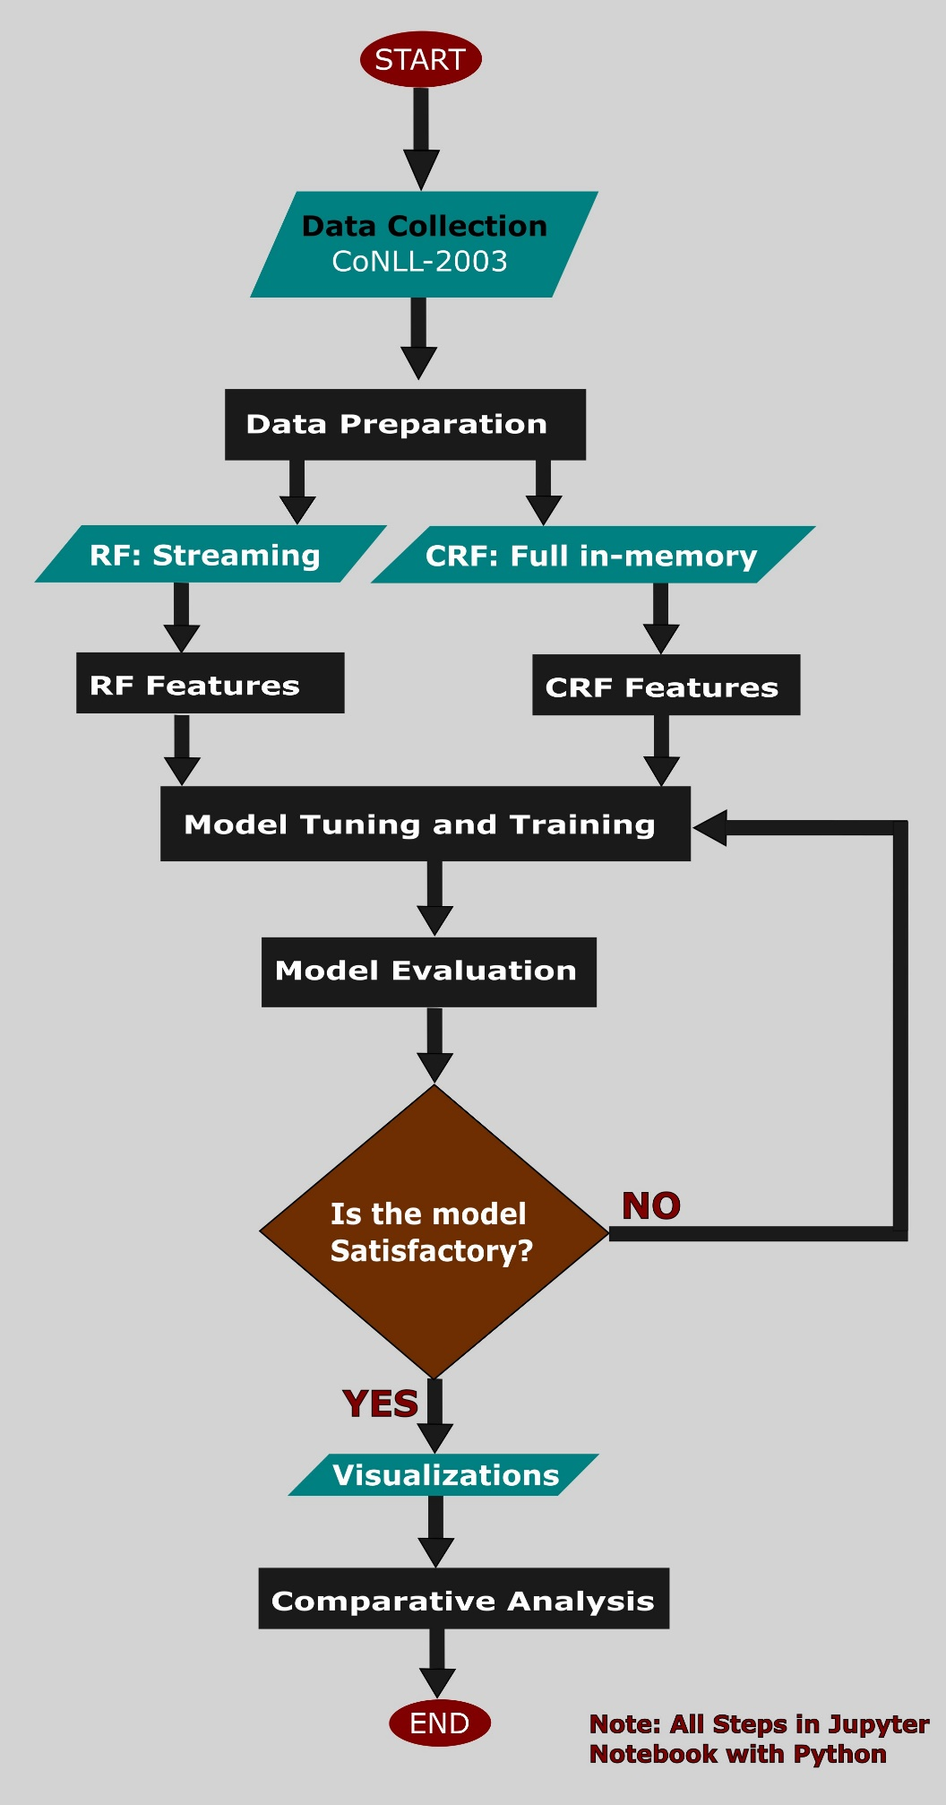
Figure 3-1: Implementation Flowchart

The CoNll-2003 Dataset
The CoNLL-2003 dataset is a prominent benchmark in the field of language-independent Named Entity Recognition (NER), introduced as part of the shared task organized by Tjong Kim Sang and De Meulder (Tjong Kim Sang and De Meulder, 2003). It comprises annotated newswire texts from the Reuters corpus in both English and German; however, the present study focuses solely on the English subset. The dataset contains four principal named entity classes: PERSON, LOCATION, ORGANIZATION, and MISC (miscellaneous entities that do not fit into the other categories). Owing to its widespread adoption and standardized structure, the CoNLL-2003 dataset continues to serve as a foundational resource for evaluating and comparing NER models in a consistent and replicable manner.
Structurally, the dataset is organized into files designated for training, validation (development), and testing, with each tokenized instance represented across four space-separated columns (Daniel and James H., 2000). The first column contains the raw token, which serves as the primary unit of analysis. The second column provides the part-of-speech (POS) tag, denoting the grammatical role of each word in the sentence. The third column includes syntactic chunk tags, which identify constituent phrasal structures such as noun and verb phrases. The final column contains the NER labels, assigning each token to a specific named entity class or marking it as non-entity.
The NER tags in this dataset conform to the IOB2 (Inside–Outside–Beginning) tagging convention (Tjong Kim Sang and De Meulder, 2003). A tag beginning with "B-" indicates the beginning of a named entity, "I-" marks continuation within the same entity type, and "O" denotes tokens outside any named entity. The four named entity types are encoded as PER (Person), LOC (Location), ORG (Organization), and MISC. It is also common for the dataset to include -DOCSTART- markers that indicate the beginning of new documents, although these are often removed in downstream applications. The availability of POS and chunk tags alongside the named entity labels presents a valuable opportunity for feature-based modeling approaches. Prior work suggests that these linguistic features can be instrumental in enhancing model performance, offering syntactic and contextual cues useful for entity classification (Ratinov and Roth, 2009).
The English portion of the CoNLL-2003 dataset is conventionally divided into three subsets: training, validation, and test sets. The training set, used to fit the models, contains approximately 14,041 sentences and 203,621 tokens extracted from 946 articles. The validation set, which facilitates hyperparameter tuning and monitors model performance during training, comprises roughly 3,250 sentences and 51,362 tokens from 216 articles. The test set, reserved for the final evaluation of generalization performance, consists of approximately 3,453 sentences and 46,435 tokens drawn from 231 articles.
The English data was curated from Reuters news articles published between August 1996 and August 1997, with the test set specifically derived from articles dated December 1996. This temporal separation between the training/validation and test sets is an intentional design element, aimed at ensuring a more robust evaluation by preventing temporal data leakage and assessing the model’s ability to generalize to future data. The significant disparity in size between the training set and the other subsets also reflects the importance of ample training data for learning reliable patterns and relationships in the context of supervised NER.
The statistics of the data used in this research are summarized in Table 3-1, below.

Table 3-1: CoNLL-2003 English Dataset Statistics
Split | Number of Articles | Number of Sentences | Number of Tokens
Training | 946 | 14,987 | 203,621
Validation | 216 | 3,466 | 51,362
Test | 231 | 3,684 | 46,435

Data Preparation
The CoNLL-2003 dataset, retrieved through the Hugging Face Datasets library (datasets.load_dataset("conll2003")), forms the basis of this study. It consists of English-language text annotated with Named Entity Recognition (NER) labels following the IOB2 tagging scheme. For example, “B-PER” indicates the beginning of a person entity, “I-LOC” denotes a token inside a location entity, and “O” represents tokens outside any named entity. The dataset is pre-partitioned into training, validation, and test subsets.
For the CRF approach, the entire dataset is loaded into memory to support sequence-level processing, which is essential for modeling contextual dependencies within sentences. In contrast, the Random Forest approach employs streaming to process the dataset in manageable chunks, thereby optimizing memory usage and ensuring scalability for large-scale token-level classification

Feature Extraction
The raw token-level data was transformed into structured inputs suitable for both CRF and RF modeling. The features include:
Shared Features
Both models utilize a shared set of linguistically motivated features, including:
- The lowercase form of each token.
- Character-level suffixes (e.g., the last two or three characters of a word).
- Orthographic patterns such as all-uppercase or title-case formatting.
- Binary indicators of digit presence within a token.
- Contextual features derived from neighboring tokens (i.e., preceding and succeeding words).
CRF-Specific Features:
The Conditional Random Fields model additionally incorporates positional and sequence-based features that help capture inter-token dependencies and relative positions within a sentence—an essential consideration for sequence labeling tasks.
Random Forest-Specific Features:
For the Random Forest model, tokens are processed in batches of 1,000 samples. The extracted features are then converted into a machine-readable format using the DictVectorizer, resulting in sparse matrix representations suitable for efficient token-level classification.

Models

Conditional Random Fields (CRF)
Conditional Random Fields (CRFs) are discriminative probabilistic models designed for sequence labeling tasks such as Named Entity Recognition (NER). Unlike generative models that model joint probabilities, CRFs directly optimize the conditional probability of a label sequence given an observed input sequence, making them well-suited for tasks where contextual dependencies among labels are crucial.
The mathematical formulation is represented by Error! Reference source not found.:
$$P\left(y | x\right)= \frac{1}{Z(x)}exp\left(\sum_{i=1}^{n}{\sum_{k=1}^{K}{λ_{k}f_{k}\left(y_{i-1},y_{i},x,i\right)}}\right)$$ | Equation 3.4.1.1
Where:
- $P\left(y | x\right)$ is the conditional probability of the label sequence $y=\left(y_{1},y_{2},…,y_{n}\right)$ given the input sequence $x=\left(x_{1},x_{2},…,x_{n}\right)$.
- $Z(x)$ is the partition function (normalization factor) that ensures the probabilities sum to one (1).
- $f_{k}\left(y_{i-1},y_{i},x,i\right)$ represents the feature functions that encode relationships between adjacent labels and observations at position i.
- $λ_{k}$ is the trainable weight corresponding to each feature function$f_{k}$.
- n is the length of the token sequence
- K is the total number of feature functions
To improve the efficacy, the log-linear model captures both transition-based dependencies (between labels) and observation-based dependencies (between input tokens and their labels).
Training Parameters:
- Optimization Algorithm: L-BFGS (Limited-memory Broyden–Fletcher–Goldfarb–Shanno), a quasi-Newton method for convex optimization.
- Regularization:
L1 regularization coefficient: $c_{1}=0.1$(encourages sparsity).
L2 regularization coefficient: : $c_{2}=0.1$(prevents overfitting).
- Max Iterations: 100 (early stopping if convergence is reached earlier).

Random Forest
As an ensemble-based classification algorithm, Random Forest operates by constructing a multitude of decision trees and aggregating their outputs to make robust predictions. In NER tasks, Random Forest treats the problem as a token-level classification task, where each token is classified independently based on its features, without considering sequential dependencies.
Mathematical the classification is represented by
Equation 3.4.2.1

$$\hat{y}=mode\left\{h_{1}\left(x\right),h_{2}\left(x\right),h_{T}\left(x\right)\right\}$$ | Equation 3.4.2.1

Where:
- $\hat{y}$ is the final prediction label for a token.
- $h_{t}\left(x\right)$ is the output of the t-th decision tree for input feature vector x.
- T is the total number of trees in the forest (100).
- X is the feature vector describing the token, including context and character-level features
Final Prediction
The final prediction is based on voting which comprises of:
- Individual Predictions: Each decision tree in the ensemble makes an independent prediction based on a random subset of features and training samples (bootstrap aggregation).
- Majority Voting (Hard Voting): The predicted label $\hat{y}$ is determined by selecting the class with the highest frequency among all individual tree predictions, hence leveraging the wisdom of the crowd, reducing variance and increasing robustness.
- Tie-Breaking (Ambiguity Resolution): In a rare-case-scenario where multiple labels receive the same number of votes (a tie), the Random Forest implementation in scikit-learn resolves such ties by choosing the label with the lowest index in the internal class list.
Training Parameters:
- Number of Trees (n_estimators): 100
- Maximum Tree Depth: 30 (to control overfitting and computation time)
- Class Weights: "balanced" (adjusts weights inversely proportional to class frequencies in the training data, handling imbalanced NER labels effectively)
- Parallel Processing (n_jobs): -1 (utilizes all CPU cores to speed up training and inference)

Evaluation Metrics
To evaluate the performance of the Random Forest (RF) and Conditional Random Field (CRF) models for Named Entity Recognition (NER) on the CoNLL-2003 dataset, several standard metrics are used, namely: accuracy, precision, recall, F1-score, macro average, weighted average, and the Area Under the Precision-Recall Curve (AUC). The metrics offer a diverse understanding of the models’ effectiveness in classifying tokens into NER categories such as "B-PER", "I-LOC", and "O".

Accuracy
Accuracy measures the proportion of correctly predicted tokens (NER tags) out of the total number of tokens in the dataset. It is calculated by dividing the number of correct predictions by the total number of predictions. A correct prediction occurs when the predicted tag for a token matches its true tag (e.g., predicting "B-PER" for a token that is actually "B-PER").
Overall model accuracy is represented by: Equation 3.5.1.1

$$Accuracy= \frac{Number of Correct Prediction}{Total Number of Predictions}$$ | Equation 3.5.1.1

Where:
- $Number of Correct Prediction$ is the sum of all tokens where the predicted tag matches the true tag, equivalent to the sum of the diagonal elements in a confusion matrix (i.e., true positives for each class).
- $Total Number of Predictions$ is the total number of tokens in the dataset, which is the sum of all elements in the confusion matrix.

Precision, Recall, and F1-Score (Per Class)
Precision (Equation 3.5.2.1), Recall (Equation 3.5.2.2), and F1-score (Equation 3.5.2.3) are calculated for each NER tag to evaluate the model’s performance on individual categories. These metrics are based on counts of true positives (TP), false positives (FP), and false negatives (FN) from the confusion matrix.
Precision measures the proportion of predicted instances of a tag that are correct:
$$Precision= \frac{TP}{TP+FP}$$ | Equation 3.5.2.1

Recall measures the proportion of actual instances of a tag that are correctly identified:
$$Recall= \frac{TP}{TP+FN}$$ | Equation 3.5.2.2

F1-Score is the harmonic mean of precision and recall, providing a balanced measure:
$$F1-Score= 2*\frac{Precision*Recall}{Precision+Recall}$$ | Equation 3.5.2.3

Where:
- $TP$ represents the True Positives (TP) - the number of tokens correctly predicted as a specific tag (e.g., a token is "B-PER" and predicted as "B-PER").
- $FP$ represents the False Positives (FP) - The number of tokens incorrectly predicted as a specific tag (e.g., a token is "O" but predicted as "B-PER").
- $FN$ represents the False Negatives (FN) - The number of tokens that are a specific tag but predicted as something else (e.g., a token is "B-PER" but predicted as "O").

Macro Average
The macro average computes the average of a metric (precision, recall, or F1-score) across all classes, treating each class equally regardless of its support. This provides an unweighted measure of performance, useful for assessing the model’s effectiveness on minority classes in an imbalanced dataset.
The macro average equations for Precision (Equation 3.5.3.1), Recall (Equation 3.5.3.2), and F1-Score (Equation 3.5.3.3) are represented as:

$$Macro Average Precision=\frac{1}{N}\sum_{i=1}^{N}{{Precision}_{i}}$$ | Equation 3.5.3.1

$$Macro Average Recall=\frac{1}{N}\sum_{i=1}^{N}{{Recall}_{i}}$$ | Equation 3.5.3.2

$$Macro Average F1-Score=\frac{1}{N}\sum_{i=1}^{N}{{F1-Score}_{i}}$$ | Equation 3.5.3.3

Where:
- N is the number of classes (for instance, 9 for the NER tags: "B-LOC," "B-MISC," "B-ORG," "B-PER," "I-LOC," "I-MISC," "I-ORG," "I-PER," "O")

Weighted Average
The weighted average accounts for class imbalance by weighting each class’s metric by its support before averaging, giving more influence to classes with higher support. Equations Equation 3.5.4.1, Equation 3.5.4.2, and Equation 3.5.4.3 detail how the weighted average is calculated for Precision, Recall and F1-Score.

$$Weighted Average Precision=\frac{\sum_{i=1}^{N}{\left({Support}_{i}*{Precision}_{i}\right)}}{\sum_{i=1}^{N}{{Support}_{i}}}$$ | Equation 3.5.4.1

$$Weighted Average Recall=\frac{\sum_{i=1}^{N}{\left({Support}_{i}*{Recall}_{i}\right)}}{\sum_{i=1}^{N}{{Support}_{i}}}$$ | Equation 3.5.4.2

$$Weighted Average F1-Score=\frac{\sum_{i=1}^{N}{\left({Support}_{i}*{F1-Score}_{i}\right)}}{\sum_{i=1}^{N}{{Support}_{i}}}$$ | Equation 3.5.4.3

Where:
- ${Support}_{i}$ is the number of instances or actual occurrences of class i in the dataset (size of the class)
- ${Precision}_{i}$ is the precision for class i, represented by Equation 3.5.4.4:
$${Precision}_{i}=\frac{{TP}_{i}}{\left({TP}_{i}+{FP}_{i}\right)}$$ | Equation 3.5.4.4

- ${Recall}_{i}$ is the Recall for class i, represented by Equation 3.5.4.5:
$${Recall}_{i}=\frac{{TP}_{i}}{\left({TP}_{i}+{FN}_{i}\right)}$$ | Equation 3.5.4.5

- ${F1-Score}_{i}$ is the F1 score for class i, represented by Equation 3.5.4.6:
$${F1-Score}_{i}=2*\frac{{Precison}_{i}*{Recall}_{i}}{\left({Precision}_{i}+{Recall}_{i}\right)}$$ | Equation 3.5.4.6

Programming Language, Software, and Libraries Used in this research

The primary programming language of choice for implementing this study is Python, largely due to its rich ecosystem of specialized libraries and frameworks. The extensive libraries and inbuilt system functions used in this study include:
Table 3-2 shows the libraries used in this study, for the implementation of CRF and RF models
Table 3-2: Libraries used in this study
Libraries | purpose
Pandas | Handling structured dataset (e.g., CoNLL-2003 dataset)
numpy | Numerical computations for feature extraction
Sklearn (scikit-learn) | Machine learning utilities (Random Forest, Evaluation metrics)
sklearn.ensemble.RandomForestClassifier | Random Forest model implementation
sklearn.feature_extraction.DictVectorizer | Converting features into numerical form
sklearn.metrics | Precision, Recall, and F1-score
sklearn.model.selection.train_test_split | Splitting dataset into training and test sets
sklearn.pipeline.pipeline | Creating model pipeline for structured processing
sklearn_crfsuite | CRF model implementation
Nltk (natural language toolkit) | Tokenization, part-of-speech (POS) tagging
spacy | Advanced NLP processing for feature extraction
Matplotlib and seaborn | Visualization of model performance

Programming Interface
Jupyter Notebook: The code was run from Visual Studio (code editor) and written in Jupyter Notebook’s interactive web-based environment, with Git’s version control.

Results
Chapter Summary
The evaluation of Random Forest (RF) and Conditional Random Field (CRF) models on the CoNLL-2003 dataset reveals significant differences in their accuracy for Named Entity Recognition (NER).
CRF demonstrates exceptional performance, achieving an accuracy of 99.9% on the training set (203,621 tokens), 97.6% on the validation set (51,362 tokens), and 95.6% on the test set (46,435 tokens). Despite a slight drop on unseen data, indicating some overfitting, CRF maintains robust generalization.
In contrast, RF exhibits moderate accuracy, with 60.6% on the training set, 58.6% on the validation set, and 59.5% on the test set, reflecting a consistent but limited performance and a slight decline on unseen data, suggesting overfitting and poor generalization. CRF’s superior accuracy underscores its strength in modeling sequential dependencies, making it highly effective for NER, while RF struggles with class imbalance and lacks inherent sequence modeling, limiting its accuracy across all splits.

The two models: RF and CRF were both evaluated on the CoNLL-2003 dataset for NER across three splits: training, validation, and test sets. The performance metrics: precision, recall, and F1-Score are analysed for each NER tag, along with macro and weighted averages to comprehensively evaluate the performance of each model. Where the values are in the range of 0 to 1, percentages are used for clarity (decimal values converted to percentages). The results of the Random Forest model are presented first, then followed by the results of the Conditional Random Fields.

Tag Distribution for the two models
First, the combined distribution of the NER tags (for both models) in the training, validation and test sets are presented. Then, model classification is evaluated using different metrics across the NER tags is presented. Figure 4-1 shows the distribution of the tags
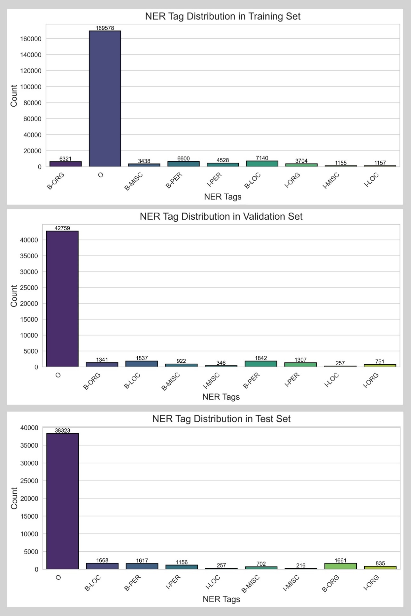
Then the model behavior is supplemented with results from the confusion matrices, F1-Scores, Precision vs Recall, Tag Distribution, and lastly Transition weights, all in chronological order. In the training set, which contains 203,621 tokens, the tag distribution is heavily imbalanced. The O tag dominates with 169,578 instances, making up approximately 83.3% of the tokens.
Figure 4-1: Tag distribution for the Training, Validation, and Test sets
Among the entity tags, B-LOC has the highest count at 7,140 (3.5%), followed by B-PER with 6,600 (3.2%), B-ORG with 6,321 (3.1%), and I-PER with 4,528 (2.2%). The remaining tags have lower counts: I-ORG with 3,704 (1.8%), B-MISC with 3,438 (1.7%), I-LOC with 1,157 (0.6%), and I-MISC with 1,155 (0.6%).

Random Forest

Model Classification
The Random Forest model's overall performance (Figure 4-2) shows an accuracy of 60.6% on the training set (203,621 tokens), 58.6% on the validation set (51,362 tokens), and 59.5% on the test set (46,435 tokens), indicating a slight drop in performance on unseen data, which suggests some overfitting.
The macro average F1-score, which treats all tags equally, is 48.1% on the training set (support: 203,621), dropping to 42.0% on validation (support: 51,362) and 40.4% on the test set (support: 46,435), highlighting challenges in generalizing to unseen data, particularly for minority tags with lower support (e.g., I-PER with 4,528 instances in training, 1,307 in validation, 1,156 in test).
The macro average precision and recall on the training set are 44.1% and 70.4%, respectively, with an arithmetic average of (44.1 + 70.4) / 2 = 57.2%, but the harmonic mean F1-score of 48.1% is lower, reflecting the imbalance between precision and recall. The weighted average F1-score, which accounts for class imbalance, is higher at 68.8% (training), 66.9% (validation), and 67.7% (test), driven largely by the model's performance on the majority class O (support: 169,578 in training, 42,759 in validation, 38,323 in test). The weighted average precision and recall on the training set are 88.5% and 60.6%, respectively, with an arithmetic average of (88.5 + 60.6) / 2 = 74.6%, while the harmonic mean F1-score is 68.8%, again lower due to the disparity between precision and recall. For the majority class O, the model performs strongly, with precision at 99.2% (training), 98.7% (validation), and 98.9% (test), but recall is lower at 58.9%, 57.8%, and 59.3%, respectively, leading to F1-scores of 3.9%, 72.9%, and 74.1%. The high support for O (169,578 in training, 83.3% of tokens) contributes to the high precision, but the moderate recall indicates that some O tokens are misclassified as entities, likely due to the model's bias towards predicting entity tags to compensate for class imbalance. The harmonic mean (F1-score) being lower than the arithmetic average on training, further illustrates this imbalance between precision and recall.

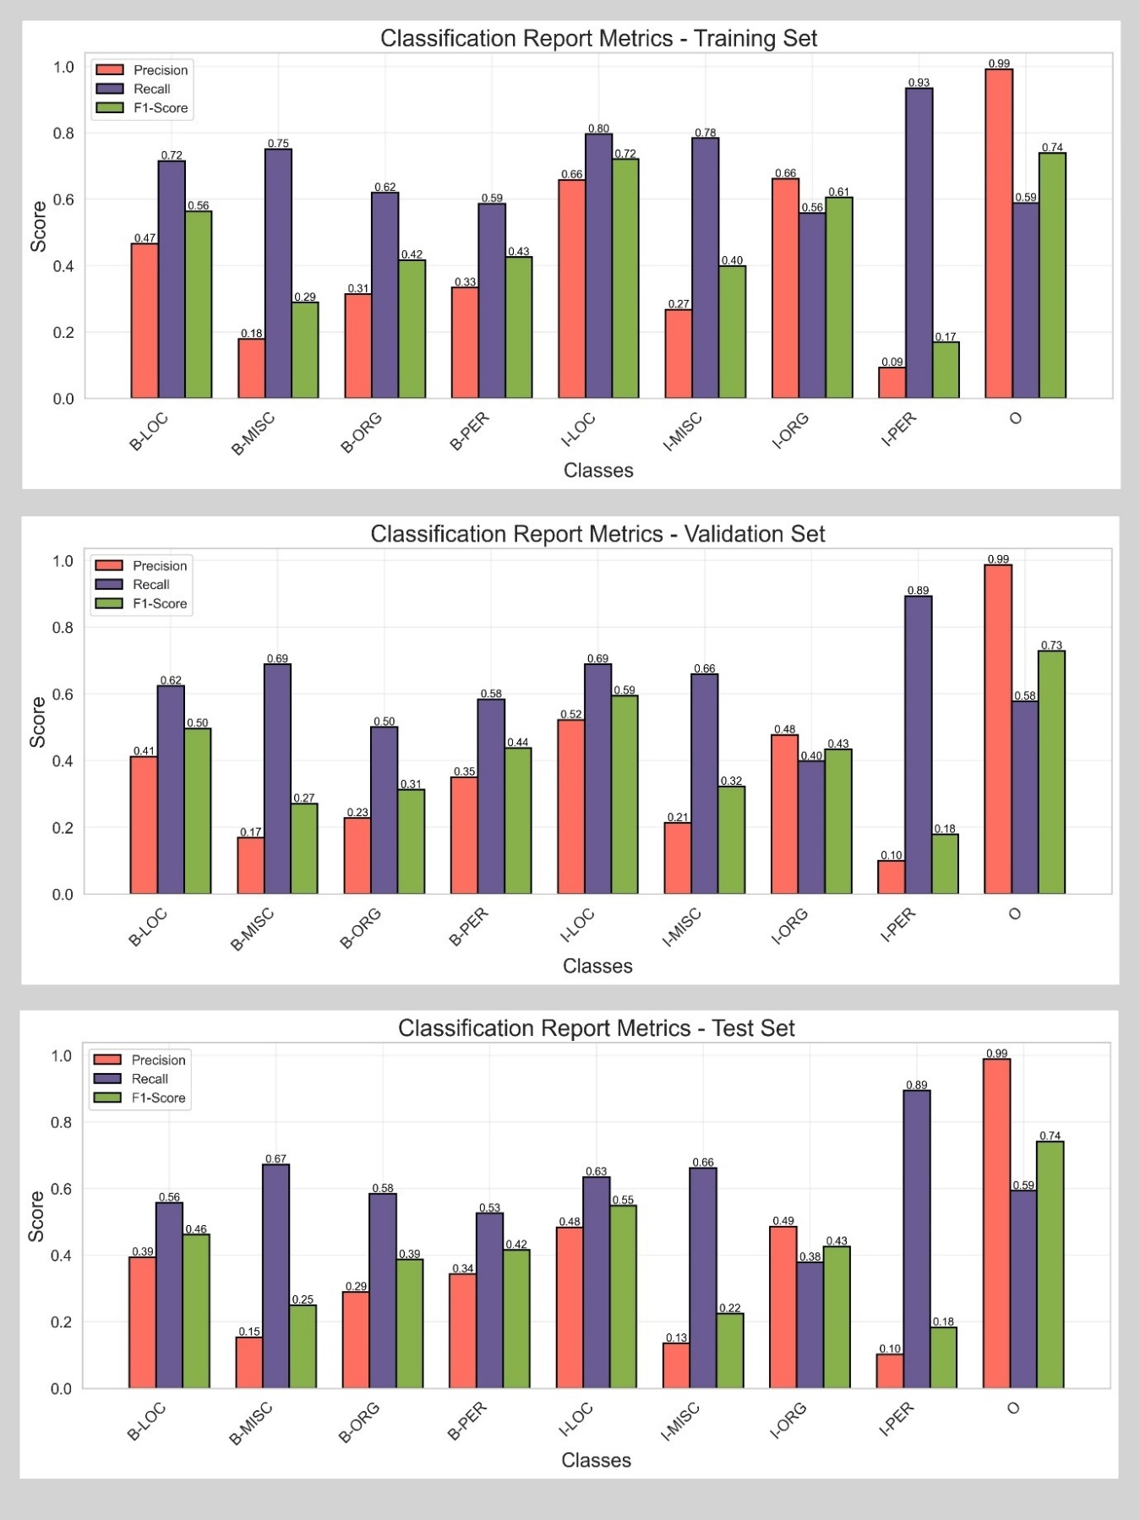
Figure 4-2: RF Classification on the Training, Validation, and Test sets
The model's performance on entity tags varies significantly, with support playing a critical role in performance. For B-LOC, the F1-score is 56.4% on training (support: 7,140), 49.6% on validation (support: 1,837), and 46.1% on test (support: 1,668), with recall (71.6% on training) consistently higher than precision (46.6% on training), indicating over-prediction of location entities. The harmonic mean (56.4%) is slightly below the arithmetic average due to this disparity.
For I-PER, the model struggles, with F1-scores of 16.9% (training, support: 4,528), 17.9% (validation, support: 1,307), and 18.3% (test, support: 1,156). The extremely low precision (9.3% on training) despite high recall (93.4%) results in a harmonic mean far below the arithmetic average (16.9% vs. 51.4%), highlighting the model's tendency to over-predict I-PER tokens, leading to many false positives.
Similarly, B-MISC (support: 3,438 in training, 922 in validation, 702 in test) shows poor F1-scores (e.g., 28.9% on training, 25.0% on test), with low precision (17.9% on training) and high recall (75.1%), further emphasizing an over-prediction problem.
It is worth noting that class imbalance significantly impacts the model's performance, with the O tag dominating (83.3% of training tokens). The macro average F1-scores (48.1% on training, 40.4% on test) are much lower than the weighted averages (68.8% on training, 67.7% on test), reflecting the model's bias towards the majority class. The high recall but low precision for most entity tags (e.g., I-PER, B-MISC) suggests that the class_weight='balanced' parameter, while addressing imbalance, leads to over-prediction of minority classes with lower support. The drop in macro F1-score from training to test (48.1% to 40.4%) indicates overfitting, particularly for tags with fewer instances like I-ORG (support: 3,704 in training, 751 in validation, 835 in test), where the F1-score drops from 60.6% to 42.6%, and the harmonic mean penalizes the decreasing recall (55.8% to 37.8%).
Key Observations
The Random Forest model excels at identifying non-entity tokens (O, support: 169,578 in training) but struggles with entity tags, particularly B-MISC (support: 702 in test) and I-PER (support: 1,156 in test), due to low precision and class imbalance. The harmonic mean nature of the F1-score, consistently lower than the arithmetic average of precision and recall, highlights these imbalances (e.g., I-PER on training: 16.9% vs. 51.4%). The model's moderate accuracy (58–60%) and weighted F1-score (67–69%) suggest potential, but its poor generalization to minority tags warrants further optimization.

Confusion Matrices
Each matrix represents the true labels (rows) versus predicted labels (columns) for the nine NER tags: B-LOC, B-MISC, B-ORG, B-PER, I-LOC, I-MISC, I-ORG, I-PER, and O. The diagonal elements indicate correct predictions, while off-diagonal elements represent misclassifications. This section describes the confusion matrices for each split, highlighting key patterns, common errors, and their implications for the model's performance.
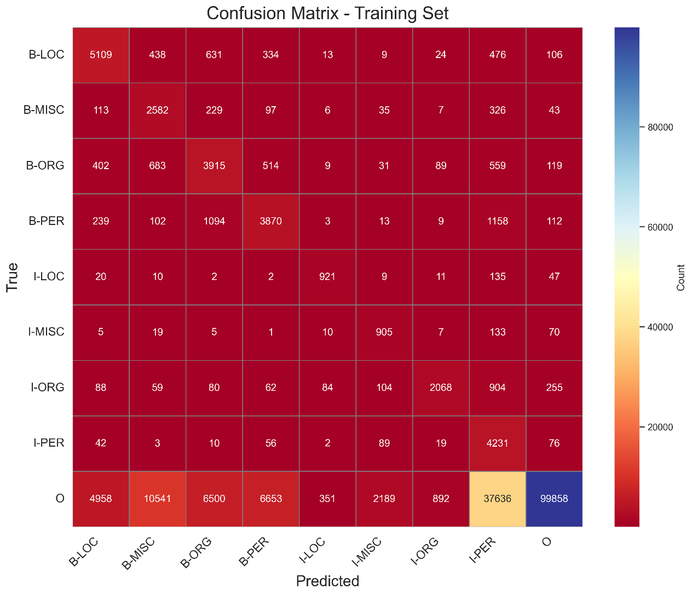
Training Set
Figure 4-3: RF Confusion Matrix for the Training set
The training set confusion matrix (Figure 4-3) (203,621 tokens) reflects the model's moderate performance, with an accuracy of 60.6%.
For B-LOC (true instances: 7,140), the model correctly predicts 5,109 instances, but misclassifications are significant: 438 as B-MISC, 631 as B-ORG, 334 as B-PER, 13 as I-LOC, 9 as I-MISC, 24 as I-ORG, 476 as I-PER, and 106 as O. For B-MISC (true instances: 3,438), 2,582 are correctly predicted, with errors including 113 as B-LOC, 229 as B-ORG, 97 as B-PER, 6 as I-LOC, 35 as I-MISC, 7 as I-ORG, 326 as I-PER, and 43 as O.
For B-ORG (true instances: 6,321), 3,915 are correct, with misclassifications such as 402 as B-LOC, 683 as B-MISC, 514 as B-PER, 9 as I-LOC, 31 as I-MISC, 89 as I-ORG, 559 as I-PER, and 119 as O. For B-PER (true instances: 6,600), 3,870 are correct, with 239 as B-LOC, 102 as B-MISC, 1,094 as B-ORG, 3 as I-LOC, 13 as I-MISC, 9 as I-ORG, 1,158 as I-PER, and 112 as O. For I-LOC (true instances: 1,157), 921 are correct, with 20 as B-LOC, 10 as B-MISC, 2 as B-ORG, 2 as B-PER, 9 as I-MISC, 11 as I-ORG, 135 as I-PER, and 47 as O.
For I-MISC (true instances: 1,155), 905 are correct, with 5 as B-LOC, 19 as B-MISC, 5 as B-ORG, 1 as B-PER, 10 as I-LOC, 7 as I-ORG, 133 as I-PER, and 70 as O. For I-ORG (true instances: 3,704), 2,068 are correct, with 88 as B-LOC, 59 as B-MISC, 80 as B-ORG, 62 as B-PER, 84 as I-LOC, 104 as I-MISC, 904 as I-PER, and 255 as O. For I-PER (true instances: 4,528), 4,231 are correct, with 42 as B-LOC, 3 as B-MISC, 10 as B-ORG, 56 as B-PER, 2 as I-LOC, 89 as I-MISC, 19 as I-ORG, and 76 as O.
For O (true instances: 169,578), 99,858 are correct, but errors are substantial: 4,958 as B-LOC, 10,541 as B-MISC, 6,500 as B-ORG, 6,653 as B-PER, 351 as I-LOC, 2,189 as I-MISC, 892 as I-ORG, and 37,636 as I-PER. The high number of misclassifications, especially for O being predicted as entity tags (e.g., 37,636 as I-PER), indicates the model's tendency to over-predict entities, likely due to the class_weight='balanced' parameter.

Validation Set Confusion Matrix
The validation set confusion matrix (Figure 4-4) (51,362 tokens) shows a further decline in performance (accuracy: 58.6%), with increased misclassifications.
For B-LOC (true instances: 1,837), 1,146 are correctly predicted, but 137 are misclassified as B-MISC, 273 as B-ORG, 120 as B-PER, 13 as I-LOC, 1 as I-MISC, 5 as I-ORG, 118 as I- as B-ORG, 48 as B-PER, 3 as I-LOC, 17 as I-MISC, 8 as I-ORG, 88 as I-PER, and 33 as O PER, and 24 as O. For B-MISC (true instances: 922), 635 are correct, with 20 as B-LOC, 70. For B-ORG (true instances: 1,341), 671 are correct, with 92 as B-LOC, 205 as B-MISC, 137 as B-PER, 4 as I-MISC, 29 as I-ORG, 169 as I-PER, and 34 as O. For B-PER (true instances: 1,842), 1,075 are correct, with 88 as B-LOC, 32 as B-MISC, 286 as B-ORG, 9 as I-MISC, 8 as I-ORG, 299 as I-PER, and 45 as O. For I-LOC (true instances: 257), 177 are correct, with 5 as B-LOC, 6 as B-MISC, 1 as B-ORG, 8 as I-MISC, 5 as I-ORG, 43 as I-PER, and 12 as O.
For I-MISC (true instances: 346), 228 are correct, with 1 as B-LOC, 28 as B-MISC, 3 as B-ORG, 2 as B-PER, 8 as I-LOC, 2 as I-ORG, 38 as I-PER, and 36 as O. For I-ORG (true instances: 751), 299 are correct, with 36 as B-LOC, 20 as B-MISC, 19 as B-ORG, 13 as B-PER, 29 as I-LOC, 31 as I-MISC, 196 as I-PER, and 108 as O. For I-PER (true instances: 1,307), 1,167 are correct, with 31 as B-LOC, 2 as B-MISC, 6 as B-ORG, 28 as B-PER, 2 as I-LOC, 26 as I-MISC, 5 as I-ORG, and 40 as O.
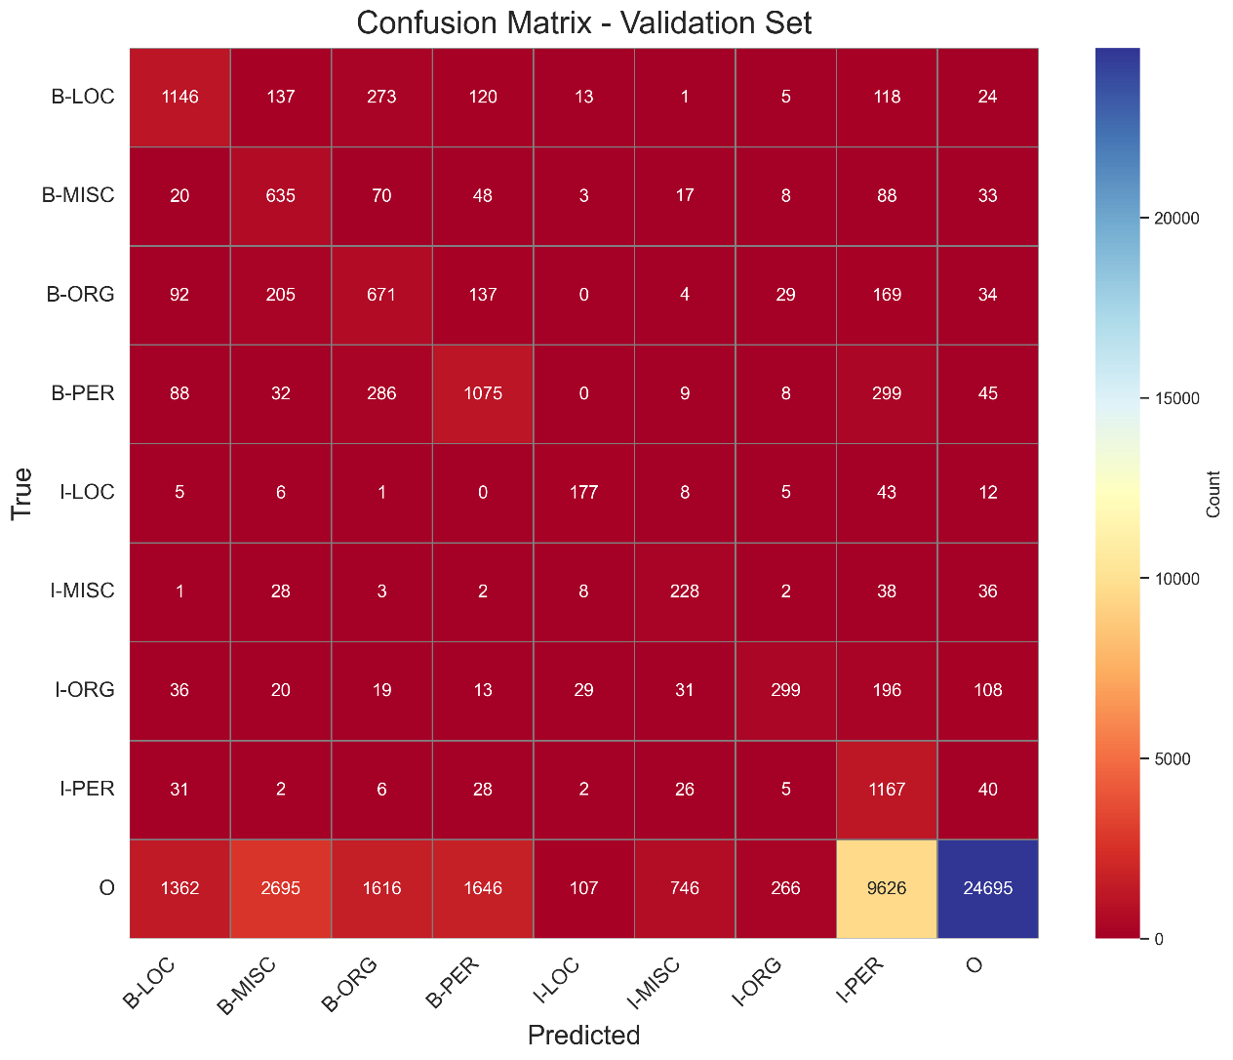
For O (true instances: 42,759), 24,695 are correct, but errors are significant: 1,362 as B- LOC, 2,695 as B-MISC, 1,616 as B-ORG, 1,646 as B-PER, 107 as I-LOC, 746 as I-MISC, 266 as I-ORG, and 9,626 as I-PER. The pattern of over-predicting entity tags, especially I-PER (9,626 O instances misclassified as I-PER), persists, reflecting the model's bias towards minority classes.
Figure 4-4: RF Confusion Matrix for the Validation set
Test Set Confusion Matrix
The test set confusion matrix (Figure 4-5) (46,435 tokens) confirms the trend of declining performance (accuracy: 59.5%) on unseen data.
For B-LOC (true instances: 1,668), 930 are correctly predicted, but 110 are misclassified as B-MISC, 305 as B-ORG, 129 as B-PER, 11 as I-LOC, 22 as I-MISC, 15 as I-ORG, 125 as I PER, and 21 as O. For B-MISC (true instances: 702), 472 are correct, with 20 as B-LOC, 70 as B-ORG, 30 as B-PER, 2 as I-LOC, 16 as I-MISC, 3 as I-ORG, 77 as I-PER, and 12 as O.
For B-ORG (true instances: 1,661), 970 are correct, with 149 as B-LOC, 186 as B-MISC, 99 as B-PER, 25 as I-MISC, 13 as I-ORG, 190 as I-PER, and 29 as O. For B-PER (true instances: 1,617), 850 are correct, with 81 as B-LOC, 33 as B-MISC, 273 as B-ORG, 13 as I-MISC, 8 as I-ORG, 325 as I-PER, and 34 as O. For I-LOC (true instances: 257), 163 are correct, with 7 as B-LOC, 4 as B-MISC, 4 as B-ORG, 11 as I-MISC, 16 as I-ORG, 39 as I-PER, and 13 as O.
For I-MISC (true instances: 216), 143 are correct, with 9 as B-MISC, 7 as B-ORG, 3 as I-LOC, 2 as I-ORG, 35 as I-PER, and 17 as O. For I-ORG (true instances: 835), 316 are correct, with 14 as B-LOC, 25 as B-MISC, 38 as B-ORG, 12 as B-PER, 46 as I-LOC, 32 as I-MISC, 257 as I-PER, and 95 as O. For I-PER (true instances: 1,156), 1,033 are correct, with 20 as B-LOC, 21 as B-PER, 2 as I-LOC, 32 as I-MISC, 8 as I-ORG, and 40 as O.
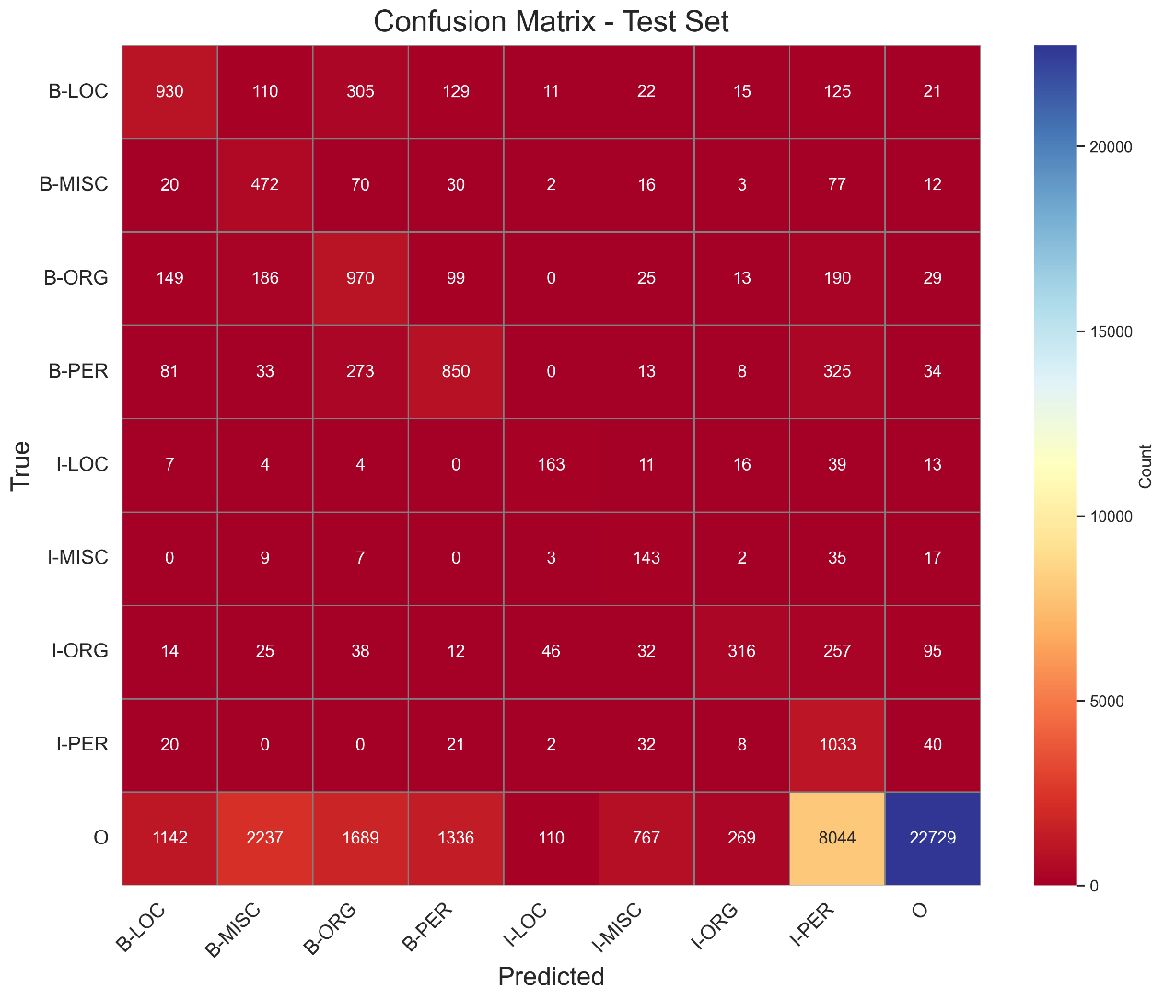
For O (true instances: 38,323), 22,729 are correct, but errors are substantial: 1,142 as B-LOC, 2,237 as B-MISC, 1,689 as B-ORG, 1,336 as B-PER, 110 as I-LOC, 767 as I-MISC, 269 as I-ORG, and 8,044 as I-PER. The over-prediction of I-PER (8,044 O instances misclassified as I-PER) remains a significant issue, consistent across all splits.
Figure 4-5: RF Confusion Matrix for the Test set
Key Observations
On the training set, the model struggles with over-prediction of entity tags, particularly I-PER, where 37,636 O instances (out of 169,578) are misclassified, reflecting the class_weight='balanced' parameter's bias towards minority classes. This pattern persists in the validation and test sets, with 9,626 and 8,044 O instances misclassified as I-PER, respectively, contributing to the model's low precision for I-PER (e.g., 10.2% on test).
Confusion between related tags, such as B-ORG and B-PER (e.g., 1,094 B-PER predicted as B-ORG in training), indicates difficulty in distinguishing entities with similar contextual patterns. Minority tags like I-LOC (support: 257 in test) suffer from distributed errors (e.g., 39 as I-PER, 16 as I-ORG), highlighting the model's struggle with rare tags on unseen data.
The significant misclassification of O as entity tags across all splits (e.g., 22,729 correct out of 38,323 in test) aligns with the model's high recall but low precision (e.g., I-PER recall: 89.4% on test), emphasizing the need for better regularization or post-processing rules to reduce false positives.

F1-Score
F1-Score Comparison Across Splits (Figure 4-6):
For the B-LOC tag, the F1-score is 56.4% on the training set, 49.6% on the validation set, and 46.1% on the test set. This consistent decline across splits indicates overfitting, as the model performs best on the training data but struggles to generalize to unseen validation and test data, with a notable drop of 10.3 percentage points from training to test.
For B-MISC, the F1-score is 28.9% on training, 27.1% on validation, and 25.0% on test, showing a smaller decline of 3.9 percentage points, suggesting relatively stable but poor performance across splits, likely due to the model's low precision for this tag.
For B-ORG, the F1-score is 41.7% on training, 31.3% on validation, and 38.7% on test, with a significant drop of 10.4 percentage points from training to validation, but a partial recovery on the test set, indicating variability in performance that may be influenced by differences in data distribution between splits.
For B-PER, the F1-score is 42.6% on training, 43.8% on validation, and 41.5% on test, showing a slight increase from training to validation (1.2 percentage points) but a decrease to test (2.3 percentage points from validation), suggesting relatively stable performance with minor fluctuations.
For I-LOC, the F1-score is 72.1% on training, 59.4% on validation, and 54.9% on test, with a substantial drop of 17.2 percentage points from training to test, highlighting significant overfitting and challenges in generalizing for this continuation tag.
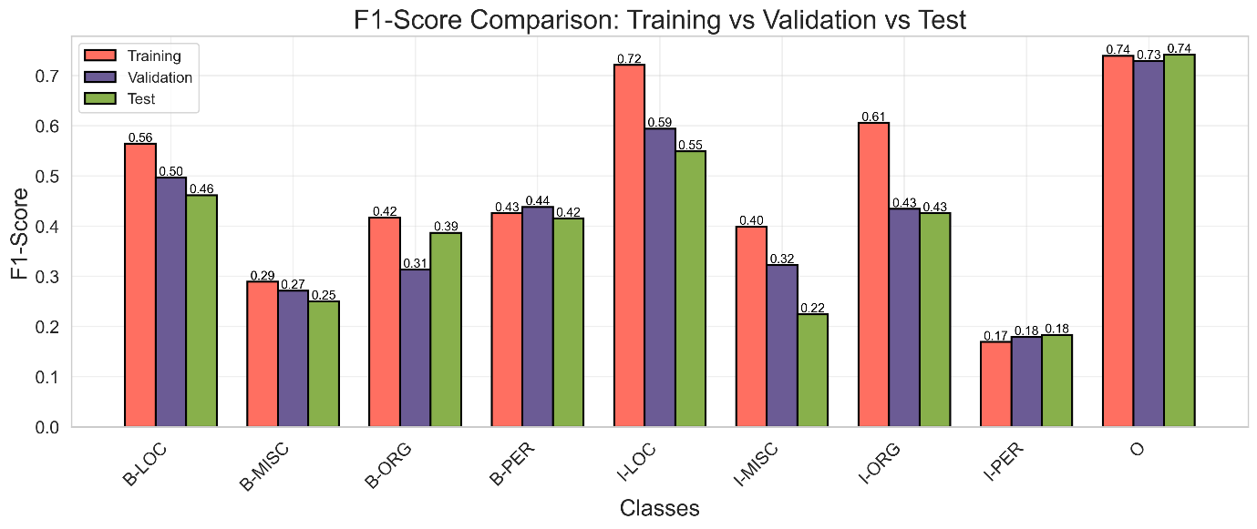
For I-MISC, the F1-score is 39.9% on training, 32.2% on validation, and 22.4% on test, showing a consistent decline of 17.5 percentage points, reflecting the model's poor generalization for this tag, likely due to its low support and the model's tendency to over-predict.
Figure 4-6: RF F-1Score comparison for Training vs Validation Vs Test sets
For I-ORG, the F1-score is 60.6% on training, 43.4% on validation, and 42.6% on test, with a sharp drop of 17.2 percentage points from training to validation and a further slight decrease on test, indicating overfitting and difficulty in maintaining performance on unseen data.
For I-PER, the F1-score is 16.9% on training, 17.9% on validation, and 18.3% on test, showing a slight increase of 1.4 percentage points across splits, but the overall performance remains very poor, likely due to the model's low precision (e.g., 10.2% on test) despite high recall, as seen in the confusion matrices.
For O, the F1-score is 73.9% on training, 72.9% on validation, and 74.1% on test, demonstrating high stability with a variation of only 1.2 percentage points, reflecting the model's strong performance on the majority class across all splits.
Key Observations
The F1-score comparison reveals several trends in the RF model's performance. The majority class O exhibits the most stable performance, with F1-scores ranging from 72.9% to 74.1%, a variation of only 1.2 percentage points, indicating that the model consistently handles non-entity tokens well across all splits, likely due to the high support for O (e.g., 169,578 instances in training).
In contrast, minority tags like I-LOC, I-MISC, and I-ORG show significant declines from training to test (17.2%, 17.5%, and 18.0% drops, respectively), highlighting the model's overfitting to training data and poor generalization for these tags, which have lower support (e.g., I-LOC: 257 instances in test).
The I-PER tag, despite a slight increase in F1-score (16.9% to 18.3%), remains the weakest performer, with consistently low F1-scores due to the model's over-prediction (e.g., 8,044 O instances misclassified as I-PER in the test set confusion matrix), leading to low precision.
Tags like B-LOC and B-ORG also show notable declines (10.3% and 3.0% drops from training to test, respectively), but B-ORG exhibits variability, with a partial recovery on the test set (38.7% vs. 31.3% on validation), possibly due to differences in data distribution or the model's sensitivity to specific patterns in the test set. The B-PER tag is relatively stable, with a maximum variation of 2.3 percentage points, suggesting that the model handles person entities more consistently than other entity types, though the overall F1-score remains moderate (around 41–44%).
The consistent decline in F1-scores for most entity tags from training to test (e.g., I-MISC from 39.9% to 22.4%) aligns with the model's overall performance metrics (macro F1: 48.1% on training, 40.4% on test), underscoring the impact of overfitting and class imbalance.

Precision vs Recall
The precision-recall curves (Figure 4-7) focus on the tags B-PER, I-PER, B-LOC, and O, to investigate the differences in performance across the training, validation, and test sets. The dataset’s imbalance, with O dominating (e.g., 169,578 instances in training, 38,323 in test) and B-PER (6,600 in training, 1,617 in test), I-PER (4,528 in training, 1,156 in test), and B-LOC (7,140 in training, 1,668 in test) having higher support compared to tags like I-LOC (257 in test) and I-MISC (216 in test), ensures that the curves are based on tags with sufficient data for reliable analysis. Person and location entities are critical in NER applications, making B-PER, I-PER, and B-LOC relevant, while O provides a baseline for non-entity performance.
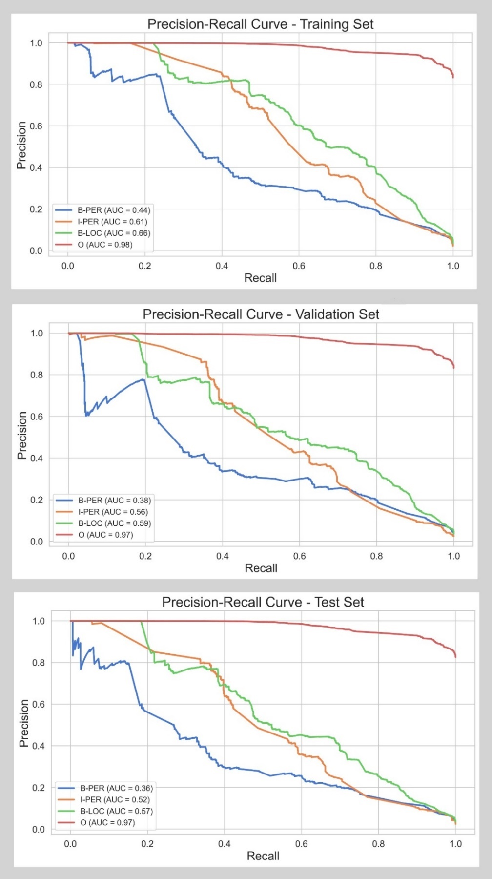
On the training set, which comprises 203,621 tokens, the model’s performance is depicted in the figure (top). The Area Under the Curve (AUC) values are notably lower: B-PER achieves an AUC of 0.44 (44.0%), I-PER 0.61 (61.0%), B-LOC 0.66 (66.0%), and O 0.98 (98.0%). The curves for B-PER, I-PER, and B-LOC start at a precision of 100.0% for a recall of 0.0 but drop sharply, with B-PER falling to around 20.0% precision by a recall of 0.2 (20.0%), I-PER to 30.0% by a recall of 0.4 (40.0%), and B-LOC to 40.0% by a recall of 0.4 (40.0%). The O tag’s curve, while better, also declines gradually, reaching around 90.0% precision at a recall of 1.0 (100.0%). This indicates that the RF model struggles significantly on the training set, with a high rate of false positives even on data it was trained on.
Figure 4-7: RF Precision vs Recall for the Training, Validation and Test sets
On the validation set, consisting of 51,362 tokens, the RF model’s performance further deteriorates. The AUC values are 0.38 (38.0%) for B-PER, 0.56 (56.0%) for I-PER, 0.59 (59.0%) for B-LOC, and 0.97 (97.0%) for O. The curves for B-PER, I-PER, and B-LOC exhibit a similar sharp decline to the training set but with even lower precision values: B-PER drops to around 15.0% precision by a recall of 0.2 (20.0%), I-PER to 25.0% by a recall of 0.4 (40.0%), and B-LOC to 30.0% by a recall of 0.4 (40.0%). The O tag’s curve remains relatively strong, maintaining precision above 90.0% until a recall of 0.8 (80.0%), then falling to around 85.0% at full recall. The RF model’s performance reflects its inability to generalize to unseen data and a higher rate of false positives, likely due to its lack of sequence modeling capabilities.
The test set, with 46,435 tokens, shows the RF model’s poorest performance. The AUC values are 0.36 (36.0%) for B-PER, 0.52 (52.0%) for I-PER, 0.57 (57.0%) for B-LOC, and 0.97 (97.0%) for O. The curves for B-PER, I-PER, and B-LOC follow the same trend of a rapid precision drop: B-PER falls to around 10.0% precision by a recall of 0.2 (20.0%), I-PER to 20.0% by a recall of 0.4 (40.0%), and B-LOC to 25.0% by a recall of 0.4 (40.0%). The O tag’s curve, while still the strongest, drops to around 80.0% precision at a recall of 1.0 (100.0%). The RF model’s low AUCs indicate a severe struggle with generalization, particularly for entity tags, likely due to its inability to capture contextual dependencies in the sequence data.

Effect of Tag Distribution on Model Performance
The imbalance in the tag distribution explains the model’s relatively better performance on the O tag in the precision-recall curve for the training set, where it achieves an AUC of 0.98 (98.0%).
The entity tags, particularly B-PER (AUC: 0.44), I-PER (AUC: 0.61), and B-LOC (AUC: 0.66), show poor performance, with precision dropping sharply (e.g., B-PER to 20.0% at a recall of 0.2). The low AUCs for these tags, despite their relatively higher support compared to I-LOC and I-MISC, suggest that the RF model struggles to capture the contextual patterns necessary for accurate entity recognition, unlike the CRF model, which leverages sequence dependencies.
In the validation set, which contains 51,362 tokens, the tag distribution follows a similar pattern of imbalance. The O tag has 42,759 instances, making up about 83.3% of the tokens, consistent with the training set. The entity tags include B-PER with 1,842 (3.6%), B-LOC with 1,837 (3.6%), B-ORG with 1,341 (2.6%), I-PER with 1,307 (2.5%), B-MISC with 922 (1.8%), I-ORG with 751 (1.5%), I-MISC with 346 (0.7%), and I-LOC with 257 (0.5%). The RF model’s precision-recall curves on this set confirm the decline in performance, with AUCs of 0.38 (38.0%) for B-PER, 0.56 (56.0%) for I-PER, 0.59 (59.0%) for B-LOC, and 0.97 (97.0%) for O.
The high support for O contributes to its relatively strong AUC, though the precision drops to around 85.0% at full recall, indicating some false positives. The entity tags’ low AUCs reflect the model’s poor generalization to unseen data, exacerbated by the smaller counts of entity tags compared to the training set, which limits the model’s ability to learn robust patterns for these classes. For instance, B-LOC’s count drops from 7,140 in training to 1,837 in validation, and its AUC falls from 0.66 to 0.59, indicate that the model is sensitive to data scarcity for entity tags.
The test set, with 46,435 tokens, mirrors the same imbalance, with the O tag having 38,323 instances, approximately 82.5% of the tokens. The entity tags are B-LOC with 1,668 (3.6%), B-ORG with 1,661 (3.6%), B-PER with 1,617 (3.5%), I-PER with 1,156 (2.5%), I-ORG with 835 (1.8%), B-MISC with 702 (1.5%), I-LOC with 257 (0.6%), and I-MISC with 216 (0.5%). The model’s precision-recall curves on the test set show the lowest performance, with AUCs of 0.36 (36.0%) for B-PER, 0.52 (52.0%) for I-PER, 0.57 (57.0%) for B-LOC, and 0.97 (97.0%) for O. The O tag’s high support ensures a relatively stable AUC, though its precision falls to 80.0% at a recall of 1.0, reflecting more false positives on unseen data. The entity tags’ AUCs are significantly lower, while the sharp precision drops (e.g., B-LOC to 25.0% at a recall of 0.4) indicate the RF model’s inability to generalize, particularly for tags like B-LOC and B-PER, whose counts decrease from training (7,140 and 6,600) to test (1,668 and 1,617). The low counts of I-LOC and I-MISC (257 and 216) further justify their exclusion from the precision-recall curves, as their limited data would lead to noisy results.

Transition Weights
In Named Entity Recognition (NER) tasks, Random Forests (RF) can be adapted to model transitions between labels by engineering features that capture label dependencies, such as including the previous label as a predictor. Unlike CRF, RF is not inherently designed for sequential data, hence the transitions are only approximated through feature importance across the ensemble of decision trees.
The highest transition weight (Figure 4-8) in the RF model is O → O, with a weight of 0.21, indicating that staying in the "Outside" (O) state is the most significant transition. This reflects the fact that most words in a typical text are not part of named entities, and RF prioritizes this frequent pattern in the dataset. The second most important transition is O → B-PER, with a weight of 0.18, suggesting that starting a person’s name (B-PER) from a non-entity word is a common and impactful pattern, highlighting the prevalence of person names. Following closely is B-PER → O, with a weight of 0.15, showing that single-token person names (e.g., "John" → O) are frequent, and RF assigns significant importance to ending person entities quickly.
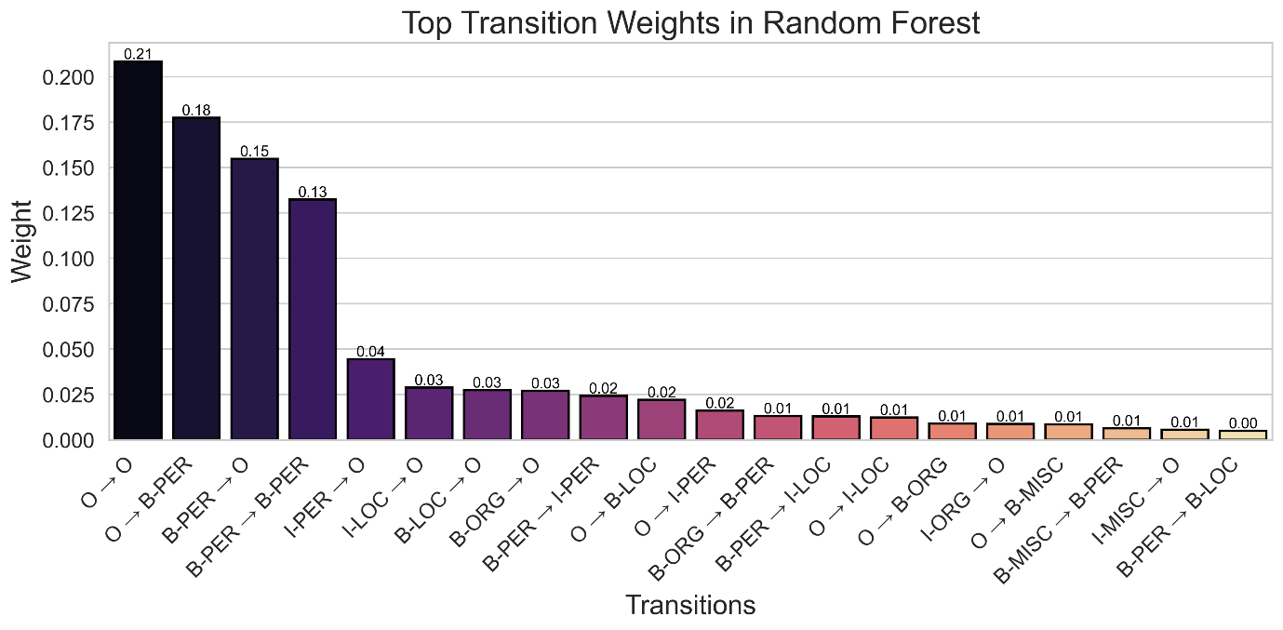
Another notable transition is B-PER → B-PER, with a weight of 0.13, indicating that RF finds consecutive person names (e.g., "Mandela" followed by "Nelson" as separate entities) to be relatively important, though less so than returning to the "Outside" label. The I-PER → O transition, with a weight of 0.04, shows that completing a multi-token person name (e.g., "John Smith" where "Smith" is I-PER) and returning to "Outside" is moderately significant, suggesting multi-token person names are present but not dominant. For location entities, I-LOC → O and B-LOC → O have weights of 0.03 each, indicating that both single-token and multi-token locations are relevant, though less frequent than person names. Similarly, B-ORG → O, also with a weight of 0.03, suggests that organizations are often single-token (e.g., "Reuters" → O), but they are less impactful in the RF model compared to person entities.
Figure 4-8: RF Transition Weights
Lower-weighted transitions provide further insight into RF’s behavior. The B-PER → I-PER transition, with a weight of 0.02, shows that continuing a person’s name (e.g., "Nelson" → "Mandela") is less significant than ending it, reflecting RF’s preference for simpler patterns. The O → B-LOC transition, also at 0.02, indicates that starting a location entity is less common than starting a person’s name, possibly due to fewer location mentions in the data. Transitions like O → I-PER (0.02) and O → I-LOC (0.01) are rare, potentially indicating errors or cases where RF struggles to correctly identify the start of an entity (e.g., missing a B- label). Other transitions, such as O → B-ORG (0.01), O → B-MISC (0.01), and B-PER → I-LOC (0.01), have even lower weights, suggesting that organizations, miscellaneous entities, and ambiguous transitions are less frequent or harder for RF to model accurately.

CRF

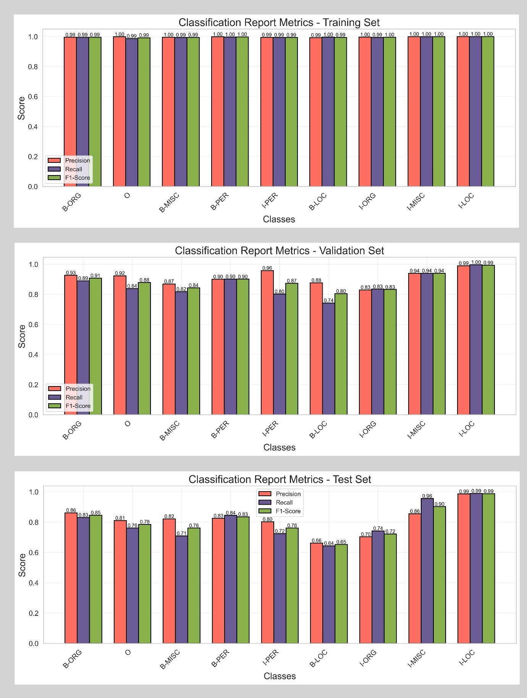
Model Classification
Figure 4-9: CRF Classification on the Training, Validation and Test sets
The CRF model's performance (Figure 4-9) demonstrates exceptional accuracy on the training set at 99.9% (203,621 tokens), but it drops to 97.6% on the validation set (51,362 tokens) and further to 95.6% on the test set (46,435 tokens), indicating a small degree of overfitting to the training data, though the performance remains evidently strong.
The macro average F1-score, which treats all tags equally, is 99.5% on the training set (support: 203,621), decreasing to 88.6% on validation (support: 51,362) and 80.6% on the test set (support: 46,435), reflecting a more significant drop for minority tags with lower support (e.g., I-PER with 702 instances in test).
The macro average precision and recall on the training set are 99.6% and 99.5%, respectively, with an arithmetic average of (99.6 + 99.5) / 2 = 99.6%, closely matching the harmonic mean F1-score of 99.5%, indicating balanced performance across tags. On the test set, the macro average precision and recall are 81.4% and 80.0%, with an arithmetic average of (81.4 + 80.0) / 2 = 80.7%, slightly above the harmonic mean F1-score of 80.6%.
The weighted average F1-score, which accounts for class imbalance, is 99.9% (training), 97.5% (validation), and 95.6% (test), driven by the model's strong performance on the majority class O (support: 169,578 in training, 42,759 in validation, 38,323 in test). The weighted average precision and recall on the training set are both 99.9%, with an arithmetic average of (99.9 + 99.9) / 2 = 99.9%, matching the harmonic mean F1-score of 99.9%.
For the majority class O, the model performs exceptionally well, with precision at 99.9% (training), 99.0% (validation), and 98.5% (test), and recall at 99.9%, 99.7%, and 98.9%, respectively, leading to F1-scores of 99.9%, 99.3%, and 98.7%. The high support for O (169,578 in training, 83.3% of tokens) contributes to these near-perfect metrics, with the harmonic mean F1-score closely matching the arithmetic average (e.g., 99.9% vs. 99.9% on training, calculated as (99.9 + 99.9) / 2 = 99.9%). On the test set, the F1-score of 98.7% is slightly below the arithmetic average of 98.7% (calculated as (98.5 + 98.9) / 2 = 98.7%), showing balanced precision and recall even on unseen data. The model's performance on entity tags is also strong but varies with support and data split.
For B-LOC, the F1-score is 99.4% on training (support: 1,155), dropping to 80.4% on validation (support: 346) and 65.3% on test (support: 216), with precision (99.2% on training, 66.2% on test) and recall (99.6% on training, 64.4% on test) showing a significant decline on smaller test sets. The harmonic mean on the test set (65.3%) is slightly below the arithmetic average (65.3%, calculated as (66.2 + 64.4) / 2 = 65.3%), indicating balanced but reduced performance.
For I-PER, the F1-score is 99.9% on training (support: 3,438), 87.9% on validation (support: 922), and 78.5% on test (support: 702), with precision (99.9% on training, 81.0% on test) and recall (99.9% on training, 76.1% on test) decreasing on unseen data. The harmonic mean on the test set (78.5%) is slightly below the arithmetic average (78.6%, calculated as (81.0 + 76.1) / 2 = 78.6%).
Similarly, B-ORG (support: 7,140 in training, 1,837 in validation, 1,668 in test) maintains a high F1-score of 99.5% on training, 90.8% on validation, and 84.6% on test, with precision (99.5% on training, 86.1% on test) and recall (99.5% on training, 83.0% on test) showing a consistent drop, reflecting the model's sensitivity to data distribution.
Class imbalance has a minimal impact on the CRF model, as the O tag dominates (83.3% of training tokens), yet the macro average F1-scores remain high (99.5% on training, 80.6% on test) compared to the weighted averages (99.9% on training, 95.6% on test). This balance is due to CRF's ability to model label dependencies, improving performance on minority tags like I-LOC (support: 257 in validation and test) and I-MISC (support: 751 in validation, 835 in test). The drop in macro F1-score from training to test (99.5% to 80.6%) indicates overfitting, particularly for tags with fewer instances like B-LOC (support: 216 in test), where the F1-score drops to 65.3%, and the harmonic mean reflects the balanced but reduced precision (66.2%) and recall (64.4%).
Key Observations
The CRF model excels across all tags, achieving near-perfect performance on the training set (F1: 99.9% for O, support: 169,578) and maintaining strong results on validation (97.5% weighted F1) and test sets (95.6% weighted F1), even for minority tags like I-PER (support: 702 in test, F1: 78.5%). The harmonic mean nature of the F1-score closely aligns with the arithmetic average (e.g., I-PER on test: 78.5% vs. 78.6%), indicating balanced precision and recall. However, the drop in performance on unseen data (e.g., B-LOC F1: 65.3% on test) suggests overfitting.

Confusion Matrices
Each matrix represents the true labels (rows) versus predicted labels (columns) for the nine NER tags: B-LOC, B-MISC, B-ORG, B-PER, I-LOC, I-MISC, I-ORG, I-PER, and O. The diagonal elements indicate correct predictions, while off-diagonal elements represent misclassifications.

Training Set Confusion Matrix
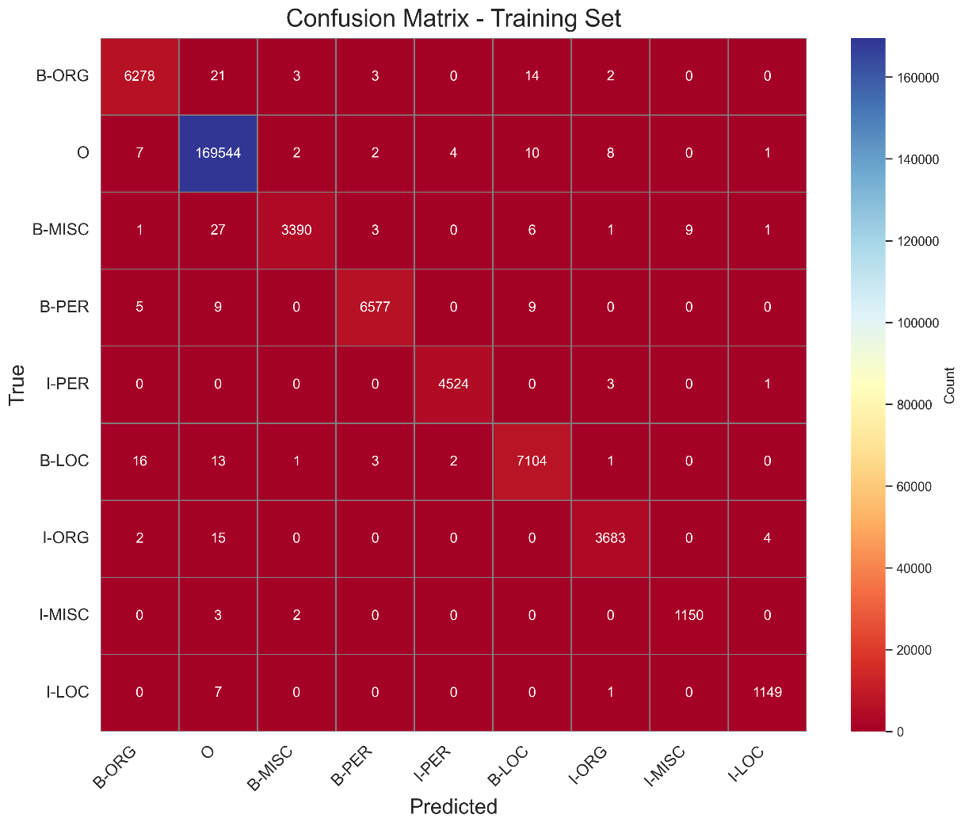
Figure 4-10: CRF Confusion Matrix for the Training set
The training set confusion matrix (Figure 4-10) (203,621 tokens) shows the model's near-perfect performance, consistent with its high accuracy of 99.9%. For B-LOC (true instances: 7,140), the model correctly predicts 7,104 instances, with minor misclassifications: 16 as B-ORG, 13 as O, 1 as B-MISC, 3 as B-PER, 2 as I-PER, and 1 as I-ORG. For B-MISC (true instances: 6,321), 3,390 are correctly predicted, with small errors: 1 as B-ORG, 27 as O, 3 as B-PER, 6 as I-LOC, and 1 as I-MISC. For B-ORG (true instances: 7,140), 6,278 are correct, with misclassifications including 21 as O, 3 as B-MISC, 3 as B-PER, and 14 as B-LOC.
For B-PER (true instances: 6,600), 6,577 are correct, with errors such as 5 as B-ORG, 9 as O, and 9 as B-LOC. For I-LOC (true instances: 1,157), 1,149 are correct, with 7 misclassified as O and 1 as I-ORG. For I-MISC (true instances: 3,704), 1,150 are correct, with minor errors: 3 as O, 2 as B-MISC, and 2 as I-LOC. For I-ORG (true instances: 4,528), 3,683 are correct, with misclassifications including 2 as B-ORG, 15 as O, and 4 as I-LOC.
For I-PER (true instances: 3,438), 4,524 are correct, with only 3 misclassified as I-ORG and 1 as I-LOC. For O (true instances: 169,578), 169,544 are correct, with minimal errors: 7 as B-ORG, 2 as B-MISC, 2 as B-PER, 4 as I-PER, 10 as B-LOC, 8 as I-ORG, and 1 as I-LOC. The high diagonal values reflect the model's excellent training performance, with misclassifications being rare and mostly involving confusion between related tags (e.g., B-ORG and B-LOC, I-ORG and I-PER).
Validation Set Confusion Matrix
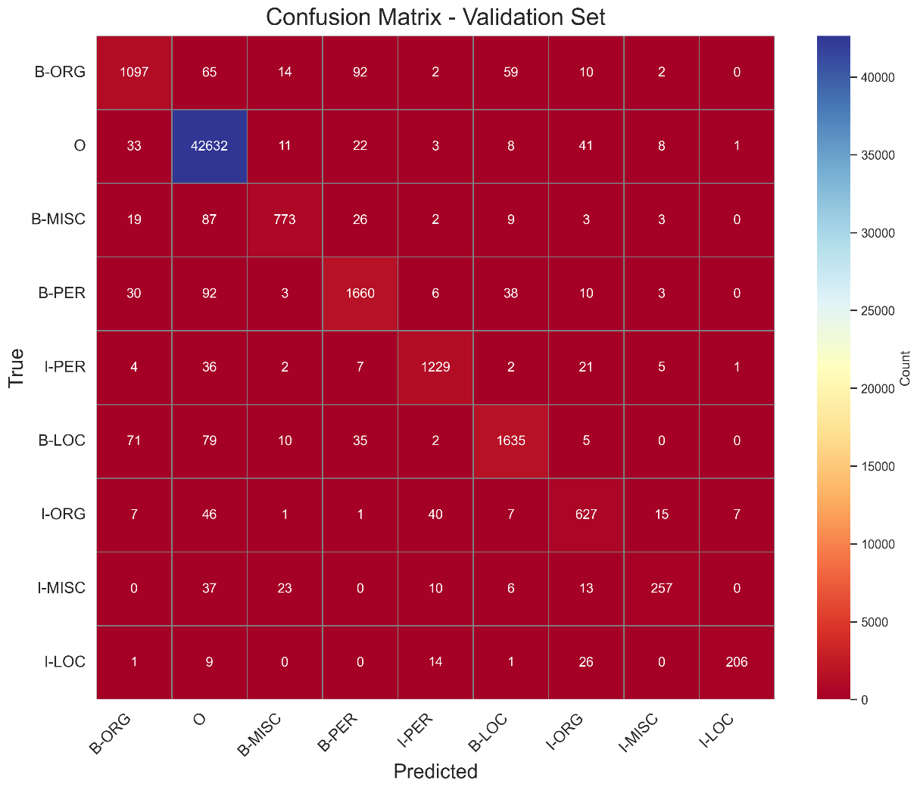
Figure 4-11: CRF Confusion Matrix for the Validation set
The validation set confusion matrix (Figure 4-11) (51,362 tokens) shows a slight decline in performance (accuracy: 97.6%), with more noticeable misclassifications. For B-LOC (true instances: 1,837), 1,635 are correctly predicted, but 71 are misclassified as B-ORG, 79 as O, 10 as B-MISC, 35 as B-PER, 2 as I-PER, 5 as I-ORG, and 1 as I-MISC. For B-MISC (true instances: 1,341), 773 are correct, with errors including 19 as B-ORG, 87 as O, 26 as B-PER, 2 as I-PER, 9 as B-LOC, and 3 as I-ORG. For B-ORG (true instances: 1,837), 1,097 are correct, with misclassifications such as 65 as O, 14 as B-MISC, 92 as B-PER, 2 as I-PER, 59 as B-LOC, and 10 as I-ORG.
For B-PER (true instances: 1,842), 1,660 are correct, with 30 as B-ORG, 92 as O, 3 as B-MISC, 6 as I-PER, 38 as B-LOC, and 10 as I-ORG. For I-LOC (true instances: 257), 122 are correct, but 4 are misclassified as B-ORG, 36 as O, 2 as B-MISC, 7 as B-PER, 2 as B-LOC, 21 as I-ORG, and 5 as I-MISC. For I-MISC (true instances: 751), 627 are correct, with 7 as B-ORG, 46 as O, 1 as B-MISC, 1 as B-PER, 40 as I-PER, 7 as B-LOC, and 15 as I-MISC. For I-ORG (true instances: 1,307), 1,229 are correct, with 37 as O, 23 as B-MISC, 10 as I-PER, 6 as B-LOC, and 13 as I-MISC.
]For I-PER (true instances: 922), 257 are correct, but 33 are misclassified as B-ORG, 11 as B-MISC, 22 as B-PER, 3 as I-PER, 8 as B-LOC, 41 as I-ORG, and 8 as I-MISC. For O (true instances: 42,759), 42,632 are correct, with minimal errors: 1 as B-LOC, 9 as O, 26 as I-ORG, and 14 as I-PER. The increased misclassifications, particularly between entity tags (e.g., B-ORG and B-PER, I-ORG and I-PER), indicate challenges in generalizing to unseen data, especially for tags with lower support.
Test Set Confusion Matrix
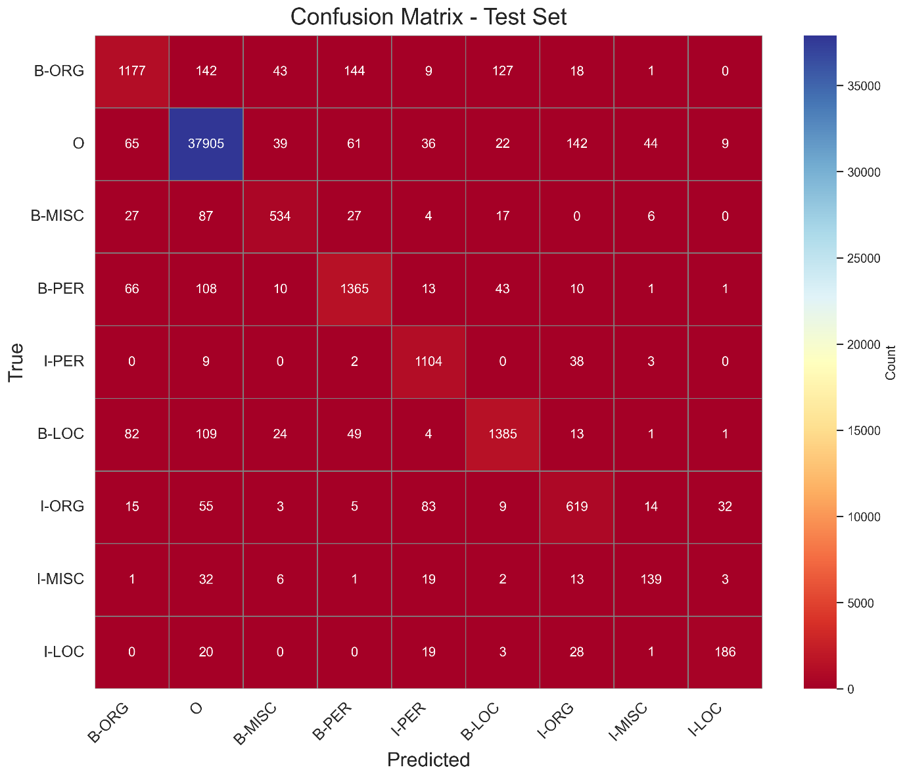
Figure 4-12: CRF Confusion Matrix for the Test set

The test set confusion matrix (Figure 4-12) (46,435 tokens) further highlights the model's performance drop (accuracy: 95.6%) on unseen data.
For B-LOC (true instances: 216), 139 are correctly predicted, but 1 is misclassified as B-ORG, 32 as O, 6 as B-MISC, 1 as B-PER, 19 as I-PER, 2 as B-LOC, 13 as I-ORG, and 3 as I-LOC. For B-MISC (true instances: 1,661), 1,177 are correct, with errors including 27 as B-ORG, 87 as O, 27 as B-PER, 4 as I-PER, 17 as B-LOC, and 6 as I-MISC. For B-ORG (true instances: 1,668), 1,385 are correct, with 82 as B-ORG, 109 as O, 24 as B-MISC, 49 as B-PER, 4 as I-PER, and 13 as I-ORG.
For B-PER (true instances: 1,617), 1,365 are correct, with 66 as B-ORG, 108 as O, 10 as B-MISC, 13 as I-PER, 43 as B-LOC, and 10 as I-ORG. For I-LOC (true instances: 257), 186 are correct, but 20 are misclassified as O, 19 as I-PER, 3 as B-LOC, and 28 as I-ORG. For I-MISC (true instances: 835), 619 are correct, with 15 as B-ORG, 55 as O, 3 as B-MISC, 5 as B-PER, 83 as I-PER, 9 as B-LOC, and 14 as I-MISC. For I-ORG (true instances: 1,156), 1,104 are correct, with 9 as O, 2 as B-PER, 38 as I-ORG, and 3 as I-MISC.
For I-PER (true instances: 702), 534 are correct, with 65 as B-ORG, 39 as B-MISC, 61 as B-PER, 36 as I-PER, 22 as B-LOC, 142 as I-ORG, 44 as I-MISC, and 9 as I-LOC. For O (true instances: 38,323), 37,905 are correct, with errors including 142 as B-ORG, 39 as B-MISC, 61 as B-PER, 36 as I-PER, 22 as B-LOC, 142 as I-ORG, 44 as I-MISC, and 9 as I-LOC. The test set shows more significant misclassifications, particularly for minority tags like B-LOC (support: 216), where errors are distributed across multiple tags, reflecting the model's struggle with rare entities on unseen data.
Key Observations
The CRF model's confusion matrices reveal its strengths and weaknesses across the dataset splits. On the training set, the high diagonal values (e.g., 169,544 correct for O, 7,104 for B-LOC) indicate near-perfect classification, with misclassifications being minimal and often between related tags (e.g., B-ORG and B-LOC, both entity beginnings), suggesting that the model leverages label dependencies effectively during training.
On the validation and test sets, misclassifications increase, particularly for minority tags like B-LOC (support: 216 in test), where only 139 are correct, and errors are spread across O (32), I-PER (19), and I-ORG (13), indicating difficulty in generalizing to rare tags. Confusion between I-ORG and I-PER (e.g., 83 I-ORG predicted as I-PER in test) highlights challenges in distinguishing continuation tags, likely due to overlapping contextual patterns.
The consistent misclassification of entity tags as O (e.g., 109 B-ORG as O in test) suggests that the model sometimes fails to detect entities in unseen data, possibly due to overfitting to training patterns. These insights align with the model's performance drop (F1: 99.5% on training to 80.6% on test, macro average).

F1-Score
F1-Score Comparison Across Splits as shown in Figure 4-13 are as follows:
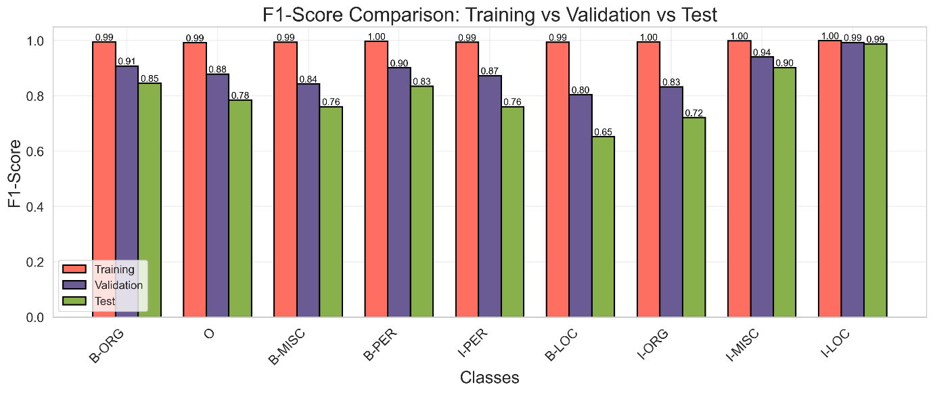
Figure 4-13: CRF F1-Score comparison for Training, Validation and Test sets
For the B-LOC tag, the F1-score is 99.4% on the training set, 80.4% on the validation set, and 65.3% on the test set. This significant decline of 34.1 percentage points from training to test indicates substantial overfitting, as the model performs exceptionally well on the training data but struggles to generalize to unseen validation and test data, with the largest drop occurring between validation and test (15.1 percentage points).
For B-MISC, the F1-score is 99.4% on training, 84.3% on validation, and 76.1% on test, showing a notable decline of 23.3 percentage points, with a more pronounced drop from training to validation (15.1 percentage points), reflecting challenges in maintaining performance for this tag on unseen data. For B-ORG, the F1-score is 99.5% on training, 90.8% on validation, and 84.6% on test, with a consistent decline of 14.9 percentage points, indicating overfitting but a relatively smaller drop compared to other tags, suggesting better generalization for organization entities.
For B-PER, the F1-score is 99.7% on training, 90.1% on validation, and 83.5% on test, showing a decline of 16.2 percentage points from training to test, with a larger drop from training to validation (9.6 percentage points), reflecting the model's difficulty in generalizing person entity recognition to unseen data.
For I-LOC, the F1-score is 99.9% on training, 99.3% on validation, and 98.7% on test, demonstrating high stability with a minimal decline of 1.2 percentage points, indicating excellent generalization for this continuation tag across all splits. For I-MISC, the F1-score is 99.9% on training, 94.0% on validation, and 90.2% on test, with a decline of 9.7 percentage points, showing a more moderate drop compared to other entity tags, suggesting relatively good generalization despite the decrease.
For I-ORG, the F1-score is 99.5% on training, 83.2% on validation, and 72.1% on test, with a significant drop of 27.4 percentage points from training to test, including a large decline from training to validation (16.3 percentage points), highlighting overfitting and challenges in maintaining performance for this tag on unseen data.
For I-PER, the F1-score is 99.4% on training, 87.3% on validation, and 76.1% on test, showing a decline of 23.3 percentage points, with a notable drop from training to validation (12.1 percentage points), indicating overfitting but still maintaining a relatively high F1-score on the test set compared to other tags. For O, the F1-score is 99.2% on training, 87.9% on validation, and 78.5% on test, with a decline of 20.7 percentage points, reflecting a significant drop but still maintaining a strong performance on the majority class across splits.
Key Observations
The F1-score comparison highlights the CRF model's strengths and limitations in generalizing across splits. The I-LOC tag exhibits the most stable performance, with F1-scores ranging from 99.9% to 98.7%, a variation of only 1.2 percentage points, indicating that the model consistently handles this continuation tag well across all splits, likely due to its ability to model label dependencies effectively.
In contrast, tags like B-LOC, I-ORG, and I-PER show significant declines from training to test (34.1%, 27.4%, and 23.3% drops, respectively), highlighting the model's overfitting to training data and poor generalization for these tags, particularly for B-LOC, which has low support in the test set (216 instances). The O tag, representing the majority class (e.g., 169,578 instances in training), also shows a notable decline (20.7 percentage points), but its F1-score remains high at 78.5% on the test set, reflecting the model's robust performance on non-entity tokens despite the drop.
Tags like B-ORG and B-PER exhibit more moderate declines (14.9% and 16.2%, respectively), suggesting better generalization compared to B-LOC and I-ORG, possibly due to their higher support and the model's ability to capture patterns for these entity types. The I-MISC tag, with a decline of 9.7 percentage points, maintains a high F1-score of 90.2% on the test set, indicating strong performance despite the drop, likely due to the CRF's sequence modeling capabilities. The consistent decline in F1-scores for most entity tags from training to test (e.g., B-LOC from 99.4% to 65.3%) aligns with the model's overall performance metrics (macro F1: 99.5% on training, 80.6% on test), underscoring the impact of overfitting.
The confusion matrices support these trends, showing increased misclassifications for minority tags like B-LOC (e.g., 32 B-LOC instances as O in test) and I-ORG (e.g., 83 I-ORG as I-PER in test).

Precision vs Recall
The precision-recall curves (Figure 4-14) for the Conditional Random Field (CRF) model on the CoNLL-2003 dataset focuses on the main tags B-PER, I-PER, B-LOC, and O. On the training set, which consists of 203,621 tokens, the curves for all four tags—B-PER, I-PER, B-LOC, and O—achieve a perfect Area Under the Curve (AUC) of 1.00 (100.0%). As shown in the figure titled "Precision-Recall Curve - Training Set," the curves are flat lines at 100.0% precision across all recall values from 0.0 to 1.0 (0.0% to 100.0%), indicating no trade-off between precision and recall. This perfect performance aligns with the model’s near-perfect accuracy of 99.9% and a macro F1-score of 99.5% on the training set, where it correctly identifies all positive instances (recall = 100.0%) without any false positives (precision = 100.0%). The confusion matrix supports this, revealing minimal misclassifications, such as only 9 B-PER instances misclassified as O out of 6,600 true B-PER instances, highlighting the model’s overfitting to the training data.
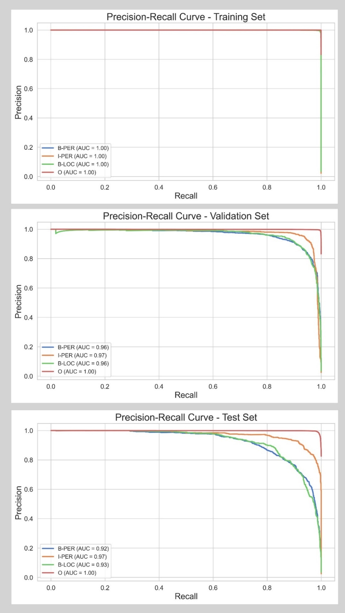
On the validation set, which includes 51,362 tokens, the performance declines, as depicted in the figure "Precision-Recall Curve - Validation Set." The AUC values drop to 0.96 (96.0%) for B-PER and B-LOC, 0.97 (97.0%) for I-PER, while O maintains a perfect AUC of 1.00 (100.0%). The curves for B-PER, I-PER, and B-LOC start at 100.0% precision for a recall of 0.0 and remain high (above 90.0%) until a recall of around 0.8 (80.0%), after which precision declines sharply, reaching around 50.0% for B-PER and B-LOC, and slightly higher at 60.0% for I-PER at a recall of 1.0 (100.0%). The O tag’s curve remains perfect, with precision at 100.0% across all recall values, reflecting its high support (42,759 instances) and minimal misclassifications (e.g., only 33 O instances misclassified as B-ORG). This decline in AUC for the entity tags indicates overfitting, as the model’s precision decreases on unseen data due to increased false positives, such as 92 B-PER instances misclassified as O in the validation confusion matrix. The I-PER tag’s slightly higher AUC of 97.0% compared to 96.0% for B-PER and B-LOC aligns with its F1-score of 87.3%, versus 90.1% for B-PER and 80.4% for B-LOC, showing better precision at higher recall values. The test set, with 46,435 tokens, shows a further decline in performance, as illustrated in the figure "Precision-Recall Curve - Test Set." The AUC values are 0.92 (92.0%) for B-PER, 0.97 (97.0%) for I-PER, 0.93 (93.0%) for B-LOC, and 1.00 (100.0%) for O. The curves for B-PER, I-PER, and B-LOC follow a similar pattern to the validation set but with a more pronounced precision drop: B-PER falls to around 40.0% at a recall of 1.0 (100.0%), B-LOC drops to 30.0%, while I-PER maintains precision above 80.0% until a recall of 0.9 (90.0%), then falls to around 50.0% at full recall. The O tag’s curve remains perfect, with an AUC of 100.0%, reflecting its high support (38,323 instances) and minimal misclassifications (e.g., 142 O as I-ORG). The significant AUC drop for B-PER (from 96.0% to 92.0%) and B-LOC (from 96.0% to 93.0%) highlights the model’s struggle with generalization, particularly for B-LOC, which has low support (216 instances) and a low F1-score of 65.3%. The confusion matrix shows increased misclassifications, such as 108 B-PER instances as O and 32 B-LOC as O, lowering precision at higher recall values. Meanwhile, I-PER’s stable AUC of 97.0% aligns with its F1-score of 78.5% and high recall of 95.5%, though its precision of 81.0% is impacted by misclassifications like 83 I-ORG as I-PER.
Figure 4-14: CRF Precison-Recall Curves for Training, Validation and Test sets
The focus on these four tags—B-PER, I-PER, B-LOC, and O—instead of the full set of nine tags (B-LOC, B-MISC, B-ORG, B-PER, I-LOC, I-MISC, I-ORG, I-PER, O) is driven by several factors. First, the CoNLL-2003 dataset is highly imbalanced, with O dominating (e.g., 169,578 instances in training) and B-PER (6,600 in training, 1,617 in test), I-PER (4,528 in training, 1,156 in test), and B-LOC (7,140 in training, 1,668 in test) having relatively higher support compared to other tags like I-LOC (257 in test) and I-MISC (216 in test). This ensures the precision-recall curves are statistically meaningful, as tags with very low support can produce noisy curves. Second, person and location entities are often critical in NER applications, such as information extraction, making B-PER, I-PER, and B-LOC particularly relevant, while O provides a baseline for non-entity performance. Third, these tags exhibit significant performance variability across splits—B-LOC’s AUC drops from 100.0% to 93.0% and its F1-score from 99.4% to 65.3%, while B-PER’s AUC falls from 100.0% to 92.0%—highlighting the model’s overfitting and generalization challenges. In contrast, tags like B-MISC (F1: 76.1% on test) and I-ORG (F1: 72.1%) show less variability due to smaller support, making them less informative for this analysis. Finally, focusing on four tags keeps the figures clear and interpretable, avoiding clutter, while providing a balanced view of beginning (B-) and continuation (I-) tags, as well as entity (PER, LOC) and non-entity (O) tags, effectively capturing the model’s strengths and weaknesses.

Effect of Tag Distribution on Model Performance
This distribution explains the CRF model’s perfect performance on the training set, where the precision-recall curves for B-PER, I-PER, B-LOC, and O all achieve an AUC of 1.00 (100.0%). The high support for O ensures minimal misclassifications (e.g., only 9 B-PER instances misclassified as O), while the relatively higher counts for B-PER, I-PER, and B-LOC allow the CRF model to learn robust patterns, leveraging its sequence modeling capabilities to achieve perfect precision and recall across all thresholds.
The validation set, with 51,362 tokens, follows a similar pattern of imbalance. The O tag has 42,759 instances, accounting for about 83.3% of the tokens, consistent with the training set. The entity tags include B-PER with 1,842 (3.6%), B-LOC with 1,837 (3.6%), B-ORG with 1,341 (2.6%), I-PER with 1,307 (2.5%), B-MISC with 922 (1.8%), I-ORG with 751 (1.5%), I-MISC with 346 (0.7%), and I-LOC with 257 (0.5%). The CRF model’s precision-recall curves on this set show a decline in performance, with AUCs of 0.96 (96.0%) for B-PER and B-LOC, 0.97 (97.0%) for I-PER, and 1.00 (100.0%) for O. The high support for O ensures its perfect AUC, with precision remaining at 100.0% across all recall values. However, the reduced counts for entity tags like B-LOC (from 7,140 in training to 1,837 in validation) and B-PER (from 6,600 to 1,842) contribute to the drop in AUC, as the model encounters more false positives on unseen data (e.g., 92 B-PER instances misclassified as O), leading to precision drops at higher recall values (e.g., B-PER to 50.0% at 100.0% recall).
In the test set, which has 46,435 tokens, the imbalance persists, with the O tag having 38,323 instances, approximately 82.5% of the tokens. The entity tags are B-LOC with 1,668 (3.6%), B-ORG with 1,661 (3.6%), B-PER with 1,617 (3.5%), I-PER with 1,156 (2.5%), I-ORG with 835 (1.8%), B-MISC with 702 (1.5%), I-LOC with 257 (0.6%), and I-MISC with 216 (0.5%). The CRF model’s precision-recall curves on the test set show further performance degradation, with AUCs of 0.92 (92.0%) for B-PER, 0.97 (97.0%) for I-PER, 0.93 (93.0%) for B-LOC, and 1.00 (100.0%) for O. The O tag’s high support ensures its perfect AUC, though the entity tags suffer from increased misclassifications (e.g., 108 B-PER as O, 32 B-LOC as O), leading to sharper precision drops (e.g., B-LOC to 30.0% at 100.0% recall). The low support for B-LOC (1,668) and B-PER (1,617) compared to the training set, combined with the CRF model’s overfitting, explains the AUC decline, though its sequence modeling still outperforms the RF model’s test set AUCs (e.g., B-PER at 0.36, B-LOC at 0.57).

Transition Weights
Transition weights (Figure 4-15) represent the likelihood of moving from one label to another (e.g., from "Beginning of an Organization" (B-ORG) to "Inside an Organization" (I-ORG)), with positive weights indicating favored transitions and negative weights suggesting unlikely or discouraged transitions. These weights are learned during training and reflect the model’s understanding of entity structure in the data.
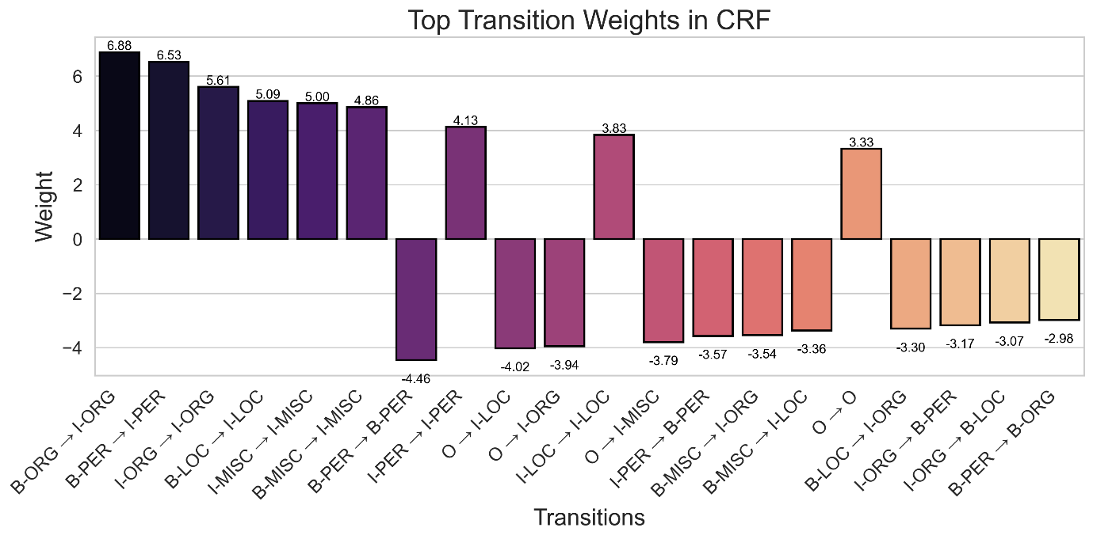
Figure 4-15: CRF Transition Weights
The highest transition weight in the CRF model is B-ORG → I-ORG, with a weight of 6.88, indicating a strong preference for continuing an organization entity once it has started (e.g., "United" → "Nations"). This suggests that multi-token organization names are common and well-represented in the dataset. Similarly, B-PER → I-PER, with a weight of 6.53, shows that the model strongly favors continuing a person’s name after it begins (e.g., "John" → "Smith"), reflecting the prevalence of multi-token person names.
The I-ORG → I-ORG transition, with a weight of 5.61, further reinforces the tendency for organizations to span multiple tokens (e.g., "United Nations" → "Security"), while B-LOC → I-LOC, at 5.09, indicates that multi-token locations (e.g., "New" → "York") are also frequent. The I-MISC → I-MISC transition, with a weight of 5.00, and B-MISC → I-MISC, at 4.86, suggest that miscellaneous entities (e.g., events or products) often extend over multiple tokens as well, such as "World Cup" → "Final."
On the other hand, several transitions have significant negative weights, indicating they are strongly discouraged by the CRF model. The B-PER → B-PER transition, with a weight of -4.46, suggests that consecutive person names (e.g., "John" → "Smith" as separate entities) are unlikely, as the model prefers to continue a person’s name with I-PER rather than starting a new entity. Similarly, O → I-LOC, with a weight of -4.02, and O → I-ORG, at -3.94, are highly discouraged, reflecting the model’s understanding that entities should start with a B- label rather than an I- label (e.g., "York" should be preceded by "New" with a B-LOC label, not O). The O → I-MISC transition, at -3.79, follows the same pattern, indicating that miscellaneous entities should also begin with a B- label. The I-PER → B-PER transition, with a weight of -3.57, further shows that the model avoids breaking a person’s name to start a new one, preferring continuity within the same entity.
Other notable transitions provide additional insight into the CRF model’s behavior. The I-PER → I-PER transition, with a weight of 4.13, supports the continuation of multi-token person names (e.g., "John Smith" → "Jr."), though it is less strong than B-PER → I-PER, suggesting that person names are typically two tokens long. The I-LOC → I-LOC transition, at 3.83, indicates that locations can extend over multiple tokens (e.g., "United Arab Emirates"), but this is less common than for organizations. The O → O transition, with a weight of 3.33, reflects the model’s recognition that most words are not part of entities, making staying in the "Outside" state a frequent pattern. Transitions like B-MISC → I-ORG (-3.54) and B-MISC → I-LOC (-3.36) are strongly discouraged, suggesting that miscellaneous entities are unlikely to be followed by parts of organizations or locations, which aligns with expected entity boundaries. Similarly, B-LOC → I-ORG (-3.30) and I-ORG → B-PER (-3.17) have negative weights, indicating that the model avoids mixing different entity types in this manner.
Overall, the CRF transition weights summarize the model’s strong preference for maintaining entity continuity, as seen in high positive weights for transitions like B-ORG → I-ORG (6.88), B-PER → I-PER (6.53), and I-ORG → I-ORG (5.61). The negative weights, such as B-PER → B-PER (-4.46) and O → I-LOC (-4.02), demonstrate the model’s adherence to proper entity boundaries, ensuring that entities start with B- labels and do not transition illogically between types.

Discussion and Conclusion
Chapter Summary
Though evident from the performance comparisons of the two models, limitations exist in both the Conditional Random Field (CRF) and Random Forest (RF) models for Named Entity Recognition (NER) on the CoNLL-2003 dataset.
CRF excels with accuracies of 99.9% (training), 97.6% (validation), and 95.6% (test), outperforming RF’s 60.6%, 58.6%, and 59.5%, respectively, but overfits, with a macro F1-score drop from 99.5% to 80.6% on the test set, notably for low-support tags like B-LOC (F1: 65.3%). RF struggles with sequential dependencies, reflected in its low macro F1-score (40.4% on test) and over-prediction of minority tags (e.g., I-PER precision: 10.2%).
Recommendations include enhancing CRF with regularization and word embeddings to mitigate overfitting, while RF could improve by adding a CRF layer for sequence modeling and using oversampling to address class imbalance, thereby improving generalization and performance on minority tags across diverse datasets.

Discussion: Comparative Performance
The evaluation of Random Forest (RF) and Conditional Random Field (CRF) models on the CoNLL-2003 dataset for Named Entity Recognition (NER) presents a number of differences in their performance, particularly in their ability to handle sequential dependencies, generalize to unseen data, and manage class imbalance. Both models were assessed across training, validation, and test sets, with performance metrics including accuracy, F1-scores, precision-recall curves, and transition weights, providing a comprehensive analysis of their strengths and weaknesses. This discussion synthesizes these results to compare RF and CRF, focusing on their overall effectiveness, handling of entity tags, and transition modeling capabilities.
The CRF model significantly outperforms RF in terms of overall accuracy and F1-scores across all splits. On the training set (203,621 tokens), CRF achieves an accuracy of 99.9% and a macro F1-score of 99.5%, compared to RF’s accuracy of 60.6% and macro F1-score of 48.1%. This gap persists on the validation set (51,362 tokens), where CRF’s accuracy is 97.6% and macro F1-score is 88.6%, while RF’s accuracy drops to 58.6% and macro F1-score to 42.0%. On the test set (46,435 tokens), CRF maintains a strong accuracy of 95.6% and a macro F1-score of 80.6%, whereas RF’s accuracy is 59.5% and macro F1-score falls to 40.4%. The weighted F1-scores further highlight this disparity, with CRF achieving 99.9% (training), 97.5% (validation), and 95.6% (test), compared to RF’s 68.8%, 66.9%, and 67.7%, respectively. These figures indicate that CRF not only excels on the training data but also generalizes far better to unseen data, with a macro F1-score drop of 18.9 percentage points from training to test (99.5% to 80.6%), compared to RF’s larger drop of 7.7 percentage points (48.1% to 40.4%). The CRF’s superior performance is largely due to its ability to model label dependencies, which is critical in NER tasks where the sequence of labels (e.g., B-PER followed by I-PER) matters.
For specific entity tags, CRF consistently outperforms RF, particularly for minority tags with lower support. For B-LOC, CRF’s F1-score on the test set is 65.3% (support: 216), compared to RF’s 46.1% (support: 1,668), despite CRF having fewer instances to learn from in the test set. This suggests that CRF better captures the contextual patterns of location entities, even with limited data. Similarly, for I-PER, CRF achieves an F1-score of 76.1% on the test set (support: 702), while RF’s F1-score is a mere 18.3% (support: 1,156), a difference of 57.8 percentage points. RF’s low F1-score for I-PER is driven by its extremely low precision (10.2% on test) despite high recall (89.4%), as seen in the confusion matrices where 8,044 O instances are misclassified as I-PER, reflecting RF’s tendency to over-predict minority classes due to the class_weight='balanced' parameter. In contrast, CRF’s balanced precision (81.0%) and recall (76.1%) for I-PER result in a harmonic mean F1-score that closely aligns with its arithmetic average (78.6%), indicating a more robust handling of class imbalance. For the majority class O (support: 38,323 in test), CRF’s F1-score is 78.5%, slightly higher than RF’s 74.1%, but CRF’s precision (98.5%) and recall (98.9%) are far more balanced than RF’s (98.9% precision, 59.3% recall), demonstrating CRF’s ability to minimize false positives while maintaining high recall.
The precision-recall curves further underscore CRF’s superiority in balancing precision and recall across splits. On the test set, CRF’s AUC values for B-PER, I-PER, B-LOC, and O are 0.92 (92.0%), 0.97 (97.0%), 0.93 (93.0%), and 1.00 (100.0%), respectively, compared to RF’s 0.36 (36.0%), 0.52 (52.0%), 0.57 (57.0%), and 0.97 (97.0%). The sharp precision drops in RF’s curves (e.g., B-PER to 10.0% at a recall of 0.2, B-LOC to 25.0% at a recall of 0.4) reflect its high false positive rate, particularly for entity tags, due to its inability to capture sequential dependencies. CRF, however, maintains higher precision at higher recall values (e.g., B-PER at 40.0% and I-PER at 50.0% at full recall), demonstrating its ability to leverage label dependencies and contextual patterns, even on unseen data. The perfect AUC of 1.00 for O in CRF across all splits, compared to RF’s 0.97 on the test set, further highlights CRF’s robustness in handling the majority class, with minimal misclassifications (e.g., 142 O as I-ORG in CRF’s test set confusion matrix vs. 8,044 O as I-PER in RF’s).
The transition weights provide deeper insight into how each model handles label dependencies, a critical aspect of NER. CRF’s transition weights reflect its strength in modeling sequential patterns, with high positive weights for logical continuations, such as B-ORG → I-ORG (6.88) and B-PER → I-PER (6.53), indicating a strong preference for multi-token entities (e.g., "United Nations" or "John Smith"). Negative weights, such as B-PER → B-PER (-4.46) and O → I-LOC (-4.02), show CRF’s adherence to proper entity boundaries, discouraging invalid transitions (e.g., starting an entity with an I- label). In contrast, RF’s transition weights, which are approximated through feature engineering, prioritize simpler patterns, with the highest weight for O → O (0.21), followed by O → B-PER (0.18) and B-PER → O (0.15). These weights suggest RF focuses on frequent transitions involving the majority class O and single-token entities, but it struggles with complex continuations, as seen in the lower weight for B-PER → I-PER (0.02) compared to CRF’s 6.53. RF’s tendency to over-segment entities is evident in its relatively high weight for B-PER → B-PER (0.13), which CRF strongly discourages (-4.46), indicating RF’s difficulty in maintaining entity continuity.
The confusion matrices reinforce these findings, showing that RF’s over-prediction of entity tags, particularly I-PER (e.g., 8,044 O instances misclassified as I-PER in the test set), leads to low precision and poor F1-scores for minority tags. CRF, however, exhibits far fewer misclassifications, even on the test set, with errors primarily between related tags (e.g., 83 I-ORG as I-PER), reflecting its ability to distinguish entity types through sequential modeling. For instance, CRF correctly predicts 37,905 out of 38,323 O instances in the test set, compared to RF’s 22,729, a difference that underscores CRF’s better handling of the majority class while also improving performance on entity tags.
Class imbalance significantly impacts RF’s performance, with the O tag dominating (83.3% of training tokens), leading to a large gap between its macro F1-score (40.4% on test) and weighted F1-score (67.7% on test). CRF, however, mitigates this imbalance effectively, with a smaller gap between its macro F1-score (80.6% on test) and weighted F1-score (95.6% on test), thanks to its ability to model label dependencies and maintain balanced precision and recall across tags. RF’s struggles with minority tags like I-LOC (F1: 54.9% on test) and I-MISC (F1: 22.4% on test) are exacerbated by their low support (257 and 216 instances in test), while CRF maintains higher F1-scores (98.7% for I-LOC, 90.2% for I-MISC), even with similar support constraints.
Conclusively, CRF outperforms RF across all evaluated metrics, demonstrating superior accuracy, F1-scores, precision-recall balance, and transition modeling. CRF’s ability to capture sequential dependencies allows it to handle both majority and minority tags effectively, resulting in robust generalization to unseen data (e.g., macro F1: 80.6% on test). RF, while achieving moderate performance on the majority class O (F1: 74.1% on test), struggles with entity tags (e.g., I-PER F1: 18.3% on test) due to its lack of inherent sequence modeling, leading to over-prediction and poor generalization (macro F1: 40.4% on test). To improve RF’s performance, incorporating sequence modeling (e.g., a CRF layer on top) or better handling of class imbalance through oversampling could be beneficial. For CRF, addressing overfitting through increased regularization or additional features (e.g., word embeddings) could further enhance its generalization, particularly for low-support tags like B-LOC (F1: 65.3% on test). These findings highlight CRF as the more effective model for NER tasks, particularly in datasets requiring strong sequential understanding, while RF may require significant modifications to achieve comparable performance.

Conclusion
The comparative evaluation of Random Forest (RF) and Conditional Random Field (CRF) models on the CoNLL-2003 dataset for Named Entity Recognition (NER) clearly demonstrates CRF’s superior performance across all key metrics, underscoring its suitability for tasks requiring sequential understanding. CRF achieves exceptional results, with an accuracy of 99.9% on the training set (203,621 tokens), 97.6% on the validation set (51,362 tokens), and 95.6% on the test set (46,435 tokens), alongside macro F1-scores of 99.5%, 88.6%, and 80.6%, respectively.
In contrast, RF’s performance is significantly weaker, with accuracies of 60.6% (training), 58.6% (validation), and 59.5% (test), and macro F1-scores of 48.1%, 42.0%, and 40.4%, respectively. CRF’s weighted F1-scores (99.9% training, 95.6% test) also far exceed RF’s (68.8% training, 67.7% test), highlighting CRF’s ability to handle both majority and minority classes effectively.
For specific tags, CRF outperforms RF significantly, such as for I-PER (F1: 76.1% vs. 18.3% on test) and B-LOC (F1: 65.3% vs. 46.1% on test), even with lower support in the test set (e.g., 702 I-PER instances for CRF vs. 1,156 for RF). The precision-recall curves further confirm CRF’s dominance, with test set AUCs of 0.92 (B-PER), 0.97 (I-PER), 0.93 (B-LOC), and 1.00 (O), compared to RF’s 0.36, 0.52, 0.57, and 0.97, respectively.
CRF’s transition weights, such as B-ORG → I-ORG (6.88) and B-PER → I-PER (6.53), reflect its strength in modeling sequential dependencies, while RF’s weights, like O → O (0.21) and O → B-PER (0.18), indicate a focus on simpler patterns, struggling with complex continuations (e.g., B-PER → I-PER at 0.02). These results establish CRF as the more effective model for NER, particularly in datasets where label dependencies are critical, while RF’s limitations in sequential modeling and generalization make it less suitable without significant enhancements.

Limitations
Despite CRF’s superior performance, both models exhibit limitations that impact their applicability in NER tasks.
For CRF, the primary limitation is overfitting, as evidenced by the significant drop in macro F1-score from 99.5% on the training set to 80.6% on the test set, a decline of 18.9 percentage points. This is particularly pronounced for tags with low support, such as B-LOC (F1: 99.4% training to 65.3% test, support: 216 in test), where the model struggles to generalize due to limited test set instances. The confusion matrices reveal increased misclassifications on unseen data, such as 32 B-LOC instances misclassified as O in the test set, indicating that CRF’s reliance on training patterns can lead to errors when data distributions shift. Additionally, CRF’s computational complexity, due to its probabilistic framework and need to compute transition weights across all labels, may pose challenges for scaling to larger datasets or real-time applications, though this was not directly measured in this study.
RF’s limitations are more pronounced, primarily originating from its inability to inherently model sequential dependencies, a critical aspect of NER. This is reflected in its poor macro F1-scores (40.4% on test) and low AUCs for entity tags (e.g., B-PER at 0.36, I-PER at 0.52 on test), as well as its tendency to over-predict minority classes, such as I-PER (8,044 O instances misclassified as I-PER in the test set confusion matrix), leading to low precision (10.2% for I-PER on test).
The class imbalance in the CoNLL-2003 dataset, with O dominating at 83.3% of training tokens (169,578 instances), exacerbates RF’s challenges, as the class_weight='balanced' parameter results in high recall but low precision for minority tags (e.g., I-PER recall: 89.4%, precision: 10.2% on test).
RF’s transition weights, approximated through feature engineering, fail to capture complex label dependencies, as seen in the low weight for B-PER → I-PER (0.02) compared to CRF’s 6.53, leading to over-segmentation (e.g., B-PER → B-PER at 0.13). Additionally, RF’s performance drop from training to test (macro F1: 48.1% to 40.4%) indicates overfitting, particularly for tags with low support like I-MISC (F1: 22.4% on test, support: 216), highlighting its sensitivity to data scarcity and lack of contextual modeling.
A shared limitation for both models is their dependence on the quality and quantity of training data. The CoNLL-2003 dataset’s imbalance, with tags like I-LOC (257 instances in test) and I-MISC (216 in test) having low support, limits the models’ ability to learn robust patterns for these classes, though CRF mitigates this better than RF.
Furthermore, this study focuses on a single dataset, which may not generalize to other domains (e.g., social media or biomedical texts) where entity distributions and contextual patterns differ. The evaluation also does not explore the impact of hyperparameter tuning or feature engineering beyond the provided setup, which could potentially improve both models’ performance.

Recommendations and Future Work
To address the identified limitations and enhance the performance of both RF and CRF models in NER tasks, the recommendations below are based on the entire study.
For CRF, mitigating overfitting is a priority. Increasing regularization, such as adjusting L1/L2 penalties, could help reduce the model’s reliance on training patterns, potentially improving generalization for low-support tags like B-LOC (F1: 65.3% on test). Cross-validation during training could also help tune hyperparameters more effectively, ensuring better performance on unseen data. Incorporating additional features, such as contextual word embeddings (e.g., BERT), could further enhance CRF’s ability to capture nuanced patterns, especially for minority tags, potentially reducing misclassifications (e.g., 32 B-LOC as O in the test set). Additionally, exploring techniques like data augmentation or synthetic data generation for low-support tags (e.g., I-LOC, I-MISC) could provide more training instances, improving generalization.
For RF, the primary recommendation is to incorporate sequence modeling capabilities to better handle label dependencies. One approach is to add a CRF layer on top of the RF model, combining RF’s feature importance with CRF’s sequential modeling, which could improve transitions like B-PER → I-PER (currently at 0.02) and reduce over-segmentation (e.g., B-PER → B-PER at 0.13). Addressing class imbalance is also critical; techniques like oversampling minority classes (e.g., SMOTE) or adjusting the class_weight parameter more finely could balance precision and recall, reducing false positives for tags like I-PER (precision: 10.2% on test). Increasing regularization, such as reducing tree depth or increasing the minimum samples per leaf, could mitigate overfitting, as seen in the macro F1-score drop from 48.1% to 40.4%. Additionally, incorporating contextual features, such as previous and next word embeddings, could help RF better approximate sequential patterns, improving its performance on entity tags (e.g., I-PER F1: 18.3% on test).
For both models, expanding the evaluation to diverse datasets (e.g., social media or biomedical texts) would provide a more comprehensive understanding of their generalizability. Exploring advanced feature engineering, such as part-of-speech tags or dependency parsing, could enhance both models’ ability to capture contextual patterns, particularly for minority tags.
Finally, conducting a detailed hyperparameter search (e.g., grid search for RF’s number of trees or CRF’s regularization parameters) could optimize performance, potentially closing the gap between training and test results for both models. These recommendations aim to leverage the strengths of CRF’s sequential modeling and RF’s feature importance while addressing their respective limitations, paving the way for more robust NER systems in future applications.

The END

References

1. Aboaoga (2013) ‘ARABIC PERSON NAMES RECOGNITION BY USING A RULE BASED APPROACH’, Journal of Computer Science, 9(7), pp. 922–927. Available at: https://doi.org/10.3844/jcssp.2013.922.927.

2. Beatrice Oyinkansola Adelakun et al. (2024) ‘Enhancing fraud detection in accounting through AI: Techniques and case studies’, Finance & Accounting Research Journal, 6(6), pp. 978–999. Available at: https://doi.org/10.51594/farj.v6i6.1232.

3. Biradar, U.B. et al. (2016) ‘Machine Learning Approach for Multi-Layered Detection of Chemical Named Entities in Text’:, International Journal of Software Science and Computational Intelligence, 8(1), pp. 1–15. Available at: https://doi.org/10.4018/IJSSCI.2016010101.

4. Chao, M.-H., Trappey, A.J.C. and Wu, C.-T. (2021) ‘Emerging Technologies of Natural Language‐Enabled Chatbots: A Review and Trend Forecast Using Intelligent Ontology Extraction and Patent Analytics’, Complexity. Edited by A.E.I.-B. Hassanien, 2021(1), p. 5511866. Available at: https://doi.org/10.1155/2021/5511866.

5. Daniel, J. and James H., M. (2000) Speech and Language Processing: An Introduction to Natural Language Processing, Computational Linguistics, and Speech Recognition | Guide books | ACM Digital Library. Available at: https://dl.acm.org/doi/book/10.5555/555733 (Accessed: 7 April 2025).

6. Debbarma*, A. et al. (2019) ‘Named Entity Recognition for a Low Resource Language’, International Journal of Recent Technology and Engineering (IJRTE), 8(3), pp. 587–590. Available at: https://doi.org/10.35940/ijrte.B2085.098319.

7. Dong, H. et al. (2022) ‘Named Entity Recognition for Public Interest Litigation Based on a Deep Contextualized Pretraining Approach’, Scientific Programming. Edited by D. Xu, 2022, pp. 1–14. Available at: https://doi.org/10.1155/2022/7682373.

8. Jiang, L. and Bolshakova, E. (no date) ‘An Experimental Study of Hybrid Machine Learning Models for Extracting Named Entities’, in. Proceedings of Third Workshop ‘Computational linguistics and language science’, pp. 50–38. Available at: https://doi.org/10.29007/dp5m.

9. Jiao, S. et al. (2021) ‘iTTCA-RF: a random forest predictor for tumor T cell antigens’, Journal of Translational Medicine, 19(1), p. 449. Available at: https://doi.org/10.1186/s12967-021-03084-x.

10. Li, Z. et al. (2024) ‘Ensemble pretrained language models to extract biomedical knowledge from literature’, Journal of the American Medical Informatics Association, 31(9), pp. 1904–1911. Available at: https://doi.org/10.1093/jamia/ocae061.

11. Liu, Z. et al. (2021) ‘NER-BERT: A Pre-trained Model for Low-Resource Entity Tagging’. arXiv. Available at: https://doi.org/10.48550/ARXIV.2112.00405.

12. Lowe, D.M. and Sayle, R.A. (2015) ‘LeadMine: a grammar and dictionary driven approach to entity recognition’, Journal of Cheminformatics, 7(S1), p. S5. Available at: https://doi.org/10.1186/1758-2946-7-S1-S5.

13. Ma, X. and Hovy, E. (2016) ‘End-to-end Sequence Labeling via Bi-directional LSTM-CNNs-CRF’, in Proceedings of the 54th Annual Meeting of the Association for Computational Linguistics (Volume 1: Long Papers). Proceedings of the 54th Annual Meeting of the Association for Computational Linguistics (Volume 1: Long Papers), Berlin, Germany: Association for Computational Linguistics, pp. 1064–1074. Available at: https://doi.org/10.18653/v1/P16-1101.

14. Magnini, B., Lavelli, A. and Magnolini, S. (2020) ‘Comparing Machine Learning and Deep Learning Approaches on NLP Tasks for the Italian Language’, in N. Calzolari et al. (eds) Proceedings of the Twelfth Language Resources and Evaluation Conference. LREC 2020, Marseille, France: European Language Resources Association, pp. 2110–2119. Available at: https://aclanthology.org/2020.lrec-1.259/ (Accessed: 7 April 2025).

15. Mathew, J., Stripelis, D. and Ambite, J.L. (2022) ‘Federated Named Entity Recognition’. arXiv. Available at: https://doi.org/10.48550/ARXIV.2203.15101.

16. McCoy, A.B. et al. (2013) ‘State of the art in clinical informatics: evidence and examples’, Yearbook of Medical Informatics, 8, pp. 13–19.

17. Nooralahzadeh, F., Lønning, J.T. and Øvrelid, L. (2019) ‘Reinforcement-based denoising of distantly supervised NER with partial annotation’, in Proceedings of the 2nd Workshop on Deep Learning Approaches for Low-Resource NLP (DeepLo 2019). Proceedings of the 2nd Workshop on Deep Learning Approaches for Low-Resource NLP (DeepLo 2019), Hong Kong, China: Association for Computational Linguistics, pp. 225–233. Available at: https://doi.org/10.18653/v1/D19-6125.

18. Okanohara, D. et al. (2006) ‘Improving the scalability of semi-Markov conditional random fields for named entity recognition’, in Proceedings of the 21st International Conference on Computational Linguistics and the 44th annual meeting of the ACL - ACL ’06. the 21st International Conference, Sydney, Australia: Association for Computational Linguistics, pp. 465–472. Available at: https://doi.org/10.3115/1220175.1220234.

19. Peilin, L. et al. (2019) ‘Medical Knowledge Extraction and Analysis from Electronic Medical Records Using Deep Learning’, Chinese Medical Sciences Journal, 34(2), pp. 133–139. Available at: https://doi.org/10.24920/003589.

20. Pereira, D.A. et al. (2011) ‘A generic Web-based entity resolution framework’, Journal of the American Society for Information Science and Technology, 62(5), pp. 919–932. Available at: https://doi.org/10.1002/asi.21518.

21. Ratinov, L. and Roth, D. (2009) ‘Design Challenges and Misconceptions in Named Entity Recognition’, in S. Stevenson and X. Carreras (eds) Proceedings of the Thirteenth Conference on Computational Natural Language Learning (CoNLL-2009). CoNLL 2009, Boulder, Colorado: Association for Computational Linguistics, pp. 147–155. Available at: https://aclanthology.org/W09-1119/ (Accessed: 7 April 2025).

22. Ronran, C., Lee, S. and Jang, H.J. (2020) ‘Delayed Combination of Feature Embedding in Bidirectional LSTM CRF for NER’, Applied Sciences, 10(21), p. 7557. Available at: https://doi.org/10.3390/app10217557.

23. Settles, B. (2004) ‘Biomedical named entity recognition using conditional random fields and rich feature sets’, in Proceedings of the International Joint Workshop on Natural Language Processing in Biomedicine and its Applications - JNLPBA ’04. the International Joint Workshop, Geneva, Switzerland: Association for Computational Linguistics, p. 104. Available at: https://doi.org/10.3115/1567594.1567618.

24. Stewart, M. and Liu, W. (2020) ‘E2EET: From Pipeline to End-to-end Entity Typing via Transformer-Based Embeddings’. arXiv. Available at: https://doi.org/10.48550/ARXIV.2003.10097.

25. Sumathipala, S., Yamada, K. and Unehara, M. (2014) ‘Protein named entity classification with probabilistic features derived from GENIA corpus and MEDLINE’, in 2014 Joint 7th International Conference on Soft Computing and Intelligent Systems (SCIS) and 15th International Symposium on Advanced Intelligent Systems (ISIS). 2014 Joint 7th International Conference on Soft Computing and Intelligent Systems (SCIS) and 15th International Symposium on Advanced Intelligent Systems (ISIS), Kita-Kyushu, Japan: IEEE, pp. 1257–1261. Available at: https://doi.org/10.1109/SCIS-ISIS.2014.7044640.

26. Tjong Kim Sang, E.F. and De Meulder, F. (2003) ‘Introduction to the CoNLL-2003 Shared Task: Language-Independent Named Entity Recognition’, in Proceedings of the Seventh Conference on Natural Language Learning at HLT-NAACL 2003. CoNLL-HLT 2003, pp. 142–147. Available at: https://aclanthology.org/W03-0419/ (Accessed: 7 April 2025).

27. Wang, H., Liu, C. and Deng, L. (2018) ‘Enhanced Prediction of Hot Spots at Protein-Protein Interfaces Using Extreme Gradient Boosting’, Scientific Reports, 8(1), p. 14285. Available at: https://doi.org/10.1038/s41598-018-32511-1.

28. Wang, Y. et al. (2020) ‘Application of Pre-training Models in Named Entity Recognition’. arXiv. Available at: https://doi.org/10.48550/arXiv.2002.08902.

29. Xu, Z., Burdick, D. and Raschid, L. (2016) ‘Exploiting Lists of Names for Named Entity Identification of Financial Institutions from Unstructured Documents’. arXiv. Available at: https://doi.org/10.48550/ARXIV.1602.04427.

30. Yang, X. et al. (2019) ‘MADEx: A System for Detecting Medications, Adverse Drug Events, and Their Relations from Clinical Notes’, Drug Safety, 42(1), pp. 123–133. Available at: https://doi.org/10.1007/s40264-018-0761-0.

31. Ye, Z. and Ling, Z.-H. (2018) ‘Hybrid semi-Markov CRF for Neural Sequence Labeling’, in Proceedings of the 56th Annual Meeting of the Association for Computational Linguistics (Volume 2: Short Papers). Proceedings of the 56th Annual Meeting of the Association for Computational Linguistics (Volume 2: Short Papers), Melbourne, Australia: Association for Computational Linguistics, pp. 235–240. Available at: https://doi.org/10.18653/v1/P18-2038.

32. Yu, J., Bohnet, B. and Poesio, M. (2020) ‘Named Entity Recognition as Dependency Parsing’. arXiv. Available at: https://doi.org/10.48550/arXiv.2005.07150.

33. Zahra, A., Hidayatullah, A.F. and Rani, S. (2022) ‘Bidirectional long-short term memory and conditional random field for tourism named entity recognition’, IAES International Journal of Artificial Intelligence (IJ-AI), 11(4), p. 1270. Available at: https://doi.org/10.11591/ijai.v11.i4.pp1270-1277.

34. Zhang, L. and Wu, H. (2021) ‘Medical Text Entity Recognition Based on Deep Learning’, Journal of Physics: Conference Series, 1744(4), p. 042209. Available at: https://doi.org/10.1088/1742-6596/1744/4/042209.

35. Zheng, J., Chen, H. and Ma, Q. (2022) ‘Cross-domain Named Entity Recognition via Graph Matching’, in Findings of the Association for Computational Linguistics: ACL 2022. Findings of the Association for Computational Linguistics: ACL 2022, Dublin, Ireland: Association for Computational Linguistics, pp. 2670–2680. Available at: https://doi.org/10.18653/v1/2022.findings-acl.210.

36. Zhong, H. and Hu, X. (2013) ‘Disease Named Entity Recognition by Machine Learning Using Semantic Type of Metathesaurus’, International Journal of Machine Learning and Computing, 3(6), pp. 494–498. Available at: https://doi.org/10.7763/IJMLC.2013.V3.367.

37. Zirikly, A. and Diab, M. (2014) ‘Named Entity Recognition System for Dialectal Arabic’, in N. Habash and S. Vogel (eds) Proceedings of the EMNLP 2014 Workshop on Arabic Natural Language Processing (ANLP). WANLP 2014, Doha, Qatar: Association for Computational Linguistics, pp. 78–86. Available at: https://doi.org/10.3115/v1/W14-3610.

Appendix

Table 5-1: Tag Distribution for both models (Training, Validation, and Test sets)

  NER Tag | Count
  B-ORG | 6321
  O | 169578
  B-MISC | 3438
  B-PER | 6600
  I-PER | 4528
  B-LOC | 7140
  I-ORG | 3704
  I-MISC | 1155
  I-LOC | 1157
  NER Tag | Count
  O | 42759
  B-ORG | 1341
  B-LOC | 1837
  B-MISC | 922
  I-MISC | 346
  B-PER | 1842
  I-PER | 1307
  I-LOC | 257
  I-ORG | 751
  NER Tag | Count
  O | 38323
  B-LOC | 1668
  B-PER | 1617
  I-PER | 1156
  I-LOC | 257
  B-MISC | 702
  I-MISC | 216
  B-ORG | 1661
  I-ORG | 835

RF Model
Table 5-2: RF Classification Report metrics – Training Set
RF Training Set Classification Report
 | precision | recall | f1-score | support
B-LOC | 0.46547 | 0.715546 | 0.564032 | 7140
B-MISC | 0.178846 | 0.751018 | 0.288895 | 3438
B-ORG | 0.314054 | 0.619364 | 0.416778 | 6321
B-PER | 0.333937 | 0.586364 | 0.425532 | 6600
I-LOC | 0.658327 | 0.796024 | 0.720657 | 1157
I-MISC | 0.267435 | 0.78355 | 0.398766 | 1155
I-ORG | 0.661548 | 0.558315 | 0.605564 | 3704
I-PER | 0.092871 | 0.934408 | 0.168949 | 4528
O | 0.991776 | 0.588862 | 0.738966 | 169578
accuracy | 0.606318 | 0.606318 | 0.606318 | 0.606318
macro avg | 0.440474 | 0.703717 | 0.480904 | 203621
weighted avg | 0.885235 | 0.606318 | 0.687936 | 203621

Table 5-3: RF Classification Report metrics – Validation Set
RF Validation Set Classification Report
 | precision | recall | f1-score | support
B-LOC | 0.412082 | 0.623843 | 0.496319 | 1837
B-MISC | 0.168883 | 0.68872 | 0.271252 | 922
B-ORG | 0.227844 | 0.500373 | 0.313112 | 1341
B-PER | 0.350277 | 0.583605 | 0.437793 | 1842
I-LOC | 0.522124 | 0.688716 | 0.59396 | 257
I-MISC | 0.213084 | 0.65896 | 0.322034 | 346
I-ORG | 0.476874 | 0.398136 | 0.433962 | 751
I-PER | 0.09937 | 0.892884 | 0.178837 | 1307
O | 0.986734 | 0.577539 | 0.728617 | 42759
accuracy | 0.5859 | 0.5859 | 0.5859 | 0.5859
macro avg | 0.384141 | 0.623642 | 0.419543 | 51362
weighted avg | 0.871289 | 0.5859 | 0.669109 | 51362

Table 5-4: RF Classification Report metrics – Test Set
RF Test Classification Report
 | precision | recall | f1-score | support
B-LOC | 0.393567 | 0.557554 | 0.461424 | 1668
B-MISC | 0.153446 | 0.672365 | 0.249868 | 702
B-ORG | 0.289035 | 0.583986 | 0.386685 | 1661
B-PER | 0.343157 | 0.525665 | 0.415242 | 1617
I-LOC | 0.48368 | 0.634241 | 0.548822 | 257
I-MISC | 0.134779 | 0.662037 | 0.223962 | 216
I-ORG | 0.486154 | 0.378443 | 0.425589 | 835
I-PER | 0.102025 | 0.893599 | 0.18314 | 1156
O | 0.988647 | 0.59309 | 0.741409 | 38323
accuracy | 0.594508 | 0.594508 | 0.594508 | 0.594508
macro avg | 0.374943 | 0.61122 | 0.404016 | 46435
weighted avg | 0.869266 | 0.594508 | 0.676824 | 46435

Table 5-5: RF Confusion Matrix – Training Set
 | B-LOC | B-MISC | B-ORG | B-PER | I-LOC | I-MISC | I-ORG | I-PER | O
B-LOC | 5109 | 438 | 631 | 334 | 13 | 9 | 24 | 476 | 106
B-MISC | 113 | 2582 | 229 | 97 | 6 | 35 | 7 | 326 | 43
B-ORG | 402 | 683 | 3915 | 514 | 9 | 31 | 89 | 559 | 119
B-PER | 239 | 102 | 1094 | 3870 | 3 | 13 | 9 | 1158 | 112
I-LOC | 20 | 10 | 2 | 2 | 921 | 9 | 11 | 135 | 47
I-MISC | 5 | 19 | 5 | 1 | 10 | 905 | 7 | 133 | 70
I-ORG | 88 | 59 | 80 | 62 | 84 | 104 | 2068 | 904 | 255
I-PER | 42 | 3 | 10 | 56 | 2 | 89 | 19 | 4231 | 76
O | 4958 | 10541 | 6500 | 6653 | 351 | 2189 | 892 | 37636 | 99858

Table 5-6: RF Confusion Matrix – Validation Set
 | B-LOC | B-MISC | B-ORG | B-PER | I-LOC | I-MISC | I-ORG | I-PER | O
B-LOC | 1146 | 137 | 273 | 120 | 13 | 1 | 5 | 118 | 24
B-MISC | 20 | 635 | 70 | 48 | 3 | 17 | 8 | 88 | 33
B-ORG | 92 | 205 | 671 | 137 | 0 | 4 | 29 | 169 | 34
B-PER | 88 | 32 | 286 | 1075 | 0 | 9 | 8 | 299 | 45
I-LOC | 5 | 6 | 1 | 0 | 177 | 8 | 5 | 43 | 12
I-MISC | 1 | 28 | 3 | 2 | 8 | 228 | 2 | 38 | 36
I-ORG | 36 | 20 | 19 | 13 | 29 | 31 | 299 | 196 | 108
I-PER | 31 | 2 | 6 | 28 | 2 | 26 | 5 | 1167 | 40
O | 1362 | 2695 | 1616 | 1646 | 107 | 746 | 266 | 9626 | 24695

Table 5-7: RF Confusion Matrix – Test Set
 | B-LOC | B-MISC | B-ORG | B-PER | I-LOC | I-MISC | I-ORG | I-PER | O
B-LOC | 930 | 110 | 305 | 129 | 11 | 22 | 15 | 125 | 21
B-MISC | 20 | 472 | 70 | 30 | 2 | 16 | 3 | 77 | 12
B-ORG | 149 | 186 | 970 | 99 | 0 | 25 | 13 | 190 | 29
B-PER | 81 | 33 | 273 | 850 | 0 | 13 | 8 | 325 | 34
I-LOC | 7 | 4 | 4 | 0 | 163 | 11 | 16 | 39 | 13
I-MISC | 0 | 9 | 7 | 0 | 3 | 143 | 2 | 35 | 17
I-ORG | 14 | 25 | 38 | 12 | 46 | 32 | 316 | 257 | 95
I-PER | 20 | 0 | 0 | 21 | 2 | 32 | 8 | 1033 | 40
O | 1142 | 2237 | 1689 | 1336 | 110 | 767 | 269 | 8044 | 22729

Table 5-8: RF F1-Score comparison for Training vs Validation vs Test sets
Class | Training F1 | Validation F1 | Test F1
B-LOC | 0.564032 | 0.496319 | 0.461424
B-MISC | 0.288895 | 0.271252 | 0.249868
B-ORG | 0.416778 | 0.313112 | 0.386685
B-PER | 0.425532 | 0.437793 | 0.415242
I-LOC | 0.720657 | 0.59396 | 0.548822
I-MISC | 0.398766 | 0.322034 | 0.223962
I-ORG | 0.605564 | 0.433962 | 0.425589
I-PER | 0.168949 | 0.178837 | 0.18314
O | 0.738966 | 0.728617 | 0.741409

Table 5-9: RF Precision vs Recall (Sample out of 17567 rows) – Training set
 | Recall | Precision | AUC
0 | 1 | 0.032413 | 0.43907
1 | 1 | 0.032414 | 0.43907
2 | 1 | 0.032414 | 0.43907
3 | 1 | 0.032414 | 0.43907
4 | 1 | 0.032416 | 0.43907
5 | 1 | 0.032416 | 0.43907
6 | 1 | 0.032417 | 0.43907
7 | 1 | 0.032417 | 0.43907
8 | 1 | 0.03242 | 0.43907
9 | 1 | 0.03242 | 0.43907

Table 5-10: RF Precision vs Recall (Sample out of 6799 rows) – Validation set
 | Recall | Precision | AUC
0 | 1 | 0.035863 | 0.381966
1 | 1 | 0.035864 | 0.381966
2 | 1 | 0.035865 | 0.381966
3 | 1 | 0.035866 | 0.381966
4 | 1 | 0.035871 | 0.381966
5 | 1 | 0.035872 | 0.381966
6 | 1 | 0.035874 | 0.381966
7 | 1 | 0.035877 | 0.381966
8 | 1 | 0.035878 | 0.381966
9 | 1 | 0.035883 | 0.381966
10 | 1 | 0.035884 | 0.381966

Table 5-11: RF Precision vs Recall (Sample out of 5924 rows) – Validation set
 | Recall | Precision | AUC
0 | 1 | 0.034823 | 0.359988
1 | 1 | 0.034824 | 0.359988
2 | 1 | 0.034825 | 0.359988
3 | 1 | 0.034826 | 0.359988
4 | 1 | 0.034827 | 0.359988
5 | 1 | 0.034827 | 0.359988
6 | 1 | 0.03483 | 0.359988
7 | 1 | 0.034833 | 0.359988
8 | 1 | 0.034834 | 0.359988
9 | 1 | 0.034835 | 0.359988
10 | 1 | 0.034836 | 0.359988

Table 5-12: RF Transition Weights
Transition | Weight | Transition | Weight | Transition | Weight
O → O | 0.208419 | B-ORG → O | 0.026997 | O → B-ORG | 0.008851
O → B-PER | 0.177345 | B-PER → I-PER | 0.024143 | I-ORG → O | 0.008703
B-PER → O | 0.154811 | O → B-LOC | 0.021949 | O → B-MISC | 0.008545
B-PER → B-PER | 0.132229 | O → I-PER | 0.015962 | B-MISC → B-PER | 0.006282
I-PER → O | 0.044467 | B-ORG → B-PER | 0.013092 | I-MISC → O | 0.005533
I-LOC → O | 0.028626 | B-PER → I-LOC | 0.012907 | B-PER → B-LOC | 0.004969
B-LOC → O | 0.027318 | O → I-LOC | 0.012259

CRF Model

Table 5-13: CRF Classification Report metrics – Training Set
 | precision | recall | f1-score | support
B-ORG | 0.99454 | 0.994958 | 0.994749 | 7140
O | 0.997646 | 0.986038 | 0.991808 | 3438
B-MISC | 0.995086 | 0.993197 | 0.994141 | 6321
B-PER | 0.99833 | 0.996515 | 0.997422 | 6600
I-PER | 0.993945 | 0.993086 | 0.993515 | 1157
B-LOC | 0.992235 | 0.995671 | 0.99395 | 1155
I-ORG | 0.995675 | 0.99433 | 0.995002 | 3704
I-MISC | 0.998675 | 0.999117 | 0.998896 | 4528
I-LOC | 0.99944 | 0.9998 | 0.99962 | 169578
accuracy | 0.99891 | 0.99891 | 0.99891 | 0.99891
macro avg | 0.996175 | 0.994746 | 0.995456 | 203621
weighted avg | 0.998909 | 0.99891 | 0.998909 | 203621

Table 5-14: CRF Classification Report metrics – Validation Set
 | precision | recall | f1-score | support
B-ORG | 0.926346 | 0.890038 | 0.907829 | 1837
O | 0.923536 | 0.838395 | 0.878908 | 922
B-MISC | 0.869255 | 0.818046 | 0.842874 | 1341
B-PER | 0.900705 | 0.901194 | 0.90095 | 1842
I-PER | 0.95814 | 0.801556 | 0.872881 | 257
B-LOC | 0.877133 | 0.742775 | 0.804382 | 346
I-ORG | 0.829365 | 0.834887 | 0.832117 | 751
I-MISC | 0.939602 | 0.940321 | 0.939962 | 1307
I-LOC | 0.989532 | 0.99703 | 0.993267 | 42759
accuracy | 0.975741 | 0.975741 | 0.975741 | 0.975741
macro avg | 0.912624 | 0.862694 | 0.885908 | 51362
weighted avg | 0.975235 | 0.975741 | 0.975333 | 51362

Table 5-15: CRF Classification Report metrics – Test Set
 | precision | recall | f1-score | support
B-ORG | 0.861318 | 0.830336 | 0.845543 | 1668
O | 0.810319 | 0.760684 | 0.784717 | 702
B-MISC | 0.821354 | 0.708609 | 0.760827 | 1661
B-PER | 0.825272 | 0.844156 | 0.834607 | 1617
I-PER | 0.801724 | 0.723735 | 0.760736 | 257
B-LOC | 0.661905 | 0.643519 | 0.652582 | 216
I-ORG | 0.702611 | 0.741317 | 0.721445 | 835
I-MISC | 0.855151 | 0.955017 | 0.902329 | 1156
I-LOC | 0.98539 | 0.989093 | 0.987238 | 38323
accuracy | 0.956477 | 0.956477 | 0.956477 | 0.956477
macro avg | 0.813894 | 0.799607 | 0.805558 | 46435
weighted avg | 0.955995 | 0.956477 | 0.955969 | 46435

Table 5-16: CRF Confusion Matrix – Training Set
 | B-ORG | O | B-MISC | B-PER | I-PER | B-LOC | I-ORG | I-MISC | I-LOC
B-ORG | 6278 | 21 | 3 | 3 | 0 | 14 | 2 | 0 | 0
O | 7 | 169544 | 2 | 2 | 4 | 10 | 8 | 0 | 1
B-MISC | 1 | 27 | 3390 | 3 | 0 | 6 | 1 | 9 | 1
B-PER | 5 | 9 | 0 | 6577 | 0 | 9 | 0 | 0 | 0
I-PER | 0 | 0 | 0 | 0 | 4524 | 0 | 3 | 0 | 1
B-LOC | 16 | 13 | 1 | 3 | 2 | 7104 | 1 | 0 | 0
I-ORG | 2 | 15 | 0 | 0 | 0 | 0 | 3683 | 0 | 4
I-MISC | 0 | 3 | 2 | 0 | 0 | 0 | 0 | 1150 | 0
I-LOC | 0 | 7 | 0 | 0 | 0 | 0 | 1 | 0 | 1149

Table 5-17: CRF Confusion Matrix – Validation Set
 | B-ORG | O | B-MISC | B-PER | I-PER | B-LOC | I-ORG | I-MISC | I-LOC
B-ORG | 1097 | 65 | 14 | 92 | 2 | 59 | 10 | 2 | 0
O | 33 | 42632 | 11 | 22 | 3 | 8 | 41 | 8 | 1
B-MISC | 19 | 87 | 773 | 26 | 2 | 9 | 3 | 3 | 0
B-PER | 30 | 92 | 3 | 1660 | 6 | 38 | 10 | 3 | 0
I-PER | 4 | 36 | 2 | 7 | 1229 | 2 | 21 | 5 | 1
B-LOC | 71 | 79 | 10 | 35 | 2 | 1635 | 5 | 0 | 0
I-ORG | 7 | 46 | 1 | 1 | 40 | 7 | 627 | 15 | 7
I-MISC | 0 | 37 | 23 | 0 | 10 | 6 | 13 | 257 | 0
I-LOC | 1 | 9 | 0 | 0 | 14 | 1 | 26 | 0 | 206

Table 5-18: CRF Confusion Matrix – Test Set
 | B-ORG | O | B-MISC | B-PER | I-PER | B-LOC | I-ORG | I-MISC | I-LOC
B-ORG | 1177 | 142 | 43 | 144 | 9 | 127 | 18 | 1 | 0
O | 65 | 37905 | 39 | 61 | 36 | 22 | 142 | 44 | 9
B-MISC | 27 | 87 | 534 | 27 | 4 | 17 | 0 | 6 | 0
B-PER | 66 | 108 | 10 | 1365 | 13 | 43 | 10 | 1 | 1
I-PER | 0 | 9 | 0 | 2 | 1104 | 0 | 38 | 3 | 0
B-LOC | 82 | 109 | 24 | 49 | 4 | 1385 | 13 | 1 | 1
I-ORG | 15 | 55 | 3 | 5 | 83 | 9 | 619 | 14 | 32
I-MISC | 1 | 32 | 6 | 1 | 19 | 2 | 13 | 139 | 3
I-LOC | 0 | 20 | 0 | 0 | 19 | 3 | 28 | 1 | 186

Table 5-19: CRF F1-Score comparison for Training vs Validation vs Test sets
Class | Training F1 | Validation F1 | Test F1
B-ORG | 0.994749 | 0.907829 | 0.845543
O | 0.991808 | 0.878908 | 0.784717
B-MISC | 0.994141 | 0.842874 | 0.760827
B-PER | 0.997422 | 0.90095 | 0.834607
I-PER | 0.993515 | 0.872881 | 0.760736
B-LOC | 0.99395 | 0.804382 | 0.652582
I-ORG | 0.995002 | 0.832117 | 0.721445
I-MISC | 0.998896 | 0.939962 | 0.902329
I-LOC | 0.99962 | 0.993267 | 0.987238

Table 5-20: CRF Precision vs Recall (Sample out of 197072 rows) – Training set
 | Recall | Precision | AUC
0 | 1 | 0.032413 | 0.99989
1 | 1 | 0.032413 | 0.99989
2 | 1 | 0.032413 | 0.99989
3 | 1 | 0.032414 | 0.99989
4 | 1 | 0.032414 | 0.99989
5 | 1 | 0.032414 | 0.99989
6 | 1 | 0.032414 | 0.99989
7 | 1 | 0.032414 | 0.99989
8 | 1 | 0.032414 | 0.99989

Table 5-21: CRF Precision vs Recall (Sample out of 50,608 rows) – Validation set
 | Recall | Precision | AUC
0 | 1 | 0.035863 | 0.96369
1 | 1 | 0.035864 | 0.96369
2 | 1 | 0.035864 | 0.96369
3 | 1 | 0.035865 | 0.96369
4 | 1 | 0.035866 | 0.96369
5 | 1 | 0.035867 | 0.96369
6 | 1 | 0.035867 | 0.96369
7 | 1 | 0.035868 | 0.96369
8 | 1 | 0.035869 | 0.96369
Table 5-22: CRF Precision vs Recall (Sample out of 45339 rows) – Test set
 | Recall | Precision | AUC
0 | 1 | 0.034823 | 0.924116
1 | 1 | 0.034824 | 0.924116
2 | 1 | 0.034824 | 0.924116
3 | 1 | 0.034825 | 0.924116
4 | 1 | 0.034826 | 0.924116
5 | 1 | 0.034827 | 0.924116
6 | 1 | 0.034827 | 0.924116
7 | 1 | 0.034828 | 0.924116
8 | 1 | 0.034829 | 0.924116

Table 5-23: CRF Transition Weights 5-1
Transition | Weight
B-ORG → I-ORG | 6.878571
B-PER → I-PER | 6.529483
I-ORG → I-ORG | 5.605046
B-LOC → I-LOC | 5.086802
I-MISC → I-MISC | 5.003394
B-MISC → I-MISC | 4.861565
B-PER → B-PER | -4.45829
I-PER → I-PER | 4.130277
O → I-LOC | -4.02041
O → I-ORG | -3.94294
I-LOC → I-LOC | 3.833873
O → I-MISC | -3.79232
I-PER → B-PER | -3.56608
B-MISC → I-ORG | -3.5398
B-MISC → I-LOC | -3.36167
O → O | 3.3265
B-LOC → I-ORG | -3.3031
I-ORG → B-PER | -3.16963
I-ORG → B-LOC | -3.06858
B-PER → B-ORG | -2.97652

