Comparison of Holt-Winters and ARIMA models in Temperature Time Series Prediction: South Sudan Average Temperatures, 1920 – 2030

University of Juba
School of Computer Science and Information Technology,

Department of Information Technology

A thesis submitted to the School of Computer Science and Information Technology, University of Juba, in partial fulfillment
of the requirements for the award of Bachelor of Science (Hons) Degree in Information Technology

By
- ALIER AJAK ACHUEK, 17-CIT-092
- DENG JOHN AKHOK, 20-CIT-143

Under the supervision of
Dr. Manzu Gerald S. KENYI, Ph.D

April 20

Approval

This is to certify that the Graduation Project titled: “Comparison of Holt-Winters and ARIMA models in Temperature Time Series Prediction: South Sudan Average Temperatures, 1920 – 2030” has been carried out under my supervision, thoroughly reviewed, and meets the academic standards required as part of the partial fulfillment of the requirements for the award of Bachelor of Science (Hons) Degree in Information Technology at the University of Juba.
The thesis presents a comparative performance analysis of the Holt-Winters and ARIMA models in temperature time-series prediction. It demonstrates the students’ comprehension of predictive modeling and optimization within the broader field of machine learning, with particular emphasis on design, experimentation, implementation, evaluation, and analysis of models.

Submitted By:
Student Names | ID
- ALIER AJAK ACHUEK | 17-CIT-092
- DENG JOHN AKHOK | 20-CIT-143
Department | Information Technology
School | School of Computer Science and Information Technology

Supervised By:
Supervisor's Name: Dr. Manzu Gerald S. KENYI, Ph.D.
Position: Lecturer
Signature: ___________
Date: 2025/04/25

Approved by:
Name: Eng. Lodu Bosco John
Position: Head, Department of Information Technology
Signature: ___________
Date: ___________

Declaration

We affirm that the research presented in this thesis is our original work and has not been submitted for any academic degree at another institution.
This study was conducted from August 2024 to April 2025 under the guidance and supervision of Dr. Manzu Gerald S. KENYI, Ph.D.

Student Names | ID | Signature | Date
- ALIER AJAK ACHUEK | 17-CIT-092 |  | 2025/4/18
- DENG JOHN AKHOK | 20-CIT-143 |  | 2025/4/18
Department | Information Technology
School | School of Computer Science and Information Technology

Dedication

We attribute the success of this work to our families, whose steadfast support and boundless encouragement were pivotal in bringing this endeavor to fruition

Acknowledgement

We extend our sincere and profound gratitude to Dr. Manzu Gerald S. Kenyi of the School of Computer Science and Information Technology, University of Juba, for his exceptional guidance and unwavering generosity in navigating the difficulties in this project.
His collaborative approach and steadfast support were instrumental throughout the research process. Dr. Manzu Gerald demonstrated remarkable enthusiasm and provided invaluable expertise in the field of Machine Learning, significantly advancing the development of our work. His dedication to fostering innovation and knowledge deeply enriched the progress of this endeavor.

Abstract

Accurate long-term temperature forecasting is essential for climate adaptation in South Sudan, where rising temperatures and extreme weather events increasingly threaten agricultural productivity, public health, and socioeconomic stability. This study evaluates and compares the performance of Holt-Winters exponential smoothing and ARIMA (1,1,1) models in predicting annual temperature trends from 2023 to 2030, utilizing a comprehensive historical dataset spanning 1920-2022.

The analysis reveals distinct climatic patterns, including cyclical fluctuations (1920-1940s), sustained warming (1950s-2012), and recent cooling (2013-2022), with average temperatures ranging between 26.5°C and 28.5°C. Model validation demonstrates ARIMA's superior predictive capability, achieving exceptional accuracy metrics (R²=0.9937, RMSE=0.0123, KGE=0.9562) compared to Holt-Winters (R²=0.9402, RMSE=0.0377, KGE=0.8661), particularly in capturing long-term trends.

Both models project continued cooling through 2030, though with differing magnitudes (27.5°C for ARIMA vs. 27.4°C for Holt-Winters), providing valuable insights for climate resilience planning. However, the study identifies critical limitations, including the models' challenges in addressing short-term climatic variability and the exclusion of key external factors like precipitation patterns and atmospheric data.

The study emphasizes the need for improved forecasting methodologies in tropical climates, recommending future work to incorporate multivariate analysis, hybrid modeling approaches combining statistical and machine learning techniques, and spatially explicit frameworks. These advancements would significantly enhance predictive accuracy and support evidence-based climate adaptation strategies in South Sudan and similar vulnerable regions facing increasing climate variability and change.

Key words: Predictive modeling, Machine Learning, ARIMA, Holt-Winters, Temperature prediction, South Sudan
Table of Contents
Approval 2
Declaration 3
Dedication 4
Acknowledgement 5
Abstract 6
Chapter 1: Introduction 9
1.1 Background 9
1.2 Problem Statement 11
1.3 Objectives 13
1.3.1 Main Objectives 13
1.3.2 Specific Objectives 13
1.3.3 Significance of the study 14
1.4 Research Questions 15
1.5 Scope 15
Chapter 2: Literature Review 17
2.1 Overview of Predictive Methodologies 17
2.2 Applications and Performance of ARIMA and SARIMA Models 18
2.3 Enhanced Models: Modified SARIMA and SARIMAX 19
2.4 Applications and Performance of the Holt-Winters Exponential Smoothing Model 20
2.5 Integration of Hybrid and Intelligent Systems 21
2.6 Summary 23
2.7 Research Gap 23
2.8 Novelty 24
Chapter 3: Methodology 26
3.1 Data Collection and Preprocessing 28
3.2 The ARIMA Model 30
3.2.1 Data Preparation for the ARIMA model: 32
3.3 The Holt-Winters Model 32
3.3.1 Data Preparation for the Holt-Winters Model 33
3.4 Evaluation Metrics: 34
3.4.1 Kling-Gupta Efficiency (KGE) 34
3.4.2 R-squared (R²) 35
3.4.3 Root Mean Square Error (RMSE) 35
3.5 Software and Libraries 36
3.5.1 Core Libraries 36
3.5.2 Modeling Libraries 36
3.5.3 Evaluation and Visualization Libraries 36
Chapter 4: RESULTS 38
4.1 Historic Trends 38
4.2 Observed (validation set) vs Predictions 40
4.3 Scatter Plot of Predictions 42
4.4 Residuals of Predictions 43
4.5 Model Performance Evaluation 44
4.5.1 Holt-Winters Model Performance 44
4.5.2 ARIMA Model Performance 46
4.6 Future Predictions 2023-2030 47
4.7 Scatter Plot of future Predictions 48
Chapter 5: Discussion and Conclusion 50
5.1 Validation of Forecasting Models 51
5.2 Model Performance and Implications for Future Forecasting 52
5.3 Future Projections and Climate Trends 53
5.4 Conclusion 53
5.5 Limitations 54
5.6 Future Work 55
References 57

Introduction
Chapter Summary
Temperature forecasting is crucial for climate adaptation, particularly in South Sudan, where rising temperatures threaten agriculture, public health, and infrastructure. The country's tropical climate has seen increasing extremes, leading to school closures and disrupted livelihoods.
Accurate long-term forecasts are essential for resilience planning, yet existing models often focus on short-term predictions, leaving a critical gap for climate-vulnerable regions. This study evaluates two time series models: Holt-Winters exponential smoothing and ARIMA models, to predict annual temperatures from 2023 to 2030 using historical data (1920–2022).
Holt-Winters accounts for seasonality, while ARIMA handles complex trends, but both assume stationarity, a challenge with climate data. South Sudan’s sparse monitoring infrastructure and climate-sensitive economy heighten the need for reliable forecasts.
By comparing model performance, this research aims to enhance predictive accuracy, supporting policymakers in agriculture, disaster preparedness, and urban planning. The findings will contribute to climate adaptation strategies in one of the world’s most vulnerable regions.

Background
Temperature forecasting is an essential aspect of climate science, agriculture, public health, and disaster preparedness, particularly in regions prone to climatic variability (Roy et al., 2024) . Rising temperatures can undermine and exacerbate food insecurity by affecting crop yields, increase the demand for cooling systems and energy consumption, and increase the prevalent of heat-related illnesses. Moreover, temperature variations influence rainfall patterns and distributions, which, in turn, influence the frequency and severity of floods, drought cycles, and water availability or scarcity.
Climatic context of South Sudan
South Sudan, located in northeastern Africa, experiences a tropical climate characterized by marked seasonal fluctuations and intensifying temperature extremes (Ndebele and Zenda, 2023). These climatic changes have far-reaching consequences, disrupting ecosystems, threatening food security, straining public infrastructure, and endangering human health and livelihoods. In recent years, a noticeable and steady rise in average temperatures has contributed to considerable challenges across sectors, contributing to severe disruptions in daily life and institutional operations.
Notably, in the years 2024 and 2025, the country experienced unprecedented temperature spikes, prompting the temporary nationwide closure of schools (Deng, 2025; Dmytro, 2025; Micheal, 2025). These closures underscore the vulnerability of essential services to climate-induced stressors and highlight the urgent need for reliable temperature prediction models to inform public policy and support long-term resilience planning (Roy et al., 2024). From farmers, health professionals and to urban planners and government officials, accurate forecasts can be vital in making informed decisions, optimize resources, and minimize associated risks.

Temperature prediction for Climate Adaption in South Sudan
Given that South Sudan’s economy is heavily dependent on climate-sensitive sectors such as agriculture, livestock, and fisheries, the importance of long-term temperature forecasting cannot be overstated. Forecasts that extend beyond immediate short-term windows offer a critical tool for climate adaptation and disaster risk reduction. Proactive temperature predictions can inform seasonal farming decisions, support effective irrigation planning, improve water resource management, and enhance readiness for climate-related disasters such as extreme heatwaves and prolonged droughts
This study seeks to conduct a comparative evaluation of two widely used time series forecasting models: the Holt-Winters exponential smoothing model (Chatfield, 1978) and the AutoRegressive Integrated Moving Average (ARIMA) model (Shumway and Stoffer, 2017). These models will be employed to predict South Sudan’s annual average temperature trends using a comprehensive historical dataset spanning from 1920 to 2022. Forecasts will extend from 2023 to 2030, providing a long-term outlook that supports adaptive strategies.
By comparing the Holt-Winters and ARIMA models in detail, this study will provide a comprehensive understanding of their predictive capabilities and limitations. The insights generated will be valuable not only to climate scientists and researchers but also to policymakers, urban developers, and environmental planners seeking to implement evidence-based adaptation and mitigation strategies. Notably, this research contributes to enhancing the predictive infrastructure required for managing climate risks and building resilience in one of the world’s most climate-vulnerable regions.

Problem Statement
South Sudan is increasingly experiencing the adverse impacts of climate change, notably rising ambient temperatures and the heightened frequency of extreme weather events such as heatwaves, prolonged droughts, and erratic rainfall (Ajak, 2018; Makale et al., 2024; Easton‐Calabria, 2025). These environmental changes pose serious threats to the nation's already fragile socioeconomic systems
Despite the growing urgency to anticipate and respond to these shifts, there remains a notable gap in the availability of long-term temperature forecasting frameworks that could support evidence-based climate adaptation and resilience planning at the national and regional levels (Mansfield et al., 2020; Badolo, 2024). Existing predictive models often emphasize short-term forecasts and fail to capture the long-range climatic patterns necessary for meaningful interventions in resource-constrained and data-scarce contexts like South Sudan (Ajak, 2018)
This study seeks to address this critical gap by investigating the applicability and performance of two well-established time series forecasting methods: the Holt-Winters exponential smoothing and the Autoregressive Integrated Moving Average (ARIMA) models, in modeling and predicting future temperature trends across South Sudan. Both models have been widely used in climate-related research, yet their comparative performance in low-resource environments, particularly in equatorial regions with distinct wet and dry seasons, remains underexplored.
The Holt-Winters method (Chatfield, 1978) is designed to accommodate trends and seasonal variations, making it particularly suitable for climate time series that exhibit periodic fluctuations such as those resulting from monsoonal cycles. It operates through triple exponential smoothing, which helps in accounting for level, trend, and seasonality.
On the other hand, the ARIMA model (Shumway and Stoffer, 2017) offers a more general and flexible statistical framework for analyzing and forecasting univariate time series by modeling autocorrelations and differencing non-stationary data to achieve stability. ARIMA is widely appreciated for its robustness and versatility, especially when dealing with complex datasets exhibiting both stochastic and deterministic elements.
However, both models are grounded in the assumption of stationarity, wherein statistical properties such as the mean, variance, and autocorrelation remain constant over time. This assumption often does not hold in the context of climate data (Li et al., 2015; Shabbir et al., 2020), particularly in regions like South Sudan where observable long-term trends and seasonal shifts are common due to the intensifying effects of global warming. Therefore, the preprocessing of temperature data such as detrending, differencing, and seasonal adjustment is a crucial step to ensure model validity and the generation of accurate forecasts.
The modeling challenge is further compounded by the multifactorial nature of temperature variability in South Sudan, which is influenced by a combination of global and regional drivers (Ajak, 2018). These include increasing concentrations of greenhouse gases, extensive deforestation, changing land-use patterns, and significant topographical diversity (Ajak, 2018). Elevation gradients and microclimatic conditions across different regions further complicate the development of generalized models. Moreover, the country's weak infrastructure for climate monitoring (Micheal, 2025), particularly in rural and remote areas, has led to severe data gaps, limiting the availability of continuous, high-quality temperature records.
In South Sudan, a large proportion of the population relies on climate-sensitive livelihoods, especially rain-fed agriculture (Deng, 2025; Dmytro, 2025), which is highly susceptible to shifts in temperature and precipitation patterns. Rising temperatures can reduce soil moisture levels, shorten growing seasons, and reduce crop yields, thereby threatening food security. Concurrently, extreme heat can exacerbate public health challenges by increasing the incidence of vector-borne and heat-related illnesses. Urban infrastructure, too, is vulnerable; without long-term projections, it is difficult to design resilient buildings, water systems, and transportation networks that can withstand future climate extremes.
Despite the critical need for reliable long-term forecasting, many existing studies utilize limited temporal datasets and offer projections that extend only a few years into the future (Mohamed et al., 2024). These constraints hinder the formulation of sustainable, long-term climate adaptation strategies.
By utilizing an extensive historical dataset spanning from 1920 to 2022, this study builds a more robust foundation for predicting temperature trends up to the year 2030. This expanded forecasting horizon is particularly valuable for guiding policy in sectors such as agriculture, water resource management, urban development, and disaster preparedness.
Through a comparative evaluation of Holt-Winters and ARIMA models, this study aims to determine which method offers superior forecasting accuracy, reliability, and practical usability for long-term temperature modeling in South Sudan’s context. By doing so, it contributes to filling a crucial research and policy gap in climate informatics, particularly in underrepresented geographical regions that are most vulnerable to climate change yet least studied in terms of predictive modeling capabilities.
The findings from this study are expected to offer actionable insights to policymakers, environmental scientists, and development planners. These insights will aid in the design and implementation of adaptive strategies that reduce vulnerability and build resilience in both rural and urban communities. This research supports the broader goal of climate justice by ensuring that even nations with limited resources are equipped with the predictive tools necessary to face the growing challenges of a warming planet.

Objectives

Main Objectives
The primary objective of this study is to evaluate and compare the performance of the Holt-Winters and ARIMA models in forecasting average annual temperature trends in South Sudan. By leveraging a century-long dataset (1920–2022) and projecting future trends through 2030, the study aims to enhance the accuracy, robustness, and contextual relevance of long-term temperature forecasting in a region that is highly sensitive to climatic variability and extremes.

Specific Objectives
Specifically, the study seeks to:
- Assess the predictive performance of Holt-Winters and ARIMA models in capturing temperature trends within South Sudan’s tropical climate.
- Analyze historical temperature data to identify seasonal and long-term climatic patterns and their relationship to broader environmental changes.
- Generate accurate temperature forecasts for the period 2023–2030 to inform climate risk assessments and resilience planning.
- Examine the strengths and limitations of each forecasting approach, particularly in relation to their applicability in climate-vulnerable regions with limited data infrastructure.
- Support climate adaptation strategies by providing actionable forecasts for use in agriculture, infrastructure development, and disaster preparedness.
- Equip policymakers, climate scientists, and local communities with reliable, data-driven insights to enhance planning and response capacity.

Significance of the study
This research holds critical significance across academic, policy, and practical domains. By systematically comparing two well-established time series models, the study contributes to the growing body of literature focused on forecasting under climate uncertainty, particularly in developing countries. Key contributions include:
- Strengthening Climate Resilience: By improving temperature predictions, the study aids South Sudan in anticipating and mitigating extreme weather events, such as the heatwaves that led to school closures in 2024 and 2025.
- Strengthening Climate Resilience: By improving long-term temperature prediction, the study supports anticipatory planning for extreme weather events such as heatwaves that have already disrupted education and health services in South Sudan.
- Enhancing Agricultural Productivity: Accurate forecasts enable farmers to plan crop cycles more effectively, adopt heat- and drought-resistant farming techniques, and optimize irrigation, reducing the risk of food insecurity.
- Supporting Climate-Informed Infrastructure: Forecast-driven insights inform the design of resilient infrastructure—buildings, roads, and utilities—that can withstand rising temperatures and associated climatic stressors.
- Improving Emergency Preparedness: Government agencies and humanitarian actors can use temperature forecasts to pre-position supplies, activate contingency plans, and improve disaster response effectiveness.
- Advancing Climate Science: The study enriches the understanding of temperature modeling in tropical climates, offering a methodological benchmark for researchers working in similar contexts.
- Guiding Policy and Governance: Results from this research can support national and sub-national climate policies, adaptation frameworks, and international commitments related to climate change, such as the Sustainable Development Goals (particularly SDG 13: Climate Action).

Research Questions
- How accurately can the Holt-Winters and ARIMA time series models forecast temperature trends in South Sudan's tropical climate from historical data spanning 1920 to 2022?
- Can the Holt-Winters and ARIMA models generate reliable temperature projections for the period 2023–2030, and what are the potential climate risks anticipated by these models?
- How do the strengths and limitations of the Holt-Winters and ARIMA models compare when applied to long-term temperature forecasting in a region with significant seasonal variability?
- How can the findings from this study enhance decision-making among policymakers, environmental researchers, and local communities regarding future temperature trends in South Sudan?

Scope
This research focuses on the analysis and forecasting of national average temperatures in South Sudan, encompassing historical data from 1920 to 2022 and extending projections through 2030. The scope is deliberately centered on national-level temperature trends, aggregating daily maximum and minimum temperature records from multiple locations across the country into a single, representative metric. By utilizing national averages, the study aims to provide a unified framework for understanding temperature dynamics that can be applicable to country-wide policy formulation, resource management, and climate adaptation strategies.
The temporal scope spans over a century of historical data, offering a robust baseline to identify long-term trends, seasonal cycles, and anomalies in South Sudan’s climate. The period from 1920 to 2022 serves as the foundation for calibrating the Holt-Winters and ARIMA models, selected for their proficiency in handling time series data with seasonal and trend components. Forecasts extending from 2023 to 2030 aim to anticipate future temperature scenarios, providing a forward-looking perspective critical for addressing the escalating impacts of climate change, such as the extreme heat events observed in 2024 and 2025.
Geographically, the study encompasses the entirety of South Sudan, susceptible to both heatwaves and flooding. However, it does not delve into sub-national or regional disparities in temperature, focusing instead on a macro-level analysis using a national average.
Methodologically, the scope is confined to the application of Holt-Winters and ARIMA, excluding other forecasting techniques to maintain a focused comparison of their predictive capabilities. This delimitation allows for an in-depth evaluation of these models’ suitability for national average temperature forecasting in a tropical context.
While the study acknowledges external factors influencing temperature, such as greenhouse gas emissions and land-use changes, these are considered contextual drivers rather than variables directly modeled, keeping the analysis centered on time series techniques.

Literature Review
Chapter Summary
The literature review highlights the effectiveness of time series models like ARIMA, SARIMA, and Holt-Winters in climate forecasting.
ARIMA and SARIMA are widely used for capturing trends and seasonality, as demonstrated in rainfall and temperature studies. Holt-Winters excels in modeling seasonal variations, making it valuable for meteorological and economic forecasting. Hybrid models, such as SARIMA-Prophet and ANFIS-ARIMA, enhance accuracy by combining statistical and machine learning techniques.
However, gaps remain in applying these models to tropical climates like South Sudan, where data scarcity and non-stationarity pose challenges. Most studies focus on short-term forecasts, neglecting long-term climate adaptation needs.
This research addresses these gaps by comparing Holt-Winters and ARIMA using a century-long dataset (1920–2022) to provide actionable 2030 projections, supporting resilience planning in climate-vulnerable regions.

Overview of Predictive Methodologies
Predictive modeling plays a vital role in many scientific and engineering domains, particularly in time series analysis where the objective is to model and forecast future values based on historical data. Time series prediction methodologies can be broadly categorized into statistical models, machine learning techniques, and hybrid approaches. Among statistical methods, Autoregressive Integrated Moving Average (ARIMA) and its seasonal variant SARIMA have been widely adopted due to their interpretability and solid theoretical grounding. Additionally, Holt-Winters exponential smoothing, which captures level, trend, and seasonality, has proven effective for various applications involving seasonal data.
Complementing these statistical models, machine learning models such as Artificial Neural Networks (ANN), Support Vector Machines (SVM), and Adaptive Neuro-Fuzzy Inference Systems (ANFIS) have gained attention for their ability to model nonlinear patterns. Recent advancements have also seen hybrid models that combine statistical and machine learning components to leverage the strengths of both paradigms.

Applications and Performance of ARIMA and SARIMA Models
Several studies have focused on using ARIMA and its seasonal extension SARIMA for accurate prediction across diverse domains such as meteorology, hydrology, energy, and transportation.
Narasimha et al. (Narasimha Murthy, Kishore Kumar and Sen, 2024) investigated the application of the Box-Jenkins Seasonal ARIMA (SARIMA) model to predict southwest monsoon rainfall in Northeast India—an agriculturally sensitive region where accurate forecasts can significantly impact planting and harvesting decisions. Their study demonstrated the model’s efficacy in capturing seasonal fluctuations associated with the June to September monsoon period, highlighting the model’s practical value in agricultural decision-making. Though focused on rainfall, their findings support the broader utility of SARIMA for climate-related time series prediction, including temperature.
In a similar line of research, Chen et al., (Chen et al., 2018) employed the SARIMA model to analyze and forecast monthly temperature data in Nanjing, China, covering a long historical range from 1951 to 2017. They assessed the model by training it on historical records (1951–2014) and testing it on recent data (2015–2017), demonstrating the importance of separating datasets for validation to ensure robust model performance and avoid overfitting. Their results underscored the potential of SARIMA to handle long-term temperature series, offering a valuable reference point for studies in regions like South Sudan where historical data may be underutilized.
Valipour (Valipour, 2015) extended the application of both ARIMA and SARIMA to long-term runoff forecasting across all U.S. states. The study found that SARIMA consistently outperformed ARIMA, delivering forecasts with less than 5% relative error. The study also emphasized second-stage forecasting for the 2001–2011 period, showcasing the value of iterative forecasting for improved water resource management under uncertainty.
(Salman and Kanigoro, 2021) provided a comparative evaluation of traditional statistical models such as ARIMA and advanced computational methods like Adaptive Neuro-Fuzzy Inference Systems (ANFIS) for forecasting meteorological parameters including wind speed, temperature, and air pressure in Istanbul, Turkey. Their work revealed that model accuracy—measured via Mean Squared Error (MSE)—could degrade with excessively large datasets, underscoring the balance between data volume and model complexity.
In another study, Milenković et al., showcased another successful use case of SARIMA for passenger flow prediction on Serbian railways, (Milenković et al., 2018), discovering substantial seasonal autocorrelation. Their model, trained on 2004–2014 data, demonstrated high predictive accuracy, highlighting SARIMA’s utility in transport modeling and operational planning.
Jain et al., (Jain and Mallick, 2016) explored ARIMA’s effectiveness in daily weather forecasting, integrating variables such as precipitation, humidity, and temperature. Their study emphasized that selecting the right time series model based on problem complexity and data features is crucial for delivering reliable and climate-sensitive forecasts. In temperature forecasting, ARIMA’s ability to model autocorrelation and trend makes it particularly useful, though its assumption of stationarity must be addressed through proper data preprocessing.

Enhanced Models: Modified SARIMA and SARIMAX
While SARIMA effectively handles seasonality, incorporating external variables (exogenous factors) can further improve model accuracy.
Vagropoulos et. Al., (Vagropoulos, Evaggelso and Chouliaras, 2016) contributed to the growing body of literature that emphasizes the incorporation of exogenous variables into traditional time series models. In their study comparing SARIMA, SARIMAX, modified SARIMA, and artificial neural networks (ANN) for photovoltaic power forecasting, they demonstrated that integrating exogenous inputs—such as weather conditions—enhanced model accuracy. Their emphasis on intraday updates also points to the value of dynamic modeling, particularly relevant for temperature prediction in regions with rapidly shifting climatic conditions.
These findings underscore the growing consensus on the importance of model enrichment—via either external regressors or hybrid architectures—to increase adaptability and resilience in prediction tasks.

Applications and Performance of the Holt-Winters Exponential Smoothing Model
Several studies have also examined the Holt-Winters exponential smoothing method, known for its ability to forecast data exhibiting trend and seasonality.
The Holt-Winters exponential smoothing method is a widely respected and extensively utilized forecasting technique, particularly for time series data characterized by both trend and seasonality. Also known as triple exponential smoothing, the method decomposes a time series into three components: level, trend, and seasonality. This decomposition allows it to effectively capture underlying patterns that are often obscured by irregular variations or short-term noise—especially prevalent in environmental and meteorological datasets such as temperature and rainfall (Trull, García-Díaz and Troncoso, 2020; Bayu, Darma Putra and Rusjayanthi, 2021).
This model’s utility is not restricted to meteorology. It has seen widespread application across various domains, including economics, energy demand forecasting, and epidemiology. For instance, (Arputhamary and Arockiam, 2016; Atoyebi et al., 2023) demonstrated its value in economic forecasting tasks, showing that its flexible structure allows it to adapt to various forms of seasonality and cyclical behavior. In the energy sector, where demand fluctuates with temperature and usage cycles, Holt-Winters has provided accurate load forecasts, enabling better supply chain planning and grid management.
Within meteorology specifically, successful implementations of the Holt-Winters model for rainfall prediction (Pertiwi, 2020; Hendri and Fadhlia, 2024) reinforce its relevance for forecasting climatic variables. These studies emphasize the model’s capability to manage nonstationarity and seasonal irregularities in environmental datasets. With the appropriate selection of smoothing parameters—namely alpha (level), beta (trend), and gamma (seasonality)—the model can yield forecasts with low error margins, making it valuable for temperature prediction tasks where precision is vital.
However, the predictive accuracy of the Holt-Winters method is heavily influenced by two critical factors: initialization and parameter optimization. (Trull, García-Díaz and Troncoso, 2020) stress the importance of using robust initialization techniques, especially when the model is applied to datasets with multiple overlapping seasonal cycles. In parallel, improvements to the classical Holt-Winters algorithm—such as automatic or grid-based parameter tuning—have enhanced its adaptability, particularly in the era of big data where high-frequency observations introduce additional forecasting complexity (Arputhamary and Arockiam, 2016). These enhancements make the model increasingly suitable for climate-sensitive regions, where abrupt changes in seasonal behavior can significantly affect forecast reliability.
A comparative study by Shabbir et al., (Shabbir et al., 2020) further validated the effectiveness of both additive and multiplicative forms of Holt-Winters exponential smoothing. Their research highlighted that the choice between additive and multiplicative versions should be informed by the nature of the underlying seasonality: additive models are suitable when the seasonal variation is constant, while multiplicative models perform better when the seasonal variation increases or decreases proportionally with the level of the series. This adaptability makes the Holt-Winters method particularly relevant for regions like South Sudan, where ambient temperature patterns often display both inter-annual variability and seasonal dependency.
Additionaly, Panda (Panda, 2020) applied Holt-Winters alongside ARIMA to model and forecast the spread of COVID-19 in India. While the primary focus of this study was epidemiological, the comparative analysis demonstrated that both models provided consistent and robust forecasts under uncertain and rapidly evolving conditions. This underscores the versatility and generalizability of Holt-Winters beyond traditional environmental modeling, suggesting its utility in any domain requiring reliable time-dependent forecasting.
As climate variability and global warming continue to challenge traditional forecasting approaches, models like Holt-Winters, especially when enhanced with modern optimization strategies, are poised to play a key role in temperature prediction and beyond.

Integration of Hybrid and Intelligent Systems
As data complexity grows, researchers have increasingly integrated soft computing techniques into traditional statistical frameworks to improve predictive accuracy and model adaptability.
Tektaş (Tektaş, 2010) for instance, evaluated adaptive neuro-fuzzy inference systems (ANFIS) in combination with ARIMA to forecast wind speed, air pressure, and temperature in Istanbul. By separating training and testing datasets, the study ensured generalizability and demonstrated the superior nonlinear modeling capabilities of ANFIS, while reaffirming ARIMA’s effectiveness in capturing linear trends. Such hybrid approaches have proven particularly valuable in contexts where data exhibit a combination of deterministic and stochastic behaviors, enabling models to generalize better and perform more robustly across diverse forecasting scenarios.
In a similar effort though not applied to temperature prediction, the hybrid SARIMA-Prophet model has emerged as a compelling approach for streamflow forecasting, especially in hydrologically complex and data-scarce regions. Manzu and Yamamoto (Manzu and Yamamoto, 2024) proposed a hybrid SARIMA-Prophet model for predicting historical streamflow time-series of the Sobat River in South Sudan. This approach combines the strengths of SARIMA, renowned for its autoregressive structure and seasonal adjustment capabilities, with Prophet’s flexibility in handling trend changes, missing data, and outlier effects. The integration of these two methodologies resulted in a significant reduction in forecasting errors. Specifically, the hybrid model achieved a Mean Absolute Error (MAE) of 4.047 m³/s, a Root Mean Squared Error (RMSE) of 6.17 m³/s, and a coefficient of determination (R²) of 0.92. These results outperformed both the standalone SARIMA (MAE: 5.39 m³/s, RMSE: 8.70 m³/s, R²: 0.85) and Prophet models (MAE: 5.35 m³/s, RMSE: 8.32 m³/s, R²: 0.86), underscoring the hybrid model’s superior capability in capturing both linear seasonal cycles and nonlinear trends associated with episodic climatic events.
The methodological advantage of the hybrid SARIMA-Prophet model lies in its ability to accommodate the dual nature of streamflow dynamics. While SARIMA, based on the Box-Jenkins methodology, effectively models temporal autocorrelation and recurring seasonal patterns, Prophet, developed by Facebook, offers resilience against structural breaks, anomalies, and irregular data intervals, all of which are common in hydrological records. Nunno et al. (Di Nunno, De Marinis and Granata, 2023) and Hosseinzadeh et al. (Hosseinzadeh et al., 2023) similarly demonstrated that combining deterministic seasonal modeling with machine learning enhancements or climate-informed inputs can lead to more accurate and reliable streamflow forecasts.
For the Sobat River, which is characterized by high climate variability and hydrological extremes, such hybrid modeling provides a robust foundation for operational forecasting. Enhanced predictive performance is vital for early warning systems, flood management, and sustainable water resource planning, particularly in regions like South Sudan where accurate hydrological forecasts are instrumental in reducing socio-economic vulnerability Yamamoto (Manzu and Yamamoto, 2024). The researcher’s integration of classical time-series methods with modern, intelligent systems thus offers a pathway to more responsive and resilient water management frameworks.

Summary
The literature highlights the widespread applicability of ARIMA, SARIMA, and Holt-Winters models in time series forecasting across climate, transportation, and energy domains. While SARIMA models are particularly effective in capturing seasonal trends, model accuracy hinges on proper training/testing separation and parameter optimization. Moreover, integrating exogenous variables or leveraging machine learning techniques enhances the adaptability of traditional models to complex datasets. The growing use of hybrid models and exogenous-aware frameworks reflects a shift towards intelligent forecasting systems capable of handling real-world variability, delivering more accurate, timely, and context-sensitive predictions.
In the context of South Sudan, where climate data is sparse and highly variable, the application of these models—particularly ARIMA and Holt-Winters—offers a practical, low-resource solution for long-term temperature forecasting. While newer machine learning models may offer marginal gains, classical time series models remain crucial tools for developing countries, offering interpretability, computational efficiency, and reliability. The insights from these studies will inform the methodological approach of this research, guiding model selection and evaluation criteria to ensure that the resulting forecasts are both accurate and actionable.

Research Gap
Despite the growing body of research on temperature forecasting using time series models, several critical gaps remain, particularly in the context of South Sudan and similar climate-vulnerable regions:
- Limited Application of Classical Time Series Models in Tropical Climates: While ARIMA and Holt-Winters have been extensively studied in temperate and developed regions, their comparative performance in tropical climates—especially in regions with pronounced wet and dry seasons like South Sudan—remains underexplored. Most existing studies focus on short-term forecasts or regions with stable climatic patterns, neglecting long-term projections in highly variable environments.
- Lack of Long-Term Forecasting for Climate Adaptation: Many studies emphasize short-term (daily, monthly, or seasonal) temperature predictions, but few extend forecasts beyond a few years. This gap is particularly problematic for South Sudan, where long-term climate adaptation strategies in agriculture, public health, and infrastructure require projections spanning decades rather than months.
- Data Scarcity and Model Robustness in Low-Resource Settings: South Sudan faces significant challenges in climate data collection, with sparse historical records and limited monitoring infrastructure. Most forecasting models assume high-quality, continuous datasets, but their applicability in data-scarce environments remains poorly understood.
- Comparative Evaluation of Holt-Winters vs. ARIMA in Equatorial Africa: While both models have been applied independently in various contexts, a direct comparison of their accuracy, reliability, and practical utility for long-term temperature forecasting in equatorial Africa is lacking. Understanding which model performs better under South Sudan’s climatic conditions is crucial for policymakers and scientists.
- Integration of Climate Change Trends in Time Series Modeling: Traditional time series models often assume stationarity, but climate change introduces non-stationary trends (e.g., rising baseline temperatures). Few studies systematically evaluate how well ARIMA and Holt-Winters capture these shifts in regions experiencing rapid warming, such as South Sudan.

Novelty
This study addresses the above gaps by introducing the following novel contributions:
- First Comparative Study of Holt-Winters and ARIMA for South Sudan’s Climate: This research provides the first detailed evaluation of these two models in forecasting long-term temperature trends in South Sudan, a region with unique climatic challenges (e.g., extreme seasonality, data scarcity, and rapid warming).
- Century-Long Dataset for Robust Baseline Analysis: Unlike previous studies that rely on shorter datasets, this study leverages a comprehensive historical temperature record (1920–2022), enabling more accurate trend detection and model calibration.
- Long-Term Projections (2023–2030) for Climate Adaptation: By generating forecasts up to 2030, this study supports proactive planning in agriculture, disaster preparedness, and public health—filling a critical gap in climate resilience strategies for South Sudan.
- Evaluation of Model Performance in Data-Scarce Contexts: The study explicitly assesses how well Holt-Winters and ARIMA perform with imperfect, sparse datasets, offering insights into their practical applicability in low-resource settings.
- Policy-Relevant Insights for Equatorial Africa: The findings will guide policymakers in selecting the most reliable forecasting method for South Sudan while providing a methodological framework applicable to other tropical, climate-vulnerable regions.
- Addressing Non-Stationarity in Climate Data: By rigorously preprocessing data (differencing, detrending, seasonal adjustment) and comparing model performance, the study contributes to best practices for handling non-stationarity in climate time series.
In conclusion, this research advances the field by bridging the gap between theoretical time series modeling and real-world climate adaptation needs in one of the world’s most vulnerable and understudied regions. The novelty lies not only in the methodological comparison but also in the actionable, long-term forecasts designed to support resilience-building in South Sudan.

Methodology
Chapter Summary
This study employs Holt-Winters and ARIMA(1,1,1) models to forecast South Sudan’s annual temperatures (1920–2030).
The dataset consists of five-year smoothed national averages (1920–2025), preprocessed via rolling mean and exponential smoothing to handle outliers and ensure stationarity. Data is split into a training set (1920–2012) for model calibration and a validation set (2013–2022) for performance assessment.
ARIMA is applied to the differenced series to capture autoregressive and moving average trends, while Holt-Winters (additive) models level, trend, and seasonality. Both models are evaluated using KGE, RMSE, and R² to measure accuracy, error magnitude, and explained variance.
Implementation uses Python with Pandas(data handling), Statsmodels (modeling), and Scikit-learn (metrics). The workflow ensures robust, interpretable forecasts for 2023–2030, supporting climate adaptation planning in South Sudan.

This study adopts a systematic and structured methodology (Figure 3-1) to forecast the national average temperatures in South Sudan over an extended period, spanning from 1920 to 2030. The prediction and forecasting process relies on the Holt-Winters and ARIMA time series models, which are widely recognized for their efficacy in capturing both seasonal and trend components inherent in time series data. These models have been selected due to their robustness in handling climatic data, which is often characterized by fluctuations and long-term trends.
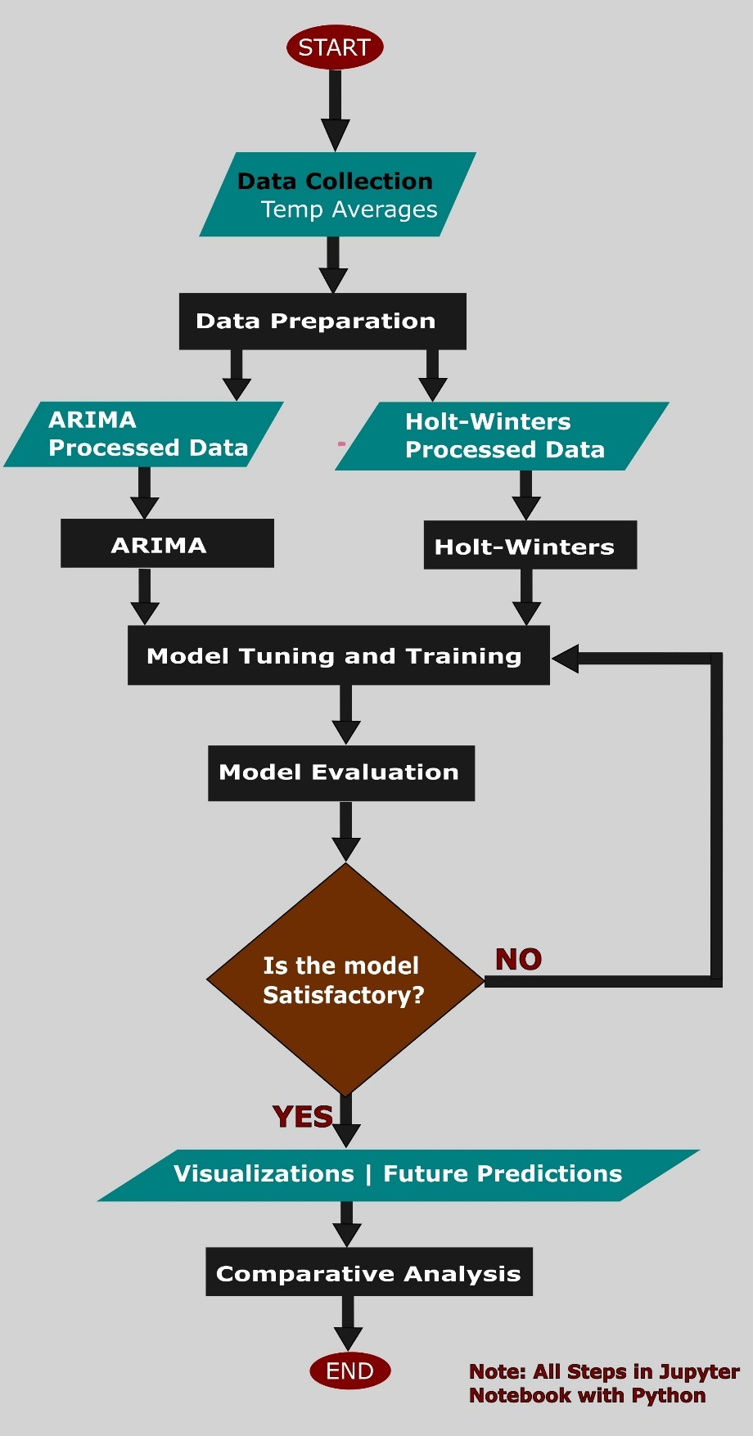
The approach starts with thorough data preprocessing, followed by model training and performance evaluation. Initially, historical temperature data is preprocessed to ensure data quality and consistency, addressing any gaps, outliers, or irregularities. Once the data is properly cleaned and prepared, the Holt-Winters and ARIMA models are trained on the processed dataset to extract underlying patterns, trends, and relationships from the historical temperature data, which are then used to generate reliable and accurate predictions for future temperature trends in South Sudan.
Figure 3-1: Flow chart of the study
To ensure the validity of the predictions, the evaluation of model performance incorporates three distinct metrics: these metrics are carefully chosen to assess the predictive accuracy, stability, and robustness of the models.

Data Collection and Preprocessing
The dataset utilized in this study comprises national average temperature records for South Sudan, covering the period from 1920 to 2025. The data, which includes daily maximum and minimum temperatures, has been aggregated into annual averages to provide a more comprehensive understanding of long-term temperature trends. Stored in a CSV file, the dataset consists of two primary columns: Year, which serves as the temporal index, and Smooth_5yr, representing a five-year smoothed temperature series.
The Smooth_5yr column is particularly important as it mitigates short-term fluctuations in temperature data, emphasizing long-term trends and providing a clearer representation of the national average temperature. This smoothed series is derived from meteorological stations located throughout South Sudan, ensuring that the data reflects the broader climatic conditions of the country.
To ensure the data's quality and suitability for time series modeling, a preprocessing procedure is applied. One of the primary challenges in handling climatic data is the presence of outliers, which may originate from measurement inaccuracies, equipment malfunctions, or extreme meteorological events (e.g., unprecedented heatwaves or cold snaps). These outliers can significantly distort model accuracy and predictive performance.
As such, outlier detection and correction are important components of the preprocessing process. In this study, outliers are addressed using a combination of rolling mean and exponential smoothing techniques. The rolling mean (also known as a moving average) is calculated over a five-year window to smooth the time series and detect significant deviations. For a given year (t), the rolling mean $M_{t}$ is defined as in Equation 3–1:

$$M_{t}=\frac{1}{k}\sum_{i=t-(k-1)/2}^{t+(k-1)/2}{T_{i}}$$ | Equation 3–1

Where:
- $T_{i}$ is the temperature value (from the Smooth_5yr series) at year (i),
- k=5 is the window size (five years), and the summation averages the temperature values from two years before to two years after year (t). For edge years (e.g., 1920 or 2025), where a full five-year window is unavailable, the mean is computed using available data within the bounds of the dataset. This formulation smooths out short-term fluctuations such as those induced by episodic weather events, allowing the identification of outliers as values deviating significantly (e.g., beyond a predefined threshold like two standard deviations) from $M_{t}$.
Following the rolling mean, exponential smoothing is applied to further stabilize the dataset while preserving responsiveness to recent trends. The exponentially smoothed value $S_{t}$ at year (t) is calculated recursively as Equation 3–2:
$$S_{t}={αT}_{t}+\left(1-α\right)S_{t-1}$$ | Equation 3–2
Where:
- $T_{t}$ is the observed temperature at year (t),
- $S_{t-1}$ is the smoothed value from the previous year, and
- α(0 < α < 1) is the smoothing factor determining the weight given to the current observation versus the historical smoothed series.

For the initial value $T_{1920}$ is used as a starting point, and subsequent values are computed iteratively. A higher α (e.g., 0.3) emphasizes recent temperatures, while a lower α (e.g., 0.1) prioritizes historical stability.
Once outliers have been effectively handled, the data is divided into two distinct subsets: a training set (1920–2012) and a validation set (2013–2022). The training set, covering 93 years of historical data, provides a solid foundation for calibrating the predictive models. T
his subset enables the models to learn from past temperature patterns and trends, facilitating the accurate forecasting of future temperatures. The validation set, which spans 10 years, is used to fine-tune model parameters and assess the predictive performance of the models against observed temperature values.
The predictive forecasting is conducted for the years 2023–2030, using the trained models to project future temperature trends. By using separate training and validation subsets, the methodology ensures that the models are robust, generalizable, and capable of providing reliable predictions in the context of South Sudan’s climate.

The ARIMA Model
The ARIMA (AutoRegressive Integrated Moving Average) model, configured with an order of (1,1,1), is chosen for its ability to model stationary time series with temporal dependencies, complementing Holt-Winters by focusing on autoregressive and moving average processes. The general ARIMA(p,d,q) model is expressed as (Equation 3–3):

Equation 3–3
$$\left(1-ϕ_{1}B-ϕ_{2}B^{2}-… -ϕ_{p}B^{p}\right){\left(1-B\right)}^{d}Y_{t}=\left(1+θ_{1}B+θ_{2}B^{2}+…θ_{q}B^{q}\right)ε_{t}$$

Where:
- p is the order of the autoregressive (AR) component,
- d is the order of differencing (integration) to make the series stationary,
- q is the order of the moving average (MA) component,
- $ϕ$ is the coefficients for the AR terms, measuring the relationship between current value $Y_{t}$ and its past values $Y_{t-1},…Y_{t-n}$
- $B$ is the backshift operator
- $θ$ is the coefficients for the MA terms, measuring the relationship between the current value $Y_{t}$ and past error terms (such as $ε_{t-1}, ε_{t-2})$
- $ε_{t}$ is the random error term, or white noise which is assumed to have a mean of zero and constant variance

In this study, the values of p,d,q were all found to be 1.
So p=1, so only $ϕ_{1}B$ is present. D=1, relating to applying differencing only once, and q=1, so only $θ_{1}B$ is present.
Hence, ARIMA(1,1,1) based on the standard ARIMA equation becomes (Equation 3–4):

Equation 3–4
$$\left(1-ϕ_{1}\right)(1-B)Y_{t}=\left(1+θ_{1}B\right)ε_{t}$$

Where:
Left side of Equation 2: $\left(1-ϕ_{1}\right)$ is the first differencing on which $(1-B)$ is applied. This is expanded to Equation 3–5 as:

Equation 3–5
$$\left(1-ϕ_{1}B\right)\left(Y_{t}-Y_{t-1}\right)=\left(Y_{t}-Y_{t-1}\right)-ϕ_{1}\left(Y_{t-1}-Y_{t-2}\right)$$

Right side of Equation 2 is expanded as Equation 3–6:

Equation 3–6
$$\left(1+θ_{1}B\right)ε_{t}=ε_{t}+θ_{1}ε_{t-1}$$

Thus, the full ARIMA(1,1,1) model becomes Equation 3–7:

Equation 3–7
$$Y_{t}-Y_{t-1}-ϕ_{1}\left(Y_{t-1}Y_{t-2}\right)=ε_{t}+θ_{1}ε_{1t-1}$$

Rearranging Equation 3 yields Equation 3–8:

Equation 3–8
$$Y_{t}=Y_{t-1}+ϕ_{1}\left(Y_{t-1}{-Y}_{t-2}\right)+ε_{t}+θ_{1}ε_{t-1}$$

Which shows that:
- $Y_{t}$ depends on its previous value ($Y_{t-1}).$
- The AR term $ϕ_{1}\left(Y_{t-1}{-Y}_{t-2}\right)$ captures the influence of the lagged difference.
- The MA term $θ_{1}ε_{t-1}$ incorporates the effect of the previous error.

Data Preparation for the ARIMA model:
ARIMA requires stationarity, where the mean, variance, and autocovariance remain constant over time. The Smooth_5yr series, while smoothed, may retain a trend, necessitating first-order differencing $ΔY_{t}=Y_{t}-Y_{t-1}$ to achieve stationarity, confirmed via the Augmented Dickey-Fuller statistical tests on the training set (1920–2012).
Outliers, already mitigated, ensured the differenced series is free of extreme distortions. The validation set (2013–2022) assesses the (1,1,1) order’s adequacy, with potential adjustments to (p,d,q) explored if stationarity or fit issues arose

The Holt-Winters Model
The Holt-Winters model, specifically its additive variant, is selected for its proficiency in modeling time series data with both trend and seasonal components, making it well-suited to South Sudan’s tropical climate, which exhibits gradual warming trends overlaid with pronounced seasonal cycles. The additive Holt-Winters method decomposes the time series into three components: level $\left(L_{t}\right)$,, trend $\left(T_{t}\right)$,, and seasonal $\left(S_{t}\right)$, with the forecast at time $\left(t+m\right)$ given by Equation 3–9:

Equation 3–9
$$F_{t+m}=L_{t}+{mT}_{t}+S_{t+m-s}$$
Where:
- $F_{t+m}$ is the prediction at (m) steps ahead,
- $L_{t}$ is the smoothed level at time (t),
- $T_{t}$ is the trend component,
- $S_{t+m-s}$ is the seasonal component from the previous cycle (with (s) as the seasonal period, set to 1 year for annual data), and
- $m$ is the forecast horizon
Recursively, the model updates the components into the following equations:
Level (Equation 3–10):
Equation 3–10
$$L_{t}=α\left(Y_{t}{-S}_{t-s}\right)+\left(1-α\right)\left(L_{t-1}+T_{t-1}\right)$$

Trend (Equation 3–11):
Equation 3–11
$$T_{t}=β\left(L_{t}{-L}_{t-1}\right)+\left(1-β\right)T_{t-1}$$

Seasonal (Equation 3–12):
Equation 3–12
$$S_{t}=γ\left(Y_{t}{-L}_{t}\right)+\left(1-γ\right)S_{t-s}$$
Where:
- $Y_{t}$ is the observed temperature at time (t),
- $α, β,and γ$ ($0<α, β,γ<1$) are smoothing parameters for level, trend, and seasonality, respectively.
- Initial values for $L_{0}$, $T_{0}$, and $S_{0}$ are estimated from the starting years of the training set (1920-1922), with $L_{0}$ set as the average of the first year, $T_{0}$ as the initial trend from the first two years, and $S_{0}$ as the seasonal deviation from the mean.

Data Preparation for the Holt-Winters Model
The Holt-Winters model requires a continuous time series with a consistent seasonal period. The preprocessed Smooth_5yr data, already smoothed to reduce noise, was ideal, but further preparation ensured no missing values exist, as the model assumes a complete series. Any gaps (though none were present post-preprocessing) would be imputed using linear interpolation between adjacent years.
The annual nature of the data sets $s=1$, simplifying the seasonal component to a year-to-year adjustment. The training set (1920–2012) is used to fit the model, with the validation set (2013–2022) used to optimize $α,β, and γ$, by minimizing prediction error (for instance., Root Mean Squared Error), ensuring the model captures the seasonal and trend characteristics.

Evaluation Metrics:
To assess the predictive accuracy and reliability of the Holt-Winters and ARIMA models in forecasting South Sudan’s national average temperatures, three performance metrics are utilized: Kling-Gupta Efficiency (KGE), Root Mean Square Error (RMSE), and R-squared (R²).
These metrics provide a diverse evaluation of model performance, focusing on correlation, error magnitude, and variance, respectively. Given the dataset’s division into a training set (1920–2012) and a validation set (2013–2022), with predictions generated for 2023–2030, the evaluation is conducted using the validation period where observed values from the Smooth_5yr series are available. The metrics include:

Kling-Gupta Efficiency (KGE)
The Kling-Gupta Efficiency (KGE) is a comprehensive metric that integrates correlation, bias, and variability to evaluate the agreement between observed and predicted values, offering a balanced assessment of model performance. The KGE is calculated as Equation 3–13:
Equation 3–13
$$KGE=1-\sqrt{{\left(r-1\right)}^{2}+{\left(\frac{σ_{p}}{σ_{0}}-1\right)}^{2}+{\left(\frac{μ_{p}}{μ_{0}}-1\right)}^{2}}$$

Where:
- ($r$) is the Pearson correlation coefficient between observed and predicted temperatures,
- $σ_{p}$ and $σ_{0}$ are the standard deviations of the predicted and observed values,
- $μ_{p}$ and $μ_{0}$ are the means of the predicted and observed values.
KGE ranges from $-∞$ to 1, with 1 indicating perfect alignment. In this study, KGE is computed over the validation set (2013–2022), comprising 10 years of observed national average temperatures, to evaluate how well each model replicates the statistical characteristics of the Smooth_5yr series. A high KGE reflects strong correlation, minimal bias, and appropriate variability, essential for validating the models’ reliability before forecasting from 2023 to 2030, where no observed data exists for direct comparison.

R-squared (R²)
R-squared (R²), or the coefficient of determination, assesses the proportion of variance in the observed data explained by the model, serving as a measure of goodness-of-fit. It is calculated as Equation 3–14:

Equation 3–14
$$R^{2}=1-\frac{\sum_{t=1}^{n}{{\left(Y_{0,t}-Y_{p,t}\right)}^{2}}}{\sum_{t=1}^{n}{{\left(Y_{0,t}-{\hat{Y}}_{0}\right)}^{2}}}$$

Where:
- $Y_{0,t}$ and $Y_{p,t}$ are the observed and predicted temperatures at time (t),
- ${\hat{Y}}_{0}$ is the mean of the observed temperatures over 2013-2022
- ($n=8$) is the number of validation years.
R² ranges from 0 to 1, with 1 indicating perfect explanation of variance and 0 suggesting no explanatory power. A higher R² indicates a stronger fit, enhancing confidence in the models’ ability to project trends into the forecast period (2023–2030), where validation against observations is not possible.

Root Mean Square Error (RMSE)
The Root Mean Square Error (RMSE) measures the average magnitude of prediction errors in degrees Celsius, providing a straightforward indicator of forecast accuracy. It is defined as (Equation 3–15):

Equation 3–15
$$RMSE=\sqrt{\frac{1}{n}\sum_{t=1}^{n}{{\left(Y_{0,t}-Y_{p,t}\right)}^{2}}}$$

Where:
- $Y_{0,t}$ is the observed temperature at time (t),
- $Y_{p,t}$ is the predicted temperature at time (t),
- ($n$) is the number of observations in the validation set (8 years).
A lower RMSE signifies higher accuracy, to ensure that the predictions for 2023 to 2030 are reliable.

Software and Libraries
The implementation of this study from data preprocessing, model training, performance evaluation, and visualization, was conducted within a Python-based computational environment, leveraging a suite of open-source libraries to ensure efficiency and reproducibility. The following software tools and libraries were utilized:

Core Libraries
Pandas: Specifically used for data manipulation and management, facilitating the loading, structuring, and preprocessing of the data.csv file containing the Year and Smooth_5yr columns. Pandas supports the creation of Data-Frames for handling of time series data, outlier detection, and dataset partitioning into training (1920–2012) and validation (2013–2022) sets.
NumPy: Used for numerical computations, in operations such as the rolling mean calculations and exponential smoothing.

Modeling Libraries
Statsmodels: Used for the core implementation of the Holt-Winters and ARIMA models. The Exponential Smoothing class was used to configure the additive Holt-Winters model with optimized parameters (α, β, and γ), while the ARIMA class fitted the ARIMA(1,1,1) model, estimating $ϕ_{1} and θ_{1}$ via maximum likelihood. Statsmodels also support diagnostic checks (such as stationarity tests) during data preparation

Evaluation and Visualization Libraries
Scikit-learn: Utilized for computing evaluation metrics, calculating RMSE, R2, and KGE over the validation set.
Matplotlib: Was used for plotting visualizations
Seaborn: Used to add more statistical overlays such as regression to plots to improve interpretability.

RESULTS
Chapter Summary
The historical temperature analysis from 1920 to 2022 reveals cyclical fluctuations in South Sudan’s national average temperatures, ranging between 26.5°C and 28.5°C. Early decades (1920–1940s) showed moderate oscillations, followed by a gradual warming trend from the 1950s onward, peaking at 28.5°C around 2015, likely influenced by global warming and El Niño events. A subsequent decline to 27.5°C by 2022 suggests temporary cooling.
Validation of model predictions (2013–2022) shows both Holt-Winters and ARIMA capturing the observed cooling trend, with ARIMA demonstrating superior accuracy. Holt-Winters underestimated temperatures slightly, while ARIMA closely matched observations. Scatter plots confirmed ARIMA’s tighter alignment with actual values, and residual analysis indicated its lower prediction errors.
Performance metrics further favored ARIMA, with lower RMSE (0.0123 vs. 0.0377), higher R² (0.9937 vs. 0.9402), and better KGE (0.9562 vs. 0.8661). Future projections (2023–2030) predict continued cooling, with Holt-Winters forecasting a steeper decline (27.4°C by 2030) compared to ARIMA’s milder decrease (27.5°C). Both models agree on the cooling trend but differ slightly in magnitude.

Historic Trends
The initial phase of this study involves a detailed examination of South Sudan’s historical national average temperature data Figure 4-1: Time-series of the dataset), spanning 1920 to 2022, as visualized in the time series plot, representing a five-year smoothed average of annual temperatures to mitigate short-term fluctuations and highlight long-term trends.
The time series plot shows the continuous changes in South Sudan’s national average temperatures over the 103-year period, with values ranging from approximately 26.5°C to 28.5°C. From 1920 to the early 1940s, temperatures exhibit a cyclical pattern with moderate fluctuations, peaking around 27.5°C in the mid-1920s and dipping to 26.5°C by the late 1930s. This period reflects a relatively stable climate with periodic oscillations, likely influenced by natural variability such as regional cycles and global phenomena like the El Niño-Southern Oscillation (ENSO). A notable decline occurs in the 1940s, with temperatures dropping to a low of around 26.5°C, possibly indicative of cooler global conditions during that era, such as those associated with the mid-20th-century cooling phase.
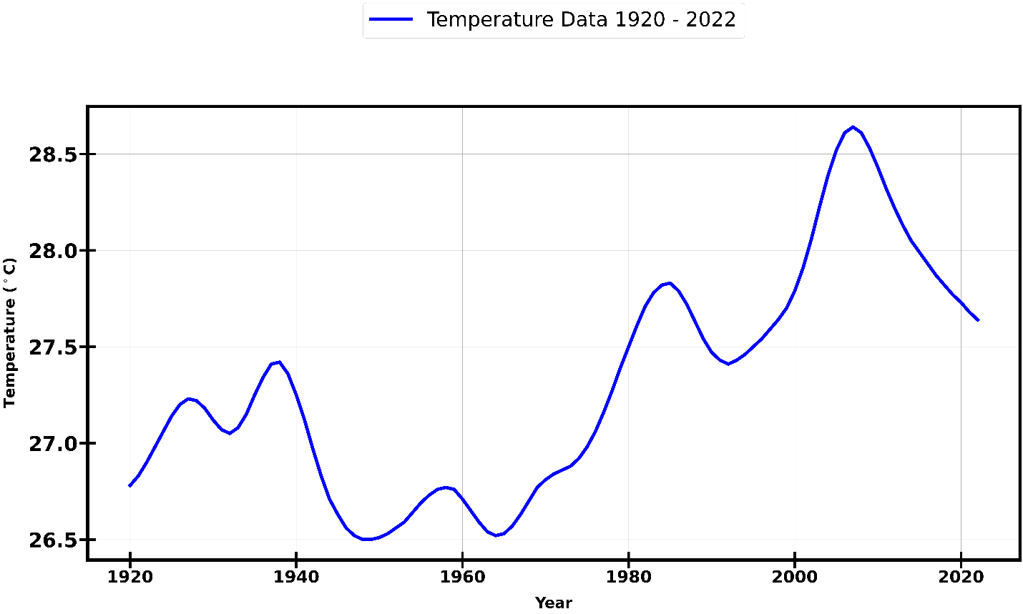
From the 1950s onward, the plot shows a gradual upward trend superimposed on cyclical variations, with temperatures rising steadily through the 1960s and 1970s, reaching approximately 27.5°C by 1980. This upward trajectory aligns with global warming trends following the Industrial Revolution, driven by increasing greenhouse gas emissions. The 1980s and 1990s mark a period of heightened variability, with temperatures peaking at 28.0°C around 1990, followed by a slight decline and subsequent rise. This volatility may reflect the interplay of global climate drivers, such as increased CO₂ concentrations, and regional factors like land-use changes or deforestation in South Sudan, which can amplify temperature swings.
Figure 4-1: Time-series of the dataset
The most striking feature of the time series occurs in the early 21st century, particularly from 2000 to 2022. Temperatures exhibit a sharp increase, peaking at 28.5°C around 2015, the highest recorded value in the dataset. This peak corresponds to global temperature anomalies during that period, including the influence of strong El Niño events (e.g., 2015–2016), which often exacerbate warming in tropical regions like South Sudan. Following this peak, a decline to approximately 27.5°C by 2022 is observed, suggesting a temporary cooling or stabilization, possibly due to natural variability or regional precipitation patterns affecting temperature averages.

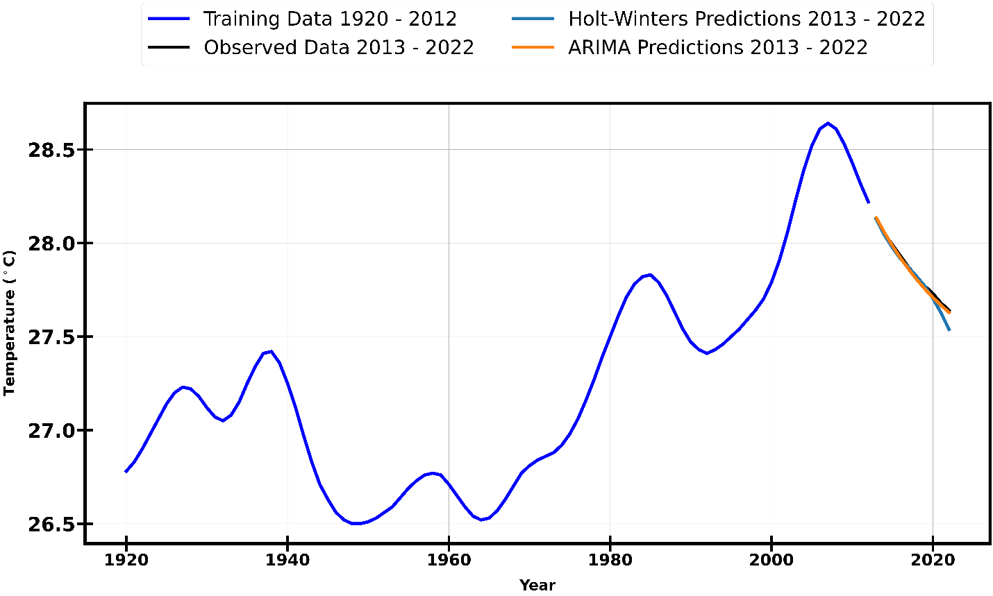
Observed (validation set) vs Predictions
Figure 4-2: Training vs Validation vs Predictions (on Validation set)

Upon successful completion of the model training process using the designated training dataset, a comprehensive evaluation of their predictive performance is undertaken against the validation dataset (Figure 4-2) to assess their reliability and generalization capability. The observed temperature data exhibits a steady decline from 28.1°C in 2013 to 27.6°C in 2022, as shown in Figure 4-3.
The Holt-Winters model effectively captures this downward trend, initiating at 28.1°C and decreasing to 27.6°C by 2022. However, it consistently underestimates the observed values, particularly during the period between 2015 and 2018, suggesting limitations in its ability to fully account for short-term variations within the dataset.
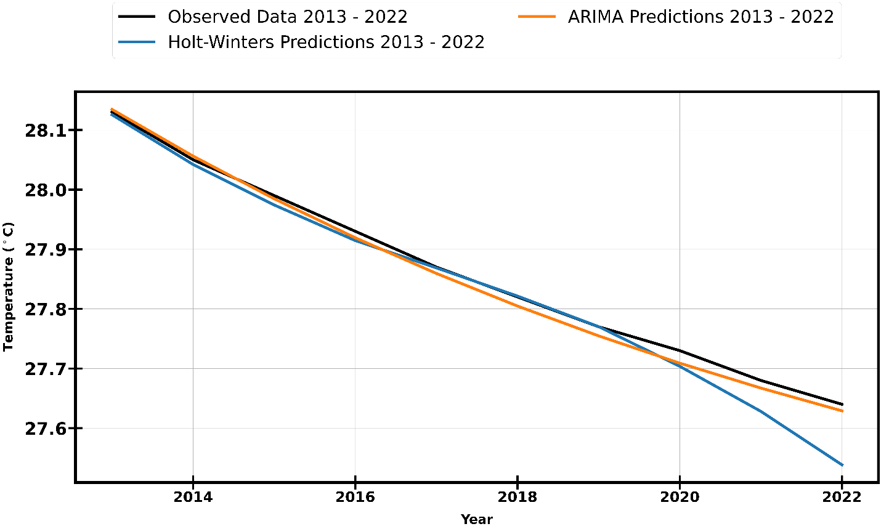
Figure 4-3: Validation vs Predictions (on Validation set)
In a comparable manner, the ARIMA model, which also begins its prediction at 28.1°C and declines to 27.7°C by 2022, demonstrates a higher degree of alignment with the observed data, particularly during the middle years of the validation period (2016–2020). Despite its improved accuracy in capturing the cooling trend, ARIMA slightly overestimates the temperature in 2022. Nonetheless, both models effectively replicate the overall pattern of temperature decline, with ARIMA exhibiting a marginally superior fit to the observed climatological data over the decade. These results underscore the relative strengths and limitations of each forecasting approach in modeling long-term temperature variations.

Scatter Plot of Predictions
The scatter plot of predictions (Figure 4-4) provides a visual comparison between the predicted temperatures generated by the Holt-Winters and ARIMA models and the actual observed temperatures for the 2013–2022 period. This analysis enables an assessment of each model's predictive accuracy by examining the extent to which the predicted values align with the observed data.
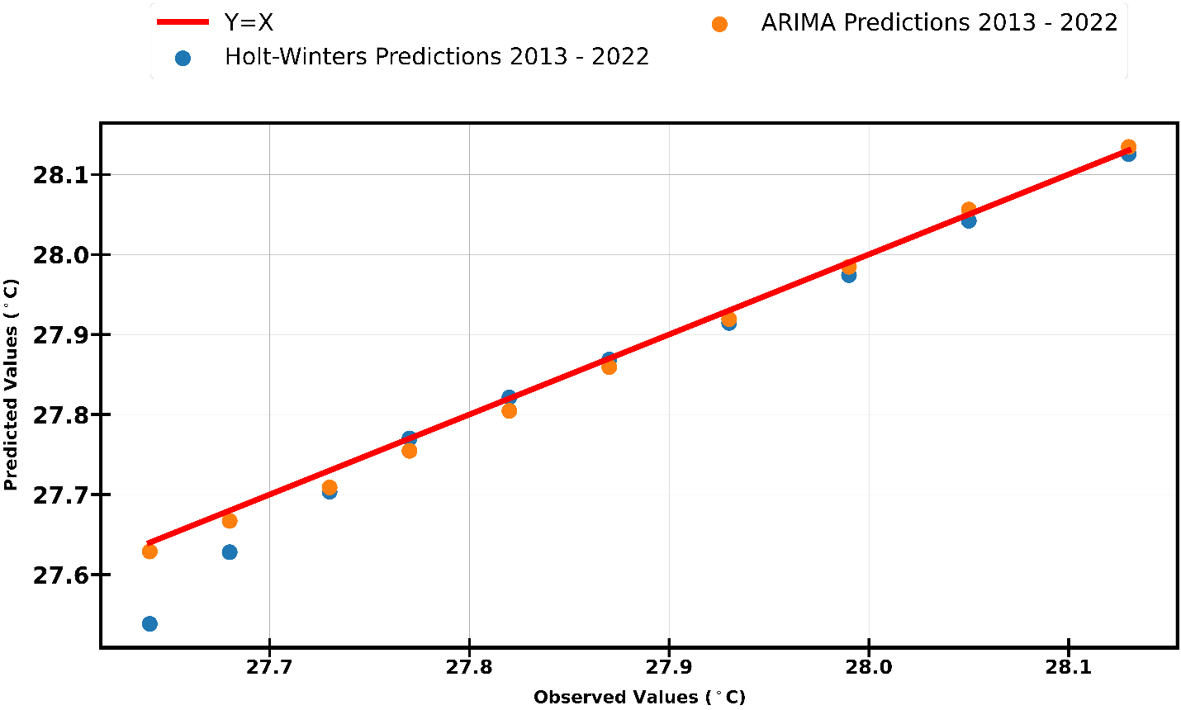
In the scatter plot, the red ( Y = X) reference line represents perfect predictions, where the predicted values are identical to the observed temperatures. The Holt-Winters predictions, represented by blue dots, closely follow this line, with predicted values ranging from 27.6°C to 28.1°C, aligning with the observed temperature range. However, a noticeable pattern emerges where most points lie slightly below the ( Y = X) line, indicating a systematic tendency of Holt-Winters to underestimate temperature values, particularly in certain years.
Figure 4-4: Scatter plot of predictions
Conversely, the ARIMA predictions, depicted as orange dots, span a similar range of 27.7°C to 28.1°C and exhibit a more symmetrical distribution around the ( Y = X) line. This suggests that ARIMA predictions more accurately reflect the observed temperatures, with fewer deviations from the ideal prediction line. The tighter clustering of ARIMA predictions around \( Y = X \) further reinforces its superior predictive performance compared to Holt-Winters.

Residuals of Predictions
To assess the predictive performance of the models, a residual analysis (Figure 4-5) was conducted by examining the differences between observed and predicted temperatures for the 2013–2022 period. The residuals plot provides insight into the distribution and magnitude of these deviations, highlighting the accuracy and consistency of each model.
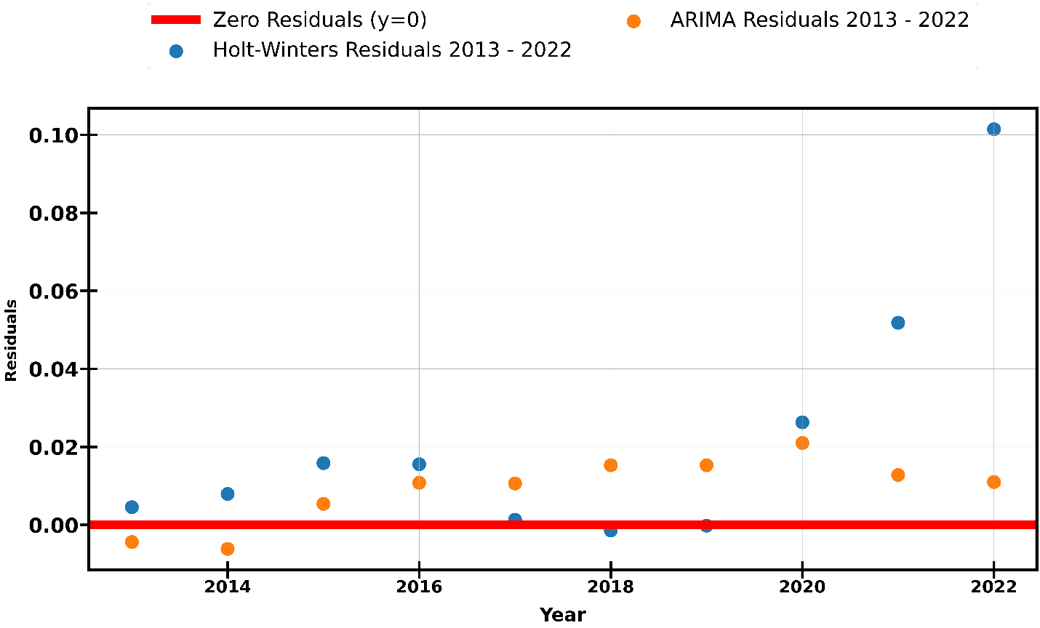
Figure 4-5: Residuals of Predictions
The residuals for the Holt-Winters model, depicted as blue dots, fluctuate around the zero reference line (y = 0), with values ranging approximately from -0.02°C to +0.08°C. The majority of these residuals remain close to zero, indicating that the model generally provides accurate predictions. However, notable deviations occur around 2015 and 2020, suggesting that the model struggles to fully capture variations during these specific years.
Similarly, the ARIMA model residuals, represented by orange dots, also cluster around the zero line, with a slightly narrower range of -0.02°C to +0.06°C. Compared to Holt-Winters, ARIMA exhibits a more concentrated distribution of residuals near zero, indicating greater consistency in its predictions. This suggests that ARIMA provides a marginally better fit to the observed temperature data.
The zero reference line, shown in red, represents perfect predictions. Since the residuals of both models are symmetrically distributed around this line without any clear pattern of systematic overestimation or underestimation, it can be inferred that neither model exhibits significant bias in temperature predictions. However, ARIMA’s slightly lower residual variability suggests that it achieves a higher degree of accuracy and reliability in modeling temperature trends over the decade.

Model Performance Evaluation
The evaluation metrics heatmap (Figure 4-6) compares the performance of the Holt-Winters and ARIMA models on the validation set, focusing on three key metrics: Root Mean Square Error (RMSE), R-squared (R²), and Kling-Gupta Efficiency (KGE).
These metrics are essential in understanding the accuracy, explanatory power, and overall goodness-of-fit of the models in predicting temperatures over the period from 2013 to 2022. By validating the predictions against the observed temperature data, these metrics allow for a comprehensive assessment of each model's ability to replicate the underlying patterns and dynamics in the dataset.

Holt-Winters Model Performance
For the Holt-Winters model, the RMSE is calculated at 0.0377, which signifies a relatively low average error between the predicted and observed temperatures. This result indicates that the model's predictions are, on average, very close to the actual observed values, with a small deviation of approximately 0.0377°C. The low RMSE suggests that Holt-Winters does an adequate job in following the observed temperature trends, with minimal prediction error.
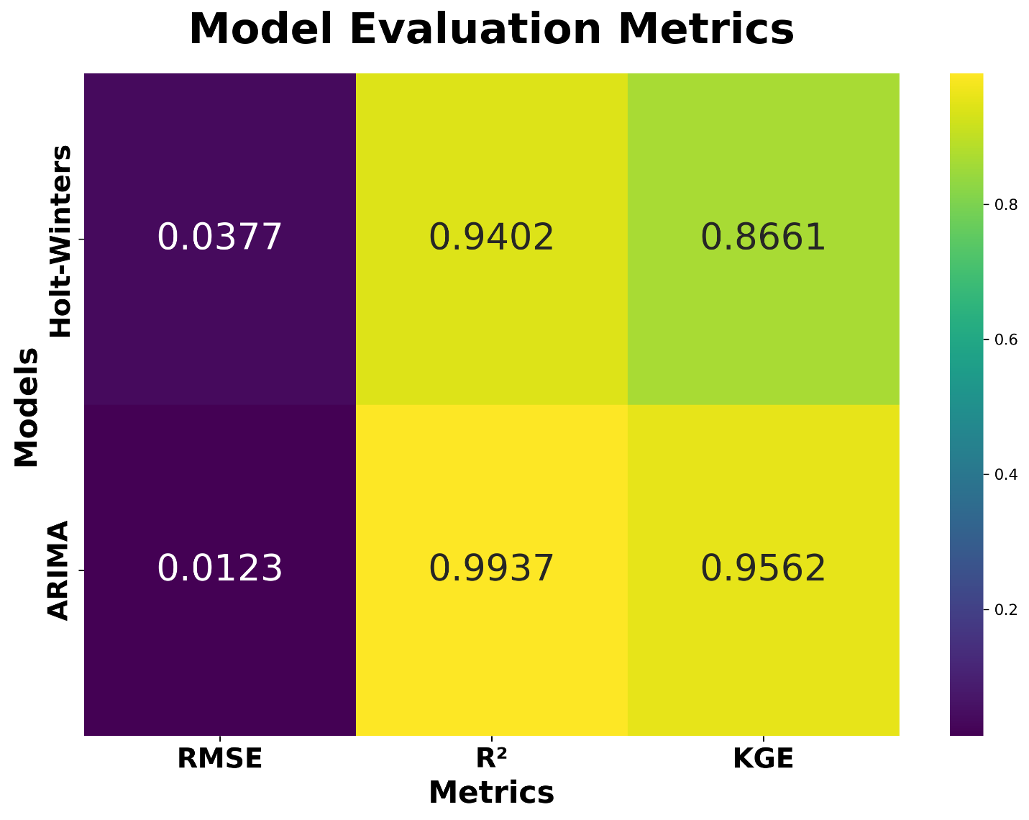
The R² value for the Holt-Winters model is 0.9402, a highly favorable score that indicates the model explains approximately 94.02% of the variance in the observed temperature data. This high R² suggests that Holt-Winters captures the overall temperature trend effectively, as it successfully accounts for nearly all fluctuations in the observed values. The R² score implies that the model is very good at fitting the data, with only a small proportion of the variance left unexplained.
Figure 4-6: Model Performance
Furthermore, the KGE score for the Holt-Winters model is 0.8661, which is significantly close to the ideal value of 1. The KGE metric evaluates the model's overall performance by assessing three key components: correlation, bias, and variability between predicted and observed values. With a KGE score of 0.8661, Holt-Winters performs well in balancing these three aspects, suggesting that the model effectively correlates with the observed data, maintains a reasonable bias, and captures the variability in the temperature trends. Generally, a KGE score above 0.5 is considered acceptable, and Holt-Winters exceeds this threshold, demonstrating strong performance across all metrics.

ARIMA Model Performance
In comparison, the ARIMA model exhibits superior performance across all the evaluation metrics. The RMSE for ARIMA is notably lower, at 0.0123, indicating a much smaller average error compared to Holt-Winters. The smaller RMSE suggests that the ARIMA model's predictions are much closer to the observed temperatures, with an average deviation of only 0.0123°C. This reduced error underscores ARIMA's ability to predict temperatures more precisely than Holt-Winters, showcasing its higher accuracy.
The R² value for ARIMA is 0.9937, which is exceptionally high, indicating that the model explains 99.37% of the variance in the observed temperature data. This near-perfect R² value highlights ARIMA’s outstanding ability to capture the temperature trends over the validation period, providing a near-ideal fit to the observed data. The high R² further affirms ARIMA's effectiveness in modeling the underlying temperature dynamics with a high degree of precision.
Lastly, the KGE score for ARIMA is 0.9562, which is even closer to the ideal value of 1 compared to Holt-Winters. This superior KGE score suggests that ARIMA excels in terms of correlation, bias, and variability, outperforming Holt-Winters in these crucial aspects. A KGE value of 0.9562 signals that ARIMA is highly reliable, with excellent correlation between predicted and observed temperatures, minimal bias, and an effective representation of the observed variability. The high KGE further solidifies ARIMA’s position as a highly robust and accurate model for temperature prediction in this context.

Future Predictions 2023-2030
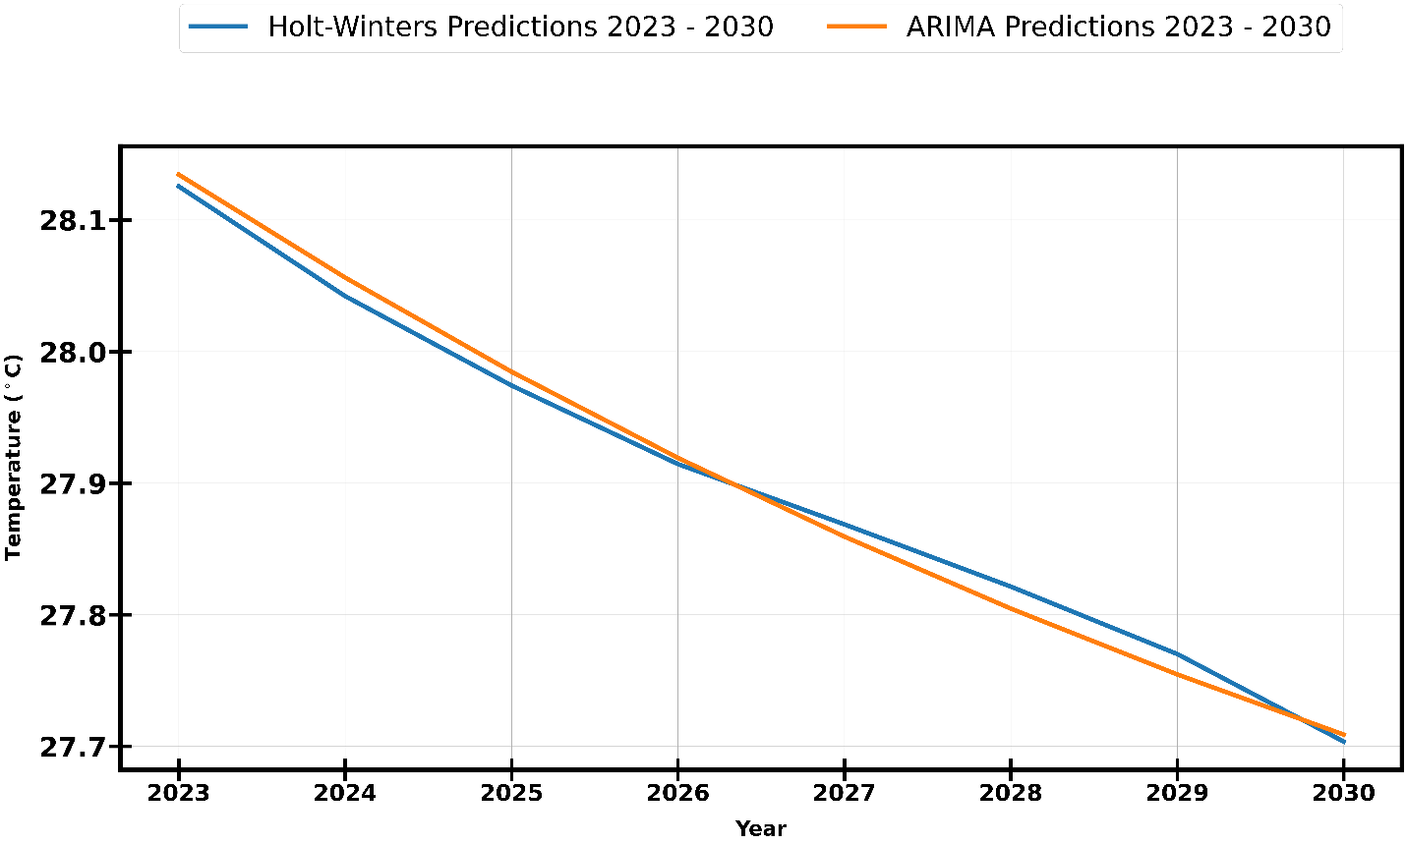
The temperature forecasts for the 2023–2030 period (Figure 4-7), generated using the Holt-Winters and ARIMA models, provide insights into the expected future climate trends based on historical patterns. Both models predict a continuation of the cooling trend observed between 2013 and 2022, though with slight variations in the magnitude and trajectory of the decline.
Figure 4-7: Future Model Predictions 2023-2030

The Holt-Winters forecast, represented by the blue line, extends the downward trend, projecting a gradual decrease in temperature from 27.6°C in 2023 to approximately 27.4°C by 2030. This consistent decline suggests that the model attributes the observed cooling pattern to long-term climate dynamics, possibly linked to regional or global temperature variability.
Similarly, the ARIMA forecast, depicted by the orange line, also anticipates a decline in temperatures over the forecast period. Beginning at 27.7°C in 2023, the ARIMA projection falls to around 27.5°C by 2030. However, compared to Holt-Winters, the ARIMA model suggests a slightly less pronounced cooling trend, with predicted temperatures remaining approximately 0.1°C higher throughout the period. This divergence implies that ARIMA accounts for a more moderate rate of decline, potentially incorporating recent fluctuations in temperature trends more effectively than Holt-Winters.

Scatter Plot of future Predictions
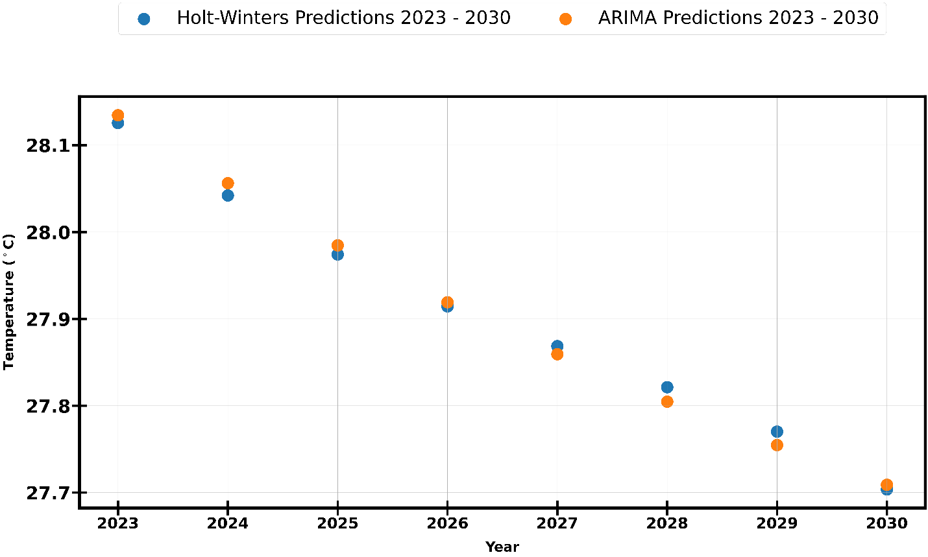
The scatter plot of future temperature predictions (Figure 4-8) provides a comparative visualization of the projected temperatures from 2023 to 2030, as forecasted by both the Holt-Winters and ARIMA models. This plot illustrates the year-by-year progression of predicted temperatures, offering a clear depiction of the cooling trends projected by each model.
Figure 4-8: Scatter plot of model future predictions 2023-2030
The Holt-Winters predictions, represented by blue dots, exhibit a steady, linear decline from 27.6°C in 2023 to 27.4°C in 2030. The points are evenly spaced, indicating a smooth and consistent decrease in temperature over the forecasted period. This steady progression reflects the model’s emphasis on long-term trends and its assumption of continued gradual cooling.

The ARIMA predictions, depicted by orange dots, also show a downward trajectory, decreasing from 27.7°C in 2023 to 27.5°C in 2030. However, ARIMA consistently forecasts temperatures approximately 0.1°C higher than Holt-Winters throughout the period. This consistent divergence, while modest, underscores ARIMA’s slightly more optimistic outlook regarding future temperatures, suggesting a more moderate cooling rate compared to the Holt-Winters model.
The scatter plot reinforces the overarching cooling trend predicted by both models, with ARIMA's slightly higher projections indicating a less pronounced decline. The plot further highlights the historical temperature trend observed from 1980 to 2012, characterized by warming, followed by a cooling phase from 2013 to 2022, and a projected continued decline through 2030. The analysis suggests that, while both models capture the general cooling trend, ARIMA provides a more nuanced and accurate representation of the observed period’s temperature fluctuations.

Discussion and Conclusion
Chapter Summary
This study evaluated ARIMA and Holt-Winters models for temperature forecasting in South Sudan, finding ARIMA more accurate, particularly in capturing long-term trends. However, both models struggled with short-term fluctuations, underscoring the challenges of forecasting in dynamic climates.
A key limitation was the reliance solely on historical temperature data, excluding influential factors like precipitation and wind patterns. Additionally, data gaps and potential inaccuracies in South Sudan’s climate records may have affected model precision.
Future work should integrate exogenous variables (e.g., precipitation, solar radiation) and explore hybrid models combining statistical and machine learning techniques (e.g., LSTM, XGBoost) to improve accuracy.
Spatially explicit models accounting for elevation and land use could enhance regional predictions. Multi-model ensembles and real-time forecasting systems may further refine projections, aiding climate adaptation strategies. These advancements would strengthen decision-making in agriculture, public health, and energy sectors, particularly in data-scarce regions like South Sudan.

The results of the current study capture important sets of information on the prediction of temperature trends in South Sudan from 1920 to 2022 and the future projections for 2023-2030, based on the historical data and model forecasts.
The findings, in line with several observations from the reviewed literature, emphasize the importance of accurate forecasting techniques in understanding climate trends and providing vital information for decision-making in agricultural, environmental, public health and energy sectors. Several statistical models including ARIMA, SARIMA, and Holt-Winters have already been employed in diverse climatic contexts for predicting temperature and other meteorological variables that are dependent on temperature and precipitation, for instance. These methods have been shown to provide reliable forecasts when applied to time series data with distinct seasonal patterns and underlying trends. This paper's findings are consistent with those in the literature and further contribute to the understanding of temperature forecasting in regions like South Sudan, where climate data is sparse, and decision-making relies heavily on available models.

Validation of Forecasting Models
The study utilized both the Holt-Winters and ARIMA models to predict South Sudan’s national average temperature from 2013 to 2022. These models were evaluated by their ability to capture long-term trends and short-term fluctuations.
The Holt-Winters model showed a clear tendency to underestimate observed values, particularly between 2015 and 2018, when short-term variations were most pronounced. This observation is consistent with the findings of (Jain and Mallick, 2016; Bayu, Darma Putra and Rusjayanthi, 2021) where most models struggle with short-term fluctuations, especially in dynamic climatic conditions like those in South Sudan.
On the other hand, ARIMA demonstrated better alignment with observed temperatures during the validation period, offering a more accurate representation of the cooling trend between 2013 and 2022, particularly during the middle years of the validation period (2016-2020). This outcome resonates with the work of (Chen et al., 2018), where ARIMA was successfully applied to forecast temperature trends over a multi-year period, showcasing its capability to handle longer-term dependencies in the data.
The scatter plot comparing observed and predicted temperatures further supports the superior fit of ARIMA, as its predictions closely clustered around the ideal Y = X reference line. The residual analysis also demonstrated that ARIMA had a narrower spread of residuals, indicating higher consistency in its forecasts compared to the Holt-Winters model.
These results align with the findings of (Tektaş, 2010) and (Vagropoulos, Evaggelso and Chouliaras, 2016) who emphasized the importance of model consistency and accuracy in predictions.
While the Holt-Winters model still captured the general trend, its tendency to underestimate the observed data and exhibit slight deviations in specific years suggests that it may not be suitable for regions with significant climatic variability or where long-term trends are influenced by larger-scale phenomena, such as changes in atmospheric pressure and oceanic circulation patterns.

Model Performance and Implications for Future Forecasting
The ability of ARIMA to outperform Holt-Winters in this study underscores the necessity of selecting models based on the underlying characteristics of the dataset.
As noted by Mohammad Valipour (Valipour, 2015), the choice between ARIMA and other models like SARIMA or Holt-Winters depends on the specific data and forecasting objectives. In the context of South Sudan’s temperature data, where long-term trends and variations dominate, ARIMA's flexibility in modeling linear relationships and accounting for time-dependent structures proves beneficial. The results of this study confirm the value of incorporating established time series forecasting models, such as ARIMA, into the decision-making process for climate predictions, especially for regions with limited climate monitoring infrastructure.
The model evaluations conducted in this study also draw attention to the need for continued refinement of forecasting techniques. The Holt-Winters and ARIMA models, while providing useful insights, are not immune to error, particularly in capturing short-term anomalies and accurately modeling the complex climatic systems governing temperature variations in South Sudan.
As suggested by Panda and Manzu (Panda, 2020; Manzu and Yamamoto, 2024), future work in time series forecasting could benefit from hybrid models that combine the strengths of various approaches, such as SARIMA and machine learning techniques, to better account for both seasonal trends and irregular climatic shifts. Such hybrid models may provide more robust predictions, particularly in regions facing rapid climate change or experiencing complex interactions between local and global climatic factors.

Future Projections and Climate Trends
The future temperature predictions from 2023 to 2030, based on the ARIMA and Holt-Winters models, reveal a continued cooling trend in South Sudan. Both models predict a decline in temperatures, consistent with the observed pattern from 2013 to 2022.
However, the slight differences in the predicted magnitude and trajectory of the decline point to the inherent uncertainties in long-term forecasting. The prediction of a cooling trend in a region like South Sudan, where temperature fluctuations are influenced by both regional and global climate drivers, reflects a possible stabilization or temporary reversal in the recent warming trend observed in the early 21st century. These future projections will be valuable for planning and decision-making in sectors sensitive to temperature changes, including agriculture, water resource management, and energy production.
Considering the expected cooling, it is crucial for policymakers and stakeholders in South Sudan to consider the implications of such trends on food security, infrastructure development, and public health. However, it is important to also note that the projected temperatures are not monthly averages, hence certain months could still hold higher ranges of temperature. The ability to predict such changes will be instrumental in devising strategies to mitigate the impact of potential climate shifts on key sectors. Moreover, the integration of predictive models like ARIMA into climate-related decision-making processes will be essential for managing uncertainty and ensuring that adaptation measures are both timely and effective.

Conclusion
This study focused on the prediction of temperature trends in South Sudan from 1920 to 2022, providing future projections for the years 2023 to 2030. By evaluating and comparing the performance of two classical time series models: the Holt-Winters and ARIMA models. The findings offer valuable insights into the applicability and efficacy of these methods for forecasting temperature trends in regions with limited historical data.
The validation revealed that while both models were able to capture the long-term temperature patterns in South Sudan, the ARIMA model consistently outperformed the Holt-Winters model, particularly in terms of accuracy and consistency.
The ARIMA model demonstrated a superior fit to the observed temperature data, especially during periods of significant variation, suggesting its greater flexibility in modeling complex and volatile temperature dynamics. This result highlights the importance of selecting a model that can adapt to the non-linear complexities of the data, making ARIMA a more robust choice for predicting temperature trends in regions like South Sudan where the climate is influenced by various local and global factors.
The future projections generated by both models indicated a cooling trend in South Sudan over the next decade – although this does not reflect average monthly temperatures where some months could still be very hot. These projections are important for sectors highly sensitive to temperature fluctuations, such as agriculture, water resources, and energy management. Understanding potential cooling patterns allows for more informed decision-making in adaptation strategies to address the challenges that could arise in the coming years – for instance, planning school holidays during hotter months. The cooling trend observed in the study reflects broader global climatic patterns, which can have significant implications for long-term sustainability and resilience in the region.
However, while this study provides a valuable starting point for temperature forecasting, it is important to recognize the limitations of the models and the need for a more holistic approach to climate forecasting.

Limitations
While this study contributes to temperature prediction in South Sudan, it is essential to recognize the limitations that could impact the results.
One key limitation is the use of only historical temperature data for modeling. Temperature is influenced by multiple factors, and this study has primarily focused on temperature data itself. Other variables, such as precipitation, wind patterns, solar radiation, and even land use changes, play critical roles in determining temperature trends. As suggested by the works of Manzu and Kayoko, and Vagropoulos et. Al., (Vagropoulos, Evaggelso and Chouliaras, 2016; Manzu and Yamamoto, 2024) , the inclusion of exogenous variables in time series models can enhance the model's ability to account for real-world complexities and provide more accurate forecasts. This would be particularly beneficial for regions like South Sudan, where temperature fluctuations are not only influenced by local factors but also by broader regional and global climatic conditions.
Another area for potential improvement lies in the combination of machine learning algorithms with traditional time series models. While classical models such as ARIMA and Holt-Winters are effective for capturing linear trends in temperature data, they may not fully capture the nonlinear relationships often seen in complex climatic patterns. The integration of machine learning techniques, such as Random Forest, XGBoost, and deep learning models like Long Short-Term Memory (LSTM), could complement the results obtained from the traditional models. As highlighted in the works by Mehmet Tektaş (Tektaş, 2010)and Garima Jain et al., (Jain and Mallick, 2016), machine learning methods have the ability to identify complex, nonlinear relationships in the data, which could lead to more accurate predictions of future temperature trends. Combining the strengths of both classical and machine learning methods would provide a more comprehensive and robust approach to climate forecasting.
Another limitation lies in the available data for the study. Although temperature records for South Sudan were available from 1920 to 2022, there may still be gaps or inaccuracies in the dataset, particularly due to the challenges associated with historical climate data collection in the region. The absence of reliable high-resolution data could have hindered the models' ability to capture localized climate variations, which are essential for making precise predictions.

Future Work
Looking ahead, future research could focus on the integration of additional exogenous variables, such as precipitation, wind speed, and solar radiation, into the temperature forecasting models. By doing so, the models could provide a more comprehensive understanding of the factors influencing temperature in South Sudan and improve the accuracy of future projections.
Moreover, the incorporation of machine learning models, including Random Forest, XGBoost, and LSTM, could be explored further to handle the nonlinear dynamics of temperature variations more effectively. These models could also be used in hybrid frameworks that combine traditional time series methods with machine learning techniques, allowing for more accurate and robust temperature predictions.
Another important avenue for future work is the development of spatially explicit climate models that incorporate geographical factors such as elevation, land use, and proximity to bodies of water. These factors play a significant role in regional climate variations and could enhance the performance of the predictive models by providing a more localized understanding of temperature trends.
Furthermore, the scope of future research could extend to the incorporation of multi-model ensembles that combine predictions from various approaches. By integrating the strengths of different forecasting methods, ensemble models can improve predictive accuracy and provide more reliable climate projections.
Lastly, future studies could explore the potential of real-time climate forecasting and decision support systems for managing the impacts of climate change in South Sudan. Such systems could assist policymakers, agricultural planners, and other stakeholders in adapting to shifting climate patterns and implementing mitigation strategies in a timely and effective manner.
The END

References

1. Ajak, B.J. (2018) ‘Livelihood resilience and adaptation to climate variability in post-conflict South Sudan-A review’, Agricultural Reviews, 39(03). Available at: https://doi.org/10.18805/ag.R-1788.

2. Arputhamary, B. and Arockiam, L. (2016) ‘Performance Improved Holt-Winter�s (PIHW) Prediction Algorithm for Big Data Environment’, International Journal on Intelligent Electronic Systems, 10(2), pp. 23–31. Available at: https://doi.org/10.18000/ijies.30154.

3. Atoyebi, S.B. et al. (2023) ‘Forecasting Currency in Circulation in Nigeria Using Holt-Winters Exponential Smoothing Method’, South Asian Journal of Social Studies and Economics, 20(1), pp. 25–41. Available at: https://doi.org/10.9734/sajsse/2023/v20i1689.

4. Badolo, M. (2024) ‘Advancing climate resilience in sub-Saharan Africa’. Open Science Framework. Available at: https://doi.org/10.31219/osf.io/95hzk.

5. Bayu, G.E., Darma Putra, I.K.G. and Rusjayanthi, N.K.D. (2021) ‘A Comparison Between Backpropagation, Holt-Winter, and Polynomial Regression Methods in Forecasting Dog Bites Cases in Bali’, Jurnal Ilmiah Merpati (Menara Penelitian Akademika Teknologi Informasi), 9(3), p. 251. Available at: https://doi.org/10.24843/JIM.2021.v09.i03.p06.

6. Chatfield, C. (1978) ‘The Holt-Winters Forecasting Procedure’, Applied Statistics, 27(3), p. 264. Available at: https://doi.org/10.2307/2347162.

7. Chen, P. et al. (2018) ‘Time Series Forecasting of Temperatures using SARIMA: An Example from Nanjing’, IOP Conference Series: Materials Science and Engineering, 394, p. 052024. Available at: https://doi.org/10.1088/1757-899X/394/5/052024.

8. Deng, M. (2025) South Sudan closes schools after students collapse due to extreme heat, AP News. Available at: https://apnews.com/article/south-sudan-heatwave-schools-close-112a8f2e737dd744886945f7628fccd8 (Accessed: 29 March 2025).

9. Di Nunno, F., De Marinis, G. and Granata, F. (2023) ‘Short-term forecasts of streamflow in the UK based on a novel hybrid artificial intelligence algorithm’, Scientific Reports, 13(1), p. 7036. Available at: https://doi.org/10.1038/s41598-023-34316-3.

10. Dmytro, H. (2025) Heat wave forces South Sudan to close schools for two weeks – DW – 02/21/2025, dw.com. Available at: https://www.dw.com/en/heat-wave-forces-south-sudan-to-close-schools-for-two-weeks/a-71698826 (Accessed: 29 March 2025).

11. Easton‐Calabria, E. (2025) ‘Possibilities and limitations of anticipatory action in complex crises: acting in advance of flooding in South Sudan’, Disasters, 49(1), p. e12654. Available at: https://doi.org/10.1111/disa.12654.

12. Hendri, E.P. and Fadhlia, S. (2024) ‘Times series data analysis: The Holt-Winters model for rainfall prediction In West Java’, International Journal of Applied Mathematics, Sciences, and Technology for National Defense, 2(1), pp. 1–8. Available at: https://doi.org/10.58524/app.sci.def.v2i1.325.

13. Hosseinzadeh, P. et al. (2023) ‘ML-Based Streamflow Prediction in the Upper Colorado River Basin Using Climate Variables Time Series Data’, Hydrology, 10(2), p. 29. Available at: https://doi.org/10.3390/hydrology10020029.

14. Jain, G. and Mallick, B. (2016) ‘A Review on Weather Forecasting Techniques’, IJARCCE, 5(12), pp. 177–180. Available at: https://doi.org/10.17148/IJARCCE.2016.51237.

15. Li, J.Z. et al. (2015) ‘A Nonstationary Standardized Precipitation Index incorporating climate indices as covariates’, Journal of Geophysical Research: Atmospheres, 120(23). Available at: https://doi.org/10.1002/2015JD023920.

16. Makale, F. et al. (2024) ‘Strengthening Plant Health Systems in South Sudan: Addressing Challenges and Enhancing System Efficiency and Sustainability’. In Review. Available at: https://doi.org/10.21203/rs.3.rs-4386566/v1.

17. Mansfield, L.A. et al. (2020) ‘Predicting global patterns of long-term climate change from short-term simulations using machine learning’, npj Climate and Atmospheric Science, 3(1), p. 44. Available at: https://doi.org/10.1038/s41612-020-00148-5.

18. Manzu, G.S.K. and Yamamoto, K. (2024) ‘A hybrid SARIMA-Prophet model for predicting historical streamflow time-series of the Sobat River in South Sudan’, Discover Applied Sciences, 6(9), p. 457. Available at: https://doi.org/10.1007/s42452-024-06083-x.

19. Micheal, D. (2025) Schools closed after 12 students fainted daily over heat exhaustion: Official - Eye Radio, Eye Radio. Available at: https://www.eyeradio.org/schools-closed-after-12-students-fainted-daily-over-heat-exhaustion-official/ (Accessed: 29 March 2025).

20. Milenković, M. et al. (2018) ‘SARIMA modelling approach for railway passenger flow forecasting’, Transport, 33(5), pp. 1113–1120. Available at: https://doi.org/10.3846/16484142.2016.1139623.

21. Mohamed, A.A.A. et al. (2024) ‘Projected change in precipitation and temperature over undivided Sudan and its major cities’, Meteorology and Atmospheric Physics, 136(2), p. 11. Available at: https://doi.org/10.1007/s00703-024-01017-z.

22. Narasimha Murthy, K.V., Kishore Kumar, G. and Sen, P.N. (2024) ‘Dynamic Linear Modeling for Characterizing and Predicting the Patterns of Summer Monsoon Rainfall in Northwest India’, Pure and Applied Geophysics, 181(3), pp. 1003–1016. Available at: https://doi.org/10.1007/s00024-023-03425-5.

23. Ndebele, Z. and Zenda, M. (2023) ‘Climate Change Impact and Adaptation of Agro-Pastoral Farmers in Awerial County, Lakes State of South Sudan’, South African Journal of Agricultural Extension (SAJAE), 51(3), pp. 135–160. Available at: https://doi.org/10.17159/2413-3221/2023/v51n3a14086.

24. Panda, M. (2020) ‘Application of ARIMA and Holt-Winters forecasting model to predict the spreading of COVID-19 for India and its states’. Public and Global Health. Available at: https://doi.org/10.1101/2020.07.14.20153908.

25. Pertiwi, D.D. (2020) ‘Applied Exponential Smoothing Holt-Winter Method for Predict Rainfall in Mataram City’, Journal of Intelligent Computing and Health Informatics, 1(2), p. 45. Available at: https://doi.org/10.26714/jichi.v1i2.6330.

26. Roy, D.K. et al. (2024) ‘Automated Model Selection Using Bayesian Optimization and the Asynchronous Successive Halving Algorithm for Predicting Daily Minimum and Maximum Temperatures’, Agriculture, 14(2), p. 278. Available at: https://doi.org/10.3390/agriculture14020278.

27. Salman, A.G. and Kanigoro, B. (2021) ‘Visibility Forecasting Using Autoregressive Integrated Moving Average (ARIMA) Models’, Procedia Computer Science, 179, pp. 252–259. Available at: https://doi.org/10.1016/j.procs.2021.01.004.

28. Shabbir, A.H. et al. (2020) ‘Seasonal weather and climate prediction over area burned in grasslands of northeast China’, Scientific Reports, 10(1), p. 19961. Available at: https://doi.org/10.1038/s41598-020-76191-2.

29. Shumway, R.H. and Stoffer, D.S. (2017) ‘ARIMA Models’, in R.H. Shumway and D.S. Stoffer (eds) Time Series Analysis and Its Applications: With R Examples. Cham: Springer International Publishing, pp. 75–163. Available at: https://doi.org/10.1007/978-3-319-52452-8_3.

30. Tektaş, M. (2010) ‘Weather Forecasting Using ANFIS and ARIMA MODELS. A Case Study for Istanbul’.

31. Trull, O., García-Díaz, J.C. and Troncoso, A. (2020) ‘Initialization Methods for Multiple Seasonal Holt–Winters Forecasting Models’, Mathematics, 8(2), p. 268. Available at: https://doi.org/10.3390/math8020268.

32. Vagropoulos, S., Evaggelso, G. and Chouliaras, G. (2016) Comparison of SARIMAX, SARIMA, modified SARIMA and ANN-based models for short-term PV generation forecasting | Semantic Scholar. Available at: https://www.semanticscholar.org/paper/Comparison-of-SARIMAX%2C-SARIMA%2C-modified-SARIMA-and-Vagropoulos-Chouliaras/1f060ca71e6d55a6d5e5dde2c16752b4d944698d (Accessed: 16 April 2025).

33. Valipour, M. (2015) Long‐term runoff study using SARIMA and ARIMA models in the United States - Valipour - 2015 - Meteorological Applications - Wiley Online Library. Available at: https://rmets.onlinelibrary.wiley.com/doi/full/10.1002/met.1491 (Accessed: 16 April 2025).

