**河南科技学院**

**2023届本科毕业论文（设计）**

**英文文献及翻译**

**Analysis of Hybrid Spectrum Sensing for 5G and 6G Waveforms**

**学生姓名： 王凯**

**所在院系： 信息工程学院**

**所学专业： 通信工程**

**评阅意见： 导师签名:**

**Analysis of Hybrid Spectrum Sensing for 5G and 6G Waveforms**

**ABSTRACT**

**More spectrum bands are needed as the number of wireless applications rises. The spectrum band, though, is now very difficult to adapt to new applications. Because of this, the spectrum is getting more crowded, which also affects quality of service (QoS). One of the most promising technologies to address the issue of spectrum scarcity is cognitive radio (CR). Spectrum sensing (SS) is thought to be essential to CR. It determines that when primary users (PUs) are not using the spectrum, the spectrum can be allocated to secondary users (SUs). In this paper, a novel 5G spectrum sensing technique was implemented using a hybrid matched filter (HMF) algorithm based on the fusion of two matched filters (MF). In addition, we compared the performance of the HMF and traditional MF in Rayleigh and Rician channels. It has been observed that the HMF performs more effectively than the conventional MF in both channels.**

**Keywords: mobile communications; 5G; beyond 5G; 6G; cognitive radio; spectrum; matched filter (MF); hybrid matched filter**

# 1 Introduction

The demand for several applications with quality of service (QoS) and high data rates in cellular systems will increase the requirement for free spectral bands. In the present scenario, the particular application is allocated a specific spectrum. However, there is a scarcity of spectrum since many applications are already using the allotted spectrum. As per the protocol of the government, the licensed spectrum cannot be utilized by an unlicensed user. It is also true that most of the spectrum is being overutilized. In recent years, the research outcomes indicate that the underutilization of OFDM spectrum is mainly due to the fixed spectrum allocation protocols of the Federal Communications Commission (FCC) [1]. Cognitive radio (CR) is considered an effective solution that can solve the spectrum scarcity problem. It scans the idle spectrum from the primary users (PUs) and allocates the idle spectrum to the secondary user without causing any interference to the primary user. This process of identifying the idle spectrum is known as “spectrum sensing techniques”. In recent years, several spectrum sensing techniques, such as energy detection (ED), MF [2], and cyclo-stationary (CS) [3], have been proposed. In the present scenario, sensing is possible only when PUs are absent. Hence, the major challenge is to implement a spectrum sensing technique in both the presence and absence of PUs. However, it is seen that the performance of the sensing algorithm degrades for various reasons, such as multi-path properties, the time-varying nature of the channel, and shadowing. Spectrum sensing plays an important role in the cognitive system and helps to overcome the interference issue during the allocation of spectrum from PUs to SUs [4]. The use of power and spectrum must be efficient in next-generation communication systems. In this sense, innovative spatial multiplexing methods, such as orbital angular momentum (OAM), are thought to have advantages over frequency multiplexing methods, such as orthogonal frequency division multiplexing (OFDM) [5]. OAMs are produced by bulk spatial light modulators, which produce an azimuthal changing phase. It is a desirable device for the creation of single photon devices necessary for quantum key distribution (QKD). Additionally, optical trapping, quantum metrology, and distant detection benefit from OAM. Each aperture incorporates a spiral phase plate (SPP), which adds data to the incoming signal [6]. OAM multiplexing provides many GHz of multiplexed bandwidth and has a good modulation bandwidth. Metasurfaces are also novel approaches for creating multiple OAM beams [7]. To increase the coverage area and efficiency of 5G networks, reconfigurable intelligent surfaces (RIS) and CR will be used to build a smart transmission system. In addition to what RIS technologies can already do, these improvements are meant to help deliver high-frequency signals for 5G to places where transmission is difficult because of obstacles, which will improve service. Although RIS-supported wireless communication offers benefits, research on RIS-supported CR networks is scant [8]. The employment of RISs in CR situations can enhance spectral sensing performance and successfully separate the UP signal from noise signals. Metasurfaces are a type of optical framework made up of arrays of subwavelength-spaced optical scatterers that are placed on top of a flat surface [9]. Reflective metasurfaces (RM) have been utilized to modify and regulate the radio wave transmission path in the context of 5G. RM are supposed to help 5G waves avoid obstacles by directing them away from them. This lowers overall attenuation and increases range [10]. The evaluation of spectrum sensing applied to CR using MATLAB simulations is discussed in this study. It aims to understand how changes in specific parameters, such as SNR, sample number, and false alarm, can affect miss-detection. First, well-known spectrum sensing methods are taken into consideration, including energy detection and matched filter detection. Then, using MATLAB simulation, a novel HMF detection method is investigated, and its effectiveness is contrasted with that of conventional MF. The proposed method, which is based on matched filter detection, is hybrid since it exhibits two distinct behaviors depending on whether the chance of a false alarm is less than or greater than 0.5. In [11], the authors implemented a spectrum sensing algorithm for binary phase shift keying (BPSK) and quadrature phase shift keying (QPSK) transmission systems. The outcomes of the experiments reveal that the present sensing methods have several drawbacks. However, cyclo-stationary gave good performance with low complexity as compared with ED and MF. In [12], the ED-based adaptive FFT sensing method is designed for the GNU’s Not Unix (GNU) Platform. It is concluded that the proposed method reduces the latency as compared with existing methods. In [13], the analysis of ED and MF algorithms is carried out in the fading and non-fading channels. The experimental outcomes reveal that the performance of the sensing algorithms is improved when an ideal threshold is selected. In [14], the authors introduced an ED algorithm based on square law, combining MIMO and OFDM waveforms. It is seen that the complexity of the proposed algorithm is low and that its performance is better than that of conventional algorithms. The authors in [15] implemented a matched filter for the 5G waveform. The proposed algorithm is applied to the 64-QAM and 256-QAM modulations, and the performance is compared with the conventional algorithms. It is concluded that the MF gives better detection at low SNR and that the complexity of the spectrum is also low for 64-QAM as compared with 256-QAM. In [16], cognitive radio is designed for the NOMA waveform. The throughput of the proposed system is better than that of conventional methods. In [17], a matched filter algorithm is implemented for the OFDM waveform-based WLAN system. The outcome of the work reveals that the sensing time for detection of the idle algorithm is lower compared with traditional sensing algorithms. The authors in [18] introduced a matched filter algorithm based on the dynamic threshold characteristics of the detector. The simulation results reveal that the efficiency of the proposed detector is better than the conventional algorithms based on the static threshold characteristic. The authors of [19] created a detection algorithm that made use of the multi-framework antenna. The key characteristic of the proposed algorithm is its ability to sense the low-level idle signal for the secondary user. The work’s outcome demonstrates that the proposed method provided efficient performance.

The contributions of this article are listed as follows:

• We look at how well double-stage matched filters and conventional matched filters work with 5G waveforms.

• Figuring out the different parameters, such as probability of detection (Pd), probability of false alarm (Pfa), bit error rate (BER), complexity, and power spectral density (PSD), and comparing them to the conventional MF algorithms.

• A novel 5G spectrum sensing technique that combines two matched filters was introduced to improve the detection sensitivity while enhancing the throughput of the framework.

The remainder of this work is organized as follows: [Section 2](https://www.mdpi.com/2079-9292/12/1/138" \l "sec2-electronics-12-00138) presents the system model. [Section 3](https://www.mdpi.com/2079-9292/12/1/138" \l "sec3-electronics-12-00138) presents the results and discussions of the proposed system. Finally, conclusions are made based upon the observed outcomes.

# 2 System Model

## 2.1 Energy Detection (ED)

The schematic of ED is shown in [Figure 1](https://www.mdpi.com/2079-9292/12/1/138" \l "fig_body_display_electronics-12-00138-f001). In this method, the received energy is compared with a predefined threshold value, and channel availability is determined. One of the main characteristics of ED is that it does not need precedent channel state information (CSI) [[28](https://www.mdpi.com/2079-9292/12/1/138" \l "B28-electronics-12-00138)]. However, the performance degrades in the presence of noise. The detection and absence of a primary user can be defined as:





Where h0 and h1 represent the availability and non-availability of Pu, z(n) is the receive signal, and σn is the Gaussian noise. The energy of the received signal is given by:



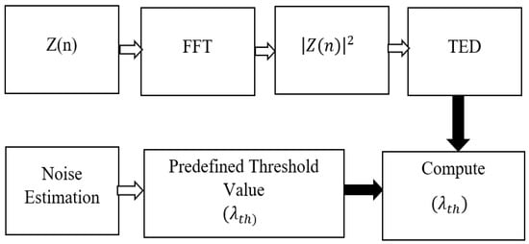

**Figure 1.** Energy Detection System.

The receiver signal in Equation (3) is compared with the predefined threshold value (λth), and the following decision is made:



The performance of the ED is defined by the probability of detection Pd and the probability of a false alarm (Pfa) given by:



## 2.2 Cyclo-Stationary (CS)

It is considered one of the most efficient algorithms to detect idle spectra due to its characteristics of retrieving every minute detail of the signal at low SNR. Using the periodic nature of the Pu in the energy of the received signal, it is possible to find out if Pu is available [[29](https://www.mdpi.com/2079-9292/12/1/138" \l "B29-electronics-12-00138)].

## 2.3 Matched Filter (MF)

The schematic of conventional MF is given in [Figure 2](https://www.mdpi.com/2079-9292/12/1/138" \l "fig_body_display_electronics-12-00138-f002). It is considered one of the most effective methods to detect the availability and non-availability of Pu at low SNR [[30](https://www.mdpi.com/2079-9292/12/1/138" \l "B30-electronics-12-00138)]. It needs prior details about the noise; however, MF outperforms the ED [[31](https://www.mdpi.com/2079-9292/12/1/138" \l "B31-electronics-12-00138)].

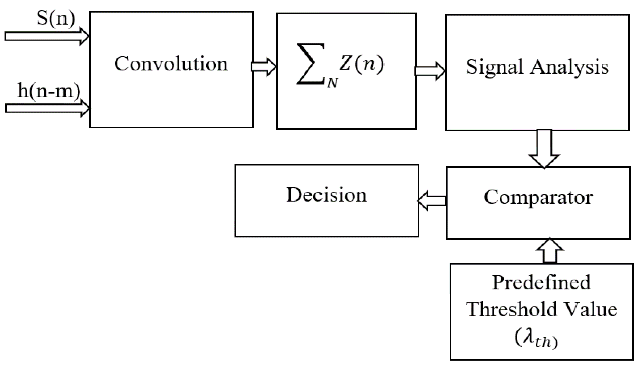

**Figure 2.**Matched filter convention for spectrum sensing.

The detection process of a matched filter can be given as follows:



Where ℎ(n − m)the characteristics of the filter, S(m) is the undetermined signal. To analyze the performance of the MF, Pd and Pfa are evaluated and given by:



From Equations (7) and (8), the threshold can be estimated as:



## 2.4 Hybrid Match Filter (HMF)

The schematic of the proposed method is given in [Figure 3](https://www.mdpi.com/2079-9292/12/1/138" \l "fig_body_display_electronics-12-00138-f003). This method combines the double MFD with the already-existing MF. Due to its hybrid nature, it exhibits two distinct behaviors: one when the likelihood of a false alarm is less than 0.5 and another when it is more than or equivalent to 0. This HMF detector basically relates to multiplications of two normal MF, where the threshold is the linear combination of two thresholds from a normal MF and the detection statistic is the linear combination of two thresholds from a double MF. The first detector, a normal MF, is used when the chance of a false alarm is greater than or equal to 0.5.



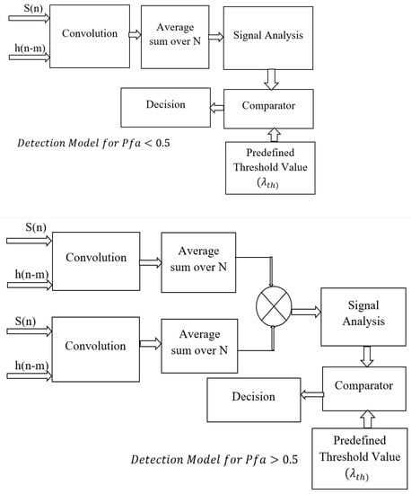

**Figure 3.**Proposed hybrid detection system.

The threshold for Pfa< and Pfa≥ is estimated by using the following equations:



# 3 Simulation Results

## 3.1 Probability of Detection Performance

The proposed HMF and conventional MF are implemented using Matlab 2014. We considered the number of samples (N = 50, 100), 64-sub-carrier, 64-QAM transmission, and Rayleigh and Rician channels used. The parameters, such as Pd, Pfa, and BER, are analyzed and evaluated. The probability of detection (Pd) performance for the HMF and conventional MF for N = 50 and 100 in the Rayleigh channels is given in [Figure 4](https://www.mdpi.com/2079-9292/12/1/138" \l "fig_body_display_electronics-12-00138-f004). In [Figure 4](https://www.mdpi.com/2079-9292/12/1/138" \l "fig_body_display_electronics-12-00138-f004), it is seen that the HMF for N = 100 obtained a gain of 2.3 dB, 4 dB, and 6 dB as compared with the HMF (N = 50) and MF (N = 100 and 50). It is concluded that the HMF obtained a signal at a lower SNR as compared with the MF. However, the intricacy of detection in 100 samples is higher as compared with 50 samples.

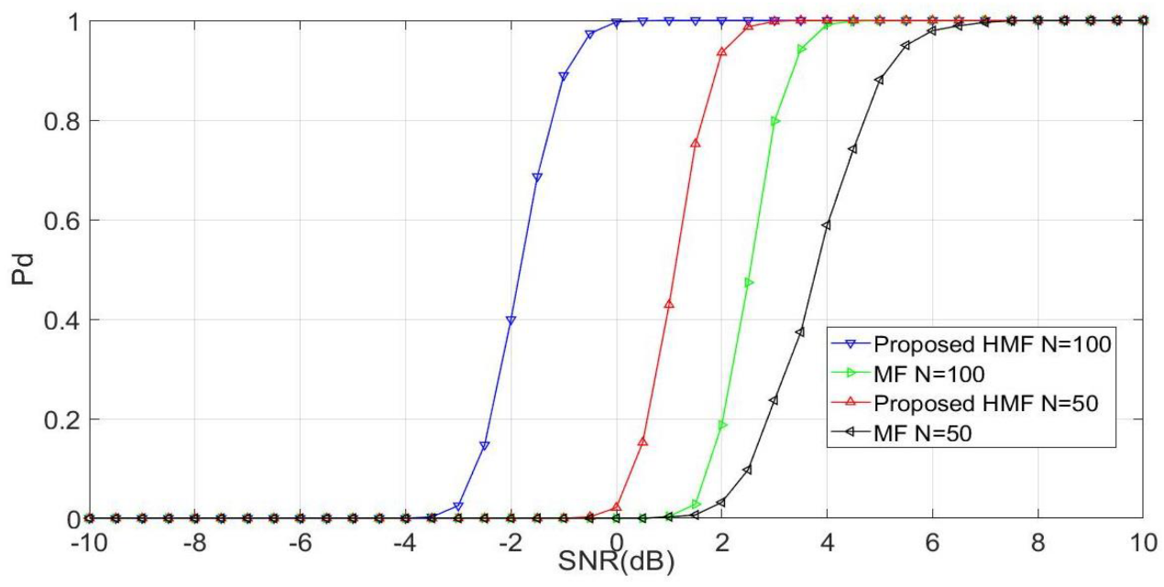

**Figure 4.**Performance of Pd and SNR for HMF and MF, considering number of samples = 50 and 100 in the Rayleigh Channel.

The detection capability for the Rician channel is given in [Figure 5](https://www.mdpi.com/2079-9292/12/1/138" \l "fig_body_display_electronics-12-00138-f005). It is seen that the performance is drastically improved as the detection is achieved at an SNR of −2 dB, −2.2 dB, 1.2 dB, and 1.3 dB for HMF (N = 100, 50) and MF (N = 100, 50). So, we can say that the proposed algorithm works well with the Rician and Rayleigh channels.

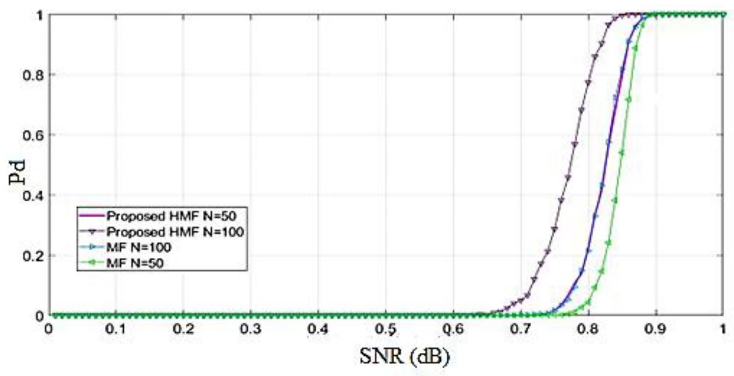

**Figure 5.**Performance of Pd and SNR for HMF and MF, considering number of samples = 50 and 100 in the Rician Channel.

## 3.2 Probability of False Alarm (Pfa) Performance

To assess the framework’s throughput, it is crucial to analyze the false alarm’s features. In a noisy environment, the features will influence how robust the spectrum sensing methods are. In sensing algorithms, the recognition of noise as the original signal is a critical problem that might impair the framework’s performance. The proposed HMF and MF algorithms’ performance is assessed and provided in [Figure 6](https://www.mdpi.com/2079-9292/12/1/138" \l "fig_body_display_electronics-12-00138-f006) and [Figure 7](https://www.mdpi.com/2079-9292/12/1/138" \l "fig_body_display_electronics-12-00138-f007). It can be seen that for N = 100, the performances of HMF and MF are equivalent for the Rican and Rayleigh channels. Thus, it can be said that, when compared to current standards, MF is the most reliable method.

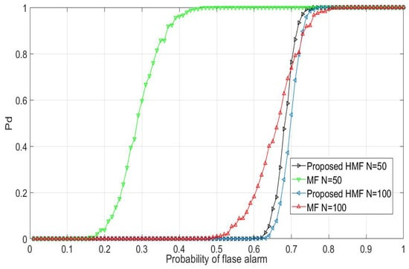

**Figure 6.**Performance of probability of detection and probability of false alarm for HMF and MF, considering number of samples = 50 and 100 in the Rayleigh Channel.

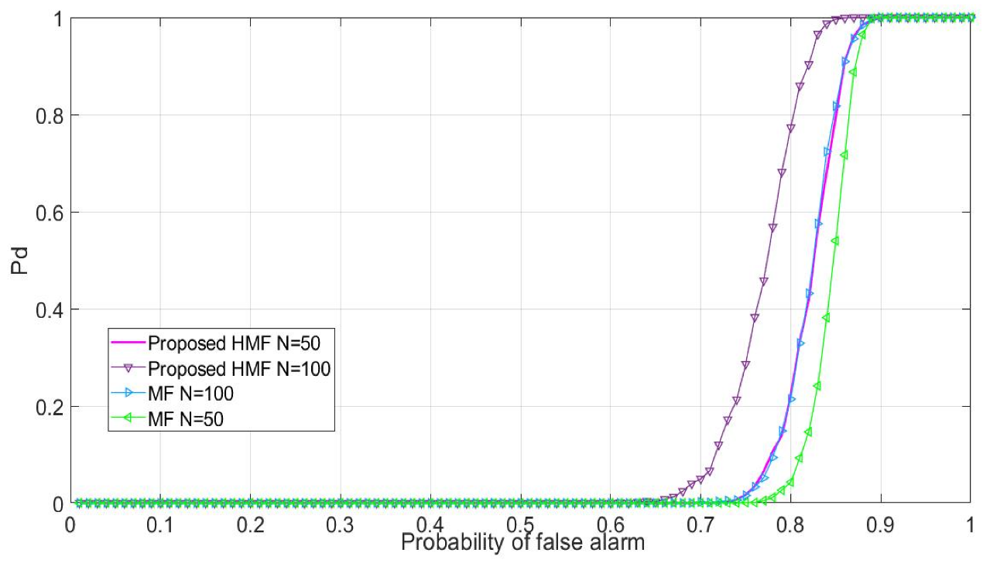

**Figure 7.**Performance of probability of detection and probability of false alarm for HMF and MF, considering number of samples = 50 and 100 in the Rician Channel.

## 3.3 BER Performance

To estimate the throughput of the proposed HMF, the BER is evaluated for the proposed HMF and conventional MF, as given in [Figure 8](https://www.mdpi.com/2079-9292/12/1/138" \l "fig_body_display_electronics-12-00138-f008) and [Figure 9](https://www.mdpi.com/2079-9292/12/1/138" \l "fig_body_display_electronics-12-00138-f009). From the figures, it is clear that the performance of the system increases when a matched filter is applied as a detection technique. In [Figure 8](https://www.mdpi.com/2079-9292/12/1/138" \l "fig_body_display_electronics-12-00138-f008), the BER is estimated for the Rayleigh channel, and it is seen that the BER of 10−2 is obtained at an SNR of 4 dB for HMF (N = 100), 6.2 dB for HMF (N = 50), 7.3 dB for MF (N = 100), and 9 dB for MF (N = 50) for the Rayleigh channel. Similarly, [Figure 9](https://www.mdpi.com/2079-9292/12/1/138" \l "fig_body_display_electronics-12-00138-f009) represents the BER performance of the Rician channel, and it is seen that a BER of 10−2 is obtained at an SNR of 5 dB for HMF (N = 100), 9.8 dB for HMF (N = 50), 15 dB for MF (N = 100), and 25 dB for MF (N = 50) for the Rayleigh channel.

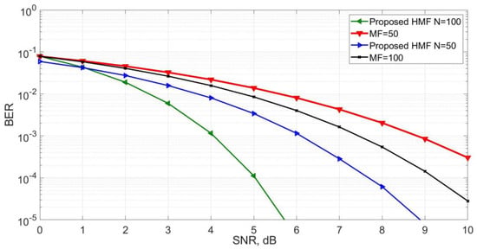

**Figure 8.**SNR Vs. BER performance for HMF and MF, considering number of samples = 50 and 100 in the Rayleigh Channel.

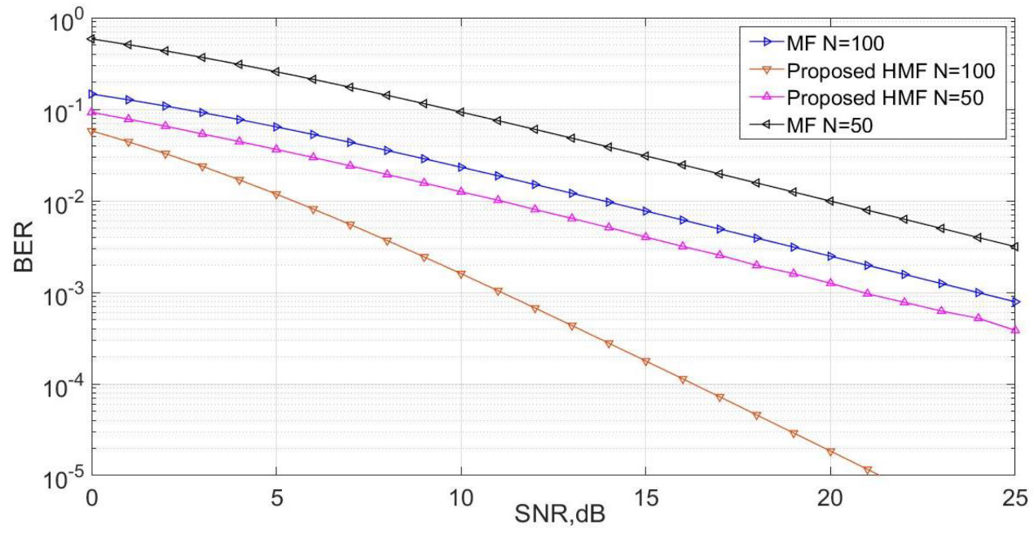

**Figure 9**.SNR Vs. BER performance for HMF and MF, considering number of samples = 50 and 100 in the Rician Channel.

This section analyzes, for the Rician channel with N = 100 samples, the risk of false alarm and the SNR characteristics of HMF and MF. It can be shown that the HMF performs better than the MF by achieving a gain of 5 dB. It follows that the HMF is considered a top choice for 5G and the radio that follows 5G. [Figure 10](https://www.mdpi.com/2079-9292/12/1/138" \l "fig_body_display_electronics-12-00138-f010) and [Figure 11](https://www.mdpi.com/2079-9292/12/1/138" \l "fig_body_display_electronics-12-00138-f011) provide the Pfa and SNR characteristics for the Rayleigh and Rician channel. The proposed HMF outperformed the current MF detection approach in terms of efficiency, even at low SNR.

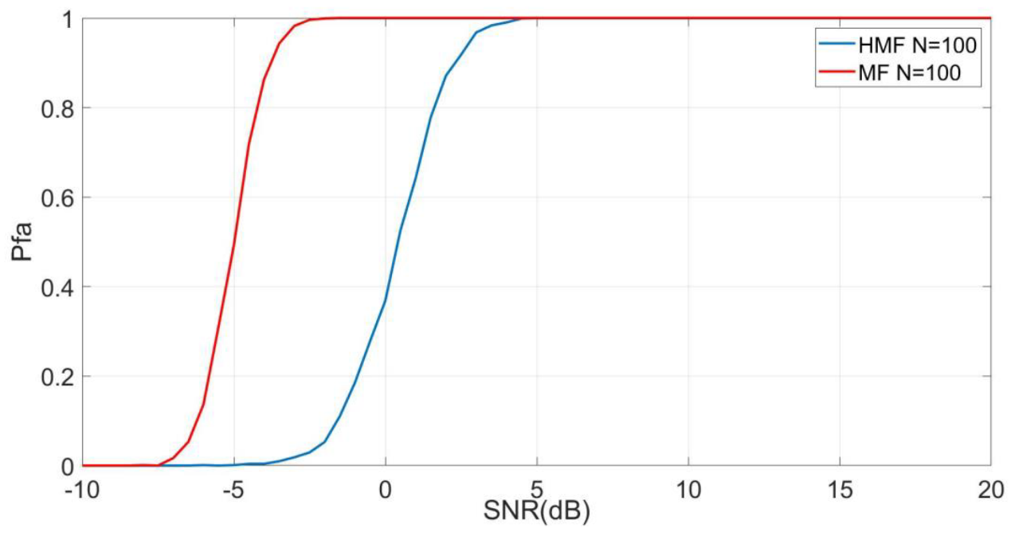

**Figure 10.**Performance of probability false alarm and signal-to-noise ratio (SNR) for HMF and MF, considering number of samples = 100 in the Rician Channel.

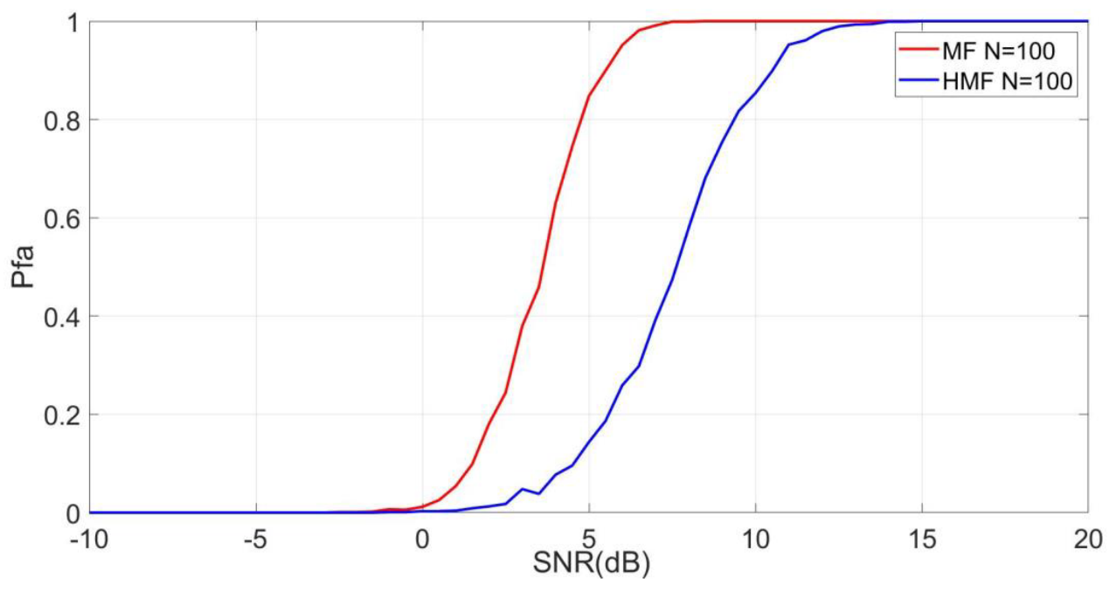

**Figure 11.**Performance of probability false alarm and signal-to-noise ratio (SNR) for HMF and MF, considering number of samples = 100 in the Rayleigh Channel.

As depicted in [Figure 12](https://www.mdpi.com/2079-9292/12/1/138" \l "fig_body_display_electronics-12-00138-f012), the effectiveness of the various SS algorithms for accurate spectrum detection is examined. The HMF, MF, CS, and ED, respectively, acquired a detection at an SNR of −2 dB, 3 dB, 5.1 dB, and 5.3 dB. As a result, it can be said that, when compared to traditional algorithms, the proposed HMF obtained optimal detection.

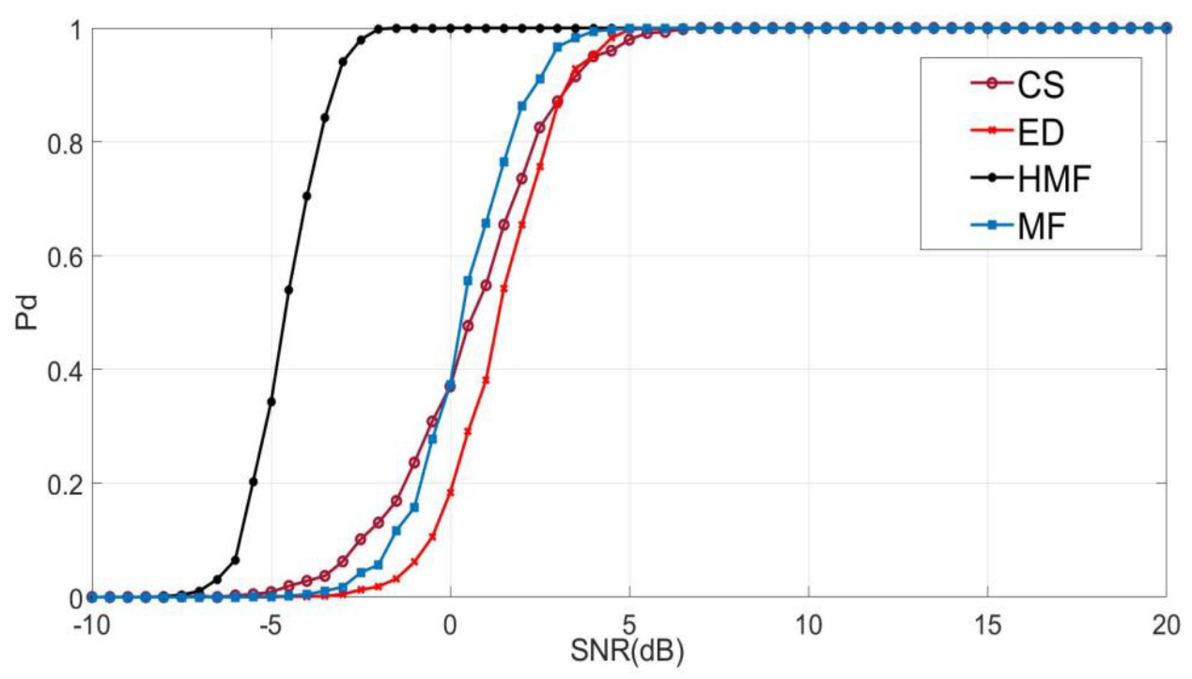

**Figure 12.**Pd and SNR for Rician channel.

In [Figure 13](https://www.mdpi.com/2079-9292/12/1/138" \l "fig_body_display_electronics-12-00138-f013), we have estimated the performance of proposed HMF and conventional SS algorithms for a condition where noise is detected as a required signal. It is seen that the HMF takes more time to detect the false signal as compared with the existing SS techniques. Hence, it is concluded that the HMF obtained optimal performance even in fading conditions.

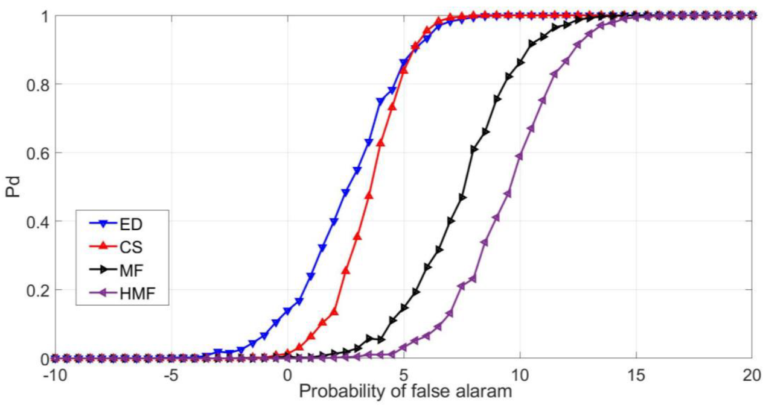

**Figure 13.**Pd and Pfa for the Rician channel.

## 3.4 Complexity

The number of athematic calculations required during a procedure is thought to represent the computation of the SS approaches, as shown in [Figure 14](https://www.mdpi.com/2079-9292/12/1/138" \l "fig_body_display_electronics-12-00138-f014). It can be seen that the use of HMF improved spectral efficiency while also making the framework more complex. The complexity of the framework is additionally increased by the use of the Fourier transform.

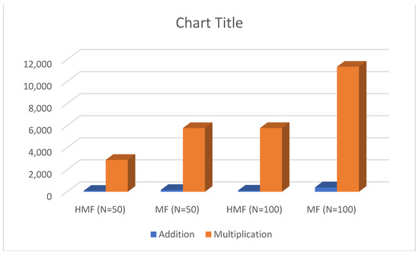

**Figure 14.**Complexity graph.

# 4 Conclusions

The proposed work highlights the capability of the HMF algorithm to sense the idle spectrum when the Pfa is greater than 0.5. The HMF and conventional MF algorithms are simulated for N = 100 and 50 samples, respectively. It is seen that the increasing number of samples will take more time to detect, and the complexity of the system will also increase. However, it enhances the performance of spectrum-sensing algorithms. The proposed HMF will take 21 s to simulate 100 samples, whereas the conventional MF will take 17 s. The parameters such as Pd, Pfa, and BER are estimated for the Rican and Rayleigh channels. It has been seen that the proposed algorithm outperforms the conventional MF. In the end, it can be said that the proposed system requires a lot of computing power but works much better than existing methods in noisy environments.

**5G和6G波形的混合频谱感知分析**

**摘要**

**随着无线应用数量的增加，频段的需求量也变得更多。然而，频谱现在很难适应新的应用。正因为如此，频谱变得越来越拥挤，这也影响了服务质量（QoS）。解决频谱稀缺问题最有前途的技术之一是认知无线电（CR）。频谱传感（SS）被认为对CR至关重要。它确定当主要用户 （PU） 不使用频谱时，可以将频谱分配给次级用户 （SU）。本文采用基于两个匹配滤波器（MF）融合的混合匹配滤波器（HMF）算法，实现了一种新的5G频谱感知技术。此外，我们比较了HMF和传统MF在瑞利和Rician通道中的性能。据观察，HMF在两个通道中都比传统的MF更有效地执行。**

**关键词：移动通信;5G;超越5G;6G;认知无线电;光谱;匹配滤波器（中频）;混合匹配筛选器**

# 1 绪论

蜂窝系统中对具有服务质量（QoS）和高数据速率的多种应用的需求将增加对自由光谱波段的需求。在当前场景中，特定应用被分配特定的频谱。然而，由于许多应用已经在使用分配的频谱，因此频谱稀缺。根据政府的协议，未经许可的用户不能使用许可频谱。同样，大多数频谱被过度利用也是事实。近年来，研究结果表明，OFDM频谱的利用不足主要是由于联邦通信委员会（FCC）的固定频谱分配协议[1]。认知无线电（CR）被认为是可以解决频谱稀缺问题的有效解决方案。它扫描来自主用户 （PU） 的空闲频谱，并将空闲频谱分配给次用户，而不会对主要用户造成任何干扰。这种识别空闲频谱的过程被称为“频谱传感技术”。近年来，已经提出了几种频谱传感技术，例如能量检测（ED），MF [2]和循环静止（CS）[3]。在当前情况下，只有在PU不存在的情况下才能进行传感。因此，主要的挑战是在存在和不存在PU的情况下实施频谱传感技术。但是，可以看出，由于多路径属性、通道的时变特性和阴影等各种原因，传感算法的性能会下降。频谱感知在认知系统中起着重要作用，有助于克服从PU到SU的频谱分配过程中的干扰问题[4]。在下一代通信系统中，功率和频谱的使用必须高效。从这个意义上说，创新的空间复用方法，如轨道角动量（OAM），被认为比频率复用方法（如正交频分复用（OFDM））具有优势[5]。OAM由体空间光调制器产生，其产生方位变化相位。它是创建量子密钥分发（QKD）所需的单光子器件的理想设备。此外，光学捕获、量子计量和远距离检测也受益于 OAM。每个孔径都包含一个螺旋相位板（SPP），该板将数据添加到输入信号中[6]。OAM 多路复用提供许多 GHz 的多路复用带宽，并具有良好的调制带宽。超表面也是创建多个OAM光束的新方法[7]。为了增加5G网络的覆盖面积和效率，将采用可重构智能表面（RIS）和CR来构建智能传输系统。除了RIS技术已经可以做的事情之外，这些改进旨在帮助将5G的高频信号传递到由于障碍而难以传输的地方，这将改善服务。尽管RIS支持的无线通信提供了好处，但对RIS支持的CR网络的研究却很少[8]。在CR情况下使用RIS可以增强频谱传感性能，并成功地将UP信号与噪声信号分离。超表面是一种光学框架，由放置在平面顶部的亚波长间隔光散射体阵列组成[9]。反射超表面（RM）已被用于在5G的背景下修改和调节无线电波传输路径.RM应该通过引导5G波远离障碍物来帮助它们避开障碍物。这降低了整体衰减并增加了范围[10]。本文讨论了利用MATLAB仿真对CR应用频谱感知的评估。它旨在了解特定参数（如SNR、样本数和误报）的变化如何影响误检。首先，考虑了众所周知的频谱传感方法，包括能量检测和匹配滤波器检测。然后，利用MATLAB仿真研究了一种新的HMF检测方法，并将其与传统MF的有效性进行了对比。所提出的基于匹配滤波器检测的方法具有混合性，因为它表现出两种不同的行为，具体取决于误报的几率是小于还是大于0.5。在[11]中，作者为二进制相移键控（BPSK）和正交相移键控（QPSK）传输系统实现了频谱传感算法。实验结果表明，该传感方法存在若干缺陷。然而，与ED和MF相比，自行车静止性能良好，复杂度低。在[12]中，基于ED的自适应FFT传感方法是为GNU的非Unix（GNU）平台设计的。结果表明，与现有方法相比，所提方法降低了延迟。 在[13]中，ED和MF算法的分析是在衰落和非衰落通道中进行的。实验结果表明，当选择理想阈值时，感知算法的性能有所提高。在[14]中，作者介绍了一种基于平方律的ED算法，结合了MIMO和OFDM波形。可以看出，所提算法复杂度较低，性能优于传统算法。作者在[15]中为5G波形实现了匹配滤波器。将所提算法应用于64-QAM和256-QAM调制，并将性能与常规算法进行比较。结果表明，与256-QAM相比，64-QAM的中频在低信噪比下具有更好的检测效果，并且频谱的复杂性也较低。在[16]中，认知无线电是为NOMA波形设计的。所提系统的通量优于传统方法。在[17]中，为基于OFDM波形的WLAN系统实现了匹配滤波算法。结果表明，与传统的感知算法相比，该算法检测空闲算法的感知时间更短。作者在[18]中引入了一种基于探测器动态阈值特性的匹配滤波算法。仿真结果表明，所提探测器的效率优于基于静态阈值特性的传统算法。[19]的作者创建了一个利用多框架天线的检测算法。该算法的主要特点是能够为次级用户感知低电平空闲信号。工作结果表明，所提出的方法提供了有效的性能。

本文的贡献如下：

• 我们来看看双级匹配滤波器和传统匹配滤波器在5G波形下的表现如何。

• 找出不同的参数，如检测概率（Pd）、误报概率（Pfa）、误码率（BER）、复杂度和功率谱密度（PSD），并将它们与传统的MF算法进行比较。

• 引入一种结合两个匹配滤波器的新型5G频谱感知技术，在提高检测灵敏度的同时提高框架的吞吐量。

这项工作的其余部分组织如下： [第 2 节](https://www.mdpi.com/2079-9292/12/1/138" \l "sec2-electronics-12-00138) 介绍了系统模型。 [第3节](https://www.mdpi.com/2079-9292/12/1/138" \l "sec3-electronics-12-00138)介绍了拟议系统的结果和讨论情况。最后，根据观察到的结果得出结论。

# 2 系统模型

## 2.1 能量检测

ED的原理图如图[1](https://www.mdpi.com/2079-9292/12/1/138" \l "fig_body_display_electronics-12-00138-f001)所示。在该方法中，将接收的能量与预定义的阈值进行比较，并确定通道可用性。ED的主要特征之一是它不需要先例通道状态信息（CSI）[[28](https://www.mdpi.com/2079-9292/12/1/138" \l "B28-electronics-12-00138)]。但是，在存在噪声的情况下，性能会下降。主要用户的检测和缺失可以定义为：





其中 h0 和 h1 表示 Pu 的可用性和不可用性，z（n） 是接收信号，σn 是高斯噪声。接收信号的能量为：





**图1.** 能量检测系统

将公式（3）中的接收器信号与预定义阈值（λth）进行比较，并做出以下决定：



ED的性能由检测概率Pd 和误报概率（Pfa）定义，如下所示：



## 2.2 循环静止 （CS）

它被认为是检测空闲频谱的最有效算法之一，因为它的特点是在低SNR下检索信号的每一分钟细节。利用Pu在接收信号能量中的周期性，可以找出Pu是否可用[[29](https://www.mdpi.com/2079-9292/12/1/138" \l "B29-electronics-12-00138)]。

## 2.3 匹配滤波器 （MF）

传统中频的原理图如图[2](https://www.mdpi.com/2079-9292/12/1/138" \l "fig_body_display_electronics-12-00138-f002)所示。它被认为是在低信噪比下检测Pu可用性和不可用的最有效方法之一[[30](https://www.mdpi.com/2079-9292/12/1/138" \l "B30-electronics-12-00138)]。它需要事先提供有关噪声的详细信息;然而，MF优于ED[[31](https://www.mdpi.com/2079-9292/12/1/138" \l "B31-electronics-12-00138)]。



**图2.**用于频谱传感的匹配滤波器约定

匹配滤波器的检测过程可以给出如下：



W这里的h（n− m）滤波器的特性，S（m）是未确定的信号。为了分析MF的性能， P d和Pfa由以下方法评估和给出：



根据公式（7）和（8），阈值可以估计为：



## 2.4 混合匹配过滤器 （HMF）

本文所提出的方法的原理图如图[3](https://www.mdpi.com/2079-9292/12/1/138" \l "fig_body_display_electronics-12-00138-f003)所示。此方法将双 MFD 与现有 MF 相结合。由于其混合性质，它表现出两种不同的行为：一种是误报的可能性小于 0.5，另一种是误报的可能性大于或等于 0。该HMF检测器基本上涉及两个正态MF的乘法，其中阈值是来自正态MF的两个阈值的线性组合，检测统计量是来自双MF的两个阈值的线性组合。当误报的几率大于或等于 0.5 时，使用第一个检测器，即普通 MF。





**图3.**提出的混合检测系统

Pfa< 和 Pfa≥的阈值使用以下公式估算：



# 3 仿真结果

## 3.1 检测性能的概率

本文提出的HMF和传统MF是使用Matlab 2014实现的。我们考虑了样本数量（N = 50，100），64-子载波，64-QAM传输以及使用的瑞利和里西安通道。分析和评估参数，如Pd，Pfa和BER。[图4](https://www.mdpi.com/2079-9292/12/1/138" \l "fig_body_display_electronics-12-00138-f004)给出了瑞利通道中N = 50和100的HMF和常规MF的检测概率（Pd）性能。在[图4](https://www.mdpi.com/2079-9292/12/1/138" \l "fig_body_display_electronics-12-00138-f004)中，可以看出，与HMF（N = 50）和MF（N = 100和50）相比，N = 100的HMF获得了2.3 dB，4 dB和6 dB的增益。结论是，与MF相比，HMF获得了较低SNR的信号。然而，与50个样本相比，100个样本的检测复杂性更高。



**图4** HMF和MF的Pd和SNR性能，考虑瑞利通道中的样本数= 50和100

[Rician](https://www.mdpi.com/2079-9292/12/1/138" \l "fig_body_display_electronics-12-00138-f005)通道的检测能力如图5所示。可以看出，HMF （N = 100， 50） 和 MF （N = 100， 50） 的检测信噪比为 −2 dB、−2.2 dB、1.2 dB 和 1.3 dB 时，性能得到了显著提高。因此，我们可以说所提出的算法与 Rician 和 Rayleigh 通道配合得很好。



**图5** HMF和MF的Pd和SNR性能，考虑Ritian通道中的样本数= 50和100

## 3.2 误报概率 （PFA） 性能

要评估框架的吞吐量，分析误报的功能至关重要。在嘈杂的环境中，这些特征将影响频谱检测方法的鲁棒性。在传感算法中，将噪声识别为原始信号是一个可能损害框架性能的关键问题。[图6](https://www.mdpi.com/2079-9292/12/1/138" \l "fig_body_display_electronics-12-00138-f006)和图[7](https://www.mdpi.com/2079-9292/12/1/138" \l "fig_body_display_electronics-12-00138-f007)评估并提供了所提出的HMF 和 MF算法的性能。可以看出，对于 N = 100，HMF 和 MF 的性能对于 Rican 和 Rayleigh 通道是等效的。因此，可以说，与现行标准相比，MF是最可靠的方法。



**图6** HMF和MF的检测概率和误报概率的性能，考虑到瑞利通道中的样本数= 50和100



**图7** HMF和MF的检测概率和误报概率的性能，考虑到Rician通道中的样本数= 50和100

## 3.3 误码率性能

为了估计拟议的HMF的吞吐量，评估了拟议的HMF和常规MF的BER值，如图[8](https://www.mdpi.com/2079-9292/12/1/138" \l "fig_body_display_electronics-12-00138-f008)和[图9](https://www.mdpi.com/2079-9292/12/1/138" \l "fig_body_display_electronics-12-00138-f009)所示。从图中可以清楚地看出，当应用匹配的滤波器作为检测技术时，系统的性能会提高。在[图8](https://www.mdpi.com/2079-9292/12/1/138" \l "fig_body_display_electronics-12-00138-f008)中，瑞利信道的误码率是估计的，可以看出，HMF （N = 100） 的信噪比为 4 dB，HMF （N = 50） 的信噪比为 6.2 dB，中频 （N = 100） 为 7.3 dB，瑞利信道的中频 （N = 50） 为 9 dB。同样，[图9](https://www.mdpi.com/2079-9292/12/1/138" \l "fig_body_display_electronics-12-00138-f009)表示Ritian信道的误码率性能，可以看出，HMF （N = 100）的信噪比为5 dB，HMF （N = 50）为9.8 dB，中频（N = 100）为15 dB，瑞利信道的MF （N = 50）为25 dB。



**图8** HMF 和 MF 的 SNR 与 BER 性能，考虑瑞利通道中的样本数 = 50 和 100



**图9** HMF 和 MF 的 SNR 与 BER 性能，考虑 Rician 通道中的样本数 = 50 和 100

本节分析了N = 100个样本的Ritian通道，误报的风险以及HMF和MF的SNR特性。可以证明，HMF通过实现5 dB的增益而比MF表现更好。因此，HMF被认为是5G和5G之后的无线电的首选。 图[10和图11](https://www.mdpi.com/2079-9292/12/1/138" \l "fig_body_display_electronics-12-00138-f010) 提供了瑞利和里西安信道的PFA和SNR特性。所提出的HMF在效率方面优于当前的MF检测方法，即使在低SNR下也是如此。



**图 10** HMF和MF的概率误报和信噪比（SNR）的性能，考虑Ririan通道中的样本数= 100



**图 11** HMF和MF的概率误报和信噪比（SNR）的性能，考虑瑞利通道中的样本数= 100

如图[12](https://www.mdpi.com/2079-9292/12/1/138" \l "fig_body_display_electronics-12-00138-f012)所示，这里检查了各种SS算法对精确频谱检测的有效性。HMF、MF、CS和ED分别在−2 dB、3 dB、5.1 dB和5.3 dB的SNR下进行了检测。因此，可以说，与传统算法相比，这里所提出的HMF获得了最佳检测。



**图 12** Rician 信道的 Pd 和 SNR

在[图13](https://www.mdpi.com/2079-9292/12/1/138" \l "fig_body_display_electronics-12-00138-f013)中，我们估计了所提出的HMF和传统SS算法在将噪声检测为所需信号的情况下的性能。可以看出，与现有的SS技术相比，HMF需要更多的时间来检测错误信号。因此，得出的结论是，即使在衰落条件下，HMF也获得了最佳性能。



**图 13** Pd 和 Pfa 代表 Rician 频道

## 3.4 复杂性

如图14所示，在一个过程中所需的无主题性计算的数量被认为代表了SS方法的计算。可以看出，HMF的使用提高了光谱效率，同时也使框架变得更加复杂。通过使用傅立叶变换，框架的复杂性进一步增加。

**图 14** 复杂性图

# 4 结论

本文重点研究了当PFA大于0.5时，HMF算法具有识别频谱的能力。分别对N=100和50个样本进行了HMF和常规MF算法仿真。可以看出，越来越多的样本将需要更多的时间来检测，系统的复杂度也会增加，但它提高了频谱感知算法的性能。所提出的HMF算法需要用21s来模拟100个样本，而传统的MF算法需要17S，对Rican和Rayleigh信道的PD、PFA和BER等参数进行了估计，结果表明该算法优于传统的MF算法。最后，可以说，本文所提出的系统虽然需要很大的计算能力，但在噪声环境下比现有方法工作得更好。