Adapting Deep Learning for P-Wave Polarity Classification in Marine OBS Environments: Application to Real-Time Focal Mechanism Monitoring at Axial Seamount

Maochuan Zhang^{1*}, William S. D. Wilcock¹, Marine Denolle¹, Felix Waldhauser², Kaiwen Wang⁴, Maya Tolstoy¹, Yen Joe Tan³
¹School of Oceanography, University of Washington, Seattle, WA, USA
²Lamont-Doherty Earth Observatory, Columbia University, Palisades, NY, USA
³Department of Earth and Environmental Sciences, The Chinese University of Hong Kong, Hong Kong S.A.R., China
⁴Institute of Geology and Geophysics, Chinese Academy of Sciences, Beijing, China

Abstract:
Determining P-wave first-motion polarity is essential for constraining focal mechanisms and understanding earthquake rupture processes. However, existing deep learning approaches are primarily trained on continental seismic networks and often perform poorly in marine environments where elevated noise levels, strong site effects, and variable couplings challenge model generalization. This study develops, to our knowledge, the first deep learning framework to advance polarity determination in oceanic settings, using data from the Ocean Observatories Initiative (OOI) Regional Cabled Array at Axial Seamount in the Pacific Ocean. We employ waveform cross-correlation-based and deep learning methods, training exclusively on a high-SNR, manually verified subset of Axial Seamount waveforms augmented with realistic noise extracted from the OOI catalog, and apply the trained models to the remaining catalog-scale data. Our newly developed model, AxialPolCap, incorporates data augmentation with waveform time-shift perturbations and demonstrates superior performance compared to existing approaches. On a held-out synthetic test set with realistic P-wave timing perturbations, AxialPolCap achieves approximately 96% polarity accuracy, compared to 80–85% for existing deep-learning models and 92% for cross-correlation, both exceeding the ~90% inter-analyst consistency reported for manual picking (Hardebeck & Shearer, 2002). Leave-one-station-out cross-validation, in which the model is trained on six stations and tested on the seventh in turn, yields 96–98% accuracy on unshifted waveforms across all held-out stations, confirming that the model generalizes without station-specific retraining. When applied to the independent 2015–2021 Axial Seamount catalog, AxialPolCap polarities agree with cross-correlation-derived polarities for ~88% of picks and the resulting focal mechanisms match cross-correlation-based solutions with a median Kagan angle of ~13°, supporting the reliability of the approach for large-scale and real-time applications.

Keywords: Marine Microseismicity, Polarity Determination, Deep Learning, Axial Seamount, Focal Mechanisms
1. Introduction
Focal mechanism solutions provide fundamental constraints on earthquake source processes and are essential for characterizing fault geometry and regional stress fields (Li et al., 2023; Messuti et al., 2023). For moderate to large earthquakes, waveform-based inversions can resolve source parameters. However, such approaches are generally impractical for microearthquakes (M<3.0) because of the high computational cost of modeling high-frequency waveforms and the strong dependence on accurate velocity models in structurally complex media (Kuang et al., 2021; Zhao et al., 2023). As a result, P-wave first-motion polarity remains the most widely used and reliable observable for constraining focal mechanisms of microearthquakes, particularly in environments with dense seismicity (Chakraborty et al., 2022; Chen et al., 2024). Extensive collections of microearthquake focal mechanisms enable high-resolution investigations of fault structures, rupture processes, and evolving stress conditions in active tectonic and volcanic systems (Li et al., 2023).
Despite its importance, reliably determining P-wave first-motion polarity remains challenging, especially for microearthquakes recorded in noisy or heterogeneous environments. Manual polarity picking is labor-intensive and subjective, requiring experienced analysts to interpret onsets that are often emergent or have a low signal-to-noise ratio (SNR) (Messuti et al., 2023). Previous studies have shown that manual polarity assignments can be inconsistent for approximately 10% of impulsive arrivals and up to 20% of emergent phases, even among expert analysts (Hardebeck & Shearer, 2002; Zhao et al., 2023). These difficulties are compounded by the rapid growth of seismic data volumes, which increasingly exceed the capacity of manual analysis and limit the feasibility of real-time or near-real-time focal mechanism determination (Li et al., 2023).
To address these limitations, automated polarity determination methods have evolved from rule-based and statistical approaches to modern deep learning techniques. Earlier computerized methods, including cross-correlation approaches, Bayesian classifiers, and amplitude-based criteria, often required substantial parameter tuning and struggled to generalize across stations, noise conditions, and source characteristics (Pugh et al., 2016; Li et al., 2023; Peng et al., 2025). In contrast, recent deep-learning models based on convolutional neural networks and attention-based architectures have demonstrated strong performance by learning discriminative features directly from raw waveforms. Models such as DiTingMotion, CFM, and EQPolarity report polarity classification accuracies of 95–98% on continental datasets (Ross et al., 2018; Messuti et al., 2023; Chen et al., 2024; Zhao et al., 2023). More recent frameworks integrate phase picking and polarity determination into unified workflows, further improving automation and efficiency (Zhang et al., 2023; Peng et al., 2025).
However, existing deep learning polarity classifiers have been developed and validated almost exclusively using continental seismic networks. Their performance and robustness in marine environments remain largely unexplored. Seafloor seismic observations are characterized by elevated ambient noise levels, strong site effects, variable coupling, and complex propagation paths, all of which may violate assumptions implicit in models trained on land-based data. Whether current deep learning models can generalize to such conditions and how they might be adapted to do so remain open questions.
The Ocean Observatories Initiative (OOI) Regional Cabled Array (RCA) at Axial Seamount provides a unique natural laboratory for addressing this gap. Since late 2014, the cabled network has recorded more than 230,000 microearthquakes with an average magnitude of approximately 0.1, offering an unprecedented, continuous, and high-quality marine seismic data set. Previous work has demonstrated that cross-correlation–based methods can automatically determine hundreds of thousands of P-wave polarities for Axial Seamount microearthquakes, far exceeding what is feasible with manual analysis (Shelly et al., 2016; Levy et al., 2018; Zhang et al., in prep.). However, the cross-correlation method requires significant computational resources when data sets are large, requires similarity between many waveforms, is hard to determine the polarity of new waveforms, produces inconsistent results across stations and subregions, and requires human interaction (Zhang et al., in prep.). These factors hinder a real-time monitoring framework.
In this study, we use waveform- and cross-correlation-based polarity data from the Axial Seamount as a benchmark to develop deep learning approaches for determining P-wave first-motion polarity in seafloor environments. We first construct a synthetic data set of approximately 150,000 waveforms with known polarities by combining realistic source radiation patterns with empirically derived noise recorded at Axial Seamount during the post-2015 eruptive quiescence. Using this data set, we perform a comprehensive benchmark comparison of four existing deep learning polarity classifiers and a cross-correlation–based method. Guided by insights from these tests, particularly regarding sensitivity to SNR and P-wave onset timing, we then systematically compare training a new model from scratch with transfer learning based on PolarCAP (Chakraborty et al., 2022). The resulting model, termed AxialPolCap, is specifically designed to improve robustness to marine noise conditions and arrival-time uncertainty. AxialPolCap achieves an average polarity classification accuracy of approximately 96% on Axial Seamount data. We further validate the model by applying it to independent seismicity recorded between January 2015 and December 2021 and by comparing the resulting focal mechanisms with those obtained using cross-correlation methods. The close agreement between the two approaches demonstrates that AxialPolCap provides reliable, automated polarity determinations suitable for large-scale and real-time applications. Finally, we integrate AxialPolCap into a real-time monitoring framework, enabling continuous focal mechanism estimation for microearthquakes at Axial Seamount.t
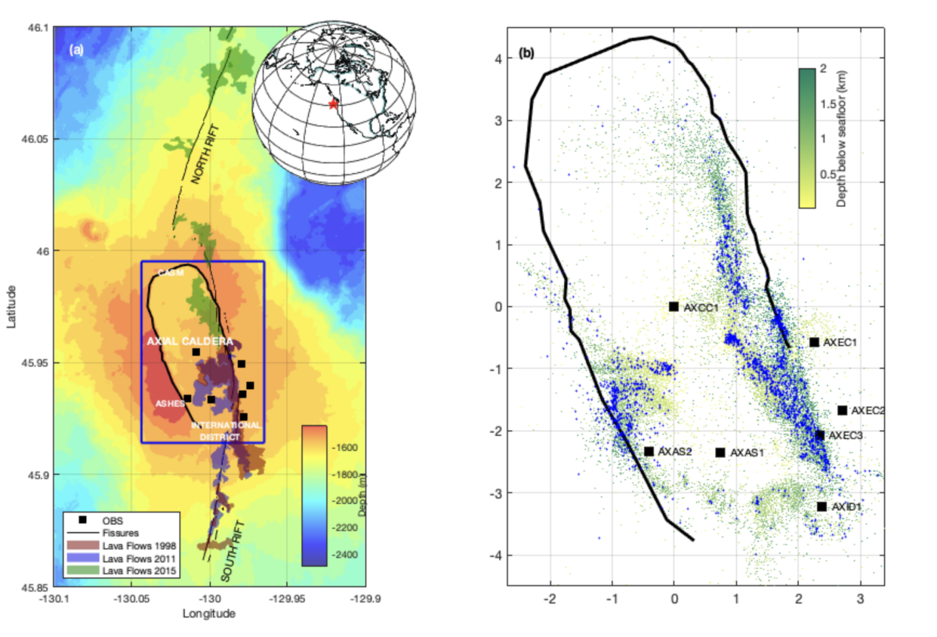
Figure 1. (a) Bathymetric map of the Axial Seamount showing the location of the caldera (bold black line), fissures (thin black lines), lava flows associated with the 1998 (Chadwick et al., 2013), 2011 (Caress et al., 2012; Chadwick et al., 2013) and 2015 (Chadwick et al., 2016; Clague et al., 2017) eruptions (brown, lavender and olive shading, respectively) and ocean bottom seismometers (OBSs) on the Ocean Observatories Initiative Regional Cabled Array (black squares). The blue box shows the area of (b). The inset shows the location of Axial Seamount. (b) Map showing the distribution of earthquakes with least 5 P and S picks color coded by depth from the catalog of Wang et al. (2024) with the caldera and OBS locations labelled by station name. Blue dots showing the templates earthquakes with high SNR waveforms.
2. Study Area and Data
2.1 Axial Seamount
The study area is Axial Seamount, an active submarine volcano located in the northeast Pacific Ocean approximately 500 km off the Oregon coast. It sits at the intersection of the Juan de Fuca Ridge and the Cobb-Eickelberg hotspot (Figure 1). The summit rises nearly 1 km and is characterized by an 8 × 3 km² horseshoe-shaped caldera with walls up to 100 m high and a floor ~1.5 km below sea level. Eruptive activity is frequent; at least 52 eruptions have occurred over the past 800 years (Clague et al., 2013, 2019), with three well-documented events in 1998, 2011, and 2015 (Dziak & Fox, 1999; Chadwick et al., 2013; Wilcock et al., 2016). The 1998 and 2011 eruptions involved dike propagation along the southern rift zone, while the 2015 eruption propagated along the northern rift (Figure 1). A shallow main magma reservoir (MMR), containing a 1–2 km wide axial magma lens (AML) at the lithosphere–asthenosphere boundary, is thought to govern eruptive activity, hydrothermal circulation, and lava chemistry (Arnulf et al., 2014, 2018; Kent et al., 2025).

2.2 Seismic Network and Earthquake Catalog
Seismic data are from the 7-station cabled network at Axial Seamount, operated by the Ocean Observatories Initiative (OOI) Regional Cabled Array (RCA) starting in late 2014. We use the comprehensive earthquake catalog of Wang et al. (2024) (publicly available at https://axialdd.ldeo.columbia.edu), which contains 144,329 hypocenters generated using supervised machine learning in real time. The catalog was constructed by applying PhaseNet (Zhu & Beroza, 2018) for phase picking, GaMMA (Zhu et al., 2022) for association, and SpecUFEx (Holtzman et al., 2018) for earthquake discrimination. Initial earthquake locations were obtained with NonLinLoc (Lomax et al., 2000) and subsequently refined using double-difference relocation with HypoDD (Waldhauser & Ellsworth, 2000; Waldhauser et al., 2020).

The catalog we used for training and testing spans from the start of OOI RCA operations on 4 November 2014 through the end of 2021. Due to data gaps and timing errors in the early network deployment, we restrict our analysis to earthquakes occurring after 22 January 2015. We further select events with at least five stations reporting both P- and S-wave picks (Figure 1). Catalog moment magnitudes Mw (Hanks & Kanamori, 1979) range from -1.7 to 3.4, with a mean of 0.2. Formal absolute location uncertainties from NonLinLoc are typically ~0.3 km vertically and ~0.2 km horizontally, while relative location uncertainties from HypoDD are on the order of tens of meters. P-wave pick timing errors average ~0.01 s. The signal-to-noise ratio (SNR) of the waveforms used for polarity determination ranges from 0 to 60 dB, following an approximately log-normal distribution (Figure 1), and the sample rate for the waveform is 200 Hz.

2.3 Synthetic Waveform Dataset for Model Training and Testing
To systematically train and benchmark deep learning (DL) models against the CC method, we created a high-fidelity synthetic waveform dataset. We selected clear, high-SNR (≥ 20 dB) waveforms from 2015–2021 across all seven stations after demeaning, detrending, and bandpass filtering between 3 and 20 Hz (Levy et al., 2018), where both the CFM and CC methods unambiguously determined polarities. These waveforms and their associated polarities were manually verified to ensure quality. Each waveform was resampled to 100 Hz, and a 1-second window centered on the P-wave pick (-0.5 s to +0.5 s) was extracted; this window length avoids contamination from S-waves, given the small aperture of the Axial network where P-S times are typically 0.2–0.5 s.

This initial set comprised ~13,000 high-quality template waveforms (Figure 2a). Following Uchide's (2020) augmentation approach, we created amplitude-sign-reversed copies of each template (i.e., the waveform amplitude is negated to flip the apparent first-motion polarity), effectively doubling the dataset to ~26,000 waveforms. This augmentation balances the 'positive' and 'negative' polarity classes, which is beneficial for classifier training (Batista et al., 2004). We reserved 20% of this augmented template set (~5,200 waveforms) as an independent test set.

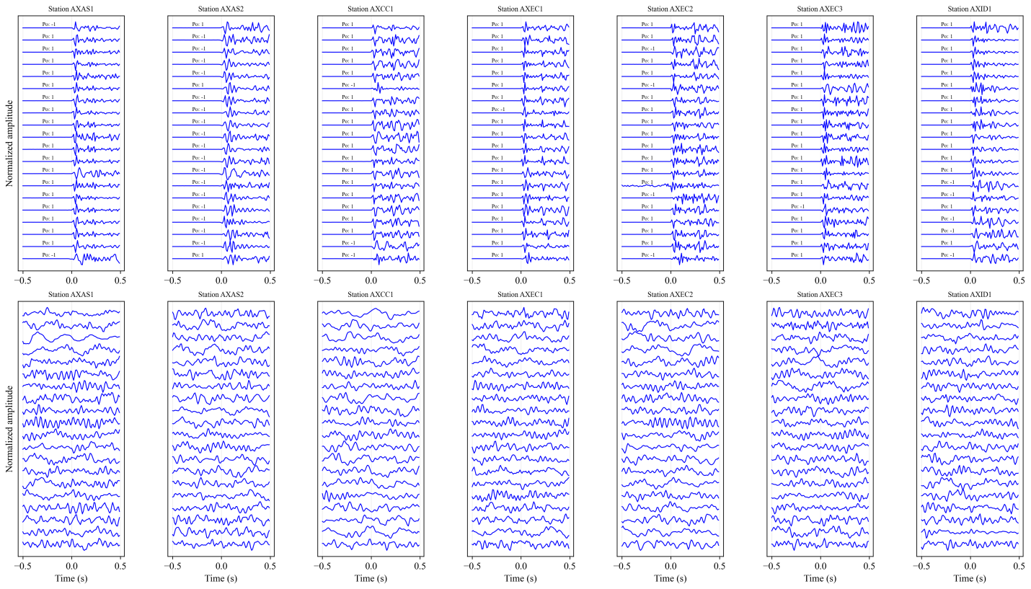
Figure 2. (a) Examples of the normalized template waveform with high SNR and clear first-motion polarities at seven stations. (b) Examples of normalized random-noise waveforms from 2016 to 2017 at seven stations.

To generate realistic, noisy seismograms, we extracted noise waveforms from 2016–2017, an interval following the 2015 eruption that has very few earthquakes (Figure 2b). Synthetic training waveforms were then created by merging each polarity-confirmed template with a randomly selected noise segment from the same station and scaling them to replicate the original SNR distribution of the catalog. This process yielded a final synthetic dataset of ~150,000 waveforms for model development and benchmarking. Example template and synthetic waveforms are shown in Figure 3.
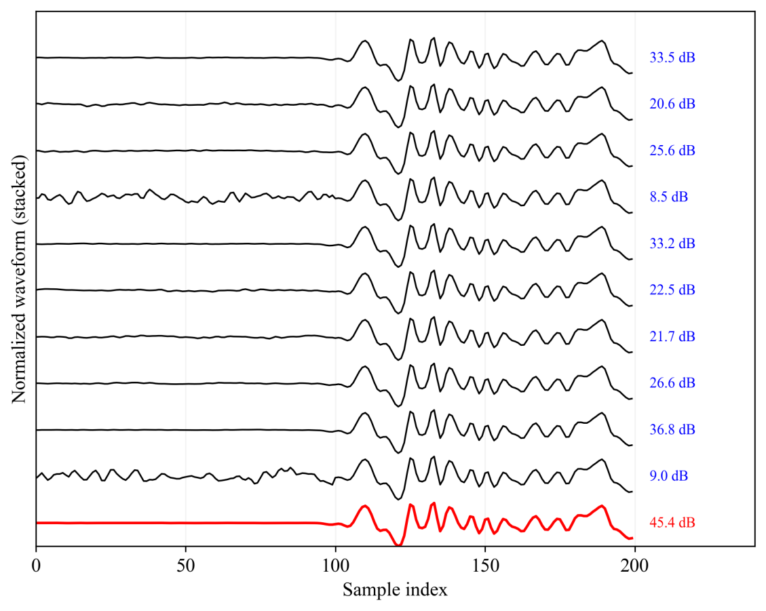
Figure 3. Examples of augmented waveforms (black), generated by adding random noise to the normalized template waveform (red) to produce a range of signal-to-noise ratios (SNRs).

To avoid label leakage, all manual polarity verification and quality control were confined strictly to the template waveforms described above. Synthetic waveforms derived from these templates were used only for model training and benchmarking. No manual inspection, label-based filtering, or performance tuning was performed on the remaining Axial Seamount catalog data. The trained models were subsequently applied to this independent, unreviewed portion of the catalog to evaluate generalization under realistic noise and picking conditions.

3 Methods and Results
3.1 Benchmark Test for Previous Deep-Learning Models and Cross-Correlation

Deep-learning approaches are inherently data driven, and their performance strongly depends on the characteristics of the training data. Here, we benchmark four recently proposed deep-learning models for automatic P-wave first-motion polarity determination (Chakraborty et al., 2022; Zhao et al., 2023; Messuti et al., 2023; Chen et al., 2024), together with a waveform cross-correlation method (Shelly et al., 2016; hereafter CC). Early deep-learning models were developed using convolutional neural network (CNN) architectures trained primarily on the Southern California Earthquake Data Center (SCEDC) dataset (Ross et al., 2018). Subsequent studies expanded the training data to include earthquakes from China to improve generalization across tectonic settings (Zhao et al., 2023; hereafter DiTingMotion). To address data scarcity in localized regions, transfer-learning strategies have also been introduced, enabling model adaptation using limited regional datasets (Chen et al., 2024; hereafter EQPolarity). More recently, models designed for both volcanic and tectonic environments have focused explicitly on the initial P-wave segment, employing attention mechanisms and incorporating P-wave pickers as auxiliary inputs to reduce sensitivity to onset timing errors (Messuti et al., 2023; hereafter CFM). In addition, PolarCAP (Chakraborty et al., 2022) applies strict data-quality filtering by excluding waveforms with signal-to-noise ratios (SNRs) below 10 dB and uses polarity flipping to balance class distributions and augment the training dataset. Collectively, these deep-learning models report accuracies of up to ~98% when evaluated against analyst-determined polarities.
For the deep-learning (DL) models evaluated in this study, all produce a binary polarity classification (up or down), but they differ substantially in their input waveform requirements, reflecting distinct architectural design choices. DiTingMotion uses a 1.28 s waveform window (128 samples at 100 Hz) centered on the P-wave arrival and uniquely incorporates a second input channel consisting of the sign of the vertical waveform difference. This additional channel is designed to enhance the identification of emergent or slow-onset P waves (Li et al., 2023; Zhao et al., 2023). EQPolarity requires a longer single-channel vertical waveform window of 6.0 s (3 s before and after the P-wave arrival), which must be resampled to 100 Hz and bandpass filtered between 1 and 20 Hz to emphasize primary seismic features while suppressing low-frequency noise (Chen et al., 2024). In contrast, CFM processes a 1.60 s window (160 samples at 100 Hz) without applying any frequency filtering; instead, it employs an adaptive clipping threshold set to 20 times the pre-arrival noise amplitude to highlight the initial P-wave oscillation (Messuti et al., 2023). PolarCAP operates on the shortest input window, using 64 samples centered on the known P-wave arrival, and requires no preprocessing beyond simple amplitude normalization by the maximum absolute value of the waveform (Chakraborty et al., 2022).
To ensure a fair benchmark across all models, we resampled all waveform templates to 100 Hz, aligned them on the P-wave arrival, and embedded them within noise windows of varying lengths. These noise windows were selected to reproduce the same signal-to-noise ratio (SNR) distribution observed in the original Axial Seamount dataset.
The benchmark tests (Figure 4) lead to three key observations. First, both DL models and the cross-correlation (CC) method exhibit strong station-dependent performance. Stations AXCC1 and AXAS1 consistently outperform AXAS2, AXEC3, and AXID1. This disparity likely reflects station location and source characteristics: AXCC1 and AXAS1 are situated near the center of the caldera, where P-wave first motions are generally clearer, whereas stations near caldera-bounding faults record more complex waveforms. In addition, AXID1 records fewer earthquakes and includes a mixture of tectonic and hydrothermal events, further degrading polarity reliability. Second, the CC method outperforms all DL models, achieving an average accuracy of approximately 92%. Third, the evaluated DL models perform 10–20% worse than their originally reported accuracies, indicating limited generalization to marine OBS data. This performance degradation suggests that existing models, trained primarily on onshore datasets, are sensitive to waveform differences and minor P-wave onset misalignments characteristic of marine environments, highlighting the need for either region-specific retraining or the development of new models tailored to seafloor seismic data.
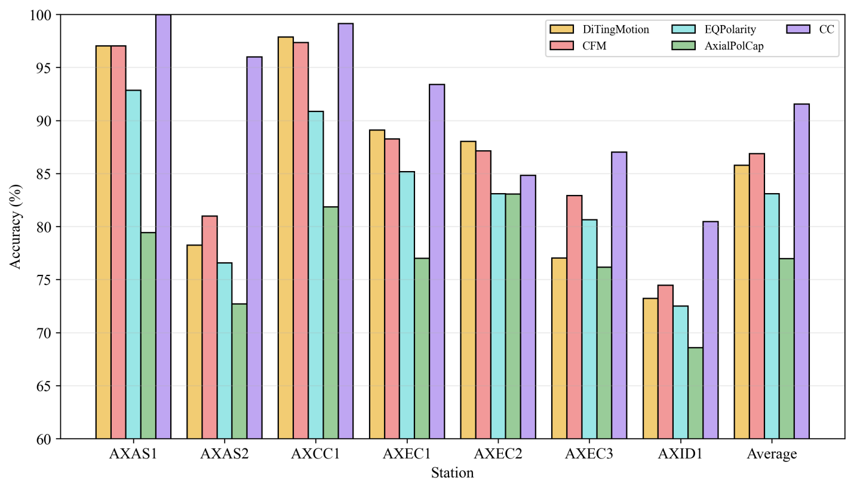
Figure 4. Station-wise P-wave first-motion polarity classification accuracy (%) on synthetic waveform comparing four existing deep-learning models (DiTingMotion, CFM, EQPolarity, and PolarCAP) and a cross-correlation (CC) baseline. Bars show accuracies for each station (AXAS1–AXID1) and the across-station Average.

3.2 Model Optimization: Training a New Model or Transfer Learning
The performance of deep-learning (DL) models for P-wave first-motion polarity determination depends primarily on arrival-time accuracy, signal-to-noise ratio (SNR), regional waveform characteristics, and training data volume. Arrival-time uncertainty is particularly critical: in DiTingMotion, a random pick error of 0.1 s reduces accuracy by up to 22% (Li et al., 2023; Zhao et al., 2023). Although time-shift augmentation improves robustness in models such as CFM and PolarCAP, unaugmented CFM accuracy drops to ~50% for a 0.1 s shift (Chakraborty et al., 2022; Messuti et al., 2023). Model performance also degrades rapidly at low SNR, with PolarCAP showing a sharp decline below 10 dB and DiTingMotion remaining sensitive to pick errors in noisy conditions despite near-optimal performance on high-SNR data (>30 dB). Regional variability further limits generalization, motivating transfer-learning strategies such as EQpolarity, which improves regional accuracy from 95.43% to 98.82% using limited local data (Chen et al., 2024). In addition, previous studies suggest that reliable performance typically requires at least ~10,000 training samples, with optimal results achieved using 20,000–30,000 waveforms (Hara et al., 2019; Messuti et al., 2023).
To evaluate these effects for seafloor seismic data, we adopt the PolarCAP model (Chakraborty et al., 2022) trained on the INSTANCE dataset (Michelini et al., 2021). PolarCAP uses an autoencoder architecture (Rumelhart et al., 1986) with two 1-D convolutional and max-pooling layers that encode the waveform into a 16-dimensional latent space, followed by a symmetric decoder and a softmax classifier (Figure 5). The model is implemented in Keras and trained using the Adam optimizer, minimizing a weighted sum of reconstruction (mean-squared error) and classification (Huber loss, δ = 0.5) losses, with weights of 1 and 200, respectively. Early stopping and adaptive learning-rate reduction are applied during training.

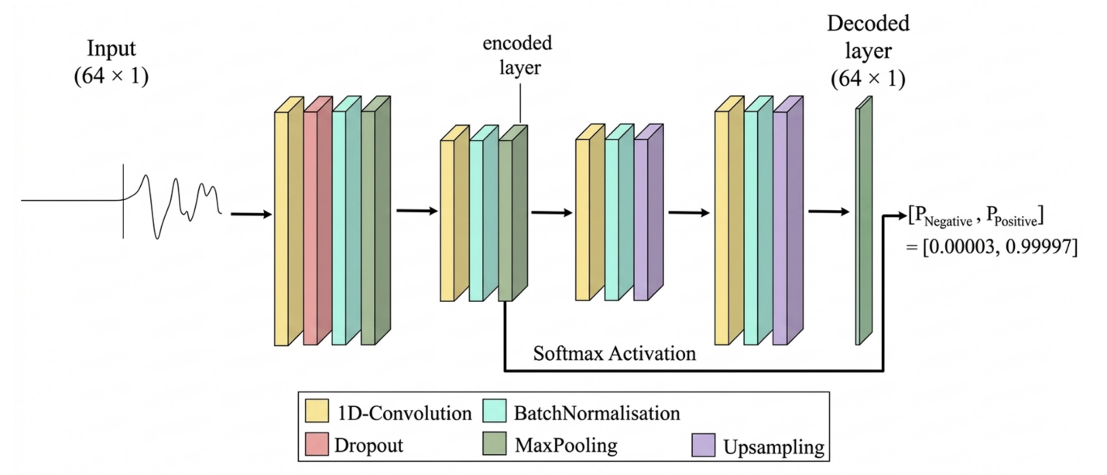
Figure 5. Autoencoder architecture used in this study (Chakraborty et al., 2022). The encoder comprises two 1D convolutional layers (ReLU; 32 and 8 filters; kernel sizes 32 and 16) with max-pooling, where each pooling step halves the data dimension, and dropout of 0.3. The decoder comprises two 1D convolutional layers (tanh and ReLU; 8 and 32 filters; kernel sizes 16 and 32), followed by a final tanh output layer. A softmax classifier applied to the encoded representation outputs the probabilities of negative and positive polarity.
Using station-specific synthetic datasets, we compare two optimization strategies: training a new model from scratch and applying transfer learning. For transfer learning, all layers except the final softmax layer are frozen and fine-tuned using synthetic waveforms, with performance evaluated on the held-out 20% test set. To assess model generalization, we also conduct a leave-one-station-out (LOSO) experiment, in which the model is trained on all but one station and evaluated on the held-out station, repeating this for each of the seven stations in turn
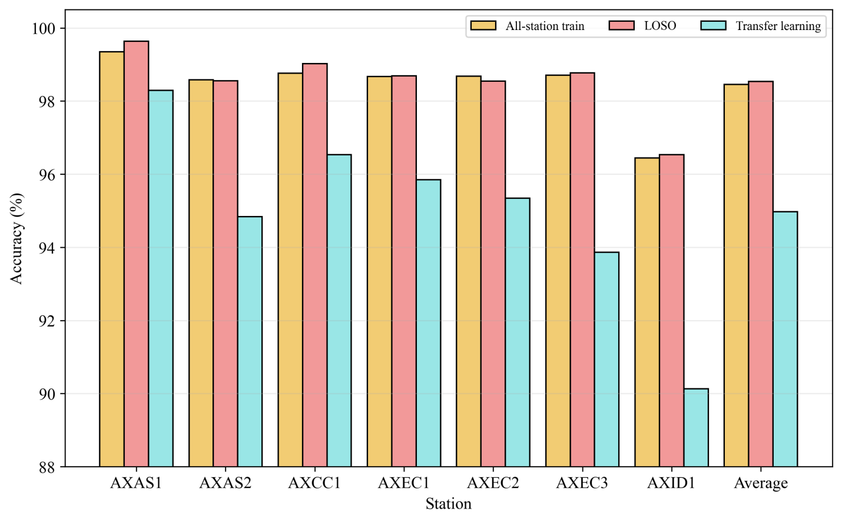
Figure 6. Accuracy (%) comparison of three training strategies for polarity classification for individual stations and the average of all stations. Accuracies shown for (1) a single model trained using data pooled from all stations, (2) seven models trained with leave-one-station-out (LOSO), and (3) a transfer learning model.

To evaluate the influence of signal-to-noise ratio (SNR) on model performance, we grouped training waveforms into three categories based on SNR: high SNR (>10 dB), low SNR (0–10 dB), and the original SNR distribution across all stations (Figure 7). Separate models were trained and transfer learning using each SNR group and evaluated on a common test dataset constructed from waveforms with the original SNR distribution.

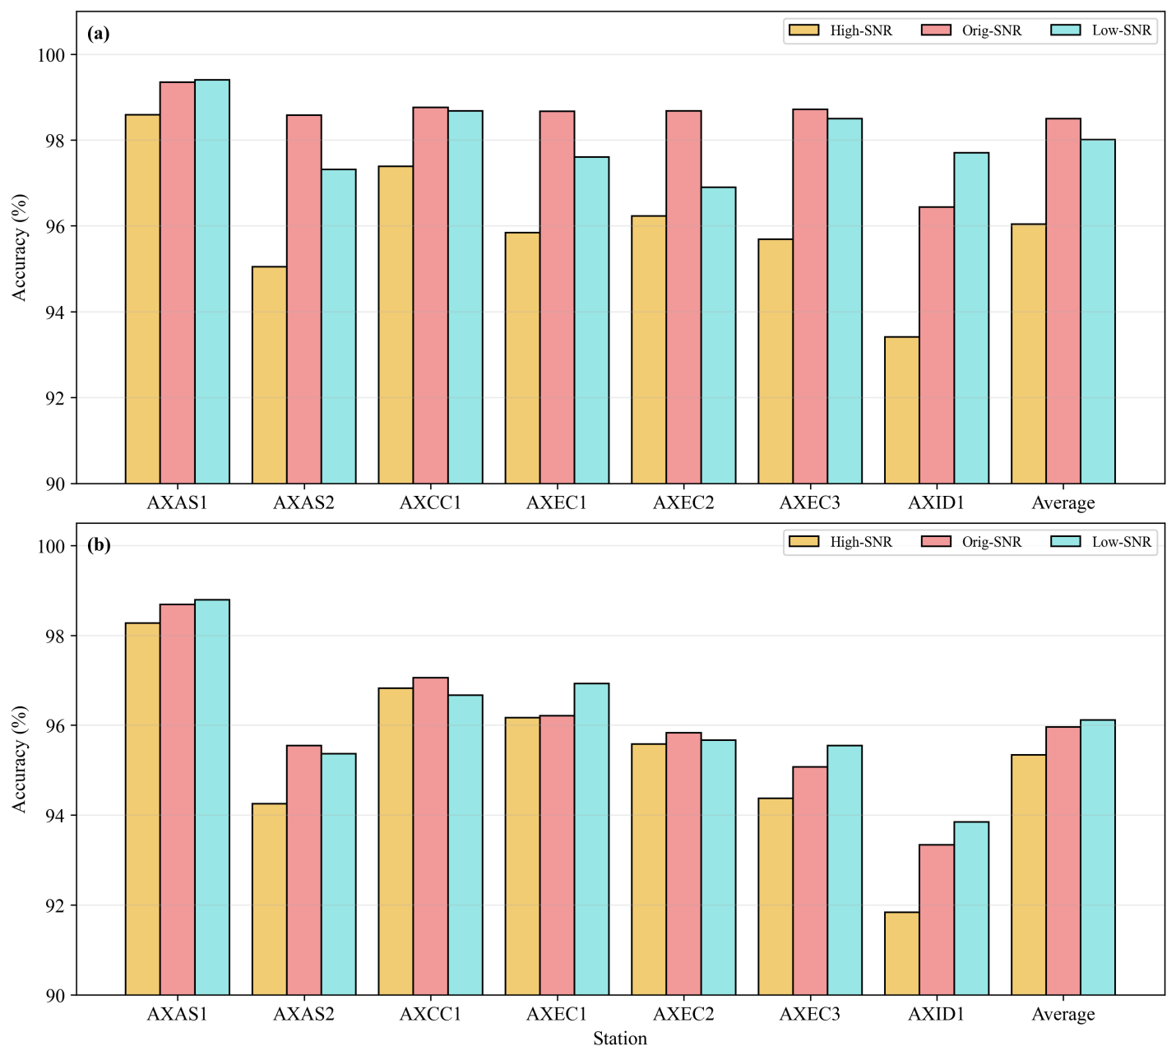
Figure 7. Impact of signal-to-noise ratio (SNR) on station-wise polarity classification accuracy. (a) Accuracy for new models trained on high SNR and low-SNR subsets compared with training on the original SNR. (b) Transfer-learning model accuracy for training with the same SNR categories as (a). Results are shown for each station and for the average of all stations.

Figure 7 summarizes the influence of training-data signal-to-noise ratio (SNR) on model performance for both the newly trained model and the transfer-learning model. For the newly trained models (Figure 7a), accuracy remains consistently high across stations, with differences between high-SNR, low-SNR, and original-SNR training generally within ~1–2%. Models trained on the original SNR distribution achieve the highest and most stable performance overall, while training exclusively on high-SNR or low-SNR subsets results in only minor accuracy degradation. In contrast, transfer-learning models (Figure 7b) exhibit a stronger dependence on the SNR characteristics of the training data. Although transfer learning performs well when trained on high- or original-SNR data, accuracy decreases more noticeably when trained on low-SNR waveforms, particularly at stations with weaker signal quality (e.g., AXID1). Network-averaged results indicate that newly trained models are largely insensitive to the SNR distribution of the training data, whereas transfer-learning models are more vulnerable to SNR mismatch between training and testing data. These results suggest that training models directly on station-diverse datasets provides greater robustness to SNR variability than fine-tuning pretrained models.
To assess the sensitivity of polarity classification to P-wave pick timing uncertainty, we evaluated both the newly trained model and the transfer learning model, each trained using data from all stations with the original SNR distribution, on test waveforms with random time shifts (Δt∼N(0,σ²) applied relative to the nominal P-wave onset, using σ=0.00, 0.01, and 0.02 s. Figure 8 shows the effect of increasing P-wave time shifts on model performance across stations. For both models, classification accuracy decreases systematically as the time shift increases, demonstrating a strong sensitivity to small errors in P-wave arrival timing. When no time shift is applied, both models achieve high accuracy above 95 percent at all stations. Introducing a time shift of σ = 0.01 s results in a clear performance reduction of approximately 5 to 10 percent, while a time shift of σ = 0.02 s leads to a pronounced degradation, with average accuracy decreasing to approximately 75 to 80 percent. The newly trained model consistently performs better than the transfer learning model under time-shifted conditions, particularly at larger offsets, indicating improved robustness to pick uncertainty. Nevertheless, both models exhibit substantial sensitivity to timing errors of only a few samples, showing that accurate P-wave arrival picks are critical for reliable first motion polarity determination and subsequent focal mechanism analysis.

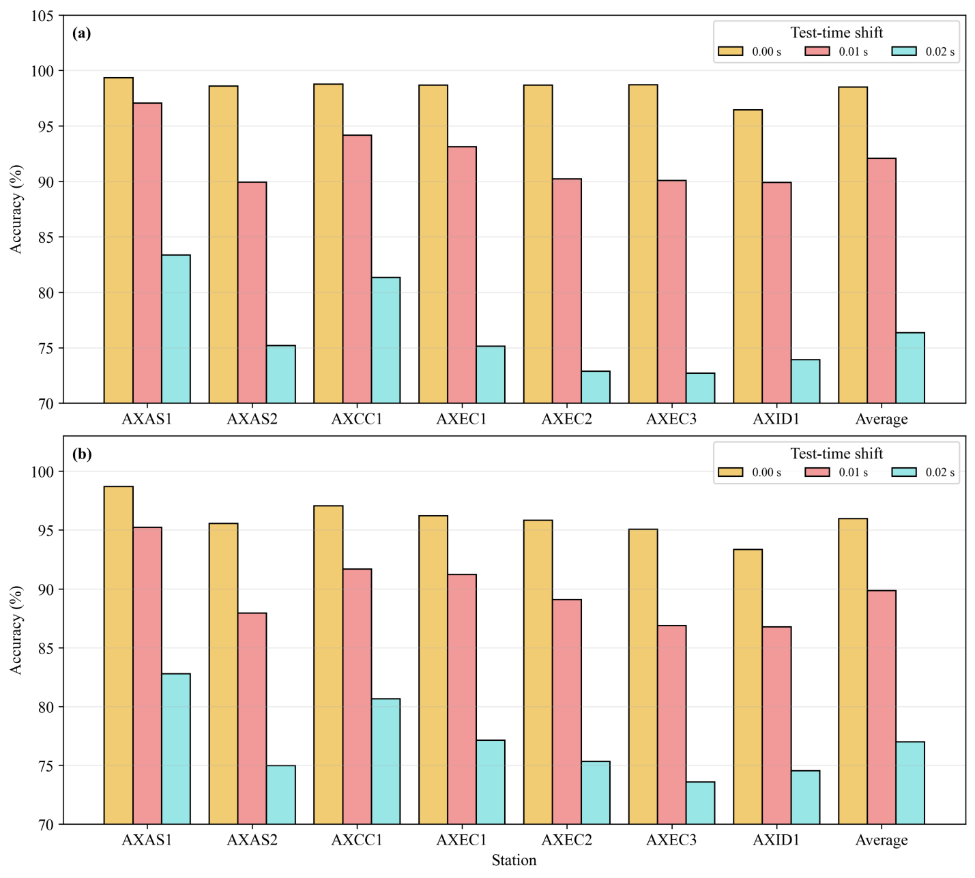
Figure 8. Accuracy of (a) newly trained and (b) transfer learning models for different P-wave time shifts. Both models were trained using data from all stations with the original SNR distribution and evaluated on test waveforms with time shifts of 0.00 s, 0.01 s, and 0.02 s.

Given the strong sensitivity of model performance to P-wave pick timing uncertainty, we further investigated whether incorporating time-shifted data during training can improve accuracy. We trained both the newly trained and transfer learning models using waveforms with imposed P-wave time shifts of σ = 0.01 s and σ = 0.02 s, and evaluated their performance on test data with a σ = 0.01 s time shift (Figure 9). For the newly trained model, training with time shifted data substantially improves performance, with accuracies generally exceeding 95 percent across most stations (Figure 9a),. Models trained using a σ = 0.01 s time shift perform slightly better than those trained with a σ = 0.02 s shift, indicating that moderate timing perturbations during training best match the level of uncertainty present in the test data.
In contrast, the transfer learning model shows consistently lower accuracy and larger performance variability across stations (Figure 9b). Although training with time shifted data improves transfer learning performance compared to unshifted training, accuracy remains 5 to 10 percent lower than that of the newly trained model at several stations. These results indicate that explicit inclusion of realistic P-wave pick uncertainty during training enhances model robustness, and that full retraining using station diverse data is more effective than transfer learning for mitigating timing related errors.
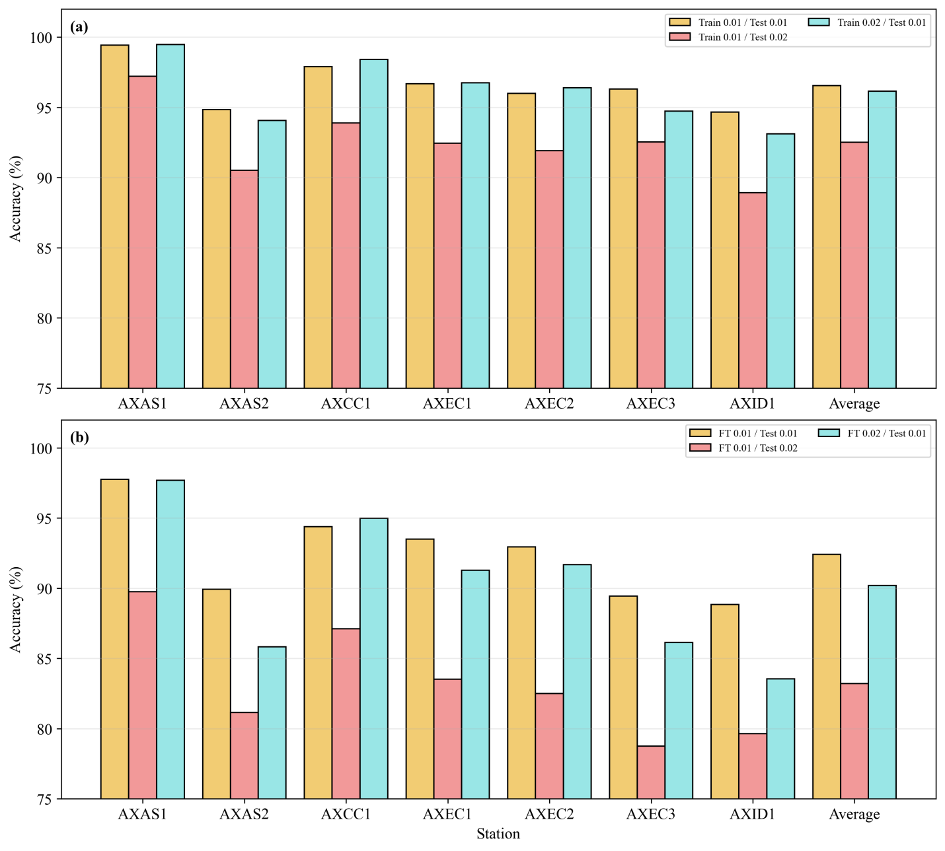
Figure 9. Classification accuracy for models trained using P-wave time shifts of σ = 0.01 s and 0.02 s and tested on waveforms with a σ = 0.01 s time shift. Results are shown for both the newly trained model and the transfer learning model.

3.3 Preferred Model
Based on the systematic experiments described above, we selected a final model — referred to as AxialPolCap — using the following configuration: trained from scratch on merged data from all seven stations, using the original catalog SNR distribution, with a σ = 0.02 s P-wave time-shift augmentation applied during training. This configuration achieves the best balance between overall accuracy and robustness to P-wave pick timing uncertainty. Evaluated on the held-out test set with a σ = 0.01 s time shift, AxialPolCap achieves an average accuracy of approximately 96% across all stations, outperforming both the unaugmented newly trained model and all transfer-learning variants. Leave-one-station-out cross-validation of this configuration confirms that the model generalizes across stations without station-specific retraining, achieving 96–98% accuracy on unshifted waveforms for each held-out station (Figure 6). We apply this model to the full 2015–2021 Axial Seamount earthquake catalog in Section 4.
4 Application to Axial Seamount

4.1 2015–2021 Earthquake Catalog
We apply the optimized AxialPolCap model to seismic waveforms for earthquakes in the catalog of Wang et al (XXXX) recorded between January 2015 and December 2021 that were not used during model training, validation, or benchmarking. This dataset comprises waveforms for XXX,XXX earthquakes and consists predominantly of lower SNR waveforms that are unreviewed. No manual polarity inspection, label-based filtering, or parameter tuning was performed on these data. For each earthquake, vertical-component waveforms were extracted at all available stations using catalog P-wave arrival times. Waveforms were demeaned, detrended, bandpass filtered between 3 and 20 Hz, resampled to 100 Hz, and normalized by their maximum absolute amplitude, following the same preprocessing procedures used during model development. A 0.64 s window centered on the P-wave pick (−0.32 to +0.32 s) was provided as input to AxialPolCap, which produced a probabilistic classification of first-motion polarity (up or down) for each station–event pair.
Using AxialPolCap, we assigned P-wave first-motion polarities (Up/Down) to all waveforms from the 2015–2021 Axial Seamount catalog. Unlike three-class polarity pickers that explicitly output an “unknown” label (e.g., Ross et al., 2018), AxialPolCap is a binary classifier, so unreliable cases must be handled through post-classification screening. This strategy follows prior deep-learning studies that accept predicted polarities only when model confidence exceeds a user-defined threshold and otherwise treat the prediction as ambiguous (e.g., Zhang et al., 2023; Peng et al., 2025). Following prior studies that use the predicted class probability as a confidence metric and Shannon entropy as a measure of predictive uncertainty, with thresholding applied to retain only reliable predictions (Tornetta, 2021; Nguyen et al., 2020; Klingspohn et al., 2017), we kept only results with confidence ≥ 0.8 and entropy ≤ 0.2 in our binary-classification experiments. This filtering retained 200,578 polarities, accounting for ~66% of all P-wave picks.
To assess the reliability of AxialPolCap predictions on real data, we compare model-derived polarities with those obtained using the waveform cross-correlation (CC) method for waveforms for which both approaches yield polarity determinations. The CC method provides a useful reference based on waveform similarity, although it is not treated as absolute ground truth. Across all stations and years, AxialPolCap agrees with CC-derived polarities for 87.70% of event pairs. For those that disagreed, we found the ML polarities are more consistent at each station (Figure 10). Agreement rates are highest at central caldera stations (AXAS1 and AXCC1) and decrease toward the network periphery (Figure 11), consistent with known spatial variations in waveform coherence and SNR. These agreement levels are comparable to, and in some cases exceed, previously reported consistency between independent polarity determination methods at Axial Seamount.
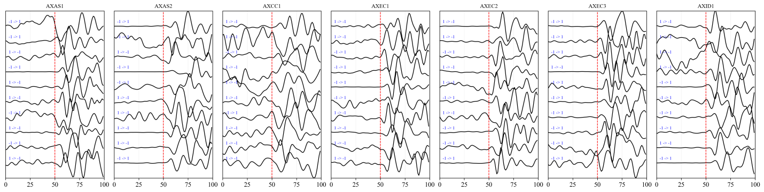
Figure 10. Examples of conflicting P-wave first-motion polarities between cross-correlation (CC) and machine-learning (ML) predictions. For each station, 10 events were randomly selected for which CC and ML polarities are non-zero but disagree. Waveforms are normalized and vertically offset; text labels indicate the polarity change (CC → ML). The vertical dashed line marks the pick time.
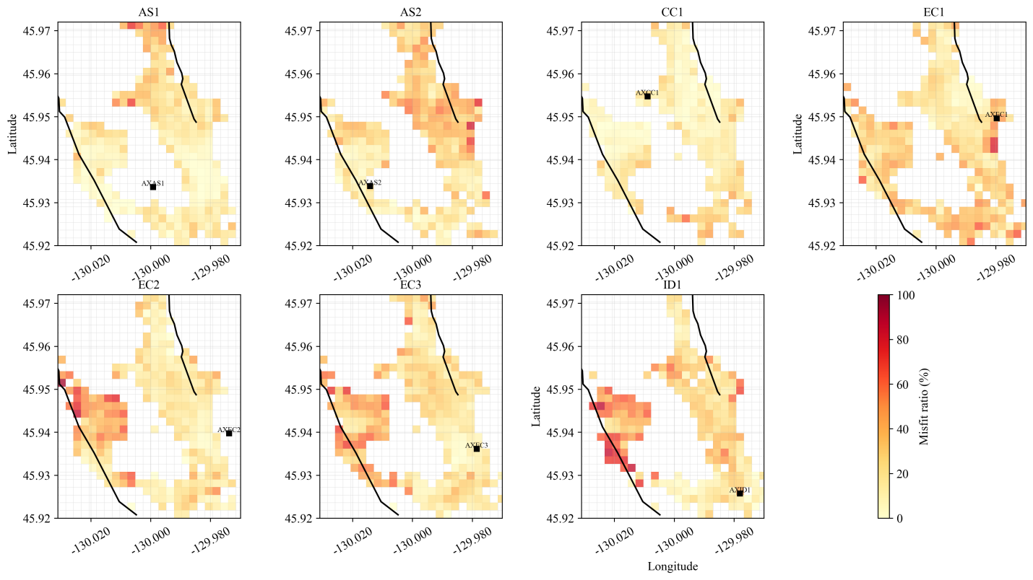
Figure 11. Spatial distribution of ML polarity misfits for the 2015-2021 Axial Seamount catalog. Each panel shows one OOI station. Colored 200 m x 200 m grid cells show the percentage of retained ML polarities that disagree with the CC polarity picks, calculated only for cells containing at least 10 retained station-event polarity measurements. Warmer colors indicate higher misfit ratios. Black lines mark the caldera rim, and black squares mark station locations.
Despite the disagreements on individual picks, the aggregate effect on focal mechanism determination is modest. Using AxialPolCap-derived polarities, we computed composite focal mechanisms for 2015–2021 microearthquakes within the same clusters defined by Zhang et al. (in prep.). The resulting mechanisms show coherent spatial and temporal structure consistent with prior studies based on cross-correlation and manual polarity analysis, including systematic variations across the West Wall, East Wall, and International District (Figure 12). Focal mechanisms computed from AxialPolCap polarities closely match those derived from cross-correlation polarities, with a median Kagan angle of ~13° (Kagan, 1991; Figure 13).
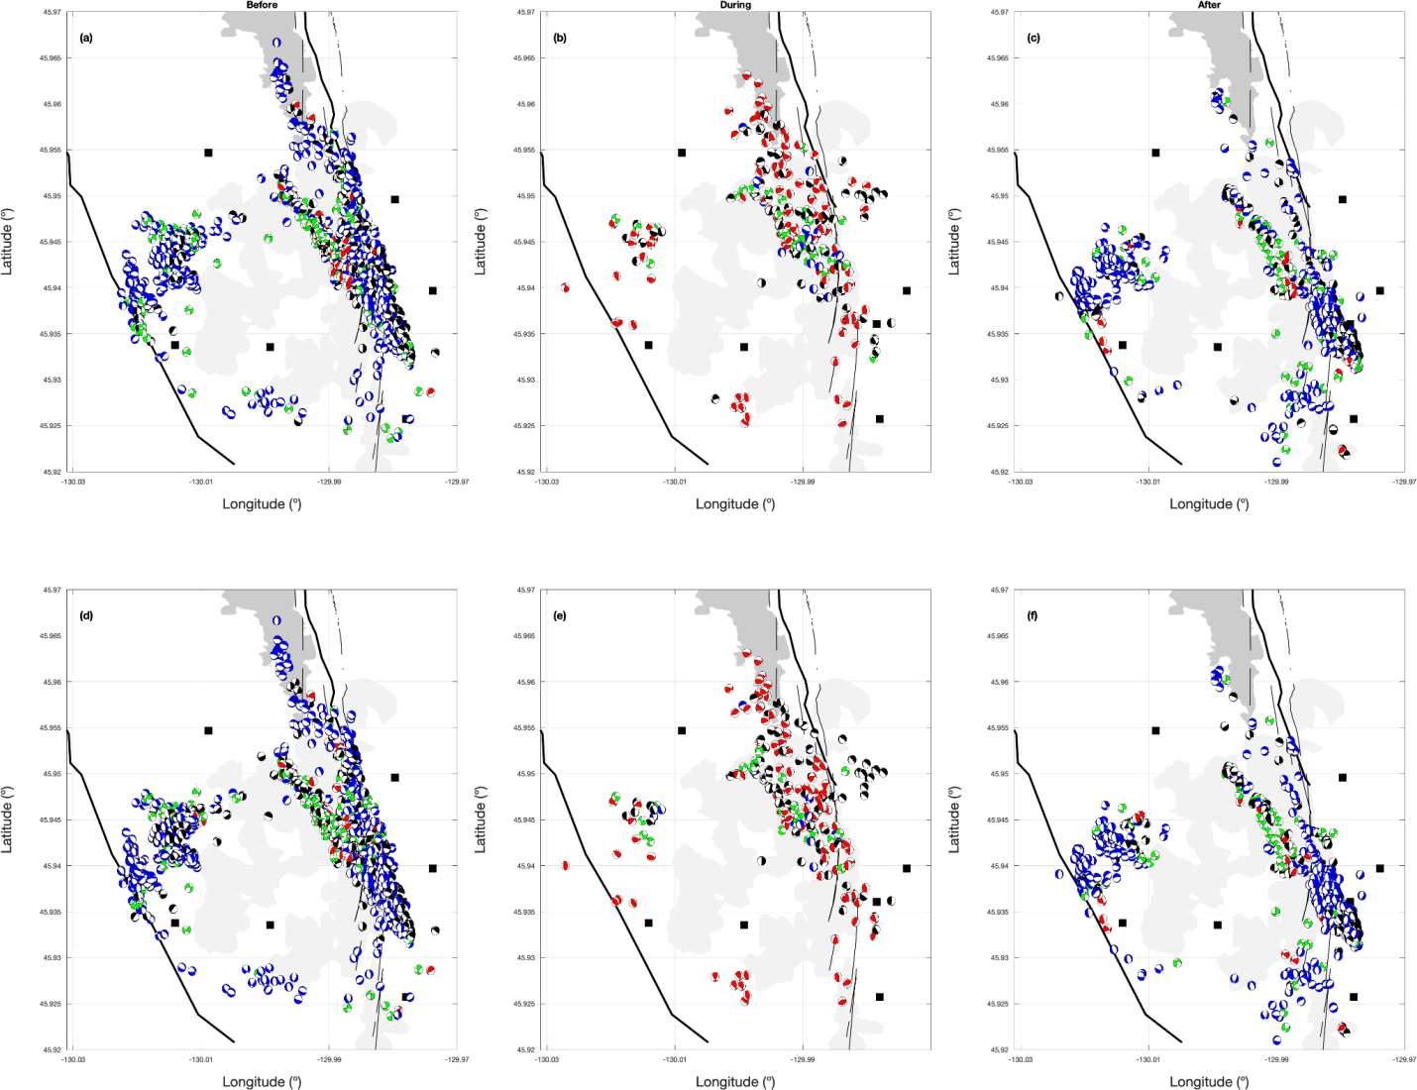
Figure 12. Comparison of focal mechanisms derived from two catalogs for events common to both datasets. Panels (a–c) show mechanisms from CC polarities, and panels (d–f) show mechanisms from the AxialPolCap. Columns correspond to before, during, and after the 2015 Axial Seamount eruption. Only focal mechanisms present in both catalogs are shown.
.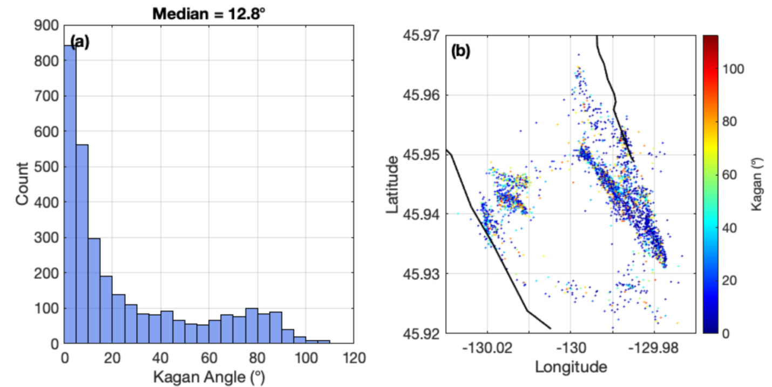
Figure 13. (a) Histogram and (b) spatial distribution of Kagan angle for focal mechanisms derived from CC and AxialPolCap polarities.
4.2 Real-Time Monitoring Framework
We have used AxialPolCap to implement a near-real-time focal mechanism capability into the as part of the Axial Seamount monitoring infrastructure. The focal mechanisms are publicly accessible through the Axial Seamount Earthquake Catalog web portal (http://axial.ocean.washington.edu/), which provides hourly-updated earthquake detections and HYPOINVERSE locations for the Ocean Observatories Initiative (OOI) Regional Cabled Array. As new seismic data are acquired and processed, AxialPolCap automatically classifies P-wave first-motion polarities for each station-event pair, and composite focal mechanisms are computed and appended to the online catalog (Figure 14). This operational pipeline enables continuous, near-real-time monitoring of stress and faulting geometry at Axial Seamount, providing the community with timely access to source mechanism information during periods of heightened volcanic or seismic activity.
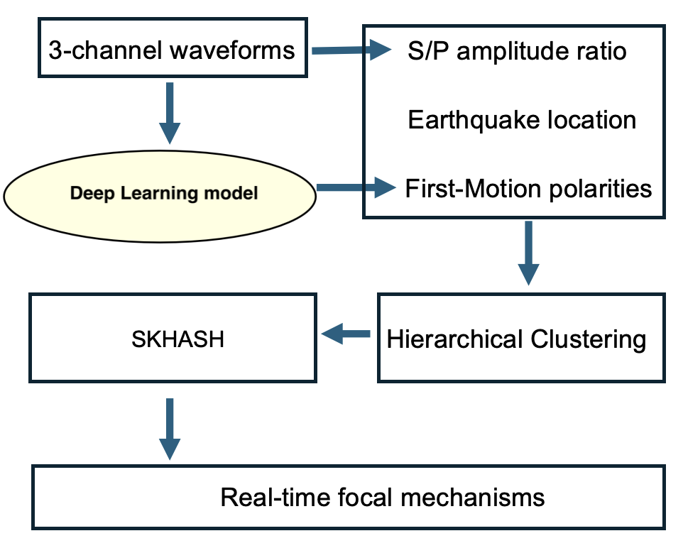
Figure 14. Schematic overview of the real-time focal mechanism pipeline. Three-component (3-channel) seismic waveforms are ingested by the deep learning model (AxialPolCap), which classifies P-wave first-motion polarities. The predicted polarities are grouped using hierarchical clustering to form event clusters, whose composite polarities are then passed to SKHASH for polarity-based focal mechanism inversion. The resulting focal mechanisms are produced in near-real time and made publicly available through the Axial Seamount Earthquake Catalog (http://axial.ocean.washington.edu/).
The pipeline operates as follows. Each hour, vertical-component waveforms are extracted for newly detected earthquakes using catalog P-wave arrival times and preprocessed identically to the training data: demeaned, detrended, bandpass filtered between 3 and 20 Hz, resampled to 100 Hz, and normalized by maximum absolute amplitude. AxialPolCap then classifies the first-motion polarity for each station–event pair, retaining only predictions with confidence ≥ 0.8 and entropy ≤ 0.2. The predicted polarities are grouped into event clusters using hierarchical clustering within each hourly batch, and composite polarities are computed for each cluster. These are passed to SKHASH (Skoumal et al., 2024) for focal mechanism inversion, and the resulting solutions are appended to the public catalog.
The pipeline has been running continuously since March 2026 and requires no manual intervention between updates. By providing probabilistic polarity estimates and confidence-weighted inputs to SKHASH, the framework supports robust focal mechanism determination even for small-magnitude events with limited station coverage. This capability is particularly valuable during periods of elevated seismicity, such as pre-eruptive swarms, when rapid, automated source characterization can inform real-time hazard assessment and guide field response at active submarine volcanic systems.

5 Discussion and Conclusion
We developed and validated AxialPolCap, which, to our knowledge, is the first deep-learning framework for automated P-wave first-motion polarity classification applied to the ocean environment at the Axial Seamount OBS network. Our results provide the first demonstration that continental deep-learning polarity models do not generalize to marine OBS networks without domain-specific adaptation, highlighting the fundamental role of ocean-noise conditions and OBS propagation effects. We also present a systematic comparison between cross-correlation–derived and machine-learning-based focal mechanisms catalog spanning the 2015–2021 eruption cycle at Axial Seamount. The framework provides a scalable and operational pathway for focal mechanisms determination in monitoring submarine volcanic systems in real time.
Benchmarking shows that existing DL polarity models perform ~10–20% worse at Axial Seamount, indicating limited out-of-domain generalization. Several factors likely contribute to this degradation. First, most Axial events are very small, so their waveforms often have low signal-to-noise ratios (SNR) in the presence of strong, ocean-generated ambient noise (e.g., currents and surface-wave energy) that differs in character from typical land noise. DL polarity accuracy is known to deteriorate rapidly at low SNR, with particularly strong declines reported below ~10 dB (Chakraborty et al., 2022). Because many DL models are trained primarily on higher-SNR, larger-magnitude earthquakes, they can struggle to separate weak P-onsets from the more complex marine wavefield. Second, widely used models (e.g., DiTingMotion and EQpolarity) are largely developed and tuned using massive land-based archives (e.g., Southern California and mainland China networks). As a result, they may implicitly learn features tied to land station responses, path effects, and tectonic settings. Applying these models to OBS data without domain adaptation, such as transfer learning or retraining with OBS-specific examples, can therefore reduce accuracy because the models have not been exposed to key aspects of underwater propagation and instrument/site characteristics (Chen et al., 2024).
The expanded polarity coverage directly improves focal-mechanism determination at Axial Seamount. By increasing the number of events with sufficient polarity constraints—particularly at lower magnitudes—the resulting catalog better resolves spatial and temporal variations in faulting associated with caldera-wall deformation and magmatic processes. The median Kagan angle of 13° indicates only a small three-dimensional rotation between mechanisms derived from AxialPolCap and cross-correlation polarities. This level of agreement is comparable to differences between independent microearthquake focal-mechanism catalogs (e.g., Hardebeck & Shearer, 2002) and is consistent with the expected uncertainty of polarity-based solutions for low-magnitude events with limited station coverage.
Disagreements between AxialPolCap and cross-correlation–derived polarities occur primarily at low signal-to-noise ratios and for waveforms near nodal-plane geometries, where first-motion polarity is inherently ambiguous. In many of these cases, AxialPolCap assigns low-confidence probabilities, indicating that disagreement reflects physical uncertainty rather than systematic model bias. Station AXID1 exhibits the highest rate of low-confidence predictions, consistent with its smaller event count and greater mixture of tectonic and hydrothermal source types, which produce more variable first-motion character than stations located at the caldera center. Cross-correlation methods may also fail to assign polarities to isolated events lacking sufficient waveform similarity, whereas AxialPolCap can provide a probabilistic estimate from single-waveform information. The probabilistic output therefore offers a practical measure of polarity confidence, allowing uncertain observations to be down-weighted rather than discarded. In practice, applying a confidence threshold of ≥0.8 and entropy ≤0.2 filters the most ambiguous predictions while retaining sufficient polarity coverage for focal-mechanism inversion; relaxing these thresholds increases polarity yield at the cost of higher disagreement with cross-correlation–derived polarities.
Cross-correlation-derived polarities and ML-derived polarities provide complementary ways to expand first-motion coverage, but they rely on different assumptions about the waveform and have different practical constraints. Cross correlation infers relative polarity from the sign of similarity between event pairs, so it is most reliable when earthquakes are clustered and waveforms are highly repeatable (Shelly et al., 2016). It provides intuitive quality control through correlation strength and network consistency, and it is generally not sensitive to small pick time errors because the measurement is controlled by the best aligning lag between two traces rather than the exact placement of a fixed window at the nominal onset. Its limitations are both methodological and operational. Performance degrades when waveform similarity breaks down due to strong path or site variability, complex scattering, or sparse seismicity, and the outcome is fundamentally relative so an external reference is needed to determine absolute sign, which typically requires a small set of trusted manual polarities. In addition, building a dense correlation matrix and solving large SVD problems can be computationally expensive, especially when starting from raw continuous data or very large catalogs (Zhang et al., in prep.).
In contrast, ML classifiers operate on single traces and can rapidly produce polarity estimates even for events that lack close neighbors, which is attractive for large catalogs and near-real-time applications. However, ML performance depends on how well the training data match the target domain, and it can be more sensitive to pick time uncertainty because a miscentered input window changes the phase content presented to the model unless robustness to time shifts is explicitly learned during training. In practice the two approaches reinforce each other, with cross correlation offering high confidence consistency checks and calibration targets, while ML fills coverage gaps where correlation connectivity is weak, together producing a more complete and better validated polarity dataset for focal mechanism analysis.
Training from scratch outperforms the transfer-learning model in our case for three related reasons. First, the pretrained model was developed primarily on higher-quality, higher-SNR waveforms (Chakraborty et al., 2022), whereas Axial OBS data span a much broader SNR range that includes abundant low-SNR arrivals where polarity performance degrades rapidly (e.g., Chen et al., 2024; Messuti et al., 2023; Ross et al., 2018). Second, our labeled dataset is large enough to support end-to-end learning, allowing the model to discover OBS-specific filters and noise-robust onset cues without relying on a pretrained representation. Third, our transfer-learning strategy freezes the feature extractor and retrains only a new classifier head. This can adjust the decision boundary for Axial labels, but it cannot fully adapt early and mid-level features to OBS noise and P-onset character, so performance can lag when the domain shift is large. Partial or full fine-tuning may improve adaptation, but it is harder to tune robustly under these conditions because it introduces additional training choices such as which layers to unfreeze and how aggressively to update them (e.g., Kumar et al., 2022; Sabha et al., 2024). Importantly, explicit time-shift augmentation during training substantially improves robustness to arrival-time uncertainty, reducing performance loss when the input window is slightly miscentered. This simple augmentation is therefore a broadly useful deployment tip for OBS settings where automated picks have variable timing precision.
The above is longwinded and ChatGPT suggested
“Training from scratch outperforms transfer learning in our case for three related reasons. First, the pretrained model was developed primarily on higher-SNR waveforms (Chakraborty et al., 2022), whereas Axial OBS data span a much broader SNR range, including abundant low-SNR arrivals where polarity performance degrades rapidly (e.g., Chen et al., 2024; Messuti et al., 2023; Ross et al., 2018). Second, our labeled dataset is sufficiently large for end-to-end learning, allowing the model to learn OBS-specific, noise-robust features. Third, because our transfer-learning strategy freezes the feature extractor and retrains only the classifier head, it cannot fully adapt to the substantial domain shift in OBS noise and P-onset characteristics. Partial or full fine-tuning may improve adaptation but introduces additional tuning choices (e.g., Kumar et al., 2022; Sabha et al., 2024). Finally, time-shift augmentation substantially improves robustness to arrival-time uncertainty, making it a simple and broadly useful strategy for OBS applications with variable pick timing.”
Because AxialPolCap requires only a single P-wave, it is well-suited for near-real-time implementation. Unlike cross-correlation workflows that depend on large template libraries and manual oversight, AxialPolCap provides immediate polarity estimates for a new earthquakes. The confidence-weighted polarity outputs are also directly compatible with advanced inversion frameworks such as SKHASH (Skoumal et al., 2024), where individual polarity weights can be incorporated to better constrain focal-mechanism uncertainty.
Overall, AxialPolCap represents the first operational deep learning framework for automated P-wave first-motion polarity classification that has been validated in a submarine volcanic environment. By requiring only a single waveform and a P arrival time, the method enables near-real-time polarity estimates and confidence weighting that can feed directly into focal mechanism pipelines such as SKHASH, supporting continuous updates rather than episodic catalog builds. Although accurate arrivals remain important and applying the model to other regions will require adaptation to local noise, instrument response, and network geometry, the workflow demonstrated here provides a practical template for extending deep learning polarity tools to other ocean bottom networks and cabled seafloor observatories worldwide. This establishes a scalable path toward routine focal mechanism monitoring of active submarine volcanoes, improving our ability to track evolving stress, fault activation, and magma transport through time.
CHATGPT response to please shorten by removing repetition and fluff and reorganizing. Not saying this better but these tools can help you to be concise.
We developed and validated AxialPolCap, the first deep-learning framework, to our knowledge, for automated P-wave first-motion polarity classification in a submarine environment. Applied to the Axial Seamount OBS network, it demonstrates that continental deep-learning (DL) polarity models have limited generalization to marine OBS data without domain-specific adaptation. We also systematically compare cross-correlation–derived and machine-learning (ML) polarity catalogs spanning the 2015–2021 eruption cycle. Together, these results establish a scalable approach for expanding polarity coverage and supporting focal-mechanism monitoring of submarine volcanic systems.

Existing DL polarity models perform approximately 10–20% worse at Axial Seamount than in their original applications, indicating substantial out-of-domain degradation. Two factors likely contribute. First, most Axial earthquakes are small and frequently have low signal-to-noise ratios (SNR) amid strong ocean-generated noise from currents and surface-wave energy. DL polarity accuracy declines rapidly at low SNR, particularly below ~10 dB (Chakraborty et al., 2022), while many models are trained primarily on larger, higher-SNR earthquakes. Second, models such as DiTingMotion and EQpolarity were developed largely from land-based networks and may therefore learn features associated with land-station responses, propagation paths, and tectonic settings. Without OBS-specific adaptation, they are not exposed to the distinctive noise and propagation characteristics of underwater environments (Chen et al., 2024).

Training AxialPolCap from scratch outperformed our transfer-learning approach. The pretrained model was developed primarily using higher-SNR waveforms, whereas our Axial dataset spans a much broader SNR range. Our labeled dataset was also sufficiently large to support end-to-end learning of OBS-specific noise and P-wave features. In contrast, our transfer-learning strategy froze the feature extractor and retrained only the classifier head, limiting adaptation to the marine environment. Partial or full fine-tuning may improve performance but introduces additional training choices (Kumar et al., 2022; Sabha et al., 2024). Explicit time-shift augmentation substantially improved robustness to arrival-time uncertainty, providing a simple strategy for OBS applications with variable pick precision.

AxialPolCap substantially expands polarity coverage, particularly for lower-magnitude earthquakes, improving focal-mechanism constraints on faulting associated with caldera-wall deformation and magmatic processes. The median Kagan angle of 13° between AxialPolCap and cross-correlation mechanisms indicates close agreement and is comparable to differences between independent microearthquake focal-mechanism catalogs (e.g., Hardebeck & Shearer, 2002). Disagreements occur primarily at low SNR and near nodal-plane geometries, where polarity is inherently ambiguous. AxialPolCap generally assigns low-confidence probabilities in these cases, suggesting that disagreement reflects physical uncertainty rather than systematic model bias. A confidence threshold of ≥0.8 and entropy ≤0.2 removes the most ambiguous predictions while retaining sufficient polarity coverage for focal-mechanism inversion.

Cross-correlation and ML provide complementary approaches to polarity determination. Cross correlation is most effective for clustered earthquakes with highly repeatable waveforms and provides useful quality control through correlation strength and network consistency (Shelly et al., 2016). However, performance decreases with path or site variability, complex volcanic scattering, and sparse seismicity. It also provides relative rather than absolute polarity and requires trusted reference polarities. Large correlation matrices and singular-value-decomposition calculations can become computationally expensive for large catalogs (Zhang et al., in prep.). In contrast, AxialPolCap operates on individual waveforms and can estimate polarity for isolated events, making it attractive for large catalogs and near-real-time applications. Its performance depends on domain-representative training data and can be sensitive to pick-time errors unless time-shift robustness is incorporated. Thus, cross correlation provides high-confidence consistency checks and calibration targets, while ML fills coverage gaps where correlation connectivity is weak.

Because AxialPolCap requires only a single waveform and P-wave arrival time, its polarity estimates can be generated rapidly and incorporated directly into focal-mechanism inversion frameworks such as SKHASH (Skoumal et al., 2024), including confidence-based weighting. Although accurate P-wave arrivals remain important, the workflow provides a practical template for applying DL polarity classification to other OBS networks and cabled seafloor observatories. Application to new regions will require adaptation to local noise, instrument response, propagation effects, and network geometry. AxialPolCap therefore provides a scalable pathway toward routine focal-mechanism monitoring of submarine volcanoes and more continuous tracking of fault activation, stress changes, and magma-related processes.

6 Data Availability Statement
The seismic data used in this study are publicly available through the Ocean Observatories Initiative (OOI) Data Portal (https://oceanobservatories.org/cabled-array-seismometer-data/), which provides access to real-time and archived waveforms from the Regional Cabled Array (RCA) at Axial Seamount. The earthquake catalog used was developed by Wang et al. (2024) and is accessible online at https://axialdd.ldeo.columbia.edu/index.html.proto. The composite focal mechanism catalog generated in this study, including 1D and 3D solutions, associated polarity determinations is available upon request from the corresponding author (Maochuan Zhang, mczhang8@uw.edu) and will be archived in a public repository (e.g., Zenodo) upon acceptance of this manuscript.

7 Acknowledgments
We acknowledge the Ocean Observatories Initiative (OOI) Regional Cabled Array for providing the data used in this study. The OOI is funded by the National Science Foundation We thank Ian Stone for discussions that helped improve the manuscript. This work was supported by NSF-OCE Grants 1536320 (F. W., M. T., Y. J. T., and D. S.) and 1536219 (W. W. and C. B.). This work was supported by NSF awards OCE-1950996 and OCE-1951448 and by NAME OF YOUR SCHOLARSHIP for M.Z.
8 References
Arnulf, A. F., Harding, A. J., Kent, G. M., Carbotte, S. M., Canales, J. P., & Nedimovic, M. R. (2014). Anatomy of an active submarine volcano. Geology, 42(8), 655-658.
Arnulf, A., Harding, A., Kent, G., & Wilcock, W. (2018). Structure, seismicity, and accretionary processes at the hot spot‐influenced Axial Seamount on the Juan de Fuca Ridge. Journal of Geophysical Research: Solid Earth, 123(6), 4618-4646.
Batista, G. E., Prati, R. C., & Monard, M. C. (2004). A study of the behavior of several methods for balancing machine learning training data. ACM SIGKDD explorations newsletter, 6(1), 20-29.
Caress, D. W., Clague, D. A., Paduan, J. B., Martin, J. F., Dreyer, B. M., Chadwick Jr, W. W., et al. (2012). Repeat bathymetric surveys at 1-metre resolution of lava flows erupted at Axial Seamount in April 2011. Nature Geoscience, 5(7), 483-488.
Chadwick, W. W., Clague, D., Embley, R., Perfit, M., Butterfield, D., Caress, D., et al. (2013). The 1998 eruption of Axial Seamount: New insights on submarine lava flow emplacement from high‐resolution mapping. Geochemistry, Geophysics, Geosystems, 14(10), 3939-3968.
Chadwick, W. W., Paduan, J., Clague, D., Dreyer, B., Merle, S., Bobbitt, A., et al. (2016). Voluminous eruption from a zoned magma body after an increase in supply rate at Axial Seamount. Geophysical Research Letters, 43(23), 12,063-012,070.
Chakraborty, M., Cartaya, C. Q., Li, W., Faber, J., Rümpker, G., Stoecker, H., & Srivastava, N. (2022). PolarCAP–A deep learning approach for first motion polarity classification of earthquake waveforms. Artificial Intelligence in Geosciences, 3, 46-52.
Chen, Y., Saad, O. M., Savvaidis, A., Zhang, F., Chen, Y., Huang, D., et al. (2024). Deep learning for P-wave first-motion polarity determination and its application in focal mechanism inversion. IEEE Transactions on Geoscience and Remote Sensing.
Clague, D. A., Dreyer, B. M., Paduan, J. B., Martin, J. F., Chadwick, W. W., Caress, D. W., et al. (2013). Geologic history of the summit of Axial Seamount, Juan de Fuca Ridge. Geochemistry, Geophysics, Geosystems, 14(10), 4403-4443.
Clague, D. A., Paduan, J. B., Caress, D. W., Chadwick, W. W., Le Saout, M., Dreyer, B. M., & Portner, R. A. (2017). High-resolution AUV mapping and targeted ROV observations of three historical lava flows at Axial Seamount. Oceanography, 30(4), 82-99.
Clague, D. A., Portner, R. A., Paduan, J. B., Le Saout, M., & Dreyer, B. M. (2019). Formation of the summit caldera at Axial Seamount. Paper presented at the AGU Fall Meeting Abstracts.
Dziak, R. P., & Fox, C. G. (1999). The January 1998 earthquake swarm at Axial Volcano, Juan de Fuca Ridge: Hydroacoustic evidence of seafloor volcanic activity. Geophysical Research Letters, 26(23), 3429-3432.
Hara, S., Fukahata, Y., & Iio, Y. (2019). P-wave first-motion polarity determination of waveform data in western Japan using deep learning. Earth, Planets and Space, 71(1), 1–11. https://doi.org/10.1186/s40623-019-1111-x
Hanks, T. C., & Kanamori, H. (1979). A moment magnitude scale. Journal of Geophysical Research: Solid Earth, 84(B5), 2348-2350.
Hardebeck, J. L., & Shearer, P. M. (2002). A new method for determining first-motion focal mechanisms. Bulletin of the seismological society of America, 92(6), 2264-2276.
Holtzman, B. K., Paté, A., Paisley, J., Waldhauser, F., & Repetto, D. (2018). Machine learning reveals cyclic changes in seismic source spectra in Geysers geothermal field. Science advances, 4(5), eaao2929.
Kent, G. M., Arnulf, A. F., Singh, S. C., Carton, H., Harding, A. J., & Saustrup, S. (2025). Melt focusing along lithosphere–asthenosphere boundary below Axial volcano. Nature, 641(8062), 380-387.
Kagan, Y. (1991). 3-D rotation of double-couple earthquake sources. Geophysical Journal International, 106(3), 709-716.
Klingspohn, W., Mathea, M., Ter Laak, A., Heinrich, N., & Baumann, K. (2017). Efficiency of different measures for defining the applicability domain of classification models. Journal of cheminformatics, 9(1), 44.
Kumar, A., Raghunathan, A., Jones, R., Ma, T., & Liang, P. (2022). Fine-tuning can distort pretrained features and underperform out-of-distribution. arXiv preprint arXiv:2202.10054.
Kuang, W., Yuan, C., & Zhang, J. (2021). Real-time determination of earthquake focal mechanism via deep learning. Nature communications, 12(1), 1-8.
Levy, S., Bohnenstiehl, D. R., Sprinkle, P., Boettcher, M. S., Wilcock, W. S. D., Tolstoy, M., & Waldhauser, F. (2018). Mechanics of fault reactivation before, during, and after the 2015 eruption of Axial Seamount. Geology, 46(5), 447-450.
Li, S., Fang, L., Xiao, Z., Zhou, Y., Liao, S., & Fan, L. (2023). Focmech-flow: automatic determination of p-wave first-motion polarity and focal mechanism inversion and application to the 2021 yangbi earthquake sequence. Applied Sciences, 13(4), 2233.
Lomax, A., Virieux, J., Volant, P., & Berge-Thierry, C. (2000). Probabilistic earthquake location in 3D and layered models: Introduction of a Metropolis-Gibbs method and comparison with linear locations. Advances in seismic event location, 101-134.
Michelini, A., Cianetti, S., Gaviano, S., Giunchi, C., Jozinović, D., & Lauciani, V. (2021). INSTANCE – the Italian seismic dataset for machine learning. Earth System Science Data, 13(12), 5509–5544. https://doi.org/10.5194/essd-13-5509-2021
Messuti, G., Scarpetta, S., Amoroso, O., Napolitano, F., Falanga, M., & Capuano, P. (2023). CFM: a convolutional neural network for first-motion polarity classification of seismic records in volcanic and tectonic areas. Frontiers in Earth Science, 11, 1223686.
Nguyen, T. T., Luong, A. V., Dang, M. T., Liew, A. W.-C., & McCall, J. (2020). Ensemble selection based on classifier prediction confidence. Pattern Recognition, 100, 107104.
Pan, S. J., & Yang, Q. (2010). A survey on transfer learning. IEEE Transactions on Knowledge and Data Engineering, 22(10), 1345–1359. https://doi.org/10.1109/TKDE.2009.191
Peng, L., Li, L., & Zeng, X. (2025). A Microseismic Phase Picking and Polarity Determination Model Based on the Earthquake Transformer. Applied Sciences, 15(7), 3424.
Pugh, D., White, R., & Christie, P. (2016). Automatic Bayesian polarity determination. Geophysical Journal International, 206(1), 275-291.
Rumelhart, D. E., Hinton, G. E., & Williams, R. J. (1986). Learning representations by back-propagating errors. Nature, 323(6088), 533–536. https://doi.org/10.1038/323533a0
Ross, Z. E., Meier, M. A., & Hauksson, E. (2018). P wave arrival picking and first‐motion polarity determination with deep learning. Journal of Geophysical Research: Solid Earth, 123(6), 5120-5129.
Sabha, S., Assad, A., Din, N., & Bhat, M. (2024). From scratch or pretrained? An in-depth analysis of deep learning approaches with limited data. International Journal of System Assurance Engineering and Management. https://doi.org/10.1007/s13198-024-02345-4.
Skoumal, R. J., Hardebeck, J. L., & Shearer, P. M. (2024). SKHASH: A Python package for computing earthquake focal mechanisms. Seismological Research Letters, 95(1), 319–329. https://doi.org/10.1785/0220230144
Shelly, D. R., Hardebeck, J. L., Ellsworth, W. L., & Hill, D. P. (2016). A new strategy for earthquake focal mechanisms using waveform‐correlation‐derived relative polarities and cluster analysis: Application to the 2014 Long Valley Caldera earthquake swarm. Journal of Geophysical Research: Solid Earth, 121(12), 8622-8641.
Tornetta, G. N. (2021). Entropy methods for the confidence assessment of probabilistic classification models. arXiv preprint arXiv:2103.15157.
Uchide, T. (2020). Focal mechanisms of small earthquakes beneath the Japanese islands based on first-motion polarities picked using deep learning. Geophysical Journal International.
Waldhauser, F., & Ellsworth, W. L. (2000). A double-difference earthquake location algorithm: Method and application to the northern Hayward fault, California. Bulletin of the seismological society of America, 90(6), 1353-1368.
Waldhauser, F., Wilcock, W., Tolstoy, M., Baillard, C., Tan, Y., & Schaff, D. (2020). Precision seismic monitoring and analysis at Axial Seamount using a real‐time double‐difference system. Journal of Geophysical Research: Solid Earth, 125(5), e2019JB018796.
Wang, K., Waldhauser, F., Schaff, D., Tolstoy, M., Wilcock, W. S., & Tan, Y. J. (2024). Real‐time detection of volcanic unrest and eruption at axial seamount using machine learning. Seismological Research Letters, 95(5), 2651-2662.
Wilcock, W. S. D., Dziak, R. P., Tolstoy, M., Chadwick Jr, W. W., Nooner, S. L., Bohnenstiehl, D. R., et al. (2016). Seismic constraints on caldera dynamics from the 2015 Axial Seamount eruption. Science, 354(6318), 1395-1399.
Zhang, J., Li, Z., & Zhang, J. (2023). Simultaneous seismic phase picking and polarity determination with an attention‐based neural network. Seismological Society of America, 94(2A), 813-828.
Zhao, M., Xiao, Z., Zhang, M., Yang, Y., Tang, L., & Chen, S. (2023). DiTingMotion: A deep-learning first-motion-polarity classifier and its application to focal mechanism inversion. Frontiers in Earth Science, 11, 1103914.
Zhu, W., & Beroza, G. C. (2018). PhaseNet: A Deep-Neural-Network-Based Seismic Arrival Time Picking Method. Geophysical Journal International.
Zhu, W., McBrearty, I. W., Mousavi, S. M., Ellsworth, W. L., & Beroza, G. C. (2022). Earthquake phase association using a Bayesian Gaussian mixture model. Journal of Geophysical Research: Solid Earth, 127(5), e2021JB023249.

