Several problems:

1. I do all the work on our private cloud, then I realize that outside can’t visit that. So, I just show some picture and give some of my thoughts.
2. I am too busy recently, so I don’t full finish all the process.

All my works are checkin to the github:

<https://github.com/maodage2005/helloworld.git>

CI process (also in the pipeline.groovy file)

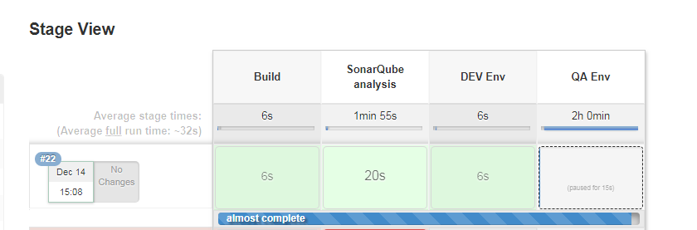

1. Build

Any checkin will trigger the build process, and output will be named as package-${build_number}.war/package-${build_number}.zip, and be placed to a share folder (//sharefolder)

1. Sonar

After build, sonar scan (code quality) will be triggered.

1. DEV Env:

DEV environment is just for DEV team to check their update, and don’t have much data, so I use docker to setup that.

Dockerfile can be found in docker/*

After docker container startup, simple smoke test will be run.

1. QA Env:

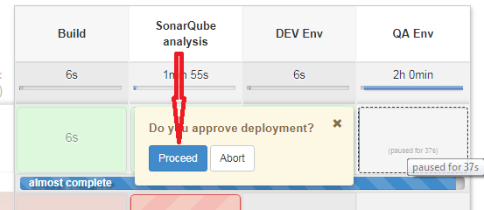

After verification of DEV site, QA can trigger QA site deployment, which will also deploy the exactly version of package in the same build process.

As QA site may have some data, and would be the same configuration of production, I will use Ansible to deploy the site. Ansible script can be found in ansible\playbook\deploy2Tomcat.yml

1. UAT/Production

Use the same script in QA site, but change inventory file (Ansible level).