A CeDeFi Wealth-Management Product: Design Specification
A Trust Architecture and Efficiency Design for On-Chain Capital and Off-Chain Quantitative Strategies
On-chain liabilities, off-chain assets.

Contents
1 Motivation: What Problem Are We Actually Solving? 1
1.1 What “CeDeFi” Means Here 1
1.2 Why Do It This Way 1
1.3 The Core Problem of This Approach: Trust 1
1.4 A Key Observation: Different-Sized Users Have Entirely Different Sensitivities 1
2 The Most Important Things to Consider When Designing This System 1
2.1 Building Trust and Security (the most important) 1
2.2 Capital Efficiency 1
2.3 Product Diversity and Composability 1
2.4 Verifiable Transparency 1
3 Design 1
3.1 Three-Layer Abstraction: User → Product → Strategy 1
3.2 On-Chain Layer: The Wealth-Management Contract Matrix 1
3.3 Custody Layer: Inbound Wallet + Unified Mapping Source 1
3.4 CEX Layer: Multiple Exchanges, Multiple Sub-Accounts 1
3.5 Three External Roles and Permission Isolation 1
3.6 Redemption Fund Flow: Decoupling Two Orders 1
3.7 Control Flow and Data Flow 1
3.8 Liquidity Management 1
3.9 NAV, Subscription/Redemption Pricing, and Sources of Yield 1
3.10 Proof of Reserve (PoR) and Liability Reconciliation 1
4 The Boundary of This Scheme: The Trust Problem Is Not Fully Eliminated 1
5 Sovereign Agent + CeDeFi: Taking the Operations Layer Out of Human Hands 1
5.1 The Common Root of the Five Residual Trust Points 1
5.2 Which Roles Are Handed to the Agent, and Which Are Kept (mapping to Chapter 3) 1
5.3 Point-by-Point Response to Chapter 4’s Residual Trust Points 1
5.4 The New Trust Surface the Sovereign Agent Introduces, and the Boundary It Cannot Erase 1
5.5 Gradual Rollout 1

1 Motivation: What Problem Are We Actually Solving?

1.1 What “CeDeFi” Means Here
The CeDeFi discussed in this specification refers to a specific class of financial product, characterized by the following pipeline:
- Capital is raised from users on-chain (USDC, BTC, ETH, and so on);
- that capital is held by a regulated custodian (Custody);
- through a Mirror mechanism, the custodied assets serve as a quota that is mapped onto centralized exchanges (CEXs);
- a quantitative team runs strategies such as Delta-neutral arbitrage on the CEXs to generate yield;
- the yield ultimately flows back on-chain and is distributed to the users who hold the product certificate (the LP Token).
In short: liabilities are raised on-chain, while assets are operated off-chain.

1.2 Why Do It This Way
A natural objection is: if the capital originates on-chain, why not simply run the strategies on-chain (in DeFi)? The answer rests on three points:
- Insufficient on-chain depth. The liquidity, slippage profile, and capacity of mainstream DeFi perpetual-futures and options markets remain one to two orders of magnitude behind top-tier CEXs such as Binance, Bybit, and OKX. Once scale grows, on-chain venues simply cannot bear the load.
- Insufficient strategy diversity. Mature market-neutral strategies — cross-exchange arbitrage, basis arbitrage, funding-rate arbitrage, market making — are still effectively executable only on CEXs for the most part. The set of strategies that can run on-chain is a strict subset of what is available on CEXs.
- Execution cost and speed. Gas fees, block times, and MEV make high-frequency quantitative trading all but infeasible on-chain.
CeDeFi is therefore, at its core, a trade-off: it sacrifices on-chain purity in exchange for off-chain depth, diversity, and efficiency.

1.3 The Core Problem of This Approach: Trust
Once capital moves from on-chain to off-chain accounts,
the user no longer holds their own assets; they hold a certificate representing the platform’s promise to return the money.
The question is therefore no longer the DeFi-style “can the smart contract be hacked?” but rather the CeFi-style:
- Will the platform abscond with the funds?
- Will the platform misappropriate the funds to plug other holes?
- If the platform becomes insolvent, whose money is mine?
- To what extent can I verify that the money is still there?
The cascade of failures — FTX, Celsius, 3AC — has demonstrated repeatedly that in a CeFi pipeline, trust is not a soft problem but a hard one that can wipe users out entirely. Any CeDeFi product that cannot offer a systematic, verifiable trust scheme is, in essence, no different from “trust me, I won’t run.”
The first and most central design objective of this specification is therefore not yield, but this: to build trust through structure rather than through promises.

1.4 A Key Observation: Different-Sized Users Have Entirely Different Sensitivities
Users of different sizes are not sensitive to the same risks:
User type | Cares most about | Insensitive to
Small (< $100K) | Yield, ease of subscription/redemption, user experience | Underlying legal structure, recourse details
Mid-size ($100K – $1M) | Yield + platform stability + PoR | Complex compliance structure
Large (> $1M, institutional) | Title to assets, recourse, liquidity, bankruptcy remoteness | A few percentage points of yield difference

Put simply:
Small money looks at yield; large money looks at safety.
A user with $10M fears not that the platform’s quant book loses 5% (quant losses are bounded) but that the platform absconds with the funds (a 100% loss). The same product line must therefore deliver on yield and experience for small users, and on legal and physical isolation for large users. This is the origin of much of the layered design that follows.

2 The Most Important Things to Consider When Designing This System
Translating the problems of Part 1 into design objectives, this specification is organized around four dimensions.

2.1 Building Trust and Security (the most important)
“Trust” is not a single thing; it is the superposition of three independent layers of assurance. If any one layer is missing, trust as a whole collapses.
Layer 1: Legal safety
The question it answers: “If the platform fails tomorrow, whose money is mine, legally?” The core instruments are:
- SPV / SPC architecture. The wealth-management business is placed inside an independent legal entity (a segregated-portfolio company). Legally, the users’ money is not the platform’s asset but an asset held in trust by the SPV. On the platform’s insolvency, these funds do not enter the liquidation estate.
- LP Token as a participating-share certificate. On-chain, the LP Token corresponds legally to Participating Shares under the SPV. Holding the LP Token equals holding a legal claim on the underlying assets, allowing the user to assert that claim directly with the liquidator, bypassing the platform.
- Optional: user-owned-account mode. For very large institutional clients, the platform may permit the use of the client’s own Custody and CEX accounts, with the platform granted only API operating permissions. In this mode, the funds physically never leave the client’s own accounts.
Layer 2: Operational safety of fund movement
The question it answers: “Even if the money is legally mine, how do I know it is physically still there — that the platform is not misappropriating it?” The core instruments are:
- Funds never leave Custody. User funds always reside with a regulated third-party custodian. What runs on the CEX is not the real assets but a trading quota mapped out via the Mirror mechanism. Even if a CEX collapses (an FTX rerun), the principal still sits safely in Custody’s segregated accounts.
- Whitelists lock down the fund path. All transfer destinations are whitelisted addresses: “Custody deposit address — wealth-management contract — Mirror to a designated CEX sub-account — flow back to a designated address.” Assets cannot flow to any wallet outside the whitelist.
- Three-way separation of permissions. On the same CEX sub-account, the quant team, the risk team, and the dashboard data source each hold a distinct, differently-scoped Key — the quant has order-placement permission only, the risk team has liquidation permission only, and the data source has read-only permission. The loss of any single Key cannot lead to funds being withdrawn.
- Proof of Reserve (PoR) + third-party audit. The custodian periodically issues a signed attestation of assets, and an independent auditor periodically verifies that “physical assets ≥ on-chain liabilities.” The liability figures come from on-chain data (transparent and queryable); the asset figures come from Custody (and can be endorsed by Custody). Alignment of the two sides demonstrates that the platform has not misappropriated funds.
- An operationally transparent dashboard. Users see in real time which product their funds are in, which strategies the product is deployed into, the strategies’ current NAV, and the coverage ratio — every black box laid open.
Layer 3: Safety of the capital itself
The question it answers: “Even if the money is not misappropriated, could the quant strategy itself lose it all?” The core instruments are:
- Delta-neutral strategies. Strategy returns are independent of market direction. Whether BTC rises or falls, the strategy targets a stable yield, eliminating directional exposure at the root. The system monitors Delta in real time and, beyond a threshold, alerts and freezes fund disbursement to prevent the quant team from quietly adding a directional bet.
- Junior tranche. The platform’s own capital (or junior capital provided by risk-tolerant users) acts as a first-loss layer. Strategy losses consume the junior tranche first and only touch user principal once it is exhausted. For fixed-income products this is a direct safety cushion.
- Liquidity safety. Mechanisms such as a T+N redemption period, a daily redemption cap, and emergency circuit breakers prevent forced liquidation and slippage losses driven by a run.

2.2 Capital Efficiency
Safety alone is not enough. If capital sits idle most of the time, the product’s yield cannot hold up. Capital efficiency is built primarily on two mechanisms.
Yield stacking
A typical example is a Treasury-enhanced product:
- the user deposits USDC;
- the USDC buys tokenized U.S. Treasuries on-chain (capturing ~4–5% Treasury yield);
- the tokenized Treasuries are custodied;
- Custody posts the Treasuries as collateral, mirrors them to a CEX, and generates a margin quota;
- on the CEX, that quota runs a Delta-neutral strategy (capturing a second layer of yield).
The user ultimately receives the stack of “Treasury yield + quant yield.” This is one of CeDeFi’s key advantages over pure on-chain DeFi: it can exploit on-chain RWA and off-chain trading venues simultaneously. The constraints are: it usually requires a USD denomination (since Treasuries are USD-priced); it depends on a specific supported combination of Custody and CEX (for example ByCustody + Bybit); and the Mirror’s legal and operational path must be robust.
Daily netting and idle-fund management
- Daily subscription/redemption netting. If on a given day one user deposits $1M and another withdraws $0.8M, the $0.8M physically does not move at all — it is offset internally, and only the $20K net amount triggers a real physical transfer. This sharply reduces Custody transfer costs, gas, and slippage.
- Cross-product liquidity scheduling. Liquidity is scheduled uniformly across all products. When product A is in net outflow and product B in net inflow, physical funds can be netted internally rather than routed externally.
- Idle-window arbitrage. Funds left idle during a redemption lock-up or as netting residue — a window of days to weeks — are automatically routed into blue-chip on-chain DeFi (Aave, tokenized money-market funds) to earn extra yield. This yield accrues to the platform and is one source supporting low-fee operation.

2.3 Product Diversity and Composability
A wealth-management platform that can operate over the long run must offer a sufficiently rich product matrix so that users with different risk appetites, capital sizes, and denomination preferences can each find a suitable instrument:
- Yield-type dimension: fixed income (for conservative users and institutions) versus floating NAV (for users willing to bear volatility in pursuit of excess return).
- Tenor dimension: on-demand T+0 / short-term T+7 / long-term T+30+, matching different liquidity needs.
- Denomination dimension: USD-denominated (easiest to connect to RWA) / BTC-denominated / ETH-denominated.
- Underlying-mapping dimension: directly mapping a single strategy versus wrapping a multi-strategy portfolio. Third parties may build secondary wrappers on top of the base products.
This is not a core safety consideration, but it is essential to the commercial viability of the product.

2.4 Verifiable Transparency
Transparency is itself a security mechanism. Even with the three security layers above in place, if the user cannot verify them, then from the user’s perspective they may as well not exist. This specification therefore treats transparency as an independent dimension:
- the liability data on the on-chain side is transparent by nature (product contracts and LP Token balances are publicly queryable);
- the asset data on the off-chain side is disclosed periodically via PoR + audit;
- the two are aligned at a per-product granularity, avoiding the situation of “global coverage but local shortfall.”

3 Design

3.1 Three-Layer Abstraction: User → Product → Strategy
On the product side, the system has three layers of abstraction:
- User layer: the user holds an LP Token representing a share of, and a legal claim on, some product. The user sees only the product — APY, start date, redemption period, risk grade — and need not know the underlying strategy details.
- Product layer: a wealth-management product (a Vault) is a standardized contract template with a fixed set of parameters (denomination, yield type, accrual/redemption rules, capacity cap, whether it carries a junior tranche, and so on). A product may purchase multiple strategies underneath and allocate capital among them by preset weights (for example, product A = 40% cross-exchange arbitrage + 60% Delta-neutral).
- Strategy layer: a strategy is a concrete profit model — cross-exchange arbitrage, basis arbitrage, Delta-neutral, market making, and so on. A strategy is abstract; it ultimately manifests on a set of CEX sub-accounts, and a single strategy often runs simultaneously across multiple sub-accounts on multiple CEXs (cross-exchange arbitrage, for instance, is inherently multi-account collaboration).
These three layers form a many-to-many relationship:
A product can buy multiple strategies; a strategy can serve multiple products; a strategy runs on multiple CEX sub-accounts; and a single CEX can host multiple strategies simultaneously.
The benefits of this abstraction are:
- The user’s view is simple — only the product needs to be understood.
- Strategies are reusable — the same strategy can be combined by multiple products at different weights.
- Capital can be accounted for in groups — at any instant one can compute precisely “how much money a given product has in a given strategy.”
- Risk control can be applied in layers — at the strategy layer (position and leverage limits) and at the sub-account layer (forced liquidation, withdrawal lockdown).
The deposit fund flow of the entire system is shown below. Taking “Vault A (stable on-demand)” as the representative case, it shows the complete pipeline: user deposit → on-chain contract → Custody → CEX → quant / risk / dashboard.
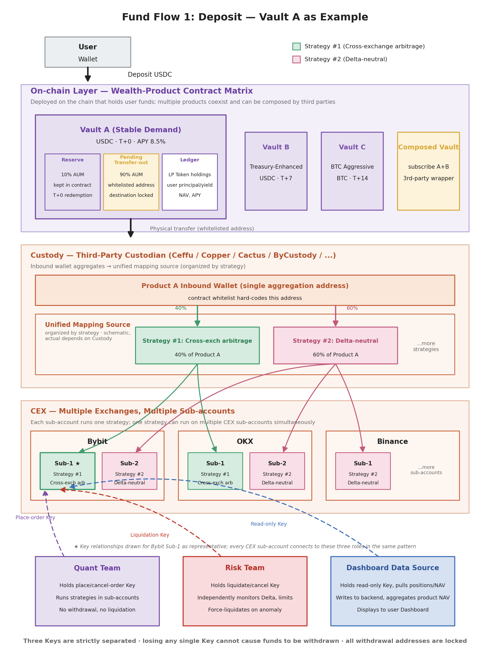
Figure 3.1 — Deposit fund flow: the three-layer mapping product → strategy → CEX sub-account, with the three-way permission separation of quant / risk / dashboard.
The remaining subsections expand on each layer in turn.

3.2 On-Chain Layer: The Wealth-Management Contract Matrix
The on-chain layer is the part the user can verify directly, and it is where the legal certificate (the LP Token) is issued. Each product is deployed as an independent Vault contract on the chain where the user’s funds reside — Solana / Ethereum / BSC / and so on.
3.2.1 Internal composition of a Vault contract
Taking Vault A (stable on-demand) as an example, the contract is internally composed of three parts:
- Reserve sub-region (10% of AUM): an on-chain reserve kept inside the contract, dedicated to T+0 instant redemption. After a user burns their LP Token, funds transfer to the user directly from this sub-region — without passing through Custody, without calling any API, settling within the transaction. This is precisely the significance of the “on-chain reserve”: keeping it inside the contract rather than at Custody is what makes instant redemption truly possible.
- Pending-transfer-out sub-region (90% of AUM): funds awaiting dispatch to Custody. The key constraint here is that the destination address is hard-coded in the contract (whitelisted) and can only be the designated Custody inbound wallet, never any other address. Even if the backend is breached, funds can only move within the whitelist.
- Ledger sub-region: maintains each user’s LP Token holdings, cumulative principal, and cumulative yield, as well as the product’s overall NAV and APY. This data is entirely on-chain, and anyone can independently verify “how much I am owed.”
3.2.2 The product matrix and composability
Vault A is only one product. The system supports deploying multiple products simultaneously to match different user needs:
- Vault B (Treasury-enhanced): USDC-denominated, fixed APR, T+7 redemption, KYC-gated, aimed at institutions.
- Vault C (BTC-aggressive): BTC-denominated, floating NAV, T+14 redemption, with a junior tranche, aimed at Web3 users.
- … and more.
More importantly, these Vaults are composable — a third party can deploy a “composite Vault” that, at the contract level, subscribes to both Vault A and Vault B at custom weights, offering a new product form. This is a key advantage over traditional CeFi platforms: the product itself is an open, composable on-chain primitive.
3.2.3 An unsolved problem: on-chain KYT
An honest admission: how to perform KYT (Know Your Transaction — anti-money-laundering checks on-chain) currently has no ideal solution. The options and their respective problems are:
- Contract calls an on-chain KYT oracle (e.g., Chainalysis Oracle, TRM): at deposit time, statically call the oracle and revert directly for blacklisted addresses. Problem: oracle data lags and has incomplete coverage; the oracle is itself centralized and constitutes a new attack surface.
- Off-chain monitoring + blacklist sync: an administrator pushes detected blacklist entries into the contract. Problem: this returns to the old road of “trust the administrator.”
- Defer KYT to the Custody side: when funds reach the Custody inbound wallet, Custody fulfills its compliance obligation and performs KYT. Problem: checking after the money has already entered the contract is pointless — the funds have already commingled into the product pool.
Until a better scheme emerges, the realistic choice of this specification is: do not perform KYT at the on-chain layer for now, and rely on the Custody-side compliance check as a backstop. This is a publicly acknowledged defect, left for future improvement (including the Sovereign Agent direction discussed in Chapter 5).

3.3 Custody Layer: Inbound Wallet + Unified Mapping Source
Custody (Ceffu / Copper / Cactus / ByCustody, and so on) is the regulated third party that physically holds user assets. The actual storage location of all user funds is here; what runs on the CEX is only the trading quota mapped out via Mirror. Custody is organized into two layers in this system.
3.3.1 Layer one: the product inbound wallet
Each product has a single inbound wallet within Custody, serving as the consolidation address hard-coded into the contract whitelist. Its roles are:
- to be the unique recipient of funds from the on-chain Vault contract;
- to act as the minimal unit of product-level asset isolation — the funds of different products are strictly separated within Custody.
3.3.2 Layer two: the unified mapping source (organized by strategy)
Funds consolidated by the inbound wallet then enter, within Custody, a “unified mapping source” — a capital pool organized by strategy. Note that the “unified mapping source” is an illustrative concept; the actual implementation depends on the Custody vendor. For example:
- Ceffu requires a 1:1 mapping: one Ceffu wallet corresponds to one Binance sub-account.
- Copper allows a single unified mapping source to map simultaneously to multiple sub-accounts across multiple CEXs.
Whichever the physical implementation, the logic can be expressed as: the inbound wallet’s funds are grouped by strategy, and each strategy corresponds to a set of Mirror targets (CEX sub-accounts). For instance, product A’s funds might be split as:
- 40% into the “Strategy #1: cross-exchange arbitrage” pool → mirrored to Bybit sub-1, OKX sub-1, and other sub-accounts;
- 60% into the “Strategy #2: Delta-neutral” pool → mirrored to Bybit sub-2, OKX sub-2, Binance sub-1, and so on.
The strategy layer is the core of this structure: it decouples “capital classification” from “the concrete sub-account.” This lets a single strategy be distributed across multiple CEXs and multiple sub-accounts (diversifying risk and adding depth), while letting NAV computation aggregate by strategy (without needing to care about the physical sub-account level).

3.4 CEX Layer: Multiple Exchanges, Multiple Sub-Accounts
The bottom layer is the various CEXs — Bybit, OKX, Binance, and so on. The funds are not here; only the “trading quota mirrored out” is here. The key design points of the CEX layer are:
- No direct withdrawal — only Mirror. Funds in a CEX sub-account are mirrored over from Custody and cannot be withdrawn directly; they must be settled back to Custody (both principal and yield).
- One sub-account runs one strategy. Multiple strategies are never mixed within a single sub-account, which simplifies risk attribution and Delta monitoring.
- One strategy is distributed across multiple sub-accounts. Cross-exchange arbitrage, for example, is inherently multi-account collaboration — positions exist simultaneously on Bybit sub-1 and OKX sub-1. Delta-neutral strategies are also frequently spread across multiple CEXs to improve depth and resilience to impact.

3.5 Three External Roles and Permission Isolation
Three roles coexist on a CEX sub-account, each holding a differently-scoped API Key. This is the core of the system’s “three-way permission split” — and the key to answering “why can funds be safely handed to a quant team to run strategies?”
3.5.1 Quant team — the place-order Key
- Permissions: place orders, cancel orders, and adjust positions within the sub-account.
- Does not have: withdrawal permission or fund-dispatch permission.
- Responsibilities: run the various strategies and generate yield.
Even if an attacker obtains the quant team’s Key, the most they can do is trade recklessly within the sub-account, causing bounded losses; they cannot withdraw funds and cannot trigger fund dispatch.
3.5.2 Risk team — the liquidation Key
- Permissions: force-liquidate positions and cancel orders.
- Does not have: position-opening permission or withdrawal permission.
- Responsibilities: independently monitor each sub-account’s Delta, leverage, and risk exposure, and force-liquidate to stop losses on anomalies.
The strict separation of the liquidation Key from the place-order Key means quant and risk form a mutual check on one another — quant can open positions, but risk can close them when necessary. This is the core mechanism preventing the quant team from quietly adding a directional bet.
3.5.3 Dashboard data source — the read-only Key
- Permissions: read-only — fetch positions, NAV, orders, and similar data.
- Does not have: any write permission.
- Responsibilities: write CEX data into the backend data warehouse; the backend aggregates by strategy to compute product NAV, then outputs to the user dashboard.
Using an independent read-only Key for the dashboard data source ensures that even if all write-permission Keys (place-order, liquidation, Custody dispatch) are disabled, the data channel shown to users remains intact; and that the asset data users see comes straight from the CEX, passing through only “read + aggregate,” with no party able to tamper with it.
3.5.4 The implicit fourth party: the fund-allocation module
Beyond the three roles above, there is an implicit one — the fund-allocation module. It holds the Custody write API and is responsible for initiating intra-Custody and cross-Custody fund dispatch, as well as delegating/undelegating funds to and from CEX sub-accounts. This module is entirely independent of quant and risk, can dispatch only within the dual constraint of the contract whitelist + the Custody whitelist, and cannot move funds out of the system.
Taken together, all permissions that touch funds are dispersed across four independent key-holders:
Role | Key permissions | Worst case if the Key is lost
Quant team | Place / cancel orders (CEX sub-account) | Reckless trading within the sub-account; bounded loss
Risk team | Force-liquidate / cancel (CEX sub-account) | Sub-account maliciously liquidated; funds cannot be moved out
Dashboard data source | Read-only (CEX sub-account) | Data display interrupted; funds unaffected
Fund-allocation module | Write API (Custody) | Dispatch within the whitelist; cannot move funds out of the system

No single key and no single module can withdraw funds on its own. This is the core guarantee of this specification along the “operational safety” dimension.

3.6 Redemption Fund Flow: Decoupling Two Orders
3.6.1 A clarification: the T+0 on-demand product has no real “redemption process”
The design premise of the T+0 on-demand product (Vault A) is precisely that a reserve of 10% of AUM covers all routine small-amount instant-redemption demand. After a user burns their LP Token, funds transfer to the user directly from the contract’s reserve sub-region, settling within the transaction, triggering no action whatsoever from Custody or the CEX. In other words, the “redemption” of a T+0 product is a transfer internal to the contract — there is no full process to draw. When the reserve level is drawn down, the backend replenishes it through routine scheduling from the “pending-transfer-out sub-region” or from strategy-layer repayments; this is a periodic operational action, not part of the trigger path of each individual redemption.
What truly requires the full pipeline are products with a redemption waiting period — T+7, T+14, and so on. Their design premise is that the user’s money spends most of its time earning yield in the strategy layer, and on redemption must be brought all the way back from there. The following uses Vault A (T+7) as the example.
3.6.2 Two orders: the user’s view vs. the system’s view
The key to understanding the redemption process is to recognize that there are in fact two independent orders, differing in lifecycle, initiator, and completion condition:
- Order A — the user → product redemption order. Initiated by the user on-chain (burn the LP Token, enter the redemption queue); the order completes when the user reclaims principal + yield after T+7. This is the only order the user perceives, and the intervening process is transparent to them.
- Order B — the product → strategy liquidation order. Initiated by the backend after end-of-day netting; the net outflow is allocated by each strategy’s weight, and the strategy layer is instructed to liquidate; the strategy layer liquidates on the CEX sub-accounts it manages, undelegates the funds back to the strategy wallet, and then sends them back to the product wallet, completing Order B. This is an order internal to the system, invisible to the user.
The benefit of decoupling the two orders is that the user’s redemption promise (T+7) and the system’s internal fund-scheduling rhythm (batch processing after daily netting) are separated. The backend can process Order B at whatever rhythm is most efficient, rather than immediately triggering a CEX liquidation for every single user redemption.
3.6.3 “Product” and “strategy” are ledger concepts; funds flow in physical wallets
Section 3.1 explained that product and strategy are two of the three abstraction layers. One point is easily confused: “product” and “strategy” are essentially ledger concepts, while the funds’ true physical location is in different wallets.
- A product’s money is physically distributed across two places: the on-chain Vault contract (reserve + pending transfer-out) and the product wallet in Custody (the single consolidation address). But this is only the cash a product directly holds — most of a product’s value is the shares it has invested in various strategies (physically located in the two places under “a strategy’s money” below: the strategy wallet + CEX sub-accounts), plus funds temporarily parked in on-chain DeFi for scheduled redemption (Earmarked). A product’s total physical assets = the cash in these two places + the value of its held strategy shares + the portion parked in DeFi, which together cover all the LP Token liabilities the product has issued on-chain (the full aggregation is given in 3.9.1).
- A strategy’s money is also physically distributed across two places: the strategy wallet in Custody (the portion of the unified mapping source belonging to that strategy) and the Mirror quota in the CEX sub-accounts. These two together are the strategy’s entire physical assets — while its “liabilities” are the “how many shares I invested in this strategy” recorded on each product’s ledger.
This distinction matters because it explains why, on redemption, funds must flow among several wallets: CEX sub-account → strategy wallet → product wallet → on-chain Vault → user. Each step is a real wallet-to-wallet transfer, because “product” and “strategy” have a well-defined asset attribution on the ledger, and funds must follow that ledger attribution.
3.6.4 Fund flow vs. control flow
The figure below explains the redemption process; it carries two flows of different natures simultaneously:
- Fund flow (solid lines): real wallet-to-wallet transfers, occurring within the Custody / CEX system.
- Control flow (dashed lines): orders and instructions issued by the backend. The backend itself is not inside the Custody / CEX system — it is external, and drives fund actions through API calls. Specifically, the fund-allocation module (holding the Custody write API) initiates inter-wallet transfers, and the quant module (holding the CEX place-order Key) initiates liquidation on the CEX sub-accounts.
Viewing these two flows separately makes the initiator and nature of each action clearer — which are real asset relocations, and which are merely the backend directing a relocation.
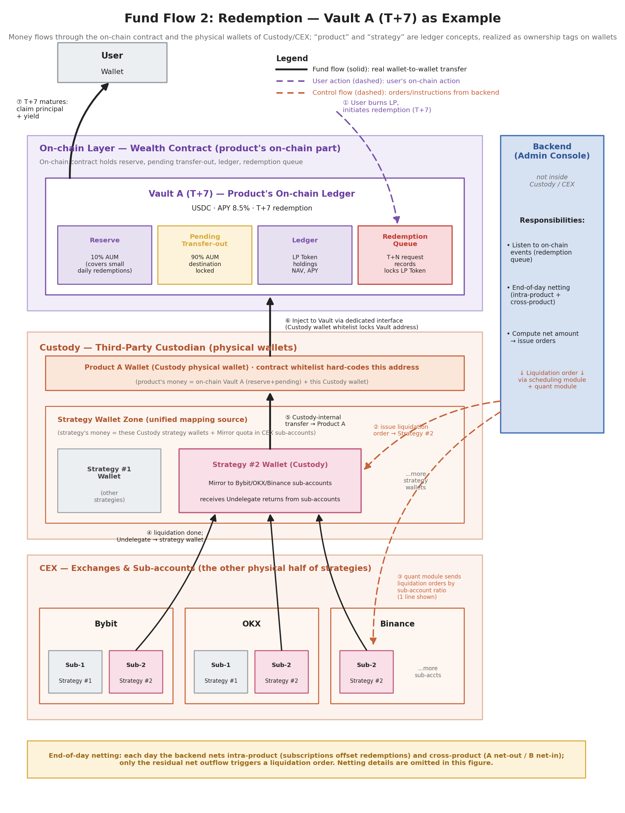
Figure 3.2 — Redemption fund flow (Vault A T+7 example): fund flow travels through wallets, control flow is initiated by the external backend; the two orders (user→product, product→strategy) are decoupled.
3.6.5 The complete pipeline: seven steps
Combining all the concepts above, the complete redemption pipeline is:
- ① The user burns the LP Token and enters the redemption queue. An on-chain action that locks the LP Token and starts the T+7 clock. This is the initiation of Order A.
- ② After end-of-day netting, the backend issues the liquidation order (Order B). The backend aggregates the day’s subscriptions and redemptions, nets within the product, and derives the product’s net outflow. It allocates the net amount by each strategy’s weight and issues liquidation orders to the relevant strategies. The strategy nets again internally; if a strategy is in net inflow after internal netting, no liquidation order need be initiated.
- ③ The strategy receives the order and issues liquidation instructions in proportion to each sub-account’s position. For example, if strategy #2 runs simultaneously on Bybit sub-2, OKX sub-2, and Binance sub-1, the strategy layer allocates the liquidation amount by a predetermined ratio. Actual execution is performed by the backend quant module via the CEX place-order Key.
- ④ CEX liquidation completes; funds are undelegated back to the strategy wallet in Custody. This is the first real asset relocation — the Mirror quota is destroyed, and the corresponding funds flow from the CEX sub-account back to the strategy wallet in Custody.
- ⑤ Strategy wallet → product wallet (an intra-Custody transfer). This is a wallet-to-wallet transfer within Custody, initiated by the fund-allocation module via the Custody write API. The transfer amount corresponds to the product’s entitled share in that strategy. Order B completes at this step.
- ⑥ The product wallet injects funds back to the on-chain Vault via a dedicated interface. The Custody product wallet is configured with the on-chain Vault contract address as a whitelisted exit, and injects funds back on-chain through a dedicated interface (the reverse of “on-chain → Custody” in the deposit flow). Once funds reach Vault A, the contract is ready to pay out to maturing users.
- ⑦ At T+7 maturity, the user claims principal + yield, and Order A completes. The user initiates the claim on-chain, the contract transfers funds from the Vault back to the user’s wallet, and the LP Token is burned.
3.6.6 End-of-day netting: why not trigger liquidation on every redemption
The timing of Order B is not “the instant a user initiates a redemption” but “after end-of-day netting, triggered on the net amount.” The reasons are:
- Intra-product netting: a single product may have both subscriptions and redemptions on the same day. If it is in net inflow, not only is no liquidation needed, but new position-opening is required instead; and if the net outflow is smaller than the adjustable range of the product’s reserve level, sometimes no underlying liquidation need be triggered at all.
- Intra-strategy netting: a product’s open/close requests are sent to the corresponding strategy. If, within one strategy, product A requests liquidation of $1M on a given day while product B requests opening of $0.8M, the strategy can settle the netting internally and trigger an actual liquidation only on the remaining $20K net amount. This sharply reduces the frequency and friction cost of CEX liquidation (the cost and risk of opening/closing positions).
The details of the netting mechanism itself (priority, cross-product compatibility checks, cross-strategy allocation rules, and so on) are fairly complex; the full scheme appears in 3.8 Liquidity Management, and the figure flags its existence via a yellow note at the bottom.

3.7 Control Flow and Data Flow
Sections 3.1–3.6 laid out the system’s static structure and its two directions of fund flow. This section answers the final question: how does the external backend drive the entire system? There are two core points. First, the backend organizes the three parties’ raw data into an internal database, and the essence of that database is a state machine. Second, the backend does only two things externally: it reads data one-way and issues instructions one-way — and any fund action must pass through mutually isolated write-permission modules, locked within the whitelist.
3.7.1 The essence of the internal database: a state machine
The backend holds two Keys (Custody read-only, CEX read-only) and continuously fetches the raw data of all three parties — the on-chain contract, Custody, and the CEX — cleaning and integrating it before writing to the core database. This database is not a heap of scattered tables; its core can be abstracted as a state machine made up of three parts: State, Transactions, and a state-transition function F(n). State is a snapshot of the system at a point in time, Transactions are all the actions that have occurred, and F(n) describes “how one order turns State N into State N+1.”
State has its own content at each of the three abstraction layers:
- Customer state: which products are held, the share of each product, cumulative yield, and current orders.
- Product state: AUM, reserve, NAV, yield, as well as how many shares of each strategy are held and each user’s holdings.
- Strategy state: unit NAV, shares, which sub-accounts on which CEXs it runs on, and which products hold it and how much.
Transactions are split into two layers, corresponding to the three-layer abstraction:
- customer side ↔ product side (user buys/sells a product; product APR changes);
- product side ↔ strategy side (product buys/sells a strategy; unit NAV update).
This state machine has one key property: every order ultimately corresponds to real Raw Data. Each order can be backed by verifiable support in the raw data on-chain, in Custody, or on the CEX; the state derived from those orders therefore also has data backing, and all dashboard data ultimately disclosed externally is traceable and verifiable. This is exactly the technical landing point of the “verifiable transparency” described in 2.4.
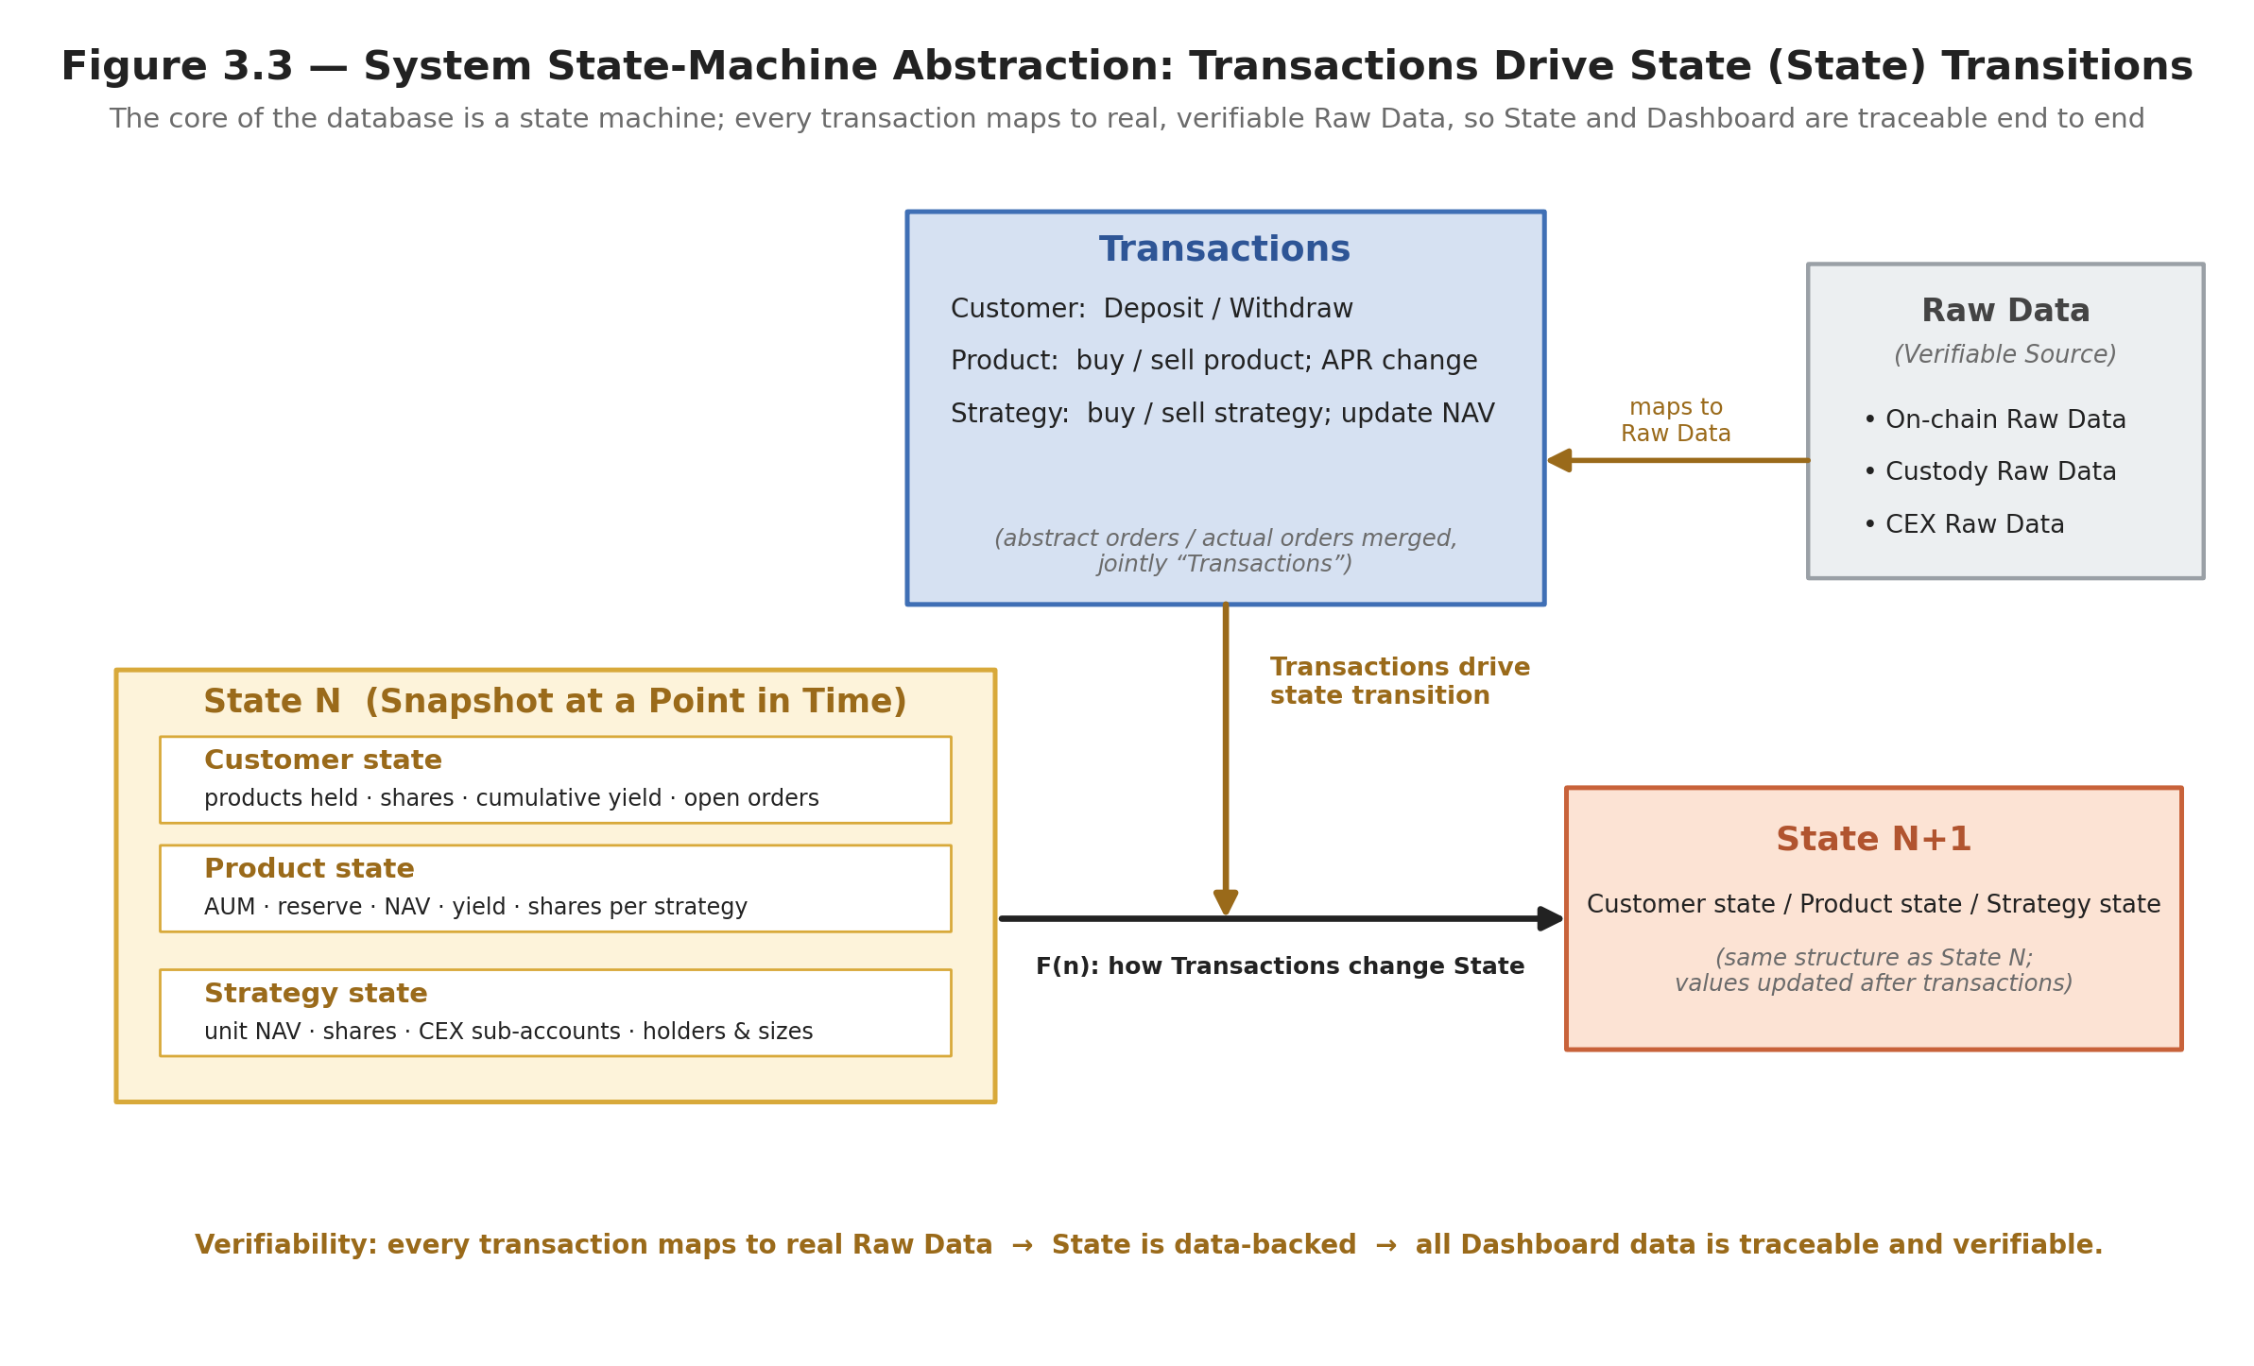
Figure 3.3 — The system’s state-machine abstraction: Transactions drive State transitions; each order corresponds to verifiable Raw Data, so State and the dashboard are traceable end to end.
3.7.2 Control flow vs. data flow: how the backend drives the system
Placing the backend within the full picture, it has only two kinds of arrows externally: solid data flow and dashed control flow — opposite in direction and strictly separated.
Data flow (solid, one-way inbound): the three parties’ raw data flows into the database backend service, is written to the core database after data integration, and the core database then discloses it externally through read-only interfaces to the operations / risk teams and the user dashboard. The NAV computation path within this is: first derive strategy NAV from the NAV of each CEX sub-account, then sum by “product × strategy” weight to obtain product NAV.
Control flow (dashed, one-way outbound): the backend issues instructions externally through three mutually isolated execution modules, each holding one write Key:
- the quant execution module (place-order Key) places / cancels / liquidates orders within CEX sub-accounts;
- the risk execution module (liquidation Key) liquidates with one click on anomalies;
- the fund-allocation module (Custody write API) transfers between Custody accounts and performs Mirror / settlement.
The backend’s “backend service” is itself an administrative console, not inside the Custody / CEX system. It internally contains role and permission management, configuration management (product / strategy / Custody / CEX configuration), order management (customer / product / strategy, three layers), Key management (read-only Keys), and the database backend service described above. It reads external data only and issues instructions only within the whitelist. Several permission-design points follow:
- Four Keys, strictly isolated. Place-order (quant), liquidation (risk), read-only (data ingest), and Custody-write (allocation) belong to different modules; leaking any single Key is insufficient to move assets out.
- Risk is an independent module. It does not accept instructions from the orchestration layer; it monitors Delta / leverage / limits / exposure on its own and force-liquidates automatically on a threshold trigger — completely separated from order-placement permission, which is why the figure has no “backend → risk” trigger line.
- Quant → fund-allocation. When the quant needs to move funds between CEX sub-accounts, it issues a request to the fund-allocation module, which executes it; the quant itself holds no Custody-related permission.
- Fund allocation moves only Custody. It performs wallet-to-wallet transfers within the dual contract + Custody whitelist, with hard-coded destinations, and does not connect directly to the CEX.
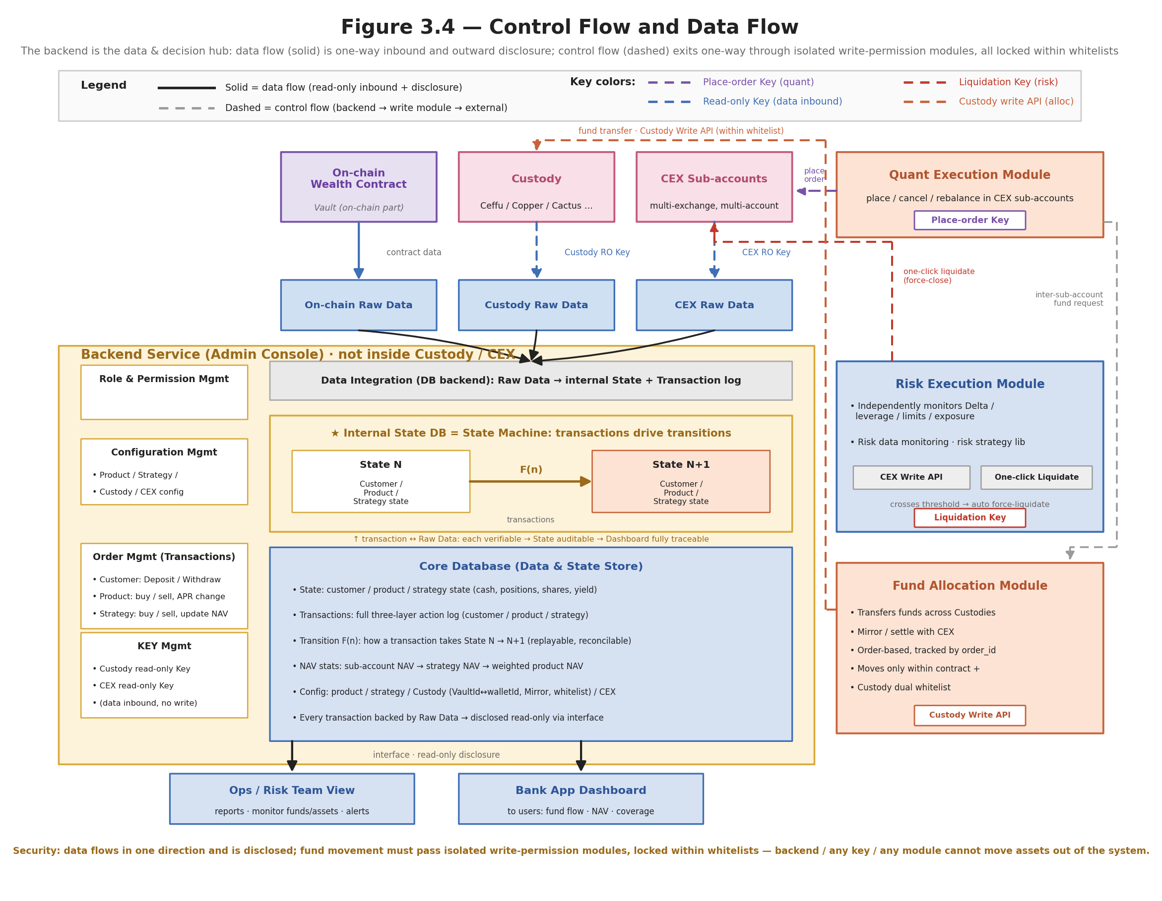
Figure 3.4 — Control flow and data flow: the backend service is the data and decision hub; data flows in one-way and is disclosed externally, control flows out one-way through independent write-permission modules, all locked within the whitelist.
Taken together, this structure yields a clear security boundary: data can only flow in one-way and be disclosed externally, while fund actions can only flow out one-way through independent write-permission modules, locked within the whitelist. The backend, any single Key, or any single module cannot move assets out of the system. This echoes the layered treatment of security in Part 2.

3.8 Liquidity Management
This section addresses a problem that runs through the whole system: under the tension of “must pay out on schedule, yet move the underlying strategies as little as possible,” how should funds be scheduled?
Consider first a product’s capital pools. All capital is split into two mutually exclusive pools, bound by one invariant:
- Unassigned (operating cash pool): new inflows, netting residue, money not yet assigned to any maturing liability. It may participate in netting and may be deployed into on-chain DeFi for opportunistic gains.
- Earmarked (redemption-reserve pool): money already locked for a specific maturing redemption (including the portion temporarily parked in DeFi for that payout). It recognizes only the maturity date and does not participate in netting again.
Invariant: once any sum moves from Unassigned into Earmarked, it leaves the netting engine’s available range until its payout completes. This invariant is the safety core of the entire liquidity scheme — “cross-time netting does not depend on future inflows,” “money in DeFi cannot be netted again,” and “settled means out of the pool” are all facets of it.
3.8.1 Two product types, two liquidity strategies
The starting point of liquidity management is that the T+0 on-demand product and the T+N term product have fundamentally different liquidity forms:
- T+0 on-demand product: keep a reserve, sacrificing some capital utilization for immediacy. The user can redeem at any time, so a readily-movable cash buffer (the reserve) must be kept in the vault, at the cost of that portion not earning full yield in the strategy layer.
- T+N term product: keep no reserve, deploy fully into strategies, just have the money ready before maturity. During the lock-up, the user’s money earns yield in the strategy layer the whole time, with capital utilization near 100%; redemption is a liability with a definite maturity date, and the system need only guarantee that “on that day, the Vault holds that much money.”
These two forms correspond to two mechanisms: reserve-level management (3.8.2), and maturity-driven payout scheduling for term liabilities (3.8.5–3.8.7).
3.8.2 T+0 reserve: target level + tolerance band
Reserve management uses a “target level + tolerance band” model, the standard practice in cash management. For example: target level 20% of AUM, tolerance band [10%, 30%]; cash breaking above 30% indicates too much idle and a good moment to buy strategies; falling below 10% indicates an insufficient buffer that should be replenished to target. But four points must be refined, or the churn trap of 3.8.3 will be hit:
- The tolerance band is a “flag attention” signal, not an “execute immediately” command. Do not fire a standalone open/close trade the moment a band edge is touched — that creates exactly the frequent open/close this specification seeks to avoid. The correct approach: the band only determines “how much cash this product net-needs adjusted today,” and the actual buy/sell amount is put into the day’s strategy-layer netting (3.8.4), offset internally against other products’ opposing flows first, with only the net amount touching the underlying.
- The urgency of breaching up vs. down is asymmetric. Breaching the upper bound (too much cash) is a “good problem,” not urgent, adjusted out gradually along the day’s netting; breaching the lower bound (insufficient cash) is the “hard problem,” and the replenishment sources have a priority order: first move the warm layer parked in on-chain DeFi (seconds to minutes, see 3.8.7) → then strategy liquidation within the day’s netting → only in extreme cases an intraday forced liquidation.
- The level value should be calibrated by data, not fixed by fiat. A reasonable level depends on the distribution of that product’s daily net outflow: roughly enough to cover the historical 95–99th-percentile multi-day cumulative net outflow, plus the daily redemption cap (3.8.8). It may be raised temporarily in highly volatile periods. 10/20/30 are reasonable initial defaults.
- The band width is itself a trade-off. The wider the band, the fewer triggers and the lower the churn, but the greater the idle-cash drag; the narrower, the reverse. Tune this width using the net-outflow distribution.
The reserve can be further split into two layers to satisfy a “millisecond-level” promise: a hot layer (truly kept in the contract, settling in milliseconds, covering routine small amounts) + a warm layer (parked in instantly-redeemable on-chain DeFi, covering the tolerance-band buffer, drawn in seconds to minutes). The “reserve in the contract enables instant redemption” of 3.2.1 refers to the hot layer.
3.8.3 The reason to move the underlying as little as possible: the real cost of opening/closing positions
Every mechanism in this section shares a single goal: to keep subscription/redemption operations from triggering extra underlying open/close actions as far as possible. The reason is that frequent open/close erodes yield on four fronts:
- Explicit transaction cost: taker fees + bid-ask spread. Delta-neutral / basis strategies are usually multi-leg (spot + perpetual), and one full round-trip pays fees multiple times.
- Slippage / market impact: the main cost of large liquidations, scaling super-linearly with size. Small amounts are immaterial; a large liquidation moves the price against itself.
- Carry interruption (the most hidden and most important): the yield of a Delta-neutral book is, in essence, the carry earned by continuously holding the position. Closing the position to free cash is, in effect, actively switching off the yield engine; reopening a few days later, the rate tier the market offers may already have worsened.
- Re-entry timing risk: after closing and reopening, the entry point may be no better than before, and fees and slippage must be paid again.
On carry interruption there are two cases:
- Funding is a discrete event, not continuous accrual. A perpetual’s funding settles in one shot at fixed settlement times (typically every 8 hours) at the instantaneous rate at that moment — only whoever holds the position at the settlement instant pays or receives once. What determines the sign and magnitude of a single funding payment is the instantaneous rate at the settlement instant, not the 8-hour average. Its “time property” shows up in frequency: the more holding periods, the more settlements experienced, and the more accumulates in expectation.
- Basis converges continuously over time. The futures/spot basis converges toward zero as expiry approaches, and that convergence is a continuous function of time — the longer held, the more captured — not dependent on any discrete settlement instant.
So the precise statement of how liquidating to pay redemptions harms yield is: (for funding) it reduces the number of future settlements that would be experienced, may miss an imminent settlement instant precisely, and the market’s rate tier may have worsened by the time positions are rebuilt; (for basis) it interrupts an ongoing continuous convergence; plus the rebuild’s fees, slippage, and entry-point risk.
One boundary must be clarified: temporarily closing before settlement to dodge an expected-negative funding payment is sometimes the correct active operation made by the strategy layer based on a rate forecast. That is a different matter from the “passive liquidation forced by the need to raise redemption cash” that this section seeks to avoid. Liquidity management aims to eliminate the latter (liquidation forced out by operational need, against the strategy’s wishes), not the former.
3.8.4 Netting happens per layer: intra-product subscription/redemption netting + intra-strategy share netting; no cross-strategy netting
Netting does not occur at only one layer; it occurs once at each layer over that layer’s “homogeneous unit,” and netting across strategies is impossible.
- Intra-product subscription/redemption netting (product layer): a product’s subscriptions and redemptions on the same day are homogeneous shares under the same product and same NAV, and can be offset directly — the cash withdrawn by redeemers is supplied by subscribers, and this portion need not touch the underlying strategies. The “net inflow / net outflow today” a product reports externally is the net amount after this netting, not the gross subscription/redemption volume.
- Intra-strategy share netting (strategy layer): after a product’s net flow is split by weight into “intents to increase/decrease shares in each strategy,” one product’s increase and another’s decrease in the same strategy are homogeneous shares under that strategy’s unit NAV, and can be offset with zero churn (shares change hands, underlying positions do not move). This is the two-pool offset expanded in 3.8.5.
- Cross-strategy netting is impossible: different strategies each have their own unit NAV, and a product’s target holding in each strategy differs; the two sets of shares are not homogeneous and have no offsettable counterpart. Product A selling strategy S1 and product B buying strategy S2 are, physically, two unrelated actions — closing S1 and opening S2; forcing a pairing merely shuffles cash between accounts — saving at most one Custody transfer, with no saving in carry or churn.
The layer relationship is therefore:
- Product layer: first do intra-product subscription/redemption netting, then split the intent. Step one offsets the day’s subscriptions and redemptions to derive the external net flow; step two splits the net flow by weight into “intents to increase/decrease shares in each strategy” and dispatches them; step three manages its own funds not yet at the withdrawal date (deployed into DeFi for yield, see 3.8.7). The product layer’s netting stops at “offsetting subscriptions/redemptions within the same product”; it has no share-level, cross-product offsetting capability.
- Strategy layer: do share-level netting, each strategy independently. Strategy S gathers all products’ increase/decrease intents toward it, offsets buys and sells internally — what is absorbed internally is a zero-churn change of share ownership — and only the net residual goes to its CEX sub-accounts for a real open/close; on completion it returns the result (fill price, share change, cash receipt/payment) to the product layer, which updates its held shares accordingly.
The strategy layer’s share netting is the runtime embodiment of 3.1’s “the strategy as the core abstraction layer, decoupling capital classification from the concrete sub-account”: it is the strategy’s internal operation as a “fund,” with products merely as its shareholders. A direct corollary follows — whether two products can save strategy-layer churn depends on whether they share the same strategy; encouraging products to share strategy pools is itself a form of liquidity optimization. Moreover, since a single strategy is by construction single-denomination, the constraint “netting pools are grouped by denomination” is automatically satisfied at the strategy layer.
3.8.5 Intra-strategy netting: two-pool offset + time priority
Each strategy gathers the day’s increase/decrease intents from all products into two pools and offsets them directly:
- Close pool (net-outflow direction): all demands to reduce a position — whether not yet instructed or already instructed and in transit but unfilled — are all “demands to turn a position into cash.”
- Open pool (net-inflow direction): all demands to add a position — whether a fresh subscription or a previously recorded pending buy — are all “demands to turn cash into a position.”
Each netting round is a two-pool offset: take min(close pool, open pool) to absorb internally, with shares changing hands at the settlement NAV (underlying positions untouched, Delta unaffected); only the net residual issues real instructions: net positive → open, net negative → close, approximately zero → fully absorbed internally for the day. There is no need to track “this one offsets that one,” because the pools are undifferentiated — the physical actions to be performed are homogeneous and mutually offsettable by construction.
Beyond the two pools there is one key parameter: the time priority of leaving the pool. When the open pool is insufficient to cover the entire close pool, the limited offset volume must first satisfy the nearest-maturing redemptions. So the close pool queues in ascending order of maturity date, and the open pool (which has no maturity pressure and acts as unordered supply) fills it from the head of the queue one entry at a time; once an entry is filled, it is settled completely and leaves the pool. For example, with both a T+3 and a T+7 redemption present, net the T+3 first — let the most time-pressured one lock in its payout source as early as possible; tight-first, loose-later is always the right direction.
Settlement must be done well: the instant any intent is settled (whether settled by internal offset or by a real fill), it immediately leaves both pools. Internally offset ones leave once both sides are settled and shares have changed hands; really-liquidated ones leave once the returned cash is locked into Earmarked. Failing this step nets the same sum twice — either promising one pot of money to two redemptions (maturity mismatch), or believing there is still a position to close when it was closed long ago. Mapped onto the state machine of 3.7.1, this is naturally the orders’ state transition: each increase/decrease intent is an order, a pool = the net amount of orders currently in the “unsettled” state, and the netting engine each round scans only unsettled orders, computes the net, and advances the state.
A use case: product A (T+0) has net outflow $100 today and needs to reduce its shares in strategy S; product B (T+7) has net inflow $80 today and wants to increase S. Internal match: B takes A’s $80 at the settlement NAV, paying $80 cash; A still lacks $20 → strategy S closes only $20, not $180 — churn down ~89%.
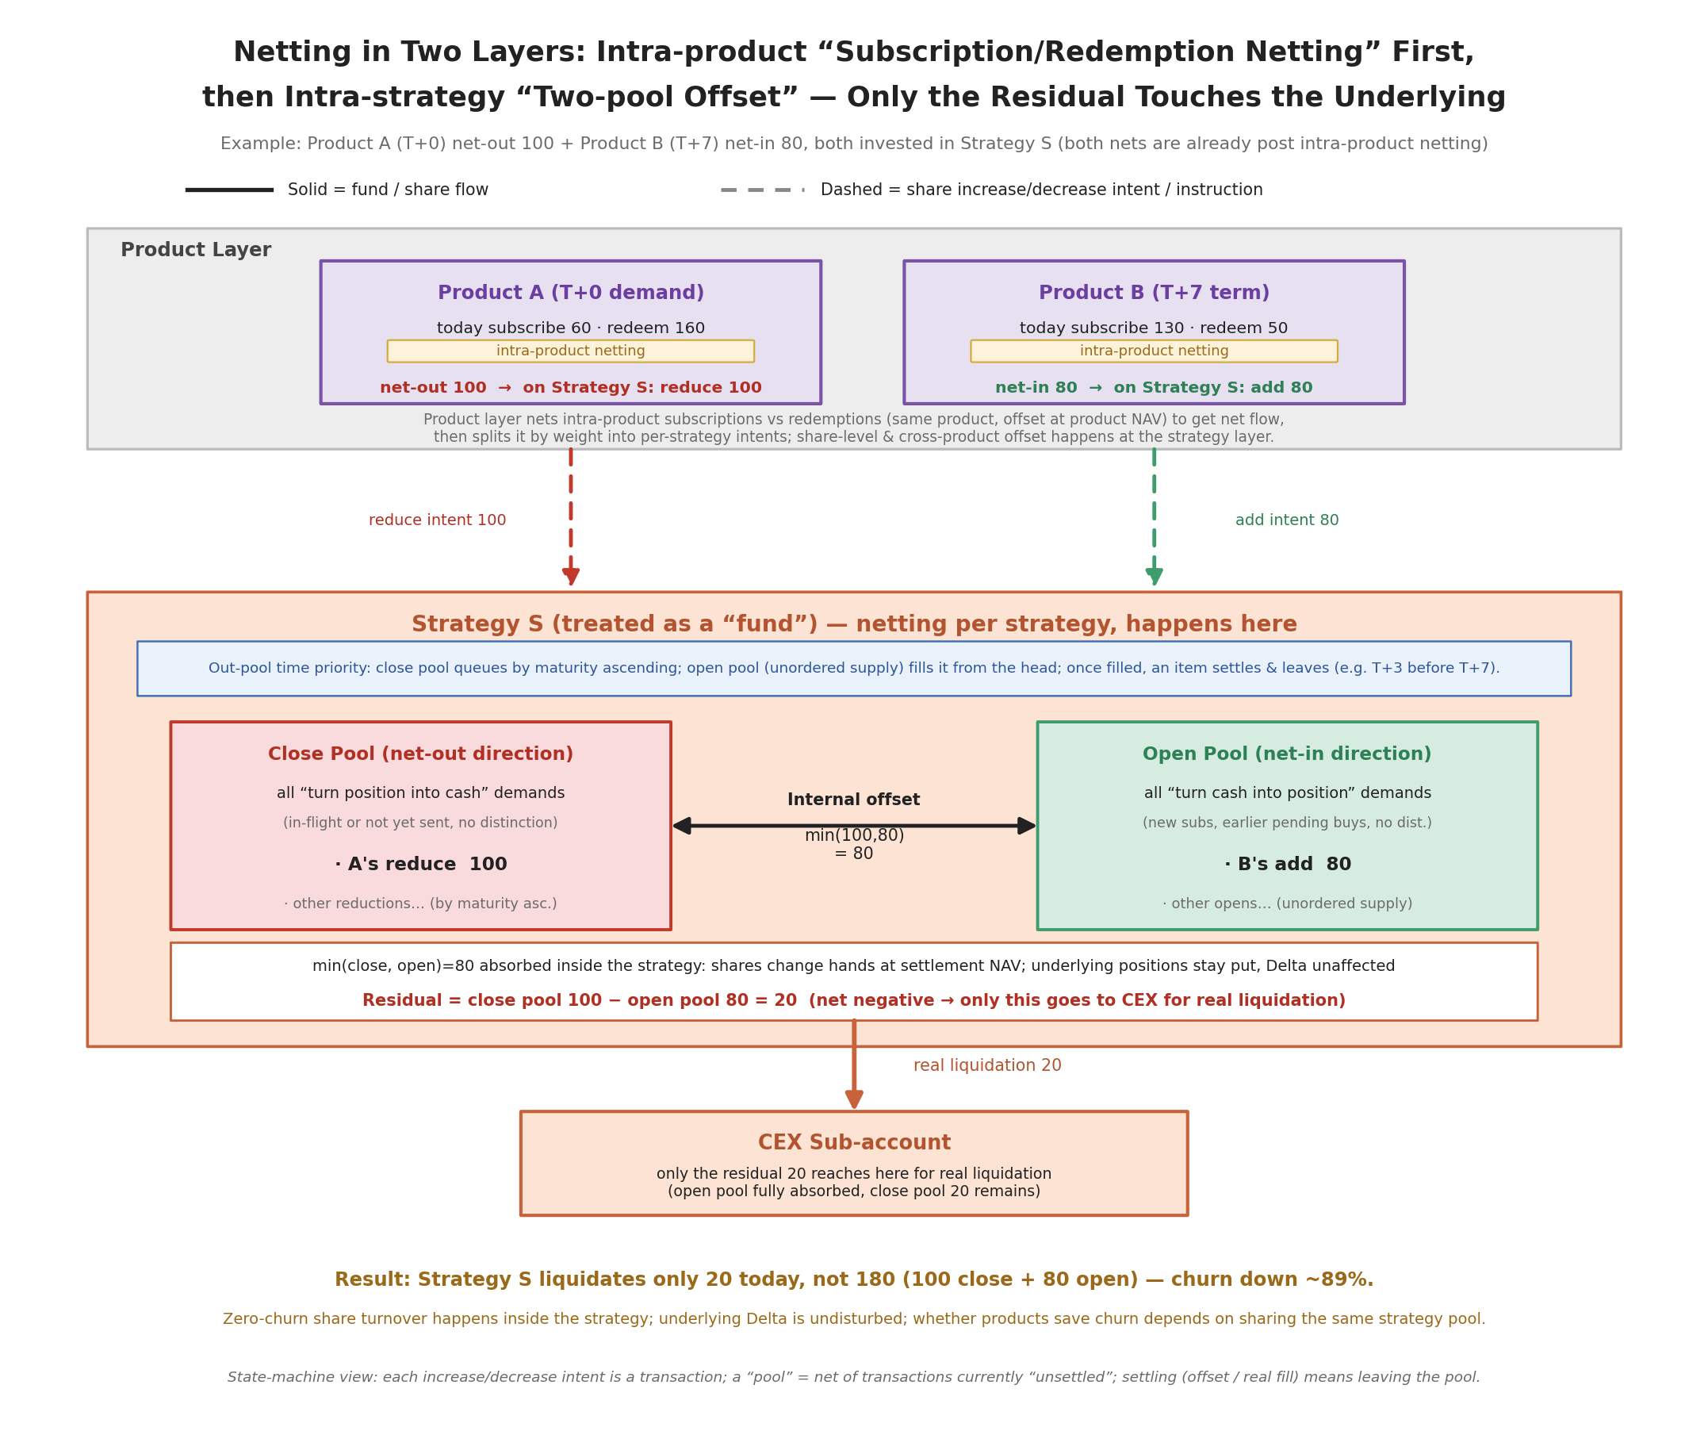
Figure 3.5 — Netting in two layers: intra-product subscription/redemption netting first, then intra-strategy “two-pool offset” on shares, touching the underlying only for the net residual.
3.8.6 Cross-time netting and the hard constraint of “pay out on schedule”
A natural idea is cross-day netting: do not liquidate a redemption today, but count on the next few days’ new subscriptions to fund it. This is the wrong approach. It generates two independent risks: inflows below expectation (in a market panic everyone redeems at once and subscriptions dry up simultaneously) and liquidation arriving too late (discovering near maturity that funds are short, while orderly liquidation takes time). Superimposed, the two are “no money on the maturity date and no time to fill” — precisely maturity mismatch, the very mechanism behind blow-ups of the Celsius type.
The hard constraint is therefore: every liability with a maturity date must be made ready before maturity using “already-realized cash sources,” never relying on “expected inflows not yet received.”
But cross-time netting has a safe, degraded version that takes only the upside and leaves no exposure:
- Provision against certain sources by default. A term redemption enters the payout arrangement on the day it is initiated: it is either absorbed by an internal share transfer that day (zero churn), or scheduled for underlying liquidation with the cash locked into Earmarked. The payout source is certain by default and depends on no future.
- Treat new inflows as “after-the-fact offsetting,” not “counting on them in advance.” If a reverse inflow does arrive before maturity, use it to cancel an unfilled liquidation instruction (zero cost), or rebuild a closed position while it is still worthwhile (recovering carry, but paying the reopen cost — done only when carry yield > reopen cost). If it comes, it is a gain; if not, the money was readied long ago — never leave exposure for its arrival.
- Convergence near maturity (a hard backstop). Set a cutoff line (for example, any portion still unprovisioned at T-2 before maturity is liquidated unconditionally to lock it in), acting while orderly liquidation is still possible, never dragging to the last day. Trade certainty for the dependence on future inflows.
Cross-time netting thus degrades into a pure-gain, no-exposure optimization: with luck it saves one open/close, and without luck it pays out losslessly because the money was readied against certain sources. In the document it should be explicitly labeled an “opportunistic optimization,” not a liquidity dependency; if the implementation cost is not worthwhile, falling back to only same-day intra-strategy netting (3.8.5) is entirely valid — same-day netting is unconditionally safe.
3.8.7 Idle-window funds: deploy into instantly-redeemable on-chain DeFi
The funds liquidated early in 3.8.6 and locked to a future maturity date, as well as the reserve’s warm layer, will have a time gap. This portion is automatically routed into blue-chip, instantly-redeemable on-chain DeFi (Aave, tokenized money-market funds, and so on) to earn a layer of extra yield, redeemed back to the Vault before maturity.
This must adhere closely to the invariant at the start of 3.8: the money parked in DeFi belongs to Earmarked, already “has an owner” (assigned to a definite maturity date and liability), and is merely awaiting collection, so it must never again be treated as a netting counterpart. Using it to satisfy another product’s liquidity need is, again, promising one pot of money to two maturity dates — maturity mismatch once more.
Constraints: use only low-risk protocols that are instantly (or far-before-maturity) redeemable; set a concentration cap per protocol so idle-window funds are not piled into a single pool; the DeFi redeemable time must be ≤ maturity date − safety margin. Yield attribution follows the convention of 2.2 (to the platform, supporting low-fee operation), and may also be adjusted per product configuration.
3.8.8 Large redemptions and other liquidity risks
Beyond levels and netting, the following must also be brought into liquidity management:
- Daily cap and large-amount booking. The “instant” of T+0 implies a per-trade/per-day size cap: a large redemption exceeding what the reserve can bear has its excess queued (temporarily downgraded to T+N), or large amounts above a threshold are required to book in advance (e.g., > $1M requires T+2 notice), giving the trading desk time to liquidate in an orderly manner without breaking the market.
- (Whether reasonable still to be considered) slippage attribution / swing pricing. A large redeemer who forces underlying liquidation should bear the slippage they cause (a redemption fee / exit-NAV adjustment) rather than spreading the cost onto remaining holders. This is both fair and a deterrent to the “first-mover advantage” that motivates runs.
- Pro-rata gating during a run. When total redemption requests in a window exceed available liquidity, pay out pro-rata and queue the rest.
- Coverage monitoring and stress testing. Continuously monitor the “available liquidity / near-term potential outflow” coverage ratio for each product and globally, and stress-test extreme scenarios (concentrated redemptions, cross-product correlated outflows, CEX downtime, stablecoin depeg).

3.9 NAV, Subscription/Redemption Pricing, and Sources of Yield
The netting of 3.8 repeatedly invokes the “settlement NAV,” and subscriptions/redemptions must also transact at some NAV. This section defines how NAV is computed, which NAV subscriptions/redemptions transact at, and where the operator’s profit comes from. First, NAV must serve three things in this system, with differing requirements, so it ultimately splits into two measures:
- For subscription/redemption pricing: how many shares $X of subscription buys on the user side, and how much money Y shares of redemption return.
- For netting settlement: at which figure to transfer strategy shares between products fairly (which we have been calling the “settlement NAV”).
- For user disclosure: where the yield on the dashboard comes from.
3.9.1 Bottom-up three-layer aggregation
NAV is aggregated bottom-up in three layers, mapping exactly onto the three-layer abstraction:
- Sub-account NAV (computed from a snapshot fetched via the CEX read-only Key): one sub-account runs one strategy, and its value contribution = spot-leg market value + perpetual-leg margin + unrealized PnL + settled-but-unwithdrawn funding − accrued fees.
- Strategy NAV: treat the strategy as a fund with “shares” and a “unit NAV.” Strategy total NAV ÷ strategy total shares = unit NAV; a product investing cash into a strategy exchanges it for shares at the current unit NAV, and when the strategy earns, the unit NAV rises and all holding products benefit in proportion to their shares. This is precisely the premise that makes “transfer shares at NAV” in netting valid.
- Product NAV: = on-chain Vault (reserve + pending transfer-out) + Custody product wallet + Σ over strategies (product’s shares of that strategy × that strategy’s unit NAV) + the market value of the Earmarked portion parked in DeFi; then ÷ total LP Token supply = the product’s external unit NAV.
Note that collateral must not be double-counted. Because the money on the CEX is a mirrored-out quota while the real collateral is in Custody, and the Mirror’s accounting differs by vendor, collateral is counted once and only once along the entire aggregation chain, and the “Custody-counted vs. CEX-counted” boundary must be drawn definitively in one stroke. Otherwise NAV is easily miscomputed, assets are counted into existence, and losses result.
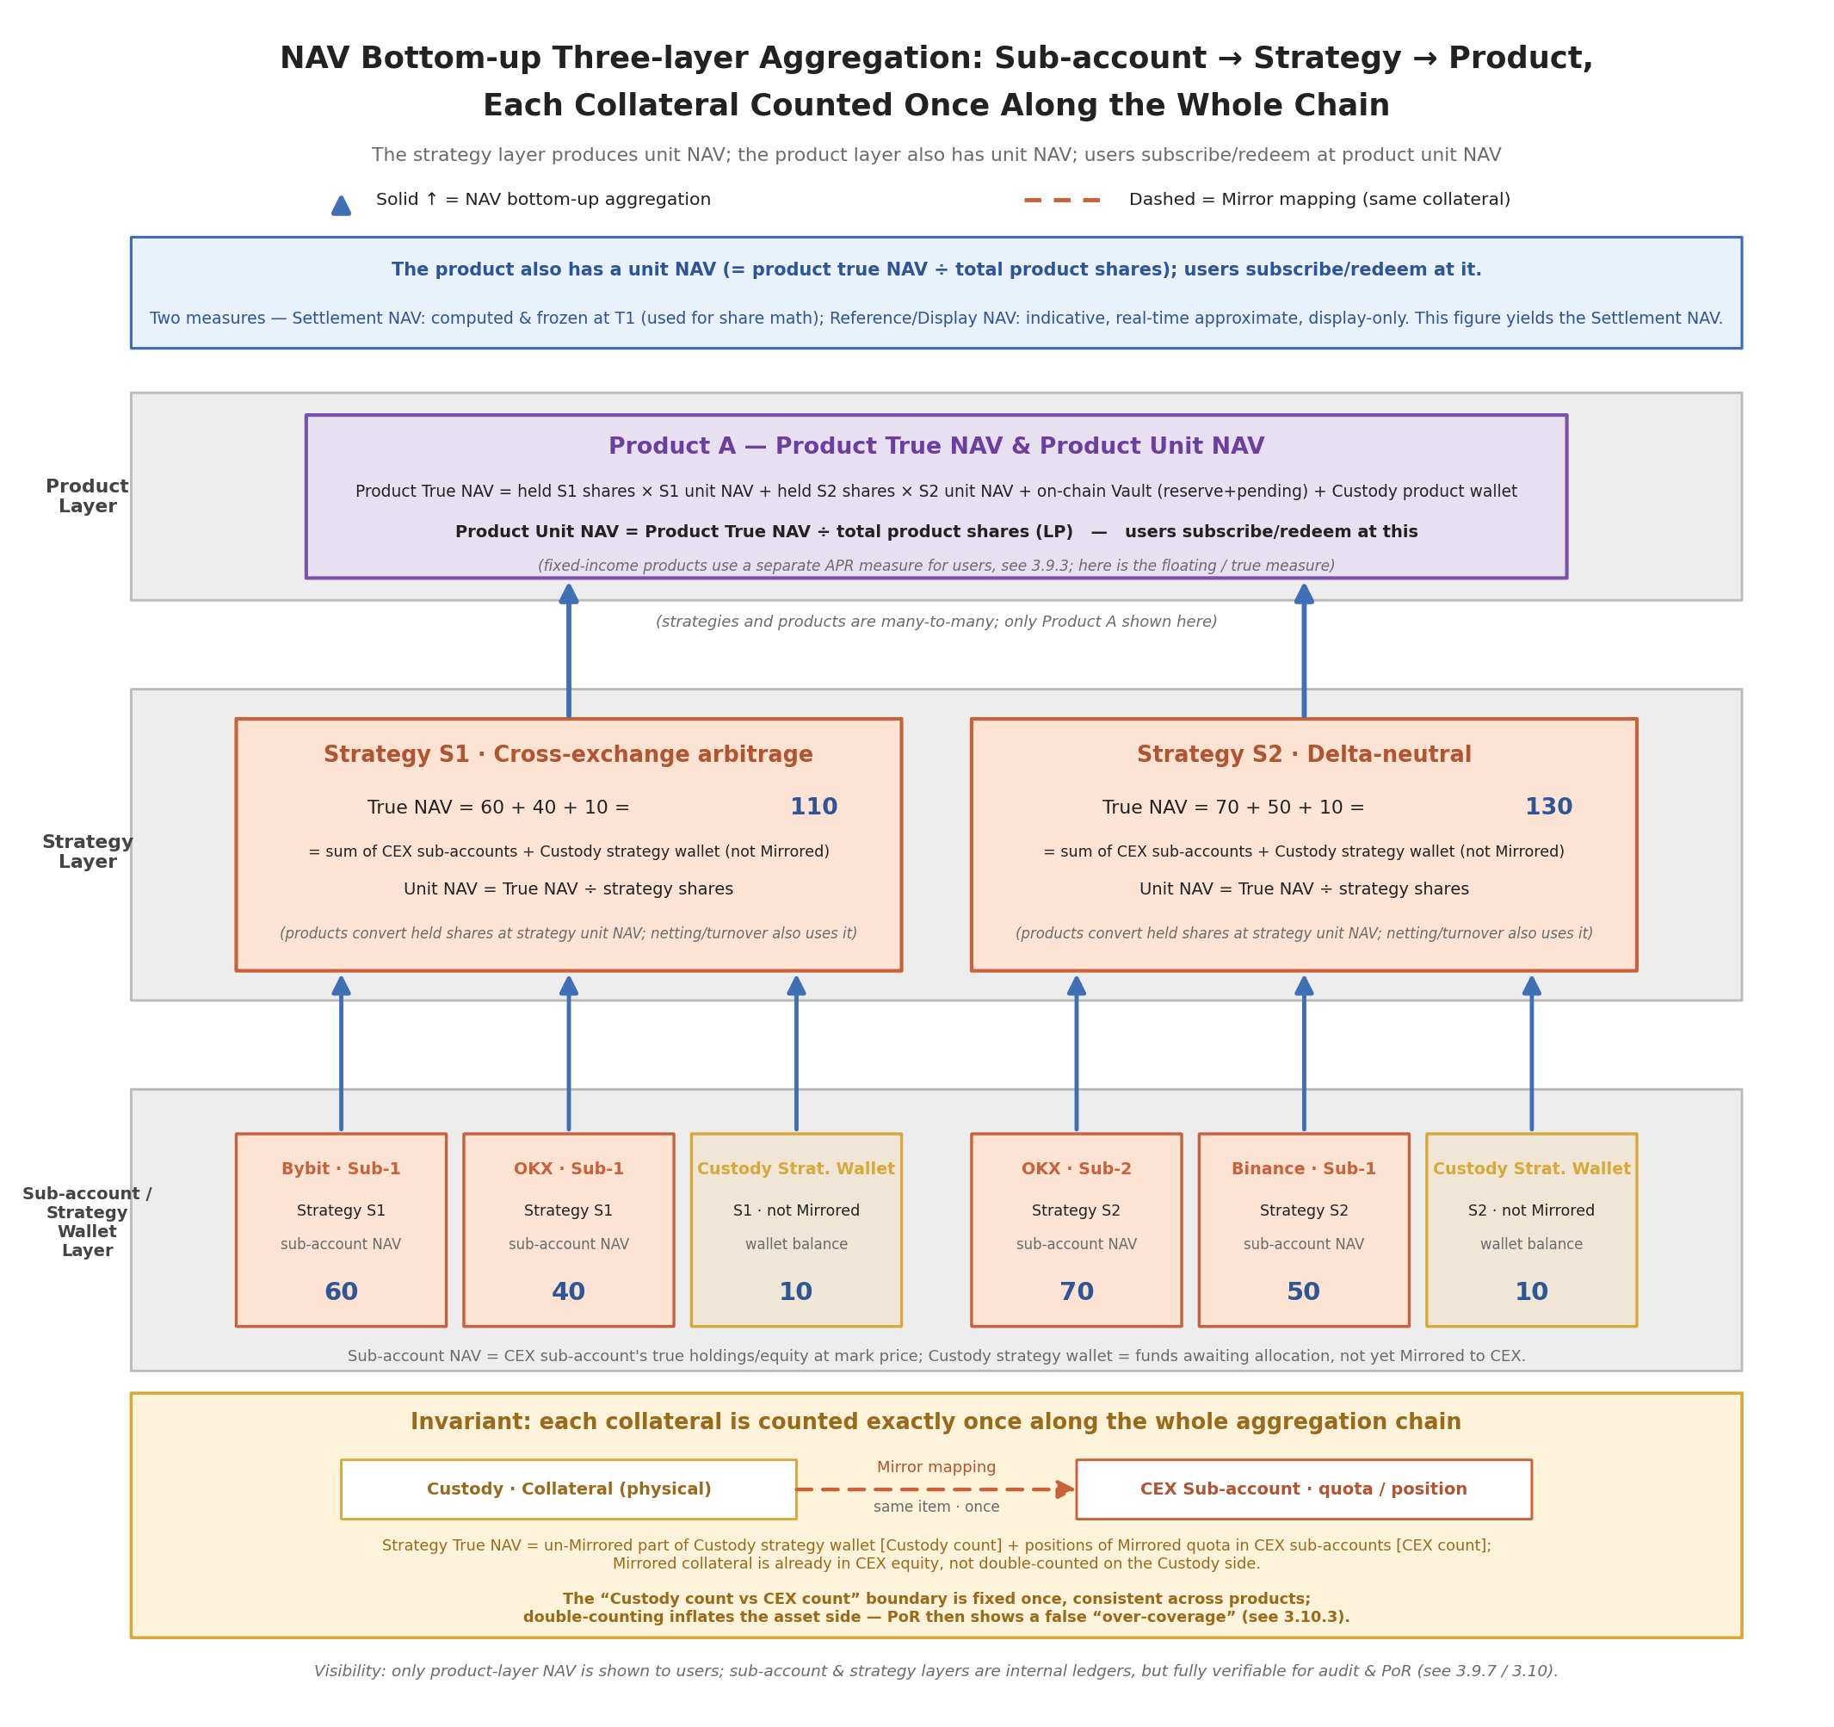
Figure 3.6 — NAV aggregated bottom-up in three layers: sub-account → strategy → product; the same collateral is counted only once along the entire chain.
3.9.2 Settlement NAV vs. display NAV
The settlement NAV bears directly on money (how shares transfer, how subscriptions/redemptions are priced), so it has two key points:
- All legs must be marked at the same instant. Delta-neutral is a spot + perpetual two-leg hedge; if the two legs are priced at inconsistent times, a nonexistent PnL and Delta will be computed. A fixed snapshot instant is therefore set (e.g., an end-of-day mark at a certain UTC time, once per day), and all legs and all sub-accounts are priced at that same snapshot.
- Use mark price, not last price. With the latest traded price, someone could “paint the tape” on a thin order book seconds before the snapshot to push the price and manipulate NAV for advantage. The exchange mark price (index price) resists manipulation and avoids thin-book noise.
There are therefore two NAVs on the user side:
- Settlement NAV (binding) — the daily end-of-day snapshot, computed at mark price, used for subscription/redemption pricing and netting share transfers; this is the one that “counts.”
- Display NAV (indicative) — for the dashboard, higher-frequency and reference-only, not used for settlement.
Hence when a user subscribes to a floating-yield product, the shares they receive are not computed immediately via the display NAV but obtained, after the day’s settlement completes, from the settlement NAV. So: the shares a user obtains when buying a product are known with a delay — see 3.9.5.
3.9.3 Fixed income vs. floating: a product may have two NAV lines
- Floating-NAV product: the external unit NAV passes through the underlying real performance directly, and the user bears the ups and downs. One NAV — simple.
- Fixed-income product: the external NAV the user sees grows deterministically at a fixed APR, independent of how much the underlying earns on a given day; but the underlying strategy’s real NAV floats. The difference is absorbed by the junior tranche: underlying excess → to the junior/platform; underlying shortfall → the junior is consumed first. So a fixed-income product has two NAV lines simultaneously — the “to-user NAV” (deterministic, computed from APR) and the “underlying real NAV” (floating), with the junior sandwiched in between.
Transferring strategy shares between products uses the “strategy’s real unit NAV,” not the product’s “to-user NAV.” Netting occurs at the strategy layer and recognizes the strategy’s real value; the fixed-income layer’s APR wrapper and junior cover are another layer of accounting laid on top of the product, a separate matter from the strategy-layer share transfer, and must not be mixed in.
3.9.4 Ordering NAV and netting: T1 pricing → T2 netting
A circular dependency hides between NAV and netting: netting needs NAV, NAV comes from the strategy’s current positions, yet netting itself changes those positions. The way to break it is to slice a day into two strictly ordered instants that do not cross:
- T1 · end-of-day snapshot + set NAV (recognize; happens first): at the settlement instant, take a same-instant mark snapshot of all CEX sub-accounts + Custody balances, and aggregate to compute each strategy’s settlement unit NAV. This NAV is computed on the “not-yet-netted, no-position-moved” stock state of the day, recognizing the real P&L the strategy itself ran over the past day, unrelated to today’s subscriptions/redemptions; once set, it is frozen and unchanged for the day.
- T2 · net + execute using the frozen NAV (happens second): take T1’s frozen unit NAV, convert each product’s increase/decrease intents toward each strategy into shares, do the two-pool offset, leave the pool by time priority, and place orders for the net residual. The entire netting reads only T1’s NAV and does not recompute; even if the net residual goes to the CEX and changes positions, that is today’s action and is reflected only in tomorrow’s next T1 snapshot — it never goes back to revise today’s frozen NAV.
The whole flow is therefore: yesterday’s stock → (T1 snapshot) → today’s settlement NAV (frozen) → (T2) → today’s netting and subscriptions/redemptions transact at this NAV → today’s new positions are produced → (tomorrow’s T1 snapshot) → tomorrow’s NAV. There is only one discipline: NAV is priced on the “pre-netting stock state,” netting uses the “frozen NAV,” and money arriving today does not participate in today’s NAV computation — it is merely the object that transacts at this NAV.
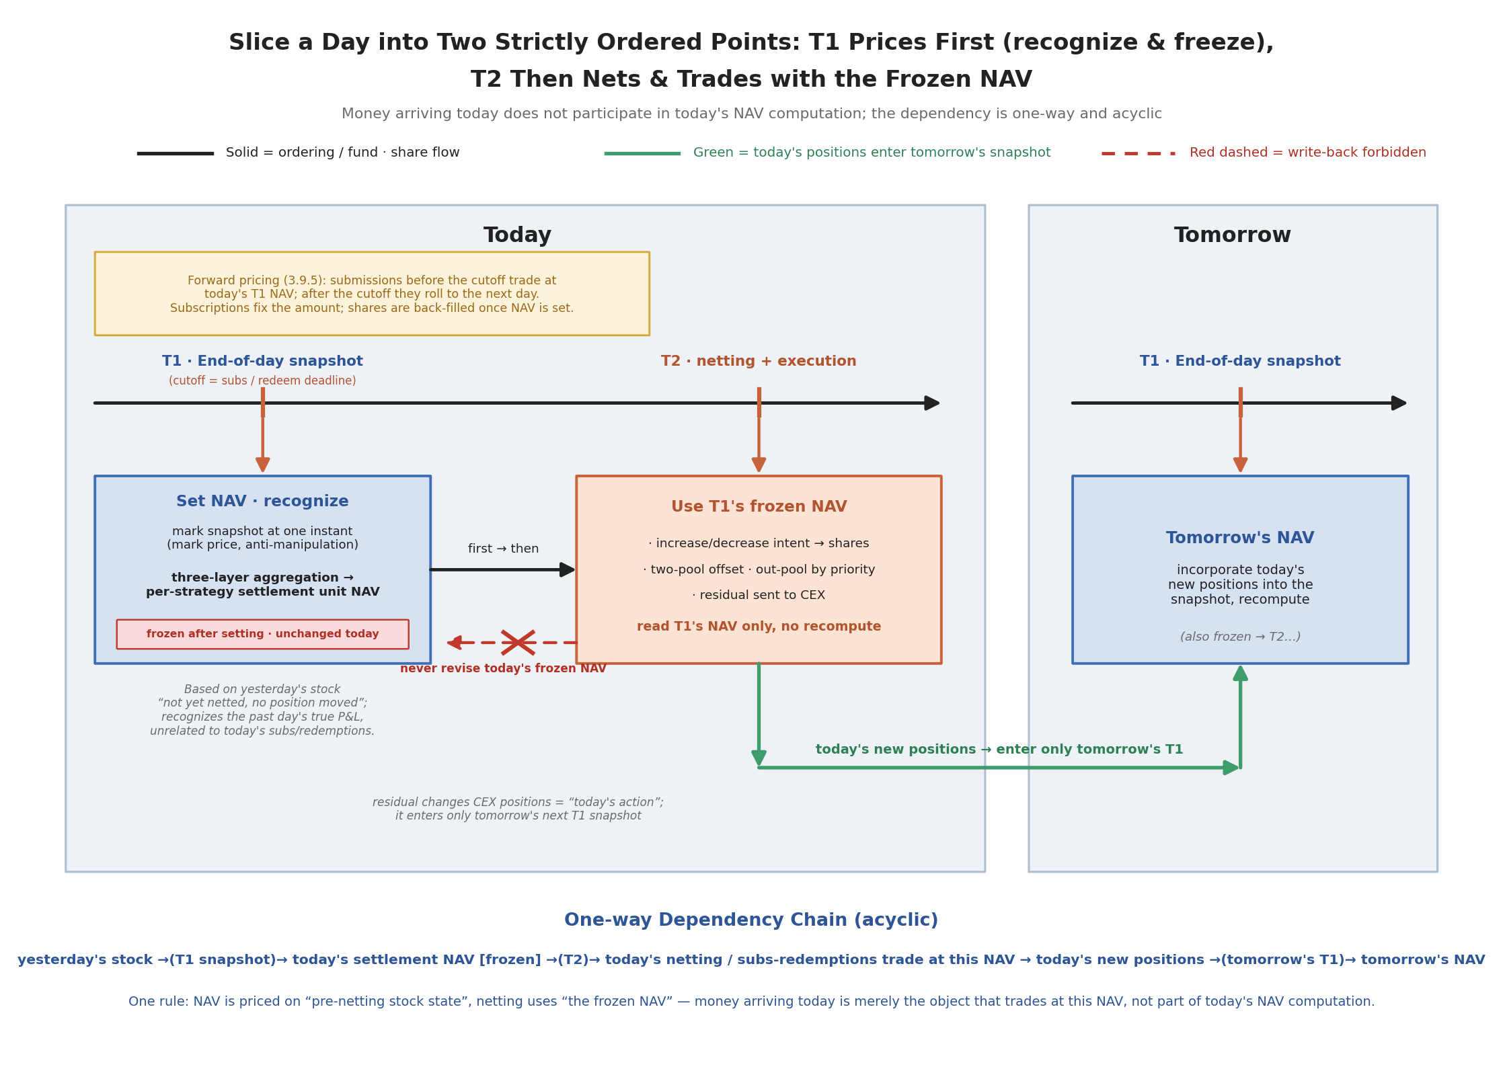
Figure 3.7 — A day sliced into two strictly ordered instants: T1 pricing (recognize and freeze) and T2 netting / execution; money arriving today does not participate in today’s NAV computation.
3.9.5 Subscription/redemption pricing: floating-NAV products must use forward pricing
There are two options for which NAV subscriptions/redemptions transact at: historical pricing (use yesterday’s published NAV, the user knows the shares on the spot at subscription) and forward pricing (use the NAV computed only after the day’s cutoff, so at subscription only the amount is known and shares are back-filled after settlement).
Floating-NAV products must choose forward pricing — this is not an experience issue but a money-leaking hard hole: if subscription at yesterday’s NAV were allowed, then when the underlying rallies during the day while that gain only enters NAV at tonight’s T1, an arbitrageur could buy already-appreciated shares at yesterday’s stale price and profit for free once NAV updates that night — money diluted out of existing holders’ pockets (the redemption side is symmetric). This is exactly the stale-price / late-trading arbitrage that produced a dedicated scandal in mutual-fund history.
The rule is therefore: subscriptions/redemptions submitted before the day’s cutoff (i.e., the T1 snapshot instant) all transact at the NAV computed at that day’s T1; those after the cutoff roll to the next day. A subscription fixes only the amount at submission, with shares back-filled once that night’s NAV is set; redemption is symmetric (fixes shares, not amount). The frontend must clearly state “transacts at the day’s end-of-day NAV; shares confirmed after settlement.” Forward pricing is mandatory only for floating-NAV products. A T+0 stable-yield product has no arbitrage window and can transact instantly.
3.9.6 Decoupling execution and pricing: an unfinished fill does not affect the set NAV
Another case: on some day user buying is exceptionally large, and the CEX side does not finish buying the net residual that day (the open pool still has a remainder). This does not affect NAV. Because NAV was already frozen before T2 execution (at T1), whether or how much execution succeeds cannot change an already-set figure. That “not-yet-deployed-to-CEX” cash has not vanished; it is merely physically still in the Custody strategy wallet, a strategy asset in cash form — and the strategy-NAV measure includes “idle cash not yet mirrored out” by construction, so this cash is simply counted into NAV 1:1 as cash.
“Not finishing the buy” changes the form of the strategy asset (cash vs. opened position), not its value. The real difference produced is not a NAV deviation but an opportunity cost — this cash sits in cash and does not capture carry in time, earning less, but it is not miscomputed. The handling rule: this (missing) yield is shared by all the strategy’s holding products in proportion to their shares (cash earns no interest, naturally reflected in NAV), and is not borne or benefited by one new subscription alone — once it transacts at the T1 NAV, the subscriber is an ordinary shareholder, sharing alike with existing users. Two kinds of “not finished” must also be distinguished: an unfinished “buy” is an opportunity-cost issue (tolerable, counted into NAV as cash); an unfinished “sell/liquidation,” if it collides with a maturity date, is a risk issue, backstopped by the T-2 convergence of 3.8.6. Moreover, if a strategy’s net residual is genuinely too large, the reasonable approach is to build positions smoothly over multiple days (to avoid breaking the CEX price oneself); during this time that portion is counted into NAV as cash and shares the opportunity cost pro-rata — symmetric to “orderly liquidation” for large redemptions: large subscriptions should likewise be allowed “orderly position-building,” not forced to fill the same day.
3.9.7 External disclosure: product NAV on-chain and the visibility boundary
The product’s external unit NAV needs to go on-chain so the on-chain Vault contract can price subscriptions/redemptions and value the LP Token. The backend computes the product unit NAV off-chain by three-layer aggregation (the end-of-day T1 one) and feeds it into the contract via an Oracle. Putting an Oracle on-chain is a mature problem; selection, update frequency, anti-manipulation delay, and the like can follow standard industry practice and are not expanded here. Note only that what goes on-chain is the product-layer NAV alone, and that it corresponds behind the scenes to the T1 “update NAV” order and its Raw Data, so the NAV obtained on-chain is a state traceable back to the original snapshot, not an isolated figure. (Oracle updates have a delay, but subscriptions/redemptions transact at the end-of-day T1 NAV anyway, in the same rhythm; as long as the Oracle updates after T1 and before the next trading window, no extra arbitrage window is introduced.)
Related to this is a visibility boundary: only the product-layer NAV is shown to users; the strategy-layer and sub-account-layer NAVs are internal accounts and are not displayed by default. The fundamental reason is that the LP Token the user holds represents, on-chain, a product share; the user has no on-chain certificate to any strategy. Strategy NAV and sub-account positions are merely intermediate quantities for computing product NAV, belonging to the operations/risk view. This is the same principle as 3.1’s “the user need only understand the product.”
But “not displayed to the user” ≠ “not verifiable.” The lower two layers’ NAVs are still fully recorded in the state machine and can still be checked by the auditor and by PoR; they simply do not appear on the retail dashboard’s main view by default. Simplified display for the user and full verifiability for the audit do not conflict. Large/institutional clients may, by client tier, optionally be granted the strategy-layer view.
3.9.8 Yield distribution and operator profit
On the revenue side, the profit sources of the floating and fixed types differ:
- Floating-NAV product → explicit fees. The underlying real yield passes through to the user in full; the platform earns no spread, and profit comes from: a management fee (annualized on AUM, accrued daily from NAV), a performance fee/carry (a cut of excess return, with a high-water mark, taken only on new highs), and redemption fees/swing pricing (a redeemer forcing liquidation bears the slippage, partly retained).
- Fixed-income product → the spread. The user takes a fixed APR, the portion of underlying real yield above the APR promise accrues to the platform/junior (as compensation for bearing the cover risk), and on a shortfall the junior is consumed first. The platform earns the “real yield − fixed APR” spread, at the cost of bearing the downside risk.
- Spanning both: idle-window DeFi yield accrues to the platform. The layer earned by Earmarked parked in DeFi accrues to the platform, supporting low-fee operation (2.2).
On the cost side, the following are all counted into operating cost: Custody costs (a custody fee, annualized bp on AUM, + a per-transfer/settlement fee — hence netting reduces physical dispatch: moving money less = paying less Custody transfer fee); CEX costs (trading fees, sub-account/API fees — the same source as the explicit fees among the four cost fronts of 3.8.3); on-chain costs (gas for subscriptions/redemptions, NAV on-chain Oracle updates, cross-chain bridges); third-party services (audit fees, PoR issuance, Oracle feeds, KYT/compliance services — the Custody-side compliance check backstopping 3.2.3 also has a cost); junior/payout risk provision (provisioning the junior for fixed-income products ties up the platform’s own capital, an opportunity cost); and infrastructure and personnel (quant, risk, ops teams and systems). What the user sees on the dashboard is the net NAV after all fees and costs have been accrued.

3.10 Proof of Reserve (PoR) and Liability Reconciliation
The goal of PoR (Proof of Reserve) is to prove, periodically and in an independently auditable way, one inequality: physical assets ≥ on-chain liabilities, covered down to each product. The three-layer NAV built in 3.9 makes both sides of this inequality computable. This section defines the two sides of the reconciliation, the granularity, the pass-through verification of the asset side, the special handling of fixed income, and the boundary of PoR’s capabilities.
3.10.1 The two sides of the reconciliation: on-chain liabilities vs. physical assets
- On-chain liability side = Σ (user-held LP Token × product external unit NAV). This is the product’s total payout promise to users on-chain. Total LP Token supply is publicly queryable on-chain, and the external unit NAV is the value put on-chain in 3.9.7 (end-of-day T1, Oracle-fed), so the liability side is computed entirely from on-chain data, depending on no off-chain ledger.
- Physical asset side = the product’s real NAV aggregated bottom-up per 3.9.1. That is, “on-chain Vault (reserve + pending transfer-out) + Custody product wallet + Σ over strategies (product’s shares of the strategy × the strategy’s real unit NAV) + the Earmarked portion parked in DeFi” — all the real assets under the product’s name scattered across physical locations.
What PoR periodically verifies is: each product’s physical asset side ≥ its on-chain liability side. The two sides use different NAV measures — the liability side uses the “to-user NAV” (for fixed income, the APR-computed promise value), and the asset side uses the “real NAV” (the underlying actual value); their difference is handled by the junior tranche of 3.10.4.

Figure 3.8 — PoR reconciliation: check “physical assets ≥ on-chain liabilities” per product, with the asset side passing through to the sub-accounts and collateral counted only once.
3.10.2 Granularity: per-product alignment, not global alignment
The reconciliation unit is the individual product, not the global total. This is the landing point of 2.4’s “avoid global coverage but local shortfall” on PoR:
- Reconciliation must consolidate the same product’s assets scattered everywhere — the on-chain Vault (reserve + pending transfer-out), the Custody product wallet, and the value of its held strategy shares — by product and verify them as a whole, rather than looking only at the balance of one address.
- Only per-product alignment can expose the case of “product A in surplus, product B in shortfall, summing to a level total.” Global reconciliation hides local shortfalls, which is exactly the most common form of misappropriation: robbing Peter to pay Paul.
- Isolation is maintained all the way down to the CEX sub-account layer in 3.4, so reconciliation can also verify down to that layer.
3.10.3 Pass-through verification of the asset side: from sub-account to product
The liability side is computed from public on-chain data and is simple to verify; the difficulty lies in the asset side — a figure aggregated over three layers, where the auditor cannot simply accept the platform-reported total but must pass through and verify the truth layer by layer. Section 3.9.7 reserved a hook for this: strategy NAV and sub-account NAV are not displayed to retail by default, but are fully verifiable to the auditor and to PoR. The asset-side verification path is bottom-up:
- Sub-account layer: the auditor, with independent CEX read-only access (or a position snapshot issued by Custody and endorsed by the CEX), reads the sub-account’s real positions directly and computes sub-account NAV, not accepting the platform’s unilateral report.
- Strategy layer: sub-account NAVs are consolidated by strategy to compute the strategy’s real NAV and unit NAV.
- Product layer: sum “product’s shares of each strategy × strategy unit NAV,” then add the on-chain Vault and Custody product-wallet balances, to obtain the product’s real NAV — this is the figure compared against the liability side.
3.10.4 Coverage ratio for fixed income: the junior must be counted into the reconciliation line
The two NAV lines of 3.9.3 make a fixed-income product’s reconciliation differ from a floating product’s:
- Floating-NAV product: the external NAV passes through the real NAV directly, the two lines coincide, reconciliation is “real assets ≥ LP × real NAV,” and a coverage ratio fluctuating around 1 is normal.
- Fixed-income product: the liability to the user grows by APR (deterministic), the underlying real assets float, and the difference is absorbed by the junior. Its reconciliation standard is real assets + junior ≥ APR liability — the junior, as a first-loss cushion, must be counted into the coverage-ratio asset side.
A fixed-income product’s PoR therefore needs to report two figures simultaneously: the true coverage ratio (real assets ÷ APR liability), reflecting the degree to which the junior has been consumed; and the with-junior coverage ratio ((real assets + junior) ÷ APR liability), reflecting whether user principal is still covered. The former breaking 1 means the junior is starting to be eaten; the latter breaking 1 is the “junior burn-through threshold” of 3.9.3 — senior-user principal begins to be impaired and the fixed promise is broken. This threshold must be explicitly monitored in the PoR report and, per the requirement of 3.9.3, disclosed to users in advance.
3.10.5 What PoR proves and does not prove
PoR can prove: at the attestation instant, the physical assets endorsed and signed by Custody are indeed ≥ the independently computable on-chain liabilities, with coverage down to each product. It turns “whether the platform misappropriated” from a verbal promise into a periodic, independently-auditable numerical conclusion whose liability side requires no trust in the platform. What PoR cannot prove:
- It depends on Custody signature honesty. The asset-side data is issued and signed by Custody; if Custody and the platform collude to forge position attestations, PoR will likewise show healthy. This is PoR’s trust root, and the source of Chapter 4’s “trust in Custody.”
- It is a point-in-time snapshot, not a continuous guarantee. Between two attestations, assets may be moved and then replenished. Raising the attestation frequency and introducing real-time PoR can narrow the window but cannot eliminate it.
- It checks “enough or not,” not “where it came from.” PoR proves assets cover liabilities, but does not prove the assets’ source is compliant.
PoR’s precise positioning is: to narrow trust from “believe the platform’s self-reported non-misappropriation” to “believe the set of external endorsements that is the Custody signature + independent audit.” This is a real narrowing, not a zeroing; the residual trust root — whether Custody colludes, whether the operations layer cheats between snapshots — is exactly what Chapter 5’s Sovereign Agent narrows further.

4 The Boundary of This Scheme: The Trust Problem Is Not Fully Eliminated
Summing all the design above — SPV, LP Token, Custody isolation, Mirror, whitelists, PoR, Delta-neutral, the junior pool, liquidity circuit breakers, a tiered dashboard, and the three-way permission separation of quant / risk / data source — this specification builds a system far safer than traditional CeFi. But it must be admitted honestly:
This scheme cannot eliminate the trust problem at its root; it only disperses trust from “a single point of trust in the platform” to “trust in a set of mutually checking roles.”
Specifically, the residual trust points include:
- Trust in Custody. PoR is issued under Custody’s signature; if Custody colludes with the platform, an attestation could in theory still be forged.
- Trust in the operations team. The fund-allocation module, the risk-execution module, API Key management — the actual operation of these off-chain systems still depends on the operations team’s internal controls, key management, and multisig governance. No matter how strict, internal controls cannot 100% rule out an “inside thief” or a major operational error.
- Trust in legal enforcement. The SPV architecture protects users in law, but the actual liquidation process still depends on courts, liquidators, and a functioning legal system. In an extreme judicial environment, this protection may not be realized in time.
- Trust in the quant team. Delta monitoring can detect deviations, but there is still a window between detection and disposition; style drift, internal wash trading, and similar issues still require after-the-fact accountability.
- Tolerance of the missing on-chain KYT. As described in 3.2.3, on-chain KYT currently has no ideal solution, and this scheme chooses to backstop this layer at Custody. This is a known defect.
In other words, the security model of this scheme is “N-party checks + multiple monitoring + legal backstop.” This is already sufficient for the vast majority of ordinary users; but for users pursuing extreme trust-minimization — especially large institutions — the fundamental question of “why must I trust your operations team” still remains.

5 Sovereign Agent + CeDeFi: Taking the Operations Layer Out of Human Hands
Chapter 4 honestly listed five residual trust points. This chapter gives the direction for narrowing them — using a “Sovereign Agent” to take over the operations layer. The definition and technical implementation of the Sovereign Agent are fully developed in the companion paper “Sovereign Agent”; this chapter assumes the reader has read that paper and does not restate it.

5.1 The Common Root of the Five Residual Trust Points
Of Chapter 4’s five points, “trust in Custody” and “trust in legal enforcement” are two physical/legal constraints outside the architecture; the remaining three — trust in the operations team, in the quant team, and in the Custody KYT backstop — share, in essence, the same root: the operations layer is still made up of humans holding keys and making decisions. However tight the internal controls, multisig, and monitoring, at bottom they all reduce to “please trust that this group of people will not do evil and will not make a major mistake.” What the Sovereign Agent does is replace that sentence with another: please trust a piece of code that no single party can sign into action, that cannot be changed after deployment, and whose every decision is on-chain auditable. This is exactly what the “Sovereign Agent” paper’s paradigm — “make dead trust live, yet still incapable of evil” — looks like when landed on this architecture.

5.2 Which Roles Are Handed to the Agent, and Which Are Kept (mapping to Chapter 3)
Chapter 3 split the operations layer into several modules each holding an independent Key: fund allocation (Custody write API), quant order placement (place-order Key), risk liquidation (liquidation Key), data ingest (read-only Key), and the internal state machine and console. The Sovereign Agent does not replace one of these modules; it becomes the executing entity that holds these permissions, and each module, by risk grade, lands in a different layer of the Agent:
- Fund allocation / Custody write → Agent main-account-level operations. Whitelisted addresses are written directly into the Soul, and every dispatch goes through threshold signing + on-chain mounting + a pre-challenge delay window. No single party — including the Agent’s creator — can move funds outside the whitelist. This is exactly the strength that the three-Key isolation of 3.5 wanted but that “humans holding keys” can never achieve.
- Quant order placement → the Agent’s Skill layer + instance accounts (high-frequency, small amounts). This dovetails naturally with Chapter 3’s “the place-order Key has no withdrawal permission”: the quant strategy (including an optional LLM assist) only decides how to trade within the whitelist, and a misjudgment causes at most poor yield, not movement of the vault — corresponding to the paper’s line, “an LLM error = poor yield, funds safe.”
- Risk liquidation → the Agent’s cognitive firewall. The Delta, leverage, and exposure thresholds are Soul red lines, and a trigger has the Agent auto-liquidate. Its failure mode is gentle: a misjudgment at most makes a position wait one more challenge period, without causing a fund loss. Whether to add a further human risk layer is discussed in 5.4.
- Data ingest + internal state machine → the Agent’s Memory and auditable trail. Chapter 3’s “each order corresponds to Raw Data, the state machine is replayable, the dashboard is traceable end to end” (2.4 / 3.7.1) is almost an isomorphism, one-to-one, with the paper’s “each decision carries an on-chain proof, Merkle batch anchoring, anyone can audit independently” — this architecture’s state machine is precisely the substrate prepared for such auditability.

5.3 Point-by-Point Response to Chapter 4’s Residual Trust Points
Placing Chapter 4’s five points under this takeover relationship, here is how far each is narrowed — and honestly which are only narrowed and which are not moved at all:
- Trust in the operations team (largely eliminated). Private keys are distributed by threshold signing across an accountable consensus network, the whitelist is written into the immutable Soul, and fund actions go through a pre-challenge. “Insider misappropriation / absconding” is sealed off at the cryptographic level, and “major operational error” is capped by the challenge window and account tiering. This is the Agent’s highest-yield item.
- Trust in the quant team (partially eliminated). Order placement is brought into a Skill, the parameter bounds are enforced by the Soul, and every action leaves an on-chain trace: out-of-bounds and wash trades are either blocked on the spot by the Soul or traceable for accountability. But whether the strategy itself is well designed, and whether to let the style drift, remain the judgment of whoever writes the Skill — the Agent does not make investment decisions for people.
- Tolerance of the missing on-chain KYT (partially mitigated). The cognitive firewall can embed checks on fund source and address profiling into the execution loop (the paper judges “behavior reasonable” rather than merely “syntactically correct”), which is stronger than a pure contract; but KYT still needs external identity and data sources at its root — the Agent improves it without solving it. The gap of 3.2.3 remains.
- Trust in Custody (not eliminated). The Agent constrains the platform side; but the real assets are still physically held by a third-party Custody, and the Agent does not hold the key to that physical custody. The paper’s multi-vendor TEE and multi-custody can harden the Agent’s own keys, but cannot guarantee Custody does not collude with the platform. The boundary listed in Chapter 4 is kept here as is.
- Trust in legal enforcement (not eliminated). SPV liquidation still depends on courts and liquidators. The Agent is an algorithmic layer and does not touch the legal layer.

5.4 The New Trust Surface the Sovereign Agent Introduces, and the Boundary It Cannot Erase
It must equally be admitted: the Agent does not reduce trust to zero, but moves it from “trust the operations team” onto a set of roots that are harder to collude and are verifiable — TEE-vendor roots, consensus custody nodes, the proof system. The paper uses multi-vendor defense-in-depth, periodic RA rotation, the challenge mechanism, and future FHE / ZKML to press this root’s risk very low; but it remains a trust assumption, only smaller, more dispersed, and auditable. Adding the two that 5.3 shows the Agent also cannot erase — Custody physical collusion and legal enforcement — the honest conclusion for this architecture is: trust is substantially narrowed, not zeroed.
One human link is deliberately kept: the risk team’s veto. Let a human (or an independent risk Agent) be able only to push the system toward more conservative behavior — force liquidation, suspend large amounts — and never to relax limits or unlock withdrawals. Combined with the paper’s account tiering (“quota is a cryptographic fact”), this is depth, not redundancy: if any one party slips, the system only becomes safer, never more dangerous.

