TECHNICAL FINDING
Wallet Completion Throughput Collapse
Evaluation of the atomic03 stress-test diagnosis and an improved investigation runbook
System: Z-Exchange wallet-to-ledger asynchronous transaction flow
Run: atomic03 | discovery profile | 24 August 2026
Fix reviewed: Commit 5faac0bc9f1d89a965f39e3cba757ecc17160819
Evidence: Five supplied dashboard captures plus repository code and DDL
Handling: Credentials and private endpoints intentionally omitted
Assessment: The approach was technically sound and reached a plausible primary root cause. Its strongest move was following end-to-end symptoms into the consumer's database call and comparing that query with the table's composite index. The report should, however, soften two causal claims and add direct query-plan plus controlled before/after evidence.

Executive conclusion
The most likely primary bottleneck was the wallet completion path querying wallet_reservations by reference_id alone while the available composite index began with initiator. Under increasing load and table growth, that predicate could not seek through the composite index. Longer database work then held request or consumer transactions open, amplified connection occupancy and shared-host CPU, increased Kafka listener processing time, and reduced complete_ledger_transaction throughput while reply backlog accumulated.
Commit 5faac0b aligns the lookup with both the domain key and the index by filtering on initiator and reference_id. It also improves the outbox claim path, but that outbox work should be documented as a secondary finding unless a separate measurement demonstrates its contribution to the observed completion collapse.
Confidence: High that the pre-fix reservation lookup did not match the composite index; medium-to-high that it caused the run-level collapse based on the supplied correlation and reported recovery. Raise this to high causal confidence with EXPLAIN ANALYZE, rows-examined evidence, and a same-environment A/B rerun.

1. Test context and symptom
The run used the wallet atomic write workload in discovery mode. It began with a 20 req/s warm stage and configured eight discovery steps at 30 req/s increments, with 90 seconds per stage. The fixture contained 1,000 wallets and injected 5% duplicate requests. Database tables and cache state were truncated before the run.
Signal | Observed or reported behavior | Initial meaning
Wallet ingress | Atomic transaction request rate climbed to roughly 250 req/s before stopping. | The load generator successfully increased offered load.
Completion | complete_ledger_transaction peaked near 70 req/s, then fell to single digits and remained low after ingress stopped. | The asynchronous reply/completion path stopped keeping pace and accumulated work.
Wallet latency | Business p95/p99 rose sharply, with multi-second spikes. | A downstream dependency or contended internal resource dominated request time.
Kafka listener | Listener processing latency remained elevated after input stopped. | The consumer callback was slow; this metric alone does not isolate broker time.
Database | The investigation identified high WalletReservationMapper.selectList latency. | The database call became a concrete localization point.
Infrastructure | The shared infrastructure host reached about 99% CPU. | The host was saturated, but the responsible process still required attribution.
Evidence discipline: The supplied screenshots do not consistently display run_id, commit SHA, database plan, backlog depth, or an explicit pre-fix/post-fix label. Therefore, numerical readings in this report are approximate, and the operator's mapper-level observation and post-fix recovery are marked as reported where they are not fully visible in the captures.

2. Reconstructed causal path
atomic_transaction ingress
-> wallet outbox -> Kafka command -> ledger post_transaction
-> Kafka ledger_reply -> wallet complete_ledger_transaction
-> WalletReservationMapper.selectList
-> excessive rows scanned / DB CPU and transaction time
-> listener acknowledgments slow -> reply backlog grows -> completion TPS falls
This chain explains why ledger command processing may remain relatively healthy while wallet-side completion falls behind: the constrained stage is the wallet consumer processing ledger replies, not necessarily the ledger posting handler or Kafka transport.

3. Evaluation of the original diagnostic procedure
Step | Original reasoning | Assessment | Recommended refinement
1 | Use non-recovery after ingress stops to rule out server saturation. | Partly flawed | Non-recovery is strong evidence of persistent bottleneck or backlog, but saturation can continue while queued work drains. Compare backlog arrival and service rates, and attribute CPU by process.
2 | Treat listener processing latency as inclusive of business work. | Correct | This avoids falsely blaming Kafka. Add broker and consumer-lag metrics to separate transport, queueing, and callback execution.
3 | Trace database latency to WalletReservationMapper.selectList and inspect its predicate/index match. | Strong | This is the key localization step. Complete it with captured SQL, EXPLAIN ANALYZE, rows examined, and slow-query digest evidence.
4 | Use Hikari and host CPU to confirm the database conclusion. | Supporting only | These signals correlate with a resource bottleneck but do not identify the query. Hikari pressure may be an effect, and shared-host CPU needs per-process attribution.
5 | Fix the reservation and outbox access paths in one commit. | Effective but mixed | The reservation change aligns query and domain key. The outbox change is valid but should be measured separately to keep the causal experiment clean.
6 | Declare the problem solved after the fix run. | Reasonable, incomplete proof | A repeatable A/B comparison with identical data, load, schema, and warm-up should demonstrate restored throughput, backlog drain, and lower DB cost.

4. Root-cause analysis

4.1 Primary finding: reservation lookup did not match the index
Before commit 5faac0b, WalletReservationRepository.selectByRefs(...) produced a predicate equivalent to the first line below, while wallet_reservations had the composite key shown on the second line. Because the leading index column was absent from the predicate, the index could not be used as an efficient seek for reference_id.
WHERE reference_id IN (?, ?, ...)
KEY (initiator, reference_id)
The fix passes the transaction initiator into both before-ledger and after-ledger reservation resolution and generates a predicate equivalent to:
WHERE initiator = ? AND reference_id IN (?, ?, ...)
UNIQUE KEY uk_wallet_reservation_initiator_ref (initiator, reference_id)
- Performance: the equality on the leftmost column allows the composite index to narrow the lookup before evaluating the reference list.
- Correctness: reference ownership is scoped to the initiator, preventing a cross-initiator collision from resolving the wrong reservation.
- Integrity: the unique key makes the code's lookup cardinality assumption enforceable by the database.
Important nuance: The performance fix is primarily the added initiator predicate. Converting the existing composite index to UNIQUE strengthens data integrity but is not what makes the leftmost-prefix lookup usable.

4.2 Why the behavior persisted after ingress stopped
Stopping new atomic requests stops new command creation, but it does not remove already queued ledger replies, pending wallet completions, database work, or retry activity. If the service rate of complete_ledger_transaction stays below the outstanding backlog's drain requirement, consumer work continues to issue the same expensive lookup. A growing table can make each scan slower, so the system may remain near a low-throughput equilibrium long after offered load reaches zero.
Therefore, the correct interpretation is: the test left behind a persistent backlog and/or shared-resource bottleneck. That observation narrows the search toward the completion path and its dependencies, but does not by itself exclude saturation.

4.3 Kafka listener latency was a symptom boundary, not a Kafka verdict
The listener processing timer spans message handling through acknowledgment. It therefore includes wallet business logic, database transactions, and reply/outbox persistence. Elevated values are consistent with the slow reservation query. To diagnose broker or consumer transport separately, compare records lag, partition skew, poll/fetch latency, rebalance events, broker produce/fetch latency, and network errors.

4.4 CPU and Hikari evidence
A shared infrastructure host at approximately 99% CPU supports the existence of resource saturation, but it does not prove MySQL was the consumer. Attribute CPU to mysqld, Kafka, Redis, and any colocated containers or processes. Similarly, Hikari active, pending, timeout, and acquisition-latency signals reveal connection pressure; they do not independently identify which SQL statement caused it.

5. Review of commit 5faac0b
Change | Why it is good | Caveat / follow-up
Reservation lookup now includes initiator | Matches the domain identity and existing composite index; narrows both before-ledger and after-ledger lookups. | Add an integration test that executes against MySQL and records the chosen plan, not only a wrapper-string unit test.
Composite key made unique | Enforces one reservation reference per initiator and supports deterministic cardinality. | Before production migration, detect and resolve duplicates; use an explicit online migration rather than relying on baseline DDL.
Outbox index changed to (outbox_status, next_attempt_at, id) | Matches equality filter, due-time range, ordering, and tuple-cursor pagination; removes the unused leading event_type column. | attempt_count remains a residual predicate. Move exhausted rows to DEAD so they do not accumulate as permanently rejected PENDING entries.
Outbox cursor changed to (next_attempt_at, id) | Makes keyset pagination consistent with oldest-due-first ordering and deterministic for equal timestamps. | Validate concurrent SKIP LOCKED behavior and starvation/retry semantics under multiple workers.
Reservation and outbox fixes share one commit | Both are valid performance/correctness improvements. | For root-cause proof, benchmark them independently or clearly state that the final experiment changed two variables.
Deployment gap: The stress compose file only runs the load container, and WALLET_STRESS_TRUNCATE_DB_BEFORE_RUN truncates rows rather than recreating schema. Changes in standard/sql/*.sql do not automatically alter an existing remote database. The code-side initiator predicate can use the pre-existing composite index, but the UNIQUE constraint and new outbox index require an explicit schema migration or database reprovisioning before they can be credited in a rerun.

6. What to add to the investigation
- Capture the actual SQL and bind-list size at the slow point; verify that the high mapper timer corresponds to the expected selectByRefs path rather than another selectList caller.
- Run EXPLAIN ANALYZE before and after. Record chosen index, access type, estimated versus actual rows, loops, time, and whether sorting or temporary work occurs.
- Use MySQL slow-query or Performance Schema statement digests to capture count, total time, p95/p99, rows examined, rows returned, lock time, and temporary table/sort indicators.
- Chart Kafka records lag and oldest unprocessed age for the ledger-reply consumer. Throughput alone cannot distinguish a quiet system from a stalled consumer.
- Chart wallet reply backlog and outbox pending count/oldest age. Compute drain rate after ingress stops; completion rate should exceed remaining arrival rate until the queue reaches zero.
- Attribute host CPU and disk pressure by process/container. Add MySQL CPU, IOPS, disk queue, buffer-pool hit/dirty pages, row-lock waits, and running-thread metrics.
- Correlate Hikari active/pending/acquisition/timeout with transaction duration. A large pool can increase database concurrency and worsen CPU contention rather than solve a slow query.
- Repeat at multiple table cardinalities. A scan-related regression should worsen predictably as wallet_reservations grows, which is a strong causal signature.

7. Improved diagnostic runbook
- Freeze context: record run_id, commit SHA, schema version, instance counts, pool sizes, topic partitions, fixture cardinality, and synchronized timestamps.
- Define the symptom: offered TPS, accepted TPS, completion TPS, error rate, p95/p99, consumer lag, and oldest backlog age. Mark the exact time ingress stops.
- Locate the queue: follow the transaction across wallet ingress, command outbox, Kafka command, ledger processing, reply outbox, Kafka reply, and wallet completion.
- Separate queueing from execution: compare broker lag with listener processing time and business-method latency. Check thread, connection, and executor queues.
- Find the expensive operation: rank database statement digests by total time and rows examined, then map the digest to repository code and transaction scope.
- Prove the access-path hypothesis: capture EXPLAIN ANALYZE and index definitions using the same predicate shape and representative IN-list size.
- Run the smallest causal experiment: change only the predicate/index under test, keep the dataset and load profile fixed, and repeat enough times to reduce noise.
- Validate recovery and invariants: backlog reaches zero, throughput catches up, latency and CPU fall, error/idempotency behavior remains correct, and wallet reservation invariants still hold.
- Add a regression guard: schema migration, MySQL integration test, query-plan review, and dashboards/alerts for scan cost and backlog age.

8. Before/after verification plan
Dimension | Control | Pass criterion
Environment | Same instance types, colocated services, replicas, pool sizes, Kafka partitions, and Redis state. | Only the intended code/schema variable differs.
Data | Same 1,000-wallet fixture and reservation/outbox cardinalities; identical truncate/reload process. | Comparable row counts and distributions before each run.
Load | Same atomic03 discovery stages, 5% duplicates, timeouts, and warm-up. | Ingress curve and accepted request mix match within normal run variance.
Query plan | Capture EXPLAIN ANALYZE for reservation and outbox queries. | Reservation lookup seeks through the initiator/reference index; materially fewer rows examined and lower execution time.
Completion | Track completion TPS, records lag, and oldest age through the cool-down period. | Completion sustains the offered rate where expected and drains the outstanding reply backlog to zero.
Latency | Compare wallet business, listener, transaction, statement, and connection-acquisition p95/p99. | The previously elevated mapper and completion-path latencies fall without shifting the bottleneck elsewhere.
Resources | Attribute CPU, I/O, MySQL threads, locks, and pool utilization. | No unexplained 99% plateau; resource curves scale smoothly with load.
Correctness | Run duplicate/idempotency and post-run database verification. | No duplicate effects; balances, reservations, double-entry ledger, and outbox delivery invariants pass.

9. Recommended final incident statement
Suggested wording: During the atomic03 discovery run, wallet ledger-reply completion stopped keeping pace with ingress and remained slow while backlog drained. Listener timing localized the delay to consumer-side processing rather than Kafka transport alone. Database instrumentation then identified WalletReservationMapper.selectList as the dominant slow operation. The query filtered by reference_id only, while the available composite index was ordered by (initiator, reference_id), preventing an efficient indexed lookup. Adding initiator to the predicate aligned the access path with the domain key and index, and the repeated test reportedly restored completion throughput and latency. Shared-host CPU and connection-pool pressure were consistent downstream effects. The same review also found an independently misaligned outbox retry index, which was corrected but should be validated separately.

10. Regression-prevention actions
Priority | Action | Owner
P0 | Create explicit production migrations for the reservation unique key and outbox claim index; precheck reservation duplicates. | Database owner
P0 | Add consumer lag and oldest-reply-age panels/alerts for wallet ledger-reply completion. | Wallet observability
P1 | Add MySQL integration coverage for selectByRefs and outbox claim queries, including representative EXPLAIN ANALYZE review. | Wallet/common-util
P1 | Expose slow-statement count, rows examined, lock time, transaction duration, and Hikari pending/timeouts by service. | Platform
P1 | Split shared infrastructure attribution by process/container and retain run annotations with SHA/schema/run_id. | Platform
P2 | Transition exhausted outbox rows from PENDING to DEAD and monitor pending count plus oldest age. | Common-util
P2 | Add a fixed-rate confirmation/soak run after discovery to validate sustainable TPS and recovery, not only the peak step. | Performance testing

11. Evidence classification
Label | Meaning in this report
Observed | Directly visible in a supplied dashboard capture or repository source.
Reported | Stated by the test operator but not fully visible in the supplied crop or backed by exported raw data.
Verified in code | Confirmed by inspecting commit 5faac0b and its parent.
Inference | A causal interpretation consistent with the evidence but still requiring a controlled experiment.

12. Source inventory
- Dashboard captures supplied with this request (wallet, ledger, data access, Kafka, and infrastructure CPU), dated 24 August 2026.
- Git commit 5faac0bc9f1d89a965f39e3cba757ecc17160819 and its parent revision.
- WalletReservationRepository, BeforePostLedgerProcessor, AfterPostLedgerProcessor, baseline wallet/ledger DDL, OutboxRepository, OutboxRetryHandler, and doc/db/outbox-claim-index.md.
- Stress configuration from deploy/docker-compose.wallet-write-stress-test.yml and stress-test/run-wallet-write-stress.sh.

Appendix A.1 - Dashboard evidence
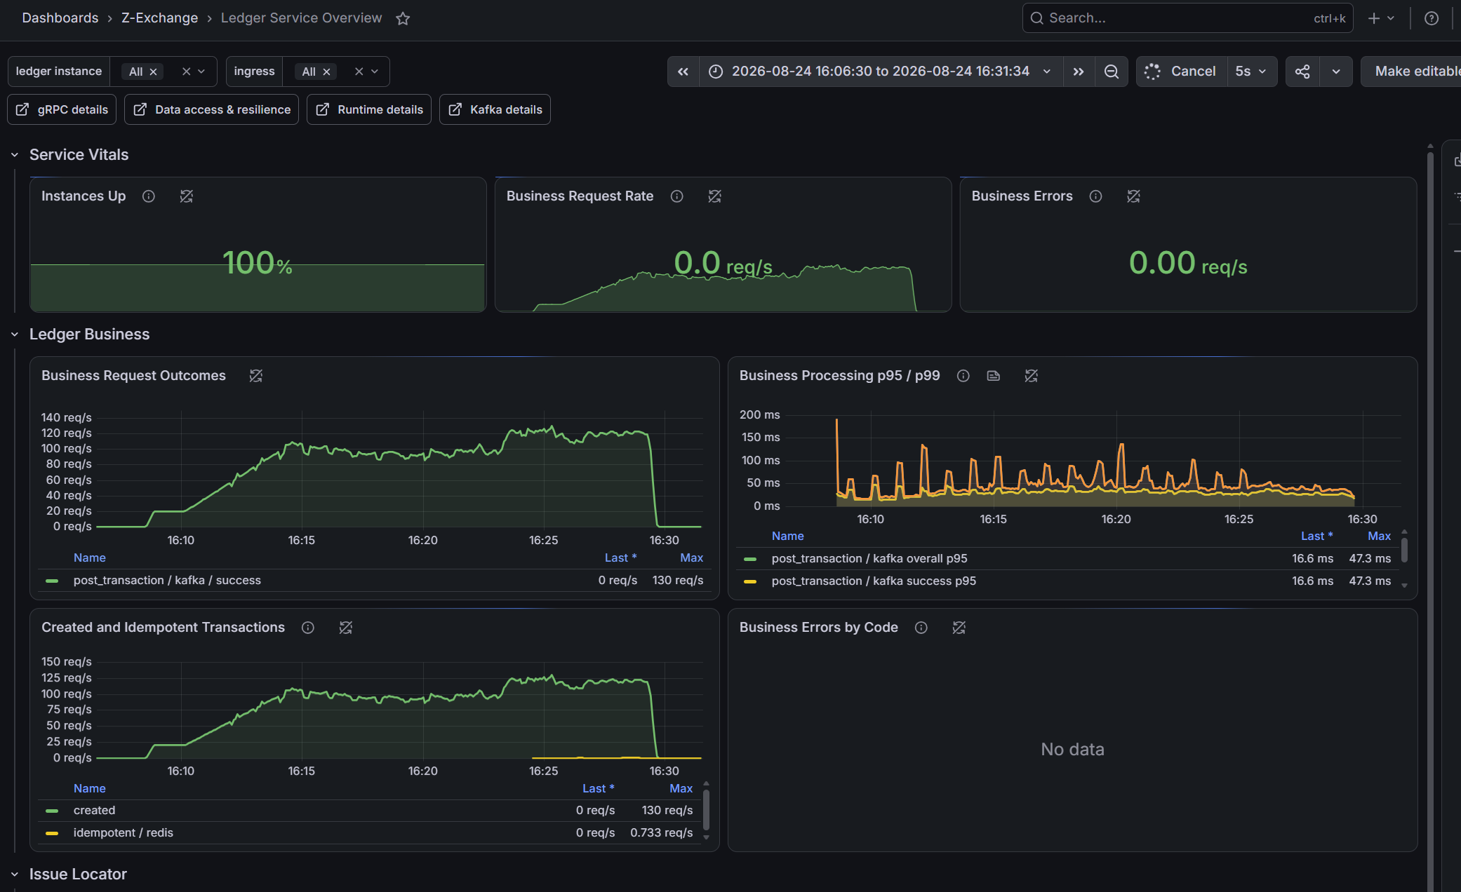
Figure 1. Ledger service overview. The capture shows command-side posting throughput and relatively low processing latency during the displayed interval; it does not by itself prove wallet reply completion was healthy.

Appendix A.2 - Dashboard evidence
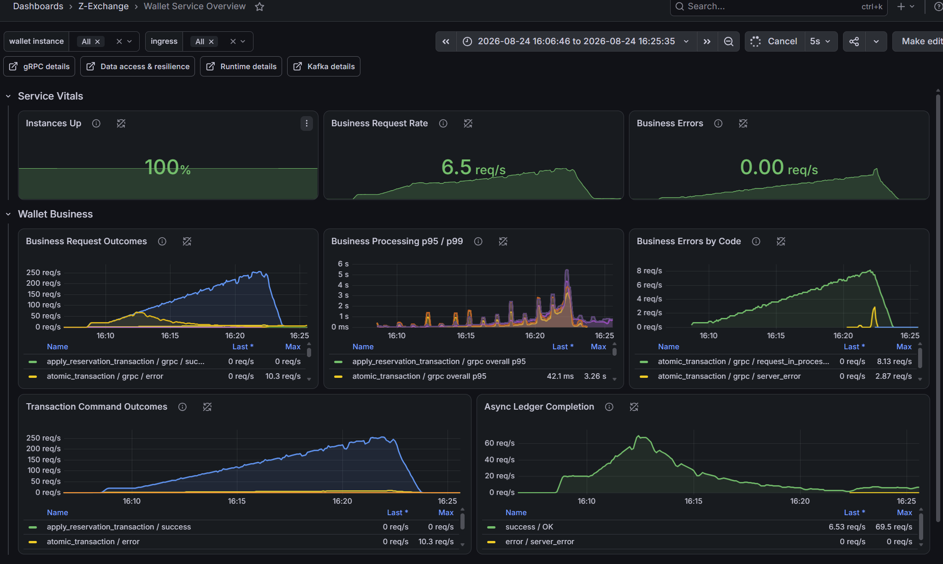
Figure 2. Wallet service overview. Atomic ingress rises toward roughly 250 req/s while asynchronous ledger completion peaks near 70 req/s and later remains in single digits; business latency and request-in-process errors increase.

Appendix A.3 - Dashboard evidence
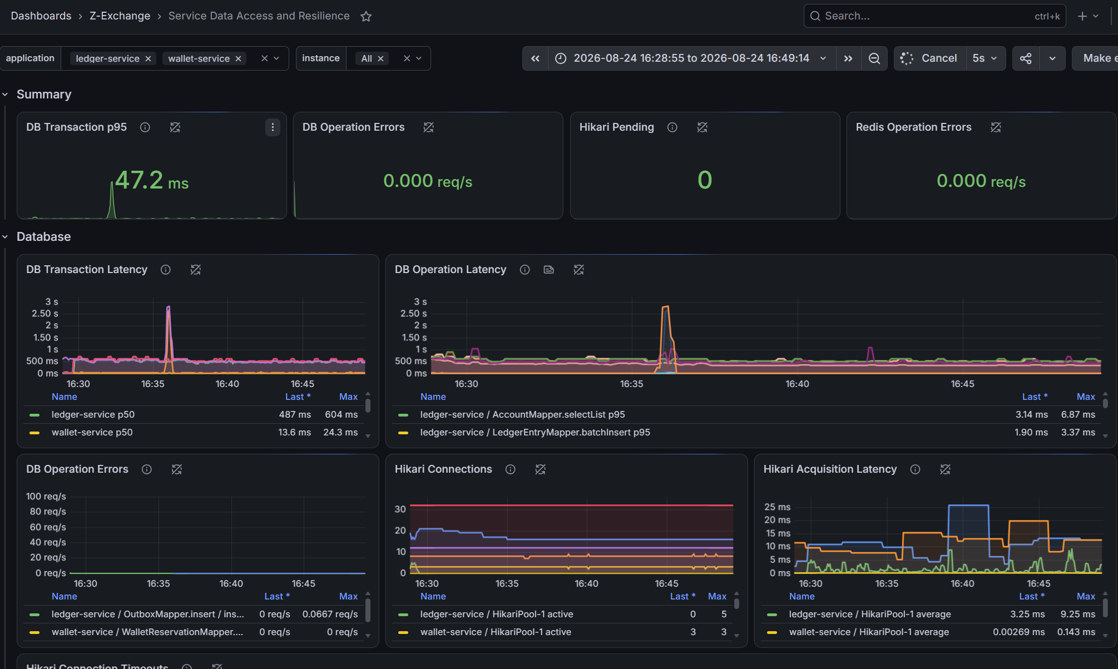
Figure 3. Data-access view after the input window. The capture supports continued database work and connection activity; the cropped legend does not expose every mapper series, so the mapper-specific diagnosis remains operator-reported unless raw panel data is exported.

Appendix A.4 - Dashboard evidence
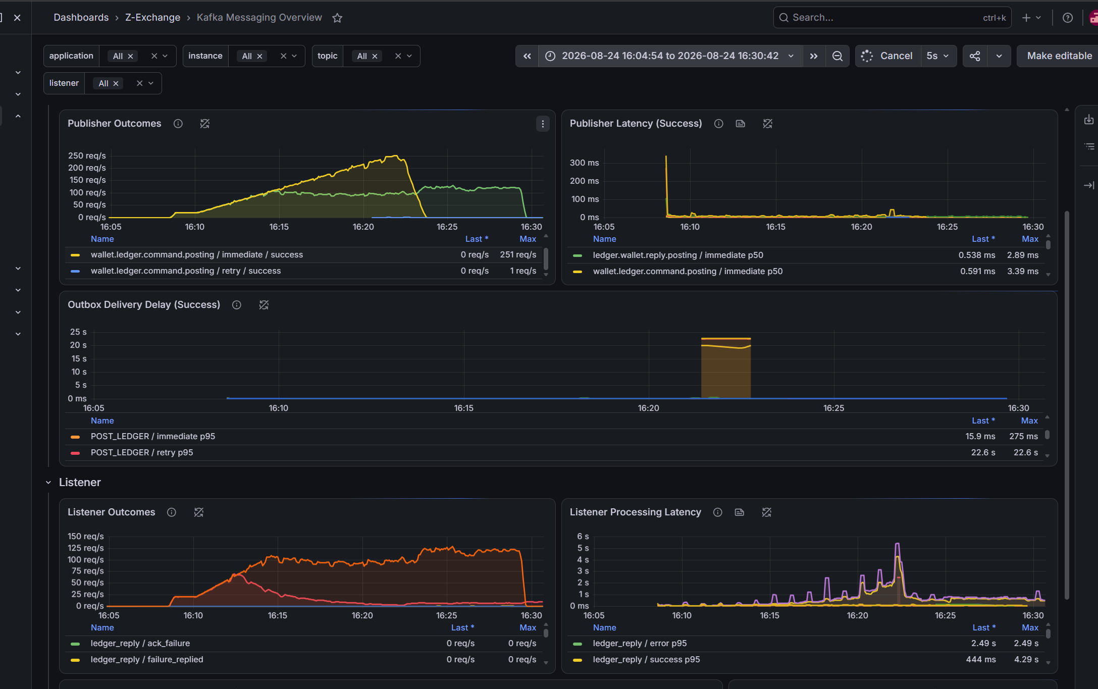
Figure 4. Kafka messaging overview. Listener processing latency reaches multi-second peaks and remains elevated after ingress falls, while publisher latency is comparatively low. Because the listener timer includes business work, this is not direct evidence of broker slowness.

Appendix A.5 - Dashboard evidence
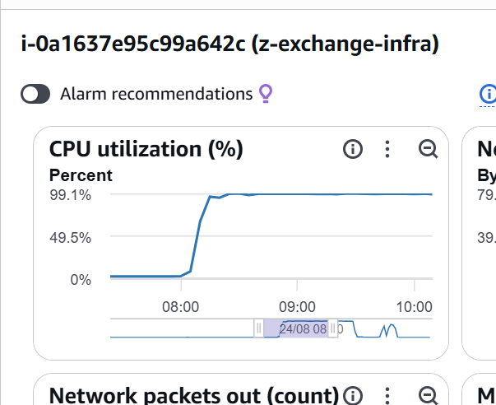
Figure 5. Shared infrastructure host CPU reaches approximately 99%. This confirms host-level saturation but requires per-process attribution before assigning the CPU to MySQL.

