

EXAMINATION PAPER: ACADEMIC SESSION 2020/2021

Campus Maritime Greenwich

Faculty Liberal Arts and Sciences

School Computing and Mathematical Sciences

Level 4

MODULE TITLE Algorithms and Data Structures

MODULE CODE COMP1819

Date and Time May 2021 - 90 minutes

Answer ALL questions

This is a multi-choice, open-book examination. You may access the internet but you may not communicate in any way with another person (including by electronic means).

To give your answers, you must:
- Submit your answers on Moodle.
- Also, make sure to mark your choices on the answer sheet (on the last page). If there is a problem with Moodle submission, please send this answer sheet to FLAS-exams@greenwich.ac.uk by the deadline.

Failure to follow any of these instructions may result in you failing the exam.

Answer all questions with the best answer(s):
- Which of the following are operations in data structures (choose 3)?

  - Traversal
  - Subtraction
  - Sorting
  - Merging
  - Travelling
  - Debugging
[4 marks]

- Which of the following can be used explain what an algorithm is (choose 2)?

  - A sequence of computational steps that transform input into the output.
  - A method calls itself.
  - A logical and mathematical model of a particular organisation of data.
  - A loosely written code to make final code.
  - A step-by-step procedure to solve a problem.
[4 marks]

- What is the Big-O performance of the following code (choose 1)?
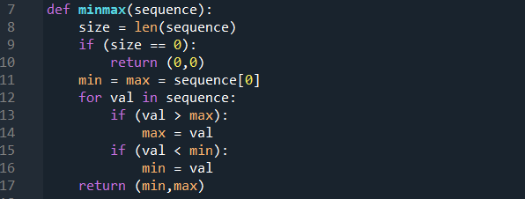

  - O(min)
  - O(size)
  - O(max)
  - O(min+max)
  - O(val)
[4 marks]

- … is very helpful in the situation when data items are stored and then retrieved in reverse order (choose 1 to fill in …)?

  - Set
  - Map
  - Stack
  - Queue
  - None of the above
[4 marks]

- What is the Big-O performance of the following code (choose 1)?

- def question(m, n):
- k = 0
- for i in range(m):
- for j in range(n):
- k += i * j
- return k

  - O(k)
  - O(m*k)
  - O(n*k)
  - O(m*n)
  - O(i*j)
[4 marks]

- Consider the following code, what would be the output from lines 37, 39 and 40 (choose 1)?

- class ArrayStack:

- def __init__(self):
- self.__stack = []

- def len(self):
- return len(self.__stack)

- def isEmpty(self):
- return self.len()==0

- def push(self, value):
- self.__stack.append(value)

- def view(self):
- return str(self.__stack)

- def pop(self):
- if self.isEmpty():
- raise StackError('stack empty')
- else:
- return self.__stack.pop()

- def peek(self, p = 0):
- if p>0 or (1 - p)>len(self.__stack):
- raise StackError('location beyond stack bottom')
- return self.__stack[p - 1]

- def top(self):
- return self.peek()

- if __name__ == '__main__':
- S = ArrayStack()
- S.push(5)
- S.push(3)
- print(S.pop())
- S.push(7)
- print(S.pop())
- print(S.pop())

  - 7
3
5
  - 3
5
7
  - 5
3
7
  - 3
7
5
  - ﻿The code will compile but there will be an exception raised.
[4 marks]

- After adding 1, 3 and 7 into an empty queue, and then deleting one element at a time, in which order will they be deleted? (Choose 1)

  - 731
  - 137
  - 713
  - 317
  - None of the above
[4 marks]

- When would it be ideal to use linear searching? (Choose 2)

  - When the list is linearly independent
  - When the list is sorted
  - When the list has only a few elements
  - When performing a few searches in an unordered list
  - When performing a search for duplicated values
  - Can be used all the time.
[4 marks]

- What is the complexity order for the best case for a linear search of n items? (Choose 1)

  - O(1)
  - O(log n)
  - O(n)
  - O(n log n)
  - O(n^2)
[4 marks]

- Which of the following would be a drawback when using linear search of n items? (Choose 1)

  - Requires more memory.
  - It is complex to understand.
  - Running time is more compared to other searching algorithms.
  - It requires looping implementation.
  - It cannot be programmed with recursion.
[4 marks]

- Which of the following data structure CANNOT be stored in a linear type (Choose 1)

  - Stack
  - Queue
  - Binary Tree
  - List
  - None of the above
[4 marks]

- Consider the following code for Bubble Sort, what would be the THIRD line of the output (from line 8)? (Choose 1)

- def bubbleSort(arr):
- n = len(arr)

- # Traverse through all array elements
- for i in range(n):

- # Last i elements are already in place
- print(arr)

- for j in range(0, n-i-1):

- # traverse the array from 0 to n-i-1
- # Swap if the element found is greater
- # than the next element
- if arr[j] > arr[j+1] :
- arr[j], arr[j+1] = arr[j+1], arr[j]

- # Driver code to test above
- arr = [64, 34, 25, 12, 22, 11, 90]

- bubbleSort(arr)

- print (arr)

  - ﻿[11, 12, 22, 25, 34, 64, 90]
  - ﻿[64, 34, 25, 12, 22, 11, 90]
  - ﻿[34, 25, 12, 22, 11, 64, 90]
  - ﻿[25, 12, 22, 11, 34, 64, 90]
  - ﻿There is an error with the code.
[4 marks]

- What is the Big O performance of the worst case with an insertion sort of n items? (Choose 1)

  - O(n/2)
  - O(log n)
  - O(n)
  - O(n log n)
  - O(n^2)
[4 marks]

- Consider the following code for Selection Sort, what would be the SECOND line of the output from line 16? (Choose 1)

- A = [64, 25, 12, 22, 11]

- # Traverse through all array elements
- for i in range(len(A)):

- # Find the minimum element in remaining
- # unsorted array
- min_idx = i
- for j in range(i+1, len(A)):
- if A[min_idx] > A[j]:
- min_idx = j

- # Swap the found minimum element with
- # the first element
- A[i], A[min_idx] = A[min_idx], A[i]
- print(A)

  - ﻿[11, 12, 25, 22, 64]
  - ﻿[11, 12, 22, 25, 64]
  - ﻿[11, 25, 12, 22, 64]
  - ﻿[64, 25, 12, 22, 11]
  - ﻿ There is an error with the code.
[4 marks]

- What would be the pre-order traversal and post-order traversal of the following binary tree? (Choose 2)
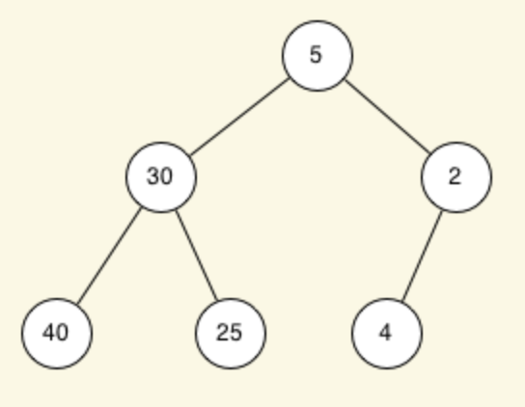

  - ﻿40, 25, 4, 30, 2, 5
  - ﻿40, 25, 30, 4, 2, 5
  - ﻿﻿5, 30, 40, 25, 2, 4
  - ﻿﻿40, 30, 25, 5, 4, 2
  - ﻿5, 30, 2, 40, 25, 4
[4 marks]

- Consider the following code using Maps, what would be the output from line 2? (Choose 1)

- m = {'a':1, 'b':2, 'd':3, 'c':3}
- print(m['d'])

  - 0
  - ﻿3
  - 4
  - None
  - There is an error with the code.
[4 marks]

- Consider the following code using Maps, what would be the output at line 14? (Choose 1)

- freq = {}
- for char in "comp 1819 algorithms and data structure":
- w = ''.join(c for c in char if c.isalpha())
- if w: # require at least one alphabetic character
- freq[w] = 1 + freq.get(w, 0)

- max_w = ''
- max_c = 0
- for (w,c) in freq.items(): # (key, value) tuples represent (w, c)
- if c > max_c:
- max_w = w
- max_c = c

- print(max_w, max_c)

  - a 4
  - t 4
  - comp 1
  - ﻿comp 4
  - ﻿There is an error with the given code.
[4 marks]

- Consider the following code using Sets, what is the output at line 21? (Choose 1)

- set1 = set([1, 2, 3, 4, 5, 6,
- 7, 8, 9, 10])
- print("Intial Set: ")
- print(set1)

- # Removing elements from Set
- set1.remove(1)
- print(set1)

- # Discard elements from Set
- set1.discard(3)
- print(set1)

- # Removing elements from Set
- for i in range(5, 10):
- set1.remove(i)
- print(set1)

- set2 = set([2, 6])

- print(set1.union(set2))

  - ﻿{2, 4, 6, 8, 10}
  - ﻿{2, 4, 6}
  - {2, 10, 4, 6}
  - ﻿{2, 4, 10}
  - ﻿There is an error with the code.
[4 marks]

- Identify the correct statements about a recursive method (choose 2)?

  - A method of solving a problem where the solution depends on solutions of smaller instances.
  - It can be an illegal call.
  - An object-oriented piece of code to execute an object.
  - A repeatedly executed block of code until a given condition is satisfied.
  - A method calls itself from its own code.
[4 marks]

- What is the output of the following code (choose 1)?

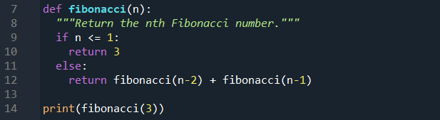

  - 1
  - 3
  - 5
  - 9
  - 11
[4 marks]
- How many times are the method drawSpiral being called in the following code (choose 1)?

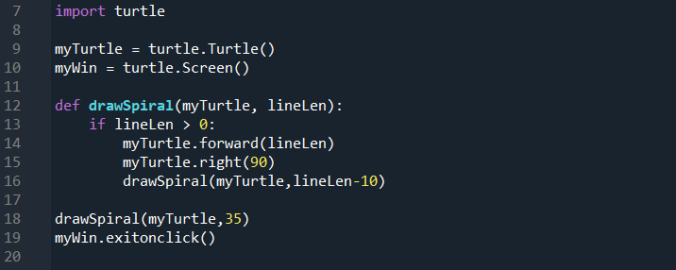

  - 1
  - 4
  - 2
  - 5
  - None of the above.
[4 marks]

- What is the Big-O performance for merging two sorted lists of size p and q (choose 1)?

  - O(p|q)
  - O(p+q)
  - O(p*log q)
  - O(q*log p)
  - O(p*q)
[4 marks]

- Given an already-sorted array, identify which sorting algorithms would have the best running time? (Choose 2)

  - Bubble Sort with a swap flag
  - Insertion Sort
  - Selection Sort
  - Quick Sort
  - Merge Sort
[4 marks]

- What is the output of the following code (choose 1)?

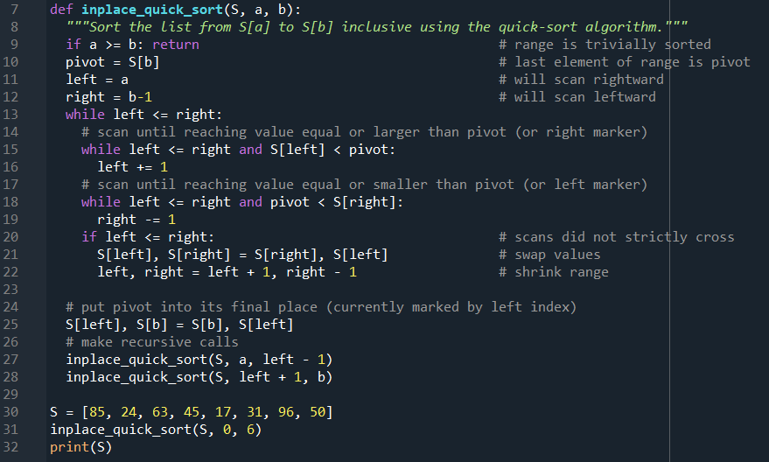

  - [85, 17, 24, 31, 45, 50, 63, 96]
  - [85, 17, 24, 31, 45, 63, 96, 50]
  - [17, 24, 31, 45, 63, 85, 96, 50]
  - [17, 24, 31, 45, 85, 63, 96, 50]
  - [17, 24, 31, 45, 50, 63, 85, 96]
[4 marks]

- How many times are the method merge_sort being called in the following code (choose 1)?

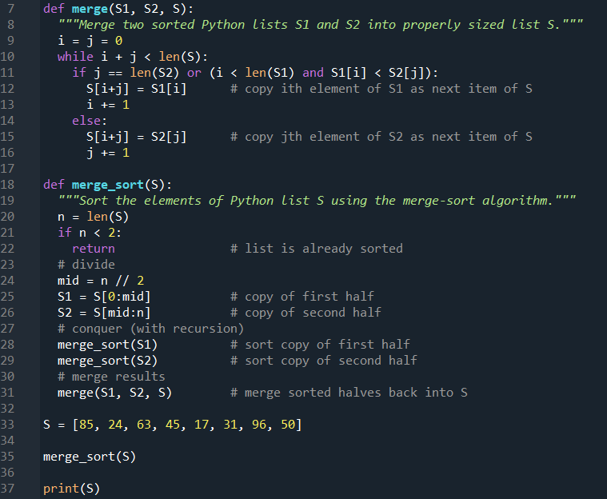

  - 15
  - 7
  - 3
  - 1
  - None of the above.
[4 marks]

Answer Sheet

TITLE OF PAPER Algorithms and Data Structures COURSE CODE COMP1819

Your Student ID (e.g 000123456): 00_______________________

Please circle all correct answers

- A B C D E F
- A B C D E
- A B C D E
- A B C D E
- A B C D E
- A B C D E
- A B C D E
- A B C D E F
- A B C D E
- A B C D E
- A B C D E
- A B C D E
- A B C D E
- A B C D E
- A B C D E
- A B C D E
- A B C D E
- A B C D E
- A B C D E
- A B C D E
- A B C D E
- A B C D E
- A B C D E
- A B C D E
- A B C D E

