**I did all the requirement**

1. Create a website by PHP

2. Create a website by PHP with AJAX

3. Create a website by PHP with MVC model and apply AJAX for searching

How website looks like

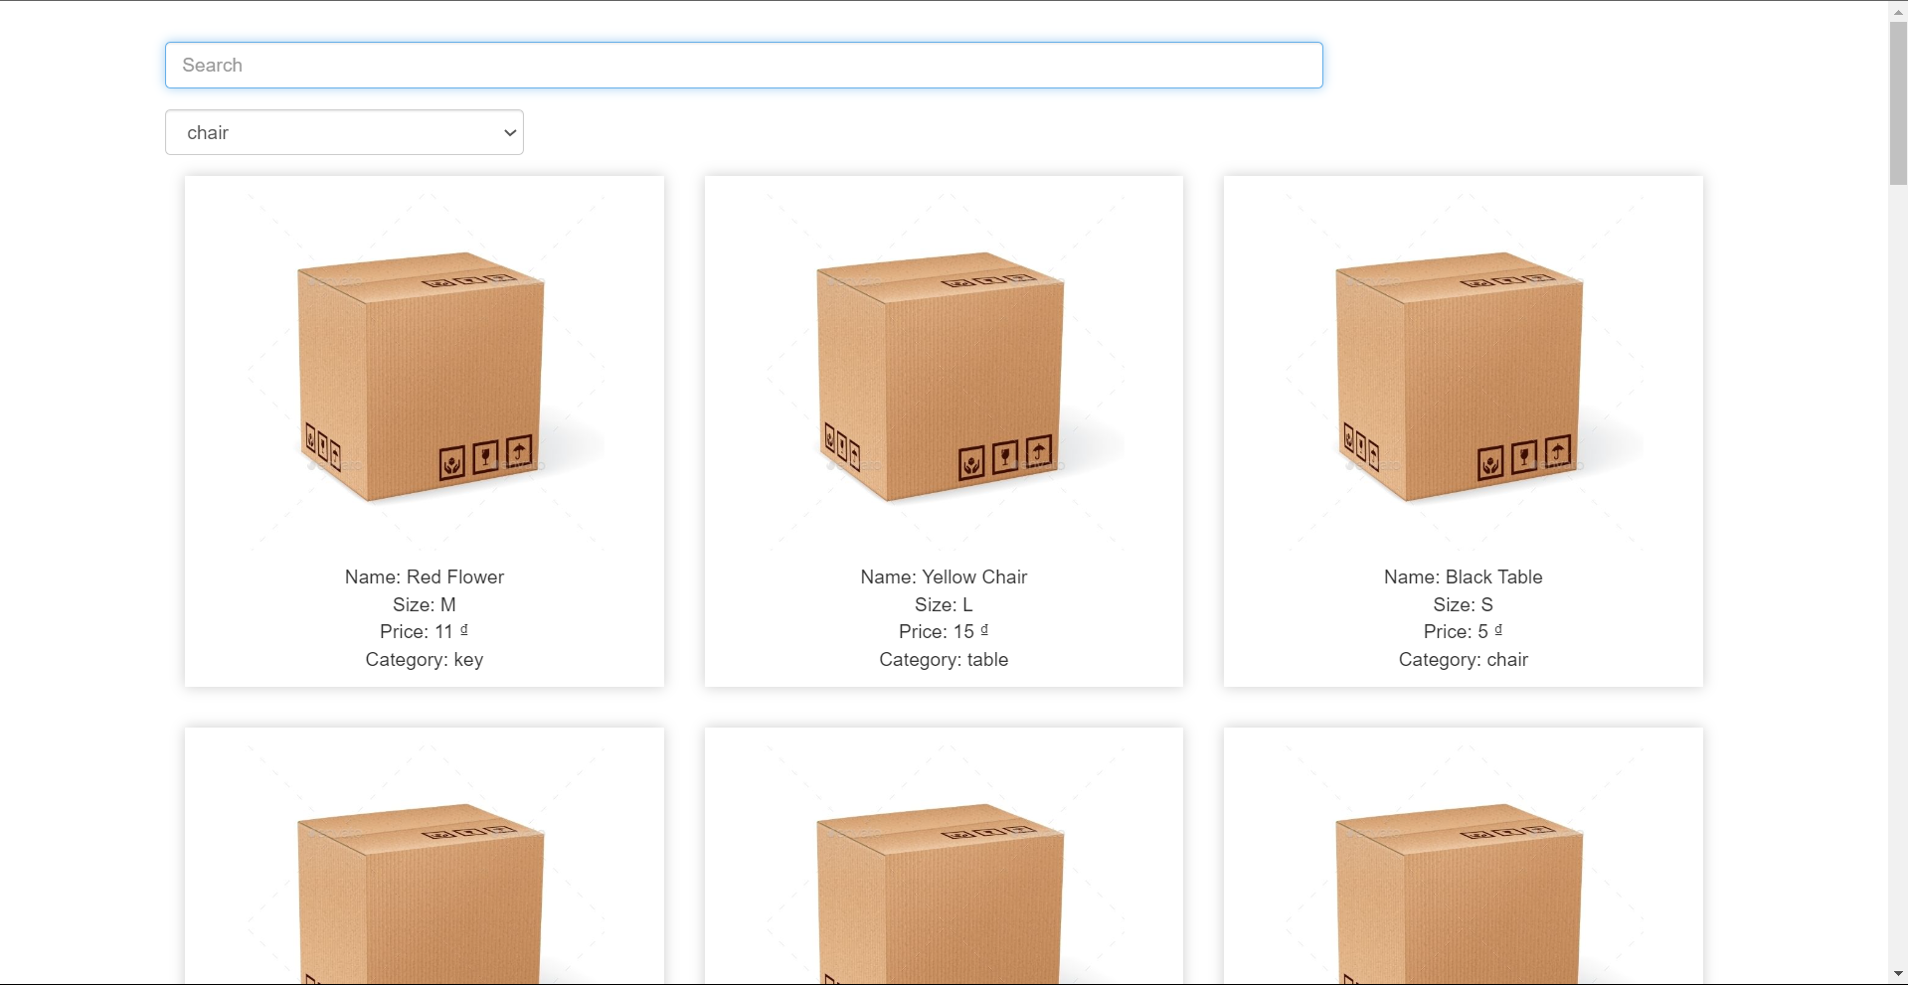

When I start to type something… It will filter

When I choose the category, it will filter

**How it works**

I did it by using Pure PHP, not framework

Appiled The MVC Design Pattern

The request come to index.php file

Then it load all the Class of project (load the Controllers, Models, …)

route.php file

The request will find route to match the **url** and **method**

If it is matched: It will handle the function of its

Example if I request to the url / and I use the GET method. It will call the function named index() in MainController class.

This is how Controller is called

If it not match to any routes: return 404

When the Controller is called (the index() function in MainController is called)

In line 14:

I initialize an Category model then use get() method, $categories will returned an array has many Category objects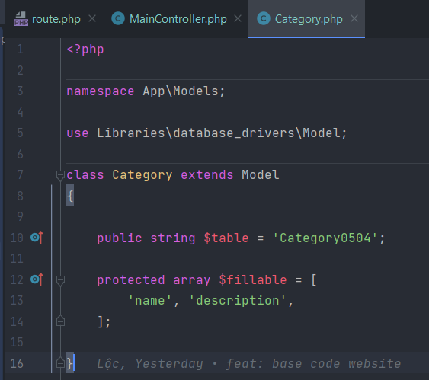

The same to line 15, initialize an Item model, then use raw() method to make an raw sql. It will return an array of Item objects, each object has category name attribute.

In line 15, I return a view name index, it means that I require a file name index.php in Views folder and put data in it

Then in index.php view file, I show the data

This is how Controller call to Model, then Model return data to Controller, then Controller brings data to View

This is how Ajax searching work

I catch the event user typing, then request the user’s input to the server

The server will get the user’s input, then query then return back.

After the Client receive the data, it will empty the div has id=product and loop the items record to show for user

4. Create & test API for website as follows

5. High Distinction Task (up to 10 pts) : Think about Payment (create a payment table and link to other part of your website, and simulate the payment with VNPay)

Sample like above, I create 5 routes for the 4th requirement, and 2 routes for the last task

It also applied the MVC architecture.

The request call the Controller, then Controller call the Model to get data, then Controller use that data to return in json type

+ GET /categories

Get all the categories, then return in json

+ GET /categories/{category}/products

Find products by category name

Get the category parameter on url then select from category where category name = …. If not found category then return error

If exist category, then select from item where category_id

Then return the items

+ GET /categories/{category}/products/{pid}

Find product by category name and product id

Like above, but select item where category_id and item_id in the parameter

Return only 1 item or error if not found

POST /categories/{category}/products

Create new product

Get the category name from url paramenter, if empty, return error

Get data from body json: name, size, price, if there is any field empty, return error

Insert into item then return that item data

+ DELETE /categories/{category}/products/{pid}

Delete product by category name and product id

Find product by category and product id, if any empty, return error

If found product, check if that product is in any order

If true then return it is in the order, can not delete

Else delete it and return success

**Test the API**

Structure of TESTAPI folder

The Client class has method like get(), post(), put(), delete() to make a simple http request, this class use CURL in PHP

Example api # GET /categories

Example api # GET /categories/{category}/products

Example api # GET /categories/{category}/products/{pid}

Example # POST /categories/{category}/products

Example: # DELETE /categories/{category}/products/{pid}

**DEMO High Distinction Task**

# POST /pay/{order_id}/{bank_code}

This API will take order_id to identify which order is being pay and the bank_code to know which payment gateway is

The API will return an payment url, the Client will redirect user to that url to pay, after user pay success, it will redirect to an url that our code config before, we use that url to complete the order by update the database that order is completed

It return an url

User pay the order

After the payment successful

It redirect to an route we config before, we use the params on the url to verify the payment.