VIETNAM GENERAL CONFEDERATION OF LABOUR

**TON DUC THANG UNIVERSITY**

**FACULTY OF INFORMATION TECHNOLOGY**



**BUI HUU LOC - 521H0504**

**ENHANCING LABOR PROTECTION**

**TRAINING WITH THE L&D**

**ERP MODULE ON ODOO**

**GRADUATION THESIS**

**COMPUTER SCIENCE**

**HO CHI MINH CITY, 2024**

VIETNAM GENERAL CONFEDERATION OF LABOUR

**TON DUC THANG UNIVERSITY**

**FACULTY OF INFORMATION TECHNOLOGY**



**BUI HUU LOC - 521H0504**

**ENHANCING LABOR PROTECTION**

**TRAINING WITH THE L&D**

**ERP MODULE ON ODOO**

**GRADUATION THESIS**

**COMPUTER SCIENCE**

Instructor

**Msc. Duong Huu Phuc**

**HO CHI MINH CITY, 2024**

**ACKNOWLEDGEMENT**

I would like to express my deepest gratitude to MSc Duong Huu Phuc for his invaluable guidance and support throughout the development of this thesis. His expertise, patience, and dedication have been instrumental in shaping this research and ensuring its successful completion.

I am immensely grateful for the time and effort he invested in mentoring me. His insightful feedback and encouragement have significantly contributed to both my academic and personal growth. Working under his supervision has been a truly enriching experience.

Thank you, Msc. Duong Huu Phuc, for your unwavering support and for helping me achieve this important milestone.

*Ho Chi Minh City, 15 June 2024*

*Students perform*

*(Sign and write full name)*

This thesis was carried out at Ton Duc Thang University.

Advisor: ............................................................................................

............................................................................................

*(Title, full name and signature)*

This thesis is defended at the Undergraduate Thesis Examination Committee was hold at Ton Duc Thang University on … /…/……

Confirmation of the Chairman of the Undergraduate Thesis Examination Committee and the Dean of the faculty after receiving the modified thesis (if any).

**CHAIRMAN DEAN OF FACULTY**

**…………………………. ………………………………**

**DECLARATION OF AUTHORSHIP**

I declare that this product report is mine alone. The research content and results in this topic are honest and have not been published in any form. The data in the tables for analysis, comments, and evaluation were collected by the author from different sources and clearly stated in the reference section.

In addition, the topic also uses a number of comments, assessments as well as data from other authors and other organizations, all with clear and specific citations and annotations of the origin.

If any fraud is discovered, I will take full responsibility for the content of the article. Ton Duc Thang University is not involved in copyright violations during my work.

*Ho Chi Minh City, 15 June 2024*

*Students perform*

*(Sign and write full name)*

**ENHANCING LABOR PROTECTION TRAINING WITH THE L&D ERP MODULE ON ODOO**

**SUMMARY**

This thesis focuses on enhancing labor protection processes by developing customized ERP modules within the Odoo platform. The labor protection industry demands strict adherence to safety regulations, and this project aims to address inefficiencies in training, assessment, incident management, and employee onboarding. Traditional methods often struggle to provide effective management and insights, resulting in gaps in compliance and safety.

The first module focuses on labor protection training. It includes a test creation system that generates and evaluates tests, an onboarding roadmap and course management system sourcing documents from the Department of Labor Protection, and comprehensive features for administrators and staff to manage training, monitor progress, and provide feedback. The expected outcomes include improved training efficiency, enhanced assessment capabilities, and detailed reporting and analytics for evaluating training effectiveness and identifying areas for improvement.

The second module addresses incident analysis and reporting. This module enables staff to submit incident reports, with AI extracting critical information such as incident type, location, and severity. Administrators can refine reports, reclassify incidents, and assign corrective actions to individuals or teams. The system employs AI to suggest corrective actions based on historical data, ensuring timely and informed responses to incidents.

The project leverages Python for development, PostgreSQL for database management, and LangChain to implement AI capabilities. These modules aim to streamline labor protection processes, enhance compliance, and ensure a safer work environment.

**CONTENTS**

LIST OF FIGURES vi

LIST OF TABLES vii

LIST OF ABBREVIATIONS viii

CHAPTER 1. INTRODUCTION 1

1.1 Topic Overview 1

1.2 System Description 2

1.3 Objectives 2

1.4 Scope 3

1.5 Limitations Object, Function and Technology 3

CHAPTER 2. SYSTEM ANALYSIS AND DESIGN 5

2.1 Software Development Life Cycle (SDLC) Model 5

2.1.1 Chosen SDLC Model 5

2.1.2 Application of the SDLC Model to the System 5

2.2 System specifications 6

2.2.1 Functional Requirements 6

2.1.2 Non-functional Requirements 7

2.1.3 System Architecture Requirements 9

2.2 Functional Diagram of System 11

2.2.1 Use-case Diagram 11

2.2.2 Actors of the System 12

2.2.3 Use-Cases of the System 12

2.2.4 Use-Case Description 15

2.3 Database Diagrams 28

2.4 Dataset 30

CHAPTER 3. TECHNOLOGY STACK 32

3.1 Odoo 32

3.2 LangChain 33

CHAPTER 4. SYSTEM IMPLEMENTATION 36

4.1 User Management Function 36

4.1.1 View Users 36

4.1.2 Add New User 37

4.1.3 Edit User Details 37

4.2 Examination Test 38

4.2.1 View Tests 38

4.2.2 Add A New Test 39

4.2.3 Evaluate The Test 42

4.2.4 Conduct The Test 43

CHAPTER 5. CONCLUSION 47

REFERENCES 49

# LIST OF FIGURES

Figure 2.1 Use-case Diagram 8

Figure 2.2 Database Diagrams 9

Figure 3.1 LangChain Platform 13

Figure 4.1 Interface of Viewing users 15

Figure 4.2 Interface of Viewing user. 16

Figure 4.3 Interface of Editing user 17

Figure 4.4 Interface of Viewing Tests 18

Figure 4.5 Interface of Creating a Test 18

Figure 4.6 Interface of Questions Generation 19

Figure 4.7 Interface of Question Management 20

Figure 4.8 Interface of Test Evaluation 21

Figure 4.9 Interface of Conduct a Test 23

Figure 4.10 Interface of Viewing Tests (staff) 24

Figure 4.11 Interface of answer question 25

# LIST OF TABLES

Table 2.1 Functional Requirement 5

Table 2.2 Non-Functional Requirement 6

Table 2.3 System Architecture Requirements 8

Table 2.4 List of actors of system 9

Table 2.5 Use-cases of the System 9

Table 2.6 Use-case Manage User 9

Table 2.7 Use-case Change Password 9

Table 2.8 Use-case Manage Test 9

Table 2.9 Use-case Manage Question 9

Table 2.10 Use-case Evaluate Test 9

Table 2.11 Use-case Manage Course 9

Table 2.12 Use-case Conduct the Test 9

Table 2.13 Use-case Check Score and Feedback 9

Table 2.14 Use-case Create Incident Report 9

Table 2.15 Use-case Manage Incident 9

Table 2.16 Use-case Assign Corrective Actions 9

# LIST OF ABBREVIATIONS

|  |  |
| --- | --- |
| API | Application Programming Interface |
| CRM | Customer Relationship Management |
| ERP | Enterprise Resource Planning |
| GPT | Generative Pre-training Transformer |
| L&D | Learning & Development |
| LLM | Large language model |
| MFA | Multi-factor authentication |
| RAG | Retrieval-Augmented Generation |
| RBAC | Role-Based Access Control |
| SME | Small and Medium Enterprise |
| URL | Uniform Resource Locator |

# INTRODUCTION

## Topic Overview

The labor protection industry is essential for ensuring the safety and well-being of workers. As industries grow and evolve, the challenges in maintaining safety standards also increase, requiring effective training programs to keep employees informed about safety protocols, regulations, and best practices. Unfortunately, traditional methods often struggle with inefficiency, inconsistency, and difficulties in managing and assessing training at scale. Technology, particularly Enterprise Resource Planning (ERP) systems, offers a powerful solution to these challenges by centralizing and simplifying complex processes.

This thesis focuses on enhancing labor protection efforts through the development of two customized ERP modules within the Odoo platform. The first module is designed to improve labor protection training by integrating test creation and evaluation, onboarding roadmaps, and course management. By sourcing relevant documentation from the Department of Labor Protection, this module provides administrators and staff with tools to effectively manage training, track progress, and give feedback.

The second module addresses incident analysis and reporting. This module enables staff to report workplace incidents easily. Using AI, the system automatically extracts key details such as the type, location, and severity of the incident. Administrators can refine these reports, reclassify incidents, and assign corrective actions, while the system suggests solutions based on past occurrences.

By leveraging the flexibility and modular nature of Odoo, this project aims to create robust tools that streamline training and incident management processes. The expected outcomes include improved training efficiency, better assessment capabilities, detailed reporting and analytics, and faster, more informed responses to workplace incidents.

## System Description

The customized ERP system developed within Odoo is designed to enhance labor protection processes by integrating two key modules: a Learning and Development (L&D) module and an Incident Analysis and Reporting module. The L&D module streamlines labor protection training with features such as test creation, distribution, and evaluation, along with an onboarding roadmap and course management system that organizes relevant documentation from the Department of Labor Protection. This ensures training content is up-to-date and regulatory-compliant. The Incident Analysis and Reporting module allows staff to report workplace incidents through a simple form, with AI automatically extracting details like type, location, and severity. Administrators can refine reports, reclassify incidents, and assign corrective actions, with AI suggesting solutions based on past incidents. Both modules offer user-friendly interfaces for administrators and staff, enabling efficient management, detailed progress tracking, feedback provision, and robust reporting. This integrated system leverages Odoo's flexibility to improve training efficiency, incident handling, and overall workplace safety.

## Objectives

This thesis aims to enhance labor protection processes through the development of a customized ERP system within the Odoo platform. The primary objectives include streamlining labor protection training by designing a Learning and Development (L&D) module that centralizes and optimizes activities such as onboarding, test creation, and course management. The module will integrate a roadmap and utilize documentation from the Department of Labor Protection to ensure regulatory compliance while offering tools for tracking progress, providing feedback, and generating detailed analytics to evaluate training effectiveness. Another key objective is to improve incident analysis and reporting by creating a module that simplifies the reporting process, employs AI to extract and classify critical details such as incident type, location, and severity, and enables administrators to refine reports, assign corrective actions, and prevent future incidents by leveraging insights from historical data. The project also seeks to utilize technologies such as Python, PostgreSQL, and AI tools like LangChain to enhance system functionality, ensuring user-friendliness, scalability, and compliance with labor protection standards.

## Scope

The scope of this thesis encompasses the development and implementation of two key modules as part of a customized ERP system built within the Odoo platform, specifically tailored for labor protection processes. The system, designed as a modular extension of Odoo, focuses on improving both training management and incident reporting. The Learning and Development (L&D) module centralizes labor protection training activities by integrating onboarding, test creation, and course management features, all aligned with guidelines and materials sourced from the Department of Labor Protection. It provides an intuitive interface for administrators and employees to manage training, monitor progress, and generate reports that assess training effectiveness and compliance gaps. The Incident Analysis and Reporting module simplifies workplace incident reporting by incorporating AI to extract and analyze key details, such as incident type, location, and severity, from submitted reports. This module supports administrators in refining and reclassifying reports, assigning corrective actions, and receiving AI-driven recommendations based on historical data to enhance safety measures. The system is targeted at medium to large enterprises and is designed to integrate seamlessly with existing Odoo deployments, offering scalability, adaptability, and improved efficiency in labor protection training and incident management processes.

## Limitations Object, Function and Technology

The system primarily focuses on labor protection processes, specifically targeting employee onboarding, continuous skill enhancement, and workplace incident management. The Learning and Development (L&D) module includes features for test creation, onboarding roadmaps, course management, progress monitoring, and feedback, but its scope is limited to labor protection training and does not extend to other training areas or general HR functionalities. Similarly, the Incident Analysis and Reporting module is designed specifically for managing workplace incidents by enabling reporting, AI-driven analysis, and corrective action assignment, but it does not address broader safety management or verification of regulatory compliance. Both modules rely on the assumption that input data, such as training materials, incident reports, and regulatory documents, are accurate and up-to-date, as the system does not include mechanisms for verifying their authenticity or relevance.

The development of both the L&D ERP module and the Incident Analysis and Reporting module is influenced by the capabilities and limitations of the technologies used, primarily Odoo, Python, and Langchain. Odoo, while offering extensive customization options, faces limitations in terms of scalability and performance, particularly when dealing with very large datasets or complex business processes. The platform's existing architecture may restrict the degree to which certain functionalities can be modified or extended, which could limit the flexibility of the system. Python, the main programming language for development, is highly versatile, but it may encounter performance bottlenecks when handling computationally intensive tasks or interacting with certain external systems, particularly in real-time processing scenarios. Langchain, which is used for implementing AI-driven features like natural language processing in the Incident Reporting module, is limited by the quality of its algorithms and the training data it uses. This can impact the accuracy and efficiency of document management and incident analysis, as the system’s AI may struggle to process certain types of input data. These limitations may also hinder the scalability of the system as the number of users or incidents grows, potentially affecting the system's performance and user experience over time.

# SYSTEM ANALYSIS AND DESIGN

## Software Development Life Cycle (SDLC) Model

### Chosen SDLC Model

The Waterfall SDLC model was selected for this thesis due to its structured and sequential approach, which is well-suited for a single developer managing all aspects of the project. The Waterfall model's clear phases—ranging from requirements gathering to system maintenance—help ensure that each stage is completed thoroughly before moving on to the next. This methodology was chosen because the system's objectives and scope were well-defined at the outset, with minimal anticipated changes during development. By following a linear progression, the model provides clarity, minimizes uncertainty, and simplifies tracking the project's progress.

### Application of the SDLC Model to the System

The Waterfall model was applied to this project in distinct stages, culminating in the deployment of the modules to the Odoo Apps Store. Following the requirements gathering and design phases, the implementation phase involved sequentially developing the Learning and Development (L&D) module and the Incident Analysis and Reporting module. After completing the implementation, the testing phase focused on integration testing to ensure the modules worked seamlessly within the Odoo platform. Integration testing verified that key functionalities, such as onboarding management, test evaluation, incident reporting, and AI-driven analysis, interacted correctly with Odoo’s core ERP features. Once the modules passed testing, they were packaged and deployed to the Odoo Apps Store, making them accessible for enterprise users. This deployment phase ensured the modules met both functional requirements and compatibility standards for the Odoo ecosystem.

## System specifications

### Functional Requirements

Table 2.1 Functional Requirement

|  |  |
| --- | --- |
| **Requirement** | **Description** |
| Test Creation and Management | - The system must be able to generate customizable tests based on content sourced from relevant labor protection documentation. It should include multiple-choice questions.  - The system must automatically grade tests upon completion, providing instant feedback to employees. |
| Training Content Management | Administrators should be able to structure and organize training materials, courses, and learning paths for employees. |
| Assessment and Feedback Mechanism | The system must evaluate test results, provide feedback to both employees and administrators, and generate automated progress reports. |
| Account Management | The system must include a robust account management feature that allows users to create, update, and manage their profiles. This should include functionalities such as: User Registration and Profile Management, Password Management, … |
| User Roles and Access Control | The system should have distinct user roles (e.g., administrator, employee) with access control mechanisms to ensure proper authorization for different tasks. |
| Incident Reporting | Staff should be able to easily create and submit incident reports. The system must support input for details like type, location, and severity of the incident. |
| AI Incident Analysis | The system should automatically analyze incident reports, extracting key details such as type, location, and severity, using AI to assist in categorizing and understanding incidents. |
| Incident Management and Reclassification | Administrators should be able to edit, reclassify, or re-evaluate incident reports, ensuring that incidents are correctly categorized and assessed. |
| Corrective Action Assignment | The system must allow administrators to assign corrective actions to individuals or groups, tracking the progress and effectiveness of the actions taken. |
| AI-Powered Corrective Action Suggestions | The system should use AI to suggest corrective actions based on historical data of similar incidents, helping administrators make informed decisions. |

### Non-functional Requirements

Table 2.2 Non-Functional Requirement

|  |  |
| --- | --- |
| **Requirement** | **Description** |
| Scalability | The system must handle an increasing number of users as the organization grows, ensuring smooth operation even with high user activity. |
| Security | Data security and confidentiality are critical, as the system handles sensitive employee records and training results. The module must follow security best practices, including encryption, secure authentication, and regular security audits. |
| Performance | The system must be responsive, with minimal delays when generating tests, processing results, or providing access to training materials. |
| Availability | To ensure continuous access to training materials and assessments, the system must be highly available, with backup and disaster recovery mechanisms in place. |
| Compatibility | The system must be compatible with multiple devices (e.g., desktop, mobile) to allow users to access the platform from different environments. |
| Usability | The user interface must be intuitive and user-friendly, reducing the learning curve for both employees and administrators. |

### System Architecture Requirements

Table 2.3 System Architecture Requirements

|  |  |
| --- | --- |
| **Requirement** | **Description** |
| ERP Integration | The system will be integrated into the Odoo ERP platform, leveraging its modular architecture to manage employee data, training records, and compliance tracking. |
| Database Management | PostgreSQL Database: The system will utilize PostgreSQL as its relational database management system, chosen for its scalability, reliability, and ability to handle complex queries. Employee data, training records, test results, and performance metrics will be stored securely in this database.  Backup and Disaster Recovery: Regular automated backups will be set up, along with a disaster recovery mechanism to ensure minimal data loss in the event of a system failure. These backups will be stored in a separate location for added security. |
| Artificial Intelligence Integration | LangChain will be used to develop an AI-powered layer that automates test generation and evaluation based on structured labor protection documents. This system will utilize a Retrieval-Augmented Generation (RAG) model to source relevant content from a pre-defined database of regulations and guidelines. The AI will analyze the data to create custom test questions, ensuring they are relevant and updated. |
| Modular Design | The system will be built as a modular extension of the Odoo ERP platform. This ensures that the labor protection module can integrate seamlessly with other Odoo modules (e.g., Human Resources, Payroll, and Employee Management) while maintaining independent functionality. The modular design will allow administrators to activate or deactivate features based on their specific organizational needs. |
| Security and Data Protection | Role-Based Access Control (RBAC): A strict role-based access control system will be implemented to ensure that only authorized users (e.g., administrators, staffs) can access sensitive information such as employee records or test results. Employees will have access only to their own records and training materials.  User Authentication and Session Management: Multi-factor authentication (MFA) will be implemented to enhance security for administrative users. Additionally, secure session management practices, such as token-based authentication, will prevent session hijacking and unauthorized access to the system. |

## Functional Diagram of System

### Use-case Diagram

Figure 2.1 Use-case Diagram

### Actors of the System

There are 3 actors and 11 Use-cases.

Table 2.4 List of actors of system

|  |  |
| --- | --- |
| **Actors** | **Description** |
| Staff | Conduct the Test  Check Score, Feedback  Create Incident |
| Admin | Manage User  Change password  Manage Incident  Assign corrective action |
| Admin  Trainer | Manage Course  Manage Question  Manage Test  Evaluate Test |

### Use-Cases of the System

Table 2.5 Use-cases of the System

|  |  |  |
| --- | --- | --- |
| **ID** | **Use-Case** | **Description** |
| UC01 | Manage User | Allows administrators to create, edit, and delete user accounts within the system. Admins can assign specific roles (e.g., staff, trainer) to users based on their job functions. They can also manage user access levels and permissions, ensuring that each user has appropriate access to system features and training materials. Additionally, administrators can view user activity logs to monitor user engagement and compliance with training requirements***.*** |
| UC02 | Change password | Allows administrators to change their own password or the passwords of other user accounts within the system. It ensures account security by allowing for password updates when necessary***.*** |
| UC03 | Manage Test | Allows administrators, trainers to create, edit, and delete tests within the system. Admins can define test parameters, such as available times, expired times. They can also select questions from the question bank and arrange them into tests based on specific training objectives. Additionally, administrators can assign tests to make them available to staff and set visibility controls to limit access to specific user***.*** |
| UC04 | Manage Question | Allows administrators, trainers to manage questions associated with specific tests. They can add new questions to enhance the test's coverage of training topics, modify existing questions to improve clarity or difficulty, and delete questions that are no longer relevant. This functionality ensures that the test content remains up-to-date and aligned with current labor protection requirements***.*** |
| UC05 | Evaluate Test | Allows administrators, trainers to review and evaluate completed tests submitted by staff members. The system automatically grades the tests, but administrators can manually review individual test results to ensure accuracy and fairness. Admins can provide additional comments or feedback. This evaluation process helps ensure that training effectiveness is assessed and that necessary improvements can be identified***.*** |
| UC06 | Manage Course | Allows administrators, trainers to create, modify, and organize training courses within the system. They can upload training content, set prerequisites, and establish course completion criteria***.*** |
| UC07 | Conduct the Test | Allows staff members to take the training tests assigned to them within the system. Upon logging into the platform, staff will navigate to the Test Management section, which lists only the tests assigned to them. Once the staff member completes the test, they can submit their answers for evaluation. The system will then grade the test automatically and provide immediate feedback, including the score and explanations for correct and incorrect answers***.*** |
| UC08 | Check Score and Feedback | After completing a test, staff members can access their scores and detailed feedback. This use case enables employees to view their test results, including overall scores and performance metrics for each question. |
| UC09 | Create Incident | Allows staff members to report workplace incidents by entering relevant details into an incident form. The system captures the type, location, and severity of the incident, and automatically categorizes it based on predefined rules. |
| UC10 | Manage Incident | Allows administrators to review and manage incident reports created by staff members. Admins can edit incident details, reclassify the incident, or adjust its severity level if necessary. |
| UC11 | Assign Corrective Action | Allows administrators to assign corrective actions to address the incidents reported. Admins can assign specific tasks to individuals or groups, and the system may suggest actions based on similar past incidents. |

### Use-Case Description

Table 2.6 Use-case Manage User

|  |  |
| --- | --- |
| **ID** | UC01 |
| **Use-Case Name** | Manage User |
| **Actors** | Admin, User (Staff, Trainer) |
| **Primary Actor** | Admin |
| **Brief Description** | This use case provides administrators with the functionality to create, edit, and delete user accounts within the system. Admins can assign specific roles to users and manage their access rights to ensure that users have the appropriate permissions based on their job functions. |
| **Trigger** | Admin clicks the User Management menu. |
| **Pre-conditions** | The admin must be logged in to the system.  The admin must have the necessary permissions to manage user accounts. |
| **Flow** | Add New User:   * Click the "Create" button. * Fill in the user details (e.g., email, name, role). * Click the "Save" button to create the new user account.   Edit Existing User:   * Select the user from the list. * Click the "Edit" button on the user row. * Modify the user details as needed (e.g., change role, update email). * Click the "Save" button to apply the changes.   Delete User:   * Select the user from the list. * Click the "Delete" button on the user row. * Confirm the deletion in the confirmation dialog.   Search and Filter:   * Use the search bar to find users by name or email. |

Table 2.7 Use-case Change Password

|  |  |
| --- | --- |
| **ID** | UC02 |
| **Use-Case Name** | Change Password |
| **Actors** | Admin, User (Staff, Trainer) |
| **Primary Actor** | Admin |
| **Brief Description** | This use case allows administrators to change their own password or the passwords of other user accounts within the system. It ensures account security by allowing for password updates when necessary. |
| **Trigger** | Admin clicks the Change Password option in the User Management menu. |
| **Pre-conditions** | * The admin must be logged in to the system. * The admin must have the necessary permissions to change passwords for other user accounts. |
| **Flow** | * Navigate to the User Management section. * Select the user account from the list whose password needs to be changed. * Click the "Change Password" button on the user row. * Enter the new password. * Click the "Submit" button to update the password. |

Table 2.8 Use-case Manage Test

|  |  |
| --- | --- |
| **ID** | UC03 |
| **Use-Case Name** | Manage Test |
| **Actors** | Admin, Trainer |
| **Primary Actor** | Admin, Trainer |
| **Brief Description** | This use case allows administrators, trainers to create, edit, and delete tests within the system. An actor can define test parameters, select questions from the question bank, and publish tests for staff members. This functionality ensures that tests are relevant and aligned with training objectives. |
| **Trigger** | The actor clicks the Test Management menu |
| **Pre-conditions** | * The actor must be logged in to the system. * The actor must have the necessary permissions to manage tests. |
| **Flow** | Add New Test   * Click the "Create" button. * Fill in the test details (e.g., title, description, availability dates). * Select questions from the question bank to include in the test (optional). * Click the "Submit" button to create the new test   Edit Existing Test:   * Select the test from the list. * Click the "Edit" button on the test row. * Modify the test details (e.g., change title, update availability dates). * Add or remove questions as needed. * Click the "Save" button to apply the changes.   Delete Test   * Select the test from the list. * Click the "Delete" button on the test row. * Confirm the deletion in the confirmation dialog   Search and Filter Tests.   * Use the search bar to find tests by title or keywords. |

Table 2.9 Use-case Manage Question

|  |  |
| --- | --- |
| **ID** | UC04 |
| **Use-Case Name** | Manage Question |
| **Actors** | Admin, Trainer |
| **Primary Actor** | Admin, Trainer |
| **Brief Description** | This use case allows administrators, trainers to create, read, update, and delete questions associated with specific tests in the system. Actor can ensure that questions are relevant and aligned with the training objectives, enhancing the effectiveness of assessments. |
| **Trigger** | The actor clicks the Questions list within a specific test. |
| **Pre-conditions** | * The actor must be logged in to the system. * The actor must have the necessary permissions to manage questions for tests. * There must be at least one test available to manage questions. |
| **Flow** | Add New Question:   * Click the "Add Question" button within the selected test. * Fill in the question details, including: Question text, Answer choices, Correct answer. * Click the "Submit" button to create the new question.   Edit Existing Question:   * Select the question from the list associated with the test. * Click the "Edit" button on the question row. * Modify the question details as needed (e.g., change question text, update answer choices). * Click the "Save" button to apply the changes.   Delete Question:   * Select the question from the list. * Click the "Delete" button on the question row. * Confirm the deletion in the confirmation dialog. |

Table 2.10 Use-case Evaluate Test

|  |  |
| --- | --- |
| **ID** | UC05 |
| **Use-Case Name** | Evaluate Test |
| **Actors** | Admin, Trainer |
| **Primary Actor** | Admin, Trainer |
| **Brief Description** | This use case enables administrators to evaluate completed tests taken by staff members. Admins, trainers can review test results, provide feedback, and make adjustments to scores if necessary. The system can automatically score the tests based on predefined correct answers, streamlining the evaluation process. |
| **Trigger** | The actor clicks the Test Management menu and selects a test that needs evaluation. |
| **Pre-conditions** | * The actor must be logged in to the system. * The actor must have the necessary permissions to evaluate tests. * The selected test must have been completed by at least one staff member. |
| **Flow** | Access Test Management:   * Navigate to the Test Management section from the admin dashboard.   Select Test for Evaluation:   * Identify and select the test that requires evaluation from the list of completed tests.   Edit Score and Feedback:   * Review the automatic score provided by the system. * If necessary, adjust the score manually based on specific circumstances (e.g., partial credit for answers). * Provide feedback for the staff member, detailing areas of improvement or commendations based on their performance. * Optionally, add comments or recommendations for further training.   Save Evaluation:   * Click the "Save" button to record the score and feedback. |

Table 2.11 Use-case Manage Course

|  |  |
| --- | --- |
| **ID** | UC06 |
| **Use-Case Name** | Manage Course |
| **Actors** | Admin, Trainers |
| **Primary Actor** | Admin, Trainers |
| **Brief Description** | This use case enables administrators, trainers to create, read, update, and delete training courses within the system. The actor can provide essential details about each course, including the title, description, and source link, ensuring that staff members have access to relevant training materials |
| **Trigger** | The actor clicks the Course Management menu |
| **Pre-conditions** | * The actor must be logged in to the system. * The actor must have the necessary permissions to manage courses |
| **Flow** | Add New Course:   * Click the "Add Course" button.   Fill in the course details, including:   * Title of the course. * Description of the course. * Source link (URL) to access the course materials. * Click the "Submit" button to create the new course.   Edit Existing Course:   * Select the course from the list. * Click the "Edit" button on the course row. * Modify the course details as needed (e.g., change title, update description, edit source link). * Click the "Save" button to apply the changes.   Delete Course:   * Select the course from the list. * Click the "Delete" button on the course row. * Confirm the deletion in the confirmation dialog.   Search and Filter Courses:   * Use the search bar to find courses by title or keywords. |

Table 2.12 Use-case Conduct the Test

|  |  |
| --- | --- |
| **ID** | UC07 |
| **Use-Case Name** | Conduct the Test |
| **Actors** | Staff |
| **Primary Actor** | Staff |
| **Brief Description** | This use case allows staff members to participate in assigned tests. Staff can view available tests, complete them within specified time frames, and submit their answers. The system ensures that tests are accessible only during their available periods and provides immediate feedback upon completion |
| **Trigger** | Staff member logs into the system and navigates to the Test Management section |
| **Pre-conditions** | * The staff member must be logged in to the system. * There must be tests assigned to the staff member that are currently available for completion. * The current time must be within the availability period of the test (after the available start time and before the expiration time). |
| **Flow** | Access Test Management:   * The staff member navigates to the Test Management section after logging in.   View Assigned Tests:   * The system displays a list of tests that are assigned to the staff member and currently available for completion.   Select Test:   * The staff member selects a test from the list to start the evaluation process.   Review Test Details:   * The system presents the test details, including: Title of the test, Description and instructions   Start the Test:   * Click the "Conduct the Test" button to begin. * The system opens the test interface with questions.   Answer Questions:   * The staff member reads each question and selects their answers.   Submit Test:   * Once all questions are answered, the staff member clicks the "Submit" button.   Confirmation and Feedback:   * After submission, the system confirms that the test has been successfully submitted. * The system provides immediate feedback, displaying the automatic score based on the correct answers. |

Table 2.13 Use-case Check Score and Feedback

|  |  |
| --- | --- |
| **ID** | UC08 |
| **Use-Case Name** | Check Score and Feedback |
| **Actors** | Staff |
| **Primary Actor** | Staff |
| **Brief Description** | This use case allows staff members to view their scores and feedback for completed tests. Staff can access their performance details, including the score, any comments from administrators, and areas for improvement, enabling them to understand their progress and plan further training if necessary |
| **Trigger** | Staff member logs into the system and navigates to the Test Management section |
| **Pre-conditions** | * The staff member must be logged in to the system. * There must be completed tests available for the staff member to view |
| **Flow** | Access Test Management:   * The staff member logs into the system and navigates to the Test Management section.   View Completed Tests:   * The system displays a list of tests of the staff member, including details such as the test title, date completed, and scores.   Select Test for Review:   * The staff member selects a specific test from the list to view their score and feedback.   View Test Details:   * The staff member reads the feedback provided by the administrator, which may include comments on performance, areas for improvement, and suggestions for further training.   Return to Test Management:   * After reviewing the score and feedback, the staff member can navigate back to the Test Management section to check scores for other tests or to return to the main dashboard |

Table 2.14 Use-case Create Incident Report

|  |  |
| --- | --- |
| **ID** | UC09 |
| **Use-Case Name** | Create Incident Report |
| **Actors** | Staff |
| **Primary Actor** | Staff |
| **Brief Description** | This use case allows staff members to report workplace incidents by filling out a form within the system. The system captures key details of the incident, such as the type, location, and severity, to ensure that the report is properly logged and analyzed |
| **Trigger** | Staff member logs into the system and navigates to the Incident Management section and click Create |
| **Pre-conditions** | * The staff member must be logged in to the system. |
| **Flow** | * Click the "Create" button. * Fill in the required details of the incident, including: * Click the "Submit" button to create the report. |

Table 2.15 Use-case Manage Incident

|  |  |
| --- | --- |
| **ID** | UC10 |
| **Use-Case Name** | Manage Incident |
| **Actors** | Admin |
| **Primary Actor** | Admin |
| **Brief Description** | This use case enables administrators to manage, review, and update incident reports submitted by staff. Admins can edit incident details, reclassify the severity, assign corrective actions, and track the status of incidents to ensure proper resolution |
| **Trigger** | Admin clicks the "Incident Management" menu |
| **Pre-conditions** | * The admin member must be logged in to the system. |
| **Flow** | View Incident Reports:   * Click the "Incident Management" menu. * Browse the list of submitted incident reports. * Click on a specific incident report to view its details.   Edit Incident Report:   * Select the incident from the list. * Click the "Edit" button to modify the incident details. * Update fields such as the incident type, location, or severity as necessary. * Click "Save" to apply changes.   Reclassify Incident Severity:   * Review the incident's severity level. * Adjust the severity level if needed (e.g., from low to high). * Save the updated severity level. |

Table 2.16 Use-case Assign Corrective Actions

|  |  |
| --- | --- |
| **ID** | UC11 |
| **Use-Case Name** | Assign Corrective Actions |
| **Actors** | Admin |
| **Primary Actor** | Admin |
| **Brief Description** | This use case allows administrators to assign corrective actions to individuals or groups in response to reported incidents. The system may suggest actions based on similar past incidents |
| **Trigger** | Admin clicks the "Incident Management" menu and choose the incident |
| **Pre-conditions** | * The admin member must be logged in to the system. |
| **Flow** | * Select the incident that requires a corrective action. * Click the "Corrective Action" input to fill. * The system may suggest corrective actions based on historical data. * Review the suggested corrective actions or input a new corrective action. * Choose the individual(s) or group(s) responsible for implementing the corrective action. * Click "Submit" to assign the corrective action. |

## Database Diagrams

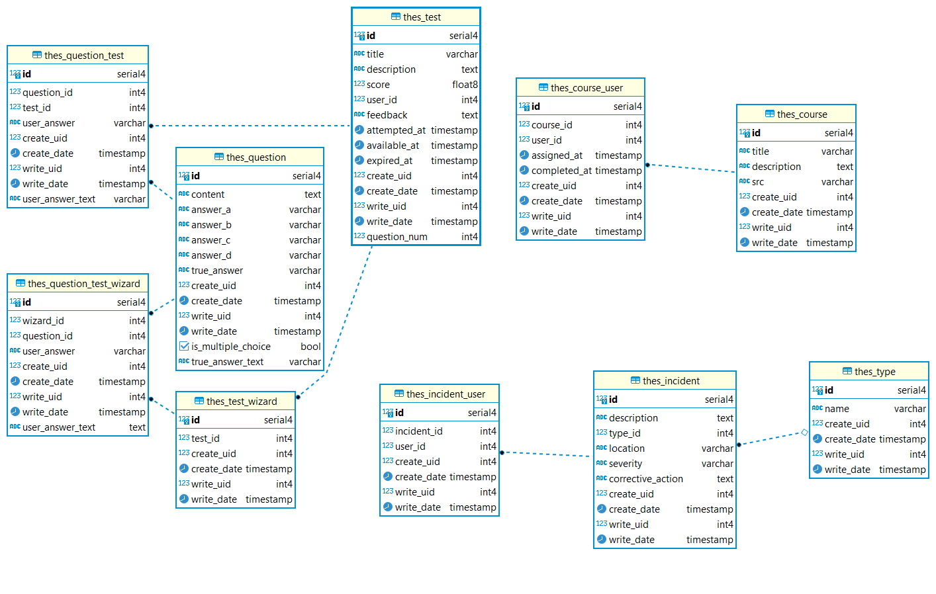

Figure 2.2 Database Diagrams

The database design for the labor protection training management system comprises several interconnected tables that collectively support the functionalities required for managing courses, questions, tests, and user interactions. Each table is designed with specific attributes to store relevant information, and relationships are established to ensure data integrity and facilitate efficient access.

The *Course* table is the foundation for training course management, storing information about the available courses for staff members. It includes fields such as *id*, which serves as a unique identifier for each course, and *title*, *description*, and *src*, which hold the course title, a detailed description of the course content, and a URL link to access the course materials, respectively.

Next, the *Question* table holds the questions used in various tests, including multiple-choice answer options. Each question is assigned a unique identifier *id*, with additional fields for content, which contains the text of the question, and *answer_a*, *answer_b*, *answer_c*, and *answer_d*, which represent the multiple-choice answers.

The *Question_Test* table establishes a many-to-many relationship between questions and tests, enabling each test to include multiple questions while allowing questions to be associated with various tests. This table includes the *question_id* and *test_id* fields, which serve as foreign keys referencing the respective tables, along with *user_answer*, which captures the answer provided by the user for each question.

The *Test* table contains critical information about the tests taken by staff members, such as the *title*, *description*, *score*, *feedback* from the administrator, and timestamps for when the test was attempted, as well as its availability period. Fields include *id*, which is a unique identifier, *title* and *description* for identifying the test, *score* for the user's performance, and *user_id* for tracking the individual who attempted the test. Additionally, *attempted_at*, *available_at*, and *expired_at* fields manage the time-related aspects of test availability, ensuring that staff can only access tests within specified timeframes.

The *thes_incident_user* table tracks user interactions with incident reports, recording details such as the user who created or last updated the incident report. It includes fields such as *user_id*, which is a foreign key referencing the user who interacted with the incident, and *incident_id*, which links to the specific incident in the *thes_incident* table.

The *thes_incident* table holds detailed information about each incident report, such as its description, location, severity, and type. It includes a unique identifier (*id*) and fields such as description to store the incident details, location to indicate where the incident occurred, and severity to define the level of seriousness (e.g., low, medium, high). The *type_id* field is a foreign key referencing the *thes_type* table to categorize the incident type. Additionally, the *corrective_action* field stores any actions taken to resolve the incident, allowing administrators to track the steps taken to address the issue.

The *thes_type* table defines the various types of incidents, such as "Workplace Injury" or "Equipment Failure," to classify incidents for better analysis and reporting. It includes fields like id, which is a unique identifier for each incident *type*, *name*, which represents the name or category of the incident, and *create_uid* and *write_uid* to track the users who created or modified the incident type record.

## Dataset

For the development of this labor protection ERP module, the dataset used is the "TECHNICAL CURRICULUM ON SAFETY AND LABOR PROTECTION" from Ba Ria - Vung Tau College of Engineering and Technology. This curriculum was chosen for several reasons, making it a suitable foundation for the test generation and course creation processes within the module.

Firstly, the dataset is comprehensive, covering a wide array of topics essential for labor protection training. It is structured into seven chapters, each focusing on a specific aspect of workplace safety and labor protection. These chapters provide a broad yet detailed overview of the necessary knowledge areas that both employees and administrators need to be familiar with to ensure safety compliance and prevent workplace accidents. The chapters include:

1. **General Overview of Labor Safety and Protection** – This chapter introduces the core concepts and regulations of labor safety, providing a fundamental understanding for both new employees and management.
2. **Health and Safety in the Workplace** – Focuses on the principles of maintaining health and safety standards in various workplace environments, including potential hazards and preventative measures.
3. **Science of Labor** – Explores the ergonomic and scientific aspects of labor safety, with attention to optimizing worker efficiency while minimizing risks.
4. **Mechanical Workshop Safety** – Offers specific guidelines for safety in mechanical workshops, including handling machinery, proper maintenance, and accident prevention protocols.
5. **Fire Safety** – A critical section that outlines fire prevention strategies, emergency responses, and risk management, ensuring workers are prepared for fire-related emergencies.
6. **5S Internal Management** – Covers the 5S organizational method (Sort, Set in Order, Shine, Standardize, Sustain), which helps in maintaining a safe, clean, and efficient workplace environment

This dataset is well-organized and specifically tailored for labor protection training. Its structure aligns well with the objectives of this project, which aims to streamline onboarding, testing, within the labor protection industry.

The main reasons for choosing this dataset over others is its accessibility and format. The curriculum is provided in DOCX format, making it significantly easier to work with compared to other training materials that were available in book or PDF form. While books and scanned documents often require extensive text extraction processes, the DOCX format allowed for more straightforward extraction and manipulation of the text. This was crucial for automating the test generation process through LangChain, as the system relies on extracting structured content from the dataset to create relevant questions and answers for various tests.

The dataset's length and detail, spanning 60 pages and 23,000 words, offer a rich and thorough basis for creating comprehensive tests, quizzes, and training programs. Its large volume ensures that a wide variety of questions can be generated, minimizing repetition and providing a broader assessment of the learner’s knowledge across multiple topics. This diversity is critical for generating randomized tests using LangChain, which draws from the dataset to create unique question sets for each assessment. The dataset is in Vietnamese adds a layer of complexity and relevance for local labor protection training.

The digital format of the DOCX file ensures that the content is easy to update and modify. As labor protection laws and best practices evolve, the ability to quickly incorporate changes into the dataset ensures that the training materials and assessments remain up-to-date and compliant with current regulations.

# TECHNOLOGY STACK

## Odoo

Odoo is a comprehensive open-source Enterprise Resource Planning (ERP) platform that offers a suite of integrated applications designed to facilitate business management across various domains. Originally launched in 2005, Odoo has evolved into a robust solution, gaining popularity among small to medium-sized enterprises (SMEs) and large organizations alike. Its modular architecture allows businesses to tailor the software to meet their specific needs by selecting and integrating only the applications relevant to their operations.

One of the standout features of Odoo is its extensive range of applications, covering areas such as accounting, sales, inventory management, human resources, project management, and customer relationship management (CRM). This modularity ensures that companies can start with basic functionalities and gradually scale up as their requirements grow, making it a highly flexible solution.

Odoo is built on modern web technologies, using PostgreSQL as its database management system, which provides a reliable and efficient means of handling data. The platform's user-friendly interface and intuitive design make it accessible to users with varying levels of technical expertise. Furthermore, Odoo supports customization through its built-in development tools, allowing organizations to modify existing applications or create new ones to suit their unique processes

Odoo's active community of developers and users contributes to its continuous improvement and innovation. This vibrant ecosystem fosters the development of third-party modules and integrations, extending the platform's capabilities and ensuring it remains relevant in a rapidly changing business environment.

Odoo also emphasizes integration, enabling seamless connectivity between different applications within the platform as well as with external systems. This feature enhances data consistency and streamlines business processes, allowing organizations to operate more efficiently and effectively.

Odoo was selected as the ERP platform for this project due to its versatility, scalability, and extensive feature set. The platform’s modular architecture allows for the customization and integration of only the necessary applications, making it ideal for a tailored solution. For this specific project, which focuses on labor protection training and incident management, Odoo’s flexibility was key in developing customized modules within the platform, such as the Learning and Development (L&D) module and Incident Reporting module.

Additionally, Odoo's open-source nature ensures that development costs are minimized, while its widespread adoption and active community support provide a strong foundation for continuous updates and improvements. The ability to leverage Odoo’s built-in development tools and integrations further supports the creation of a seamless system that can easily connect with existing business operations. Odoo’s user-friendly interface and ability to scale up as the organization grows make it a practical choice for enterprises looking for an ERP solution that can evolve alongside their needs.

## LangChain

LangChain is an innovative framework designed to simplify the development of applications that utilize large language models (LLMs) for natural language processing tasks. Emerging as a solution to the growing need for advanced AI capabilities in various domains, LangChain provides developers with a powerful toolkit for building applications that can generate, manipulate, and understand human language in a contextual and dynamic manner.

One of the key features of LangChain is its ability to facilitate the creation of applications that integrate seamlessly with multiple data sources. This capability allows developers to build applications that not only leverage the language generation capabilities of LLMs but also access real-time data, enhancing the relevance and accuracy of the generated content. For instance, applications can query databases, utilize APIs, or extract information from documents, providing a richer context for language processing tasks.

LangChain adopts a modular approach, enabling developers to customize and extend the framework according to their specific needs. It offers various components, such as prompt templates, chains, and agents, which can be easily combined to create complex workflows. This modularity encourages flexibility and allows developers to rapidly prototype and iterate on their applications.

Figure 3.1 LangChain Platform

(Source: Understanding the LangChain Framework on Medium)

The framework also emphasizes the use of "chains," which are sequences of operations that can be executed in a defined order. This feature is particularly useful for creating multi-step processes, such as retrieving information, processing it, and generating a coherent response based on the input. By structuring workflows into chains, developers can streamline application logic and improve maintainability.

LangChain’s integration capabilities extend beyond data retrieval; it can connect with various LLMs, including popular models like OpenAI's GPT-4 and other transformer-based architectures. This compatibility allows developers to choose the most suitable model for their application, depending on the specific use case and desired performance characteristics.

LangChain provides a framework for managing memory, enabling applications to maintain context over extended interactions. This feature is crucial for building conversational agents and other applications that require an understanding of user intent and context over multiple exchanges.

LangChain was chosen for this project due to its flexibility, scalability, and seamless integration with large language models (LLMs). Given the project's focus on automating test generation and incident reporting using AI, LangChain’s modular approach and ability to integrate with diverse data sources made it the ideal choice for building customized applications. The framework's ability to handle real-time data and perform contextual language processing allowed for dynamic generation of questions, answers, and incident reports based on continuously updated data.

Moreover, LangChain’s integration with popular LLMs like GPT-4 provided the necessary power to process and generate meaningful content efficiently. The use of chains for structuring workflows enabled the development of sophisticated multi-step processes, such as extracting key information from documents and generating actionable insights for labor protection training and incident analysis.

# SYSTEM IMPLEMENTATION

## User Management Function

The "Manage User" function is a critical component of the labor protection training management system, enabling administrators to efficiently oversee user accounts within the application. This function includes several essential capabilities that facilitate user account management, including creating, updating, locking, and unlocking user accounts.

### View Users

The system provides administrators with the ability to view a list of all registered users.

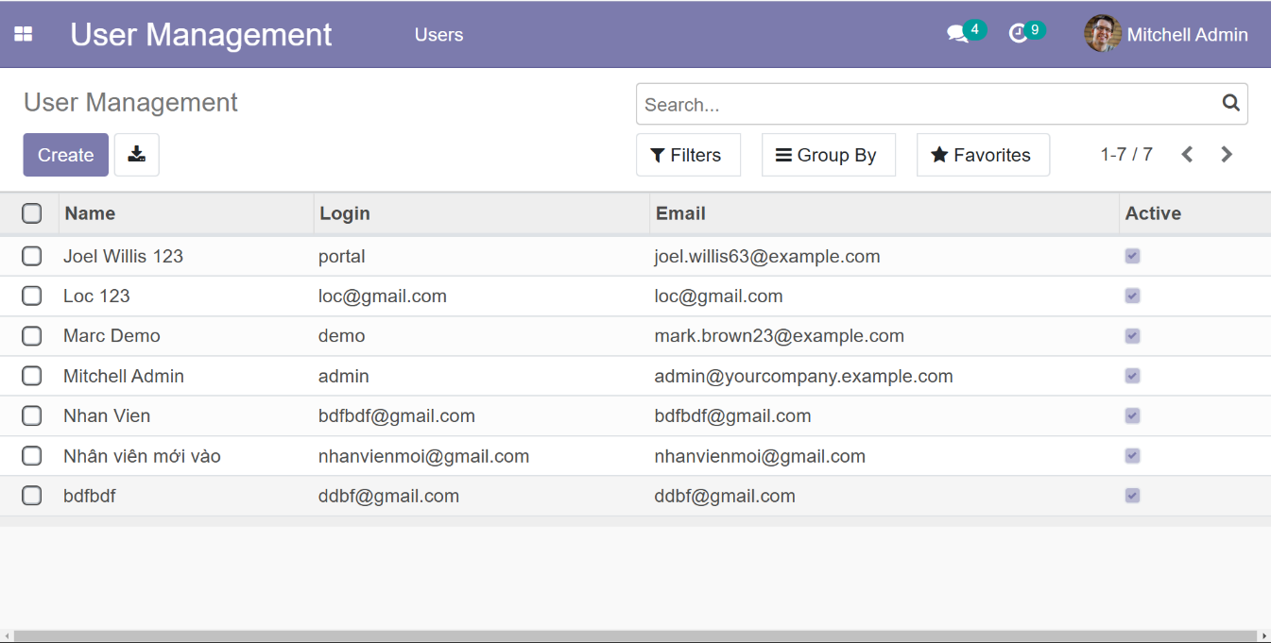

Figure 4.1 Interface of Viewing users

### Add New User

Administrators can create new user accounts for staff members.

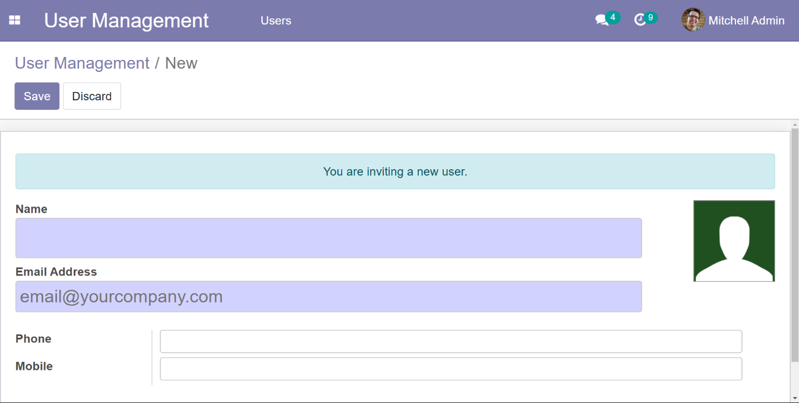

Figure 4.2 Interface of Viewing user.

Functionality:

* The administrator clicks on the "Add User" button.
* A form appears prompting the administrator to fill in.
* After entering the information, the administrator submits the form, and the system performs validation checks to ensure the data is correct. Upon successful validation, a new user account is created.

### 4.1.3 Edit User Details

Administrators can modify existing user account information as needed.

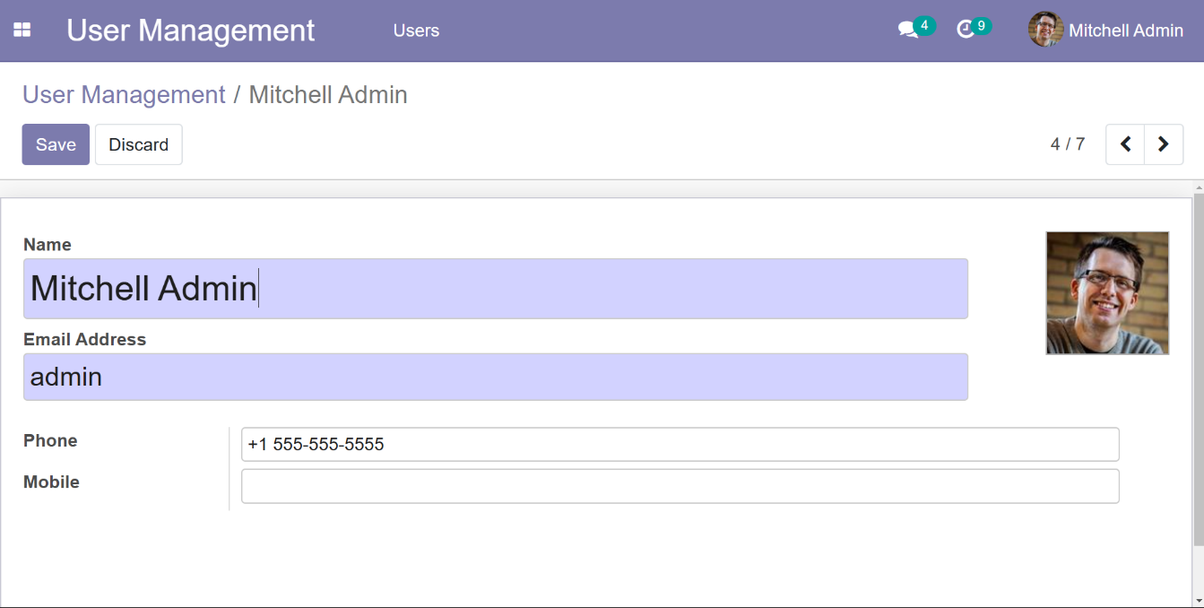

Figure 4.3 Interface of Editing user

Functionality:

* The administrator selects a user from the list and clicks the "Edit" button.
* The system retrieves the current details of the selected user and displays them in an editable form.
* The administrator can update the user's name, email, password, and role.
* After making the necessary changes, the administrator submits the form, and the system updates the user’s information accordingly

## 4.2 Examination Test

### 4.2.1 View Tests

The system provides administrators with an overview of all tests created within the platform

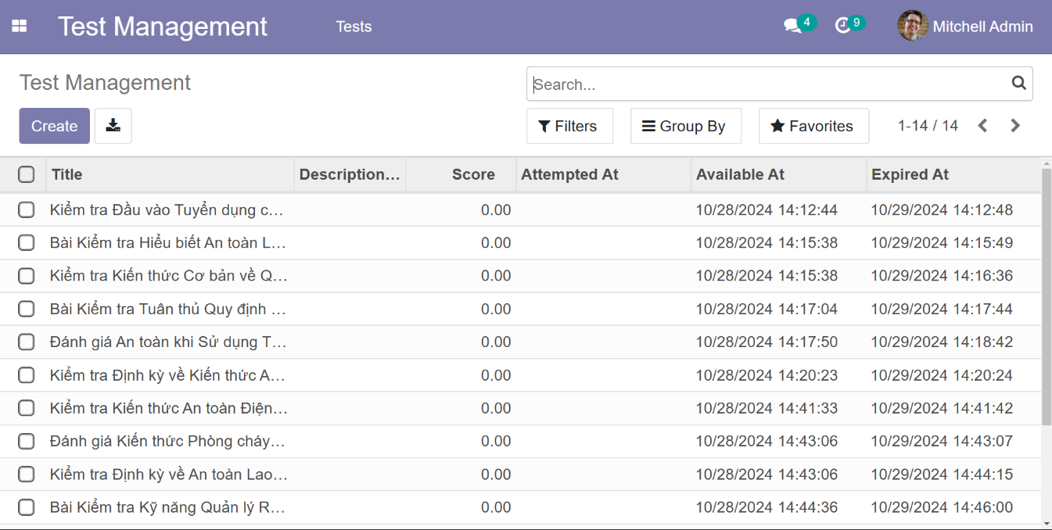

Figure 4.4 Interface of Viewing Tests

### 4.2.2 Add A New Test

The "Create Test" function allows administrators to generate customized tests tailored to the labor protection training curriculum. Leveraging the capabilities of LangChain, this function enables the random generation of questions and answers, ensuring a diverse and dynamic assessment experience for staff members. By integrating LangChain, the system can create tests that are not only relevant but also engaging and challenging.

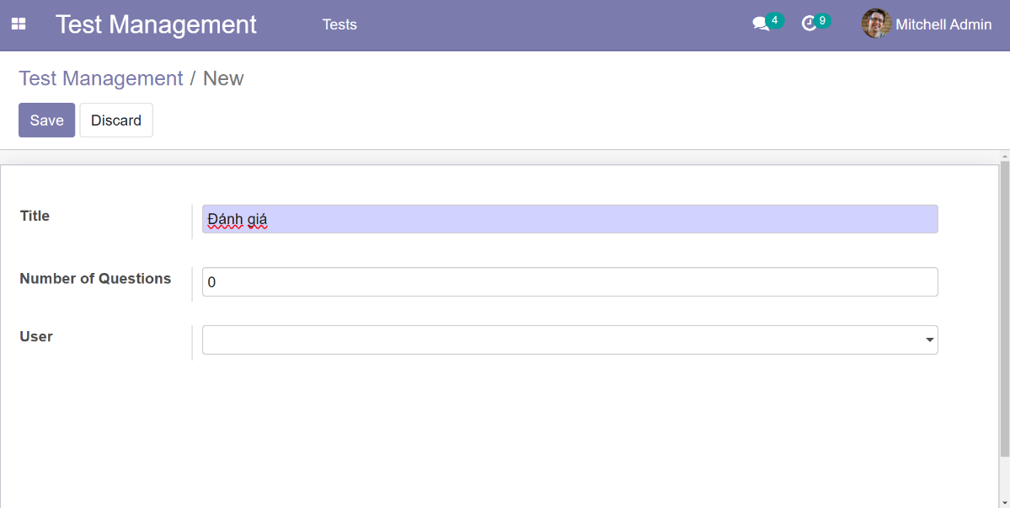

Figure 4.5 Interface of Creating a Test

Functionality:

* The administrator navigates to the "Test Management" section and clicks on the "Add" button.
* The administrator fills out the test creation form.
  + - Fields to Complete:

**Title**: A brief and descriptive title for the test.

**Description**: An overview of the test content and objectives.

**Score Criteria**: The passing score or grading criteria for the test.

**Availability Period**: Start and end dates defining when the test will be accessible to staff.

* System generates a random selection of questions for the test
* LangChain utilizes its predefined prompt templates and models to generate a set of random questions based on specified criteria.
* The generated questions are accompanied by multiple-choice answers (A, B, C, D), ensuring that they are contextually relevant and varied.

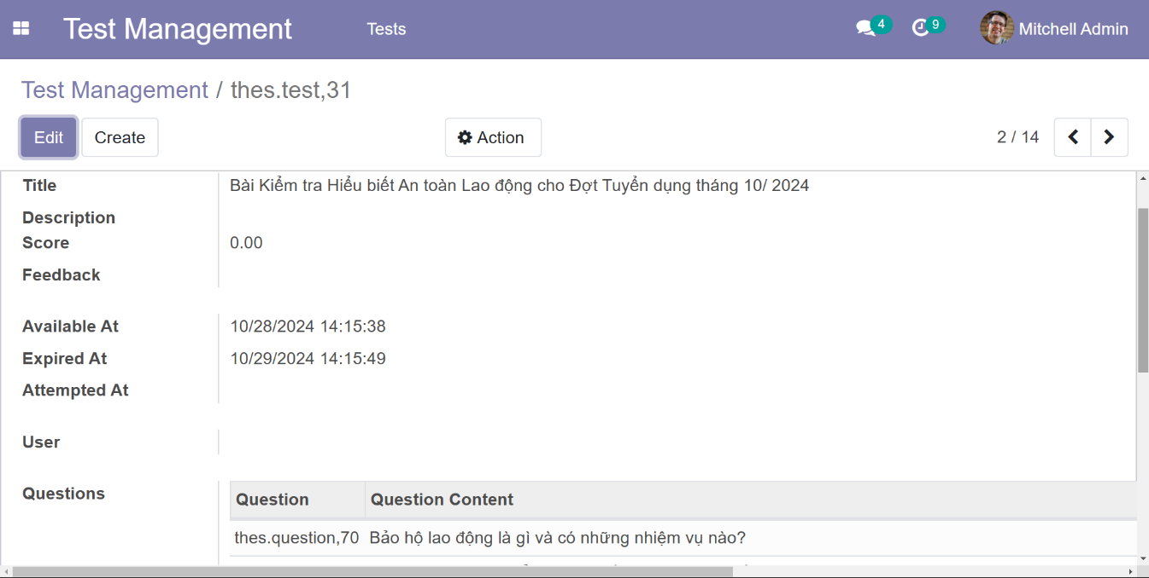

Figure 4.6 Interface of Questions Generation

* Review and Modify Generated Questions:
* After the questions are generated, the administrator reviews them for relevance and appropriateness.
* The generated questions are displayed in a list format, allowing the administrator to:
* Edit Questions: Modify the wording or structure of any question if needed.
* Edit Answers: Adjust the provided answers to ensure clarity and correctness.
* Delete Questions: Remove any questions that are deemed unsuitable.
* Administrators have the option to add custom questions manually, enriching the test with specific content as needed.

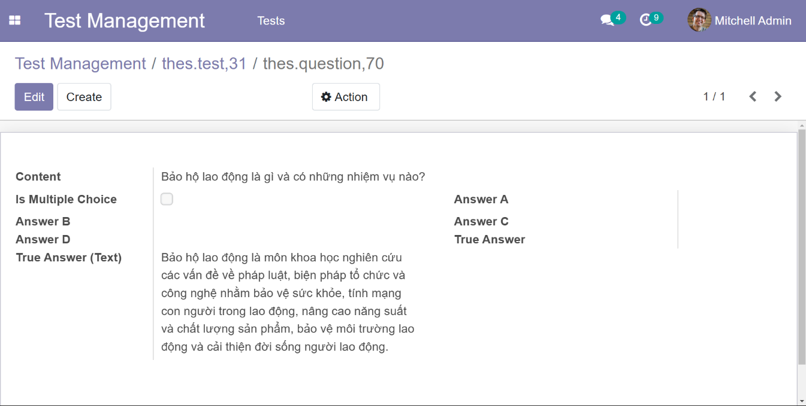

Figure 4.7 Interface of Question Management

* Finalizing the Test Creation
* Once the questions are reviewed and finalized, the administrator proceeds to save the test.
* The administrator clicks the "Save" button.
* The system stores the test, including all associated questions and answers, in the database.

### 4.2.3 Evaluate The Test

The "Evaluate Test" function allows administrators to assess completed tests taken by staff members, provide feedback, and assign scores. While the system automates scoring for multiple-choice questions using predefined correct answers, administrators can manually review results, provide qualitative feedback, and adjust scores where necessary. This ensures both automated efficiency and human oversight for more accurate evaluations.

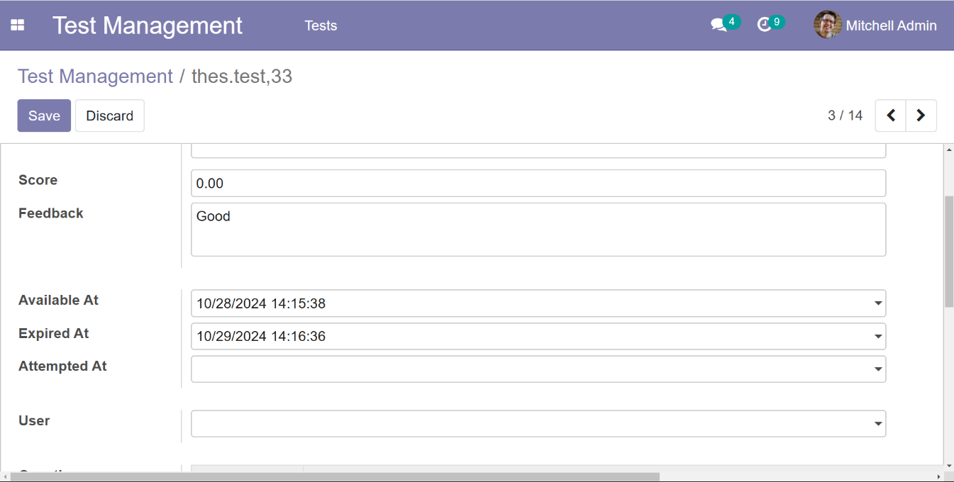

Figure 4.8 Interface of Test Evaluation

Functionality:

* The administrator clicks on the "Manage Tests" menu.
* A list of tests is displayed.
* Selecting a Test to Evaluate.
* Administrators have the option to override or adjust the automated score, feedback if necessary.
* Once the evaluation is complete, the administrator submits the final score and feedback.

**Automated vs. Manual Evaluation**

The system distinguishes between automated scoring and manual evaluation.

**Automated Scoring**: The system calculates the score based on predefined correct answers for multiple-choice questions. This automatic process speeds up evaluation and reduces administrative workload.

**Manual Evaluation**: While automated scoring is useful for objective questions, administrators can adjust scores and provide more personalized feedback based on subjective criteria. This hybrid approach balances efficiency with detailed evaluation when necessary.

### 4.2.4 Conduct The Test

The " Conduct a Test" function allows staff members to take assigned tests within a specified time frame. The tests assess their knowledge on labor protection topics, with questions generated using the LangChain integration. Staff can only access tests that are currently available, ensuring they complete them within the designated *time period*. The system provides an intuitive interface for answering questions and submitting test results.

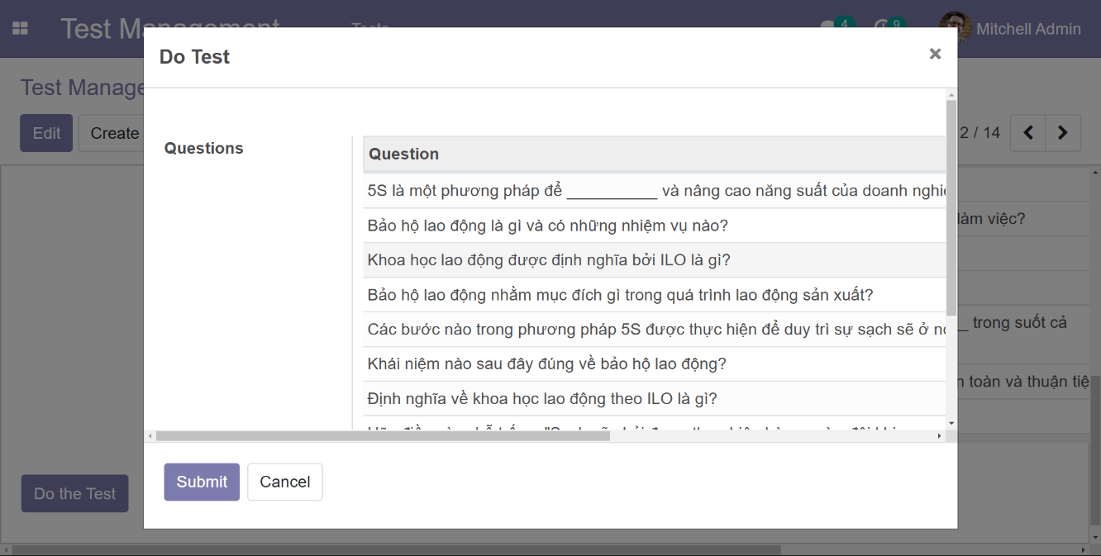

Figure 4.9 Interface of Conduct a Test

Accessing Assigned Tests:

* Staff members can only see the tests that have been assigned to them and are available for completion.
* The staff member logs into the system and navigates to the "Test Management" section.
* A list of available tests is displayed, showing the test titles and descriptions.
* Tests will only appear if the current time (now) is between the test's *available_at* and *expired_at* dates.
* Tests that are outside the availability window or already completed are not visible in the "Conduct the Test" section.

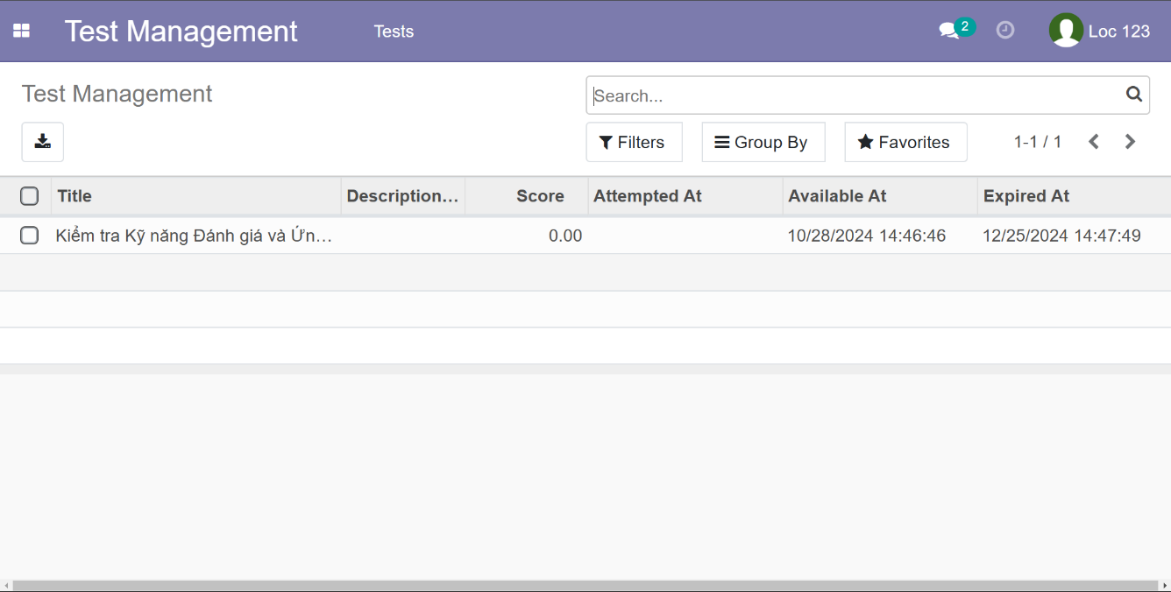

Figure 4.10 Interface of Viewing Tests (staff)

**Selecting a Test to Take**

* The staff member selects an available test from the list to begin.
* Clicking on the test title opens the test interface.
* The interface includes test details such as: Test title, Description, …

**Answering Questions**

* The staff member proceeds to answer the questions in the test.
* The system presents the test questions all at once.
* Each question includes:
* The question content (from the question table).
* Multiple-choice answers (A, B, C, D), where the user selects the correct option.
* For each question, the staff member selects one answer before moving to the next question.
* The system validates the response to ensure an answer is selected before proceeding.
* If the test allows navigation, staff can review and change their answers before submitting.

**Submitting the Test**

* Once all questions have been answered, the staff member submits the test for scoring.
* Clicking "Submit" finalizes the test attempt and prevents further changes.
* The system records the staff member's answers in the *question_test* table, storing the *question_id*, *test_id*, and *user_answer*.

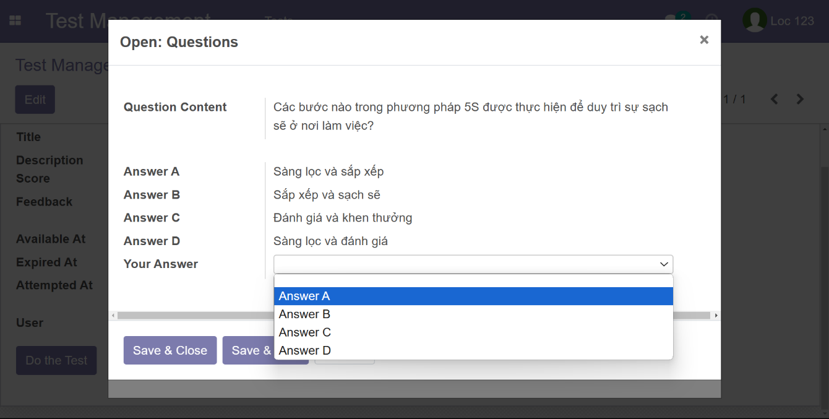

Figure 4.11 Interface of answer question

**Automatic Scoring and Feedback**

* The system compares the user's answers (*user_answer* in *question_test*) with the correct answers stored in the question table.
* It calculates the total score and stores it in the score field of the test table.

# CONCLUSION

This thesis focused on optimizing labor protection processes by developing a tailored Learning and Development (L&D) ERP module on the Odoo platform. The primary goal was to improve onboarding, training, assessment, and incident management for employees within the labor protection industry. By utilizing Odoo’s modular design and integrating AI tools like LangChain, the system automated key aspects of test generation, user management, course administration, evaluation processes, and incident handling.

* **Automated Test Creation**: The integration of LangChain allowed the automatic generation of randomized questions and answers for tests, enhancing efficiency in the assessment process.
* **Comprehensive Training Management**: The module enabled administrators to manage onboarding roadmaps, courses, and tests efficiently, while providing staff members with easy access to assigned learning resources and assessments.
* **Incident Reporting and Management**: The second module allowed staff to report incidents, with automatic categorization of the incident type, location, and severity. Administrators could then manage these reports by editing, reclassifying, and assigning corrective actions to prevent future incidents.
* **Effective Evaluation System**: The system combined automated scoring for objective questions with manual oversight, allowing administrators to adjust scores and provide personalized feedback, resulting in a balanced approach to staff evaluation.
* **Improved User Management**: The "Manage User" functionality provided administrators with full control over staff access, roles, and account settings, supporting a secure and well-regulated system.
* **Enhanced Learning Experience**: Staff members could easily take tests, check their scores and feedback, and access learning materials, resulting in a streamlined and user-friendly experience.

Future Development Directions:

* **Enhanced Reporting and Analytics**: Adding predictive analytics and customizable dashboards for more detailed insights into training effectiveness and employee performance.
* **Gamification**: Introducing elements like badges, leaderboards, and achievements to increase employee engagement with the training process.
* **Expanded Course and Test Customization**: Supporting multimedia content and reusable question banks to enhance the learning experience.
* **Integration with External Platforms**: Linking with external learning platforms (e.g., Coursera) and developing APIs for integration with HR and compliance systems.

# REFERENCES

Odoo Documentation – Odoo S.A. (2023). Odoo Documentation. Available at: https://www.odoo.com/documentation

Brownlee, J. (2021). Artificial Intelligence for Test Generation. Machine Learning Mastery. Available at: https://machinelearningmastery.com

LangChain Documentation – LangChain (2024). Building Language Model Applications. Available at: https://docs.langchain.com

Pande, D., & Patil, A. (2020). Microservices Architecture for Scalable and Efficient ERP Systems. International Journal of Computer Applications, 176(23), 1-7.

Singh, A., & Kaur, G. (2021). ERP Systems in Organizational Training and Development: Role in Compliance and Learning Management. Journal of Business Systems, Governance and Ethics, 16(1), 45-56.

Kumar, R. (2022). AI and Natural Language Processing in Learning Management Systems. AI and Education Journal, 12(3), 112-127.

Patel, D., & Nair, M. (2023). Secure Data Handling in ERP Systems: Best Practices for Encryption and Authentication. Information Systems Security Journal, 14(2), 90-105.