BayesPharma: Bayesian methods for pharmacology models
Madeline J. Martin
Elayne Vieira Diaz
P. Walter German
Elyssa B. Margolis
Matthew J. O’Meara
In pharmacology, many experiments seek to measure how a reductive biological system responds to one or more treatments. Here, we present BayesPharma, a collection of Bayesian methods to increase the robustness of the analysis and interpretation of dose response data. BayesPharma is an R package built around the Stan ecosystem that facilitates a principled Bayesian workflow. It can be used to fit and analyze foundational pharmacology models, serve as a pedagogical framework for learning Bayesian methods, and help build and analyze sophisticated pharmacological models. We describe the BayesPharma framework here, and illustrate its application to several case studies.

Introduction
As pharmacology experiments increase in complexity, it becomes increasingly challenging to analyze them. Although various frameworks exist for fitting pharmacology models using maximum likelihood estimation, such as GraphPad Prism(GraphPad Software, LLC 2023) and the drc dose-response curves R package(Ritz et al. 2015), it is much less accessible to fit pharmacology models using Bayesian statistics, which is a principled approach to quantify model uncertainty before and after data collection. In practice, Bayesian modeling requires defining a functional form, a prior distribution over the model parameters, and a likelihood function that describes the data generation process. Then, using Markov chain Monte Carlo (MCMC) or variational inference, the prior and the likelihood are combined to generate samples from the posterior distribution over the parameters. These samples can be used directly to answer scientific questions like “what are the model parameters” and “how confident should we be?” Crucially, Bayesian modeling workflows enable incremental addition of complexity to allow for the capture of important signal in the data generation process.
There has been substantial progress in general computational frameworks to facilitate developing and applying Bayesian models. A key example is the Stan package and the ecosystem of supporting tools. Stan provides a domain-specific language to describe probabilistic models, inference engines, front-end interfaces through many common programming languages, and a suite of tools to analyze fit models(Carpenter et al. 2017; Bürkner 2017; Vehtari, Gelman, and Gabry 2017a; Gabry and Mahr 2017; Kay 2018; Wickham 2009; Wickham et al. 2019; Team and Others 2013). Among the front-end interfaces, the Bayesian Regression Modeling using Stan (BRMS) package in R facilitates rapid model development through formulas similar to other regression models in R like lm() and the mixed effects regression package lme4(R_Core_Team2023-um?; Bates et al. 2015). BRMS not only supports defining linear and nonlinear predictors, but also hierarchical models and a range of pre-specified or custom response functions. Once specified as formulas, brms transforms the model through a series of different representations to allow them to be run on computer hardware. Once the model has run, it returns a set of samples from the posterior distribution, which can be used to analyze the model fit and make inferences.
In pharmacology, dose-response modeling through the foundational sigmoidal Hill-equation, Michaelis Menten enzyme kinetics, and multi-drug synergy models are widely used to probe biological systems and develop therapeutics. A limitation of the current tools is that it isd currently not straightforward for practitioners to implement and analyze these types of models using Bayesian statistics. To fill this gap, here we developed the BayesPharma R package, a Bayesian pharmacology modeling framework that implements foundational pharmacology models so that they can be easily used through brms, Stan, and other tools in the Stan ecosystem. After reviewing related work and basic Bayesian modeling concepts, we describe the package architecture and demonstrate the utility through several case studies.

Related work
Broadly, the increase in maturity in Bayesian modeling frameworks is making Bayesian modeling more accessible to practitioners, where it has seen a steady increase in popularity across the social sciences, econometrics, and biostatistics. For general Bayesian modeling theory, there are many excellent textbooks(Gelman et al. 2013; McElreath 2016; Gelman and Hill 2006; Johnson, Ott, and Dogucu 2022), online resources(Betancourt 2023; Posit Software, PBC 2023; Herbert Lee 2023) and prescriptive guidance(Depaoli and Schoot 2017; Kruschke 2021; Gelman et al. 2020). While in theory, Bayesian modeling relies on relatively straightforward statistical principles discussed in the following section, in practice, it is often impossible to fit models analytically. Instead, fitting Bayesian models typically requires using computational simulations or approximations. While bespoke inference methods can be implemented from scratch, for practitioners, it is useful to build on computational frameworks that support model specification, work with probability distributions and samples, and implement algorithms to conduct simulation and variational based inference. Frameworks differ by the language ecosystem they build on, how tightly the components are coupled, and the maturity of the framework, including support for diverse models and analyses and practitioner support such as documentation and usage guides. Beyond the Stan framework, which is written in C++ and has command line (cmdstanr), R (stanr) and, python (PyStan) interfaces, the JAGS (Just another Gibbs Sampler) framework is also implemented in C++ and has an R front end with a domain specific language and inference engine(Plummer 2003). Historically both Stan and JAGS grew out of the BUGS (Bayesian Inference using Gibbs Sampling) that was originally developed in the late 1980s(Spiegelhalter et al. 1996). In contrast, PyMC is implemented in C++ with a Python API and a range of modules for Bayesian inference(Salvatier, Wiecki, and Fonnesbeck 2016). Pyro is built on Pytoch(Paszke et al. 2019) and JAX(James Bradbury 2018) and wraps arbitrary Python code as a probabilistic model, and has an emphasis on deep-learning based variational inference. Turing is implemented in Julia, leveraging the expressive type system to support specifying probabilistic models and performing inference(Bezanson et al. 2017).
Over the past three decades, Bayesian methods have also become increasingly common in clinical pharmacology(Ashby 2006; Grieve 2007; Campbell 2017; Yang and Novick 2019; Lakshminarayanan and Natanegara 2019; Cooner 2019; Lesaffre, Baio, and Boulanger 2020; Faya et al. 2021; Ruberg et al. 2023). For example, the first approved COVID-19 Pfizer/Biontech vaccine used a Bayesian clinical trial design(Polack et al. 2020; Senn 2022). While there has been some application of Bayesian modeling for the analysis of high-throughput screening(Wei et al. 2013; Lock and Dunson 2015; Shterev et al. 2021; Ma and Kummer 2021; Tansey et al. 2021), and dose response modeling(Smith and Marshall 2006; Johnstone et al. 2017; Labelle, Marinier, and Lemieux 2019; Gould 2019; Arezooji 2020; Semenova et al. 2021), the models tend to be bespoke and highly sophisticated. In contrast, we aimed to lower the barrier of entry by building simple models while maintaining the flexibility needed to incrementally add complexity by building on a mature Bayesian modeling framework.

Bayesian Modeling Workflow
Bayesian statistics is a principled strategy to fit models to data. The key idea is that before seeing the data, the researcher defines a prior distribution over possible models indexed by model parameters, then the prior is combined with the data through Bayes theorem to produce the posterior distribution over the parameters. Bayes’ theorem can be derived from basic facts about probability distributions. While many have encountered examples of mathematical probability distributions, e.g., the normal distribution over all real numbers or binomial distribution for flips of a biased coin, it is worth thinking about what a probability distribution means from a computational perspective. Roughly, they are objects that support two types of operations, (1) it is possible to draw samples from them and (2) given a region of outcome space, we can ask what is the probability of drawing a sample in that region? For a one-dimensional probability distribution, when we draw many samples, we can form a histogram, and once we have generated this, we can then questions about the distribution, such as, what fraction have values larger than a given value. For two random variables, we can think of a sample as a scatter plot over the different dimensions.
Here, we give an informal derivation of Bayes’ theorem: Consider a noisy data generation process with parameters $θ∈Θ$ that can generate data $\text{D}∈D$. Assume we have an initial guess of possible parameters represented as a prior distribution $P\left(θ\right)$ and a way to evaluate how likely a dataset is given a candidate set of parameters, which we call the likelihood conditional probability distribution $P\left(\text{D}|θ\right)$. We would like to observe a data D and use it to find a better estimate of the parameters, which we call the posterior conditional probability distribution $P\left(θ|\text{D}\right)$. Consider the joint distribution of $θ$ and $\text{D}$, $P\left(θ,\text{D}\right)$. A basic fact of probability distributions is that it is possible to factorize joint distributions into conditional distributions in two different ways:
$$P\left(θ|\text{D}\right)P\left(\text{D}\right)=P\left(θ,\text{D}\right)=P\left(\text{D}|θ\right)P\left(θ\right)$$
Dividing through by $P\left(\text{D}\right)$ gives
$$\begin{matrix}P\left(θ|D\right) & =\frac{P\left(D|θ\right)⋅P\left(θ\right)}{P\left(D\right)} \\ \text{POSTERIOR} & =\frac{\text{LIKELIHOOD}⋅\text{PRIOR}}{\text{EVIDENCE}}\end{matrix}$$
Inspecting this equation, we see that the posterior distribution is proportional to the likelihood time of the prior. Since we want the posterior distribution to be a valid probability distribution that must integrate to $1$, we can understand the evidence $P\left(\text{D}\right)$ to be the unique normalization constant needed to make the equation work. While in principle the evidence term can be computed explicitly, it is often intractable. Instead, we can borrow ideas from statistical mechanics and try to sample parameters according to the posterior distribution. If we interpret the negative log of the posterior probability as a potential energy function, we can simulate how a particle would move on the parameter space over time—like a ball rolling over a hilly landscape—and then take snapshots of the trajectory as our samples. Given enough time, if the particle can access all parts of the probability distribution, one can show that the snapshots will form an unbiased sample from the posterior distribution. The key insight that makes this strategy useful is that evaluating the local change in energy (which determines a particle’s trajectory) does not require computing the global absolute energy, and therefore sidesteps computing the intractable evidence normalization constant. Different algorithms have been implemented to do this type of sampling, including Markov Chain based samplers such as Metopolis Hastings Monte CarloHastings (1970), Gibbs Sampling(Geman and Geman 1984), and Hamiltonian Monte CarloNeal (1996), which considers the energy gradient. Stan uses a variant of Hamiltonian Monte Carlo called No-U-Turn Sampling (NUTs)(Hoffman, Gelman, and Others 2014), which aims to dampen unproductive oscillations to accelerate sampling. An alternative sampling strategy, called variational inference, aims to simplify the computation by defining a more tractable functional form for the posterior and optimizes it to estimate an evidence lower bound (ELBO)(Kucukelbir et al. 2015; Blei, Kucukelbir, and McAuliffe 2017). Depending on the complexity of the functional form, variational inference can be more effective than sampling-based strategies, though typically it is both faster and less accurate.
There are a few key takeaways from understanding the derivation of Bayes’ theorem. First, the posterior distribution—the thing we are trying to estimate in Bayesian statistics—is a distribution over the parameters, not a distribution over, e.g., sampled data. Second, for inference, we combine the prior and the likelihood in a sampling algorithm to generate samples from the posterior distribution. Third, sampling-based inference methods that are run for only a finite amount of time, such as NUTs, are biased by their the initial conditions, while variational inference based methods are biased by the mismatch between the low complexity of the variational family and the high complexity of the true posterior, therefore inference is not guaranteed to work.
Since Bayesian modeling requires multiple steps, it can be non-trivial for beginners to get started. So, towards using Bayesian modeling effectively in practices, there have been efforts in the Bayesian modeling community to describe a principled Bayesian workflow, such as that described by (Gelman et al. 2020; Van de Schoot et al. 2020), for building robust Bayesian models and using them to draw inferences. The main steps involve
- Define and fit a probabilistic model, which combines a prior distribution over a set of parameters with the data to draw samples from the posterior distribution over the parameters using Hamiltonian Markov chain Monte Carlo.
- Check for sampling convergence.
- Use prior and posterior predictive checks to evaluate the model specification and fit.
- Use cross validation to evaluate the generalizability of the model.
- Assess inferences that can be made from the model.

BayesPharma package design
We designed the BayesPharma package to support modeling of pharmacology data using the principled Bayesian workflow. As described above, the workflow involves four phases: model specification, model fitting, model evaluation, and interpretation. Here we will describe the BayesPharma interface and how we recommend using it.
To provide data to the BayesPharma package, the user provides an R data.frame with columns for the response, treatments, and optionally additional covariates such as drug_id or batch_id. The data is passed to a model function that optionally includes arguments to customize the formula, prior, initial values, and other arguments to control the model fitting. The BayesPharma package then passes the user input to brms::brm() along with custom stan code specific for the selected model. Once the model is fit, the resulting brms::brmsfit object is returned to the user and can be used for analysis.

Model specification
Formula: The goal of the formula is to describe how the data is generated conditional on the model parameters. Syntactically, BayesPharma model formulas build a brms::brmsformula, which is similar to the formula specification syntax in base R and other R regression modeling packages. A brms::brmsformula consists of an equation that declares how the response on the left side is sampled from a parameterized distribution on the right side. For the linear formulas in BRMS, brms::lf(), the right side specifies mean response with a linear combination of covariates added together with implicitly defined model parameters. For example, the formula
$$\text{response}∼1+\text{drug_id}$$
says that response is sampled from a distribution with mean $β_{0}⋅1+β_{1}⋅{\text{drug_id}}_{1}+β_{2}⋅{\text{drug_id}}_{2}+…β_{n}⋅{\text{drug_id}}_{n}$ where $β_{i}$ are scalar parameters and ${\text{drug_id}}_{i}$ is an indicator variable for drug $i$. By default, the sampling distribution is a Gaussian, but other distributions can be specified from the distribution family with a link function using the family argument. For example, to model count data, which is strictly positive, set family=brms::poisson(). To model more general sampling equations, brms::formula can be specified as non-linear by setting nl=TRUE, and all model parameters must be explicitly defined. Building on this framework, the brms package supports a wide range of types of regression models including hierarchical models or random effects models. Moreover, it can support observational models that handle, for example, missing data or measurement error, which are described in detail in(Bürkner 2017). The BayesPharma package extends the brms formula syntax by defining Stan functions for foundational model types, such as the sigmoid function to model Hill-equation dose response models. For each model, functions are provided to help build the formula, for example
# This formula...
demo_formula <- BayesPharma::sigmoid_agonist_formula(
predictors = 1 + drug_id)
# will generate the equivalent formula as this
demo_formula_alt <- brms::brmsformula(
response ~ sigmoid(ec50, hill, top, bottom, log_dose),
nl = TRUE,
family = brms::student()) +
brms::lf(ec50 ~ 1 + drug_id) +
brms::lf(hill ~ 1 + drug_id) +
brms::lf(top ~ 1 + drug_id) +
brms::lf(bottom ~ 1 + drug_id)
Data: The data to be passed to the model should be in an R data.frame and organized into a “tidy” format. This means that each observation is in a single row and there there are columns for the response, and model specific covariates such as log_dose for the sigmoid model, and additional experimental covariates that can be used as predictors. See table XXX for the required columns (Treatments and Response) for each of the implemented model types
To get data in to a tidy form, it is possible to use the range of tools from the R tidyverse libraries. For example, if data is organized in plate-layout with multiple observations per row, the tidyr::pivot_longer function can be used to transform the shape of data.frame into one observation per row. Once the data is in a tidy format, the dplyr package can be used to manipulate the data, including using filter to subset the rows, select to subset the columns, mutate to compute new columns rowwise, group_by with summarize and reframe to perform split-apply-combine patterns over groups of rows, or <inner, left, right, full, cross, or semi>_join to merge using SQL-like semantics. The stringr package can manipulate string data, and for exploratory visualization, the ggplot2 package implements the grammar-of-graphics workflow for mapping data in a tidy format to aesthetic attributes of geometric objects in the plot, such as the coordinates of points or lines. For a good introduction to data manipulation using the tidyverse see the R for Data Science (2e) book and website (https://r4ds.hadley.nz/). Through each of the vigenttes below, we will make use of the tidyverse data manipulation.
To illustrate, we will create demonstration data for three drugs C1, C2, C3 with different ${\text{EC}}_{50}$ values of $10 \text{nM}$, $100 \text{nM}$, and $1 μ\text{M}$ measured and sigmoidal responses.
demo_data <- tibble::tibble(
drug_id = c("C1", "C2", "C3"),
ec50 = c(-8, -7, -6)) |>
dplyr::cross_join(
tidyr::expand_grid(
log_dose = seq(-7, -5, length.out = 10),
replica = c(1,2,3))) |>
dplyr::mutate(
mean_response = BayesPharma::sigmoid(
ac50 = ec50,
hill = 1,
top = 1,
bottom = 0,
log_dose = log_dose),
response = c(
stats::rnorm(
n = dplyr::n(),
mean = mean_response,
sd = ifelse(replica == 1, .2, .8))))
Note that the tidyverse framework—and especially the dplyr package—uses what is called non-standard-evaluation, where column names (e.g., ec50 and log_dose in the dplyr::mutate() call) can be treated as variables without needing to put them in quotation marks.
Prior: A key principle of Bayesian models is that they require specifying priors. For newcomers, understanding how these priors should be specified and justified tends to be one of the more challenging parts of the modeling process. From a practical perspective, priors can be thought of as just defining a weighted region of parameter space over which to optimize the model to best fit the data. In particular, the more compact and closely aligned the priors are with the data, the easier it is for the model to fit the data. Therefore, for setting up and getting started with a new model fit, the stronger (more constrained) the priors the easier the model is to fit. From a scientific perspective, since priors and posterior distributions can be interpreted as capturing the uncertainty in parameters before and after observing the data, the weaker (less constrained) priors, the less biased the inference, “letting the data speak for itself”. Ultimately, however, in Bayesian modeling, it is not possible to completely remove the bias due to the prior. This means that in a complete Bayesian analysis, some substantive argument should be made to justify that inferences from the model are not sensitive to reasonable choices of the prior. In a way, this actually makes choosing the prior less stressful as there is no singular best prior choice, and instead it reflects the scientific questions of the modeling process. For a deeper discussion and practical advice, see: the prior choice recommendations page on the Stan wiki. To facilitate specifying priors for each of the BayesPharma models, the BayesPharma package implements helper functions, for example
# This formula
demo_prior <- BayesPharma::sigmoid_agonist_prior()
# will generate the equivalent formula as this
demo_prior_alt <- c(
brms::prior(prior = normal(-6, 2.5), nlpar = "ec50"),
brms::prior(prior = normal(1, 1), nlpar = "hill", lb = 0.01),
brms::prior(prior = normal(1, 0.5), nlpar = "top"),
brms::prior(prior = normal(0, 0.5), nlpar = "bottom"))
The brms::prior function takes in Stan code (in this case the Normal distribution, which is defined in the Stan documentation), the nlpar defines the non-linear parameter, and optional arguments ub and lb give upper or lower bounds. For each BayesPharma prior helper function, individual priors can either be explicitly given to override the defaults, or specified as numeric constants to fix them to a particular value.
Init: To estimate the posterior distribution using sampling-based inference, the initial parameters values must be given. Then during inference, the parameters are simulated so that they hopefully converge to a sample from the posterior distribution. Therefore, the initial parameter values should at least be in a feasible region of parameter space to get the simulation to rapidly mix. For each model, the BayesPharma package provides default initialization values. Typically, if a different prior is given the initial values can be adjusted along with the updated prior.
# This formula
demo_init <- BayesPharma::sigmoid_agonist_init()
# will generate the equivalent initial values as this
demo_init_alt <- function() {
list(
b_ec50 = function(){as.array(-6)},
b_hill = function(){as.array(1)},
b_top = function(){as.array(1)},
b_bottom = function(){as.array(0)})
}
Note that the b_ in the function list corresponds to how the parameter names are translated by BRMS from the input formula to the Stan modeling language.
To summarize the different model types implemented in BayesPharma so far,
Name | Type | Treatments | Parameters | Response
Sigmoid | one treatment | log_dose | top, bottom, AC50, hill | response
MuSyC | two treatments | logd1, logd2 | logE[0-3], logC[1,2], h[1,2], logalpha | response
tQ | enzyme kinetics | series_index, time, ET, ST | Kcat, kM | P

Model fitting
Once the components of the model have been specified, each model type provides a function to integrate the formula, data, prior, init, and additional arguments to build and fit the model.
# This model ...
demo_model <- BayesPharma::sigmoid_model(
formula = demo_formula,
data = demo_data,
prior = demo_prior,
init = demo_init)
# is equivalent to:
demo_model_alt <- brms::brm(
formula = demo_formula,
data = demo_data,
prior = demo_prior,
init = demo_init,
control = list(adapt_delta = 0.99),
iter = 8000,
stanvars = BayesPharma::sigmoid_stanvar())
brms::expose_functions(demo_model_alt, vectorize = TRUE)
demo_model_alt$model_type <- "sigmoid"
The call to brms::expose_functions() allows calling the compiled model functions in R, which is needed for the downstream analysis described in the next section.

Model Evaluation
Following the principled Bayesian workflow, evaluation of the model fit involves evaluating not only the parameter estimates, but also confirming inference convergence, checking how sensible the prior and posterior distributions are with the scientific understanding of the problem, selecting among alternative models, and testing hypotheses. We briefly review these points here:
Convergence: For sampling-based inference, while simulations are guaranteed to converge to the posterior eventually, for any finite sample, there is a risk that the samples may be biased by the initial values. To assess convergence, a key strategy is to run multiple chains and compare the within chain correlation against the between chain covariation in parameter estimates. If the chains have not converged, then the between chain covariation will be high. To quantify(Gelman and Rubin 1992), define $\hat{R}$, where values greater than 1 (e.g., 1.1 and larger) indicate lack of convergence.
To mitigate this bias, there are two key strategies. First, sample the model for longer, or second, reparametrize the model to make it easier to sample. A benefit of the NUTs sampling algorithm used by Stan is that it will report when the sampling has gotten stuck and give warnings. Michael Betancout has a detailed discussion about these warnings, what they mean, and how to resolve them on his website, his chapter on Identifiability and Divergences is particularly helpful.
Prior and Posterior Predictive Checks: A key strategy in developing and checking the quality of a model is to sample from the prior and posterior distributions and visualize the resulting outcomes. In sampling from the prior, the goal is to make sure that the resulting distributions are consistent with the scientific understanding of the model. For example, if the collected data are counts, but the default Normal distribution family is used, then since the Normal distribution has infinite support, the prior model may generate samples with negative counts, which does not make sense. Seeing these negative counts would motivate using either a family bounded below by zero, or setting a lower bound of zero by setting lb = 0 in the prior specification.
For posterior predictive distributions, the goal is to generate samples from the posterior and qualitatively evaluate if it is consistent with the observed data. For example, if the observed data are multi-modal, but the posterior samples are unimodal, this may suggest that a different functional form is needed. Using plots and visualizations can reveal these and other issues with the model that may need to be explicitly handled (See Model Selection below). Note that in contrast with typical frequentist modelling, the goal is not to construct the simplest meaningful model in order to have the most power to reject it, the goal is to construct a model that best fits the data in order to give the best interpretation of the observations.
Model Selection: A general modeling strategy is to begin with simpler models and incrementally increase model complexity to handle nuance as needed. Simpler models are not only easier to interpret, but given a simple model and complex model that explain the data equally, Occam’s razor says that the more simple model should be preferred, in part because it is more likely to generalize to unseen contexts. Evaluating model fit while considering model complexity is non-trivial for non-Bayesian models and can be done in ad-hoc ways through the number of parameters, deviance scores, etc. However, for Bayesian models, explicitly modeling the model uncertainty gives a principled approach by measuring the marginal likelihood of the data given the model, quantified by expected log-posterior density (ELPD) of held out data. Instead of splitting the data into train/test split, k-fold or leave-one-out (LOO) cross-validation can be used, where the model is fit to a portion of the data and the ELPD is measured on the rest, across multiple partitions. Re-fitting the model for each data-point is computationally intensive, but it can be approximated through Pareto Smoothed Importance Sampling (PSIS) and is implemented in the loo package(Vehtari, Gelman, and Gabry 2017b). By default, the BayesPharma package models compute the loo criterion. Checking the model$criteria$loo will summarize the outlier data points (Pareto k-statistics > 0.7). See Loo interpretation for more guidance in how to interpret the summary statistics. Then, given two models for the same data, calling brms::loo_compare(model1, model2, ...), will rank the models based on their ELPD. See the case-studies for concrete examples. An alternative strategy to compare models is to use Bayesian Model Averaging (BMA), where multiple models are fit separately and then averaged depending on their ability to explain the data. The models that receive weights greater than zero contribute to explaining the overall data distribution.
Hypothesis Testing: After models have been fit and selected, the posterior distribution can be used to test hypotheses. For example, to test if one parameter is greater than another, the fraction of samples from the posterior in which the condition is true can be interpreted as a p-value.
Together, these stages of model fitting and evaluation are the foundation for a principled work, that is outlined in more detail in (Gelman et al. 2020). Understanding what steps need to be communicated depends on the the context, the case-studies in the following sections illustrate templates that can be for typical Pharmacology analyses.

Case Studies
In this section, we will consider several models as case studies: the sigmoidal hill model in Section 1.1, the MuSyC synergy model in Section 1.4}, and the Michaelis-Menten enzyme progress curve in Section 1.5}. For each, we will implement it, apply it to example data by fitting different models, and compare the models based on their fit of the data and inferences that can be made.

Hill Equation
In this case study, we are going to reanalyze the dose responses of 4 Kappa Opioid receptor (KOR) antagonists from a study performed by Margolis et al. (-Margolis et al. (2020)) using the BayesPharma package. Whole cell electrophysiology in acute rat midbrain slices was used to evaluate the pharmacological properties of four novel KOR antagonists: BTRX-335140, BTRX-395750, PF-04455242, and JNJ-67953964.
Originally, the dose-response analysis was performed using the drc package in R, which implements the minimization of negative log likelihood function and reduces to least square estimation for a continuous response. The data were normalized to % baseline agonist response, measuring the extent of blockade of agonist response in the presence of different concentrations of antagonist. These data were then fit to a 4-parameter log-logistic dose response model, setting the top (max agonist response) to 100% and estimating the IC50, its variance, and the bottom (min agonist response).

Fitting the sigmoid model
Using the BayesPharma package, we can re-fit the sigmoid model with a negative slope, and fix the top parameter to 100 as the response is normalized to a no-antagonist baseline.
For the prior, we are going to use a normal distribution because the response values are continuous. First, we will run the analysis with the top (max response) parameter prior set to a constant value of 100 because top is normalized to 100 and is the default broad prior for the ic50, hill, and bottom parameters. Broad priors represent unbiased uncertainty and provide an opportunity for extreme responses.
The level of informativeness of the prior will affect how much influence the prior has on the model. Here is more information on prior choice recommendations.
kor_prior <- BayesPharma::sigmoid_antagonist_prior(top = 100)
kor_prior
prior class coef group resp dpar nlpar lb ub source
normal(-6, 2.5) b ic50 <NA> <NA> user
normal(-1, 1) b hill <NA> 0.01 user
constant(100) b top <NA> <NA> user
normal(0, 0.5) b bottom <NA> <NA> user

Prior predictive checks
Following the Bayesian workflow, before fitting the model, it is good to check the prior predictive distributions to see if they are compatible with the domain expertise. So, before running the model, we will verify that the prior distributions cover a plausible range of values for each parameter. To do this, we want to sample only from the prior distributions by adding sample_prior = "only" as an argument to the sigmoid_model function. We will use the default response distribution of the model (family = gaussian()).
kor_sample_prior <- BayesPharma::sigmoid_model(
data = kor_antag |> dplyr::select(substance_id, log_dose, response),
formula = BayesPharma::sigmoid_antagonist_formula(),
prior = kor_prior,
init = BayesPharma::sigmoid_antagonist_init(),
sample_prior = "only")
And then plot of the prior predictive distributions:
kor_sample_prior |>
BayesPharma::plot_density_distribution()
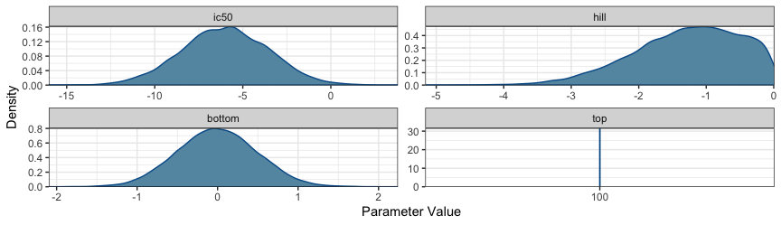
KOR antagonists prior distribution
To sample from the model, we will use the Stan NUTs Hamiltonian Monte Carlo, and initialize the parameters to the prior means to help with model convergence, using the default values of ec50 = -9, hill = -1, top = 100, bottom = 0.
kor_model <- BayesPharma::sigmoid_model(
data = kor_antag |> dplyr::select(substance_id, log_dose, response),
formula = BayesPharma::sigmoid_antagonist_formula(
predictors = 0 + substance_id),
prior = kor_prior,
init = BayesPharma::sigmoid_antagonist_init())

Analyzing model fit
The brms generated model summary shows the formula that the expected response a is sigmoid function of the log_dose with four parameters, and a shared Gaussian distribution. Each parameter is dependent on the substance_id. Since we want to fit a separate model for each substance, we include a 0 + to indicate that there is no common intercept. The data consists of 73 data points and the posterior sampling was done in 4 chains each with 8000 steps with 4000 steps of warm-up. The population effects for each parameter summarize the marginal posterior distributions, as well as the effective sample size in the bulk and tail. This gives an indication of the sampling quality, with an ESS of > 500 samples being good for this type of model.
Family: gaussian
Links: mu = identity; sigma = identity
Formula: response ~ sigmoid(ic50, hill, top, bottom, log_dose)
ic50 ~ 0 + substance_id
hill ~ 0 + substance_id
top ~ 0 + substance_id
bottom ~ 0 + substance_id
Data: data (Number of observations: 73)
Draws: 4 chains, each with iter = 8000; warmup = 4000; thin = 1;
total post-warmup draws = 16000
Population-Level Effects:
Estimate Est.Error l-95% CI u-95% CI Rhat Bulk_ESS Tail_ESS
ic50_substance_idBTRX_335140 -8.84 0.20 -9.19 -8.40 1.00 13473 8514
ic50_substance_idBTRX_395750 -8.24 0.45 -8.91 -7.41 1.00 10230 5212
ic50_substance_idJNJ -9.15 0.32 -9.76 -8.50 1.00 14299 10633
ic50_substance_idPF -6.16 1.07 -7.68 -3.35 1.00 8515 5579
hill_substance_idBTRX_335140 -1.46 0.59 -2.88 -0.59 1.00 14861 10852
hill_substance_idBTRX_395750 -0.90 0.51 -2.26 -0.26 1.00 10030 5245
hill_substance_idJNJ -1.01 0.51 -2.39 -0.40 1.00 14591 11599
hill_substance_idPF -0.31 0.25 -0.92 -0.03 1.00 8333 6175
bottom_substance_idBTRX_335140 0.00 0.50 -0.97 0.98 1.00 17655 11077
bottom_substance_idBTRX_395750 0.01 0.50 -0.97 1.00 1.00 16946 10718
bottom_substance_idJNJ -0.00 0.50 -0.98 0.98 1.00 18840 11775
bottom_substance_idPF 0.00 0.50 -0.99 0.98 1.00 17637 11034
top_substance_idBTRX_335140 100.00 0.00 100.00 100.00 NA NA NA
top_substance_idBTRX_395750 100.00 0.00 100.00 100.00 NA NA NA
top_substance_idJNJ 100.00 0.00 100.00 100.00 NA NA NA
top_substance_idPF 100.00 0.00 100.00 100.00 NA NA NA
Family Specific Parameters:
Estimate Est.Error l-95% CI u-95% CI Rhat Bulk_ESS Tail_ESS
sigma 32.15 2.86 27.17 38.47 1.00 13145 10225
Draws were sampled using sampling(NUTS). For each parameter, Bulk_ESS
and Tail_ESS are effective sample size measures, and Rhat is the potential
scale reduction factor on split chains (at convergence, Rhat = 1).

Traceplot
The model ran without warning messages, meaning there were no parameter value problems or MCMC conflicts. The bulk and tail ESS indicate high resolution and stability. The R-hat for each parameter equals 1.00 and the traceplot shows the chains mixed well, indicating the chains converged.
kor_model |>
bayesplot::mcmc_trace()
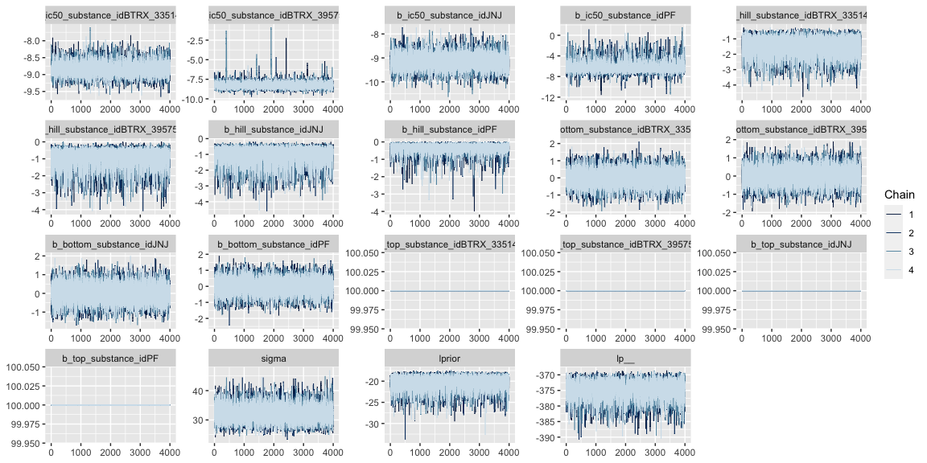

Compare prior and posterior marginal distributions
Displayed below is a plot for the prior and posterior distributions of the parameters (prior is pink and posterior is teal). This can be useful for comparing the density distribution of the prior and posterior produced by the model:
BayesPharma::plot_prior_posterior_densities(
model = kor_model,
predictors_col_name = "substance_id",
half_max_label = "ic50",
title_label="")
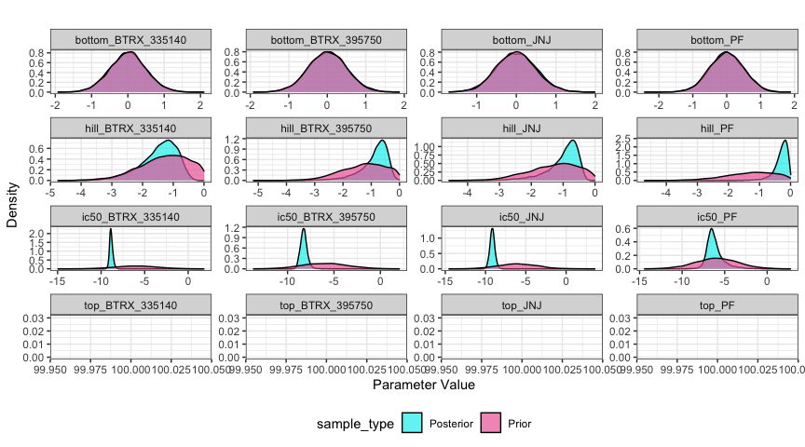
KOR antagonists model, compare prior and posterior distributions for each substance
Displayed below is a plot of the posterior distributions for each parameter with the confidence intervals and mean. This is a useful visual of the model results and can highlight the mode and high-density intervals:
BayesPharma::plot_posterior_density(
kor_model,
predictors_col_name = "substance_id",
half_max_label = "ic50",
title_label = "")
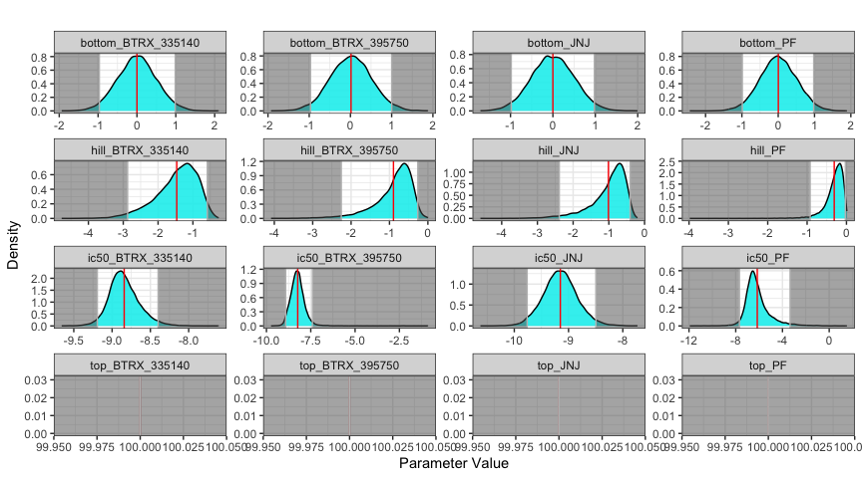
KOR Antagonists, posterior distribution for each substance
Displayed below is a plot of a sample of 100 sigmoid dose-response curves from the posterior distribution (purple) and the median quantile intervals:
BayesPharma::plot_posterior_draws(
model = kor_model,
title = "")
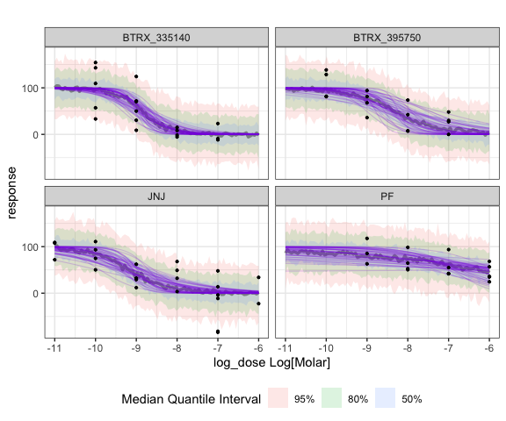
KOR antagonists, posterior draws

Comparing alternative models
To test the sensitivity of the analysis to the prior, we can re-fit the model with a more informative prior:
prior class coef group resp dpar nlpar lb ub source
normal(-8.5, 0.5) b ic50 <NA> <NA> user
normal(-1, 0.5) b hill <NA> 0.01 user
constant(100) b top <NA> <NA> user
normal(10, 15) b bottom <NA> <NA> user
Re-fitting the model with the kor_prior2 gives:
Family: gaussian
Links: mu = identity; sigma = identity
Formula: response ~ sigmoid(ic50, hill, top, bottom, log_dose)
ic50 ~ 0 + substance_id
hill ~ 0 + substance_id
top ~ 0 + substance_id
bottom ~ 0 + substance_id
Data: data (Number of observations: 73)
Draws: 4 chains, each with iter = 8000; warmup = 4000; thin = 1;
total post-warmup draws = 16000
Population-Level Effects:
Estimate Est.Error l-95% CI u-95% CI Rhat
ic50_substance_idBTRX_335140 -8.82 0.22 -9.23 -8.37 1.00
ic50_substance_idBTRX_395750 -8.58 0.31 -9.17 -7.95 1.00
ic50_substance_idJNJ -8.95 0.31 -9.54 -8.31 1.00
ic50_substance_idPF -8.18 0.44 -9.07 -7.33 1.00
hill_substance_idBTRX_335140 -1.19 0.36 -1.98 -0.57 1.00
hill_substance_idBTRX_395750 -1.06 0.39 -1.91 -0.42 1.00
hill_substance_idJNJ -0.85 0.33 -1.70 -0.39 1.00
hill_substance_idPF -0.72 0.45 -1.73 -0.08 1.00
bottom_substance_idBTRX_335140 1.75 10.51 -19.33 21.63 1.00
bottom_substance_idBTRX_395750 15.52 11.09 -7.25 36.21 1.00
bottom_substance_idJNJ -2.75 9.88 -22.75 15.49 1.00
bottom_substance_idPF 31.33 11.50 7.08 51.87 1.00
top_substance_idBTRX_335140 100.00 0.00 100.00 100.00 NA
top_substance_idBTRX_395750 100.00 0.00 100.00 100.00 NA
top_substance_idJNJ 100.00 0.00 100.00 100.00 NA
top_substance_idPF 100.00 0.00 100.00 100.00 NA
Bulk_ESS Tail_ESS
ic50_substance_idBTRX_335140 12968 9856
ic50_substance_idBTRX_395750 13495 11917
ic50_substance_idJNJ 11926 11320
ic50_substance_idPF 13873 11687
hill_substance_idBTRX_335140 14366 9881
hill_substance_idBTRX_395750 13448 9123
hill_substance_idJNJ 13051 12454
hill_substance_idPF 10016 6852
bottom_substance_idBTRX_335140 14843 11317
bottom_substance_idBTRX_395750 12970 10677
bottom_substance_idJNJ 11425 11404
bottom_substance_idPF 11105 10690
top_substance_idBTRX_335140 NA NA
top_substance_idBTRX_395750 NA NA
top_substance_idJNJ NA NA
top_substance_idPF NA NA
Family Specific Parameters:
Estimate Est.Error l-95% CI u-95% CI Rhat Bulk_ESS Tail_ESS
sigma 31.88 2.84 26.90 37.94 1.00 14411 11779
Draws were sampled using sampling(NUTS). For each parameter, Bulk_ESS
and Tail_ESS are effective sample size measures, and Rhat is the potential
scale reduction factor on split chains (at convergence, Rhat = 1).

Comparing the Two Models Using LOO-Comparison:
One way to evaluate the quality of a model is for each data-point, re-fit the model with remaining points and evaluate the log probability of the point in the posterior distribution. Taking the expectation across all points gives the Expected Log Pointwise predictive Density (ELPD). Since this is computationally challenging to re-fit the model for each point, if the model fits the data reasonably well, then the ELPD can be approximated using the Pareto smoothed importance sampling (PSIS). Using the LOO package, Pareto k value for each data point is computed that indicate how well that data point is fit by the model, where k < 0.5 is good, 0.5 <= k < 0.7 is OK, and 0.7 <= k is bad. Evaluating the model for the KOR antagonists shows that the model fits the data well.
Computed from 16000 by 73 log-likelihood matrix
Estimate SE
elpd_loo -360.5 6.5
p_loo 6.9 1.1
looic 720.9 13.0
------
Monte Carlo SE of elpd_loo is 0.0.
All Pareto k estimates are good (k < 0.5).
See help('pareto-k-diagnostic') for details.
Since ELPD is a global measure of model fit, it can be used to compare models. Using loo_compare from the LOO package returns the elpd_diff and se_diff for each model relative the model with the lowest ELPD. The kor_model2, the model with more informative prior, is the preferred model, but not significantly.
No problematic observations found. Returning the original 'loo' object.
elpd_diff se_diff
kor_model2 0.0 0.0
kor_model -0.9 1.2

Analysis Using the drc Package
Here we will analyze the KOR antagonist data using the drc package and compare it to the results from the BayesPharma analysis.
We will fix the top to 100 and fit the ic50, hill, and bottom.
drc_models <- kor_antag |>
dplyr::group_by(substance_id) |>
dplyr::group_nest() |>
dplyr::mutate(
model = data |>
purrr::map(~drc::drm(
response ~ log_dose,
data = .x,
fct = drc::L.4(fixed = c(NA, NA, 100, NA),
names = c("hill", "bottom", "top", "ic50")))))
drc_models |>
dplyr::mutate(summary = purrr::map(model, broom::tidy, conf.int = TRUE)) |>
tidyr::unnest(summary) |>
dplyr::arrange(term, substance_id) |>
dplyr::select(-data, -model, -curve)
# A tibble: 12 × 8
substance_id term estimate std.error statistic p.value conf.low conf.high
<chr> <chr> <dbl> <dbl> <dbl> <dbl> <dbl> <dbl>
1 BTRX_335140 bottom 1.31 19.4 0.0675 9.47e- 1 -40.0 42.6
2 BTRX_395750 bottom 29.5 9.40 3.14 7.85e- 3 9.20 49.8
3 JNJ bottom -18.1 26.7 -0.681 5.04e- 1 -73.7 37.4
4 PF bottom 39.4 30.8 1.28 2.22e- 1 -27.0 106.
5 BTRX_335140 hill 4.06 9.20 0.441 6.65e- 1 -15.5 23.7
6 BTRX_395750 hill 9.82 164. 0.0600 9.53e- 1 -344. 364.
7 JNJ hill 1.17 0.580 2.02 5.69e- 2 -0.0378 2.38
8 PF hill 1.13 1.33 0.855 4.08e- 1 -1.73 4.00
9 BTRX_335140 ic50 -8.91 0.308 -28.9 1.42e-14 -9.57 -8.26
10 BTRX_395750 ic50 -8.97 0.505 -17.8 1.70e-10 -10.1 -7.88
11 JNJ ic50 -8.77 0.670 -13.1 2.89e-11 -10.2 -7.37
12 PF ic50 -7.96 1.27 -6.29 2.78e- 5 -10.7 -5.23
Displayed below is the comparison of results from drc and BayesPharma for each parameter of the dose-response curve. Here we see that the Bayesian method provides a distribution curve as evidence and has smaller confidence intervals than most of the standard errors provided by the drc method.
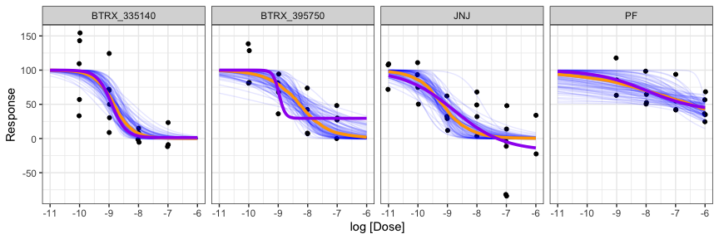
KOR antagonists conditional effects. The blue lines are samples from the BayesPharma kor_model posterior distribution, the orange line is the conditional mean, and the purple line is the conditional mean for the drc model fit.

MuSyC synergy model
When two different treatments are combined they may interact. For end-point assays, if the response is stronger or weaker than what would be expected with an additive model, the treatments are said to be epistatic. For sigmoidal dose-response models, however, the analysis may be more complicated. One drug may not only may shift the maximal response (efficacy) of the other, but it may also shift the effective dose and shape of the response (potency). Historically a range of models have been proposed that capture different aspects of synergy, for example the Bliss independence(Bliss 1956) and Loewe additivity(Loewe 1926) are null-models for no synergistic efficacy or potency, respectively. The SynergyFinder R package(Ianevski, Giri, and Aittokallio 2022) and the synergy python package(Wooten and Albert 2021) can be used to visualize treatment interactions, compute a range of synergy scores, and test if the interactions are significant.
Recently Meyer et al.(Meyer et al. 2019, Wooten2021–lg) derived an integrated functional synergistic sigmoidal dose-response, which has the Loewe and Bliss models as special cases. They implemented a Bayesian model-fitting strategy in Matlab, and a maximum likelihood model-fitting into the synergy python package. To make the model more accessible to the pharmacology community, in this section, we briefly review the MuSyC functional form, describe a Bayesian implementation in Stan/BRMS, and illustrate using the model to re-analyze how drugs and voltage may interact to modulate the current through a potassium channel.

MuSyC Functional Form
The functional form for the MuSyC model gives an equation for the response $\color{brown}{E_d}$ at doses of $\color{teal}{d_1}$ and $\color{teal}{d_2}$ of the two treatments and has $9$ free parameters $\color{purple}{C_1}$, $\color{purple}{C_2}$, $\color{brown}{E_0}$, $\color{brown}{E_1}$, $\color{brown}{E_2}$, $\color{brown}{E_3}$, $\color{purple}{h_1}$, $\color{purple}{h_2}$, $\color{purple}{\alpha}$:

To interpret these parameters if we set $\color{teal}{d_2}=0$, then which is the Hill equation, which we modeled above . If we then additionally set $\color{teal}{d_1}=0$ then $\color{brown}{E_d}=\color{brown}{E_0}$, in the limit as ${\color{teal}{d_1}}\rightarrow \infty$ then ${\color{brown}{E_d}}\rightarrow {\color{brown}{E_1}}$, and if ${\color{teal}{d_1}}=\color{purple}{C_1}$ then ${\color{brown}{E_d}} = ({\color{brown}{E_0}} + {\color{brown}{E_2}})/2$, which is the half maximal response (either the $\color{brown}{\mbox{IC}_{50}}$ if treatment $1$ is an inhibitor or $\color{brown}{\mbox{EC}_{50}}$ if treatment $1$ is agonist). The slope at ${\color{teal}{d_1}}={\color{purple}{C_1}}$ is
The evaluation of the functional form for ${\color{brown}{E_d}}$ is numerically unstable. To transform using the $\text{log_sum_exp}$ trick, let
Then
$$E_{d}=\text{exp}​\left(\text{log_sum_exp}\left(\text{numerator_parts}\right)−\text{log_sum_exp}\left(\text{denominator_parts}\right)\right).$$

Implementation and usage of the MuSyC model in Stan/BRMS

Michaelis-Menten enzyme progress model

Enzyme Kinetic Modeling
Enzymes are proteins that catalyze chemical reactions. Not only do they facilitate producing virtual all biological matter, but they are crucial for regulating biological processes. In the early 20th century Michaelis and Menten described a foundational kinematic model for enzymes, where the substrate and enzyme reversibly bind, the substrate is converted to the product and then released.
$$
E + S \xrightleftharpoons[k_b]{k_f} C \xrightarrow{k_{cat}} E + P
$$
where the free enzyme (E) reversibly binds to the substrate (S) to form a complex (C) with forward and backward rate constants of kf and kb, which is irreversibly catalyzed into the product (P), with rate constant of kcat, releasing the enzyme to catalyze additional substrate. The total enzyme concentration is defined to be the ET := E + C. The total substrate and product concentration is defined to be ST := S + C + P. The Michaelis constant is the defined to be the kM := (kb + kcat) / kf. The kcat rate constant determines the maximum turn over at saturating substrate concentrations, Vmax := kcat * ET. The rate constants kcat and kM can be estimated by monitoring the product accumulation over time (enzyme progress curves), by varying the enzyme and substrate concentrations.
By assuming that the enzyme concentration is very low (ET << ST), they derived their celebrated Michaelis-Menten kinetics. Since their work, a number of groups have developed models for enzyme kinetics that make less stringent assumptions. Recently (Choi, Rempala, and Kim 2017), described a Bayesian model for the total QSSA model. To make their model more accessible, we have re-implemented it in the Stan/BRMS framework and made it available through the BayesPharma package.

Outline for Vignette
Next we will formally define the problem and formulate the model as the solution to an ordinary differential equation. To illustrate, we will consider a a toy system where we assuming the kcat and kM are known and simulate a sequence of measurements using deSolve. We will then implement the ODE in Stan/BRMS using stanvars and show how the parameters of the toy system can be estimated. Since it is common to vary the enzyme and substrate concentrations in order to better estimate the kinematic parameters, we will show how we can improve the Stan/BRMS model to allow multiple observations, each with an arbitrary number of measurements. Then finally, we will consider a real enzyme kinetics data set and use the Stan/BRMS model to estimate the kinematic parameters. We will compare estimated parameters with those fit using standard approaches.

Problem Statement
Implement the total QSSA model in stan/BRMS, a refinement of the classical Michaelis-Menten enzyme kinetics ordinary differential equation described in (Choi, et al., 2017, DOI: 10.1038/s41598-017-17072-z). From their equation 2:
Observed data:
M = number of measurements # The product concentration Pt is measured
t[M] = time # at M time points t
Pt[M] = product #
ST = substrate total conc. # Substrate and enzyme concentrations are
ET = enzyme total conc. # assumed to be given for each observation
Model parameters:
kcat # catalytic constant
kM # Michaelis constant
ODE formulation:
dPdt = kcat * ( # Change in product concentration at time t
ET + kM + ST - Pt +
-sqrt((ET + kM + ST - Pt)^2 - 2* ET * (ST - Pt))) / 2
initial condition:
P := 0 # There is zero product at time 0
In (Choi, Rempala, and Kim 2017) they prove, that the tQ model is valid when
$$\frac{K}{\left(2⋅ST\right)}⋅\frac{\left(ET+kM+ST\right)}{\sqrt{{\left(ET+kM+ST+P\right)}^{2}−4⋅ET\left(ST−P\right)}}≪1,$$
where K = kb/kf is the dissociation constant.

Simulate one observation
Using the deSolve package we can simulate data following the total QSSA model. Measurements are made with random Gaussian noise with mean 0 and variance of 0.5. To visualize, the true enzyme progress curve is shown in blue, and the enzyme progress curve fit to the noisy measurements with a smooth loess spline is shown in orange. While the smooth fits well, we cannot estimate the parameters for the curve from it.
tQ_model_generate <- function(
time, kcat, kM, ET, ST) {
ode_tQ <- function(time, Pt, theta) {
list(c(theta[1] * (
ET + theta[2] + ST - Pt -
sqrt(
(ET + theta[2] + ST - Pt)^2 -
4 * ET * (ST - Pt))) / 2))
}
deSolve::ode(
y = 0, times = time, func = ode_tQ,
parms = c(kcat, kM))
}
data_single <- tQ_model_generate(
time = seq(0.00, 3, by=.05),
kcat = 3, kM = 5, ET = 10, ST = 10) |>
as.data.frame() |>
dplyr::rename(P_true = 2) |>
dplyr::mutate(
P = rnorm(dplyr::n(), P_true, 0.5), # add some observational noise
ST = 10, ET = 10)
head(data_single)
time P_true P ST ET
1 0.00 0.0000000 -0.1952277 10 10
2 0.05 0.7311578 0.3337647 10 10
3 0.10 1.4243598 1.8453044 10 10
4 0.15 2.0794197 2.1755056 10 10
5 0.20 2.6964485 3.2259417 10 10
6 0.25 3.2758537 4.1491231 10 10
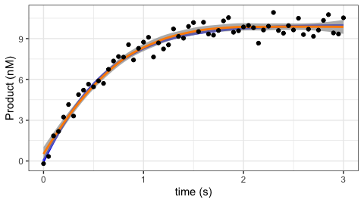
Simulated enzyme progress curve with parameters kcat=3, kM=5, and total substrace and enzyme concentrations to 10 nM, simulated over 3 seconds

Fitting a single ODE observation in BRMS
To implement in BRMS, we can use the stanvars to define custom functions. The key idea is call the ODE solver, in this case the backward differentiation formula (bdf) used to solve stiff ODEs, passing a function ode_tQ that returns dP/dt, the change in product at time t. The ode_tQ function depends on the product at time t as the state vector, the kinematic parameters to be estimated kcat and kM and the user-provided data of the enzyme and substrate concentrations ET and ST. To call ode_dbf we pass in the initial product concentration and time (both equal to zero), measured time-points, parameters and user defied data. Finally we, extract the vector of sampled vector of product concentrations which we return.
stanvars_tQ_ode <- brms::stanvar(scode = paste("
vector tQ_ode(
real time,
vector state,
vector params,
data real ET,
data real ST) {
real Pt = state[1]; // product at time t
real kcat = params[1];
real kM = params[2];
vector[1] dPdt;
dPdt[1] = kcat * (
ET + kM + ST - Pt
-sqrt((ET + kM + ST - Pt)^2 - 4 * ET * (ST - Pt))) / 2;
return(dPdt);
}
", sep = "\n"),
block = "functions")
stanvars_tQ_single <- brms::stanvar(scode = paste("
vector tQ_single(
data vector time,
vector vkcat,
vector vkM,
data vector vET,
data vector vST) {
vector[2] params;
params[1] = vkcat[1];
params[2] = vkM[1];
vector[1] initial_state;
initial_state[1] = 0.0;
real initial_time = 0.0;
int M = size(time);
vector[1] P_ode[M] = ode_bdf( // Function signature:
tQ_ode, // function ode
initial_state, // vector initial_state
initial_time, // real initial_time
to_array_1d(time), // array[] real time
params, // vector params
vET[1], // ...
vST[1]); // ...
vector[M] P; // Need to return a vector not array
for(i in 1:M) P[i] = P_ode[i,1];
return(P);
}
", sep = "\n"),
block = "functions")
To use this function, we define kcat and kM as parameters and that we wish to sample P ~ tQ(...). Since all the data points define a single observation, we set loop = FALSE. We use gamma priors for kcat and kM with the shape parameter alpha=4 and the rate parameter beta=1. The prior mean is alpha/beta = 4/1 = 4 and the variance is alpha/beta^2 = 4/1 = 4. We also bound the parameters from below by 0. We initialize each chain at the prior mean and use cmdstanr version 2.29.2 as the backend, and use the default warmup of 1000
model_single <- brms::brm(
formula = brms::brmsformula(
P ~ tQ_single(time, kcat, kM, ET, ST),
kcat + kM ~ 1,
nl = TRUE,
loop=FALSE),
data = data_single |> dplyr::filter(time > 0),
prior = c(
brms::prior(prior = gamma(4, 1), lb = 0, nlpar = "kcat"),
brms::prior(prior = gamma(4, 1), lb = 0, nlpar = "kM")),
init = function() list(kcat = 4, kM = 4),
stanvars = c(
stanvars_tQ_ode,
stanvars_tQ_single))
Fitting the model takes ~15 seconds, with Rhat = 1 and effective sample size for the bulk and tail greater than 1400 for both parameters. The estimates and 95% confidence intervals are good.
Family: gaussian
Links: mu = identity; sigma = identity
Formula: P ~ tQ_single(time, kcat, kM, ET, ST)
kcat ~ 1
kM ~ 1
Data: dplyr::filter(data_single, time > 0) (Number of observations: 60)
Draws: 4 chains, each with iter = 2000; warmup = 1000; thin = 1;
total post-warmup draws = 4000
Population-Level Effects:
Estimate Est.Error l-95% CI u-95% CI Rhat Bulk_ESS Tail_ESS
kcat_Intercept 2.99 0.47 2.19 4.01 1.00 1218 1482
kM_Intercept 4.40 2.09 1.19 9.18 1.00 1211 1460
Family Specific Parameters:
Estimate Est.Error l-95% CI u-95% CI Rhat Bulk_ESS Tail_ESS
sigma 0.52 0.05 0.43 0.63 1.00 1626 1451
Draws were sampled using sampling(NUTS). For each parameter, Bulk_ESS
and Tail_ESS are effective sample size measures, and Rhat is the potential
scale reduction factor on split chains (at convergence, Rhat = 1).
To visualize the posterior distribution vs. the prior distribution, we first sample from the prior, using the same brms::brm call with sample_prior = "only" the argument.
model_single_prior <- model_single |>
stats::update(
sample_prior = "only",
iter = 2000)
And to plot, we use tidybayes to gather the draws and ggplot2 to map them to curves, with the prior as the orange curve, posterior as the blue curve, and the true parameter marked as a vertical line.
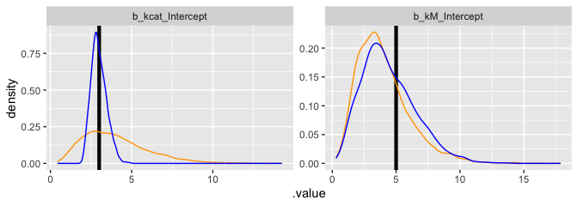

Next, we plot the prior and posterior samples as a scatter plot. Note that the high correlation of the kcat and kM parameters in the posterior. This is expected, and typically better estimates require varying the enzyme and substrate concentrations.
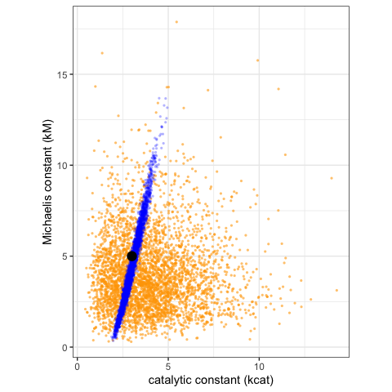

Fitting multiple observations
Next we will extend the BRMS model to allow fitting common kcat, kM concentrations based on multiple replicas, or varying substrate/enzyme concentrations using BRMS. To demonstrate, we varying the enzyme and substrate concentrations, to better fit the kinematic parameters.
data_multiple <- tidyr::expand_grid(
kcat = 3,
kM = 5,
ET = c(3, 10, 30),
ST = c(3, 10, 30)) |>
dplyr::mutate(observation_index = dplyr::row_number()) |>
dplyr::rowwise() |>
dplyr::do({
data <- .
time <- seq(0.05, 3, by=.05)
data <- data.frame(data,
time = time,
P = tQ_model_generate(
time = time,
kcat = data$kcat,
kM = data$kM,
ET = data$ET,
ST = data$ST)[,2])
}) |>
dplyr::mutate(P = rnorm(dplyr::n(), P, 0.5))
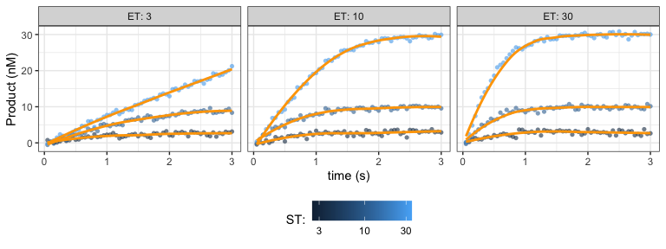

Next we will implement tQ_multiple as a brms::stanvar object.
stanvars_tQ_multiple <- brms::stanvar(scode = paste("
vector tQ_multiple(
array[] int replica,
data vector time,
vector vkcat,
vector vkM,
data vector vET,
data vector vST) {
int N = size(time);
vector[N] P;
int begin = 1;
int current_replica = replica[1];
for (i in 1:N){
if(current_replica != replica[i]){
P[begin:i-1] = tQ_single(
time[begin:i-1],
vkcat,
vkM,
vET[begin:i-1],
vST[begin:i-1]);
begin = i;
current_replica = replica[i];
}
}
P[begin:N] = tQ_single(time[begin:N], vkcat, vkM, vET[begin:N], vST[begin:N]);
return(P);
}", sep = "\n"),
block = "functions")
Then we will use it to fit multiple measurements for the same enzyme
model_multiple <- brms::brm(
formula = brms::brmsformula(
P ~ tQ_multiple(observation_index, time, kcat, kM, ET, ST),
kcat + kM ~ 1,
nl = TRUE,
loop=FALSE),
data = data_multiple,
prior = c(
brms::prior(prior = gamma(4, 1), lb = 0, nlpar = "kcat"),
brms::prior(prior = gamma(4, 1), lb = 0, nlpar = "kM")),
init = function() list(kcat = 4, kM = 4),
stanvars = c(
stanvars_tQ_ode,
stanvars_tQ_single,
stanvars_tQ_multiple))
model_multiple
To assess the model fit, we will re-fit the model just sampling from the prior
model_multiple_prior <- model_multiple |>
stats::update(
sample_prior = "only",
iter = 2000)
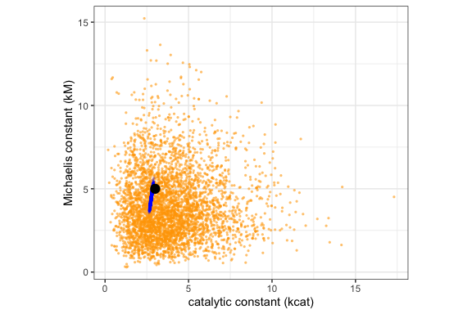

Next we will sample enzyme progress curves from the posterior
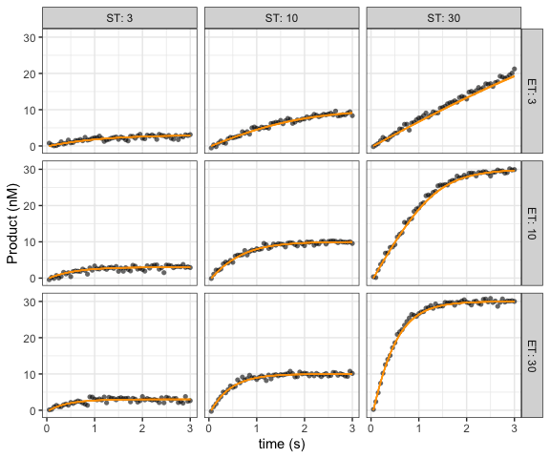

Over dispersed negative binomial response
The response of an assay results from a measurement of the experimental system. Often the measurements are normalized so that the response for negative control is 1 (e.g. diseased) and the positive control is 0 (e.g. healthy). However when the robustness of the measurement depends on the measured value, this normalization can make it difficult to combine different measurements. An alternative approach is to model the measurements directly, to take into account the uncertainty associated with the response. To illustrate, if the measurement is the relative number of cells having a phenotype, then five out of ten cells and five thousand out of ten thousand cells will have the same response of 0.5, but the former will a less reliable measurement.
Arezooji, Dorsa Mohammadi. 2020. “A Markov Chain Monte-Carlo Approach to Dose-Response Optimization Using Probabilistic Programming (RStan),” November. https://arxiv.org/abs/2011.15034.
Ashby, Deborah. 2006. “Bayesian Statistics in Medicine: A 25 Year Review.” Stat. Med. 25 (21): 3589–3631. https://doi.org/10.1002/sim.2672.
Bates, Douglas, Martin Mächler, Ben Bolker, and Steve Walker. 2015. “Fitting Linear Mixed-Effects Models Using Lme4.” J. Stat. Softw. 67 (October): 1–48. https://doi.org/10.18637/jss.v067.i01.
Betancourt, Michael. 2023. “Michael Betancourt: Writing.” https://betanalpha.github.io/writing/.
Bezanson, Jeff, Alan Edelman, Stefan Karpinski, and Viral B Shah. 2017. “Julia: A Fresh Approach to Numerical Computing.” SIAM Rev. 59 (1): 65–98. https://doi.org/10.1137/141000671.
Blei, David M, Alp Kucukelbir, and Jon D McAuliffe. 2017. “Variational Inference: A Review for Statisticians.” J. Am. Stat. Assoc. 112 (518): 859–77. https://doi.org/10.1080/01621459.2017.1285773.
Bliss, C I. 1956. “The Calculation of Microbial Assays.” Bacteriol. Rev. 20 (4): 243–58. https://doi.org/10.1128/br.20.4.243-258.1956.
Bürkner, Paul-Christian. 2017. “Brms: An R Package for Bayesian Multilevel Models Using Stan.” J. Stat. Softw. 80 (1): 1–28. https://doi.org/10.18637/jss.v080.i01.
Campbell, Gregory. 2017. “Bayesian Methods in Clinical Trials with Applications to Medical Devices.” Communications for Statistical Applications and Methods 24 (6): 561–81.
Carpenter, Bob, Andrew Gelman, Matthew D Hoffman, Daniel Lee, Ben Goodrich, Michael Betancourt, Marcus A Brubaker, Jiqiang Guo, Peter Li, and Allen Riddell. 2017. “Stan: A Probabilistic Programming Language.” J. Stat. Softw. 76 (January). https://doi.org/10.18637/jss.v076.i01.
Choi, Boseung, Grzegorz A Rempala, and Jae Kyoung Kim. 2017. “Beyond the Michaelis-Menten Equation: Accurate and Efficient Estimation of Enzyme Kinetic Parameters.” Sci. Rep. 7 (1): 17018. https://doi.org/10.1038/s41598-017-17072-z.
Cooner, F. 2019. “Considerations and Bayesian Applications in Pharmaceutical Development for Rare Diseases.” Bayesian Applications in Pharmaceutical Development. https://doi.org/10.1201/9781315099798-17/considerations-bayesian-applications-pharmaceutical-development-rare-diseases-freda-cooner.
Depaoli, Sarah, and Rens van de Schoot. 2017. “Improving Transparency and Replication in Bayesian Statistics: The WAMBS-Checklist.” Psychol. Methods 22 (2): 240–61. https://doi.org/10.1037/met0000065.
Duane, Simon, A D Kennedy, Brian J Pendleton, and Duncan Roweth. 1987. “Hybrid Monte Carlo.” Phys. Lett. B 195 (2): 216–22. https://doi.org/10.1016/0370-2693(87)91197-X.
Faya, Paul, Perceval Sondag, Steven Novick, Dwaine Banton, John W Seaman, Jr, James D Stamey, and Bruno Boulanger. 2021. “The Current State of Bayesian Methods in Nonclinical Pharmaceutical Statistics: Survey Results and Recommendations from the DIA / ASA‐BIOP Nonclinical Bayesian Working Group.” Pharmaceutical Statistics. https://doi.org/10.1002/pst.2072.
Gabry, Jonah, and Tristan Mahr. 2017. “Bayesplot: Plotting for Bayesian Models.” R Package Version 1 (0).
Gelman, Andrew, John B Carlin, Hal S Stern, David B Dunson, Aki Vehtari, and Donald B Rubin. 2013. Bayesian Data Analysis. Chapman; Hall/CRC.
Gelman, Andrew, and Jennifer Hill. 2006. Data Analysis Using Regression and Multilevel/Hierarchical Models. Cambridge University Press.
Gelman, Andrew, and Donald B Rubin. 1992. “Inference from Iterative Simulation Using Multiple Sequences.” Stat. Sci. 7 (4): 457–72.
Gelman, Andrew, Aki Vehtari, Daniel Simpson, Charles C Margossian, Bob Carpenter, Yuling Yao, Lauren Kennedy, Jonah Gabry, Paul-Christian Bürkner, and Martin Modrák. 2020. “Bayesian Workflow,” November. https://arxiv.org/abs/2011.01808.
Geman, S, and D Geman. 1984. “Stochastic Relaxation, Gibbs Distributions, and the Bayesian Restoration of Images.” IEEE Trans. Pattern Anal. Mach. Intell. 6 (6): 721–41. https://doi.org/10.1109/tpami.1984.4767596.
Gould, A Lawrence. 2019. “BMA-Mod: A Bayesian Model Averaging Strategy for Determining Dose-Response Relationships in the Presence of Model Uncertainty.” Biom. J. 61 (5): 1141–59. https://doi.org/10.1002/bimj.201700211.
GraphPad Software, LLC. 2023. GraphPad Prism.
Grieve, Andrew P. 2007. “25 Years of Bayesian Methods in the Pharmaceutical Industry: A Personal, Statistical Bummel.” Pharm. Stat. 6 (4): 261–81. https://doi.org/10.1002/pst.315.
Hastings, W K. 1970. “Monte Carlo Sampling Methods Using Markov Chains and Their Applications.” Biometrika 57 (1): 97–109. https://doi.org/10.1093/biomet/57.1.97.
Herbert Lee. 2023. “Coursera: Bayesian Statistics Specialization.” https://www.coursera.org/specializations/bayesian-statistics.
Hoffman, Matthew D, Andrew Gelman, and Others. 2014. “The No-U-Turn Sampler: Adaptively Setting Path Lengths in Hamiltonian Monte Carlo.” J. Mach. Learn. Res. 15 (1): 1593–623.
Ianevski, Aleksandr, Anil K Giri, and Tero Aittokallio. 2022. “SynergyFinder 3.0: An Interactive Analysis and Consensus Interpretation of Multi-Drug Synergies Across Multiple Samples.” Nucleic Acids Research. https://doi.org/10.1093/nar/gkac382.
James Bradbury. 2018. “JAX: Composable Transformations of Python+NumPy Programs.”
Johnson, Alicia A, Miles Q Ott, and Mine Dogucu. 2022. Bayes Rules!: An Introduction to Applied Bayesian Modeling. CRC Press.
Johnstone, Ross H, David J Gavaghan, Ross H Johnstone, Rémi Bardenet, David J Gavaghan, and Gary R Mirams. 2017. “Hierarchical Bayesian Inference for Ion Channel Screening Dose-Response Data [Version 2; Peer Review: 2 Approved].” Wellcome Open Research 1.
Kay, M. 2018. “Tidybayes: Tidy Data and Geoms for Bayesian Models.” R Package Version 1 (3).
Kruschke, John K. 2021. “Bayesian Analysis Reporting Guidelines.” Nat Hum Behav 5 (10): 1282–91. https://doi.org/10.1038/s41562-021-01177-7.
Kucukelbir, Alp, Rajesh Ranganath, Andrew Gelman, and David Blei. 2015. “Automatic Variational Inference in Stan.” In Advances in Neural Information Processing Systems 28, edited by C Cortes, N D Lawrence, D D Lee, M Sugiyama, and R Garnett, 568–76. Curran Associates, Inc.
Labelle, Caroline, Anne Marinier, and Sébastien Lemieux. 2019. “Enhancing the Drug Discovery Process: Bayesian Inference for the Analysis and Comparison of Dose–Response Experiments.” Bioinformatics 35 (14): i464–73. https://doi.org/10.1093/bioinformatics/btz335.
Lakshminarayanan, Mani, and Fanni Natanegara. 2019. Bayesian Applications in Pharmaceutical Development. CRC Press.
Lesaffre, Emmanuel, Gianluca Baio, and Bruno Boulanger. 2020. Bayesian Methods in Pharmaceutical Research. CRC Press. https://doi.org/10.1201/9781315180212.
Lock, Eric F, and David B Dunson. 2015. “Shared Kernel Bayesian Screening.” Biometrika 102 (4): 829–42. https://doi.org/10.1093/biomet/asv032.
Loewe, S. 1926. “Effect of Combinations: Mathematical Basis of Problem.” Arch. Exp. Pathol. Pharmakol. 114: 313–26.
Ma, Eric J, and Arkadij Kummer. 2021. “Principled Decision-Making Workflow with Hierarchical Bayesian Models of High-Throughput Dose-Response Measurements.” Entropy 23 (6). https://doi.org/10.3390/e23060727.
Margolis, Elyssa B, Tanya L Wallace, Lori Jean Van Orden, and William J Martin. 2020. “Differential Effects of Novel Kappa Opioid Receptor Antagonists on Dopamine Neurons Using Acute Brain Slice Electrophysiology.” PLoS One 15 (12): e0232864. https://doi.org/10.1371/journal.pone.0232864.
McElreath, Richard. 2016. Statistical Rethinking: A Bayesian Course with Examples in R and Stan. CRC Press/Taylor & Francis Group.
Metropolis, Nicholas, Arianna W Rosenbluth, Marshall N Rosenbluth, Augusta H Teller, and Edward Teller. 1953. “Equation of State Calculations by Fast Computing Machines.” J. Chem. Phys. 21 (6): 1087–92. https://doi.org/10.1063/1.1699114.
Meyer, Christian T, David J Wooten, B Bishal Paudel, Joshua Bauer, Keisha N Hardeman, David Westover, Christine M Lovly, Leonard A Harris, Darren R Tyson, and Vito Quaranta. 2019. “Quantifying Drug Combination Synergy Along Potency and Efficacy Axes.” Cell Syst 8 (2): 97–108.e16. https://doi.org/10.1016/j.cels.2019.01.003.
Neal, Radford M. 1996. “Monte Carlo Implementation.” In Bayesian Learning for Neural Networks, edited by Radford M Neal, 55–98. New York, NY: Springer New York. https://doi.org/10.1007/978-1-4612-0745-0\_3.
Paszke, Adam, Sam Gross, Francisco Massa, Adam Lerer, James Bradbury, Gregory Chanan, Trevor Killeen, et al. 2019. “PyTorch: An Imperative Style, High-Performance Deep Learning Library,” December. https://arxiv.org/abs/1912.01703.
Plummer, Martyn. 2003. “JAGS: A Program for Analysis of Bayesian Graphical Models Using Gibbs Sampling.” In 3rd International Workshop on Distributed Statistical Computing. 124th Series.
Polack, Fernando P, Stephen J Thomas, Nicholas Kitchin, Judith Absalon, Alejandra Gurtman, Stephen Lockhart, John L Perez, et al. 2020. “Safety and Efficacy of the BNT162b2 mRNA Covid-19 Vaccine.” N. Engl. J. Med. 383 (27): 2603–15. https://doi.org/10.1056/NEJMoa2034577.
Posit Software, PBC. 2023. “Bookdown.org Tag: Bayesian.” https://bookdown.org/home/tags/bayesian/.
Ritz, Christian, Florent Baty, Jens C Streibig, and Daniel Gerhard. 2015. “Dose-Response Analysis Using R.” PLoS One 10 (12): e0146021. https://doi.org/10.1371/journal.pone.0146021.
Ruberg, Stephen J, Francois Beckers, Rob Hemmings, Peter Honig, Telba Irony, Lisa LaVange, Grazyna Lieberman, James Mayne, and Richard Moscicki. 2023. “Application of Bayesian Approaches in Drug Development: Starting a Virtuous Cycle.” Nat. Rev. Drug Discov., February, 1–16. https://doi.org/10.1038/s41573-023-00638-0.
Salvatier, John, Thomas V Wiecki, and Christopher Fonnesbeck. 2016. “Probabilistic Programming in Python Using PyMC3.” PeerJ Comput. Sci. 2 (April): e55. https://doi.org/10.7717/peerj-cs.55.
Semenova, Elizaveta, Maria Luisa Guerriero, Bairu Zhang, Andreas Hock, Philip Hopcroft, Ganesh Kadamur, Avid M Afzal, and Stanley E Lazic. 2021. “Flexible Fitting of PROTAC Concentration–Response Curves with Changepoint Gaussian Processes.” SLAS DISCOVERY: Advancing the Science of Drug Discovery 26 (9): 1212–24. https://doi.org/10.1177/24725552211028142.
Senn, Stephen. 2022. “The Design and Analysis of Vaccine Trials for COVID-19 for the Purpose of Estimating Efficacy.” Pharm. Stat. 21 (4): 790–807. https://doi.org/10.1002/pst.2226.
Shterev, Ivo D, David B Dunson, Cliburn Chan, and Gregory D Sempowski. 2021. “BHTSpack: Bayesian Multi-Plate High-Throughput Screening of Compounds.”
Smith, Michael K, and Scott Marshall. 2006. “A Bayesian Design and Analysis for Dose-Response Using Informative Prior Information.” J. Biopharm. Stat. 16 (5): 695–709. https://doi.org/10.1080/10543400600860535.
Spiegelhalter, D, A Thomas, N Best, and W Gilks. 1996. “BUGS 0.5: Bayesian Inference Using Gibbs Sampling–Manual.” version ii. Medical Research Council Biostatistics Unit, Cambridge.
Tansey, Wesley, Kathy Li, Haoran Zhang, Scott W Linderman, Raul Rabadan, David M Blei, and Chris H Wiggins. 2021. “Dose–Response Modeling in High-Throughput Cancer Drug Screenings: An End-to-End Approach.” Biostatistics 23 (2): 643–65. https://doi.org/10.1093/biostatistics/kxaa047.
Team, R Core, and Others. 2013. “R: A Language and Environment for Statistical Computing.” Vienna, Austria.
Van de Schoot, Rens, Duco Veen, Laurent Smeets, Sonja D Winter, and Sarah Depaoli. 2020. “A Tutorial on Using the WAMBS Checklist to Avoid the Misuse of Bayesian Statistics.” Small Sample Size Solutions: A Guide for Applied Researchers and Practitioners; van de Schoot, R. , Miocevic, M. , Eds, 30–49.
Vehtari, Aki, Andrew Gelman, and Jonah Gabry. 2017a. “Erratum to: Practical Bayesian Model Evaluation Using Leave-One-Out Cross-Validation and WAIC.” Stat. Comput. 27 (5): 1433–33. https://doi.org/10.1007/s11222-016-9709-3.
———. 2017b. “Practical Bayesian Model Evaluation Using Leave-One-Out Cross-Validation and WAIC.” Stat. Comput. 27 (5): 1413–32. https://doi.org/10.1007/s11222-016-9696-4.
Wei, Xin, Lin Gao, Xiaolei Zhang, Hong Qian, Karen Rowan, David Mark, Zhengwei Peng, and Kuo-Sen Huang. 2013. “Introducing Bayesian Thinking to High-Throughput Screening for False-Negative Rate Estimation.” J. Biomol. Screen. 18 (9): 1121–31. https://doi.org/10.1177/1087057113491495.
Wickham, Hadley. 2009. Ggplot2: Elegant Graphics for Data Analysis. New York, NY: Springer.
Wickham, Hadley, Mara Averick, Jennifer Bryan, Winston Chang, Lucy McGowan, Romain François, Garrett Grolemund, et al. 2019. “Welcome to the Tidyverse.” J. Open Source Softw. 4 (43): 1686. https://doi.org/10.21105/joss.01686.
Wooten, David J, and Réka Albert. 2021. “Synergy: A Python Library for Calculating, Analyzing and Visualizing Drug Combination Synergy.” Bioinformatics 37 (10): 1473–74. https://doi.org/10.1093/bioinformatics/btaa826.
Yang, Harry, and Steven Novick. 2019. Bayesian Analysis with R for Drug Development: Concepts, Algorithms, and Case Studies. CRC Press.

