Bilstm:

Implementation notes:
- Implemented in Pytorch
- Pytorch batching is hideous, I implemented this assignment 3 times.
- Batching was implemented by grouping sequences of the same length together, yet this hurts the randomization. To still get good results, I had to use small batch sizes.
- Batching made it difficult to get good results.

Parameters:

Word embedding dimensions: 50
Character embedding dimensions: 25
Hidden dimensions: number of tags * 4 (180 for POS, 32 for NER)
Initial learning rate: 0.001
Optimizer: Adam

Results (4 graphs each, sentences is not divided by 100): Blue – train loss, Orange – train accuracy.

POS:

(a) (b)
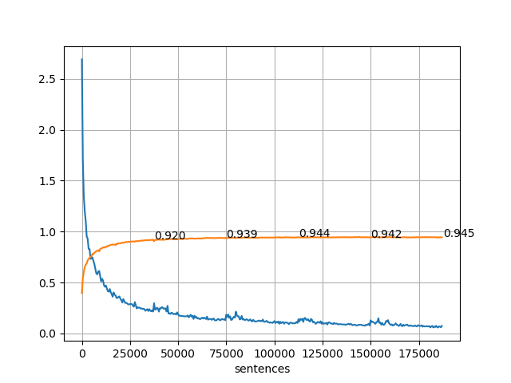
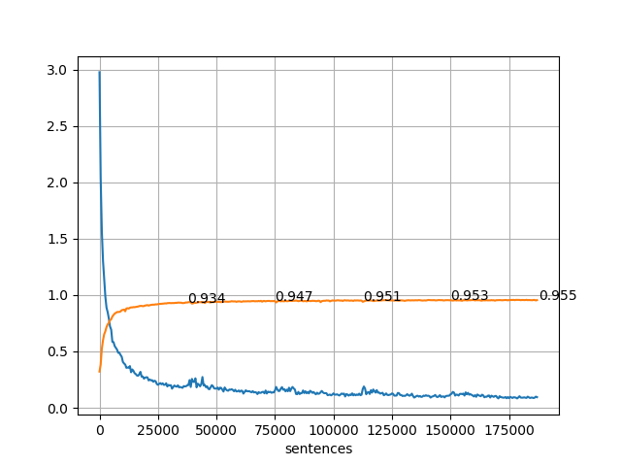

(c) (d)

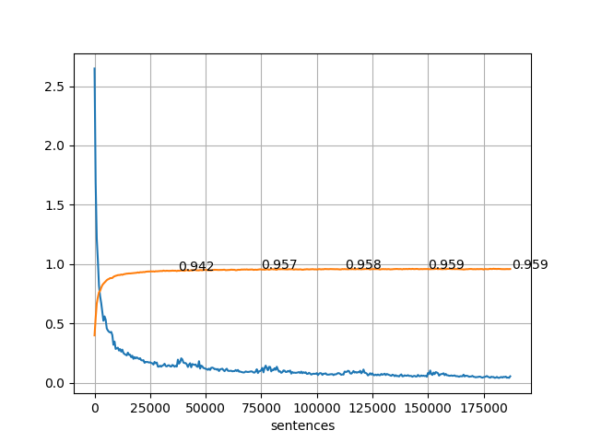
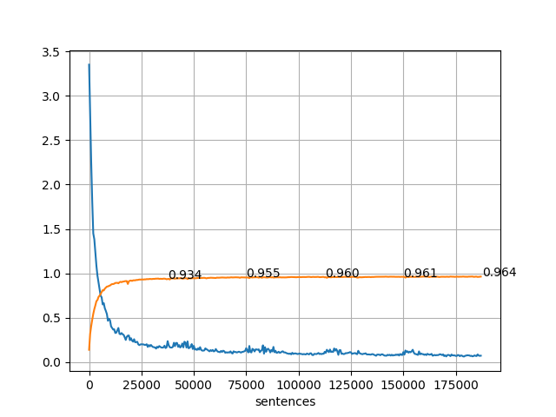

NER:

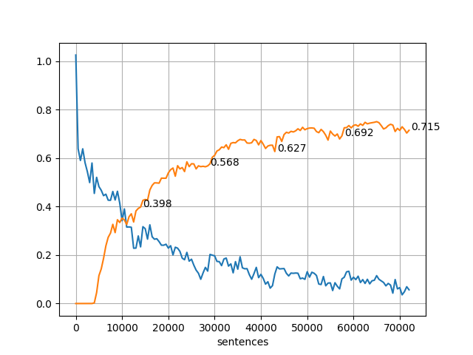
(a) (b)
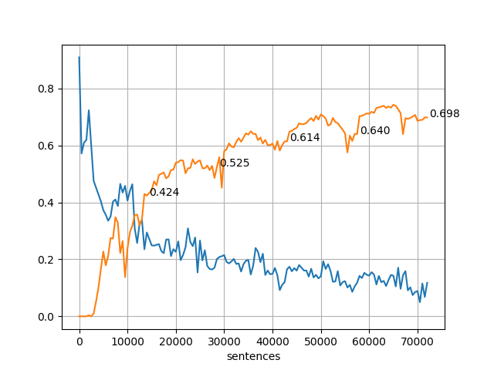

(c) (d)
