Part 3
About tagger2.py

Exactly the same as tagger1.py, except it loads a pretrained model (embeddings and vocab file).

Another difference, is here I lower case all the input (to fit the pretrained model), and not doing the trick of replacing digits with ‘#’ (again, to fit the pretrained model).

POS dataset:

- Dev accuracy: 94.9%
- Parameters:
  - window_size: 2
  - learning rate (start): 0.001
  - batch size: 500
  - epoches: 6
- Hard coded tricks:
  - Adam optimizer
  - Add <s>, </s> words to start & end of each sentence.
  - Lower case the data.
  - Filter rare words that occurred in the training set < 4 times. Replace with UUUNNNKKK
  - Any unknown word while testing is replaced with UUUNNNKKK

Notes & Impressions:
- Converged much quicker then tagger1.py. (93% after 1 epoch)
- Final results were the same results as tagger1.py
- I said in part1 Capital letters & replacing numbers did not affect POS accuracy, it is proven here (against common sense).

Command line to run:
[TODO]

Graph:
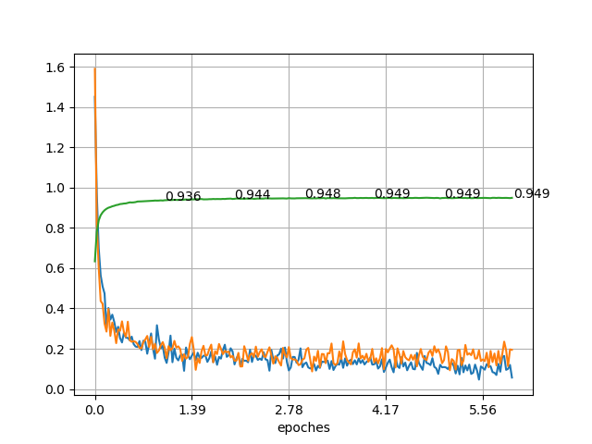

- Dev accuracy
- Dev loss
- Train loss

Final accuracy: 94.9% (roughly same as tagger1 95.1%)

NER dataset:

- Dev accuracy: 73.8%
- Parameters:
  - window_size: 2
  - learning rate (start): 0.001
  - batch size: 500
  - epoches: 12 (only parameter different then POS)
- Hard coded tricks:
  - Same as POS

Notes & Impressions:

- Dev loss is much more eratic then dev loss at part1.
- Lower accuracy then part1.
- My conclusion: pretrained model made no difference, but the necessity to lower case everything, and drop the digit to # replacement hurt performance a lot. We will find proof of this in part4.

Command line to run:
[TODO]

Graph:
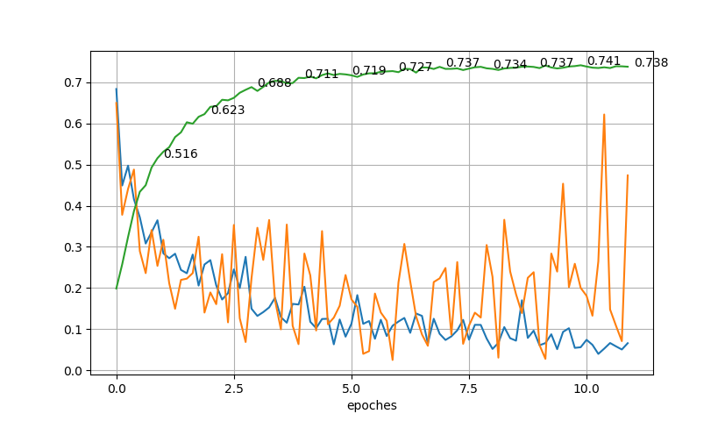

- Dev accuracy
- Dev loss
- Train loss

Final accuracy: 73.8% (<76.9% of tagger1)

