Part 1
About tagger1.py

As per the instructions, tagger.py only extract from word w into featues: w(i-2), w(i-1), w(i), w(i+1), w(i+2).

Layer 1: Feature vector is multiplied by an embedding vector of depth 50, then it is concatonated (order matters).
Layer #: Batch normalization.
Layer 2: Hidden layer with dim num_labels*4, activation: tanh
Layer #: Dropout
Layer 3: output: num_labels, activation: softmax
Loss function: Cross Entropy

Notes:
1) I added batch normalization & dropout to the instructed model to prevent overfitting. In reality it seemed to have no effect but I kept it.
2) To avoid duplicating code between tagger 1 2 & 3, model.py has a single Model class for all of them.
Input tensor is of the shape [batch_size, 5, 1] for tagger1.py & tagger2.py. And [batch_size,5,3] for tagger3.py
(More explanation in part3.pdf)

POS dataset:

- Dev accuracy: 95.1%
- Parameters:
  - window_size: 2
  - learning rate (start): 0.001
  - batch size: 500
  - epoches: 8
- Hard coded tricks:
  - Adam optimizer
  - Add START, END words to start & end of each sentence.
  - Don’t lower case the data, allow capital letters.
  - Filter rare words that occurred in the training set < 4 times. Replace with UNK
  - Any unknown word while testing is replaced with UNK
  - Replace all digits with ‘#’ character, to reduce number of unknown words. I.e 111 → ###, 999 → ###

Notes & Impressions:
- Keeping capital letters did not make any difference in the POS dataset, I kept it because it made sense.
- Same for replacing digits with ‘#’.
- The model converged after 8 epoches, if I kept training more, accuracy on dev set remained the same and then declined a bit. (overfitting)
- Loss on dev & train was pretty much identical all through the training, meaning a reduction in training loss meant reduction in dev loss.
It is a good sign.

Command line to run:
[TODO]

Graph:
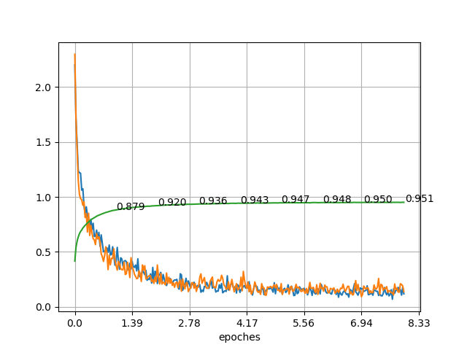

- Dev accuracy
- Dev loss
- Train loss

Note:
- Plotting – The model converged in very small number of epoches (8), so computing loss, acc at the end of every epoch would produce small number of points. The x axis is still epoches, but I evaluated the model every 50 batches (to add more points to the graph).
- The numbers on the green line, are the accuracy of the dev set at the end of every epoch.
- Final accuracy: 95.1%

NER dataset:

- Dev accuracy: 76.9%
- Parameters:
  - window_size: 2
  - learning rate (start): 0.001
  - batch size: 500
  - epoches: 20 (only parameter different then POS)
- Hard coded tricks:
  - Same as POS

Notes & Impressions:

- Was much harder to train.
- Loss of dev set is pretty jumpy, it is very different then the train loss. I believe it is because NER is tagging unknown words pretty much, so while training, it is possible for names of people and organizations to appear in the training word corpus. Dev set introduce those names as unknown words, making them much harder to predict with a single word embeddings: UNK.
- Evaluation of accuracy: We were required to omit the O tag, but it is also possible for the model to predict no O tag for an O tag word. I omitted only “correctly predicted” O tags. “wrongly predicted” O tags were added to the error. (I do not know if other students did the same, but my method is more strict, giving me lower score).

Command line to run:
[TODO]
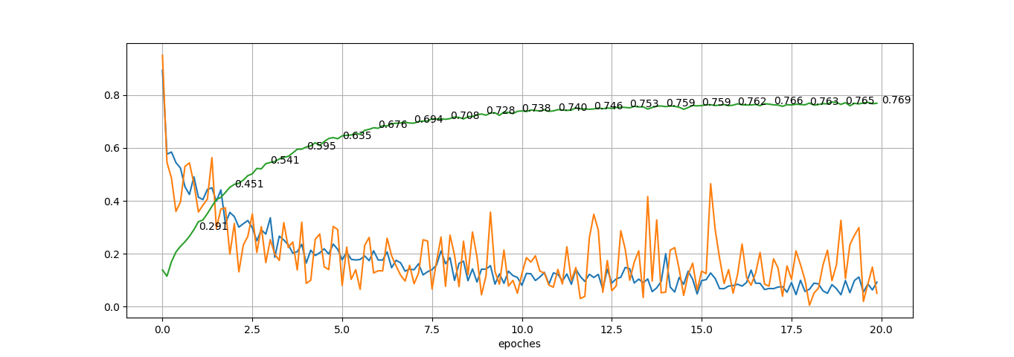

- Dev accuracy
- Dev loss
- Train loss

Final accuracy: 76.9%

